Web Development Lab Record

Basic Information
Experiment No: | 01
Title: | Design of a Static Web Page Using Pure HTML Semantic Components

Objective / Aim
To design and implement a static web page using core HTML5 semantic elements (header, nav, section, article, aside, footer) .

System Requirements
Hardware:
- Processor: Intel Core i5 or equivalent
- RAM: 8 GB
- Storage: 256 GB SSD (minimum free space 1 GB)
Software:
- Operating System: Windows 11 / Linux
- Code Editor: Visual Studio Code
- Browser: Google Chrome / Mozilla Firefox
- Runtime/Database: Not required (pure static HTML page)

Architecture / Design
The document follows a linear semantic flow: <header> (site title + navigation) → <section id="home"> (hero/intro) → a two-column structural <table> containing <main> (articles + form) on the left and <aside> (sidebar references) on the right → <footer> (copyright). Data flow is purely presentational; no client-server communication occurs since the page is fully static.

Source Code
File: index.html
<!DOCTYPE html>
<html lang="en">
<head>
<meta charset="UTF-8">
<title>Pure Semantic HTML Static Webpage</title>
</head>
<body>

<!-- Header Section -->
<header>
<table width="100%" border="0" cellspacing="0" cellpadding="10">
<tr>
<td>
<h1>StaticWeb</h1>
</td>
<td align="right">
<nav>
<a href="#home">Home</a> &nbsp;|&nbsp;
<a href="#articles">Articles</a> &nbsp;|&nbsp;
<a href="#about">About</a> &nbsp;|&nbsp;
<a href="#contact">Contact Us</a>
</nav>
</td>
</tr>
</table>
</header>

<hr>

<!-- Hero / Showcase Section -->
<section id="home">
<center>
<h2>Semantic Structures Without CSS</h2>
<p>This layout uses raw HTML components to build an organized document hierarchy that browsers can cleanly parse out-of-the-box.</p>
<p><a href="#articles"><b>Read Our Articles Below &darr;</b></a></p>
</center>
</section>

<hr>

<!-- Main Content Layout using a Structural Table -->
<table width="100%" border="0" cellspacing="0" cellpadding="20">
<tr valign="top">

<!-- Left Side: Main Content Column -->
<td width="70%">
<main id="articles">

<article>
<h2>1. Core Structural Tags</h2>
<p>Published: July 7, 2026</p>
<p>When you omit cascading style sheets entirely, the semantic markup handles all of the structural heavy lifting. Elements like <code>&lt;main&gt;</code>, <code>&lt;article&gt;</code>, and <code>&lt;section&gt;</code> tell screen readers and web scrapers exactly how information flows.</p>
<p>Using raw browser defaults ensures excellent loading performance, perfect accessibility compliance, and absolute structural clarity.</p>
</article>

<br><hr><br>

<article>
<h2>2. Native Interaction Elements</h2>
<p>Published: July 5, 2026</p>
<p>Browsers come equipped with excellent interactive elements by default. We can capture text inputs, provide multiple-choice configurations, and submit structured information to backend parsers using pure markup.</p>

<h3>Interactive Demonstration Forms</h3>
<form id="contact" action="#" method="post">
<fieldset>
<legend><b>User Inquiry Form</b></legend>
<p>
<label for="name">Full Name: </label>
<input type="text" id="name" name="username" required placeholder="John Doe">
</p>
<p>
<label for="email">Email Address: </label>
<input type="email" id="email" name="useremail" required>
</p>
<p>
<label for="topic">Inquiry Topic: </label>
<select id="topic" name="usertopic">
<option value="general">General Feedback</option>
<option value="technical">Technical Architecture</option>
<option value="academics">Academic Curriculum</option>
</select>
</p>
<p>
<label for="message">Message Details:</label><br>
<textarea id="message" name="usermessage" rows="5" cols="40" placeholder="Type your notes here..."></textarea>
</p>
<p>
<input type="submit" value="Submit Form Data">
<input type="reset" value="Clear Entries">
</p>
</fieldset>
</form>
</article>

</main>
</td>

<!-- Right Side: Sidebar Column -->
<td width="30%" bgcolor="#f4f4f4">
<aside id="about">
<h3>Document References</h3>
<p>Static pages map data out directly without real-time database queries or processor overhead.</p>

<h4>Core Benefits:</h4>
<ul>
<li>Instant browser painting</li>
<li>Low memory footprints</li>
<li>High data compatibility</li>
</ul>

<h4>Required Components:</h4>
<ol>
<li>Document Type Definition</li>
<li>Semantic Wrapper Blocks</li>
<li>Data Input Control Interfaces</li>
</ol>
</aside>
</td>

</tr>
</table>

<hr>

<!-- Footer Section -->
<footer>
<center>
<p>&copy; 2026 Pure HTML Architecture. Assembled completely without style configurations.</p>
</center>
</footer>
</body>
</html>

Compilation / Execution Steps
- Save the source code above as lab1.html
- Open the file directly in any modern web browser (double-click, or right-click → Open With → Browser).
- No server, build step, or dependency installation is required since the page uses only static HTML.
- Verify that navigation links scroll to the corresponding #home, #articles, #about, and #contact sections.

Expected Output / Screenshots
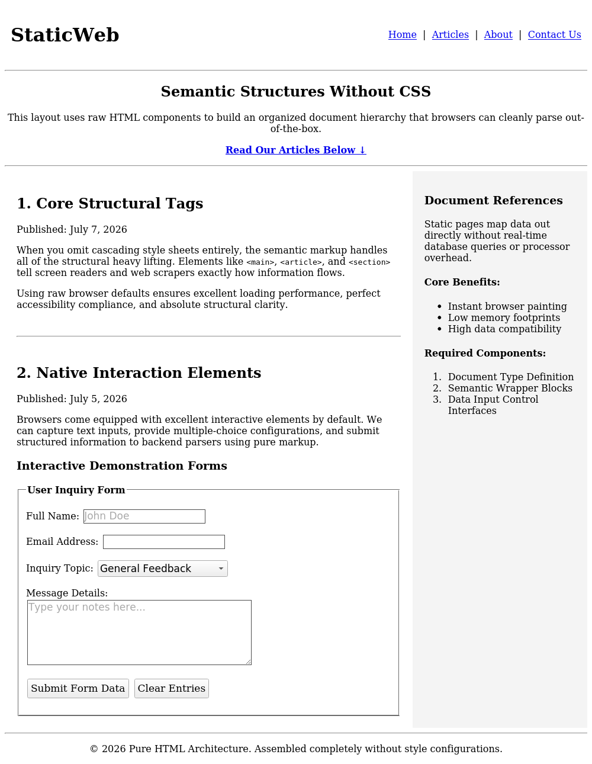

Result / Conclusion
The static web page was successfully designed and implemented using pure HTML5 semantic elements and native form controls, without relying on any CSS styling. The output confirmed that browsers can independently structure, render, and make an accessible document navigable using markup alone, satisfying the experiment's objective.

