Web Development Lab Record
Basic Information
Experiment No: | 02
Title: | Design Webpage using HTML5 & CSS3
Objective / Aim
To design and implement a webpage for ANITS (Anil Neerukonda Institute of Technology & Sciences) using HTML5 semantic elements and CSS3 styling, demonstrating the separation of structure (HTML) and presentation (CSS) through an externally linked stylesheet.
System Requirements
Hardware:
- Processor: Intel Core i5 or equivalent
- RAM: 8 GB or above
- Storage: 256 GB SSD / HDD
Software:
- Operating System: Windows 11
- Code Editor: Visual Studio Code with Live Server extension
- Browser: Google Chrome / Microsoft Edge
- Runtime: None — static HTML5 + CSS3 files
Architecture / Design
File Structure:
- lab2.html — HTML5 structure (header, nav, section, main, article, aside, form, footer)
- lab2.css — CSS3 styling linked via <link rel="stylesheet" href="lab 2.css">
Page Layout:
- <header> — ANITS logo (h1) + <nav> with Home / Departments / About / Contact Us links
- <section id="home"> — Gradient hero banner with institute name, description, and CTA link
- <div class="container"> (Flexbox row) — <main> (70%) + <aside> (30%)
- <main id="articles"> — CSE department article + Student Enquiry Form
- <aside id="about"> — About ANITS, Key Highlights, Departments Offered
- <footer> — copyright text
CSS3 Features Demonstrated:
- Flexbox layout (header, .container, form inputs)
- Linear gradient background (hero section)
- Box shadow and border radius (main content card, buttons, inputs)
- Transitions (nav link hover, submit/reset button hover)
- Reset/base styling using the universal selector (*)
Source Code — lab2.html
<!DOCTYPE html>
<html lang="en">
<head>
<meta charset="UTF-8">
<title>ANITS - Anil Neerukonda Institute of Technology & Sciences</title>
<link rel="stylesheet" href="lab 2.css">
</head>
<body>

<!-- Header Section -->
<header>
<h1>ANITS</h1>
<nav>
<a href="#home">Home</a>
<a href="#articles">Departments</a>
<a href="#about">About</a>
<a href="#contact">Contact Us</a>
</nav>
</header>

<!-- Hero / Showcase Section -->
<section id="home">
<h2>Anil Neerukonda Institute of Technology & Sciences</h2>
<p>A premier engineering institution in Visakhapatnam, focused on academic excellence, research, and strong industry-oriented learning.</p>
<p><a href="#articles"><b>Explore Our Departments Below &darr;</b></a></p>
</section>

<!-- Main Content Layout -->
<div class="container">

<!-- Left Side: Main Content Column -->
<main id="articles">

<article>
<h2>1. Computer Science Engineering</h2>
<p>Established with modern labs and industry-aligned curriculum</p>
<p>The CSE department focuses on core programming, data structures, AI/ML, and software development, preparing students for top tech careers through strong placement support.</p>
<p>Students get hands-on exposure to real-world projects using tools like <code>Python</code>, <code>Java</code>, and cloud platforms.</p>
</article>

<article>
<h2>2. Student Enquiry Form</h2>
<p>For admissions and general queries</p>
<p>Prospective students and parents can use the form below to reach out to the ANITS admissions office for any information regarding courses, fees, or campus facilities.</p>
<br>
<h3>Contact ANITS</h3>
<form id="contact" action="#" method="post">
<fieldset>
<legend><b>Admission Enquiry Form</b></legend>
<p>
<label for="name">Full Name:</label>
<input type="text" id="name" name="username" required placeholder="John Doe">
</p>
<p>
<label for="email">Email Address:</label>
<input type="email" id="email" name="useremail" required>
</p>
<p>
<label for="topic">Enquiry Topic:</label>
<select id="topic" name="usertopic">
<option value="admissions">Admissions</option>
<option value="academics">Academic Curriculum</option>
<option value="placements">Placements</option>
</select>
</p>
<p>
<label for="message">Message Details:</label><br>
<textarea id="message" name="usermessage" rows="5" cols="40" placeholder="Type your query here..."></textarea>
</p>
<p>
<input type="submit" value="Submit Enquiry">
<input type="reset" value="Clear Entries">
</p>
</fieldset>
</form>
</article>

</main>

<!-- Right Side: Sidebar Column -->
<aside id="about">
<h3>About ANITS</h3>
<p>ANITS is known for its strong academic reputation, modern infrastructure, and excellent placement record across top companies.</p>

<h4>Key Highlights:</h4>
<ul>
<li>Experienced faculty</li>
<li>Well-equipped labs</li>
<li>Strong placement cell</li>
</ul>

<h4>Departments Offered:</h4>
<ol>
<li>Computer Science Engineering</li>
<li>Electronics & Communication</li>
<li>Mechanical Engineering</li>
</ol>
</aside>

</div>

<!-- Footer Section -->
<footer>
<p>&copy; 2026 ANITS - Anil Neerukonda Institute of Technology & Sciences. All Rights Reserved.</p>
</footer>

</body>
</html>

Source Code — lab2.css
/* ===== Reset & Base ===== */
* {
margin: 0;
padding: 0;
box-sizing: border-box;
}

body {
font-family: 'Segoe UI', Arial, sans-serif;
background-color: #f9f9f9;
color: #333;
line-height: 1.6;
}

/* ===== Header ===== */
header {
display: flex;
justify-content: space-between;
align-items: center;
background-color: #1e3c72;
color: white;
padding: 15px 30px;
}

header h1 {
font-size: 24px;
}

nav a {
color: white;
text-decoration: none;
margin-left: 20px;
font-weight: bold;
transition: 0.3s;
}

nav a:hover {
color: #ffcc00;
}

/* ===== Hero Section ===== */
#home {
text-align: center;
padding: 50px 20px;
background: linear-gradient(to right, #2a5298, #4facfe);
color: white;
}

#home h2 {
font-size: 28px;
margin-bottom: 15px;
}

#home p {
max-width: 600px;
margin: 0 auto 10px auto;
}

#home a {
color: #ffcc00;
text-decoration: none;
}

/* ===== Main Layout ===== */
.container {
display: flex;
gap: 25px;
padding: 30px;
align-items: flex-start;
}

main {
flex: 7;
background-color: white;
padding: 25px;
border-radius: 10px;
box-shadow: 2px 2px 10px rgba(0,0,0,0.1);
}

aside {
flex: 3;
background-color: #f4f4f4;
padding: 20px;
border-radius: 10px;
}

/* ===== Articles ===== */
article {
margin-bottom: 25px;
padding-bottom: 20px;
border-bottom: 1px solid #ddd;
}

article h2 {
color: #1e3c72;
margin-bottom: 8px;
}

article p {
margin-bottom: 10px;
}

code {
background-color: #eee;
padding: 2px 6px;
border-radius: 4px;
font-family: monospace;
}

/* ===== Form ===== */
form fieldset {
border: 1px solid #ccc;
border-radius: 8px;
padding: 20px;
}

form legend {
padding: 0 10px;
color: #1e3c72;
}

form label {
display: inline-block;
width: 130px;
font-weight: bold;
}

form input[type="text"],
form input[type="email"],
form select,
form textarea {
width: 60%;
padding: 8px;
margin: 6px 0;
border: 1px solid #ccc;
border-radius: 6px;
}

form input[type="submit"],
form input[type="reset"] {
padding: 8px 18px;
margin-top: 10px;
margin-right: 10px;
border: none;
border-radius: 6px;
background-color: #1e3c72;
color: white;
cursor: pointer;
}

form input[type="submit"]:hover,
form input[type="reset"]:hover {
background-color: #4facfe;
}

/* ===== Sidebar ===== */
aside h3 {
color: #1e3c72;
margin-bottom: 10px;
}

aside h4 {
margin-top: 15px;
margin-bottom: 8px;
}

aside ul, aside ol {
margin-left: 20px;
}

/* ===== Footer ===== */
footer {
text-align: center;
padding: 18px;
background-color: #1e3c72;
color: white;
margin-top: 20px;
}

Compilation / Execution Steps
- Create a project folder and save the HTML file as lab2.html inside it.
- Create lab2.css in the same folder and paste the CSS source code.
- Open the folder in Visual Studio Code.
- Install the Live Server extension if not already installed.
- Right-click lab2.html → select "Open with Live Server".
- Browser opens automatically and renders the styled ANITS webpage.
- Verify header, hero section, articles, sidebar, enquiry form, and footer render correctly with CSS3 styling.
Expected Output / Screenshot
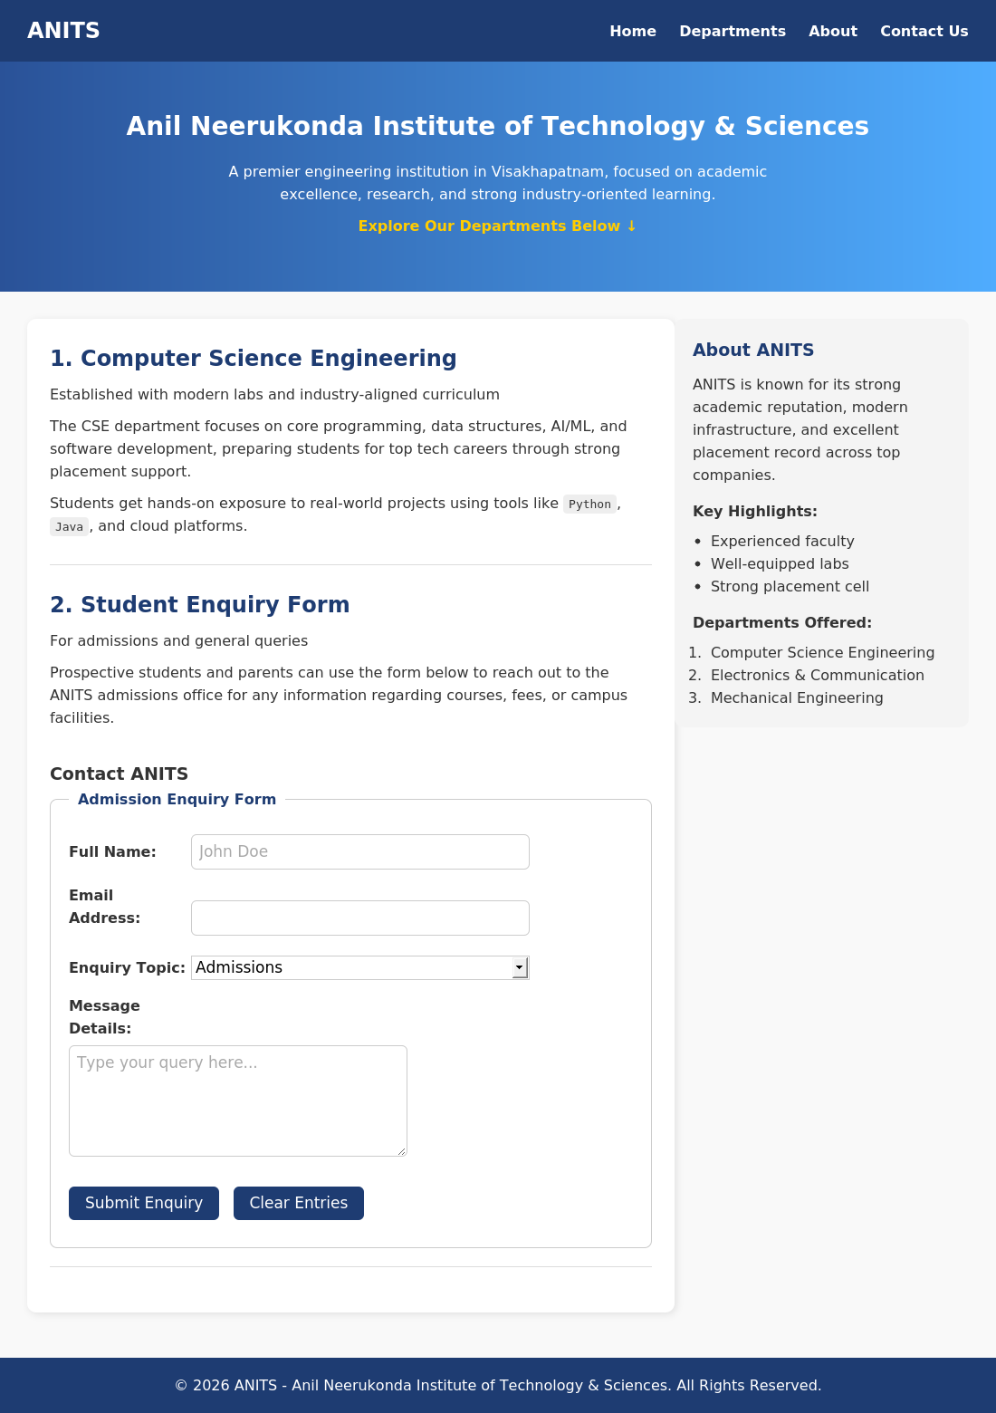
The screenshot above shows the ANITS webpage rendered in a Chromium browser, executed directly from the lab2.html and lab2.css source files. It demonstrates the gradient hero section, flexbox-based two-column layout, styled admission enquiry form, and footer.
Result / Conclusion
The experiment was successfully completed. A fully styled ANITS webpage was designed and implemented using HTML5 semantic elements structured in lab2.html, with all visual styling defined separately in lab2.css using CSS3 features including flexbox layout, gradients, box shadow, border radius, and transitions. The separation of structure and presentation was clearly demonstrated.

