Amazon Music Clustering
Analysis Report
Author: Akshaya Vinod Kumar - Marine Biologist & Data Science Practitioner
Capstone 4: HCL GUVI - Data Science with ML & AI Certification
Domain: Music Analytics / Unsupervised Machine Learning

1. Problem Statement
With millions of songs available on platforms like Amazon Music, manually categorizing tracks into genres is impractical. This project groups songs into clusters based purely on their audio characteristics - tempo, energy, danceability, acousticness, and more - using unsupervised machine learning, without relying on any pre-existing genre labels.

2. Dataset
- Source: single_genre_artists.csv - 95,837 songs, 23 columns
- Quality: No missing values, no duplicate rows
- Clustering features (10): danceability, energy, loudness, speechiness, acousticness, instrumentalness, liveness, valence, tempo, duration_ms
- Reference-only columns: name_song, name_artists, genres, id_songs, id_artists - excluded from clustering, used for interpretation

3. Methodology
- Preprocessing: dropped duplicates (none found); excluded identifier/text columns from the clustering input.
- Scaling: applied StandardScaler to all 10 features - essential since clustering is distance-based and features like tempo and duration_ms live on entirely different scales than danceability or energy (0-1).
- Choosing k: swept k = 2 to 10, recording inertia (Elbow Method) and Silhouette Score (computed on an 8,000-song sample for tractability) at each k.
- Clustering: fit final K-Means with the selected k on the full scaled dataset.
- Dimensionality reduction: PCA to 2 components for visualization only - clustering itself uses the full 10-dimensional space.
- Interpretation: profiled each cluster's mean feature values and translated the statistics into business-readable labels.

4. Choosing the Number of Clusters
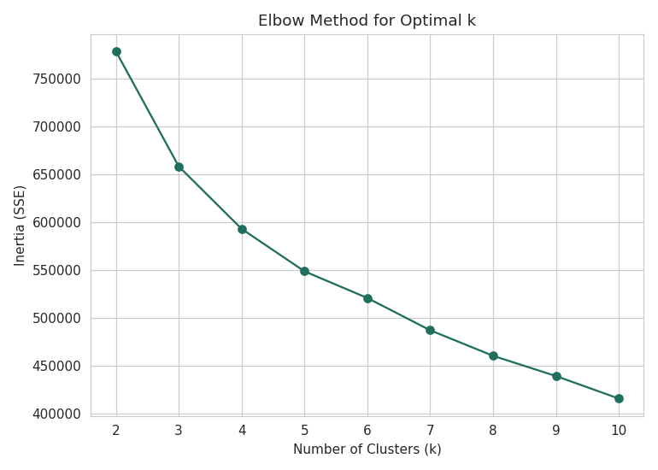
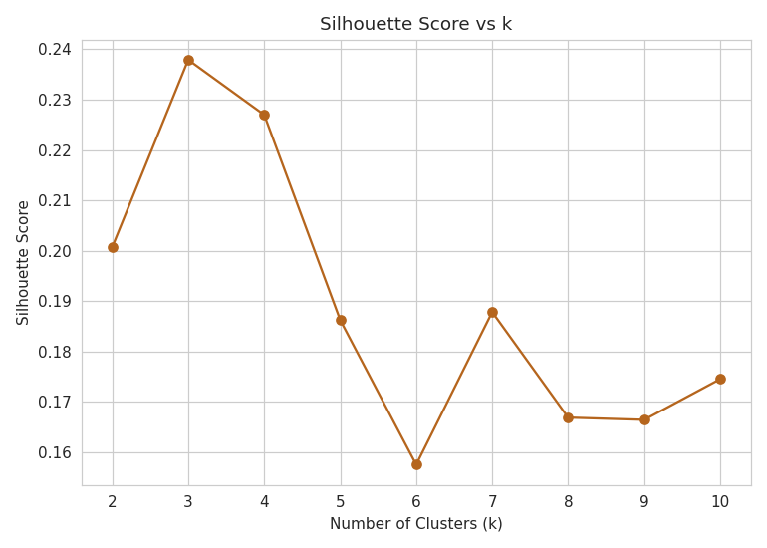
Figure 1-2: Elbow Method and Silhouette Score across k = 2-10

K | Inertia | Silhouette Score
2 | 778,814 | 0.2007
3 | 658,335 | 0.2379
4 | 593,031 | 0.2270
5 | 548,595 | 0.1862
6 | 520,711 | 0.1575
7 | 486,936 | 0.1878
8 | 460,215 | 0.1669
9 | 439,037 | 0.1664
10 | 415,492 | 0.1745

k = 3 was selected: it has both the highest silhouette score in the sweep and sits right at the elbow's inflection point, where additional clusters stop meaningfully reducing inertia.

5. Final Model & Evaluation
Metric | Value
Algorithm | K-Means (k = 3, random_state = 42, n_init = 10)
Silhouette Score (8k sample) | 0.2379
Davies-Bouldin Index (full data) | 1.5702
PCA variance explained (2D) | 45.9% (PC1: 27.1%, PC2: 18.8%)

A silhouette score in the 0.2-0.3 range is typical and expected for real-world audio data - musical style exists on a continuum (a track can be both danceable and acoustic), so perfect separation (~1.0) is not a realistic target.

6. Cluster Visualization
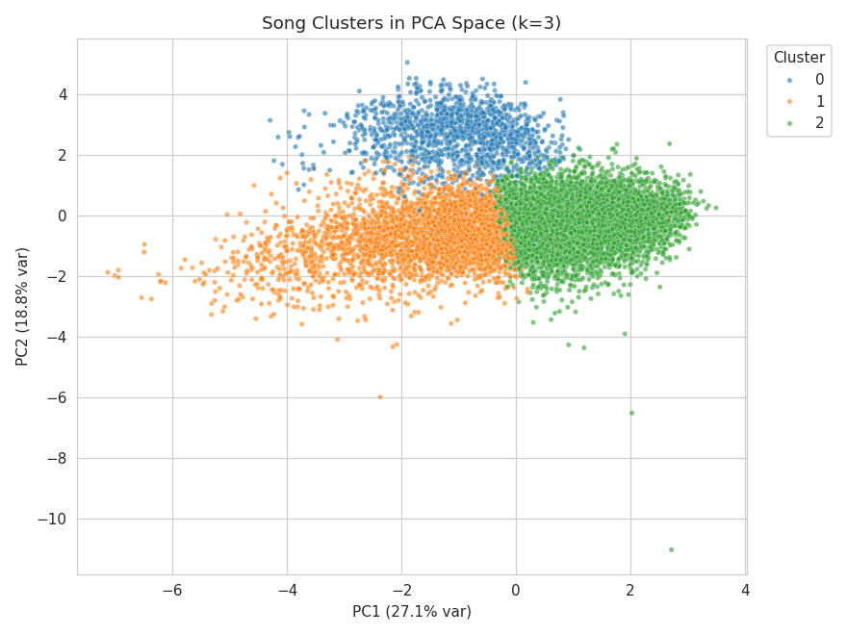
Figure 3: Songs projected onto the top 2 principal components, colored by cluster
The three clusters separate cleanly along PC1, which is dominated by the acousticness/energy/loudness axis.
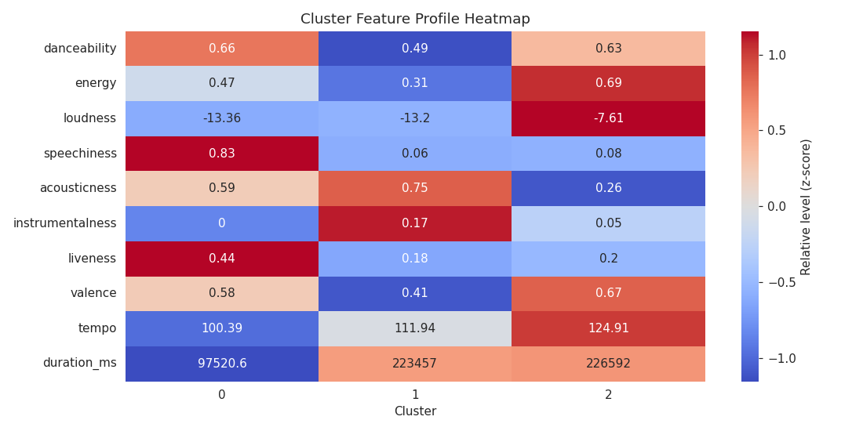
Figure 4: Cluster feature profile heatmap
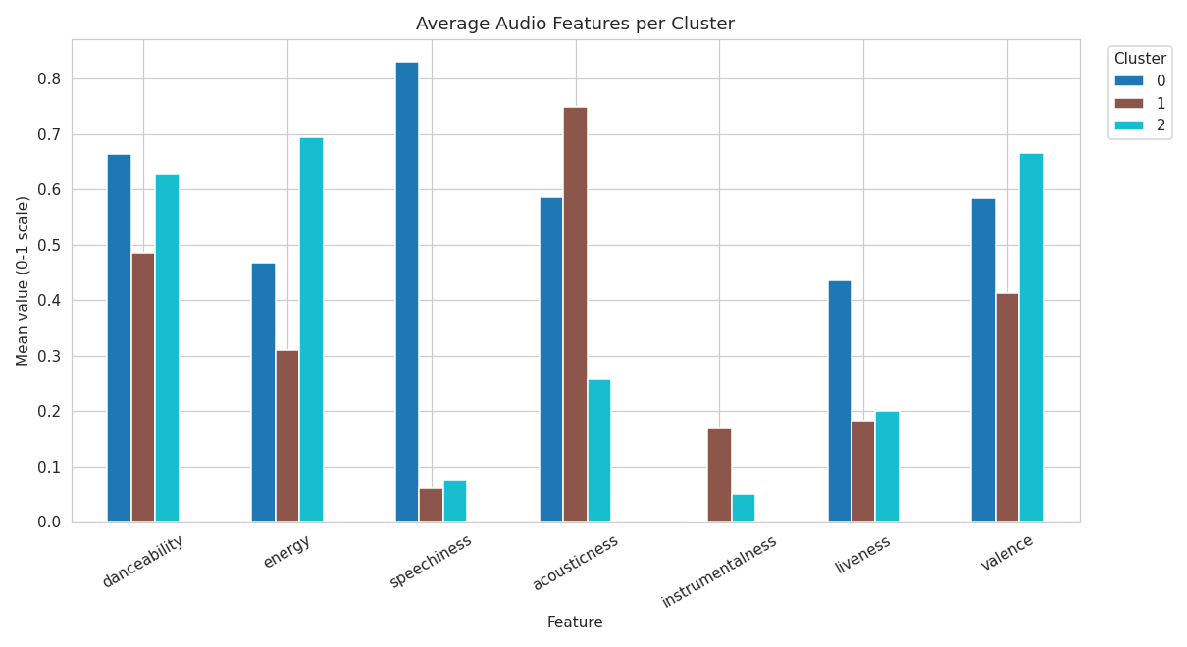
Figure 5: Average audio features per cluster
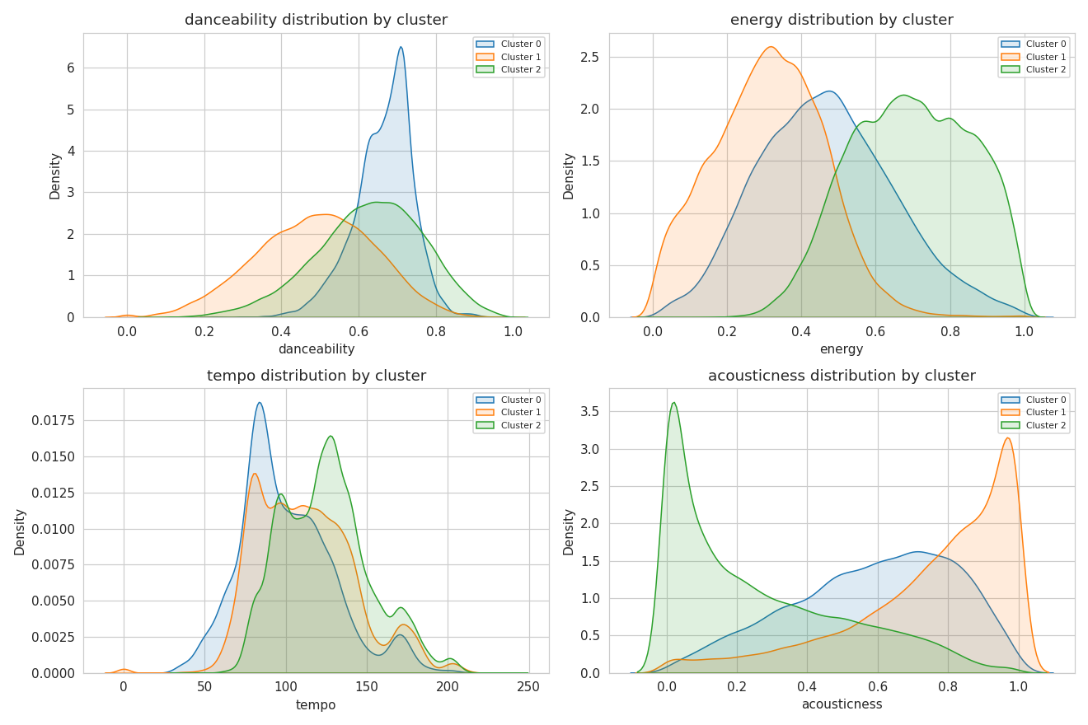
Figure 6: Feature distributions split by cluster

7. Cluster Profiles & Business Interpretation
Metric | Cluster 0 | Cluster 1 | Cluster 2
Size | 13.1% (12,513) | 32.2% (30,807) | 54.8% (52,517)
Danceability | 0.66 | 0.49 | 0.63
Energy | 0.47 | 0.31 | 0.69
Acousticness | 0.59 | 0.75 | 0.26
Speechiness | 0.83 | 0.06 | 0.08
Valence | 0.58 | 0.41 | 0.67
Tempo (bpm) | 100 | 112 | 125
Avg. Duration | 98s | 223s | 227s
Label | Spoken-Word / Short-Form Talk Tracks | Acoustic / Mellow Ballads | Upbeat / High-Energy Dance Tracks

Cluster 0 - Spoken-Word / Short-Form Talk Tracks: speechiness of 0.83 is far above the typical “musical” threshold (~0.33), and average duration (98s) is less than half of the other clusters - strongly indicative of interludes, comedy bits, poetry, or audiobook-style spoken content mixed into the catalog rather than conventional music.
Cluster 1 - Acoustic / Mellow Ballads: high acousticness (0.75) paired with the lowest energy (0.31) and lowest valence (0.41) in the dataset - calmer, more reflective or melancholic material; classic “chill” or “focus” playlist material.
Cluster 2 - Upbeat / High-Energy Dance Tracks: the majority class (55%) - high energy, highest valence (happiest), fastest tempo, and loudest average loudness. This is the mainstream “pop/dance” core of the catalog.

8. Business Use Cases Enabled
- Personalized Playlist Curation: Cluster 2 → workout/party playlists; Cluster 1 → chill/study playlists; Cluster 0 should generally be filtered out of music-only playlists.
- Improved Song Discovery: nearest-neighbor search within a cluster (by scaled feature distance) surfaces genuinely similar-sounding tracks - implemented in the companion Streamlit app's “Find Similar Songs” tab.
- Artist Analysis: an artist's distribution across clusters reveals catalog versatility vs. a single signature sound.
- Market Segmentation: cluster sizes give a catalog-level view of content mix (55% mainstream dance-pop vs. 32% acoustic vs. 13% talk-content).

9. Deliverables
- Source code: AmazonMusicClustering.ipynb (executed end-to-end, Google Colab)
- Final CSV: amazon_music_clustered_output.csv (95,837 rows + cluster column)
- Visualizations: elbow plot, silhouette plot, PCA scatter, heatmap, bar chart, distribution plots
- Bonus interactive app: streamlit_app.py (Streamlit app link attached in the GitHub README)
- This report

10. Limitations & Future Work
- Moderate separation: Silhouette/Davies-Bouldin scores indicate moderate (not razor-sharp) separation - expected given the continuous, overlapping nature of musical style.
- Sampled silhouette: the silhouette score is computed on an 8,000-song sample for computational tractability rather than all 95,837 songs; directionally reliable but not an exact full-dataset figure.
- Future work: genre metadata (already present in the genres column) as a validation signal against the unsupervised clusters; sub-clustering within Cluster 2 (the largest, 55% of data) to find finer-grained mood distinctions; t-SNE as an alternative to PCA for visualization; or DBSCAN/Hierarchical clustering as additional cross-validation of the 3-cluster structure.

