ELK LOCAL DEPLOYMENT
Step-by-Step Procedure with Execution Evidence
Ubuntu Virtual Machine | Elasticsearch | Logstash | Kibana

Team Members | Akshaya, Aahlada, Suraj, Akshaya
Date | 30-09-2026
Evidence source | ELK Ubuntu execution Document supplied in this task
Deployment type | Local / self-hosted on Ubuntu VM
Documentation format | Step → purpose → command → related screenshot

1. Purpose
This document records the local deployment of the ELK stack on Ubuntu. Each step contains a short explanation of why the command was used, the command itself, and the screenshot that most closely corresponds to that activity in the supplied execution evidence.

2. Deployment Flow
Ubuntu → Java → Elastic repository → Elasticsearch → Logstash → Kibana → Verification
The commands below follow the manager-provided procedure. Where troubleshooting was required during execution, the corrective action is documented separately rather than replacing the original procedure.
STEP 01 — Update Ubuntu package information
What was done: Refresh the local APT package index before installing dependencies.
Command(s):
sudo apt update
Execution screenshot – related evidence
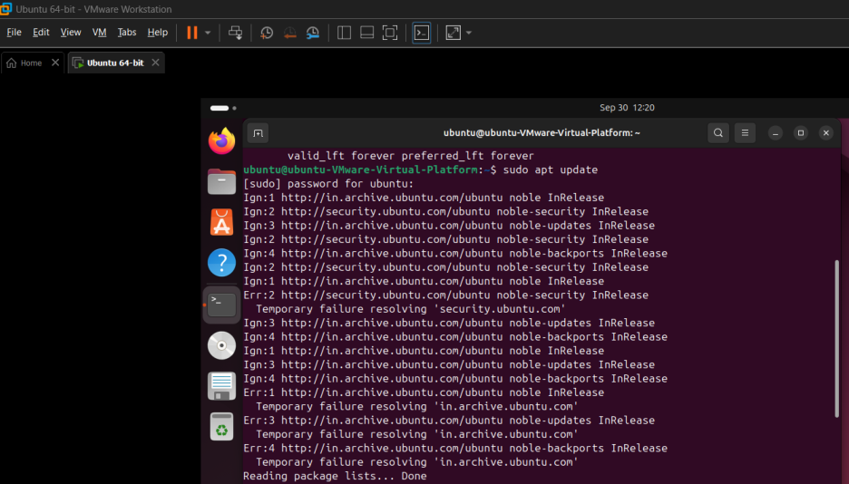

STEP 02 — Install Java 11 JRE
What was done: Install the Java runtime required by the supplied ELK procedure.
Command(s):
sudo apt install openjdk-11-jre
Execution screenshot – related evidence
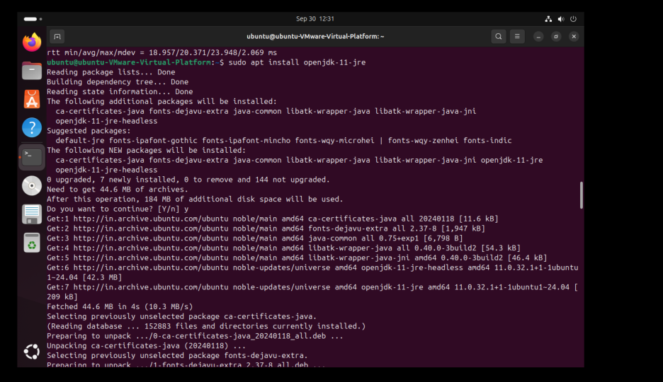

STEP 03 — Verify Java installation
What was done: Confirm that the Java runtime is installed and report the Java version.
Command(s):
java -version
Execution screenshot – related evidence
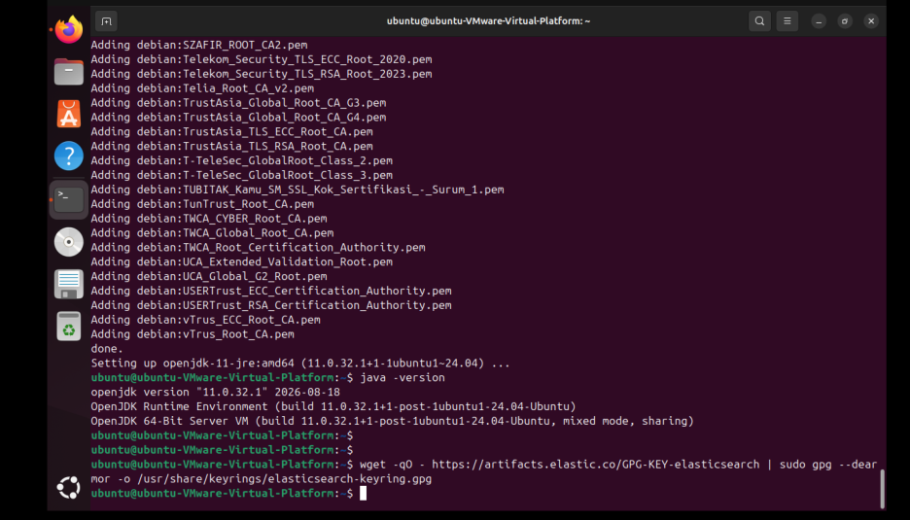

STEP 04 — Add Elasticsearch signing key
What was done: Add Elastic's public signing key so APT can verify Elastic packages.
Command(s):
wget -qO - https://artifacts.elastic.co/GPG-KEY-elasticsearch | sudo gpg --dearmor -o /usr/share/keyrings/elasticsearch-keyring.gpg
Execution screenshot – related evidence

STEP 05 — Install HTTPS transport support
What was done: Install APT HTTPS transport support for the Elastic package repository.
Command(s):
sudo apt-get install apt-transport-https
Execution screenshot – related evidence
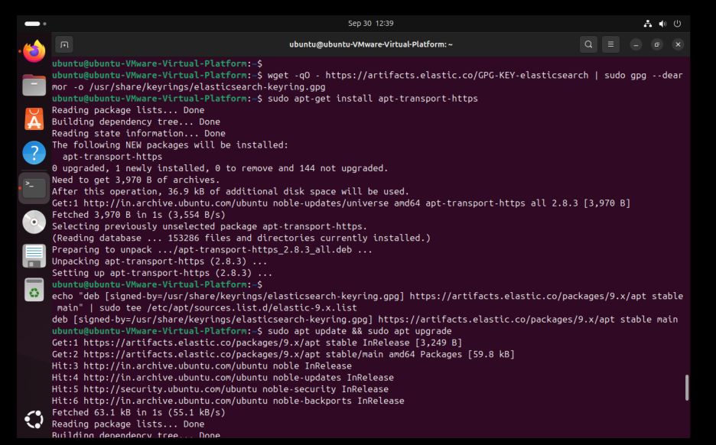

STEP 06 — Add Elastic 9.x APT repository
What was done: Register the Elastic 9.x repository with APT.
Command(s):
echo "deb [signed-by=/usr/share/keyrings/elasticsearch-keyring.gpg] https://artifacts.elastic.co/packages/9.x/apt stable main" | sudo tee /etc/apt/sources.list.d/elastic-9.x.list
Execution screenshot – related evidence

STEP 07 — Refresh package lists with Elastic repository
What was done: Reload APT metadata so Elasticsearch can be installed from the Elastic repository.
Command(s):
sudo apt update
Execution screenshot – related evidence

STEP 08 — Install Elasticsearch
What was done: Install the Elasticsearch Debian package.
Command(s):
sudo apt-get update && sudo apt-get install elasticsearch
Execution screenshot – related evidence

STEP 09 — Configure Elasticsearch
What was done: Configure the node, network binding, discovery seed, security and initial master settings.
Command(s):
sudo nano /etc/elasticsearch/elasticsearch.yml
Note: Required settings: node.name: node-1; network.host: 0.0.0.0; discovery.seed.hosts: ["127.0.0.1"]; xpack.security.enabled: true; cluster.initial_master_nodes: ["node-1"].
Execution screenshot – related evidence
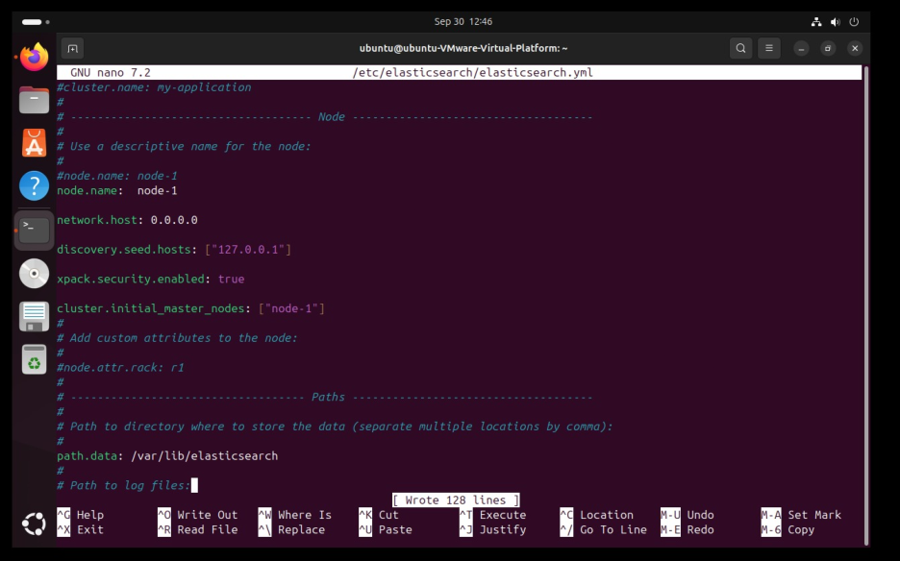

STEP 10 — Set Elasticsearch log permissions
What was done: Apply the permissions specified by the manager to the Elasticsearch log directory.
Command(s):
sudo chmod 755 -R /var/log/elasticsearch/
Execution screenshot – related evidence
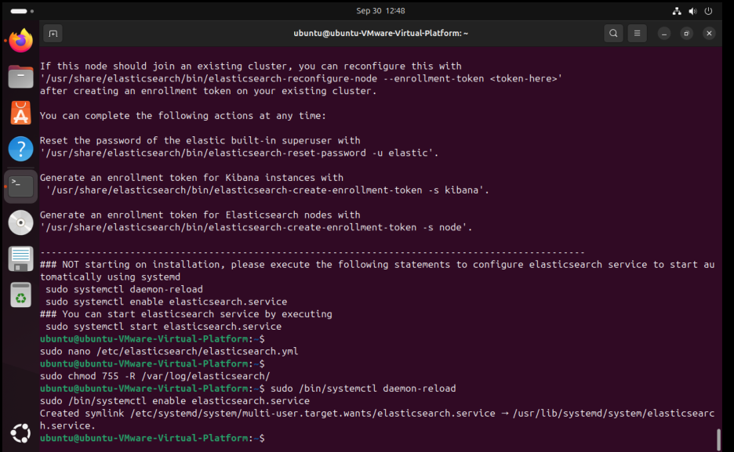

STEP 11 — Reload systemd and enable Elasticsearch
What was done: Reload service definitions and configure Elasticsearch to start automatically at boot.
Command(s):
sudo /bin/systemctl daemon-reload
sudo /bin/systemctl enable elasticsearch.service
Execution screenshot – related evidence
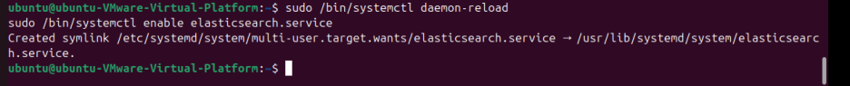

STEP 12 — Start and verify Elasticsearch service
What was done: Start Elasticsearch and verify its systemd status.
Command(s):
sudo /bin/systemctl start elasticsearch.service
sudo /bin/systemctl status elasticsearch.service
Execution screenshot – related evidence
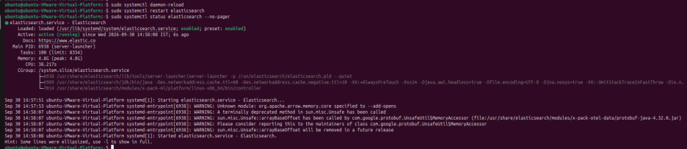

STEP 13 — Reset the elastic user password
What was done: Generate/reset the built-in elastic user password for authenticated access.
Command(s):
sudo /usr/share/elasticsearch/bin/elasticsearch-reset-password -u elastic
Note: The actual generated password is intentionally redacted from this document.
Execution screenshot – related evidence
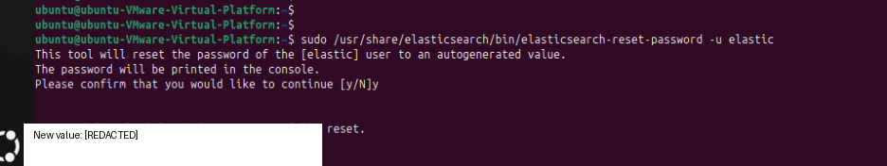

STEP 14 — Verify Elasticsearch API
What was done: Test the local Elasticsearch HTTP API using the elastic account.
Command(s):
curl -k -u elastic https://127.0.0.1:9200
Note: The screenshot shows a JSON response from Elasticsearch, confirming API availability.
Execution screenshot – related evidence


STEP 15 — Install Kibana
What was done: Install the Kibana web interface.
Command(s):
sudo apt-get install kibana
Execution screenshot – related evidence
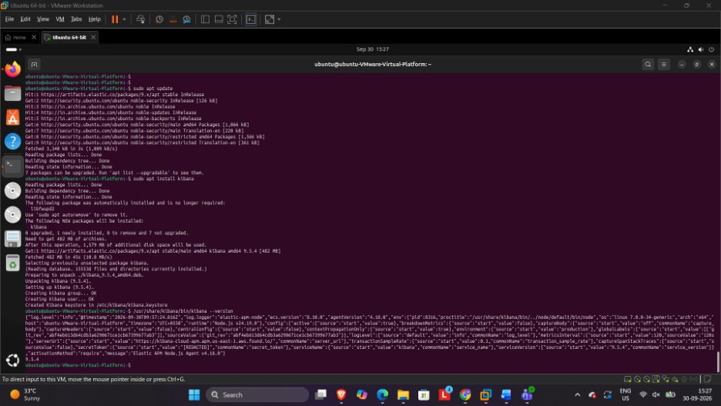

STEP 16 — Start Kibana
What was done: Start the Kibana service and confirm that its HTTP server is running.
Command(s):
sudo systemctl start kibana
Note: The execution evidence shows Kibana reporting its HTTP server as running.
Execution screenshot – related evidence
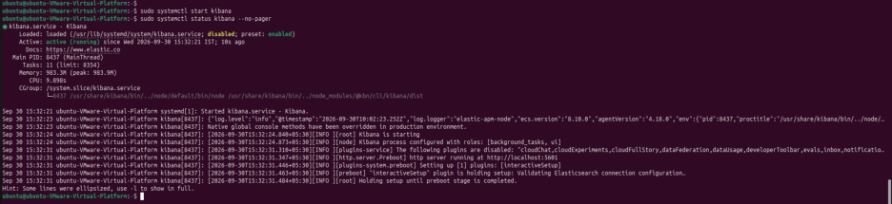

STEP 17 — Open Kibana enrollment page
What was done: Open Kibana in the browser and begin the Elasticsearch enrollment/configuration process.
Command(s):
Open http://<VM-IP>:5601 in a browser
Note: Enrollment material is redacted in the screenshot.
Execution screenshot – related evidence
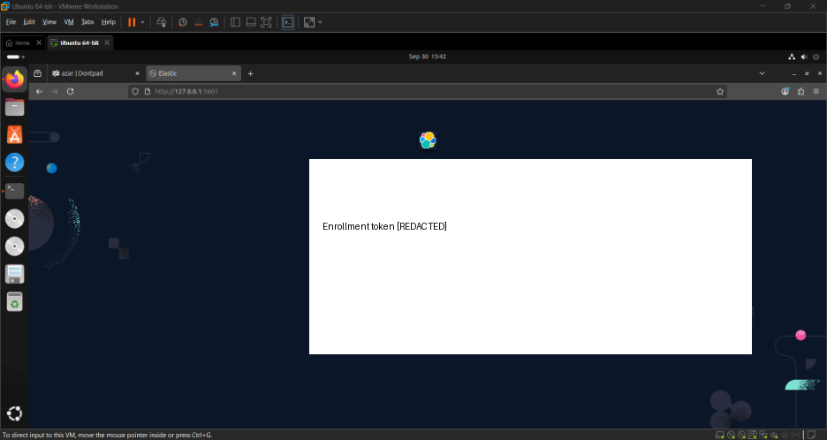

STEP 18 — Verify Kibana service activity
What was done: Review the Kibana service output/logs to confirm that the service is operating.
Command(s):
sudo systemctl status kibana
Execution screenshot – related evidence
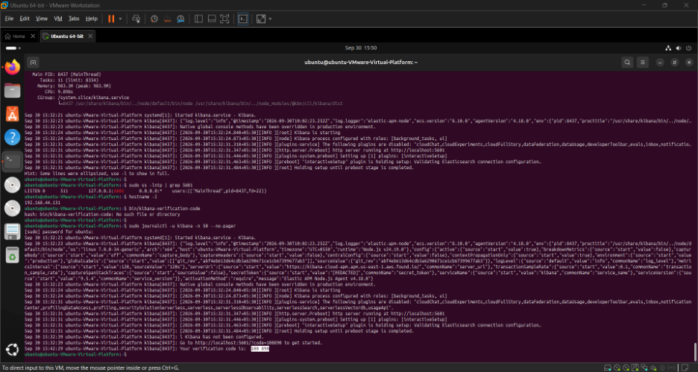

STEP 19 — Create a Logstash test log
What was done: Write a simple test message to a file for log-ingestion verification.
Command(s):
echo "Hello from Logstash" | sudo tee -a /tmp/logstash-test.log
Execution screenshot – related evidence

STEP 20 — Verify Kibana home page
What was done: Confirm successful access to the Kibana interface after configuration.
Command(s):
Open Kibana in the browser
Execution screenshot – related evidence
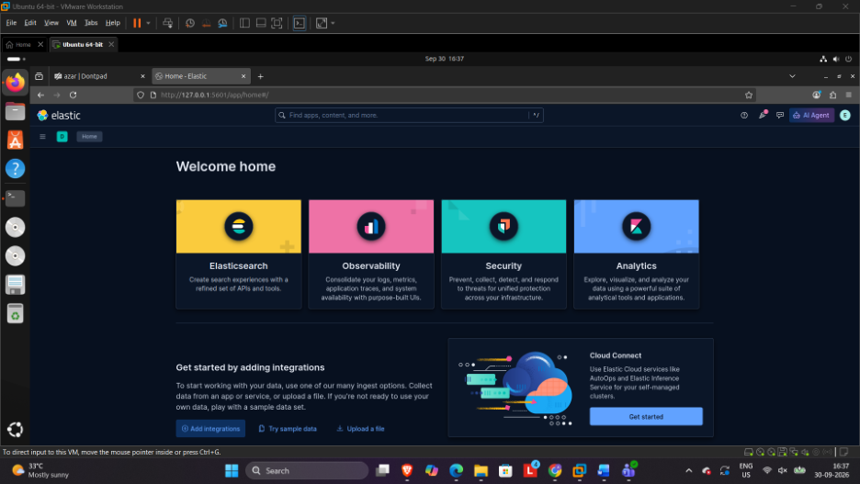

STEP 21 — Verify log data in Kibana Discover
What was done: Use Kibana Discover to confirm that the Logstash test message is visible in indexed data.
Command(s):
Open Kibana → Discover
Execution screenshot – related evidence
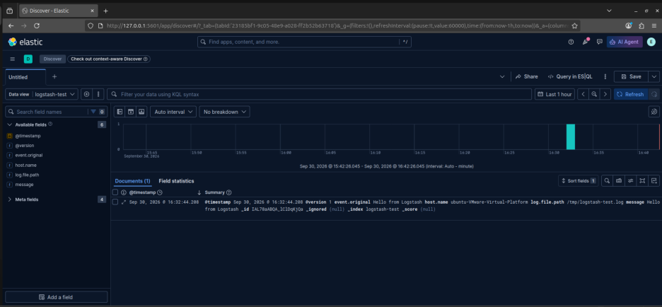

3. Additional Commands
The following commands were included in the manager-provided procedure and are retained here for completeness. Some do not have a dedicated screenshot in the supplied evidence PDF.
Activity | Command | Purpose
Logstash installation | sudo apt install logstash -y | Installs Logstash.
Enable Logstash | sudo systemctl enable logstash | Configures Logstash to start automatically.
Test Logstash configuration | sudo -u logstash /usr/share/logstash/bin/logstash --path.settings /etc/logstash -t | Checks Logstash configuration syntax.
Test a specific pipeline | /usr/share/logstash/bin/logstash -f /etc/logstash/conf.d/your-config.conf --config.test_and_exit | Validates a specific Logstash pipeline without permanently running it.
Kibana configuration | sudo nano /etc/kibana/kibana.yml | Opens the Kibana configuration file.
Kibana server port | server.port: 5601 | Sets Kibana's web server port.
Kibana network binding | server.host: "0.0.0.0" | Allows Kibana to listen on all VM network interfaces.
Generate Kibana encryption keys | cd /usr/share/kibana/bin  sudo ./kibana-encryption-keys generate | Generates the three Kibana encryption keys.
Store security encryption key | ./kibana-keystore add xpack.security.encryptionKey | Stores the Kibana security encryption key.
Store reporting encryption key | ./kibana-keystore add xpack.reporting.encryptionKey | Stores the Kibana reporting encryption key.
Store saved-object encryption key | ./kibana-keystore add xpack.encryptedSavedObjects.encryptionKey | Stores the encrypted saved objects key.
Reset kibana_system password | sudo /usr/share/elasticsearch/bin/elasticsearch-reset-password -u kibana_system | Generates/resets the Kibana system user's password.
Reset elastic password | sudo /usr/share/elasticsearch/bin/elasticsearch-reset-password -u elastic | Generates/resets the built-in elastic user's password.
Create Kibana enrollment token | cd /usr/share/elasticsearch/bin  sudo ./elasticsearch-create-enrollment-token --scope kibana | Creates an enrollment token for Kibana.
Generate Kibana verification code | cd /usr/share/kibana/bin  ./kibana-verification-code | Generates the verification code used during Kibana setup.

4. Final Verification Checklist
- Java 11 installed and verified with `java -version`.
- Elastic APT repository added and package metadata updated.
- Elasticsearch configuration saved and service enabled.
- Elasticsearch API returned JSON from port 9200.
- Kibana service started and browser interface opened on port 5601.
- A Logstash test message was written to `/tmp/logstash-test.log`.
- Kibana Discover displayed the Logstash test data.

5. Conclusion
The ELK stack was successfully deployed locally on an Ubuntu virtual machine by following the manager-provided procedure. The work began with updating the APT package index and installing the Java 11 runtime, which was verified with the Java version check. The Elastic signing key, HTTPS transport support and the Elastic 9.x APT repository were then added so that the Elastic packages could be installed securely.
Elasticsearch was installed and configured with the required node, network, discovery and security settings. Log directory permissions were applied, the service was enabled to start at boot and started, and its status was confirmed. The built-in elastic user password was reset (the generated value is redacted in this document), and a request to port 9200 returned a JSON response, confirming that the Elasticsearch API was running.
Kibana was then installed and started, and its web interface was opened on port 5601 to complete the enrollment process. A test message was written to /tmp/logstash-test.log for log-ingestion verification, and the message was confirmed in Kibana Discover. The additional Logstash and Kibana configuration commands from the manager-provided procedure are recorded in Section 3 for reference.
Every step is documented as Step Number → What was done → Command → Related screenshot, and all credential values have been redacted. Together, these steps show a working local ELK environment with Elasticsearch and Kibana running and log data visible in Kibana.

