LAB REPORT
Elastic Cloud SIEM Deployment
& Endpoint Log Ingestion
Step-by-Step Implementation Report

Interns | - Aahlada  - Akshaya  - Akshay  - Suraj
Date and Day | 28.09.2026 , Monday
Environment | Elastic Cloud (Trial), Windows 10/11 VM
Platform | Elastic Cloud Hosted

1. Objective
The objective of this lab is to deploy a cloud-native Elastic Stack environment using Elastic Cloud and configure log shipping from a Windows endpoint virtual machine using the Elastic Agent. The workflow covers the Elastic Cloud deployment, exploration of Elasticsearch and Kibana, Fleet-based agent management, Windows Agent installation, agent-policy configuration, and verification of Windows event logs in Kibana Discover.

2. Environment and Architecture
Cloud Platform | Elastic Cloud Hosted
Elastic Environment | Elastic Cloud Trial
Core Components | Elasticsearch, Kibana, Fleet / Fleet Server
Target Endpoint | Windows 10/11
Endpoint Collection | Elastic Agent with Windows Security/System logs and system metrics

The intended data flow is: Windows endpoint → Elastic Agent → Fleet-managed configuration → Elastic Cloud → Kibana Discover for log analysis. The supplied brief also records that outbound TLS communication required firewall access on ports 9243/443.

3. Implementation Procedure - WINDOWS 11
Step 1 — Start and Verify the Elastic Cloud Environment
- Create an Elastic Cloud trial deployment using Elastic Cloud Hosted.
- Complete the initial Elastic Cloud account/deployment setup shown in the supplied screenshots.
- Complete the email verification step when prompted.
- Proceed to the Elastic Security environment after the Elastic Cloud setup is complete.
- Verify that the deployment provides access to the Elasticsearch and Kibana components.
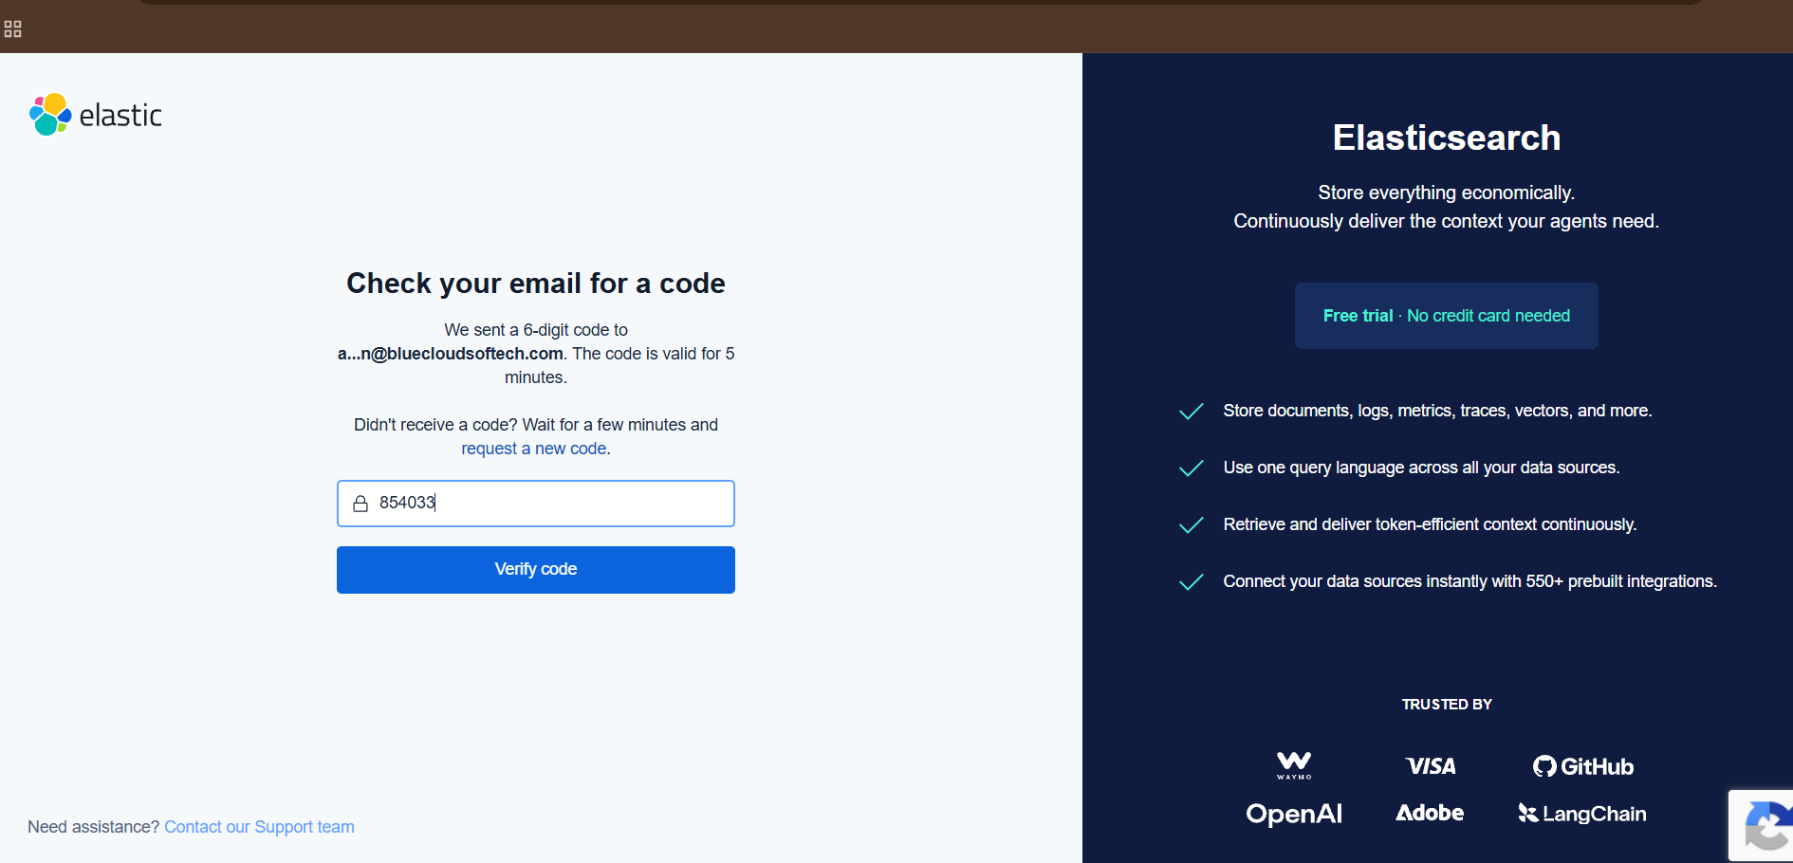
Figure 1. Elastic Cloud email verification screen from the supplied setup evidence.
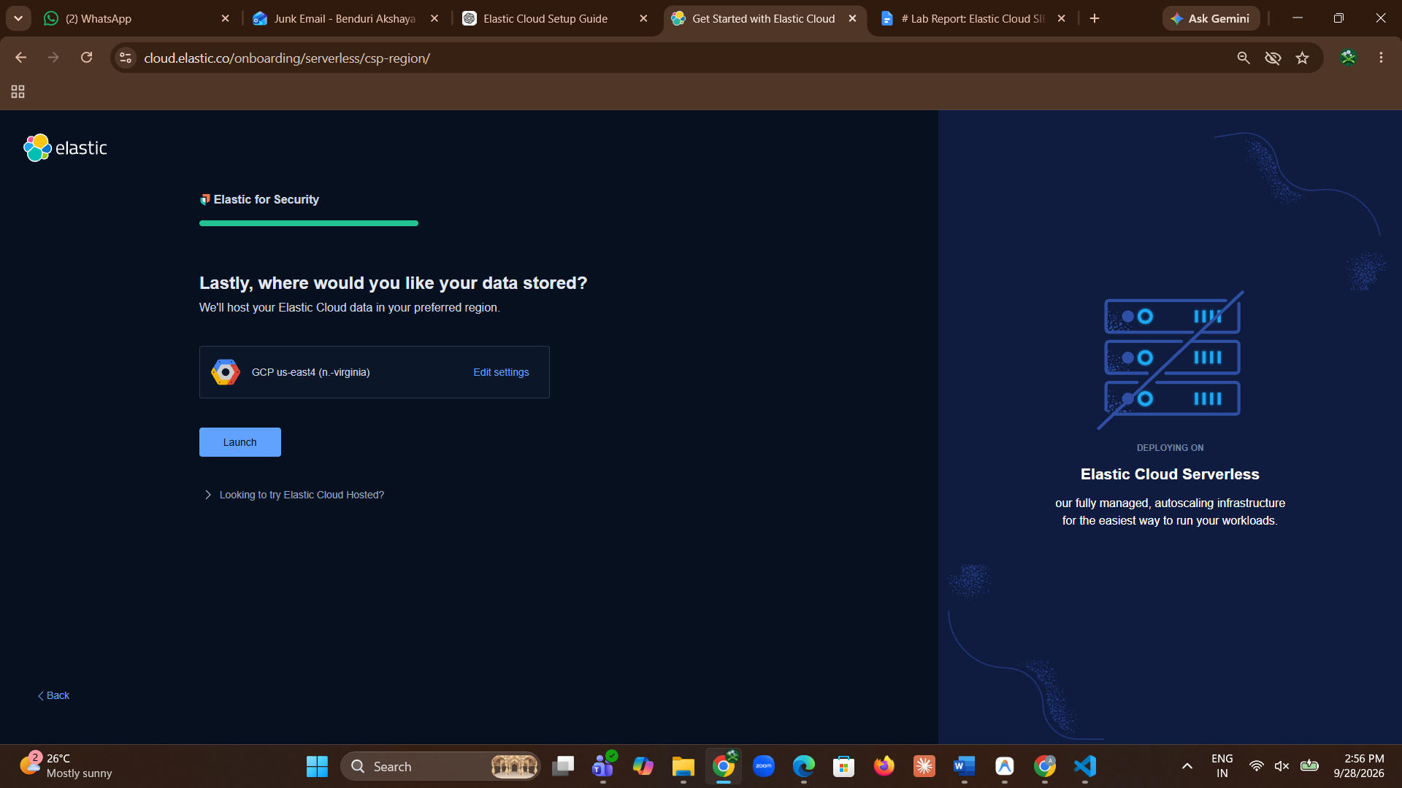
Figure 2. Elastic Cloud setup screen showing the data-storage/deployment configuration stage.
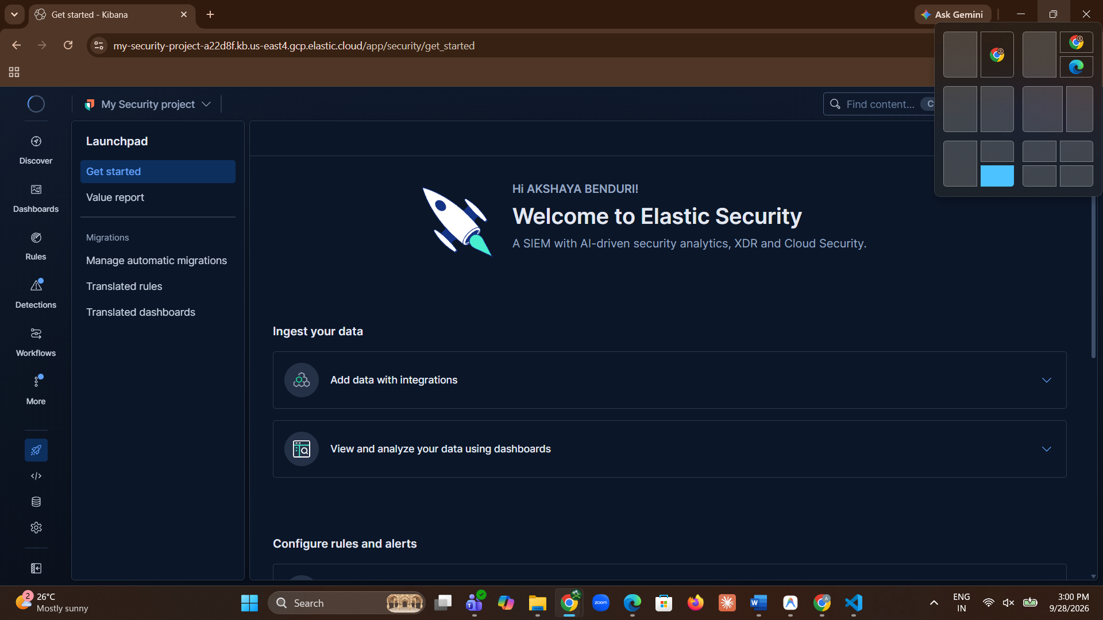
Figure 3. Elastic Security landing screen after entering the deployed environment.

Step 2 — Explore the Elastic Security / Kibana Interface
- Open the Elastic Security/Kibana interface associated with the deployment.
- Use the interface to access the areas required for endpoint management and log analysis.
- The supplied brief identifies Dashboards, Discover, and Fleet as the main Kibana areas explored during the lab.
- The screenshots also show the initial Elastic Security use-case selection and the Fleet area used later for agent enrollment.
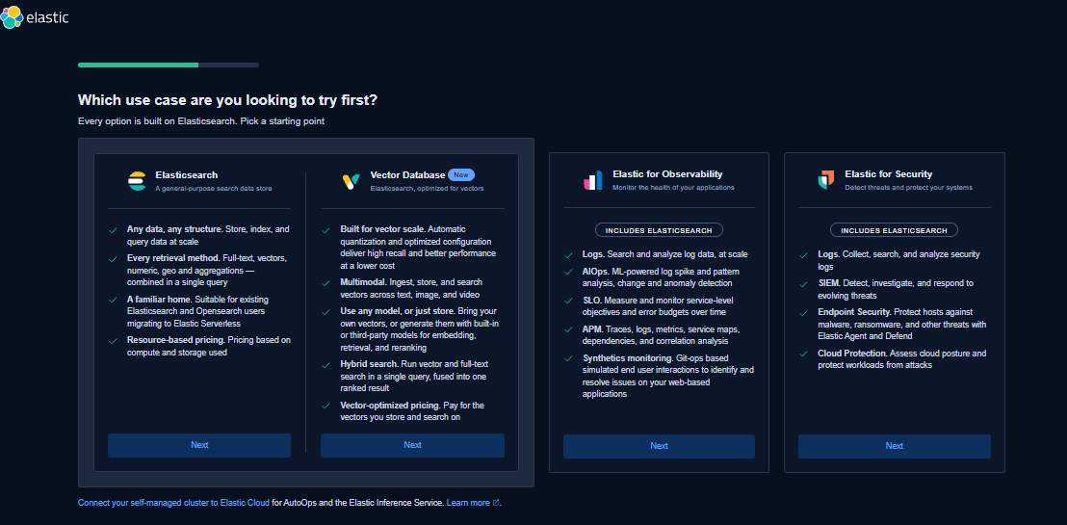
Figure 4. Elastic Security use-case selection screen shown during the initial setup.
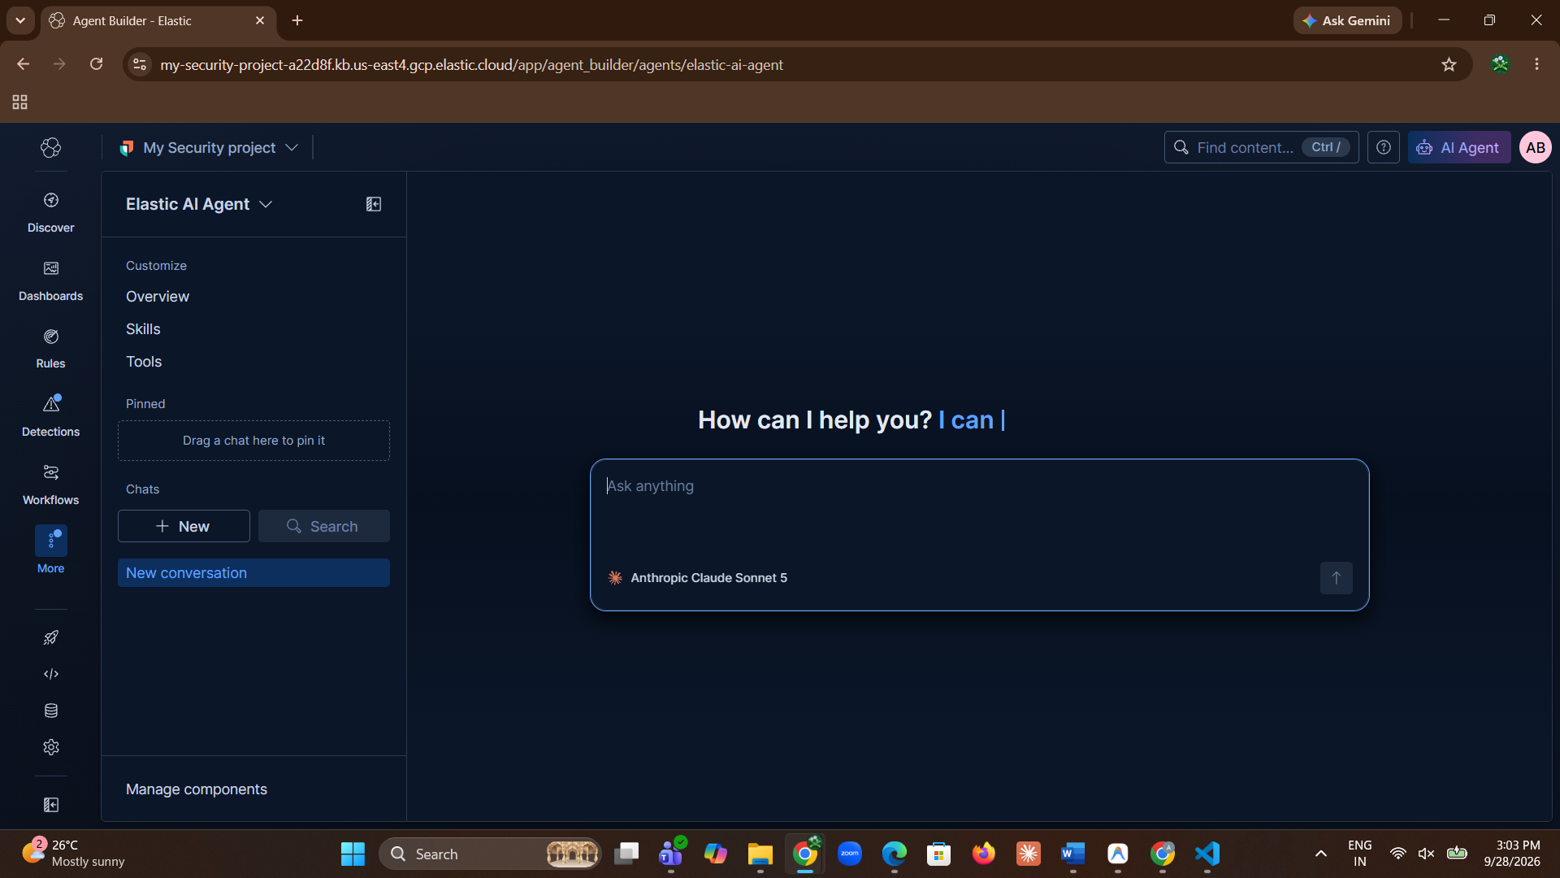
Figure 5. Elastic Security/Fleet interface navigation evidence.

Step 3 — Open Fleet and Begin Agent Management
- Open the Settings area in Kibana.
- Use the search bar in Settings to locate Fleet, as shown in the supplied instructions.
- Open Fleet and go to the Agents area.
- The initial Fleet view may show that no agents are enrolled yet; this is the starting point before the Windows endpoint is registered.
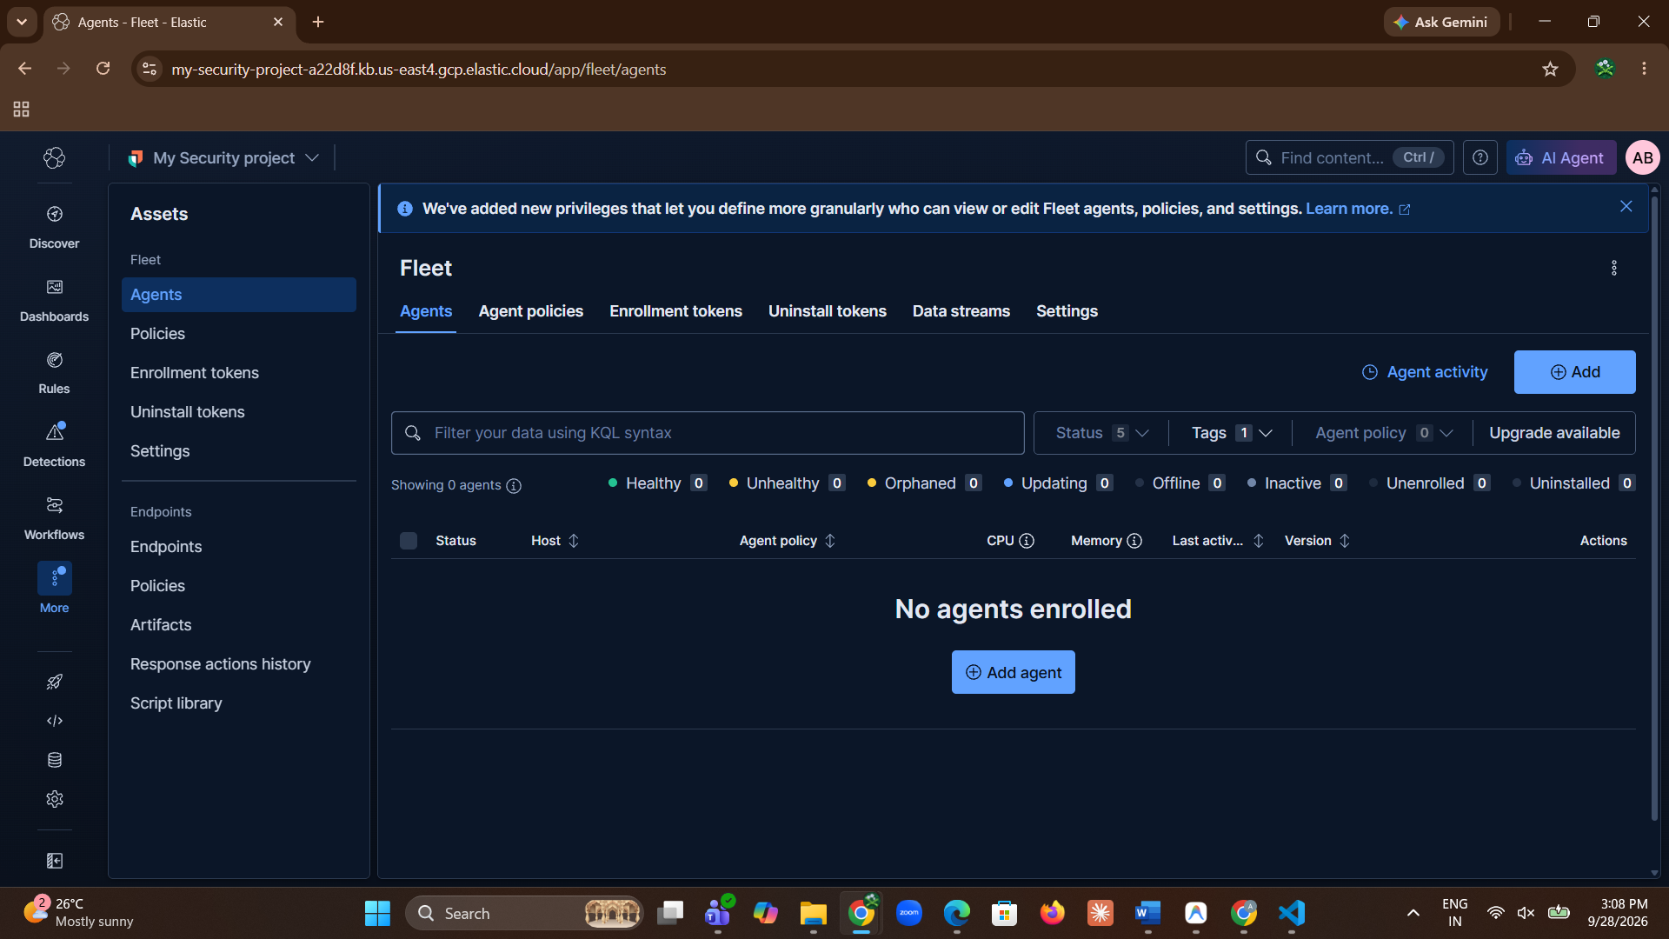
Figure 6. Fleet → Agents view before the Windows endpoint is enrolled.
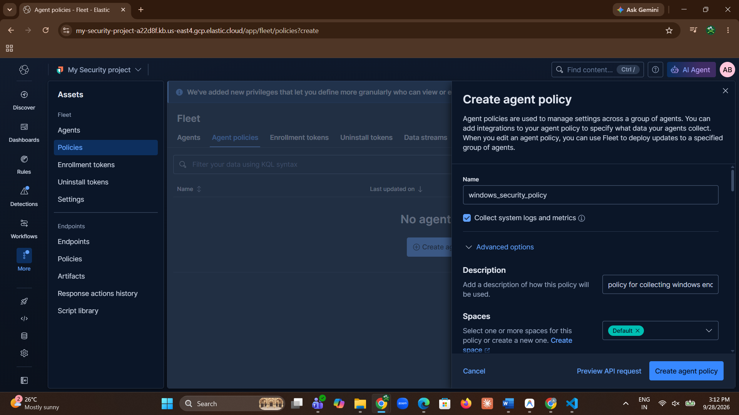
Figure 7. Create agent policy panel opened from Fleet.

Step 4 — Create and Configure the Agent Policy
- From Fleet, select the option to create an agent policy.
- Provide the policy information required by the Fleet interface.
- Ensure that collection of agent logs and system metrics is enabled, as indicated in the supplied instructions.
- Use the policy configuration to prepare the endpoint for centrally managed log collection.
- Create the policy and proceed to the integration configuration.
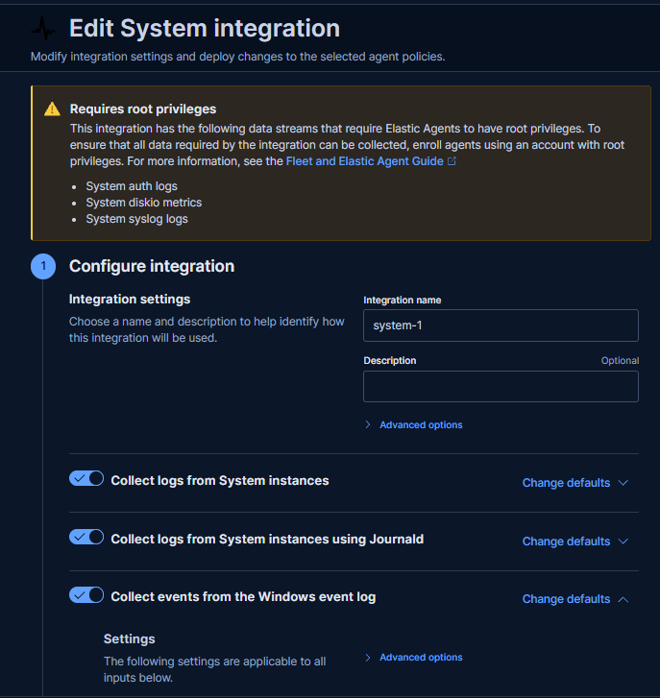
Figure 8. System integration configuration screen showing the collection options for agent logs and Windows data.
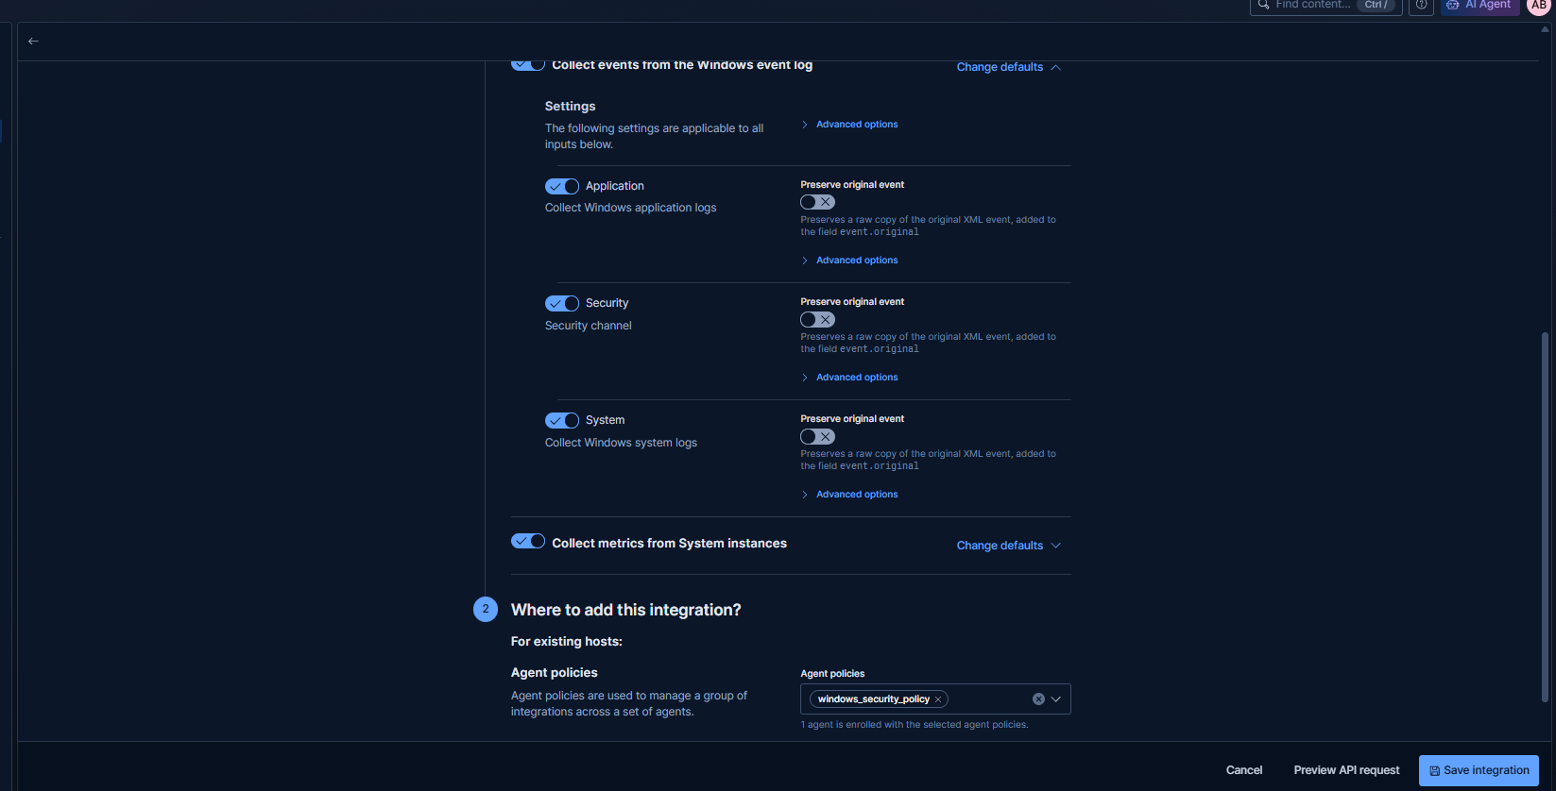
Figure 9. Agent/system integration configuration stage from the supplied setup evidence.
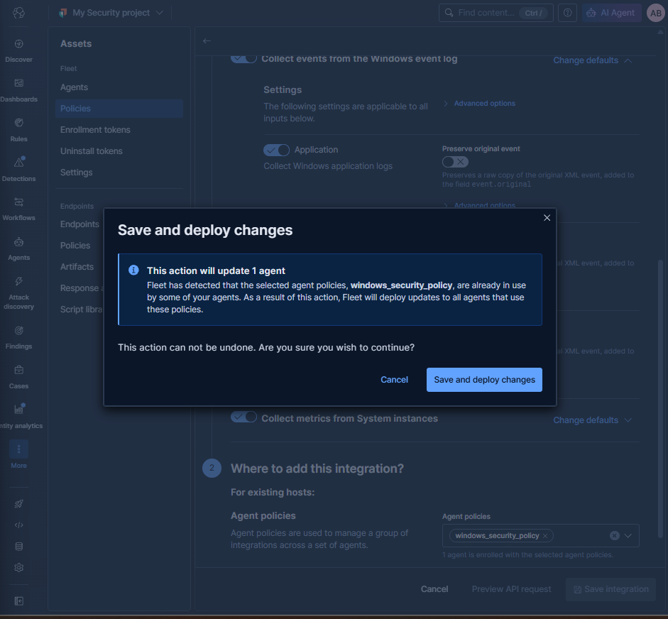
Figure 10. Save and deploy changes dialog for the configured integration/policy.

Step 5 — Add the Windows System Integration
- Within the agent policy, configure the Windows system integration.
- The supplied evidence shows options for collecting logs from the system and Windows event-log sources.
- Keep the relevant collection options enabled according to the lab configuration.
- Save and deploy the changes so that the policy is ready for the endpoint.
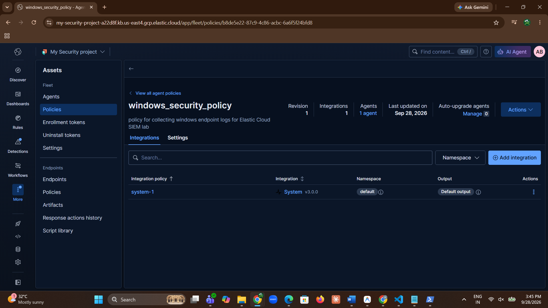
Figure 11. Agent policy page showing the configured Windows security policy/integration.

Step 6 — Install the Elastic Agent on the Windows 11
- Move to the target Windows 11(own laptop).
- Use the Fleet enrollment flow to obtain the agent installation/enrollment information required for the endpoint.
- Run the Elastic Agent installation script in PowerShell with Administrator privileges.
- Allow the installation to complete and verify that the Elastic Agent service is registered successfully.
- The lab brief specifically records successful registration of the Elastic Agent service.
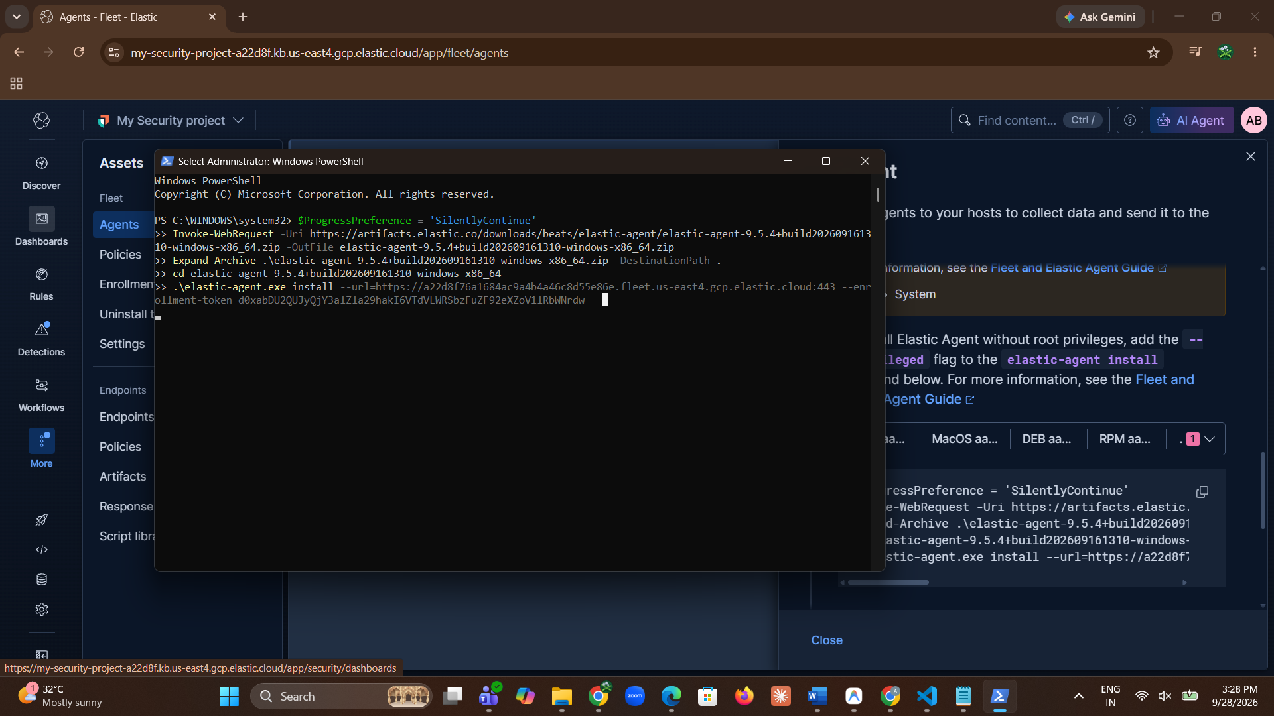
Figure 12. Windows PowerShell console showing the Elastic Agent installation/enrollment activity.

Step 7 — Confirm Agent Enrollment and Health
- Return to Kibana → Fleet → Agents.
- Confirm that the Windows endpoint appears in the Agents list after installation.
- Check the agent status in the Kibana interface.
- The lab brief records the expected verification state as Healthy.
- Once the endpoint is enrolled, the agent policy can be managed centrally through Fleet rather than configuring every endpoint independently.
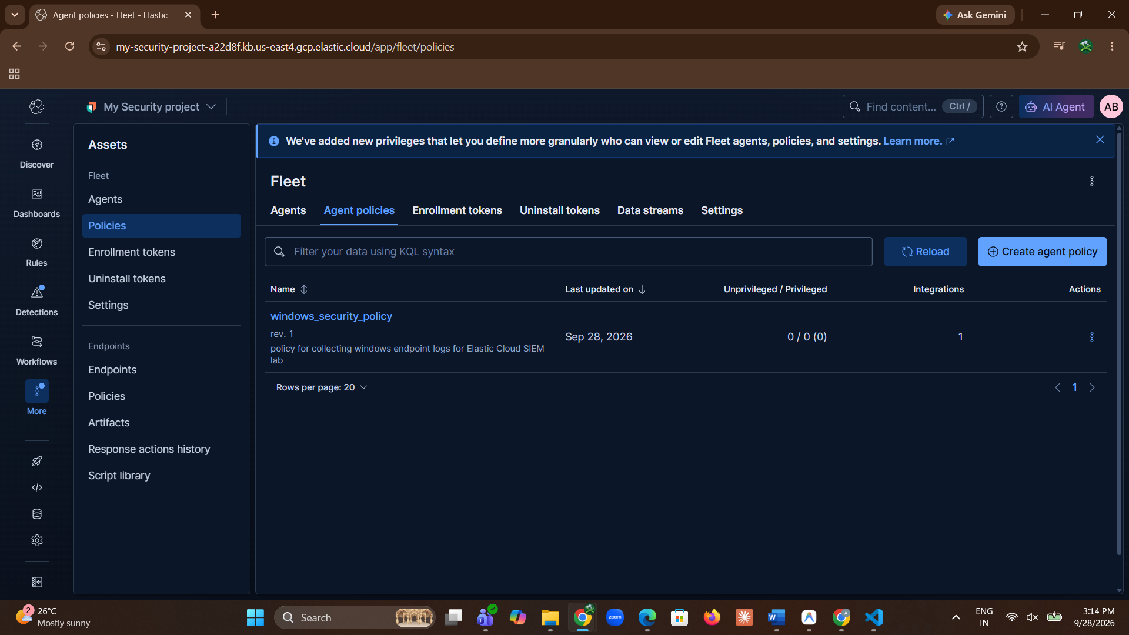
Figure 13. Fleet Agents view showing the enrolled endpoint and its policy/status information.

Step 8 — Verify Windows Event Log Ingestion in Discover
- Open the Discover tab from the Kibana menu.
- Query the incoming endpoint data generated by the Windows Agent.
- Verify that Windows Security and System event logs are available in Discover.
- Inspect the returned event records to confirm that endpoint telemetry is reaching Elastic Cloud.
- The supplied lab brief identifies Discover as the final verification point for incoming Windows Event Logs.
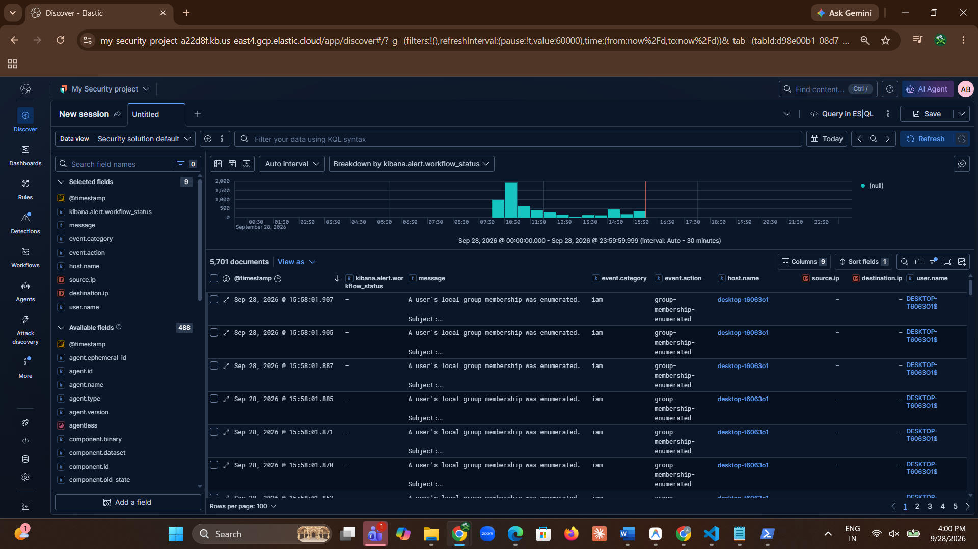
Figure 14. Kibana Discover showing incoming Windows event data.
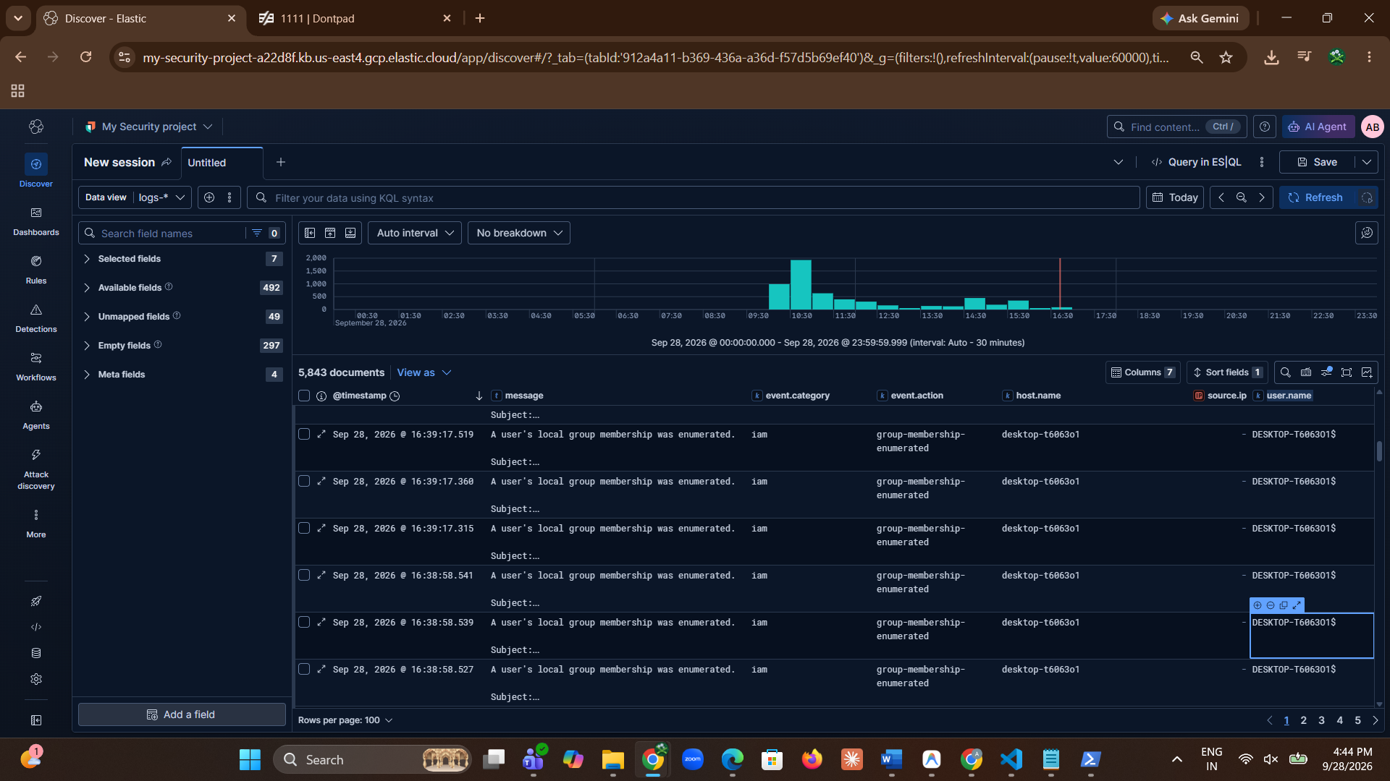
Figure 15. Additional Kibana Discover evidence showing Windows endpoint events.

4. Verification Results
Verification Area | Expected/Recorded Evidence | Status
Elastic Cloud deployment | Trial deployment created and Elasticsearch/Kibana connectivity verified | Completed
Kibana / Fleet | Fleet accessed and agent policy configured | Completed
Windows Elastic Agent | Agent installed through Administrator PowerShell and service registered | Completed
Fleet agent health | Agent status checked in Kibana; brief records Healthy | Healthy
Windows logs | Security and System logs queried in Discover | Verified
Network connectivity | Outbound TLS communication on 9243/443 checked | Verified

5. Conclusion
The Elastic Cloud SIEM lab was successfully completed by deploying Elastic Cloud, creating a Windows endpoint security policy, and installing and enrolling Elastic Agent on the Windows host. Windows system logs were successfully collected and sent to Elastic Cloud, where they were verified using Kibana Discover. This lab provided practical knowledge of centralized log collection, storage, searching, and analysis using the Elastic platform and helped demonstrate how Elastic can be used for security monitoring and investigation in a SOC environment.

