“Linux Signal-Based Process Controller”
A Flask Dashboard for Monitoring Linux Processes and Controlling Them with POSIX Signals
A Project Report Submitted in the partial fulfillment of the requirements for the award of the degree of
BACHELOR OF TECHNOLOGY
In
DEPARTMENT OF COMPUTER SCIENCE AND ENGINEERING
By
K. SWATHI SREE | 2520030410
P. ASRITHA CHOWDARY | 2520030592
Y. AKSHAYA | 2520030577

Under the Esteemed Guidance of
K. Hema
Department of Computer Science and Engineering


K L (Deemed to be) University
DEPARTMENT OF COMPUTER SCIENCE AND ENGINEERING
Declaration
The Project Report entitled “Linux Signal-Based Process Controller” is a record of Bonafide work of K. SWATHI SREE - 2520030410, P. ASRITHA CHOWDARY - 2520030592, Y. AKSHAYA - 2520030577 submitted in partial fulfillment for the award of B. Tech in Computer Science and Engineering to the K L University. The results embodied in this report have not been copied from any other departments/University/Institute.

K. SWATHI SREE | 2520030410
P. ASRITHA CHOWDARY | 2520030592
Y. AKSHAYA | 2520030577
K L (Deemed to be) University
DEPARTMENT OF COMPUTER SCIENCE AND ENGINEERING
CERTIFICATE
This is to certify that the mini project based report entitled “Linux Signal-Based Process Controller” is a bonafide work done and submitted by K. Swathi Sree – 2520030410, P. Asritha Chowdary – 2520030592, Y. Akshaya – 2520030577 in partial fulfillment of the requirements for the award of the degree of BACHELOR OF TECHNOLOGY in Department of Computer Science and Engineering, K L (Deemed to be University), during the academic year 2026-2027.

Signature of the Guide

Signature of the Course Coordinator | Signature of the HOD
ACKNOWLEDGEMENT
The success of this project would not have been possible without the timely help and guidance of many people. We wish to express our sincere thanks to all those who assisted us in one way or another in completing this project.
Our greatest appreciation goes to our Course Coordinator Course Coordinator name and our guide K. Hema, Department of Computer Science and Engineering, whose support, encouragement and guidance cannot be expressed in words.
We express our gratitude to Dr. P. Venkateshwara Rao (CSE), Head of the Department of Computer Science and Engineering, for providing us with adequate facilities, ways and means by which we were able to complete this project-based lab.
We thank all the members of the teaching and non-teaching staff who assisted us directly or indirectly in the successful completion of this project. Finally, we sincerely thank our parents, friends and classmates for their kind help and cooperation during our work.
K. SWATHI SREE | 2520030410
P. ASRITHA CHOWDARY | 2520030592
Y. AKSHAYA | 2520030577
Abstract
Learning how an operating system manages processes can be abstract when students rely only on diagrams and terminal commands. Process states, process identifiers and signals are easy to memorise but hard to see in action, and experimenting on a real system can disturb unrelated processes or require administrator rights. This project, the Linux Signal-Based Process Controller, addresses that gap with a small web dashboard that makes real operating-system behaviour visible and safe to explore.
The backend is written in Python with the Flask framework. It reads live process information (name, state and resident memory) from the Linux /proc file system, starts a dedicated child process, and delivers the POSIX signals SIGSTOP, SIGCONT, SIGINT and SIGTERM to it with os.kill(). Users can also create batches of real demo processes (sleeping, memory-demo or low-CPU workers) from the interface or through a restricted plain-English instruction box, and then pause, resume or terminate each one individually. A responsive HTML, CSS and JavaScript dashboard talks to the backend through a REST API, refreshes every two seconds, and shows a timestamped event log of every operation.
Safety is a central design goal. Signals are sent only to processes that the application itself created, the client can never supply an arbitrary target PID for the main demo, SIGKILL is rejected by the API, user text is never executed as a shell command, and the server listens on localhost only. The application runs as an ordinary user on Ubuntu or Ubuntu on WSL. The project includes nine automated tests that start a real child process and verify the full signal life cycle; all nine pass. The result is a compact, reliable teaching tool that turns abstract process and signal concepts into observable behaviour.
Index
S. No. | Chapter | Topics / Subtopics | Page No.
 | Acknowledgement |  | i
 | Abstract |  | ii
1 | Introduction |  | 1–2
 |  | 1.1 Background of the Project | 1
 |  | 1.2 Problem Statement | 1
 |  | 1.3 Scope of the Project | 1
 |  | 1.4 Objectives of the Project | 1
 |  | 1.5 Importance of the Application | 2
 |  | 1.6 Target Users / Audience | 2
2 | OS Concepts and Background Study |  | 3–4
 |  | 2.1 Operating System Concepts Related to the Project | 3
 |  | 2.2 Existing Methods / Algorithms | 4
 |  | 2.3 Proposed Approach | 4
 |  | 2.4 Advantages of the Proposed Approach | 4
3 | System Requirements |  | 5–6
 |  | 3.1 Hardware Requirements | 5
 |  | 3.2 Software Requirements | 5
 |  | 3.3 Operating System Environment – Ubuntu / WSL | 5
 |  | 3.4 Development Tools and Compilers | 5
4 | Technology and Tools Used |  | 7–8
 |  | 4.1 Python Programming | 7
 |  | 4.2 Flask Web Framework | 7
 |  | 4.3 Linux System Calls and the /proc Interface | 7
 |  | 4.4 Threads and Synchronization | 7
 |  | 4.5 Linux Commands and Utilities | 7
 |  | 4.6 Other Tools / Libraries Used | 8
5 | System Architecture and Design |  | 9–12
 |  | 5.1 Overall System Architecture | 9
 |  | 5.2 System Workflow | 9
 |  | 5.3 Flowchart / Data Flow | 10
 |  | 5.4 Module Description | 11
 |  | 5.5 Input and Output Design | 12
6 | Implementation |  | 13–17
 |  | 6.1 Module-wise Implementation | 13
 |  | 6.2 Algorithm / Pseudocode | 14
 |  | 6.3 Core Python Implementation | 14
 |  | 6.4 Linux System Calls / APIs Used | 16
 |  | 6.5 Process Implementation | 16
 |  | 6.6 IPC / Synchronization Implementation | 16
 |  | 6.7 Memory Management Implementation | 17
 |  | 6.8 User Interface Implementation | 17
7 | Execution and Demonstration |  | 18–21
 |  | 7.1 Setup and Compilation in Ubuntu | 18
 |  | 7.2 Execution Commands | 18
 |  | 7.3 Sample Inputs and Outputs | 18
 |  | 7.4 Screenshots of Execution | 19
 |  | 7.5 Demonstration of OS Concepts | 20
 |  | 7.6 Automated Test Results | 21
8 | Conclusion |  | 22–23
 |  | 8.1 Summary of the Project | 22
 |  | 8.2 Objectives Achieved | 22
 |  | 8.3 Results Achieved | 22
 |  | 8.4 Skills and Learning Outcomes | 23
 |  | 8.5 Limitations and Future Enhancements | 23
9 | References |  | 24–24
 |  | 9.1 Books | 24
 |  | 9.2 Research Papers | 24
 |  | 9.3 Linux / GNU Documentation | 24
 |  | 9.4 Online Resources | 24

CHAPTER 1: INTRODUCTION

1.1 Background of the Project
Every program that runs on an operating system becomes a process. The kernel creates it, gives it a unique process identifier (PID), schedules it on the CPU and tracks its state, for example running, sleeping or stopped. Linux also lets processes and the kernel communicate through signals, short asynchronous notifications such as SIGSTOP (pause), SIGCONT (resume), SIGINT (interrupt) and SIGTERM (ask to terminate). Understanding these two ideas, processes and signals, is a core part of any operating systems course.
In classrooms these ideas are usually taught with diagrams and a few terminal commands such as ps, top and kill. The output of those commands is text that scrolls past quickly, and a beginner cannot easily connect a signal that was sent with the change of state that followed. The Linux Signal-Based Process Controller was created to close that gap by presenting live process data and signal effects in a clear, interactive browser dashboard.

1.2 Problem Statement
Students need a controlled and visible environment in which they can watch real Linux processes change state when signals are delivered. Existing tools either require typing precise commands against real system processes, which is risky, or require root privileges, or hide the mechanism behind a graphical task manager. The problem addressed by this project is to design and build a safe, easy-to-run application that:
- shows real processes, their states and memory use, read directly from the Linux kernel's /proc file system;
- lets the user start processes and send real POSIX signals to them, and shows the result immediately;
- guarantees that only processes created by the application can be signalled, so that no unrelated system process is ever disturbed.

1.3 Scope of the Project
The project is a local educational demonstration. It runs on a single Linux machine (Ubuntu or Ubuntu on WSL) as an ordinary user. Within this scope it provides process monitoring, one managed demo child process, user-created batches of demo workers, four signals (SIGSTOP, SIGCONT, SIGINT, SIGTERM), a restricted instruction box, a REST API and a timestamped event log.
The following are deliberately outside the scope: controlling arbitrary system processes, remote or multi-user access, authentication, persistent storage of events and use as a production process manager.

1.4 Objectives of the Project
- Display real Linux processes with PID, name, kernel state and resident memory.
- Demonstrate SIGSTOP, SIGCONT, SIGINT and SIGTERM on a real child process.
- Restrict signal delivery to processes that the application manages.
- Provide a browser dashboard and REST endpoints for all operations.
- Allow users to create multiple real demo processes through the interface or a constrained instruction field.
- Log every operation with a timestamp, target PID, result and status, and return meaningful error messages.
- Keep the setup small and simple enough for a college project, with automated tests.

1.5 Importance of the Application
The application turns abstract concepts into something observable. A student can press Pause (SIGSTOP) and watch the state change to Stopped (T), press Resume (SIGCONT) and watch it return, and then read the event log to see exactly what was sent and when. Because the application is sandboxed to the processes it creates, students can experiment freely without fear of damaging the system. It also demonstrates good engineering practice: input validation, an allowlist for signals, bounded resource limits and automated tests.

1.6 Target Users / Audience
- Students of operating systems and Linux courses who want to see processes and signals in action.
- Faculty and lab instructors who need a safe live demonstration tool.
- Beginners learning Linux system administration concepts such as process states and the /proc file system.

CHAPTER 2: OS CONCEPTS AND BACKGROUND STUDY

2.1 Operating System Concepts Related to the Project

Process and PID
A process is a program in execution. Each process has a unique PID. In this project the Flask server is itself a process, and it creates child processes with Python's subprocess.Popen, which on Linux uses the fork and exec family of system calls underneath.

Process states
The kernel records a state for every process. The State line of /proc/PID/status uses a single-letter code. The dashboard translates the codes into readable labels:
Code | Label in dashboard | Meaning
R | Running | Running or ready to run on a CPU
S | Sleeping | Waiting for an event (interruptible sleep)
D | Uninterruptible | Waiting for I/O and cannot be interrupted
T | Stopped | Paused, for example after SIGSTOP
Z | Zombie | Finished but not yet collected by its parent
I | Idle | Idle kernel thread

Signals
A signal is a small asynchronous message delivered by the kernel to a process. Some signals can be caught or ignored by the receiving process; SIGSTOP and SIGKILL cannot. The signals used by this project are:
Signal | No. | Default behaviour and use here
SIGSTOP | 19 | Stops (pauses) the process. Cannot be caught. Used for the Pause button.
SIGCONT | 18 | Continues a stopped process. Used for the Resume button.
SIGINT | 2 | Interrupt request, normally sent by Ctrl+C. The demo child handles it and exits.
SIGTERM | 15 | Polite request to terminate. The demo child handles it and exits.

Signal numbers shown are those used on x86 Linux.

The /proc file system
/proc is a virtual file system that the kernel uses to expose information about running processes. Each running process has a directory named after its PID. Reading /proc/PID/status returns the process name, its state and, in the VmRSS field, the resident set size, which is the amount of physical memory the process currently occupies. No special privileges are needed to read the status of ordinary processes.

Sessions, permissions and reaping
Children created by the application are started with start_new_session=True, which places them in their own session so that they are independent of the server's terminal. An unprivileged user can send signals only to processes it owns, which is why the application needs no root access. When a child exits, its parent must collect its exit status, otherwise it remains a zombie; the application collects it with wait() and poll() on the stored Popen object.

2.2 Existing Methods / Algorithms
Method | What it does | Limitation for learning
ps / top / htop | Lists processes and their states in a terminal | Text-only; signals are not sent from the same screen
kill / pkill | Sends a signal to a PID or by name | Requires exact commands; easy to target the wrong process
GUI task managers | Show processes and offer End Task | Hide which signal is used and why
Process supervisors (systemd, supervisord) | Start, stop and restart services | Too complex and powerful for a classroom demo

2.3 Proposed Approach
The proposed approach combines monitoring and control in one safe web interface. A Flask server reads /proc for the live process table, starts child processes under its own control, and exposes a small REST API. The browser dashboard polls this API every two seconds. When the user presses a signal button, the server validates the request against a fixed allowlist, confirms that the target is a process the application created, sends the signal with os.kill(), reads the new state from /proc, and records the event in a log.

2.4 Advantages of the Proposed Approach
- Visible: process states, PIDs, memory and signal results appear together on one screen.
- Safe: signals reach only application-created processes; SIGKILL and arbitrary PIDs are rejected.
- Accessible: no root privileges, one external dependency (Flask) and a one-command start script.
- Testable: a REST API can be exercised automatically, which allowed nine automated tests.
- Extensible: the clear module structure makes features such as persistent history or charts easy to add.

CHAPTER 3: SYSTEM REQUIREMENTS

3.1 Hardware Requirements
The project has no special hardware needs. Any computer that can run Ubuntu natively or Ubuntu under Windows Subsystem for Linux (WSL) is sufficient.
Component | Requirement
Processor | Any modern x86-64 processor
Memory | Enough free RAM for the Python server and the demo workers; each memory-demo worker allocates up to 32 MB, so creating many of them needs correspondingly more free memory
Storage | A small amount of disk space for the project files and a Python virtual environment
Display | Any screen that can show a web browser

3.2 Software Requirements
Software | Requirement
Operating system | Ubuntu 22.04 / 24.04 or a recent Ubuntu release (native or Ubuntu on WSL)
Python | Python 3.10 or later, with the python3-venv package
Framework | Flask 3.x (Flask>=3.0,<4.0 in requirements.txt)
Web browser | Any current browser (Chrome, Edge or Firefox)
Editor (optional) | Visual Studio Code

3.3 Operating System Environment – Ubuntu / WSL
The application depends on the Linux /proc file system and on POSIX signals, so it must run on Linux. On Windows it should be run inside an Ubuntu distribution under WSL, not in PowerShell or the Windows command prompt. The server binds to 127.0.0.1:5000; with WSL's localhost forwarding the dashboard can be opened from a browser on the Windows side at the same address. For best results the project files should be kept in the Ubuntu file system rather than on a mounted Windows drive.

3.4 Development Tools and Compilers
Python is an interpreted language, so the project needs no separate compiler. The tools used during development and testing were:
- Python 3 interpreter and the venv module for an isolated environment;
- pip for installing Flask from requirements.txt;
- the unittest module for automated tests;
- a terminal (Ubuntu shell) with curl for trying the REST API by hand;
- Visual Studio Code as an optional editor.

CHAPTER 4: TECHNOLOGY AND TOOLS USED

4.1 Python Programming
The whole backend, about 420 lines in app.py, is written in Python 3. Python was chosen because its standard library exposes the needed operating-system features directly: os for kill and the file system, signal for signal constants, subprocess for creating child processes, threading for locks, and re for the instruction parser. This keeps the code short and easy to read for students.

4.2 Flask Web Framework
Flask is a lightweight Python web framework. It is used to serve the dashboard page (GET /) and to provide the JSON REST API under /api/. Flask's built-in test client is also used by the automated tests, so the API can be tested without opening a network port. The development server runs in threaded mode so that the dashboard can poll while an operation is in progress.

4.3 Linux System Calls and the /proc Interface
Python's high-level calls map onto the Linux mechanisms described below (see also Section 6.4). The most important are os.kill(pid, sig), which invokes the kill(2) system call to deliver a signal; subprocess.Popen, which creates a child process; and reads of /proc/PID/status, which obtain the process state and memory use.

4.4 Threads and Synchronization
Flask handles several requests at the same time on different threads, and all of them share the registry of managed processes and the event log. A single re-entrant lock, threading.RLock, guards these shared structures so that two requests cannot change them at the same time. Section 6.6 describes this in detail.

4.5 Linux Commands and Utilities
Command | Use in this project
sudo apt install python3 python3-venv | Install Python and the virtual-environment module
./run.sh | Create the virtual environment, install Flask and start the server
python -m unittest discover -s tests -v | Run the automated test suite
curl | Call the REST API from the terminal
ps, top, grep State /proc/PID/status | Confirm the process states shown by the dashboard

4.6 Other Tools / Libraries Used
- HTML5, CSS3 and JavaScript (Fetch API): the dashboard in templates/index.html, with no front-end framework.
- JSON: the data format of all requests and responses.
- unittest: Python's standard test framework, used with Flask's test client.
- atexit: registers a cleanup function that terminates managed processes when the server exits.

CHAPTER 5: SYSTEM ARCHITECTURE AND DESIGN

5.1 Overall System Architecture
The system has three layers. The browser dashboard is the user interface. The Flask REST API validates requests, keeps the registry of managed processes and the event log, and performs all operating-system work. The Linux layer consists of the /proc file system, which supplies process data, and the managed child and demo worker processes that receive the signals.
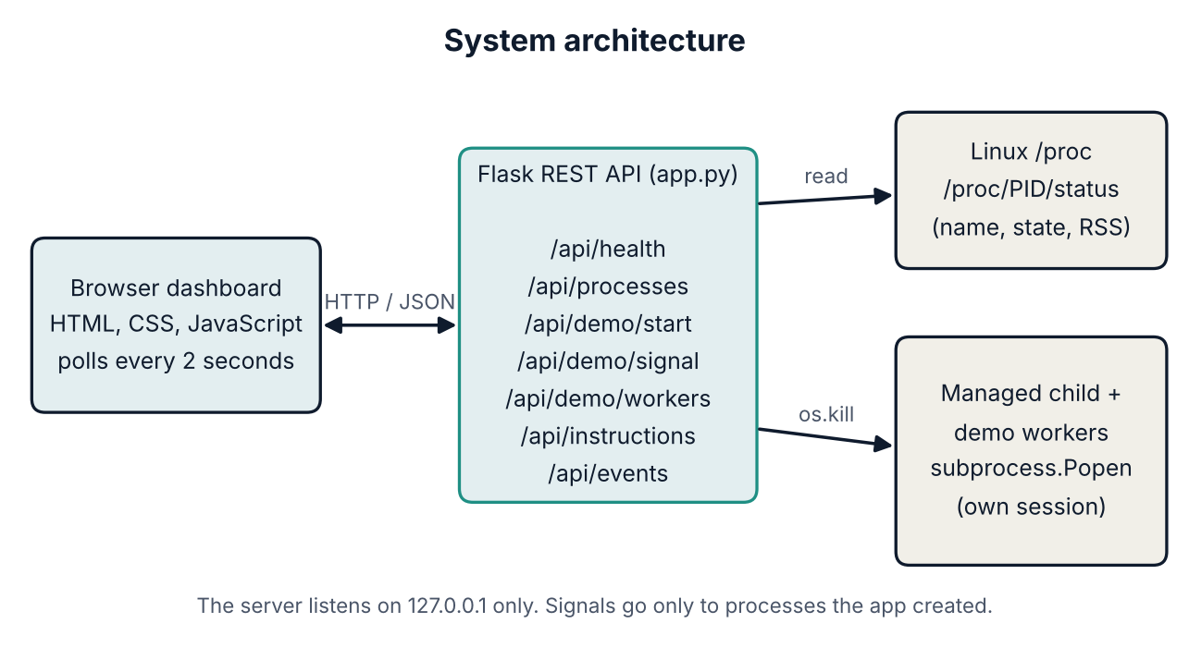
Figure 5.1: System architecture

Safety boundaries
- The main demo API never accepts a target PID from the client.
- Signal names are checked against a fixed allowlist of four signals.
- Only PIDs held in the application's own Popen registry can be signalled.
- The server binds to 127.0.0.1, not to all network interfaces.
- No shell is invoked, and no browser-supplied text is executed as a command.

5.2 System Workflow
- The browser calls /api/processes; the server lists the numeric folders in /proc and reads each status file.
- The browser calls /api/health to learn whether /proc is available and what the managed child is doing.
- The user presses Start demo; the server creates one child with subprocess.Popen and stores its handle.
- The user presses a signal button; the server validates the signal name, takes the PID from the stored handle and calls os.kill.
- The server rereads /proc/PID/status (or waits for the child to exit) and writes an entry to the event log.
- The browser refreshes the process table, the managed-process card, the worker table and the event log every two seconds.
- In Process Lab, the user creates a batch of workers or types an instruction; every created PID is tracked, and per-worker signals are accepted only for tracked PIDs.

5.3 Flowchart / Data Flow
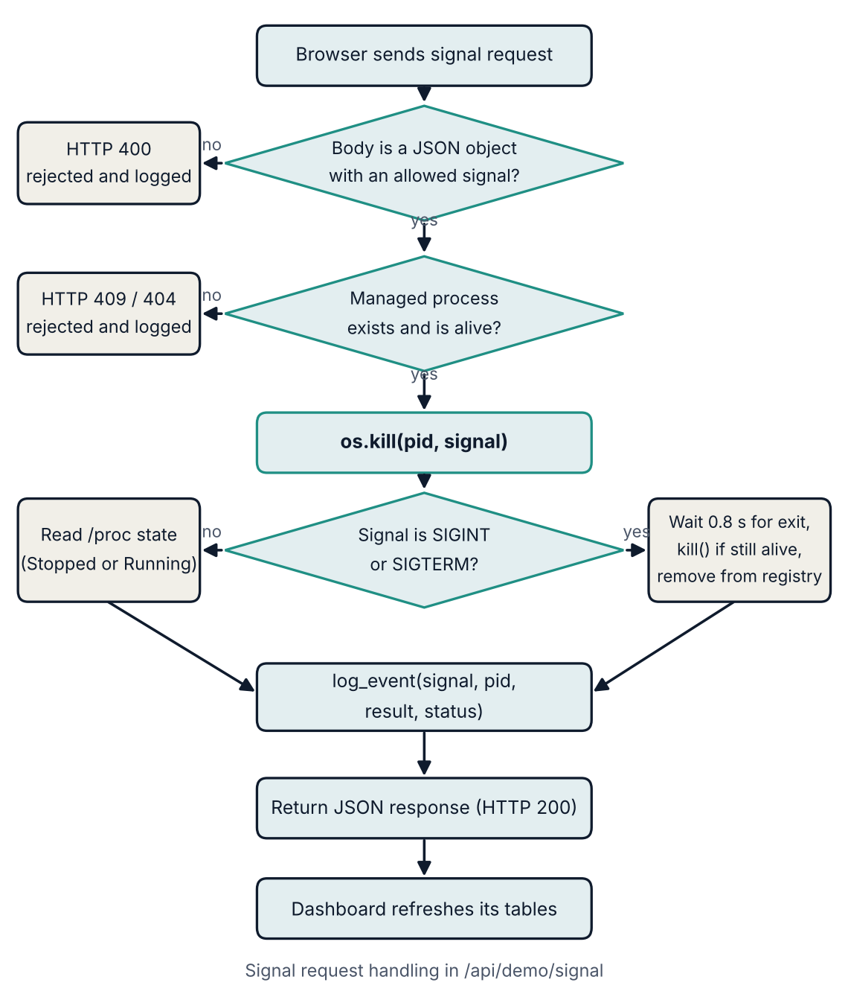
Figure 5.2: Flow of a signal request
The managed demo process moves through the following life cycle. A stopped process returns to the running or sleeping state when it receives SIGCONT; SIGINT or SIGTERM ends it.
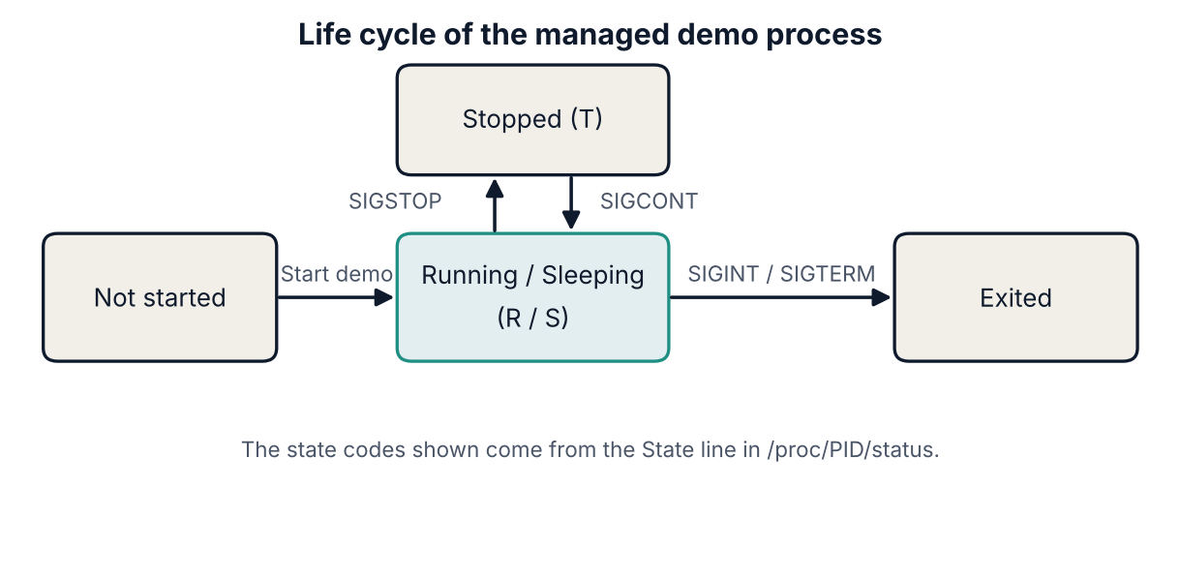
Figure 5.3: Life cycle of the managed demo process

5.4 Module Description
Module (in app.py / files) | Responsibility
Process discovery (process_list, process_state) | Scan /proc and read name, state and VmRSS of each process
Managed child (child_code, /api/demo/start) | Start one isolated Python child that stays alive and handles SIGINT and SIGTERM
Signal controller (/api/demo/signal) | Validate the request, call os.kill, observe the new state
Worker manager (create_workers, terminate_worker) | Create bounded batches of demo workers and signal only registered ones
Instruction parser (execute_instruction) | Match a short allowlisted command grammar; never run text as a command
Event log (log_event, /api/events) | Keep the latest 300 events with timestamp, signal, PID, result, status and detail
Cleanup (cleanup) | Terminate managed processes when the server exits
Dashboard (templates/index.html) | Present all data and controls in the browser
Tests (tests/test_app.py) | Automated checks of the API and signal life cycle

5.5 Input and Output Design

Inputs
- Button clicks on the dashboard (Start, Pause, Resume, Interrupt, Terminate, Create processes, Terminate all).
- Batch form: number of processes (1 to 30), process type and memory size (1 to 32 MB).
- Instruction text, for example create 10 sleepers, create 5 memory workers, create 3 workers, pause PID 1234, resume PID 1234 or terminate PID 1234.

REST API
Method | Endpoint | Purpose
GET | / | Dashboard HTML page
GET | /api/health | Backend and managed-process status
GET | /api/processes | Process listing read from /proc
POST | /api/demo/start | Start the managed child (HTTP 201, or 409 if already running)
POST | /api/demo/signal | Send one allowed signal to the managed child
GET | /api/events | Recent event log, newest first
GET | /api/demo/workers | List demo workers created by the dashboard
POST | /api/demo/workers | Create a bounded batch of demo workers
POST | /api/demo/workers/<pid>/signal | Signal a dashboard-managed worker only
POST | /api/instructions | Run an allowlisted plain-English instruction

Outputs
Every API response is JSON. Successful signal responses contain the message, PID, signal and resulting state. Errors contain an error field with a clear message and use the status codes 400 (bad input), 403 (permission denied), 404 (not a managed worker), 409 (no active process or already running) and 500 (system error). The dashboard shows the same information as tables, status cards and a scrolling event log.

CHAPTER 6: IMPLEMENTATION

6.1 Module-wise Implementation

Process discovery
process_list() scans /proc, and for each folder whose name is a number calls process_state(pid), which parses /proc/PID/status. A process may vanish between the scan and the read, so FileNotFoundError, ProcessLookupError, PermissionError and ValueError are caught and the process is simply skipped. The result is sorted by PID.

Managed demo child
POST /api/demo/start launches a small Python program (returned by child_code()) with subprocess.Popen. Its standard streams are detached and it runs in a new session. The child installs handlers for SIGTERM and SIGINT that print a message and exit, then loops forever. Only one managed child can exist at a time; a second start request returns HTTP 409.

Signal controller
POST /api/demo/signal checks that the body is a JSON object and that the signal name is in the allowlist. It then takes the PID from the stored Popen object, calls os.kill, waits briefly and rereads the state. For SIGINT and SIGTERM it gives the child 0.8 seconds to exit and uses proc.kill() only as a last-resort fallback on that exact child.

Worker manager
create_workers(count, kind, memory_mb) validates the batch size (1 to 30), the worker type (sleeper, memory or worker) and the memory size (1 to 32 MB), enforces a total of 50 managed workers, and starts each worker with Popen. Every worker is stored in the _workers dictionary keyed by PID. terminate_worker(pid, signal_name) refuses any PID that is not in this dictionary.

Instruction parser
execute_instruction(text) normalises the text and matches it against a few regular expressions with re.fullmatch. Recognised forms create sleeper, memory or worker processes, or map the verbs pause/stop, resume/continue, interrupt and terminate to SIGSTOP, SIGCONT, SIGINT and SIGTERM for a given worker PID. Anything else raises an error. The text is never passed to a shell, eval or exec.

Event log and cleanup
log_event() appends a dictionary containing timestamp, signal, PID, result, status and detail to a list protected by the lock and trims it to the last 300 entries. cleanup(), registered with atexit, sends SIGTERM to the managed child and all workers when the server stops, falling back to kill() if needed.

6.2 Algorithm / Pseudocode

Algorithm 1: Send a signal to the managed process
INPUT: JSON body {"signal": NAME}
1. IF body is not a JSON object -> return HTTP 400
2. IF NAME is not in {SIGSTOP, SIGCONT, SIGTERM, SIGINT} -> return HTTP 400
3. ACQUIRE lock
4. IF no managed process or it has exited -> return HTTP 409
5. pid <- managed process PID (from the stored Popen object)
6. os.kill(pid, signal number of NAME)
7. IF NAME is SIGINT or SIGTERM:
wait up to 0.8 s for the child to exit
IF still alive: kill() that child, wait again
clear managed process; state <- "Exited"
ELSE:
state <- label read from /proc/pid/status
8. log_event(NAME, pid, result, state)
9. RELEASE lock and return HTTP 200 with pid, signal and state

Algorithm 2: Create demo workers
INPUT: count, kind, memory_mb
1. IF count not an integer in 1..30 -> error
2. IF kind not in {sleeper, memory, worker} -> error
3. IF memory_mb not an integer in 1..32 -> error
4. ACQUIRE lock; remove workers that have already exited
5. IF live workers + count > 50 -> error
6. FOR i = 1..count: start a worker with Popen; store it by PID
7. log_event(CREATE_BATCH, ...) and return the list of PIDs

6.3 Core Python Implementation

Reading process state from /proc
def process_state(pid):
"""Read state/name/RSS from /proc/<pid>/status and stat."""
try:
with open(f"/proc/{pid}/status", "r", encoding="utf-8", errors="replace") as f:
lines = f.readlines()
fields = {}
for line in lines:
if ":" in line:
key, value = line.split(":", 1)
fields[key] = value.strip()
state = fields.get("State", "unknown").split()[0]
name = fields.get("Name", "unknown")
vmrss = fields.get("VmRSS", "0 kB").split()
memory_kb = int(vmrss[0]) if vmrss else 0
return {"pid": pid, "name": name, "state": state, ...}
except (FileNotFoundError, ProcessLookupError, PermissionError, ValueError):
return None

The allowlist and the managed child
ALLOWED_SIGNALS = {"SIGSTOP": signal.SIGSTOP, "SIGCONT": signal.SIGCONT,
"SIGTERM": signal.SIGTERM, "SIGINT": signal.SIGINT}

def child_code():
code = (
"import signal,time,sys\n"
"def stop(signum, frame):\n"
" print('received', signal.Signals(signum).name, flush=True)\n"
" if signum == signal.SIGINT: raise KeyboardInterrupt\n"
" if signum == signal.SIGTERM: sys.exit(0)\n"
"signal.signal(signal.SIGTERM, stop)\n"
"signal.signal(signal.SIGINT, stop)\n"
"print('managed-demo-ready', flush=True)\n"
"while True: time.sleep(1)\n"
)
return [sys.executable, "-u", "-c", code]

Delivering the signal
with _lock:
proc = _managed
if proc is None or proc.poll() is not None:
_managed = None
log_event(name, None, "error", "rejected", "No active managed demo process.")
return jsonify({"error": "No active managed demo process. Start it first."}), 409
pid = proc.pid
try:
os.kill(pid, ALLOWED_SIGNALS[name])
time.sleep(0.12)
state = process_state(pid)
if name in ("SIGTERM", "SIGINT"):
try:
proc.wait(timeout=0.8)
except subprocess.TimeoutExpired:
proc.kill()
proc.wait(timeout=0.8)
_managed = None
final_state = "Exited"
else:
final_state = state["state_label"] if state else "Unknown"

Restricting worker signals to registered PIDs
def terminate_worker(pid, signal_name, log=True):
"""Signal only a PID whose Popen object is in the dashboard-owned registry."""
if signal_name not in ALLOWED_SIGNALS:
raise ValueError("Unsupported signal.")
with _lock:
item = _workers.get(pid)
if item is None:
raise KeyError("That PID is not a live demo worker managed by this dashboard.")

6.4 Linux System Calls / APIs Used
Python call in the project | Linux mechanism | Purpose
os.kill(pid, sig) | kill(2) | Deliver SIGSTOP, SIGCONT, SIGINT or SIGTERM
subprocess.Popen(..., start_new_session=True) | fork / exec, setsid | Create a child in its own session
Popen.poll(), Popen.wait() | waitpid(2) | Check or collect a child's exit status
Popen.kill() | kill(2) with SIGKILL | Last-resort fallback on the exact managed child
open("/proc/PID/status") | procfs | Read process name, state and VmRSS
os.scandir("/proc") | getdents on procfs | Enumerate running processes
signal.signal() in the child | sigaction(2) | Install SIGINT and SIGTERM handlers

6.5 Process Implementation
Every managed process is a real operating-system process with its own PID, created by subprocess.Popen. The managed child runs a short Python program that installs signal handlers and then sleeps in a loop, so it stays alive until it receives a signal. Demo workers come in three types:
Worker type | Behaviour
Sleeping process | Sleeps for 600 seconds; uses almost no resources
Memory worker | Allocates a bytearray of the chosen size (1 to 32 MB) and then sleeps
Low-CPU worker | Wakes once per second in a loop

All of them are started with their input and output detached, in their own session, so that they cannot read from or write to the server's terminal. Because the parent keeps the Popen handle of each one, it can later collect its exit status and avoid zombies.

6.6 IPC / Synchronization Implementation
- Signals are the inter-process communication mechanism between the controller and the children.
- HTTP with JSON on localhost is the communication path between the browser and the server.
- Mutual exclusion: a single threading.RLock named _lock protects _managed, _workers and _events. Because Flask runs in threaded mode, two requests (for example a poll and a signal) may run at once; the lock makes each change to shared data atomic. A re-entrant lock is used because some functions that hold the lock call other functions that also take it, for example terminate_worker called from cleanup.
- Polling: the dashboard asks for fresh data every two seconds instead of using server push, which keeps the design simple.

6.7 Memory Management Implementation
The dashboard reports memory as resident set size (RSS), read from the VmRSS field of /proc/PID/status. RSS is the part of a process that is currently held in physical memory, not its virtual size. Memory workers allocate a bytearray of the requested size so that the effect on RSS can be seen. To protect the host, memory per worker is limited to 32 MB, a batch is limited to 30 processes, and at most 50 workers may exist at once. The event log is also bounded to the latest 300 entries so that the server's own memory use cannot grow without limit.

6.8 User Interface Implementation
The user interface is a single page (templates/index.html) written in semantic HTML and CSS with a dark theme, plus plain JavaScript that uses the Fetch API. It is responsive, so it adapts to narrow screens. The page contains these areas:
- Status header and cards: backend connection, number of visible processes, managed PID, demo state and number of recorded events.
- Managed demo process: the Start, Pause (SIGSTOP), Resume (SIGCONT), Interrupt (SIGINT) and Terminate (SIGTERM) buttons. Signal buttons are disabled until a managed process exists.
- Process Lab: the batch form, the instruction box, the table of managed demo workers with per-worker controls, and a bulk Terminate all demo workers button.
- Live Linux processes: the table of PID, name, state and memory read from /proc, refreshed every two seconds.
- Signal event log: newest events first, with timestamp, signal, PID, result and status.
Error messages from the API are shown in the interface so that the user always knows why an action was rejected.

CHAPTER 7: EXECUTION AND DEMONSTRATION

7.1 Setup and Compilation in Ubuntu
Python programs are not compiled, so there is no compilation step. The setup installs Python, creates a virtual environment, installs Flask and starts the server. From the extracted project folder in an Ubuntu terminal:
sudo apt update
sudo apt install -y python3 python3-venv
chmod +x run.sh
./run.sh

The first run creates a .venv folder, installs Flask and starts the server on http://127.0.0.1:5000. The terminal must stay open while the application is used. Manual setup is also possible:
python3 -m venv .venv
source .venv/bin/activate
python -m pip install --upgrade pip
python -m pip install -r requirements.txt
python app.py

7.2 Execution Commands
Action | Command
Start the server | ./run.sh (or: python app.py inside the virtual environment)
Open the dashboard | http://127.0.0.1:5000 in a browser
Run the automated tests | python -m unittest discover -s tests -v
Stop the server | Ctrl+C in the terminal; managed processes are cleaned up

7.3 Sample Inputs and Outputs
The following output was captured by running the application and calling its REST API with curl. Long responses are shortened with "...".

Starting the managed process and pausing it
$ curl -s -X POST localhost:5000/api/demo/start -d '{}'
{"managed":{"pid":339,"running":true,"state":"Running",...},
"message":"Managed demo process started."}

$ curl -s -X POST localhost:5000/api/demo/signal -d '{"signal":"SIGSTOP"}'
{"message":"SIGSTOP sent successfully.","pid":339,
"signal":"SIGSTOP","state":"Stopped",...}

$ grep State /proc/339/status
State: T (stopped)

Resuming and interrupting
$ curl -s -X POST localhost:5000/api/demo/signal -d '{"signal":"SIGCONT"}'
{"message":"SIGCONT sent successfully.","pid":339,
"signal":"SIGCONT","state":"Sleeping",...}

$ curl -s -X POST localhost:5000/api/demo/signal -d '{"signal":"SIGINT"}'
{"message":"SIGINT sent successfully.","pid":339,
"signal":"SIGINT","state":"Exited",...}

Rejected requests
$ curl -s -X POST localhost:5000/api/demo/signal -d '{"signal":"SIGKILL"}'
{"error":"Signal must be one of SIGSTOP, SIGCONT, SIGTERM, SIGINT."}
HTTP 400

$ curl -s -X POST localhost:5000/api/instructions -d '{"instruction":"run rm -rf /"}'
{"error":"Instruction not recognized. Try: 'create 10 sleepers', ... "}
HTTP 400

Creating workers with an instruction
$ curl -s -X POST localhost:5000/api/instructions -d '{"instruction":"create 3 sleepers"}'
{"message":"Created 3 sleeping demo process(es).","pids":[342,343,344]}

7.4 Screenshots of Execution
Figure 7.1 shows the layout of the dashboard: the status cards, the managed demo process controls, the Process Lab, the live process table and the event log. This image was captured before the page's first data refresh, so the values still show their loading state.
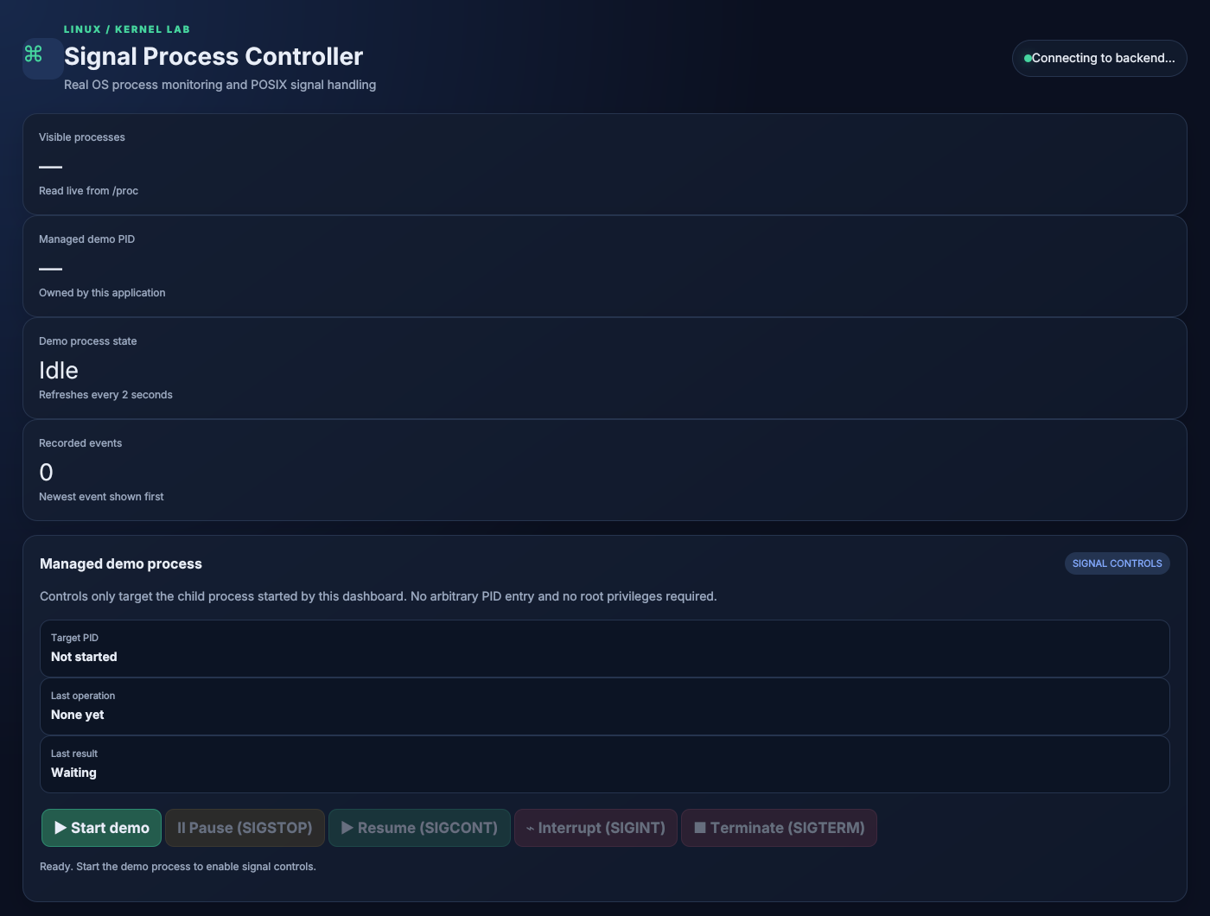
Figure 7.1: Dashboard layout (managed demo process controls and Process Lab follow below)
Figure 7.2: Insert a screenshot of the dashboard after pressing Start demo, showing the managed PID

Figure 7.2: Managed demo process started
Figure 7.3: Insert a screenshot after pressing Pause (SIGSTOP), showing the state Stopped (T)

Figure 7.3: Process paused with SIGSTOP
Figure 7.4: Insert a screenshot of the Process Lab with a batch of workers and the event log

Figure 7.4: Demo workers and the signal event log

7.5 Demonstration of OS Concepts
Step in the demonstration | OS concept | What is observed
Open the dashboard | /proc file system | Live list of PIDs, names, states and RSS read from the kernel
Press Start demo | Process creation (fork / exec) | A new PID appears and is owned by the application
Press Pause (SIGSTOP) | Signal delivery, process state | State becomes Stopped (T)
Press Resume (SIGCONT) | Signal delivery, scheduling | Process leaves the stopped state and runs or sleeps again
Press Interrupt or Terminate | Signal handling, process termination | Child handles the signal, exits and is reaped
Create a batch of workers | Multiple processes, memory (RSS) | Distinct PIDs with state and memory per worker
Send an unsupported signal or PID | Protection and permissions | Request rejected; no process is affected
Read the event log | Auditing | Timestamped record of every operation

7.6 Automated Test Results
The test suite in tests/test_app.py uses Flask's test client and starts a real managed child process. It was run with python -m unittest discover -s tests -v on Linux. The output (test names shortened) was:
test_create_multiple_workers_from_ui_api ... ok
test_dashboard ... ok
test_health_and_process_listing ... ok
test_instruction_creates_workers_and_rejects_arbitrary_input ... ok
test_invalid_signal_rejected ... ok
test_real_signal_lifecycle ... ok
test_signal_without_child_rejected ... ok
test_worker_batch_limits_and_kind_validation ... ok
test_worker_signals_only_apply_to_managed_workers ... ok

Ran 9 tests in 0.720s

OK

Test | What it verifies
test_dashboard | The page loads and contains the instruction box and worker table
test_health_and_process_listing | Health is OK; the /proc listing includes the test's own PID
test_invalid_signal_rejected | SIGKILL is refused with HTTP 400
test_signal_without_child_rejected | Signalling with no child returns HTTP 409
test_real_signal_lifecycle | Start, duplicate start (409), SIGSTOP gives Stopped, SIGCONT resumes, SIGINT and SIGTERM exit, and all four signals appear in the event log
test_create_multiple_workers_from_ui_api | Five workers get five distinct PIDs with valid states
test_worker_signals_only_apply_to_managed_workers | A worker can be paused, resumed and terminated; a foreign PID gets HTTP 404
test_instruction_creates_workers_and_rejects_arbitrary_input | "create 3 sleepers" works; "run rm -rf /" is rejected
test_worker_batch_limits_and_kind_validation | Batches over 30 and unknown worker types are rejected

CHAPTER 8: CONCLUSION

8.1 Summary of the Project
The Linux Signal-Based Process Controller is a local web application that makes Linux process management visible. A Flask backend reads live process data from /proc, starts and tracks child processes, and delivers the POSIX signals SIGSTOP, SIGCONT, SIGINT and SIGTERM with os.kill(). A browser dashboard shows process states, memory use, per-worker controls and a timestamped event log. Strict safety rules ensure that only processes created by the application can be signalled.

8.2 Objectives Achieved
Objective | How it was achieved
Display real Linux processes | process_list() reads PID, name, state and RSS from /proc and the dashboard refreshes every 2 seconds
Demonstrate four signals | SIGSTOP, SIGCONT, SIGINT and SIGTERM are delivered with os.kill() and verified by tests
Restrict signals to managed processes | Allowlist, stored Popen handles and a worker registry; SIGKILL and foreign PIDs are rejected
Dashboard and REST API | Ten endpoints and a single-page HTML/JavaScript interface
Create multiple demo processes | Batch form and allowlisted instruction box, within the limits of 30 per batch and 50 in total
Logging and error messages | Event log with timestamp, signal, PID, result and status; clear JSON error responses
Small and simple setup | One dependency (Flask) and a one-command start script

8.3 Results Achieved
- All 9 automated tests passed in about 0.7 seconds.
- SIGSTOP changed the managed process to the Stopped (T) state, confirmed in /proc/PID/status; SIGCONT resumed it.
- SIGINT and SIGTERM each caused the managed child to exit and were recorded in the event log.
- Unsupported signals (such as SIGKILL), unknown PIDs, over-large batches and unsafe instruction text were all rejected with clear errors.
- The application ran as an ordinary user, without root privileges.
Exact process counts and memory values vary from machine to machine and with user permissions.

8.4 Skills and Learning Outcomes
- Understanding of process creation, process states, PIDs, sessions and process reaping in Linux.
- Practical knowledge of POSIX signals, their default behaviour and which ones can be caught.
- Reading kernel data from the /proc file system.
- Designing a REST API with input validation, status codes and an allowlist-based security model.
- Using locks to protect shared data in a multi-threaded server.
- Writing automated tests with unittest, and presenting technical results in a web interface.

8.5 Limitations and Future Enhancements

Limitations
- The application is for local educational use only; the Flask development server is not production-hardened and there is no authentication or CSRF protection.
- The event history and the worker registry are kept in memory and are lost when the server restarts.
- Process visibility depends on Linux permissions and procfs settings.
- State changes are asynchronous, so the dashboard may show a change up to about two seconds late.
- The SIGINT demonstration uses an explicit handler in the child; sending SIGINT with os.kill does not simulate a keyboard Ctrl+C in a terminal.
- User instructions are limited to the documented patterns; it is not an unrestricted natural-language agent.

Future enhancements
- Persistent event history in SQLite, with export.
- Authentication and CSRF protection for multi-user use.
- Charts for process-state distribution and memory use.
- A configurable refresh interval and pagination of the process table.
- Packaging as a systemd service with hardened permissions.

CHAPTER 9: REFERENCES

9.1 Books
- A. Silberschatz, P. B. Galvin and G. Gagne, Operating System Concepts, Wiley.
- M. Kerrisk, The Linux Programming Interface, No Starch Press, 2010.
- A. S. Tanenbaum and H. Bos, Modern Operating Systems, Pearson.

9.2 Research Papers
No research papers were used directly. The project is based on the standard textbooks and the official documentation listed in this chapter.

9.3 Linux / GNU Documentation
- Linux manual page signal(7): https://man7.org/linux/man-pages/man7/signal.7.html
- Linux manual page proc(5): https://man7.org/linux/man-pages/man5/proc.5.html
- Linux manual page kill(2): https://man7.org/linux/man-pages/man2/kill.2.html

9.4 Online Resources
- Python documentation, subprocess module: https://docs.python.org/3/library/subprocess.html
- Python documentation, os.kill: https://docs.python.org/3/library/os.html#os.kill
- Python documentation, signal module: https://docs.python.org/3/library/signal.html
- Flask documentation: https://flask.palletsprojects.com/
- Ubuntu on WSL documentation: https://documentation.ubuntu.com/wsl/

