**Multiplayer Bowling Alley**

Design the entire bowling alley system. One bowling game will be played by multiple players on one lane. During the game, players and their scores will be maintained and shown by the system and winner will be declared at the end of the game. Likewise multiple games can played in parallel on multiple lanes.

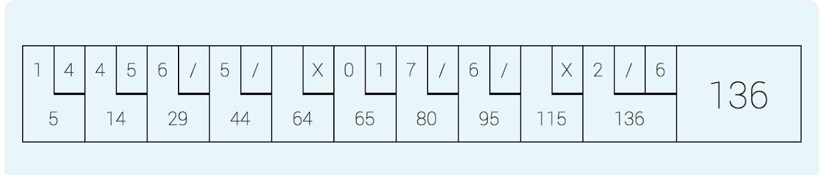

Some rules about Bowling -

* A game consists of ten (10) sets as shown in the attachment.
* In each set, the player has two opportunities to knock down ten (10)pins.
* The score for a set is the total number of pins knocked down, plus bonuses for strikes and spares.
* A spare(depicted by ‘/‘) is when the player knocks down all ten (10) pins in two tries. If there is a spare the player gets 5 bonus points.
* A strike(depicted by ‘X’) is when the player knocks down all ten (10) pins on his/her **first try**. If there is a strike the player gets 10 bonus points. If the person knocks down all the 10 pins in the second try,it should be considered a spare.
* In the final (10th) set an player who rolls a spare or strike is allowed to roll one extra balls to complete the set. However only a maximum of three balls can be rolled in the final set.

Example:

Intheattachmenttheplayerknocks1pininfirsttryand4insecondtryinthefirstsetandthetotal score is5.

In the second set the player knocks 4 pins in first try and 5 in second try and the cumulative score is 14.

In the third set the player knocks 6 pins in first try and the remaining 4 in second try (a spare indicated by the symbol “/“) and the cumulative score is 29 (14+10+5 bonus).

In the forth set the player knocks 5 pins in first try and the remaining 5 in second try (a spare indicated by the symbol “/“) and the cumulative score is 44 (29+10+5 bonus).

In the fifth set the player knocks down all 10 pins in first try(a strike indicated by the symbol “X“) and the cumulative score is 64 (44+10+10 bonus).

In the final set the player knocks 2 in first try and the remaining 8 in second attempt (spare indicated by “/“). The player is allowed to roll an extra ball and this time knocks down 6 pins

So In the final set he gets 21(10+5+6) points and the total tally is 136 points.

Points for Consideration:

1. Make sure you code is modular & extensible and follows OOP best practices - good set of classes and separation of concerns.
2. For the purposes of the implementation, you can use a random number between 0 to 10 to simulate the score of each attempt by the player.
3. We should be able to easily plugin different strategies for score calculation. e.g. We should be able to add more strategies like strike and spare.