MACHINE LEARNING
Specialization Notes — Week 1
Introduction · Supervised vs Unsupervised Learning
Regression · Cost Function · Gradient Descent
Reference: Machine Learning Specialization (Andrew Ng, DeepLearning.AI / Stanford Online)
Personal revision notes — written in own words for interview & project readiness

Table of Contents

Topic 1 — Introduction to Machine Learning

1️⃣ Introduction
Machine Learning (ML) is the branch of Artificial Intelligence that gives computers the ability to learn patterns from data and make decisions or predictions without being explicitly programmed for every rule. Instead of hand-coding logic, we feed the algorithm examples and let it discover the underlying pattern.

2️⃣ Definition
Arthur Samuel's Definition (1959):
"Machine Learning is the field of study that gives computers the ability to learn without being explicitly programmed."

In simple terms: a program is said to learn from experience E, with respect to task T and performance measure P, if its performance on T (measured by P) improves with experience E.

3️⃣ Why is it Needed?
- Some problems are too complex to solve with fixed, hand-written rules (e.g., recognizing handwriting, detecting spam, recommending products).
- Rules that work today may not generalize tomorrow — data-driven models can adapt as new data arrives.
- Traditional programming: Rules + Data → Output. Machine Learning: Data + Output → Rules (the model learns the rules itself).

4️⃣ Applications of Machine Learning
- Web search — ranking search results (Google, Bing).
- Speech recognition — voice assistants like Siri, Alexa, Google Assistant.
- Computer vision — face recognition, self-driving car perception.
- Recommendation systems — Netflix, Amazon, YouTube suggestions.
- Healthcare — disease prediction, medical image diagnosis.
- Finance — fraud detection, credit scoring, stock trend analysis.
- Agriculture, climate science, robotics — an emerging and fast-growing area beyond traditional software.

🧠 Memory Tip
Analogy:
Traditional programming is like giving someone a recipe (rules) to cook a dish (output). Machine Learning is like giving someone many finished dishes (data + output) and asking them to figure out the recipe (rules) themselves.

1️⃣1️⃣ Interview Points
Question | Key Point to Mention
What is Machine Learning? | Field that enables computers to learn patterns from data instead of explicit rules (Arthur Samuel, 1959).
How is ML different from traditional programming? | Traditional: rules + data → output. ML: data + output → rules (model).
Name 3 real-world ML applications. | Recommendation systems, spam filters, speech recognition, fraud detection.

1️⃣2️⃣ Quick Revision
- ML = computers learning patterns from data instead of fixed rules.
- Arthur Samuel (1959) coined the term.
- Traditional programming ≠ ML in how the 'logic' is produced.
- Applications: search, vision, speech, recommendations, healthcare, finance.

Topic 2 — Supervised vs Unsupervised Machine Learning

1️⃣ Introduction
Machine Learning algorithms are broadly grouped by the type of data they learn from and the kind of problem they solve. The two foundational categories are Supervised Learning and Unsupervised Learning.

2️⃣ Definition
Type | Definition
Supervised Learning | Learns a mapping from input (x) to output (y) using a dataset that already contains the correct answers ('labels').
Unsupervised Learning | Learns patterns or structure from data that has no labels — the algorithm figures out the structure on its own.

3️⃣ Why is it Needed?
Real-world data comes in both labeled and unlabeled forms. Supervised learning is needed whenever we want to predict a specific known outcome (price, disease presence, category). Unsupervised learning is needed when we want to explore/discover unknown structure in data where no labels exist or labels are too expensive to collect.

4️⃣ Working / Concept
Supervised Learning — Part 1 & 2:
- The training set consists of input-output pairs: (x⁽¹⁾, y⁽¹⁾), (x⁽²⁾, y⁽²⁾), ... (x⁽ᵐ⁾, y⁽ᵐ⁾).
- The algorithm learns a function f that maps x → ŷ (predicted output) such that ŷ is close to the true y.
- Two main types:
  - Regression — predicts a continuous numeric value (e.g., house price).
  - Classification — predicts a category from a small, finite set of possible outputs (e.g., malignant / benign).

Unsupervised Learning — Part 1 & 2:
- Only inputs x are given — there is no 'right answer' y to learn from.
- The goal is to find structure, patterns, or groupings in the data automatically.
- Main types:
  - Clustering — group similar data points together (e.g., customer segmentation).
  - Anomaly detection — identify unusual data points (e.g., fraud detection).
  - Dimensionality reduction — compress data while preserving important information.
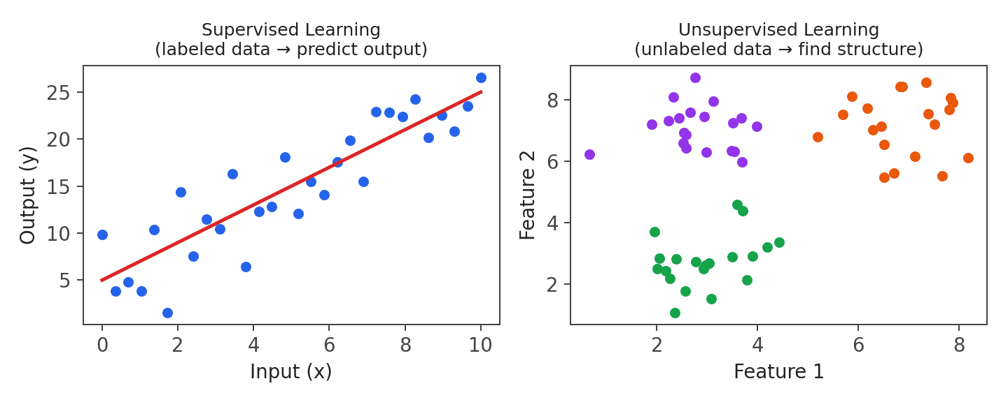
Fig 2.1 — Supervised learning fits a line to labeled data; unsupervised learning groups unlabeled data into clusters.

6️⃣ Example
Scenario | Type
Predicting house price from size, location | Supervised — Regression
Classifying an email as spam or not spam | Supervised — Classification
Grouping news articles by topic without predefined categories | Unsupervised — Clustering
Detecting unusual credit card transactions | Unsupervised — Anomaly Detection

8️⃣ Applications
- Supervised: spam detection, medical diagnosis, price prediction, image classification.
- Unsupervised: customer segmentation, topic modeling, market basket analysis, DNA/gene grouping.

9️⃣ Advantages
- Supervised: high accuracy when labeled data is available; clear evaluation metric (compare prediction to true label).
- Unsupervised: doesn't need expensive/manual labeling; can reveal hidden structure humans might miss.

🔟 Limitations
- Supervised: requires large amounts of labeled data, which is expensive and time-consuming to collect.
- Unsupervised: harder to evaluate ('correctness' is subjective); results can be harder to interpret.

⚠️ Common Mistakes
- Assuming unsupervised learning can 'predict' a specific labeled outcome — it cannot; it only finds structure.
- Confusing classification (discrete categories) with regression (continuous numbers).

🔗 Topic Connections
Supervised learning splits further into Regression (Topic 3 onward — linear regression, cost function, gradient descent) and Classification (covered later using logistic regression). This week's remaining topics build the regression pipeline end-to-end.

1️⃣1️⃣ Interview Points
Question | Key Point to Mention
Difference between supervised and unsupervised learning? | Supervised uses labeled data (x,y pairs) to predict outputs; unsupervised uses unlabeled data (x only) to find structure.
Regression vs Classification? | Regression predicts continuous values; classification predicts discrete categories.
Give an example of clustering. | Customer segmentation, grouping similar news articles.
Is anomaly detection supervised or unsupervised? | Typically unsupervised — learns what 'normal' looks like and flags outliers.

1️⃣2️⃣ Quick Revision
- Supervised = labeled data (x → y); Unsupervised = unlabeled data (x only, find structure).
- Supervised splits into Regression (continuous) and Classification (discrete).
- Unsupervised includes clustering, anomaly detection, dimensionality reduction.
- Jupyter Notebooks are the standard tool used to write and run ML code interactively in Python.

Topic 3 — Regression Model (Linear Regression)

1️⃣ Introduction
Linear regression is the simplest and most widely used supervised learning algorithm for regression problems. It fits a straight line through the training data to predict a continuous output.

2️⃣ Definition
Linear regression models the relationship between an input feature x and an output y as a straight line: given a new x, the model predicts ŷ using a linear function of x.

3️⃣ Why is it Needed?
- Many real relationships are approximately linear (e.g., more house area → generally higher price).
- It's simple, fast to train, easy to interpret, and forms the mathematical foundation for more complex models (including neural networks).

4️⃣ Working / Concept
- Training set: a collection of (x, y) example pairs used to train the model.
- x = input/feature (e.g., house size); y = actual output/target (e.g., price).
- ŷ (y-hat) = the model's prediction for a given x.
- The learning algorithm's job: choose parameters w (weight) and b (bias) so the line f(x) fits the training data as closely as possible.
- This case with only 1 input feature is called Univariate Linear Regression.
f_{w,b}(x) = wx + b
- w — weight (slope of the line): how much y changes per unit change in x.
- b — bias (y-intercept): the predicted value when x = 0.
- x — input feature.
- f_{w,b}(x) or ŷ — the model's predicted output for input x.
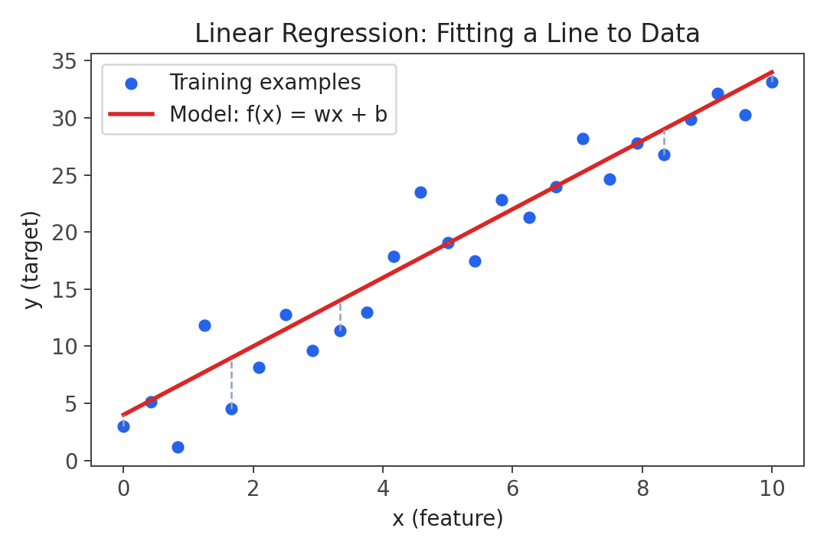
Fig 3.1 — Linear regression fits the line f(x) = wx + b to minimize the distance (dashed) between predictions and actual data points.

6️⃣ Example
Predicting house price from size: suppose the model learns w = 150 and b = 50 (in thousands of ₹ per sq.ft and a base price). For a house of size x = 1000 sq.ft:
f(1000) = 150(1000)/1000 + 50 = 200 (₹ Lakhs, illustrative)
(Numbers simplified for illustration — the exact scale depends on how features are engineered.)

8️⃣ Applications
- House price prediction from size/location.
- Predicting sales based on advertising spend.
- Estimating exam scores from hours studied.
- Forecasting demand, temperature trends, or stock price trends (as a baseline model).

9️⃣ Advantages
- Simple to understand and implement.
- Computationally inexpensive and fast to train.
- Coefficients (w, b) are directly interpretable.

🔟 Limitations
- Only captures linear relationships — fails on data with curved/complex patterns.
- Sensitive to outliers, which can heavily skew the fitted line.

🧠 Memory Tip
Analogy:
Think of f(x) = wx + b like a recipe: b is the base amount you always start with (even with zero of x), and w is how much extra you add for every unit of x you use.

⚠️ Common Mistakes
- Confusing w (slope) with b (intercept) — remember b is the value when x = 0.
- Assuming linear regression can be used directly for classification problems (it cannot, without modification).

🔗 Topic Connections
Linear regression is the model; but how do we know if the chosen w, b are 'good'? That is measured using the Cost Function (Topic 4), and the best w, b are found using Gradient Descent (Topic 5).

1️⃣1️⃣ Interview Points
Question | Key Point to Mention
What is the equation of linear regression? | f(x) = wx + b, where w = slope/weight, b = intercept/bias.
What does 'univariate' mean here? | Only one input feature x is used.
Why choose linear regression as a starting model? | Simple, interpretable, computationally cheap, good baseline.
Limitation of linear regression? | Cannot model non-linear relationships without feature engineering.

1️⃣2️⃣ Quick Revision
- f(x) = wx + b — w is slope, b is intercept.
- Univariate regression = single input feature.
- Goal: choose w, b so the line best fits the training data.
- Fast, interpretable, but only models linear relationships.

Topic 4 — Cost Function

1️⃣ Introduction
Once we have a model f(x) = wx + b, we need a way to measure how good a particular choice of w and b is. The Cost Function provides that measurement.

2️⃣ Definition
The Cost Function J(w, b) measures the average error between the model's predictions and the actual target values across the entire training set. A lower cost means a better fit.

3️⃣ Why is it Needed?
- We need a single numeric score to compare different choices of w and b.
- Without a cost function, there's no objective way to say one line 'fits better' than another.
- This score becomes the target that Gradient Descent tries to minimize.

4️⃣ Working / Concept
- The most common cost function for linear regression is the Mean Squared Error (MSE).
- For each training example, compute the error: prediction − actual (ŷ⁽ⁱ⁾ − y⁽ⁱ⁾).
- Square the error (so positive and negative errors don't cancel out, and larger errors are penalized more).
- Average this over all m training examples (the extra ÷2 is a mathematical convenience that simplifies the derivative used later in gradient descent).
J(w,b) = (1/2m) · Σᵢ₌₁ᵐ (f_{w,b}(x⁽ⁱ⁾) − y⁽ⁱ⁾)²
- m — number of training examples.
- f_{w,b}(x⁽ⁱ⁾) — model's prediction for the i-th example.
- y⁽ⁱ⁾ — actual target value for the i-th example.
- (f(x) − y)² — squared error for one example (penalizes larger mistakes more heavily).
- 1/2m — averages the total squared error; the 2 cancels neatly when differentiating during gradient descent.

7️⃣ Visualizing the Cost Function
If we fix b and vary only w, plotting J(w) produces a characteristic bowl (U) shape — a convex curve with exactly one minimum point. When both w and b vary, J(w, b) forms a 3-D bowl (or a set of concentric oval contours when viewed from above).
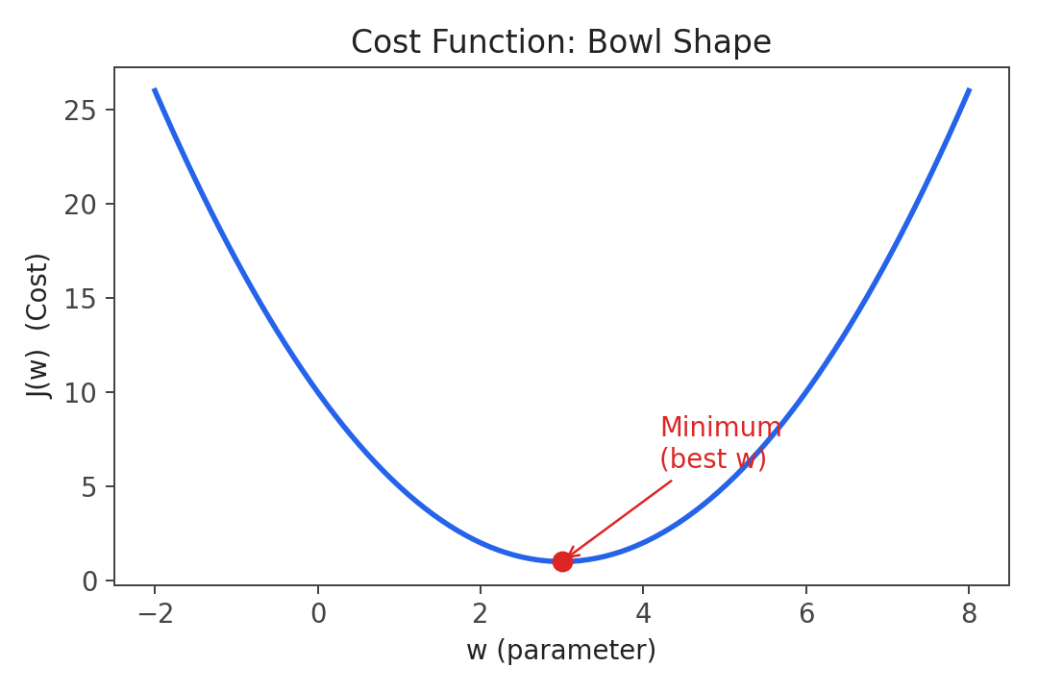
Fig 4.1 — J(w) is convex: it has a single global minimum, which is the goal of training.

6️⃣ Example
If a model predicts ŷ = 210 for a house whose true price is y = 200 (in ₹ Lakhs), the squared error for that example is (210 − 200)² = 100. J(w, b) averages this squared error across all training houses.

8️⃣ Applications
- Used in every regression algorithm as the training objective (linear regression, polynomial regression, neural network regression heads).
- Variants (MAE, Huber loss, cross-entropy for classification) are chosen depending on the problem type and sensitivity to outliers.

9️⃣ Advantages
- MSE is smooth and differentiable everywhere — ideal for gradient-based optimization.
- Convex shape guarantees gradient descent will find the global minimum for linear regression (no risk of getting stuck in a local minimum).

🔟 Limitations
- Squaring the error makes MSE very sensitive to outliers — a few extreme errors can dominate the cost.
- Not directly interpretable in the original units of y (since the error is squared).

🧠 Memory Tip
Analogy:
Think of J(w,b) like a golf course shaped like a bowl. Your ball (current w, b) always rolls toward the lowest point — that lowest point is the best-fit line.

⚠️ Common Mistakes
- Confusing the cost function J(w,b) (measures fit over the whole dataset) with the model f(x) (predicts a single output).
- Forgetting to square the error — without squaring, positive and negative errors could cancel out and hide real mistakes.

🔗 Topic Connections
The cost function tells us how good a line is. It does not, by itself, tell us how to improve w and b — that is the job of Gradient Descent (Topic 5), which uses the shape/slope of J(w,b) to iteratively walk downhill toward the minimum.

1️⃣1️⃣ Interview Points
Question | Key Point to Mention
What is the cost function used in linear regression? | Mean Squared Error: J(w,b) = (1/2m) Σ(f(x⁽ⁱ⁾) − y⁽ⁱ⁾)².
Why square the error instead of using absolute value? | Squaring is differentiable everywhere and penalizes large errors more; absolute value has a non-differentiable kink at 0.
Why is the shape of J(w,b) important? | It's convex (bowl-shaped) for linear regression, guaranteeing a single global minimum reachable by gradient descent.
Why divide by 2m and not just m? | The 2 cancels out neatly with the power rule when taking the derivative during gradient descent — a mathematical convenience.

1️⃣2️⃣ Quick Revision
- J(w,b) = (1/2m) Σ (prediction − actual)² — measures average model error.
- Lower J = better fit.
- J(w) is convex/bowl-shaped → exactly one global minimum.
- Sensitive to outliers due to squaring.

Topic 5 — Train the Model with Gradient Descent

1️⃣ Introduction
Gradient Descent is the optimization algorithm used to automatically find the values of w and b that minimize the cost function J(w, b).

2️⃣ Definition
Gradient Descent is an iterative algorithm that starts with some initial values of w and b, and repeatedly adjusts them in small steps, in the direction that reduces J(w,b) the fastest, until it converges to (or near) the minimum.

3️⃣ Why is it Needed?
- For simple linear regression there are closed-form solutions, but they don't scale to complex models with many parameters (e.g., neural networks).
- Gradient descent is a general-purpose optimization method that works for almost any differentiable cost function, making it the backbone of modern ML and deep learning training.

4️⃣ Working / Concept (Implementing Gradient Descent)
- Start with initial guesses for w and b (often 0).
- Compute the gradient (partial derivative) of J with respect to w and b — this tells the slope/direction of steepest increase.
- Update w and b by moving a small step in the opposite direction of the gradient (i.e., downhill).
- Repeat until the updates become very small (convergence) — meaning w, b are no longer changing much and J(w,b) is near its minimum.
- Important: w and b must be updated simultaneously — compute both new values first, then update both together (not one after another using the already-updated value).
w := w − α · ∂J/∂w b := b − α · ∂J/∂b
- α (alpha) — the learning rate: controls how big each step is.
- ∂J/∂w, ∂J/∂b — the gradient (slope) of the cost function with respect to w and b.
- := — assignment (update the variable with a new value).
For linear regression specifically, the derivatives work out to (Gradient Descent for Linear Regression):
∂J/∂w = (1/m) Σᵢ (f(x⁽ⁱ⁾) − y⁽ⁱ⁾)·x⁽ⁱ⁾ ∂J/∂b = (1/m) Σᵢ (f(x⁽ⁱ⁾) − y⁽ⁱ⁾)
- These are substituted into the update rule above and repeated for many iterations (this is called Batch Gradient Descent, since it uses all m training examples in every single update step).
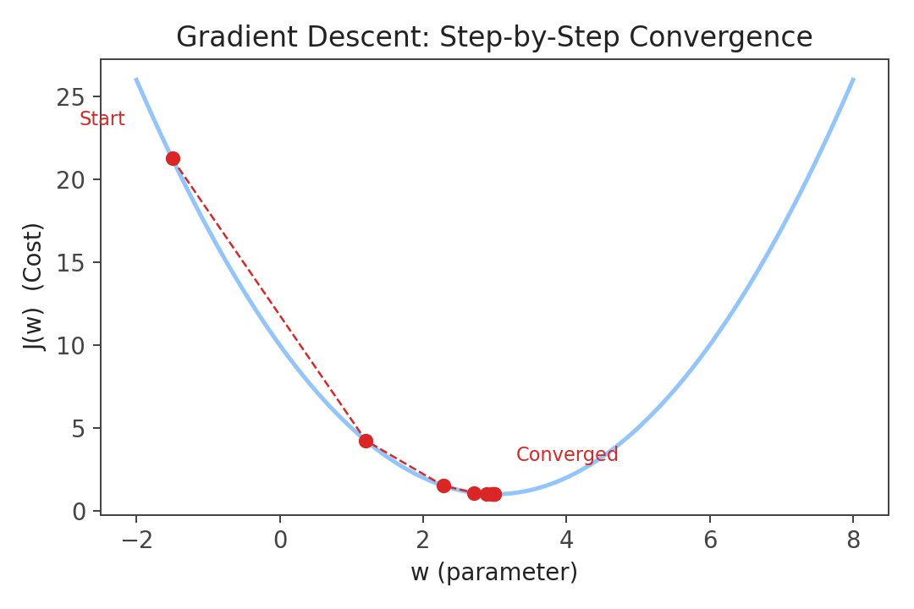
Fig 5.1 — Gradient descent takes repeated steps downhill along the cost curve until it converges near the minimum.

4️⃣ Learning Rate (α)
The learning rate α is one of the most important hyperparameters to tune:
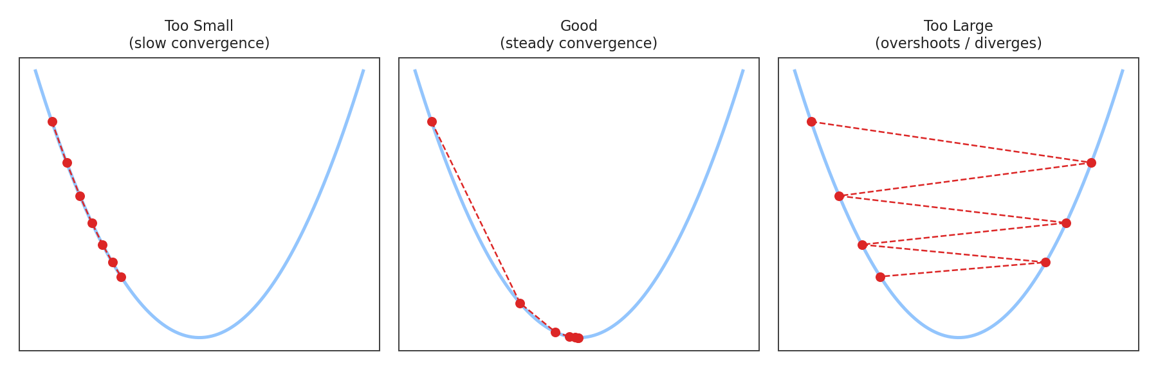
Fig 5.2 — Effect of learning rate: too small wastes time; too large can overshoot or diverge; a good rate converges steadily.
Learning Rate | Effect
Too small | Gradient descent works but takes a very large number of iterations — slow convergence.
Too large | Gradient descent may overshoot the minimum and fail to converge, or even diverge (cost increases).
Just right | Cost decreases steadily on each iteration and converges efficiently.
Near the minimum | Steps automatically get smaller because the gradient (slope) itself becomes smaller — no need to manually decrease α.

6️⃣ Example (Running Gradient Descent)
Starting from w = 0, b = 0 with a suitable learning rate, each iteration nudges w and b slightly toward the values that minimize J(w,b). After enough iterations, w and b converge to the values shown earlier in the Regression Model example (e.g., w ≈ 150, b ≈ 50), at which point predictions closely match the training data.

8️⃣ Applications
- Training linear and logistic regression models.
- Training deep neural networks (via backpropagation, which is gradient descent applied layer by layer).
- Any optimization problem with a differentiable objective function.

9️⃣ Advantages
- General-purpose — works for simple models and extremely complex ones (deep learning).
- Computationally efficient per step, especially with variants like Stochastic/Mini-batch Gradient Descent.
- Guaranteed to reach the global minimum for convex cost functions like linear regression's MSE.

🔟 Limitations
- Choosing a good learning rate can require trial and error.
- For non-convex cost functions (common in deep learning), gradient descent can get stuck in local minima or saddle points.
- Batch gradient descent (using all m examples per step) can be slow on very large datasets.

🧠 Memory Tip
Analogy:
Imagine standing on a foggy hillside and wanting to reach the bottom. You can't see the whole hill, but you can feel which direction slopes downward under your feet. You take a small step downhill (learning rate = step size), then feel again, and repeat — that's gradient descent.

⚠️ Common Mistakes
- Updating w first and then using the new w to compute the update for b — always compute both updates first, then apply them simultaneously.
- Setting the learning rate too high without checking whether the cost is actually decreasing each iteration.
- Believing gradient descent always converges to the global minimum — true only for convex functions like linear regression's cost; not guaranteed for non-convex functions.

🔗 Topic Connections
Gradient descent is the engine that uses the shape of the Cost Function (Topic 4) to find the best parameters for the Regression Model (Topic 3). Together, Model → Cost Function → Gradient Descent form the complete training loop used throughout the rest of the ML Specialization, including for classification and neural networks.

1️⃣1️⃣ Interview Points
Question | Key Point to Mention
What is gradient descent? | An iterative optimization algorithm that updates parameters in the direction of steepest descent to minimize a cost function.
What is the role of the learning rate? | Controls step size; too small = slow, too large = may overshoot/diverge.
Why must updates to w and b be simultaneous? | To ensure both updates use the same (old) parameter values — matches the true mathematical gradient step.
Does gradient descent always find the global minimum? | Only guaranteed for convex cost functions (like linear regression's MSE); not guaranteed for non-convex functions.
What is Batch Gradient Descent? | A version of gradient descent that uses the entire training set (all m examples) to compute each update step.

1️⃣2️⃣ Quick Revision
- Gradient descent iteratively updates w, b to minimize J(w, b).
- Update rule: w := w − α·∂J/∂w, b := b − α·∂J/∂b (simultaneous update).
- α (learning rate) controls step size — too small = slow, too large = diverges.
- Batch gradient descent uses all m training examples per step.
- Convex cost function (linear regression) → guaranteed global minimum.

References
- Andrew Ng, Machine Learning Specialization — DeepLearning.AI & Stanford Online (Coursera). Course 1, Week 1: Introduction to Machine Learning.
- Notes written independently, in own words, for personal revision, interview preparation, and future project reference.

