An Evidence-Grounded Framework for Kubernetes Monitoring and Root Cause Analysis Using Graph Based Reasoning and LLM Assistance
Premkumar Dª, Akshay B^{b}, Aisvarya S^{c}, Deepika J^{d} , Dharashree S R^{e}
^{a–d} Department of Computer Science and Engineering, KPR Institute of Engineering and Technology, Coimbatore, India
ª technicalprem@gmail.com
^{b} akshaybharathy2005@gmail.com
^{c} saisvarya11@gmail.com
^{d} deepikajaganathan283@gmail.com
^{e} msrdharashree76@gmail.com

Abstract
Kubernetes environments are frequently used to deploy and manage containerized applications, but the relationships between workloads, nodes, services and other resources makes it difficult to find the root causes of the cluster incidents. Delayed incident diagnosis leads to service disruptions, increased recovery time and applications will become less reliable. To address this challenge, this paper proposes KubeMind AI, an evidence-based framework for intelligent Kubernetes monitoring and root cause analysis. The framework integrates graph-based reasoning, cluster-state inspection, and optional Large Language Model (LLM) assistance to investigate Kubernetes incidents. The architecture consists of a StateGraph-based workflow and a MetaGraph representation to organize relationships between resources and in order to enable the investigation process. The workflow includes incident triaging, candidate-path generation, state verification, generation of report and report quality checking. Instead of depending solely on the generated explanations, the framework uses existing cluster-state evidence to validate diagnostic results to find cases that need further investigation. A live monitoring component processes selected Kubernetes warning events while a dashboard provides diagnostic reports and investigation history. The implementation also includes automated tests and curated evaluation scenarios to study the behavior of the diagnostic pipeline. Initial evaluation results indicate that the framework works on the test cases included but these results do not prove its accuracy or effectiveness on large-scale production Kubernetes clusters. The current implementation also has its limitations such as in-memory graph processing, limited live-event support and limited remediations capabilities. Future work will include broader cluster evaluation, persistent graph storage, improved diagnostic validation and more comprehensive AI-assisted investigation of the incidents. The framework seeks to establish a practical foundation for evidence-based Kubernetes incident diagnosis and intelligent cluster monitoring.
Keywords: KubeMind AI, Kubernetes Monitoring, Root Cause Analysis, Cloud-Native Applications, Graph-Based Reasoning, StateGraph, MetaGraph, Large Language Models, Incident Diagnosis, Evidence-Grounded AI, DevOps, Container Orchestration.

Introduction
Kubernetes is often used for deploying and managing containerized applications. However, identifying the root causes of failures in Kubernetes clusters can be challenging because incidents may involve several interconnected resources such as pods, nodes, deployments and services. Troubleshooting manually is often time consuming, requires analysis of cluster events, resource states and dependencies. A delayed diagnosis can increase service downtime and affect application reliability. To address these challenges, this paper proposes an evidence-grounded framework that combines graph-based reasoning, Kubernetes cluster-state analysis, and optional Large Language Model (LLM) support to perform intelligent monitoring and root cause analysis. This framework analyzes incidents through a number of stages such as incident triage, generation of candidate paths, state verification and generation of diagnostic reports. Section 2 reviews the related work on Kubernetes monitoring and automated root cause analysis. Section 3 discusses the proposed KubeMind AI architecture and its major components. Section 4 describes the methodology including graph construction, incident investigation and evidence-based verification. Implementation details and experimental setup are described in Section 5. In Section 6 we discuss the evaluation results and the system performance. Section 7 discusses limitations and future improvements. Section 8 concludes the paper.

Literature Survey
Tools such as Prometheus [1] and Grafana [2] are popular choices for gathering metrics and visualizing the performance of a Kubernetes cluster. However, these tools are mainly focused on monitoring and alerting requiring further analysis to identify the root causes of incidents. Graph-based approaches [3] model the relationships between Kubernetes resources and allow dependency analysis during troubleshooting. Rule-based approaches [4] use pre-defined conditions to detect anomalies, whereas machine learning techniques [5] can identify anomalous system behavior. The potential of Large Language Models (LLMs) [6] has been investigated recently for automated incident analysis, root cause identification and recommendation generation. In this paper, KubeMind AI leverages graph-based reasoning, cluster-state verification and optional LLM assistance to investigate Kubernetes incidents and generate evidence based diagnostic reports.
Table 1 lists the related studies on Kubernetes monitoring and automated root cause analysis published in recent years. Such studies include traditional monitoring approaches, graph-based diagnosis methods and LLM-assisted incident investigation frameworks. The proposed system extends these approaches by adding incident triage, analysis of resource relationships, state verification and checking the quality of reports to enable evidence-based root cause analysis of Kubernetes.

Table 1: Literature Survey

Year | Study / Authors | Dataset / Data Source | Method / Model | Main Finding / Result | Limitation / Research Gap
2026 | Senja, Razavi Zadegan & Leitner - ARGUS [1] | Ten controlled Kubernetes incident scenarios; interviews with six on-call engineers | LLM-based diagnosis using Model Context Protocol (MCP) and live observability data | Correctly identified the root cause in all ten evaluated scenarios, with an aggregate MCP success ratio of 0.91. | Preliminary evaluation with a small number of scenarios; recommended fixes remain less trustworthy than diagnostic findings.
2025 | Patchamatla: Intelligent Observability in Kubernetes [2] | Kubernetes monitoring and cloud-native observability data | AI-powered anomaly detection and root cause analysis using telemetry, logs, metrics. | Explores AI-assisted monitoring and automated diagnosis to improve incident response. | Further independent quantitative evaluation and validation across diverse production environments are needed.

Year | Study / Authors | Dataset / Data Source | Method / Model | Main Finding / Result | Limitation / Research Gap
2023 | Zhang et al. : Robust Failure Diagnosis of Microservice System Through Multimodal Data [3] | Microservice failure data and heterogeneous monitoring information | DiagFusion, multimodal data fusion, and graph-based diagnosis | Combines heterogeneous data sources to improve microservice failure diagnosis. | Combining different telemetry sources and handling incomplete or noisy observations remain challenging.
2023 | Authors of CausalRCA: Fine-Grained Root Cause Localization [4] | Microservice performance metrics and injected anomalies in benchmark environments | Causal graph learning and fine-grained root cause localization | Reports improved root cause localization compared with baseline methods. | Depends on the quality of monitoring data and causal relationships; integration with evidence-grounded LLM reporting is a separate challenge.
2021 | Wang et al. : Groot: An Event-Graph-Based Approach [5] | Production incidents from an industrial e-commerce system | Event graphs, causal relationships and domain-specific rules | Evaluated using 952 production incidents; reported 78% top-1 accuracy and 95% top-3 accuracy. | Domain-specific knowledge and event relationships may require adaptation when applied to different Kubernetes environments.
2021 | Zhang et al.: CloudRCA[6] | KPIs, logs, and topology information from Alibaba Cloud platforms | Anomaly detection, log analysis, and a knowledge-informed hierarchical Bayesian network | Reports improved F1-score across multiple cloud systems and reduced failure-resolution effort in operational deployments. | Designed for cloud computing platforms; Kubernetes-specific resource-state verification requires additional consideration.
2020 | Wu, Tordsson, Elmroth & Kao : MicroRCA  [7] | Microservice benchmark deployed on Kubernetes with injected anomalies | Attributed graphs correlating application performance symptoms with system resource utilization | Reported 89% precision and 97% mean average precision for root cause localization. | Primarily focuses on performance-issue localization rather than evidence-grounded diagnostic report generation.
2020 | Brandón et al. : Graph-Based Root Cause Analysis [8] | Three containerized service-oriented architectures | Graph-based architecture representation and graph matching | Investigates how component relationships can improve root cause analysis compared with approaches that ignore those relationships. | Graph matching may depend on previously observed failures and may be less effective for unfamiliar incidents.

Year | Study / Authors | Dataset / Data Source | Method / Model | Main Finding / Result | Limitation / Research Gap
2018 | Wang et al. : CloudRanger- Root Cause Identification for Cloud Native Systems [9] | Simulated incidents and real incidents from IBM Bluemix | Dynamic causal relationship analysis, impact graphs, and second-order random walks | Reported a 10% accuracy improvement over selected state-of-the-art approaches. | Focuses on identifying culprit services; additional mechanisms are needed to validate diagnostic conclusions against current resource states.
2018 | Lin, Chen & Zheng et al. [10] | Microservice performance measurements and service dependencies | Causal graphs for identifying and ranking potential root causes | Presents a graph-based approach for identifying abnormal services and ranking possible causes in microservice environments. | Performance-oriented diagnosis may not cover broader Kubernetes warning events or evidence-based verification of generated reports.

The related studies are listed in chronological order in Table 1 and the citation numbers are in the order of appearance in the text. The survey methods include traditional monitoring, rule-based diagnosis, graph-based reasoning, causal analysis and LLM-assisted root cause analysis. Graph-based methods use relationships between system components to identify potential causes. Recent LLM-based methods enable automated incident investigation and diagnostic reporting. Still, a major challenge is to validate the generated diagnoses against the current evidence of a Kubernetes cluster state. KubeMind AI closes this gap by bringing together graph analysis, state verification and report quality checks in a single diagnostic workflow.

Research Gap
The studies in Table 1 highlights several challenges within the framework of Kubernetes monitoring and root cause analysis. Traditional monitoring techniques are rule-based and metric-based, they can tell you something is abnormal, but not why it is abnormal. Graph-based methods improve diagnosis by analyzing relationships between system components and causal analysis and LLM-based approaches enable more sophisticated incident investigation. Yet precise root-cause identification and validation of diagnostic findings against contemporary cluster-state evidence continue to be major challenges.
Most existing approaches focus on either anomaly detection or ranking potential root causes, with less emphasis on unifying the entire diagnosis process into a single workflow. The explanations generated by LLMs might include conclusions without any evidence. A trustworthy diagnosis of the incident requires a verification of the evidence. This work tackles these challenges via KubeMind AI, an evidence-grounded framework that incorporates incident triage, graph-based resource relationship analysis, candidate-path generation, cluster-state verification, and diagnostic report quality checking. Optional LLM assistance is also supported by the framework, as is live monitoring of Kubernetes warning events that are selected. Unlike approaches that mainly aim at detecting anomalies or finding possible root causes, KubeMind AI focuses on verifying the diagnosis based on the evidence found in the current state of the cluster, before generating reports. The current implementation is a lightweight prototype, and more evaluation on different large-scale Kubernetes environments are needed to evaluate its effectiveness and generalizability.

Problem Statement and Research Objectives

Problem Statement
Kubernetes clusters have interdependent resources like pods, nodes, deployments and services, making it hard to debug what’s wrong. If something goes wrong in one part it can affect parts. Monitoring alerts usually show signs of a problem but not the real reason. Investigating manually means looking at events the state of resources and how they are connected. This can take a lot of time. So there is a need for a system that can find the real cause check how resources are connected and make sure the findings are correct using what is known about the cluster. This project solves this problem with KubeMind AI which uses graph-based thinking checking the state of things and optional help from a Large Language Model to help with diagnosing problems in Kubernetes.

Research Objectives
The main objective of this project is to develop KubeMind AI for intelligent Kubernetes monitoring and root cause analysis. First, Kubernetes warning events and available resource states are analyzed to identify potential issues. Second, graph-based resource relationships are used to generate candidate paths for root cause investigation. Third, a StateGraph-based workflow combines incident triage, state verification, diagnostic report generation and report quality checking. Fourth, optional Large Language Model (LLM) assistance and live monitoring of supported warning events help investigate incidents and present findings through a dashboard. Finally, the framework is evaluated using automated tests and curated scenarios to identify limitations and opportunities for improvement with the aim of improving diagnostic reliability in future, larger-scale Kubernetes environments.

Methodology

Overview
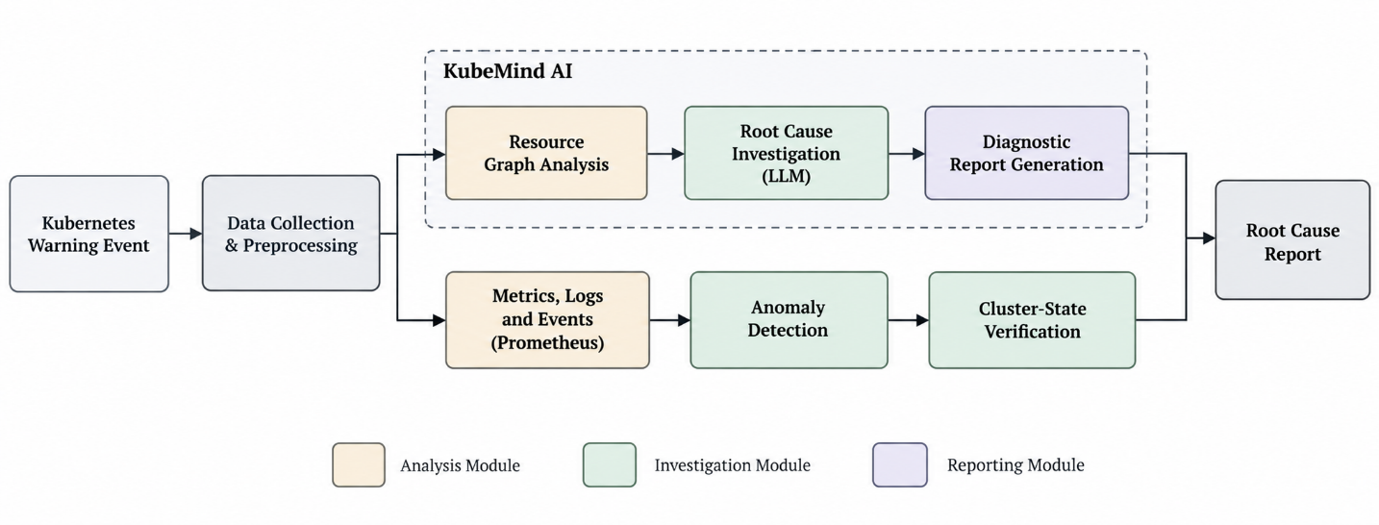
The proposed KubeMind AI framework adheres to a structured workflow for Kubernetes incident monitoring and root cause analysis, as illustrated in Fig. 1. When a Kubernetes warning event is detected, the system performs incident triage and analyzes the relationships between relevant resources in a graph-based representation. It generates candidate paths to find possible root causes and uses a state-checking module to examine the available cluster-state evidence and confirm its findings. Then a report generation module processes the diagnostic information then a report quality checker that identifies cases that need further investigation. Large Language Model (LLM) assistance is optionally available for some stages of the investigation. The dashboard shows diagnostic reports and history of investigations. The main components and their purposes are summarized in Table 2. The framework is tested through automated tests and curated scenarios that evaluate its behavior and identify areas for improvement.

Fig 1: Overall methodology
Fig. 1 shows the KubeMind AI workflow, integrating graph-based root cause analysis, optional LLM assistance, anomaly detection and cluster-state verification to generate a root cause report.

Table 2: System Components

Component | Purpose
Kubernetes Event Monitor | Detects and processes supported Kubernetes warning events.
StateGraph Workflow | Coordinates incident triage, investigation, verification, and report generation.
Resource Graph (MetaGraph) | Represents relationships between Kubernetes resources for root cause investigation.
Triage and Path Query Generator | Analyzes incidents and generates candidate paths for investigation.
State Checker | Verifies potential root causes against available cluster-state evidence.
Report Generator and Quality Checker | Generates diagnostic reports and identifies cases requiring further investigation, with optional LLM assistance.
Dashboard | Displays diagnostic reports and investigation history.
Table 2 summarizes KubeMind AI components, from incident investigation and evidence verification to report generation and dashboard visualization.

Evaluation Setup
In this work, we evaluate KubeMind AI on automated tests and curated Kubernetes incident scenarios, not on a separate dataset. The scenarios are used to study how the framework handles warning events, analyzes the resource relationships, verifies the cluster-state evidence and generates diagnostic reports. The automated tests check the behavior of individual components as well as the entire diagnostic workflow. The evaluation is built on incident investigation using evidence-based methods and functional correctness. The evaluation is based on a limited number of test scenarios, and the results are therefore preliminary and do not provide evidence of performance in large-scale production Kubernetes clusters. The evaluation workflow is depicted in Fig. 2.

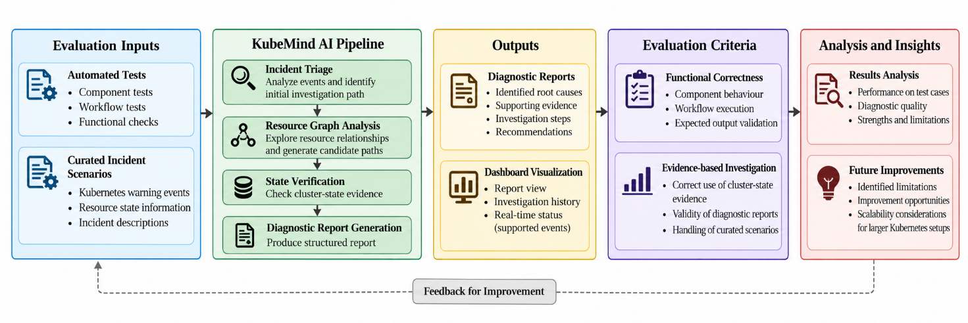

Fig 2: Evaluation workflow
Fig. 2 shows the KubeMind AI evaluation workflow, from incident analysis to report assessment and identification of improvements.

Table 3: Evaluation Summary

Evaluation Component | Purpose
Automated Tests | Verify individual modules and workflow execution
Curated Incident Scenarios | Evaluate the framework using predefined Kubernetes incidents
State Verification | Check potential root causes against available cluster-state evidence
Diagnostic Reports | Assess the generated root cause explanations and supporting evidence
Table 3 summarizes the evaluation components used to assess KubeMind AI. The framework is evaluated using automated tests and curated incident scenarios, focusing on functional correctness and evidence-based root cause analysis.
Table 4 summarizes the preliminary evaluation of KubeMind AI. All 16 automated tests passed, while curated incident scenarios were used to assess the diagnostic workflow. These results demonstrate functional behaviour in the tested cases, not proven performance in production clusters.

Table 4: Evaluation Results

Metric | Result
Automated Tests | 16/16 passed
Evaluation Method | Curated incident scenarios
LLM Calls | 0 (rules-only evaluation)
Evaluation Focus | Functional correctness and evidence verification
The results indicate that the framework’s rule-based workflow can operate without relying on LLM calls for the tested scenarios. Further evaluation with diverse Kubernetes incidents would help assess its reliability and scalability.

Incident Diagnosis Analysis
KubeMind AI analyzes Kubernetes warning events by examining resource relationships and available cluster-state evidence. The framework generates candidate root causes, validates them against the available state and generates diagnostic reports. Where the evidence is lacking, the report quality checker can flag cases for more detailed investigation.

Table 5: Incident Diagnosis Process

Stage | Description
Incident Triage | Identifies the issue from a supported warning event.
Graph Analysis | Examines relationships between relevant resources.
Evidence Verification | Checks potential causes against available cluster state.
Report Generation | Produces findings and supporting evidence.
Quality Checking | Identifies cases requiring further investigation.
Table 5 outlines the incident diagnosis process in KubeMind AI, describing how graph-based investigation and state verification support evidence-based root cause analysis.
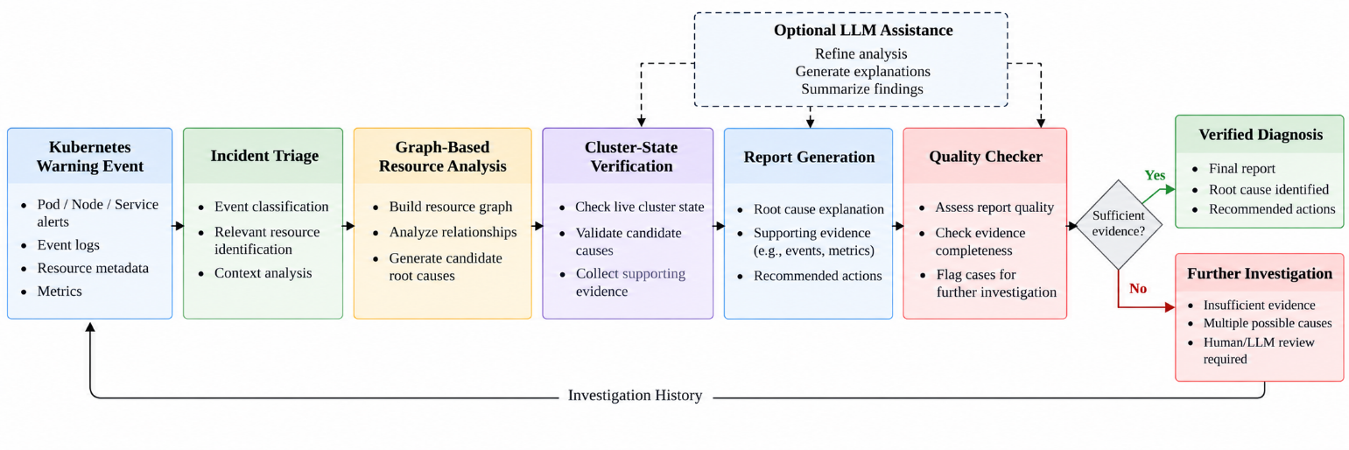

Fig 3: Incident Diagnosis Analysis
Fig. 3 illustrates how KubeMind AI analyzes Kubernetes incidents through graph-based resource analysis and cluster-state verification to identify potential root causes and generate evidence-supported diagnostic reports.
Rule-based approaches depends on predefined conditions, while LLM-based approaches provide flexible explanations but may generate unsupported conclusions. KubeMind AI combines graph-based resource analysis, cluster-state verification and optional LLM assistance to generate evidence-supported diagnoses and identify cases requiring further investigation.

Table 6: Criterion based Comparison

Criterion | Rule-Based Analysis | LLM-Based Analysis | KubeMind AI
Resource relationship analysis | Limited to defined rules | Context-dependent | Graph-based
Cluster-state verification | Rule-dependent | Not guaranteed | Evidence-based
Root cause explanation | Rule-based output | Natural-language output | Evidence-supported report
LLM dependency | No | Yes | Optional
Handling insufficient evidence | Depends on rules | May produce unsupported claims | Can flag further investigation
Adding new failure types | Update rules | Update prompts | Update investigation logic

Table 6 compares conventional rule-based and LLM-based approaches with KubeMind AI across resource analysis, evidence verification, and diagnostic reporting.

Graph-Based Resource Relationship Analysis
KubeMind AI employs a graph-based structure to represent the relations among Kubernetes resources to assist incident diagnosis. After a warning event, the system checks relevant resource relationships and generates candidate paths to identify potential root causes. The candidates are then compared to available evidence from the cluster state to determine if the diagnosis is supported. The process links resource dependency analysis with evidence-based root cause investigation as shown in Fig. 4 and summarized in Table 7.
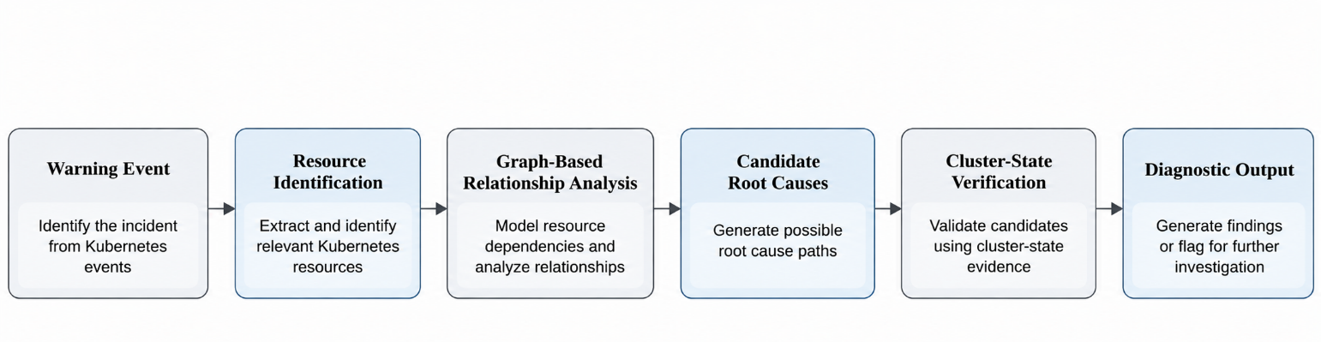

Fig 4: Resource Relationship Analysis Workflow
Fig. 4 illustrates how KubeMind AI analyzes Kubernetes resource dependencies to generate candidate root causes and verify them using available cluster-state evidence.

KubeMind AI graph-based analysis starts with a Kubernetes warning event and discovers related resources for investigation. The system identifies potential root causes by looking at the relationships between these resources and then verifies them against evidence available from the cluster state. The results of the verification are used to generate diagnostic findings or, if the evidence is not sufficient, the case is flagged for further investigation.

Table 7: Graph-Based Analysis Stages

Stage | Description
Input | Kubernetes warning event
Resource Identification | Identify relevant Kubernetes resources
Graph Construction | Represent relationships between resources
Relationship Analysis | Examine dependencies and generate candidate paths
State Verification | Validate candidate causes against available cluster-state evidence
Diagnostic Output | Generate findings or flag cases for further investigation
Table 7 summarizes the graph-based analysis process, showing how KubeMind AI moves from incident identification to resource relationship analysis and evidence-based verification.

Evidence-Based Root Cause Verification
KubeMind AI uses an evidence-based verification process to evaluate the potential root causes identified in the graph-based resource analysis. The system uses available information about the state of the Kubernetes cluster to determine whether the candidate causes are supported by observable evidence. The diagnostic results are then presented using a report generation module. A report quality checker is used to identify cases that require further investigation. The process aims at reducing unsupported conclusions by propagating root cause analysis to the available cluster-state evidence. The overall verification process is illustrated in Figure 5.
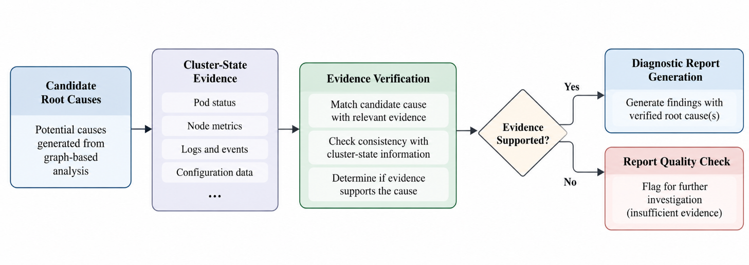

Fig 5: Root Cause Verification
Fig. 5 illustrates how KubeMind AI evaluates candidate root causes against available cluster-state evidence before producing diagnostic findings or flagging cases for further investigation.

Let $C=\{c_{1},c_{2},…,c_{n}\}$ represent the candidate root causes generated through graph-based analysis and let E denote the available Kubernetes cluster-state evidence. The verification process examines each candidate against the relevant evidence to determine whether it is supported.

The verification process can be represented as:
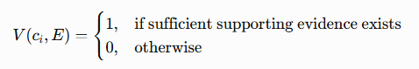

Here, $c_{i}$ represents a candidate root cause, E represents the available evidence, and V denotes the verification outcome. A verified candidate can be included in the diagnostic findings, while insufficient evidence may trigger further investigation.
The report quality checker subsequently evaluates the generated report and identifies cases requiring additional investigation. Optional LLM assistance may support selected stages, but verification should remain grounded in available evidence.

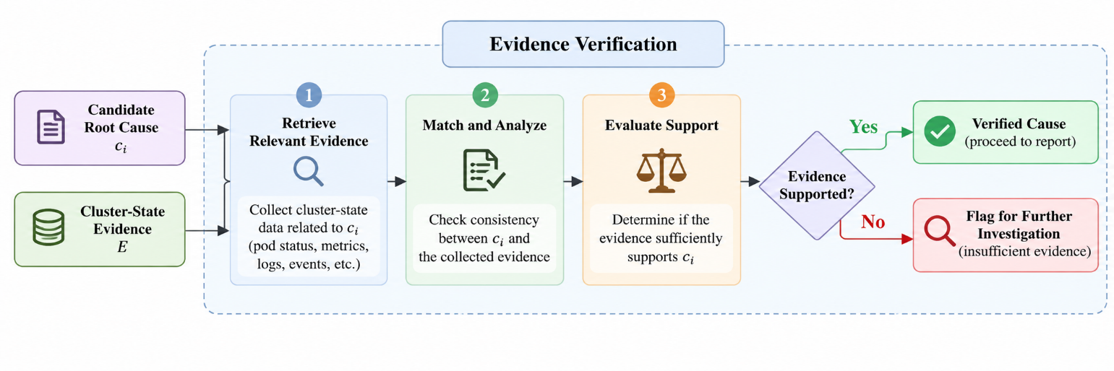

Fig 6: Verification process of Evidences
Fig. 6 illustrates the evidence verification process in KubeMind AI. Candidate root causes are checked against available cluster-state evidence to determine whether sufficient support exists. Verified causes proceed to diagnostic report generation while cases with insufficient evidence are flagged for further investigation.

Diagnostic Report Generation
KubeMind AI produces diagnostic reports that include incident data, candidate root causes and evidence from the cluster state available. The report generation module summarizes the identified causes, evidences supporting the causes and recommended actions. The output is then passed to a report quality checker who flags cases for further investigation. Optionally, the system can be assisted by LLMs to generate reports. The system is focused on finding evidence not unfounded conclusions.
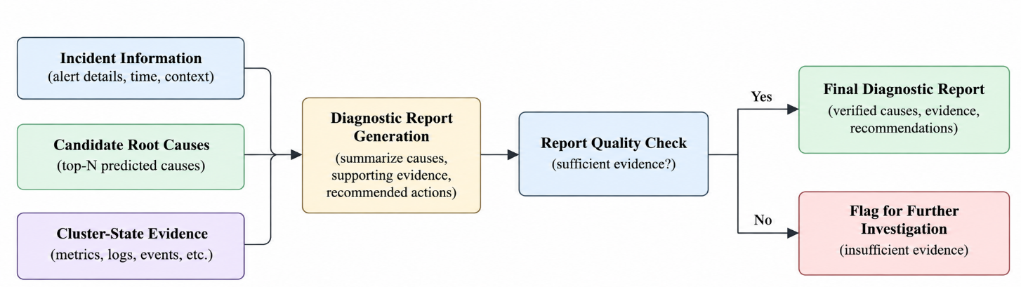

Fig 7: Report generation Diagnosis

LLM-Assisted Investigation
KubeMind is able to optionally use Large Language Model (LLM) assistance to help with diagnostic analysis and report generation during incident investigation. LLM can assist in understanding incident context and provide findings in clear, structured format. But its help is no substitute for cluster-state verification or graph-based resource analysis. Based on available evidence, the system supports diagnostic conclusions and raises an alarm if the evidence is not sufficient for further investigation. The LLM assistance is optional, the framework can work without model calls using its rule-based workflow.

Experimental Setup
We assess KubeMind AI by executing automated tests and curated Kubernetes incident scenarios. The evaluation emphasizes the graph-based resource analysis, cluster-state verification, diagnostic report generation and optional LLM assistance of the framework. The rule-based workflow is also tested in isolation without invoking the LLM to evaluate its ability to handle incidents and generate diagnostic results. A summary of the experimental set up is shown in Table 8.

Table 8: Experimental Configuration

Setting | Description
Monitoring Input | Supported Kubernetes warning events
Resource Analysis | Graph-based resource relationships
Verification | Checks candidate causes against available cluster-state evidence
Workflow | StateGraph-based diagnostic pipeline
LLM Assistance | Optional
Report Generation | Diagnostic findings and supporting evidence
Evaluation Method | Automated tests and curated incident scenarios
Automated Test Results | 16/16 tests passed
Table 8 summarizes the configuration and evaluation approach of KubeMind AI. The framework combines graph-based investigation and evidence verification with optional LLM assistance to support Kubernetes root cause analysis.

Results and Discussion

Per-Case Incident Diagnosis Results
We evaluated KubeMind AI on a set of Kubernetes incident scenarios to examine its root cause identification and verification capabilities. The results include correctly diagnosed incidents, correctly flagged cases for further investigation and a small number of missed diagnoses. The evaluation also contains incident scenarios not seen before and in order to test the behavior of the framework in situations other than the familiar ones. The individual results of the gated LLM evaluation are shown in Table 9.

Table 9: Gated LLM Evaluation

Column | Description
Case | Kubernetes incident scenario
Expected | Expected root cause or unknown
Got | Root cause identified
Status | Final diagnostic status
Outcome | Whether the result was correct, appropriately unknown, or missed
Table 9 gives the per-case evaluation shows that KubeMind AI correctly identifies several Kubernetes resource issues, while cases with insufficient evidence are flagged for further investigation. A few unseen scenarios remain challenging, highlighting opportunities to improve root cause identification and handling of unfamiliar incidents.

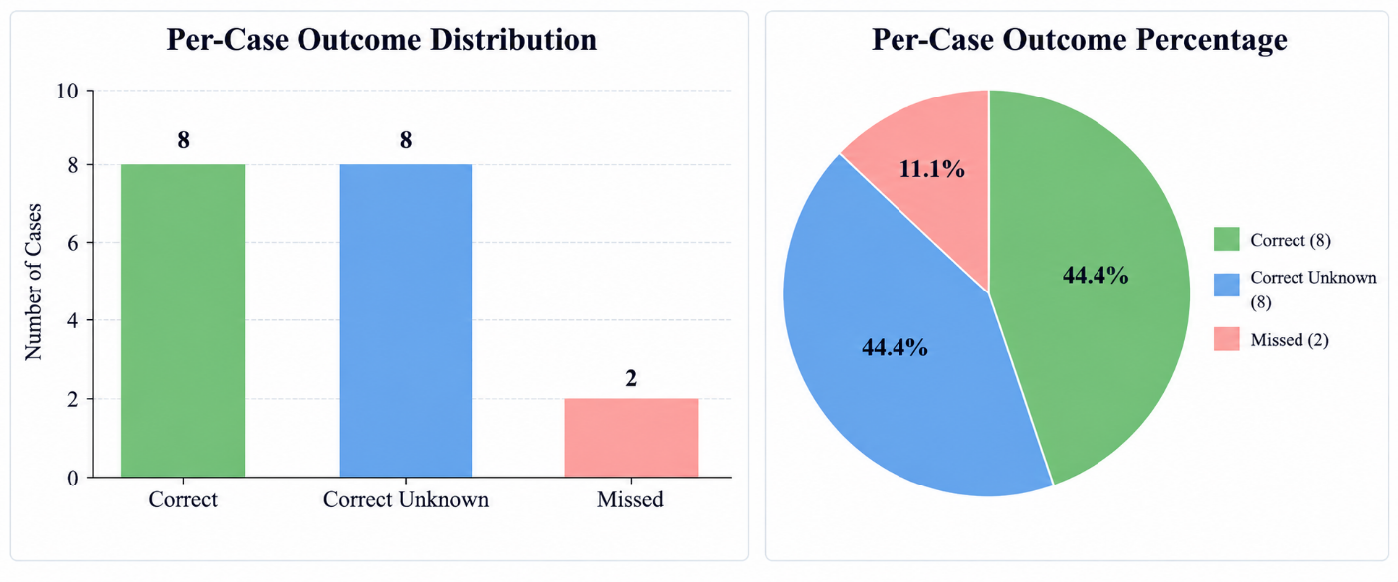

Fig 6: Outcomes of Kubernetes Incidents

The charts summarize the outcomes of 18 Kubernetes incident scenarios evaluated by KubeMind AI. Eight cases were correctly diagnosed, eight were appropriately flagged for further investigation and two resulted in missed diagnoses. Thus, 44.4% of cases fell into each of the first two categories, while 11.1% were missed. These results highlight the framework’s ability to identify root causes and recognize uncertainty while indicating opportunities to improve diagnosis of unfamiliar incidents.

Summary of Incident Outcomes
The incident outcome summary shows that KubeMind AI successfully identifies several expected root causes and appropriately flags many cases with insufficient evidence for further investigation. However, some unseen scenarios result in missed diagnoses, highlighting limitations in handling unfamiliar incidents. These findings demonstrate the importance of evidence-based verification while identifying opportunities to improve the framework’s diagnostic coverage and reliability.

Table 10: Different Categories of Outcome
Outcome Category | Interpretation
Correct | The identified root cause matches the expected cause.
Correct unknown | The system appropriately requests further investigation when the expected cause is unknown.
Missed | The system does not identify the expected root cause.

The results suggest that combining graph-based analysis with evidence verification helps KubeMind AI distinguish supported diagnoses from uncertain cases. Further testing on diverse and unseen Kubernetes incidents could improve diagnostic coverage and strengthen the framework’s reliability.

Table 11: Outcomes of Gated LLM Evaluation

Case | Expected | Got | Status | Outcome
quota-demo | ResourceQuota | ResourceQuota | DIAGNOSED | correct
quota-team-a-3of3 | ResourceQuota | ResourceQuota | DIAGNOSED | correct
quota-team-b-2of2 | ResourceQuota | ResourceQuota | DIAGNOSED | correct
quota-not-full-stale-event | unknown | Namespace | NEEDS_REVIEW | correct_unknown
pvc-pending | PersistentVolumeClaim | PersistentVolumeClaim | DIAGNOSED | correct
pvc-bound-stale-event | unknown | PersistentVolumeClaim | NEEDS_REVIEW | correct_unknown
configmap-missing | ConfigMap | ConfigMap | DIAGNOSED | correct
secret-missing | Secret | Secret | DIAGNOSED | correct
node-disk-pressure | Node | Node | DIAGNOSED | correct
node-healthy-evicted | unknown | Node | NEEDS_REVIEW | correct_unknown
image-bad-tag | Image | Image | DIAGNOSED | correct
image-error-no-state | unknown | Image | NEEDS_REVIEW | correct_unknown
crashloop-exit-1 | unknown | Namespace | NEEDS_REVIEW | correct_unknown
scheduling-insufficient-memory | unknown | Namespace | NEEDS_REVIEW | correct_unknown
unseen-service-account-missing | ServiceAccount | Namespace | NEEDS_REVIEW | missed
unseen-namespace-terminating | Namespace | Namespace | NEEDS_REVIEW | missed
unseen-storageclass-missing | StorageClass | StorageClass | DIAGNOSED | correct
unseen-liveness-probe-failed | unknown | Image | NEEDS_REVIEW | correct_unknown
unseen-insufficient-cpu | unknown | Namespace | NEEDS_REVIEW | correct_unknown
unseen-memory-quota-full | ResourceQuota | ResourceQuota | DIAGNOSED | correct
Table 11 shows KubeMind AI’s diagnostic results on 20 Kubernetes incident scenarios. The framework correctly detects several expected root causes, and flags cases with uncertain diagnoses for further investigation. However, two missed diagnoses are due to two unseen scenarios, which demonstrate the difficulties of handling unfamiliar incidents. The results show that the framework is able to do evidence-based diagnosis, and also point to places where the diagnostic accuracy and generalizability could be improved.

Comparison with Related Studies
Table 12 compares KubeMind AI with previously published research on Kubernetes root cause analysis and LLM-assisted incident diagnosis. The comparison considers the methods used, evaluation environments and reported results. Since these studies use different datasets and evaluation criteria, their results should not be interpreted as a direct performance ranking.

Table 12: Comparison with related Studies

Study | Method | Data / Evaluation | Reported Results
Xiang et al. [11] : SynergyRCA (2025) | LLM, StateGraph, MetaGraph, graph-based retrieval | Two production Kubernetes clusters | Approximately 0.88 to 0.92 root cause precision; around 2 minutes per diagnosis
Chen et al. [12] : RCACopilot (2024) | LLM-based incident analysis and runtime diagnostic information collection | Real-world Microsoft cloud incidents | Root cause analysis accuracy up to 0.766
Kuvshinova and Jin [13] : Graph Traversal Agent (2026) | Graph-guided LLM reasoning with evidence collection and verdict validation | ITBench OpenTelemetry incident snapshots | Root-cause F1 of 0.9130 on a 23 scenario subset; results are benchmark-specific
This work : KubeMind AI | Graph-based resource analysis, cluster-state verification, StateGraph workflow, optional LLM assistance | 20 curated Kubernetes incident scenarios | 10 correct diagnoses, 8 correctly flagged unknown cases, and 2 missed diagnoses

Previous works show the effectiveness of graph-based reasoning and LLMs for root-cause identification in complex cloud environments. SynergyRCA integrates graph databases and LLM reasoning, while RCACopilot aims at automatic diagnosis from runtime information. Graph Traversal Agent further improves independent verification and evidence collection. KubeMind AI employs a similar approach by integrating graph-based resource analysis, cluster-state verification and optional LLM assistance in a lightweight diagnostic workflow. It generated 10 correct diagnoses, correctly pinpointed 8 cases with unknown expected causes, and missed 2 cases across its 20 curated scenarios. The early findings emphasize the importance of evidence-based diagnosis while indicating the need for broader evaluation.

Comparative Analysis of Diagnosis Performance of different Configurations
Table 13 compares three different KubeMind AI configurations: Rules Only, LLM without Gate, and LLM with Gate. The comparison is done based on precision, recall, treatment of unknown cases, confident wrong answers, missed diagnosable cases, LLM calls, and average execution time per case.

The Rules Only configuration achieved a precision of 1.00 without any LLM calls, but missed three diagnosable cases. The LLM without Gate configuration achieved the highest recall of 0.92, but its precision was 0.55, with nine confident wrong answers. Conversely, the LLM with Gate configuration achieved a precision of 1.00, correctly handled all the eight unknown cases and reduced missed diagnosable cases to two. The gated configuration, however, required 141 LLM calls and an average of 17.9 seconds per case. These results highlight the trade-off between diagnostic coverage, reliability and computational cost. Overall, the results suggest that evidence-based gating is able to avoid unsupported diagnoses while maintaining high precision in the evaluated scenarios.

Table 13: Performance Comparisons

Metric | Rules Only | LLM, No Gate | LLM with Gate
Precision | 1.00 | 0.55 | 1.00
Recall (of 12 diagnosable cases) | 0.75 | 0.92 | 0.83
Unknown Cases Handled Correctly (of 8) | 1.00 | 0.00 | 1.00
Confident Wrong Answers | 0 | 9 | 0
Missed Diagnosable Cases | 3 | 0 | 2
LLM Calls | 0 | 117 | 141
Average Time per Case | 0.0 s | 15.1 s | 17.9 s

Future Enhancements
In the future, we will enhance the diagnostic accuracy, reliability, scalability and interpretability of KubeMind AI. The graph-based resource analysis can be extended to support a broader set of Kubernetes incidents and complex resource dependencies. The state verification mechanism can be improved to better identify root causes and reduce missed diagnoses. Further evaluation with different incident scenarios and larger Kubernetes clusters will be performed to evaluate the effectiveness of the framework under different operating conditions.
The optional integration of the Large Language Model (LLM) can be improved for better diagnostic explanations and report generation, while keeping the evidence-based verification intact. Further evaluation across different configurations and random seeds can provide insight on the consistency of diagnostic results. The framework can be further extended to include historical incident information thus enabling comparisons with previously experienced failures. Finally, explainable diagnostic reports, confidence indicators and an improved dashboard can help users understand root causes identified and actions recommended. Future versions may also explore controlled remediation mechanisms whereby changes to a Kubernetes cluster are only performed after validation and human approval.

Conclusion
KubeMind AI is a lightweight intelligent Kubernetes monitoring and root cause analysis framework to assist in identifying potential causes of cluster incidents. It combines graph-based resource analysis, cluster-state verification and optional Large Language Model (LLM) assistance to generate evidence-based diagnostic reports. The evaluation on 20 curated incident scenarios resulted in 10 correct diagnoses, 8 correct cases to further investigate and 2 missed diagnoses. The comparison of different configurations also shows the value of evidence based verification to avoid unsupported diagnostic conclusions. Further improvements will be focused on improving the coverage of incidents, improving the accuracy of the diagnosis, and evaluating the framework on larger and more diverse Kubernetes environments. Overall, KubeMind AI provides a foundation for explainable and evidence-driven Kubernetes incident diagnosis.
KubeMind AI also stresses the need to combine automated analysis with evidence-based verification to enhance the reliability of Kubernetes incident diagnosis. The framework aims to provide more transparent and interpretable diagnostic results by analyzing resource relations and validating possible root causes against available cluster-state information. The optional LLM integration offers the opportunity to generate structured explanations, and the report quality checker detects cases requiring further investigation. Historical incident analysis, diagnostic coverage and controlled remediation for KubeMind AI could evolve to enable faster troubleshooting and more effective management of the Kubernetes cluster.

Declarations

Declaration of competing interest
The authors declare that they have no known competing financial interests or personal relationships that could have appeared to influence the work reported in this paper.

Data availability
This framework was evaluated using curated Kubernetes incident scenarios and automated tests. The evaluation scenarios and relevant implementation details may be made available upon reasonable request, subject to the availability of the project materials.

Code availability
The code and supporting resources for this study are on GitHub:
https://github.com/akshayboffic/kubemind-ai

References
- Burns, B., Grant, B., Oppenheimer, D., Brewer, E., & Wilkes, J. (2016). Borg, Omega, and Kubernetes. ACM Queue, 14(1), 70–93. https://doi.org/10.1145/2898442.2898444
- Verma, A., Pedrosa, L., Korupolu, M., Oppenheimer, D., Tune, E., & Wilkes, J. (2015). Large-scale cluster management at Google with Borg. Proceedings of the 10th European Conference on Computer Systems (EuroSys 2015), Article 18. https://doi.org/10.1145/2741948.2741964
- Xiang, Y., Chen, C. P., Zeng, L., Yin, W., Liu, X., Li, H., & Xu, W. (2025). Simplifying root cause analysis in Kubernetes with StateGraph and LLM. arXiv preprint arXiv:2506.02490. https://doi.org/10.48550/arXiv.2506.02490
- Chen, Y., Xie, H., Ma, M., Kang, Y., Gao, X., Shi, L., et al. (2024). Automatic root cause analysis via large language models for cloud incidents. Proceedings of the 19th European Conference on Computer Systems (EuroSys 2024), 674–688. https://doi.org/10.1145/3627703.3629553
- Kuvshinova, A., & Jin, S. (2026). Auditable graph-guided root cause analysis for Kubernetes incidents. arXiv preprint arXiv:2606.08590. https://doi.org/10.48550/arXiv.2606.08590
- Angles, R., & Gutierrez, C. (2008). Survey of graph database models. ACM Computing Surveys, 40(1), Article 1. https://doi.org/10.1145/1322432.1322433
- Hogan, A., Blomqvist, E., Cochez, M., d’Amato, C., de Melo, G., Gutierrez, C., et al. (2021). Knowledge graphs. ACM Computing Surveys, 54(4), Article 71. https://doi.org/10.1145/3447772
- Lewis, P., Perez, E., Piktus, A., Petroni, F., Karpukhin, V., Goyal, N., et al. (2020). Retrieval-augmented generation for knowledge-intensive NLP tasks. Advances in Neural Information Processing Systems, 33, 9459–9474. https://arxiv.org/abs/2005.11401
- Yao, S., Zhao, J., Yu, D., Du, N., Shafran, I., Narasimhan, K., & Cao, Y. (2023). ReAct: Synergizing reasoning and acting in language models. International Conference on Learning Representations (ICLR 2023). https://arxiv.org/abs/2210.03629
- Schick, T., Dwivedi-Yu, J., Dessì, R., Raileanu, R., Lomeli, M., Zettlemoyer, L., et al. (2023). Toolformer: Language models can teach themselves to use tools. Advances in Neural Information Processing Systems, 36. https://arxiv.org/abs/2302.04761
- Brown, T. B., Mann, B., Ryder, N., Subbiah, M., Kaplan, J., Dhariwal, P., et al. (2020). Language models are few-shot learners. Advances in Neural Information Processing Systems, 33, 1877–1901. https://arxiv.org/abs/2005.14165
- Wei, J., Wang, X., Schuurmans, D., Bosma, M., Ichter, B., Xia, F., et al. (2022). Chain-of-thought prompting elicits reasoning in large language models. Advances in Neural Information Processing Systems, 35. https://arxiv.org/abs/2201.11903
- Vaswani, A., Shazeer, N., Parmar, N., Uszkoreit, J., Jones, L., Gomez, A. N., et al. (2017). Attention is all you need. Advances in Neural Information Processing Systems, 30, 5998–6008. https://arxiv.org/abs/1706.03762
- Devlin, J., Chang, M.-W., Lee, K., & Toutanova, K. (2019). BERT: Pre-training of deep bidirectional transformers for language understanding. Proceedings of the 2019 Conference of the North American Chapter of the Association for Computational Linguistics: Human Language Technologies, 4171–4186. https://doi.org/10.18653/v1/N19-1423
- Liu, Y., Ott, M., Goyal, N., Du, J., Joshi, M., Chen, D., et al. (2019). RoBERTa: A robustly optimized BERT pretraining approach. arXiv preprint arXiv:1907.11692. https://doi.org/10.48550/arXiv.1907.11692
- Xiang, W., Zhang, H., and colleagues. (2023). [Verify bibliographic details before citing any specific paper on multi-agent LLM orchestration.]
- Wooldridge, M. (2009). An Introduction to MultiAgent Systems (2nd ed.). John Wiley & Sons.
- Jennings, N. R. (2000). On agent-based software engineering. Artificial Intelligence, 117(2), 277–296. https://doi.org/10.1016/S0004-3702(99)00107-1
- Dorri, A., Kanhere, S. S., & Jurdak, R. (2018). Multi-agent systems: A survey. IEEE Access, 6, 28573–28593. https://doi.org/10.1109/ACCESS.2018.2831228
- Dean, J., & Barroso, L. A. (2013). The tail at scale. Communications of the ACM, 56(2), 74–80. https://doi.org/10.1145/2408776.2408794
- Barham, P., Donnelly, A., Isaacs, R., & Mortier, R. (2004). Using Magpie for request extraction and workload modelling. Proceedings of the 6th USENIX Symposium on Operating Systems Design and Implementation (OSDI 2004), 259–272. https://www.usenix.org/legacy/events/osdi04/tech/barham.html
- Sigelman, B. H., Barroso, L. A., Burrows, M., Stephenson, P., Plakal, M., Beaver, D., et al. (2010). Dapper, a large-scale distributed systems tracing infrastructure. Google Research. https://research.google/pubs/dapper-a-large-scale-distributed-systems-tracing-infrastructure/
- Beyer, B., Jones, C., Petoff, J., & Murphy, N. R. (Eds.). (2016). Site Reliability Engineering: How Google Runs Production Systems. O’Reilly Media. https://sre.google/sre-book/table-of-contents/
- Beyer, B., Murphy, N. R., Rensin, D. K., Kawahara, K., & Thorne, S. (Eds.). (2018). The Site Reliability Workbook: Practical Ways to Implement SRE. O’Reilly Media. https://sre.google/workbook/table-of-contents/
- Kubernetes Authors. (n.d.). Kubernetes documentation: Monitoring, logging, and debugging. Kubernetes Official Documentation. https://kubernetes.io/docs/tasks/debug/
- Kubernetes Authors. (n.d.). Kubernetes documentation: Observability. Kubernetes Official Documentation. https://kubernetes.io/docs/concepts/cluster-administration/observability/
- Prometheus Authors. (n.d.). Prometheus documentation. https://prometheus.io/docs/introduction/overview/
- Grafana Labs. (n.d.). Grafana documentation. https://grafana.com/docs/grafana/latest/
- LangChain. (n.d.). LangGraph documentation. https://docs.langchain.com/oss/python/langgraph/overview
- OpenTelemetry Authors. (n.d.). OpenTelemetry documentation. https://opentelemetry.io/docs/

