Remove Duplicate:
if len(c) == 1 : return 0
if len(c) == 2: return 0 if c[1]==1 else 1
if c[2]==1:
return 1 + jumpingOnClouds(c[1:])
if c[2]==0:
return 1 + jumpingOnClouds(c[2:])

var jumps = 0;
for(int i=0; i<n-1; i++, jumps++)
if (i+2 < n && c[i+2] == 0)
i++;

Console.WriteLine(jumps)

import sys

def countingValleys(n, steps):
seaLevel = valley = 0

for step in steps:
if step == 'U':
seaLevel += 1
else:
seaLevel -= 1

if step == 'U' and seaLevel == 0:
valley += 1

return valley

static int countingValleys(int n, String s) {

int valleyCounter = 0, altitude = 0;

for (int i = 0; i < n; i++) {
char ch = s.charAt(i);
if (ch == 'U') {
altitude++;
if (altitude == 0) {
valleyCounter++;
}

} else {

altitude--;
}
}
return valleyCounter;
}

static int sockMerchant(int n, int[] ar) {

HashSet<Integer> set = new HashSet<Integer>();
int count = 0;
for(int i =0;i<n;i++){
if(set.contains(ar[i])){
set.remove(ar[i]);
count++;
}
else {
set.add(ar[i]);
}
}
return count;

}

// Traverse through the first list
for (T element : list) {

// If this element is not present in newList
// then add it
if (!newList.contains(element)) {

newList.add(element);
}
}

// return the new list
return newList;
Or Create a LinkedHashSet from this ArrayList. This will remove the duplicates
// Create a new LinkedHashSet
Set<T> set = new LinkedHashSet<>();

// Add the elements to set
set.addAll(list);

// Clear the list
list.clear();

// add the elements of set
// with no duplicates to the list
list.addAll(set);

// return the list
return list;

Arrays.sort(inputList, String.CASE_INSENSITIVE_ORDER);

invert Number - Write A Function To Reverse A Number

while (number != 0) {
invert = (invert * 10) + (number % 10);
number = number / 10;
}
return invert;

Check Whether a Number is Prime or Not
because no number is divisible by more than its half.

To Find Out The First Two Max Values From An Array

public class findTwoMaxValue {
public void GetTwoMaxValues(int[] nums) {

int maxOne = 0;
int maxTwo = 0;
for (int n : nums) {
if (maxOne < n) {
maxTwo = maxOne;
maxOne = n;
} else if (maxTwo < n) {
maxTwo = n;
}

}

System.out.println("Max1 - " + maxOne);
System.out.println("Max2 - " + maxTwo);
}

Find The Longest Substring From A Given String Which Doesn’t Contain Any Duplicate Characters
import java.util.HashSet;

public class SubString {
public static String subString(String input){

HashSet<Character> set = new HashSet<Character>();

String longestOverAll = "";
String longestTillNow = "";

for (int i = 0; i < input.length(); i++) {
char c = input.charAt(i);

if (set.contains(c)) {
longestTillNow = "";
set.clear();
}
longestTillNow += c;
set.add(c);
if (longestTillNow.length() > longestOverAll.length()) {
longestOverAll = longestTillNow;
}
}

return longestOverAll;
}

public static void main(String[] args) {
String input = "substringfindout";
System.out.println(subString(input));
}
}

- You are going to need a start and an end locator(/pointer) for the string and an array where you store information for each character: did it occour at least once?
- Start at the beginning of the string, both locators point to the start of the string.
- Move the end locator to the right till you find a repetition (or reach the end of the string). For each processed character, store it in the array. When stopped store the position if this is the largest substring. Also remember the repeated character.
- Now do the same thing with the start locator, when processing each character, remove its flags from the array. Move the locator till you find the earlier occurrence of the repeated character.
- Go back to step 3 if you haven't reached the end of string.

Get Rid of Multiple Spaces from A String
public class removeExtraSpaces {

public static void main(String args[]){

String input = "Try to remove extra spaces.";
StringTokenizer substr = new StringTokenizer(input, " ");
StringBuffer sb = new StringBuffer();

while(substr.hasMoreElements()){
sb.append(substr.nextElement()).append(" ");
}

System.out.println("Actual string: " + input);
System.out.println("Processed string: " + sb.toString().trim());
}
}

String Reverse With And Without StringBuffer Class
public String invertWithStringBuffer(String str) {

StringBuffer buffer = new StringBuffer(str);
buffer.reverse();
return buffer.toString();
}

public String invertWithoutStringBuffer(String str) {

int length = str.length();
String original = str;
String invert = "";
for (int i = length - 1; i >= 0; i--) {
invert = invert + original.charAt(i);
}
return invert;
}

- Reverse
- internal static void ReverseString(string str)
- {

- char[] charArray = str.ToCharArray();
- for (int i = 0, j = str.Length - 1; i < j; i++, j--)
- {
- charArray[i] = str[j];
- charArray[j] = str[i];
- }
- string reversedstring = new string(charArray);
- Console.WriteLine(reversedstring);
- }

1. 2. internal static void chkPalindrome(string str)
2. {
3. bool flag = false;
4. for (int i = 0, j = str.Length - 1; i < str.Length / 2; i++, j--)
5. {
6. if (str[i] != str[j])
7. {
8. flag = false;
9. break;
10. }
11. else
12. flag = true;
13. }
14. if (flag)
15. {
16. Console.WriteLine("Palindrome");
17. }
18. else
19. Console.WriteLine("Not Palindrome");
20. }

def swap_case(s):
result = ""
for i in s:
if i.isupper():
result += i.lower()
else:
result += i.upper()
return result

def mutate_string(string, position, character):
return string[:position] + character + string[position+1:]

def count_substring(string, sub_string):

return(sum([1 for i in range(0, len(string) - len(sub_string) + 1)
if (string[i:(len(sub_string)+i)] == sub_string)]))

count = 0
for i in range(0,len(string)):
if string[i:].find(sub_string)!= -1:
i = string[i:].find(sub_string)
print("i: ",i)
count +=1

# wrong code
return count

if __name__ == '__main__':
s = input()
print(any(c.isalnum() for c in s))
print(any(c.isalpha() for c in s))
print(any(c.isdigit() for c in s))
print(any(c.islower() for c in s))
print(any(c.isupper() for c in s))

for ct in ['isalnum()','isalpha()','isdigit()','islower()','isupper()']:
print(any(eval("c."+ct) for c in s))

textwrap.wrap(string,8)
def wrap(string, max_width):
return textwrap.fill(string, max_width)

------------.|.------------
---------.|..|..|.---------
------.|..|..|..|..|.------
---.|..|..|..|..|..|..|.---
----------WELCOME----------
---.|..|..|..|..|..|..|.---
------.|..|..|..|..|.------
---------.|..|..|.---------
------------.|.------------

n, m = map(int,input().split())
pattern = [('.|.'*(2*i + 1)).center(m, '-') for i in range(n//2)]
print('\n'.join(pattern + ['WELCOME'.center(m, '-')] + pattern[::-1]))

def print_formatted(number):
# your code goes here
#l = [[str(i), str(oct(i)[2:]) , str(hex(i)[2:]).upper(), str(bin(i)[2:] for i in range(number)]
#print (l)
#string = ['str(i)','str(oct(i)[2:])','str(hex(i)[2:]).upper()','str(bin(i)[2:]']
#l = [list(x) for i in string eval(string[i])]
#l=[]
#for i in string:
#l.append(eval(string[i]))
#print(l)
#return l

width = len("{0:b}".format(number))
for i in range(1,n+1):
print("{0:{width}d} {0:{width}o} {0:{width}X} {0:{width}b}".format(i,width=width))

if __name__ == '__main__':
n = int(input())
print_formatted(n)

https://www.geeksforgeeks.org/python-format-function/

import string
alpha = string.ascii_lowercase

n = int(input())
L = []
for i in range(n):
s = "-".join(alpha[i:n])
L.append((s[::-1]+s[1:]).center(4*n-3, "-"))
print('\n'.join(L[:0:-1]+L))

def print_rangoli(size):
myStr = 'abcdefghijklmnopqrstuvwxyz'[0:size]

for i in range(size-1, -size, -1):
x = abs(i)
if x >= 0:
line = myStr[size:x:-1]+myStr[x:size]
print ("--"*x+ '-'.join(line)+"--"*x)
import string

size = int(input())
alphabet = string.ascii_lowercase

for i in range(size - 1, 0, -1):
row = ["-"] * (size * 2 - 1)
for j in range(0, size - i):
row[size - 1 - j] = alphabet[j + i]
row[size - 1 + j] = alphabet[j + i]
print("-".join(row))

for i in range(0, size):
row = ["-"] * (size * 2 - 1)
for j in range(0, size - i):
row[size - 1 - j] = alphabet[j + i]
row[size - 1 + j] = alphabet[j + i]
print("-".join(row))

def print_rangoli(size):
# your code goes here

alpha = 'abcdefghijklmnopqrstuvwxyz'[0:size]
L = []
for i in range(size):
s = "-".join(alpha[i:size])
L.append((s[::-1]+s[1:]).center(4*size-3, "-"))
print('\n'.join(L[:0:-1]+L))

if __name__ == '__main__':

• --------e--------
• ------e-d-e------
• ----e-d-c-d-e----
• --e-d-c-b-c-d-e--
• e-d-c-b-a-b-c-d-e
• --e-d-c-b-c-d-e--
• ----e-d-c-d-e----
• ------e-d-e------
• --------e--------
•
#!/bin/python3

import math
import os
import random
import re
import sys

# Complete the solve function below.
def solve(s):
k = s.split()
l = [x.capitalize() for x in k]
return " ".join(l)

if __name__ == '__main__':
fptr = open(os.environ['OUTPUT_PATH'], 'w')

s = input()

result = solve(s)

fptr.write(result + '\n')

fptr.close()

' '.join(map(str.capitalize, string.split(' ')))

#wrong
def minion_game(string):
ACount = 0
Bcount = 0

for i in range(0,len(string)):
k = string.count(string[:i])

print(string[:i])
if string[i] in ('A','E','I','O','U'):
ACount =+ k
else:
Bcount =+ k

print(ACount,Bcount)

if __name__ == '__main__':

def minion_game(s):
# your code goes here
vowels = 'AEIOU'

kevsc = 0
stusc = 0
for i in range(len(s)):
if s[i] in vowels:
kevsc += (len(s)-i)
else:
stusc += (len(s)-i)

if kevsc > stusc:
print("Kevin", kevsc)
elif kevsc < stusc:
print("Stuart", stusc)
else:
print("Draw")

if __name__ == '__main__':
s = input()
minion_game(s)

def merge_the_tools(string, k):
# your code goes here
while string:
s = string[0:k]
seen = ''
for c in s:
if c not in seen:
seen += c
print(seen)
string = string[k:]

n = int(input())
s = set(map(int, input().split()))

for _ in range(int(input())):
p = input().split()
if p[0] == "pop":
s.pop()
elif p[0] == "remove":
s.remove(int(p[1]))
elif p[0] == "discard":
s.discard(int(p[1]))

print(sum(s))

n = int(input())
s = set(map(int, input().split()))
N = int(input())
for _ in range(N):
command = input().split()
cmd = command[0]
args = ""
if len(command)>1 :
args = command[1]
eval("s."+cmd+"("+args+")")
print(sum(s))

https://github.com/marinskiy/HackerrankPractice
n1 = input()
a = set(map(int,input().split()))
n2 = input()
b = set(map(int,input().split()))

print(len(a | b))
n1 = input()
a = set(map(int,input().split()))
n2 = input()
b = set(map(int,input().split()))

print(len(a.union(b)))

>>> s = set("Hacker")
>>> print s.union("Rank")
set(['a', 'R', 'c', 'r', 'e', 'H', 'k', 'n'])

>>> print s.union(set(['R', 'a', 'n', 'k']))
set(['a', 'R', 'c', 'r', 'e', 'H', 'k', 'n'])

>>> print s.union(['R', 'a', 'n', 'k'])
set(['a', 'R', 'c', 'r', 'e', 'H', 'k', 'n'])

>>> print s.union(enumerate(['R', 'a', 'n', 'k']))
set(['a', 'c', 'r', 'e', (1, 'a'), (2, 'n'), 'H', 'k', (3, 'k'), (0, 'R')])

>>> print s.union({"Rank":1})
set(['a', 'c', 'r', 'e', 'H', 'k', 'Rank'])

>>> s | set("Rank")
set(['a', 'R', 'c', 'r', 'e', 'H', 'k', 'n'])

>>> s = set("Hacker")
>>> print s.intersection("Rank")
set(['a', 'k'])

>>> print s.intersection(set(['R', 'a', 'n', 'k']))
set(['a', 'k'])

>>> print s.intersection(['R', 'a', 'n', 'k'])
set(['a', 'k'])

>>> print s.intersection(enumerate(['R', 'a', 'n', 'k']))
set([])

>>> print s.intersection({"Rank":1})
set([])

>>> s & set("Rank")
set(['a', 'k'])

Set .symmetric_difference() Operation

Your task is to find the total number of students who have subscribed to either the English or the French newspaper but not both

# Enter your code here. Read input from STDIN. Print output to STDOUT
from itertools import product

A = list(map(int,input().split()))
B = list(map(int, input().split()))
print(*(product(A,B)))

# Enter your code here. Read input from STDIN. Print output to STDOUT
from itertools import permutations

A,B = input().split()

#print(*[''.join(i) for i in permutations(sorted(A),int(B))],sep='\n')

#l = ''.join(permutations(sorted(A),int(B)))
#print(l)
#print(*l, sep = "\n")

permutations = sorted(list(permutations(A, int(B))))

[print("".join(i)) for i in permutations]

# Enter your code here. Read input from STDIN. Print output to STDOUT
from itertools import combinations

A, B = input().split()

#mine
#for i in range(1, int(n)+1):
#for j in combinations(sorted(s), i):
#print ''.join(j)

#for i in range(1, int(B)+1):
# p = sorted(list(combinations(A, int(B))))
#[print("".join(i)) for i in p]

print("\n".join([(''.join(p)) for i in range(1,int(B)+1) for p in combinations(sorted(A), i)]))

import collections

numShoes = int(raw_input())
shoes = collections.Counter(map(int, raw_input().split()))
numCust = int(raw_input())

income = 0

for i in range(numCust):
size, price = map(int, raw_input().split())
if shoes[size]:
income += price
shoes[size] -= 1

print income

SELECT DISTINCT city FROM station WHERE city REGEXP "^[aeiou].*";

7 //Write a method to replace all spaces in a string with '%20'
public static class ReplaceSpace
{
public static string Replace(string s)
{
s = s.Trim();
s = s.Replace(" ", "%20");
return s;
}
}

8 class Program
{
static void Main()
{
string value = "rstuvwxyz";
// Avoid full length.
for (int length = 1; length < value.Length; length++)
{
// End index is tricky.
for (int start = 0; start <= value.Length - length; start++)
{
string substring = value.Substring(start, length);
Console.WriteLine(substring);
}
}
}
}

From: Akshay CA <Akshay.CA@lntinfotech.com>
Sent: Tuesday, December 3, 2019 6:27 PM
To: Akshay CA <Akshay.CA@lntinfotech.com>
Subject:

https://www.csharpstar.com/csharp-program-to-get-max-occured-character-in-a-string/

1. if (table.IndexOf(value) == -1)
{
// Append to the table and the result.
table += value;
result += value;
}

2. char[] char1 = word1.ToLower().ToCharArray();
char[] char2 = word2.ToLower().ToCharArray();

//Step 2
Array.Sort(char1);
Array.Sort(char2);

//Step 3
string NewWord1 = new string(char1);
string NewWord2 = new string(char2);

//Step 4
//ToLower allows to compare the words in same case, in this case, lower case.
//ToUpper will also do exact same thing in this context
if (NewWord1 == NewWord2)

3. public static string Reverse(string x)
{
string result = "";
for (int i = x.Length - 1; i >= 0; i--)
result += x[i];
return result;
}
4.//Count the words
foreach (string y in x.Split(' '))
result++;

return result;

5.
public static bool IsPalindrome(string word)
{
int min = 0;
int max = word.Length - 1;
while (true)
{
if (min > max)
{
return true;
}
char a = word[min];
char b = word[max];
if (char.ToLower(a) != char.ToLower(b))
{
return false;
}
min++;
max--;
}
}
6.public static char MostOccurringCharInString(string charString)
{
int mostOccurrence = -1;
char mostOccurringChar = ' ';
foreach (char currentChar in charString)
{
int foundCharOccreence = 0;
foreach (char charToBeMatch in charString)
{
if (currentChar == charToBeMatch)
foundCharOccreence++;
}
if (mostOccurrence < foundCharOccreence)
{
mostOccurrence = foundCharOccreence;
mostOccurringChar = currentChar;
}
}
return mostOccurringChar;
}

SELECT TOP 1 CITY, LEN(CITY) FROM STATION ORDER BY LEN(CITY),CITY;
SELECT TOP 1 CITY, LEN(CITY) FROM STATION ORDER BY LEN(CITY) DESC,CITY;

Nonparametric algorithm called random forests.
Random forests are an example of an ensemble method, a method that relies on aggregating the results of an ensemble of simpler estimators.
Random forests are an example of an ensemble learner built on decision trees

each node in the tree splits the data into two groups using a cutoff value within one of the features.

A simple decision tree built on this data will iteratively split the data along one or the other axis according to some quantitative criterion, and at each level assign the label of the new region according to a majority vote of points within it.
from sklearn.tree import DecisionTreeClassifier
from sklearn.ensemble import BaggingClassifier

is what underlies an ensemble method called bagging. Bagging makes use of an ensemble (a grab bag, perhaps) of parallel estimators, each of which overfits the data, and averages the results to find a better classification. An ensemble of randomized decision trees is known as a random forest.
from sklearn.ensemble import RandomForestClassifier

Random forests can also be made to work in the case of regression (that is, continuous rather than categorical variables).
from sklearn.ensemble import RandomForestRegressor

from sklearn.cross_validation import train_test_split
Xtrain, Xtest, ytrain, ytest = train_test_split(digits.data, digits.target,
random_state=0)
model = RandomForestClassifier(n_estimators=1000)
model.fit(Xtrain, ytrain)
ypred = model.predict(Xtest)

from sklearn import metrics
print(metrics.classification_report(ypred, ytest))

from sklearn.metrics import confusion_matrix
mat = confusion_matrix(ytest, ypred)
sns.heatmap(mat.T, square=True, annot=True, fmt='d', cbar=False)

The multiple trees allow for a probabilistic classification: a majority vote among estimators gives an estimate of the probability (accessed in Scikit-Learn with the predict_proba() method).

PCA is fundamentally a dimensionality reduction algorithm, but it can also be useful as a tool for visualization, for noise filtering, for feature extraction and engineering, and much more.
In principal component analysis, one quantifies this relationship by finding a list of the principal axes in the data, and using those axes to describe the dataset.
The fit learns some quantities from the data, most importantly the “components” and “explained variance”:

let’s visualize them as vectors over the input data, using the “components” to define the direction of the vector, and the “explained variance” to define the squared-length of the vector

PCA for dimensionality reduction involves zeroing out one or more of the smallest principal components, resulting in a lower-dimensional projection of the data that preserves the maximal data variance.

PCA dimensionality reduction means: the information along the least important principal axis or axes is removed, leaving only the component(s) of the data with the highest variance.

Reduction in dimension – and have done this in an unsupervised manner—that is, without reference to the labels.

One way we might imagine reducing the dimension of this data is to zero out all but a few of these basis vectors.

create a server that will act as an HTTP proxy to "trick" the browser into believing that Selenium Core and the web application being tested come from the same domain. This system became known as the Selenium Remote Control or Selenium 1.

- Right-click on "newproject" and select Properties.
- On the Properties dialog, click on "Java Build Path".
- Click on the Libraries tab, and then
- Click on "Add External JARs.."
boolean result = str1.contentEquals( str3 );
org.openqa.selenium.*- contains the WebDriver class needed to instantiate a new browser loaded with a specific driver
import org.openqa.selenium.Alert;

Alert alert = driver.switchTo().alert();

and then automatically close the alert box using the "switchTo().alert().accept()" method.
driver.switchTo().alert().dismiss();

Declare the drop-down element as an instance of the Select class. In the example below, we named this instance as "drpCountry".

just like WebElement
Select drpc = new Select(driver.find..)
drpc.selectbyvisibletext()
drpc.selectbyindex()
- for all select value exists a delselect value
- isMultiple() - true if multiple selecting is allowed
- deselectAll() - clear all
remember linktext and partiallinktext

Handling special keyboard and mouse events are done using the Advanced User Interactions API. It contains the Actions and the Action classes that are needed when executing these events.

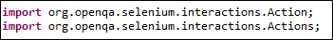
Instantiate a new Actions object.

Instantiate an Action using the Actions object in step 2.
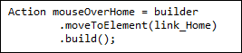

The build() method is always the final method used so that all the listed actions will be compiled into a single step.

the perform() method when executing the Action object we designed in Step 3.

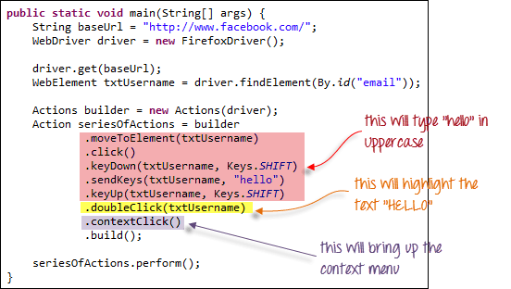

an example of a dynamic table of Sales. Based on input date filters, number of rows will get altered. So, it is dynamic in nature.

Web elements are nothing but HTML elements like textbox, dropdowns radio buttons, submit buttons, etc. These HTML elements are written with start tag and ends with an end tag.

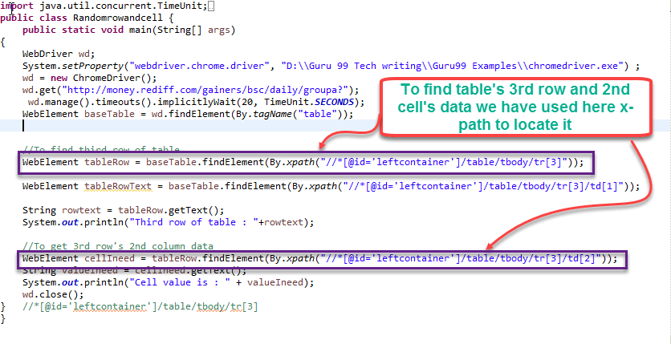
The desired capability is a series of key/value pairs that stores the browser properties like browsername, browser version, the path of the browser driver in the system, etc. to determine the behaviour of the browser at run time.

importorg.openqa.selenium.remote.DesiredCapabilities;
DesiredCapabilities capabilities = DesiredCapabilities.internetExplorer();

capabilities.setCapability(CapabilityType.BROWSER_NAME, "IE");
capabilities.setCapability(InternetExplorerDriver.
INTRODUCE_FLAKINESS_BY_IGNORING_SECURITY_DOMAINS,true);
The tooltip is a text that appears when a mouse hovers over an object like a link, an image, a button, text area, etc. in a web page. The text often gives more information about the object on which it appears.

broken links

import java.net.HttpURLConnection;
List<WebElement> links = driver.findElements(By.tagName("a"));
Iterator<WebElement> it = links.iterator();
url = it.next().getAttribute("href");

Send http request
HttpURLConnection class has methods to send HTTP request and capture HTTP response code. So, output of openConnection() method (URLConnection) is type casted to HttpURLConnection.
huc = (HttpURLConnection)(new URL(url).openConnection());
huc.setRequestMethod("HEAD");
huc.connect();
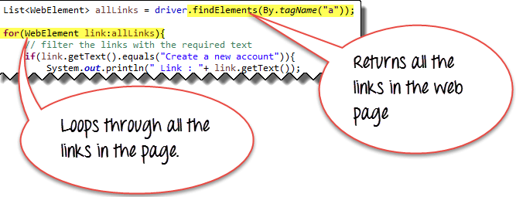

(No subject)





[Draft]
This message hasn't been sent.
Saved: Sat 07-12-2019 07:26
SELECT DISTINCT city FROM station WHERE city REGEXP "^[aeiou].*";

7 //Write a method to replace all spaces in a string with '%20'
public static class ReplaceSpace
{
public static string Replace(string s)
{
s = s.Trim();
s = s.Replace(" ", "%20");
return s;
}
}

8 class Program
{
static void Main()
{
string value = "rstuvwxyz";
// Avoid full length.
for (int length = 1; length < value.Length; length++)
{
// End index is tricky.
for (int start = 0; start <= value.Length - length; start++)
{
string substring = value.Substring(start, length);
Console.WriteLine(substring);
}
}
}
}








Akshay CA
Tue 03-12-2019 18:26
- Akshay CA

https://www.csharpstar.com/csharp-program-to-get-max-occured-character-in-a-string/

1. if (table.IndexOf(value) == -1)
{
// Append to the table and the result.
table += value;
result += value;
}

2. char[] char1 = word1.ToLower().ToCharArray();
char[] char2 = word2.ToLower().ToCharArray();

//Step 2
Array.Sort(char1);
Array.Sort(char2);

//Step 3
string NewWord1 = new string(char1);
string NewWord2 = new string(char2);

//Step 4
//ToLower allows to compare the words in same case, in this case, lower case.
//ToUpper will also do exact same thing in this context
if (NewWord1 == NewWord2)

3. public static string Reverse(string x)
{
string result = "";
for (int i = x.Length - 1; i >= 0; i--)
result += x[i];
return result;
}
4.//Count the words
foreach (string y in x.Split(' '))
result++;

return result;

5.
public static bool IsPalindrome(string word)
{
int min = 0;
int max = word.Length - 1;
while (true)
{
if (min > max)
{
return true;
}
char a = word[min];
char b = word[max];
if (char.ToLower(a) != char.ToLower(b))
{
return false;
}
min++;
max--;
}
}
6.public static char MostOccurringCharInString(string charString)
{
int mostOccurrence = -1;
char mostOccurringChar = ' ';
foreach (char currentChar in charString)
{
int foundCharOccreence = 0;
foreach (char charToBeMatch in charString)
{
if (currentChar == charToBeMatch)
foundCharOccreence++;
}
if (mostOccurrence < foundCharOccreence)
{
mostOccurrence = foundCharOccreence;
mostOccurringChar = currentChar;
}
}
return mostOccurringChar;
}
To fetch column names from table in SQL

Select * from INFORMATION_SCHEMA.
COLUMNS
Where TABLE_NAME = ‘statement’

To convert the column names to list. Find (.+) in regular expression and replace it with “\1” and find \r\n (Windows carriage returns) replace it with , at last var ass= to have square brackets

Stale element error might because of
- The Element has been deleted
- The Element is not attached to the DOM

JAVA: Collections is a group of individual objects represented as a single unit. Set, list, queue, dequeue

Py: List comprehensions provide a concise way to create lists. `

Lambda x: x

The keyword: lambda
A bound variable: x
A body: x

F or f

F”Hello , {name}. you are {age}”
f”{2*37}”
‘74’
f”{name.lower()}”
f”{self.first_name}”

str() and repr() both are used to get a string representation of object.

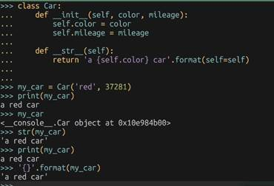

map(func, iter) function returns a list of the results after applying the given function to each item of a given iterable(list tuple etc.)

test = list(map(list,;l))

below 3 codes are same:
- Squares=[]
For x in range(10):
Squares.append(x**2)

- Squares = list(map(lambda x:x**2, range(10)))
- Squares = [x**2 for x in range(10)]
[(x,y) for x in [1,2,3] for y in [3,1,4] if x !=y]
Nested: [[row[i] for row in matrix] for I in range(4)]

del is a way to remove an item from a list given its index instead of its value

join() method is a string method and returns a string in which the elements of sequence have been joined by str separator
takes iterable – objects capable of returning its members one at a time ( List, Tuple, String, Dictionary and Set.
Returns a concatenated elements of iterable

Strip() in built function of python is used to remove all the leading and trailing spaces from a string
String.strip([remove]) – remove(optional)

Selenium: unzip selenium jar and run in cmd
Selenium-2.53.1>python setup.py install

If button is inside <form> tag or button is outside <form> tag the click() method won’t

Most of the selenium functions are in the form of underscores : find_elements_by_class_name(“d”)

Python unittest library inherits its root from a third-party module known as PyUnit like Junit made up of 5 elements
- Test Loader - releases a testsuite object that carries those case an
- Test Case – holds the test handlers and provides hooks for preparing each handler and cleaning up after execution
- Test Suite – container
- Test runner – provides a runnable interface for the execution of tests
- Test report
We can create one or more tests by inheriting the TestCase class available in the unittest module, also need to provide a corresponding test method ( a handler) to the derived class. To finalize a test case
, we can use assert or any of its variations for reporting test status

assertEqual()
assertTrur()
asserRaises() to verify that an expected exception gets raised
in additional to test handlers, we can also add routines like setup() and teardown() to manage the creation and disposition of any objects or conditions that are mandatory for a test.

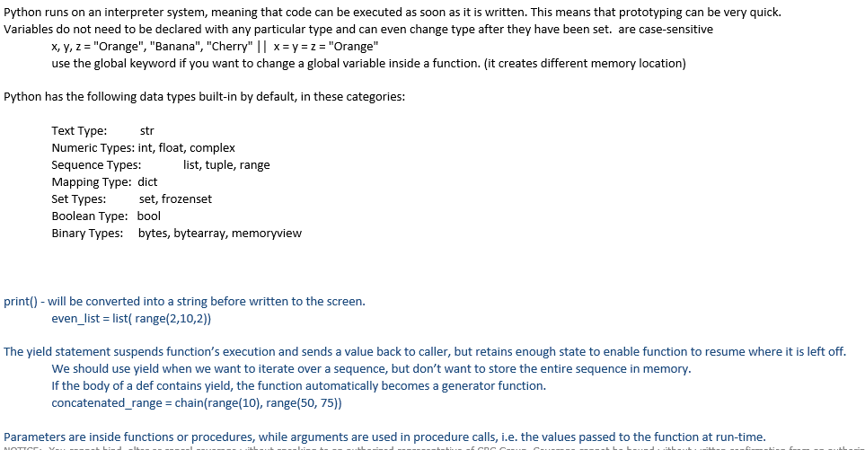
Import unittest
Class SearchText(unittest.TestCase):

setUp method works as an entry point for the test cases.
Good practice to prefix their methods with ‘test’ helps runner distinguish between a test and other methods, runner calls teardown() after test execution

Running the tests from the command line would require us to add a call to the main() method in the test script towards the end

If __name__ = ‘__main__’:
Unittest.main()

Python selenium-python-test.py

We should be able to share instances between the methods instead of creating a new instance every time.

Methods along with @classmethod decorator. These methods enable us to set the values at the class level rather than at the method level. The values initialized at class level are shared between the test methods
The unittest module has a TestSuite class which makes it easy to create

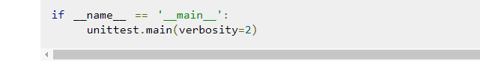
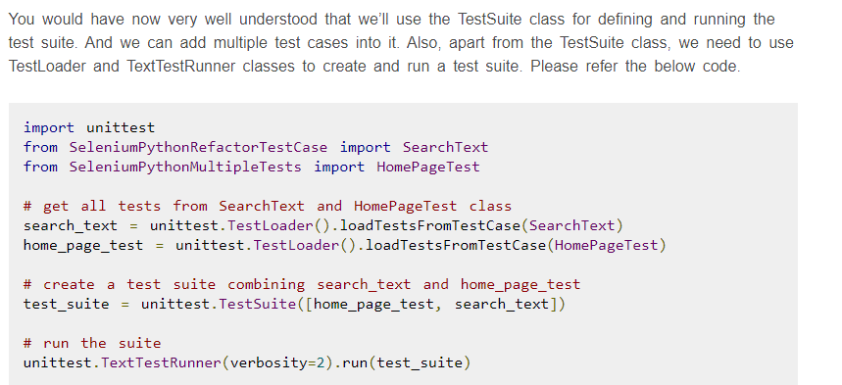

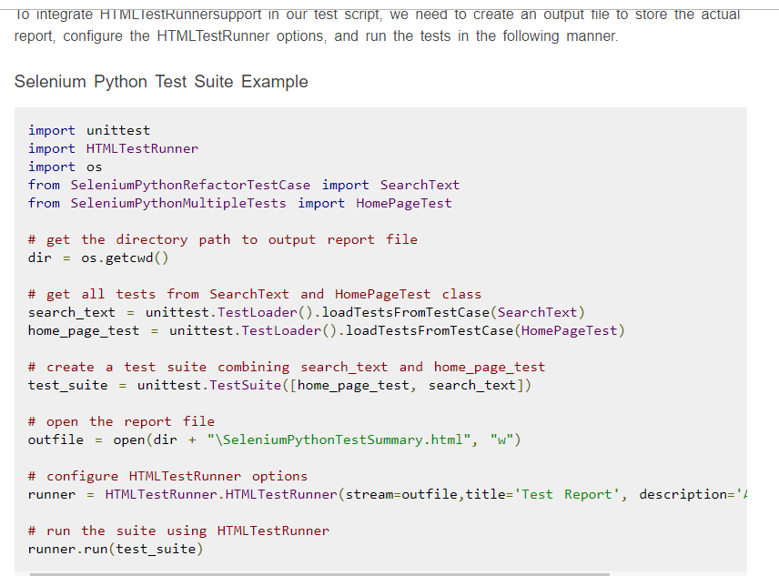

08232019 Selenium
Contents
POM 30
Properties c# 32
XPATH 33
Xpath loactors 33
Using xpath 33

POM
The main advantage of Page Object Model is that if the UI changes for any page, it don’t require us to change any tests, we just need to change only the code within the page objects (Only at one place).
Ex:
public class SignInPage {
private WebDriver driver;
Private By headerPageText = By.cssSelector(“.hidden-small”);
}
Page Object model is writing all the functionalities / reusable components of a page that we want to automate in a separate class.
"Within your web app’s UI there are areas that your tests interact with. A Page Object simply models these as objects within the test code. This reduces the amount of duplicated code and means that if the UI changes, the fix need only be applied in one place."
When ever we are navigating to other page, we need to return that page object. Else Return the current page object as this action doesn't navigate to a other page represented by another Page Object
Selenium Page Factory Pattern is like an extension to Page Object Model , but Page Factory is much enhanced model.
"Factory class can be used to make using Page Objects simpler and easier".
We should initialize page objects using initElements() method from PageFactory Class
Once we call initElements() method, all elements will get initialized. PageFactory.initElements() static method takes the driver instance of the given class and the class type, and returns a Page Object with its fields fully initialized.

HomePage homePage = new HomePage(driver); PageFactory.initElements(driver, homePage);
Or
HomePage homePage = PageFactory.initElements(driver, HomePage.class);
#or as a constructor
public HompePage(WebDriver driver) {
this.driver = driver;
PageFactory.initElements(driver, this);
}
An exception will be thrown if the class cannot be instantiated.
Page Factory will initialize every WebElement variable with a reference to a corresponding element on the actual web page based on “locators” defined. This is done by using @FindBy annotations.
Annotations are used to give descriptive names for WebElements to improve code readability. And annotation @FindBy is used to identify Web Elements in the page.
The @FindBy annotation supports all the other locators strategies that we use:
id, name, className, css, xpath, tagName, linkText and partialLinkText
@FindBy(how = How.ID, using = "username")
private WebElement userName;
Or
@FindBy(id="username")
private WebElement userName;
Or
@FindBy(className=".input.username")
private WebElement userName;
Or
@FindBy(tagName = "mylist")
private List<WebElement> links;
Or
@FindBy(name="username")
@CacheLookup
private WebElement userName;
lazy initialization is the tactic of delaying the creation of an object, the calculation of a value, or some other expensive process until the first time it is needed.
There are some other advantages, such as additional annotations like:
@FindBy(name = "q")
@CacheLookup
private WebElement searchBox;
That @CacheLookup makes the lookup for the element happen just once. After that, it will be cached in the variable and accessible much faster.

CacheLookup attribute can be used to instruct the InitElements() method to cache the element once its located and so that it will not be searched over and over again – this is useful when the elements that are always going to be there
But whenever we use @CacheLookup annotation, we will be losing one of the page factory benefit as it will find the element once and then keep a reference to it, hence, we are more likely to see StaleElementExceptions.
The page object pattern simply abstracts business logic away from the physical structure of the pages.

Parallel execution
https://www.seleniumeasy.com/selenium-tutorials/parallel-execution-in-selenium-grid

To access from the App.config
public static string CashReceiptCreateUrl { get; private set; } =
ConfigurationManager.AppSettings.Get("CashReceiptCreateUrl");

Properties c#

https://docs.microsoft.com/en-us/dotnet/csharp/programming-guide/classes-and-structs/properties

https://docs.microsoft.com/en-us/dotnet/csharp/programming-guide/classes-and-structs/restricting-accessor-accessibility

XPATH

Xpath loactors
Id,classname,name,link text, xpath, css path

XPath(XML path) is used to find the location of any element on a webpage using HTML DOM structure.
Xpath = //(current node)tagname(input,div,img)[@(selects attribute)Attribute(attribute name)=’value’(value of the attribute)]
Xapth= //tagname[@Attribute=’Value’]
Relative Xpath the path starts from the middle of the HTML DOM structure. It starts with the double forward slash (//), which means it can search the element anywhere at the webpage.

XPath axes search different nodes in XML document from current context node. XPath Axes are the methods used to find dynamic elements, which otherwise not possible by normal XPath method having no ID, Classname, Name, etc.
Axes methods are used to find those elements, which dynamically change on refresh or any other operations. There are few axes methods commonly used in Selenium Webdriver like child, parent, ancestor, sibling, preceding, self, etc.

Using xpath
- Basic Xpath
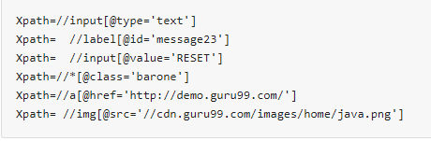
- Contains()
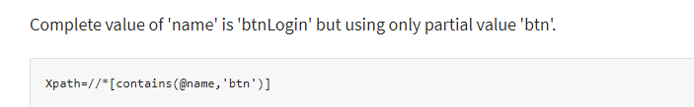
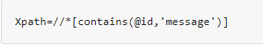
//*[contains(text(), ‘xyz’)]

- Using OR & AND
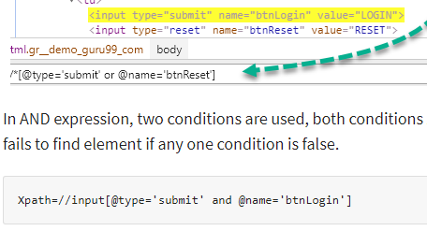
- Start-with function
If ID
Id=" message12"
Id=" message345"
Id=" message8769"
and so on.. but the initial text is same. In this case, we use Start-with expression.
//label[starts-with(@id,’message’)]
- Text()
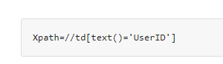
- XPath axes methods: find the complex or dynamic elements.
  - Following - Selects all elements in the document of the current node( ) [ UserID input box is the current node] as shown in the below screen.
  - 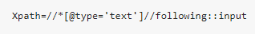
  - 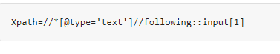
  - Ancestor: The ancestor axis selects all ancestors element (grandparent, parent, etc.) of the current node
  - 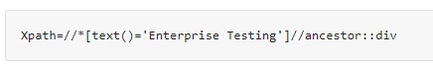
  - 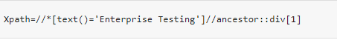
  - Child: Selects all children elements of the current node
  - 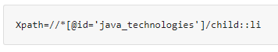
  - 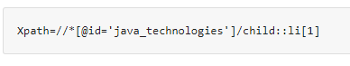
  - Preceding: Select all nodes that come before the current node
  - 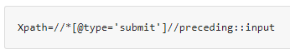
  - 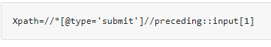
  - Following-sibling: Select the following siblings of the context node. Siblings are at the same level of the current node
  - 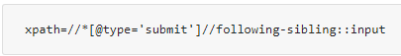
  - Parent: Selects the parent of the current node
  - 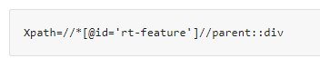
  - 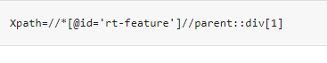
  - Self: Selects the current node or 'self' means it indicates the node itself
  - 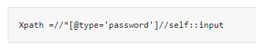
  - Descendant: Selects the descendants of the current node
  - 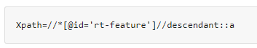
  - 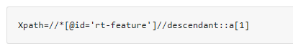

NUNIT
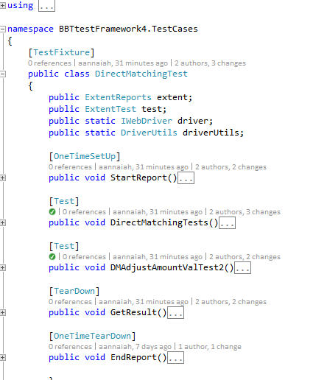

XUNIT
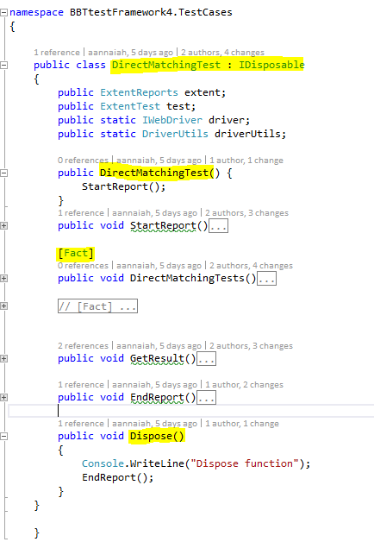

Questions
If we remove parameter (int x) or we remove @override, the program compiles fine.

Annotations in Java
Annotations are used to provide supplement information about a program.
- Annotations start with ‘@’.
- Annotations do not change action of a compiled program.
- Annotations help to associate metadata (information) to the program elements i.e. instance variables, constructors, methods, classes, etc.
- Annotations are not pure comments as they can change the way a program is treated by compiler. See below code for example.

/* Java program to demonstrate that annotations are
not barely comments (This program throws compiler
error because we have mentioned override, but not
overridden, we haver overloaded display) */
class Base
{
public void display()
{
System.out.println("Base display()");
}
}
class Derived extends Base
{
@Override
public void display(int x)
{
System.out.println("Derived display(int )");
}

public static void main(String args[])
{
Derived obj = new Derived();
obj.display();
}
}
10: error: method does not override or implement
a method from a supertype
https://www.geeksforgeeks.org/annotations-in-java/

How ? QCWorkAllocationScreen.CurrentUrl
%TEMP%\VisualStudioTestExplorerExtensions

4009614 90154540

alternate to sleep ?

//Call executeAsyncScript() method to wait for 5 seconds
js.executeAsyncScript("window.setTimeout(arguments[arguments.length - 1], 5000);");

js.executeScript("alert('Welcome to Guru99');");

JavaScriptExecutor.ExecuteClickScript("arguments[0].click();", checkbox);

4010249_530535_Electronic

SpecFlow
SpecRun.SpecFlow.2-4-0
Specrun.Specflow

https://specflow.org/documentation/Generate-Tests-from-MsBuild/

guru99
GIT- > Jenkins
need a mechanism by which our two different executions should not overlap with each other. This can be achieved using Session Handling in Selenium.
create a new instance of a WebDriver object, a new 'sessionId' will be generated and attached with that particular Firefox/Chrome/IE Driver ().(is an in-built functionality)

run Parallel Tests with Selenium (testng.xml)<?xml version="1.0" encoding="UTF-8"?>
<!DOCTYPE suite SYSTEM "http://testng.org/testng-1.0.dtd">
<suite name="TestSuite" thread-count="3" parallel="methods" >
<test name="testGuru">
<classes>
<class name="TestGuru99MultipleSession">
<include value="testGuru99TC1" dependsOnMethods=" testGuru99TC2"/>
<include value="testGuru99TC2"/>
</class>
</classes>
</test>
</suite>
one can use "parallel" attribute
instances: Test cases in same instance will execute parallel but two methods of two different instances will run in different thread.
The attribute thread-count allows you to specify how many threads should be allocated for this execution.

You can set order and dependency of Test Case execution - we will use 'dependsOnMethods' attribute to make dependency and order of execution.

AutoIT
Use the IDE to develop the .exe file
and use the Runtime class allows the script to interface with the environment in which the script is running.
getRuntime() get the current runtime associated with this process.
exec() methods execute the AutoIT script ( FileUpload.exe )
Runtime.getRuntime().exec("E:\\AutoIT\\FileUpload.exe");

IASC.BBT.UI.Automation.API/IASC.BBT.UI.Automation.API/Controllers/DBSStatementController.cs31
31. return null

IASC.BBT.UI.Automation.API/IASC.BBT.UI.Automation.Services/CPSStatementService.cs
30 use return statementId instead of statusid

IASC.BBT.UI.Automation.API/IASC.BBT.UI.Automation.Services/DBSStatementService.cs
29 use return statementId instead of statusid

POC for BDD and Cucumber based Test Automation Framework

Table of Contents

Purpose 44
Project for barebones QA Automation Testing using: 44
What is BDD? 45
How Can I write tests without actual code? 46
Advantages: 47
Demo: 47
Summary: 47

Purpose
To create Test suite for Regression tests in CRC- CPS application giving maximum test coverage using the BDD approach.

Project for barebones QA Automation Testing using:

- Selenium – It is a portable framework for testing web applications.
- C# - Programming language used to write test script
- SpecFlow - SpecFlow is the open source port of Cucumber for .NET. Define automatic tests in Gherkin and execute them using xUnit.
- Cucumber - A cucumber is a tool based on Behavior Driven Development (BDD) framework which is used to write acceptance tests for the web application.
- Gherkin - Gherkin is a Business Readable, Domain Specific Language created especially for behavior descriptions. It gives you the ability to remove logic details from behavior tests.
- Xunit - xUnit.net is a free, open source, community-focused unit testing tool for the .NET Framework.
- Page Object Model Design Patten - It is widely used design pattern in Selenium for enhancing test maintenance and reducing code duplication.

What is BDD?

- BDD keeps Business Behavior in sync with Software Development
- Extends Test Driven Development to cover Business Acceptance Tests

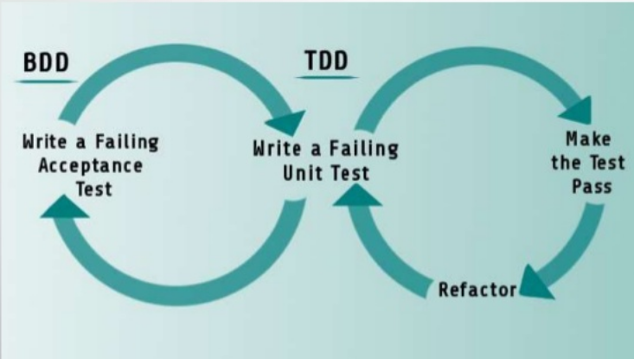

How Can I write tests without actual code?

- BDD uses Simple English Syntax – Gherkin
- BDD uses example based ‘Scenarios’
- Each ‘Scenario’ is noted in the form of ‘Given’, ’When’, ’Then’
Feature file:
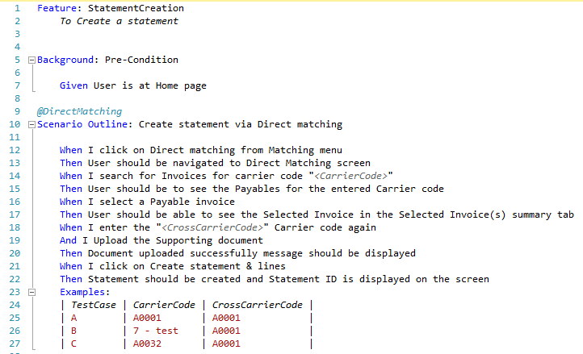
Step Definitions:
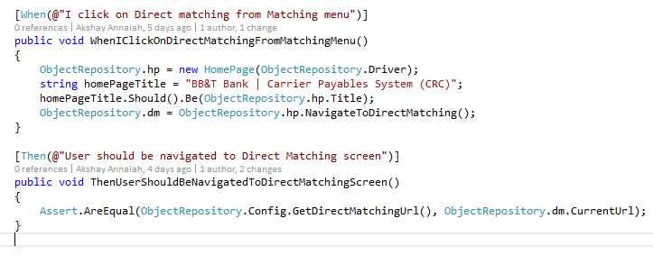

Advantages:

- BDD allows building on top of existing scenarios easily.
- Existing step-definitions can be re-used, only the new steps need to be written.
- Less Code Repetition – better regression framework.

Demo:
- Statement creation via Direct Matching
- Source Code : http://bhmtfsapp02:8080/tfs/crcinscollection/CRC%20_CPSDBS/_git/iasc-crc-automation?version=GBmaster&_a=contents

Summary:

- BDD minimizes communications, hides implementation details and provides robust regression tests.
- BDD provides Building Blocks of scenarios and step definitions, so incremental test can be written easily.

PyDev

Is the python development env for eclipse

Questions
If we remove parameter (int x) or we remove @override, the program compiles fine.

Annotations in Java
Annotations are used to provide supplement information about a program.
- Annotations start with ‘@’.
- Annotations do not change action of a compiled program.
- Annotations help to associate metadata (information) to the program elements i.e. instance variables, constructors, methods, classes, etc.
- Annotations are not pure comments as they can change the way a program is treated by compiler. See below code for example.

/* Java program to demonstrate that annotations are
not barely comments (This program throws compiler
error because we have mentioned override, but not
overridden, we haver overloaded display) */
class Base
{
public void display()
{
System.out.println("Base display()");
}
}
class Derived extends Base
{
@Override
public void display(int x)
{
System.out.println("Derived display(int )");
}

public static void main(String args[])
{
Derived obj = new Derived();
obj.display();
}
}
10: error: method does not override or implement
a method from a supertype
https://www.geeksforgeeks.org/annotations-in-java/

How ? QCWorkAllocationScreen.CurrentUrl
Install and Configure PyDev in Eclipse
1. Go to Windows > Preferences > Interpreter-Python. Click on "OK" button
2. Give the "interpreter name" and the "exe file name" of Python.
3. While creating a new project select 'PyDev Project'
4. Folder structure: Hello - _pycache_- _init_.py, hello.py, pypy.py
5. After creating a new package, the next step is to createPyDev Module
6. Createa new PyDev module. Right click on package > New >Other>PyDev module.

Page Object Model pattern for modeling different pages of the application, to ensure the framework was robust and resistant to UI changes.

Jenkins
Jenkins is an open source Continuous Integration server capable of orchestrating a chain of actions that help to achieve the Continuous Integration process
(and not only) in an automated fashion.

A Continuous Integration Pipeline is a powerful instrument that consists of a set of tools designed to host, monitor, compile and test code, or code changes, like
Continuous Integration Server (Jenkins, Bamboo, CruiseControl, TeamCity, and others)
Source Control Tool (e.g., CVS, SVN, GIT, Mercurial, Perforce, ClearCase and others)
Build tool (Make, ANT, Maven, Ivy, Gradle, and others)
Automation testing framework (Selenium, Appium, TestComplete, UFT, and others)

Learn

1. Python - automatic memory management, portable, huge standard library, built in DS and DT and its open source , simple and easy

2. PEP 8 - https://www.python.org/dev/peps/pep-0008/

3. Data serialization is the process of converting structured data to a format that allows sharing or storage of the data in a form that allows recovery of its original structure.
Pickling - is the process whereby a Python object hierarchy is converted into a byte stream,
and Unpickling - is the inverse operation, whereby a byte stream is converted back into an object hierarchy.
Python - list, tuple, dictionary and set

List - [], mutuable DT, A list is an ordered collection of values.
When we use a variable i and assign a value to it, say integer 5 to it, you can think of it as creating an object (i.e. instance) i of class (i.e. type) int.
append method for the list class which allows you to add an item to the end of the list.
Python’s print() function comes with a parameter called ‘end’. By default, the value of this parameter is ‘\n’, i.e. the new line character.
# ends the output with a <space>
print("Welcome to" , end = ' ')
print("GeeksforGeeks", end = ' ')

del shoplist[0]
shoplist.sort()
shoplist.append('rice')
List.pop(0) - 0 is index
List.remove(4) - 4 is the value

Tuples - (),used for grouping data, are used to hold together multiple objects - immutable unlike list
Tuple assignment (name, surname, b_year, movie, m_year, profession, b_place) = julia # tuple packing and unpacking
(a, b) = (b, a) - swap without using temp variable
Tuples as return values like return (c,a)

>>> 7 // 4 = 1 #floor division

Dictionary {}, del , inventory["pears"] = 100 , add key:value pairs. dictionaries are mutable,
methods - d.keys() and values()
The items method also returns a view, which promises a list of tuples — one tuple for each key:value pair:
for (k,v) in eng2sp.items():
print("Got",k,"that maps to",v)
.copy() # Shallow copy

sparse matrix: matrix = {(0, 3): 1, (2, 1): 2, (4, 3): 3} ,
matrix[(0,3)] will give error
The first argument is the key; the second argument is the value get should return if the key is not in the dictionary:
>>> matrix.get((1, 3), 0)
0
>>> letter_counts = {}
>>> for letter in "Mississippi":
... letter_counts[letter] = letter_counts.get(letter, 0) + 1
...
>>> letter_counts
{'M': 1, 's': 4, 'p': 2, 'i': 4}

Sets are unordered collections of simple objects.

4. Python language is an interpreted language. Python program runs directly from the source code. It converts the source code that is written by the programmer into an intermediate language,
which is again translated into machine language that has to be executed.

5. Python memory is managed by Python private heap space.
The allocation of Python heap space for Python objects is done by Python memory manager.
Python also have an inbuilt garbage collector

6. Memcached is a general-purpose distributed memory caching system.

7. Dogpile effect is referred to the event when cache expires, and websites are hit by the multiple requests made by the client at the same time.

8. split function in Python - breaks a string into a list of words. By default, any number of whitespace characters is considered a word boundary string.split("/")
opposits is join() - glue.join(List) or "".join(List)

>>> xs = list("Crunchy Frog")
>>> xs
["C", "r", "u", "n", "c", "h", "y", " ", "F", "r", "o", "g"]

9. 10//5 = 2 and 10.0//5.0 = 2.0.
// operator - It is a Floor Divisionoperator - quotient showing only digits
round() is the opposite

10. Modules and Packages
Each module(piece of software that has a specific functionality) is a different file, which can be edited separately

11. Delete a file in python $os.remove (filename) or os.unlink(filename)

12. Python Script executable on Unix- the first line must begin with # ( #!/usr/local/bin/python)

13. To share global variables across modules within a single program, create a special module.
Import the config module in all modules of your application.
The module will be available as a global variable across modules.
Global variables: Those variables that are only referenced inside a function are implicitly global.

14. Modules is the way to structure program. Each Python program file is a module, which imports other modules like objects and attributes.
Package: The folder of Python program is a package of modules. A package can have modules or subfolders.

15. __init__ - This initializer method is automatically called whenever a new instance of Point is created
The self parameter (we could choose any other name, but self is the convention) is automatically set to
reference the newly created object that needs to be initialized.
p = Point() # Instantiate an object of type Point

A func that creates a new object instance is called a constructor
The combined process of “make me a new object” and “get its settings initialized to the factory default settings” is called instantiation.

We can modify the attributes in an instance using dot notation:
>>> p.x = 3
The expression p.x means, “Go to the object p refers to and get the value of x”.
16. Objects are mutable - box.width += 50
17. "is" - This type of equality is called shallow equality because it compares only the references, not the contents of the objects.
To compare the contents of the objects — deep equality
def same_coordinates(p1, p2): return (p1.x == p2.x) and (p1.y == p2.y)
Of course, if the two variables refer to the same object, they have both shallow and deep equality.
18. Copying an object is often an alternative to aliasing. The copy module contains a function called copy that can duplicate any object:
import copy
>>> p1 = Point(3, 4)
>>> p2 = copy.copy(p1)
>>> p1 is p2
False
>>> same_coordinates(p1, p2)
True

To copy a simple object like a Point, which doesn’t contain any embedded objects, copy is sufficient. This is called shallow copying.
the copy module contains a function named deepcopy that copies not only the object but also any embedded objects. It won’t be surprising to learn that this operation is called a deep copy.
>>> b2 = copy.deepcopy(b1) //Now b1 and b2 are completely separate objects.

TIP BOOK

*args is used to send a non-keyworded variable length argument list to the function

Syntax: dictionary.items()

Parameters: This method takes no parameters.

Returns: A view object that displays a list of a given dictionary’s (key, value) tuple pair.

**kwargs allows you to pass keyworded variable length of arguments to a function. You should use **kwargs if you want to handle named arguments in a function.

Python debugger (pdb).
set break points- pdb.set_trace()

Commands:

c: continue execution
w: shows the context of the current line it is executing.
a: print the argument list of the current function
s: Execute the current line and stop at the first possible occasion.
n: Continue execution until the next line in the current function is reached or it returns.

JSON:
json.dumps(x, indent=4, separators=(", ", ": "), sort_keys=True)

RegEx

A RegEx, or Regular Expression, is a sequence of characters that forms a search pattern.
Python has a built-in package called `re`

al{2} - "a" followed by exactly two "l"
aix+ - "ai" followed by 1 or more "x" characters
aix* - 0 or more
$ - end, ^ start with, . any character, \ - special char, [] - set of char

findall() function returns a list containing all matches.
search() function searches the string for a match, and returns a Match object if there is a match
split() function returns a list where the string has been split at each match + maxsplit parameter
sub() function replaces the matches with the text of your choice + count parameter

Match object has properties
.span() returns a tuple containing the start-, and end positions of the match.
.string returns the string passed into the function
.group() returns the part of the string where there was a match
If there is no match, the value None will be returned, instead of the Match Object.

Package
A package contains all the files you need for a module.
pip install camelcase
pip uninstall camelcase
list command to list all the packages installed on your system

TRY - Except
The try block lets you test a block of code for errors.
The except block lets you handle the error.
The finally block lets you execute code, regardless of the result of the try- and except blocks.

Print one message if the try block raises a NameError and another for other errors:

try:
print(x)
except NameError:
print("Variable x is not defined")
except:
print("Something else went wrong")

try-else: You can use the else keyword to define a block of code to be executed if no errors were raised
The finally block, if specified, will be executed regardless if the try block raises an error or not,This can be useful to close objects and clean up resources:

String format()
The format() method allows you to format selected parts of a string.
price = 49
txt = "The price is {} dollars"
print(txt.format(price))
txt = "The price is {:.2f} dollars"
txt1 = "My name is {fname}, I'am {age}".format(fname = "John", age = 36)
txt2 = "My name is {0}, I'am {1}".format("John",36)
txt3 = "My name is {}, I'am {}".format("John",36)
Formatting Types - Inside the placeholders you can add a formatting type to format the result:

FILES

open() function takes two parameters; filename, and mode.

"r" - Read - Default value. Opens a file for reading, error if the file does not exist
"a" - Append - Opens a file for appending, creates the file if it does not exist
"w" - Write - Opens a file for writing, creates the file if it does not exist
"x" - Create - Creates the specified file, returns an error if the file exists

"t" - Text - Default value. Text mode
"b" - Binary - Binary mode (e.g. images)

The open() function returns a file object, which has a read() method for reading the content of the file: + can specify how many elements
+ for one line f.readline()
f.close() everytime you open()

NOTE: While looping through the file. for . loop through the file line by line
You should always close your files, in some cases, due to buffering, changes made to a file may not show until you close the file.

Note: the "w" method will overwrite the entire file.

To delete a file, you must import the OS module, and run its os.remove() function:
To avoid getting an error, you might want to check if the file exists before you try to delete it:
if os.path.exists("demofile.txt"):
os.remove("demofile.txt")
To delete an entire folder, use the os.rmdir() method:
Note: You can only remove empty folders

Learn S

1. EH:When the exception occurs in a method, the process of creating the exception object and handing it over to runtime environment
is called “throwing the exception”.

Exception handling refers to the anticipation, detection, and resolution of programming application, and communications errors.
1. custom message in your logs
2. just eat up the exception and want your test to carry on with rest of the execution.
3. In case you want to perform some series of steps on occurring of an certain exception
4. TimeoutException: Thrown when there is not enough time for a command to be completed.
UnableToCreateProfileException: You can open a browser with certain options using profiles, but sometimes a new version of Selenium Driverserver or browser may not support the profiles.
UnableToSetCookieException: Occurs if a driver is unable to set a cookie.
UnexpectedAlertPresentException: This Selenium exception happens when there is the appearance of an unexpected alert.
UnexpectedTagNameException: Happens if a support class did not get a web element as expected.
InvalidCookieDomainException: This happens when you try to add a cookie under a different domain rather than the current URL.
InvalidCoordinatesException: This happens if the coordinates offered to an interacting operation are not valid.
InvalidElementStateException: This Selenium exception occurs if a command cannot be finished as the element is invalid.
InvalidSessionIdException: Takes place when the given session ID is not included in the list of active sessions, which means the session does not exist or is inactive either.
InvalidSwitchToTargetException: Happens if frame or window target to be switched does not exist.
ElementClickInterceptedException: The command could not be completed as the element receiving the events is concealing the element which was requested clicked.
ElementNotInteractableException: This Selenium exception is thrown when an element is presented in the DOM but it is impossible to interact with such element.
NoAlertPresentException: Happens when you switch to no presented alert.
NoSuchAttributeException: Occurs when the attribute of element could not be found.
NoSuchContextException: Happens in mobile device testing and is thrown by ContextAware.
NoSuchCookieException: This exception is thrown if there is no cookie matching with the given pathname found amongst the associated cookies of the current browsing context’s active document.
NoSuchElementException: Happens if an element could not be found.
NoSuchFrameException: Takes place if frame target to be switch does not exist.
NoSuchWindowException: Occurs if window target to be switch does not exist.
NotFoundException: This exception is subclass of WebDriverException. It happens when an element on the DOM does not exist.
5. A try block can be followed by multiple catch blocks.
6. Throw keyword is used to throw exception to the runtime to handle it.

W3 Python,

OPERATORS:
Ass: +=, -=,*=,/=
| - OR, ^ - XOR, >> and << -> shifts
Comp: >= greater than or equal to
<= lesser than

NOTE: always the '=' sign is in the right end side

Logical: and , or , not

Identity operators: is, is not == return T/F if both varibales are the same object
if a = 20 , b= 20 , is T if (a is b) ; b= 30 , is F if (a is b)

Membership Operators: in , not in == used to test if a sequence is presented in an object

Bitwise: Bitwise operators are used to compare (binary) numbers: & , |,^,~

COLLECTIONS:
List is a collection which is ordered and changeable. Allows duplicate members.
Tuple is a collection which is ordered and unchangeable. Allows duplicate members.
Set is a collection which is unordered and unindexed. No duplicate members.
Dictionary is a collection which is unordered, changeable and indexed. No duplicate members.

Choosing the right type for a particular data set could mean retention of meaning, and, it could mean an increase in efficiency or security.

List: [],thislist[1],thislist[-1] = "black",loop - for,check - if, len(), add - append("black [end of the list] & specific location - insert(1,"orange"),
remove("banana") `specific element`, `specific index` pop(index) - or last item if index is not specified ; del - removes the specified index also can delete the whole list
clear() - empties the list
**COPY - You cannot copy a list simply by typing list2 = list1, because: list2 will only be a reference to list1, and changes made in list1 will automatically also be made in list2.
so use copy() or list() [newlist = thislist.copy() newlist = list(thislist)]
join - '+' or append using for loop or extend() (can append tuples also) [list1.extend(list2)] or list thislist = list(("apple", "banana", "cherry")) # note the double round-brackets
count("black") Returns the number of elements with the specified value

NOTE:the return value will be a new list with the specified items

Tuple: () , Tuples are unchangeable, or immutable (can't add or remove) [You can convert the tuple into a list, change the list, and convert the list back into a tuple]
y = list(x),y[1] = "kiwi",x = tuple(y), || To create Tuple With One Item [thistuple = ("apple",)] is tuple else ("apple") is str
can't remove element from tuple but can delete (del) the whole tuple
t = t + (element,) to add

Sets: {} , Once a set is created, you cannot change its items, but you can add new items. add() & update()
remove() or discard() or pop() - only the last element , clear() empties the set, del - completely delete
JOin - union(), [returns new set] or update() will exclude any duplicate items.
See reference from w3 for more details

Dictionary:
Access: thisdict["model"] or get("model")
Loop: When looping through a dictionary, the return value are the keys of the dictionary, but there are methods to return the values as well.
for x in thisdict: print(thisdict[x])
for x in thisdict.values(): print(x)
remove: pop("model") [can't pop empty], popitem() method removes the last inserted item
del keyword removes the item with the specified key name
del thisdict["model"]
Copy: just like lists you can copy() or using the constructor
The fromkeys() method returns a dictionary with the specified keys and values. dict.fromkeys(keys, value) || value will be set to all the keys
items()- returns view object.The view object contains the key-value pairs of the dictionary, as tuples in a list.

IF..ELSE
if, elif , else
short hand if: if a > b: print("a is greater than b")
short hand if..else: print("A") if a > b else print("B")
print("A") if a > b else print("=") if a == b else print("B")
syntax: .OP. if .OP. else .OP. if .OP. else .OP. if .OP. else .OP.
can use and, or

WHILE Loops
while and for
(as long as a condition is true) (for loop is used for iterating over a sequence (that is either a list, a tuple, a dictionary, a set, or a string))
break statement we can stop the loop even if the while condition is true
continue statement we can stop the current iteration, and continue with the next
while-else - statement we can run a block of code once when the condition no longer is true
For-else - block of code to be executed when the loop is finished

The range() function returns a sequence of numbers, starting from 0 by default, and increments by 1 (by default), and ends at a specified number.

FUNCTION
A function is a block of code which only runs when it is called.
a function is defined using the def keyword
To call a function, use the function name followed by parenthesis
Information can be passed to functions as parameter.

Keyword Arguments (kwargs) - You can also send arguments with the key = value syntax.
def my_function(child3, child2, child1): ... my_function(child1 = "Emil", child2 = "Tobias", child3 = "Linus")
Arbitrary Arguments (*args) - do not know how many arguments that will be passed
function will receive a tuple of arguments, and can access the items accordingly:

def foo(*positional, **keywords):
print "Positional:", positional
print "Keywords:", keywords

>>> foo('one','two',c='three',d='four')
Positional: ('one', 'two') //if only keyword args are passed empty tuple () will be created
Keywords: {'c': 'three', 'd': 'four'} // if only positional args are passed empty dict {} will be created

Recursion (means a defined function can call itself.)
def tri_recursion(k):
if(k>0):
result = k+tri_recursion(k-1)
print(result)
else:
result = 0
return result

print("\n\nRecursion Example Results")
tri_recursion(5)

LAMBDA
A lambda function is a small anonymous function
A lambda function can take any number of arguments, but can only have one expression.

lambda arguments : expression
x = lambda a, b, c : a + b + c
print(x(5, 6, 2))

Why Use

def myfunc(n):
return lambda a : a * n

mydoubler = myfunc(2)
mytripler = myfunc(3)

print(mydoubler(11))
print(mytripler(11))

ARRAYS:

The isinstance() function is used to determine if an instance is also an instance of a certain parent class.

guru99
GIT- > Jenkins
need a mechanism by which our two different executions should not overlap with each other. This can be achieved using Session Handling in Selenium.
create a new instance of a WebDriver object, a new 'sessionId' will be generated and attached with that particular Firefox/Chrome/IE Driver ().(is an in-built functionality)

run Parallel Tests with Selenium (testng.xml)<?xml version="1.0" encoding="UTF-8"?>
<!DOCTYPE suite SYSTEM "http://testng.org/testng-1.0.dtd">
<suite name="TestSuite" thread-count="3" parallel="methods" >
<test name="testGuru">
<classes>
<class name="TestGuru99MultipleSession">
<include value="testGuru99TC1" dependsOnMethods=" testGuru99TC2"/>
<include value="testGuru99TC2"/>
</class>
</classes>
</test>
</suite>
one can use "parallel" attribute
instances: Test cases in same instance will execute parallel but two methods of two different instances will run in different thread.
The attribute thread-count allows you to specify how many threads should be allocated for this execution.

You can set order and dependency of Test Case execution - we will use 'dependsOnMethods' attribute to make dependency and order of execution.

AutoIT
Use the IDE to develop the .exe file
and use the Runtime class allows the script to interface with the environment in which the script is running.
getRuntime() get the current runtime associated with this process.
exec() methods execute the AutoIT script ( FileUpload.exe )
Runtime.getRuntime().exec("E:\\AutoIT\\FileUpload.exe");

OOP

NOTE:
There is a sub-set of functionality that the user is allowed to call, termed the interface

The four principles of object-oriented programming are encapsulation, abstraction, inheritance, and polymorphism.

Encapsulation
Encapsulation is achieved when each object keeps its state private, inside a class.
Other objects don’t have direct access to this state. Instead, they can only call a list of public functions — called methods.

Encapsulation is used to hide the mechanics of the object, allowing the actual implementation of the object to be hidden,
so that we don't need to understand how the object works. All we need to understand is the interface that is provided for us.

encapsulation as "data-hiding"

Abstraction
natural extension of encapsulation. Applying abstraction means that each object should only expose a high-level mechanism for using it.
This mechanism should hide internal implementation details. It should only reveal operations relevant for the other objects.

An abstract class is a class that is incomplete, in that it describes a set of operations, but is missing the actual implementation of these operations.
Cannot be instantiated. Can only be used through inheritance.
This we are forcing all derived classes to write a draw() (abstract) method if they are to be instantiated.

inheritance
Objects are often very similar. They share common logic. But they’re not entirely the same.
The child class reuses all fields and methods of the parent class (common part) and can implement its own (unique part).

Polymorphism
Many forms which inherit from the parent class
Polymorphism means "multiple forms". In OOP these multiple forms refer to multiple forms of the same method,
where the exact same method name can be used in different classes, or the same method name can be used in the
same class with slightly different paramaters. There are two forms of polymorphism, over-riding and over-loading.

over-riding is the term used to describe the situation where the same method name is called on two different objects and each object responds differently.
Over-Loading is the second form of polymorphism. The same method name can be used, but the number of parameters or the types of parameters can differ, allowing the correct method to be chosen by the compiler..

The object-oriented programming approach encourages:
Modularisation, Software re-use,

A class should:
Provide a well-defined interface.
Represent a clear concept.
Be complete and well-documented.
The code should be robust.

You could think of a class as the description of a concept, and an object as the realisation of this description to create an independent distinguishable entity.
These objects should have their own identity and are independent from each other.

Contents
Python for DS and AI 69
Types 69
Expressions and Variables 69
Strings 69
Lists and Tuples 70
Dictionaries 70
Sets 70

Python for DS and AI

Types
Type() – to find out the type
Casting- int(), float(), int(‘A’) – error
Int and float can be converted to string by – str(1)
type(True) : bool
int(True) – 1 // if we casting
bool(1) – True and bool(2) – False

Expressions and Variables

Expressions are a type of operations (arithmetic) the python performs // operands – numbers; operators – sign
/ - float division
// - integer division

Strings

It’s a sequence of characters
Starts with 0 from LHS and -1 from RHS for example “Michael Jackson” 0 to 14 from LHS and from RHS its –1 to -15
If we are doing Name[0:4] 4th index won’t be counted , 0th index will.
We can also add stride values Name[::2] – every second variable
We can add (+) and replicated (*) , cannot change the value of the string, but can create a new string
- Strings are immutable
- Back slashes represent the beginning of escape sequence
- Have apply methods that work on lists and tuples
- String A -> Method -> new String B
- Name.find(‘el’) : 5 will return the index, if not -1 (finds the starting index of a substring)

Lists and Tuples

- Compound data types
- ( Tuples ) are an ordered sequence , comma separated elements within parentheses
- Can be indexed Ex: Tuple1[0]: “disco” . negative index is also allowed.
- Can concatenate , can slice [0:3] , len ()
- Immutable
  - Each variable does not contain a tuple but references the same immutable tuple object
  - Must create a new tuple instead Ex: RatingsSorted = sorted(Ratings)
- Nesting is allowed NT = (1,2,(“pop”,”rock”),(3,4),(“disco”, (1,2)))
  - NT[2]: (“pop”,”rock”)[1] =”rock” -> NT[2][1] =”rock”
- [ List ] - are an ordered sequence , comma separated elements with square brackets
- Mutable
  - Apply method L.extend([“pop”,10])
  - L.append([2,3,4,5])
    - Append-only adds one element to the list
  - Del(A[1]), “hard rock”.split() //separated by space if no argument is given
  - Clone lists like B = A[:] – Variable B references the original list
- Multiple names referring to the same object is known as aliasing

Dictionaries

- Type of collection
- Dictionary has keys (analogous to the index) and values (to the element)
- Denoted by curly brackets {}
- Keys have to be immutable and unique
- Values can be immutable, mutable and duplicates
- Each key and values pair is separated by a comma
  - {“key1” : 1,”key2”: “2”,”key3”:[3,3,3],”key4”: (4,4,4),(‘key5’):5}
  - Key to look at the value , square brackets DICT[“Thriller”]
  - We can add new entry DICT[“Graduation”] = ‘2007’
  - Delete del(DICT[‘Thriller’])
  - To find ‘Graduation’ in DICT
  - DICT.keys() = [ “Thriller,”back in black”….] likewise for DICT.values()

Sets

- Type of collection
- Like list and tuples but unordered , only have unique values
- Sets do not record element position
- Sets only have unique elements
- Curly brackets. Upon creation duplicate elements won’t be present
- Set1 ={“pop”,”rock”,”hip-hop”, “pop”} = set1: {“pop”,”rock”,”hip-hop”}
- You can convert a list to a set by using the function set, this is called type casting – set()
- Album_set = set(album_list) when done all the duplicates in the list is removed
- Can add with A.add(“NSYNC”)
- A.remove(‘NSYNC’)
- “abc” in A – True / False
- Mathematical set operations
  - Intersection - & [ set3 = set1 & set2]
  - Union - set1.union(set2)
  - Check if subset – set3.issubset(set1) – True/False
- Python
- 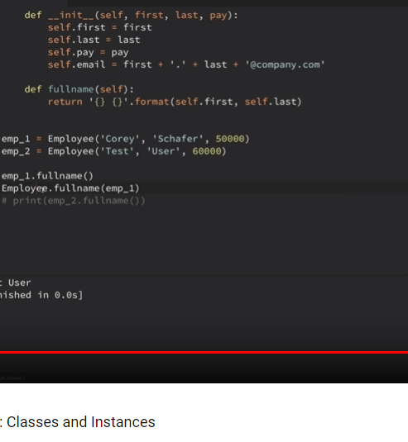

Learn

1. Python - automatic memory management, portable, huge standard library, built in DS and DT and its open source , simple and easy

2. PEP 8 - https://www.python.org/dev/peps/pep-0008/

3. Data serialization is the process of converting structured data to a format that allows sharing or storage of the data in a form that allows recovery of its original structure.
Pickling - is the process whereby a Python object hierarchy is converted into a byte stream,
and Unpickling - is the inverse operation, whereby a byte stream is converted back into an object hierarchy.
Python - list, tuple, dictionary and set

List - [], mutuable DT, A list is an ordered collection of values.
When we use a variable i and assign a value to it, say integer 5 to it, you can think of it as creating an object (i.e. instance) i of class (i.e. type) int.
append method for the list class which allows you to add an item to the end of the list.
Python’s print() function comes with a parameter called ‘end’. By default, the value of this parameter is ‘\n’, i.e. the new line character.
# ends the output with a <space>
print("Welcome to" , end = ' ')
print("GeeksforGeeks", end = ' ')

del shoplist[0]
shoplist.sort()
shoplist.append('rice')
List.pop(0) - 0 is index
List.remove(4) - 4 is the value

Tuples - (),used for grouping data, are used to hold together multiple objects - immutable unlike list
Tuple assignment (name, surname, b_year, movie, m_year, profession, b_place) = julia # tuple packing and unpacking
(a, b) = (b, a) - swap without using temp variable
Tuples as return values like return (c,a)

>>> 7 // 4 = 1 #floor division

Dictionary {}, del , inventory["pears"] = 100 , add key:value pairs. dictionaries are mutable,
methods - d.keys() and values()
The items method also returns a view, which promises a list of tuples — one tuple for each key:value pair:
for (k,v) in eng2sp.items():
print("Got",k,"that maps to",v)
.copy() # Shallow copy

sparse matrix: matrix = {(0, 3): 1, (2, 1): 2, (4, 3): 3} ,
matrix[(0,3)] will give error
The first argument is the key; the second argument is the value get should return if the key is not in the dictionary:
>>> matrix.get((1, 3), 0)
0
>>> letter_counts = {}
>>> for letter in "Mississippi":
... letter_counts[letter] = letter_counts.get(letter, 0) + 1
...
>>> letter_counts
{'M': 1, 's': 4, 'p': 2, 'i': 4}

Sets are unordered collections of simple objects.

4. Python language is an interpreted language. Python program runs directly from the source code. It converts the source code that is written by the programmer into an intermediate language,
which is again translated into machine language that has to be executed.

5. Python memory is managed by Python private heap space.
The allocation of Python heap space for Python objects is done by Python memory manager.
Python also have an inbuilt garbage collector

6. Memcached is a general-purpose distributed memory caching system.

7. Dogpile effect is referred to the event when cache expires, and websites are hit by the multiple requests made by the client at the same time.

8. split function in Python - breaks a string into a list of words. By default, any number of whitespace characters is considered a word boundary string.split("/")
opposits is join() - glue.join(List) or "".join(List)

>>> xs = list("Crunchy Frog")
>>> xs
["C", "r", "u", "n", "c", "h", "y", " ", "F", "r", "o", "g"]

9. 10//5 = 2 and 10.0//5.0 = 2.0.
// operator - It is a Floor Divisionoperator - quotient showing only digits
round() is the opposite

10. Modules and Packages
Each module(piece of software that has a specific functionality) is a different file, which can be edited separately

11. Delete a file in python $os.remove (filename) or os.unlink(filename)

12. Python Script executable on Unix- the first line must begin with # ( #!/usr/local/bin/python)

13. To share global variables across modules within a single program, create a special module.
Import the config module in all modules of your application.
The module will be available as a global variable across modules.
Global variables: Those variables that are only referenced inside a function are implicitly global.

14. Modules is the way to structure program. Each Python program file is a module, which imports other modules like objects and attributes.
Package: The folder of Python program is a package of modules. A package can have modules or subfolders.

15. __init__ - This initializer method is automatically called whenever a new instance of Point is created
The self parameter (we could choose any other name, but self is the convention) is automatically set to
reference the newly created object that needs to be initialized.
p = Point() # Instantiate an object of type Point

A func that creates a new object instance is called a constructor
The combined process of “make me a new object” and “get its settings initialized to the factory default settings” is called instantiation.

We can modify the attributes in an instance using dot notation:
>>> p.x = 3
The expression p.x means, “Go to the object p refers to and get the value of x”.
16. Objects are mutable - box.width += 50
17. "is" - This type of equality is called shallow equality because it compares only the references, not the contents of the objects.
To compare the contents of the objects — deep equality
def same_coordinates(p1, p2): return (p1.x == p2.x) and (p1.y == p2.y)
Of course, if the two variables refer to the same object, they have both shallow and deep equality.
18. Copying an object is often an alternative to aliasing. The copy module contains a function called copy that can duplicate any object:
import copy
>>> p1 = Point(3, 4)
>>> p2 = copy.copy(p1)
>>> p1 is p2
False
>>> same_coordinates(p1, p2)
True

To copy a simple object like a Point, which doesn’t contain any embedded objects, copy is sufficient. This is called shallow copying.
the copy module contains a function named deepcopy that copies not only the object but also any embedded objects. It won’t be surprising to learn that this operation is called a deep copy.
>>> b2 = copy.deepcopy(b1) //Now b1 and b2 are completely separate objects.

TIP BOOK

*args is used to send a non-keyworded variable length argument list to the function

Syntax: dictionary.items()

Parameters: This method takes no parameters.

Returns: A view object that displays a list of a given dictionary’s (key, value) tuple pair.

**kwargs allows you to pass keyworded variable length of arguments to a function. You should use **kwargs if you want to handle named arguments in a function.

Python debugger (pdb).
set break points- pdb.set_trace()

Commands:

c: continue execution
w: shows the context of the current line it is executing.
a: print the argument list of the current function
s: Execute the current line and stop at the first possible occasion.
n: Continue execution until the next line in the current function is reached or it returns.

Learn

1. Python - automatic memory management, portable, huge standard library, built in DS and DT and its open source , simple and easy

2. PEP 8 - https://www.python.org/dev/peps/pep-0008/

3. Data serialization is the process of converting structured data to a format that allows sharing or storage of the data in a form that allows recovery of its original structure.
Pickling - is the process whereby a Python object hierarchy is converted into a byte stream,
and Unpickling - is the inverse operation, whereby a byte stream is converted back into an object hierarchy.
Python - list, tuple, dictionary and set

List - [], mutuable DT, A list is an ordered collection of values.
When we use a variable i and assign a value to it, say integer 5 to it, you can think of it as creating an object (i.e. instance) i of class (i.e. type) int.
append method for the list class which allows you to add an item to the end of the list.
Python’s print() function comes with a parameter called ‘end’. By default, the value of this parameter is ‘\n’, i.e. the new line character.
# ends the output with a <space>
print("Welcome to" , end = ' ')
print("GeeksforGeeks", end = ' ')

del shoplist[0]
shoplist.sort()
shoplist.append('rice')
List.pop(0) - 0 is index
List.remove(4) - 4 is the value

Tuples - (),used for grouping data, are used to hold together multiple objects - immutable unlike list
Tuple assignment (name, surname, b_year, movie, m_year, profession, b_place) = julia # tuple packing and unpacking
(a, b) = (b, a) - swap without using temp variable
Tuples as return values like return (c,a)

>>> 7 // 4 = 1 #floor division

Dictionary {}, del , inventory["pears"] = 100 , add key:value pairs. dictionaries are mutable,
methods - d.keys() and values()
The items method also returns a view, which promises a list of tuples — one tuple for each key:value pair:
for (k,v) in eng2sp.items():
print("Got",k,"that maps to",v)
.copy() # Shallow copy

sparse matrix: matrix = {(0, 3): 1, (2, 1): 2, (4, 3): 3} ,
matrix[(0,3)] will give error
The first argument is the key; the second argument is the value get should return if the key is not in the dictionary:
>>> matrix.get((1, 3), 0)
0
>>> letter_counts = {}
>>> for letter in "Mississippi":
... letter_counts[letter] = letter_counts.get(letter, 0) + 1
...
>>> letter_counts
{'M': 1, 's': 4, 'p': 2, 'i': 4}

Sets are unordered collections of simple objects.

4. Python language is an interpreted language. Python program runs directly from the source code. It converts the source code that is written by the programmer into an intermediate language,
which is again translated into machine language that has to be executed.

5. Python memory is managed by Python private heap space.
The allocation of Python heap space for Python objects is done by Python memory manager.
Python also have an inbuilt garbage collector

6. Memcached is a general-purpose distributed memory caching system.

7. Dogpile effect is referred to the event when cache expires, and websites are hit by the multiple requests made by the client at the same time.

8. split function in Python - breaks a string into a list of words. By default, any number of whitespace characters is considered a word boundary string.split("/")
opposits is join() - glue.join(List) or "".join(List)

>>> xs = list("Crunchy Frog")
>>> xs
["C", "r", "u", "n", "c", "h", "y", " ", "F", "r", "o", "g"]

9. 10//5 = 2 and 10.0//5.0 = 2.0.
// operator - It is a Floor Divisionoperator - quotient showing only digits
round() is the opposite

10. Modules and Packages
Each module(piece of software that has a specific functionality) is a different file, which can be edited separately

11. Delete a file in python $os.remove (filename) or os.unlink(filename)

12. Python Script executable on Unix- the first line must begin with # ( #!/usr/local/bin/python)

13. To share global variables across modules within a single program, create a special module.
Import the config module in all modules of your application.
The module will be available as a global variable across modules.
Global variables: Those variables that are only referenced inside a function are implicitly global.

14. Modules is the way to structure program. Each Python program file is a module, which imports other modules like objects and attributes.
Package: The folder of Python program is a package of modules. A package can have modules or subfolders.

15. __init__ - This initializer method is automatically called whenever a new instance of Point is created
The self parameter (we could choose any other name, but self is the convention) is automatically set to
reference the newly created object that needs to be initialized.
p = Point() # Instantiate an object of type Point

A func that creates a new object instance is called a constructor
The combined process of “make me a new object” and “get its settings initialized to the factory default settings” is called instantiation.

We can modify the attributes in an instance using dot notation:
>>> p.x = 3
The expression p.x means, “Go to the object p refers to and get the value of x”.
16. Objects are mutable - box.width += 50
17. "is" - This type of equality is called shallow equality because it compares only the references, not the contents of the objects.
To compare the contents of the objects — deep equality
def same_coordinates(p1, p2): return (p1.x == p2.x) and (p1.y == p2.y)
Of course, if the two variables refer to the same object, they have both shallow and deep equality.
18. Copying an object is often an alternative to aliasing. The copy module contains a function called copy that can duplicate any object:
import copy
>>> p1 = Point(3, 4)
>>> p2 = copy.copy(p1)
>>> p1 is p2
False
>>> same_coordinates(p1, p2)
True

To copy a simple object like a Point, which doesn’t contain any embedded objects, copy is sufficient. This is called shallow copying.
the copy module contains a function named deepcopy that copies not only the object but also any embedded objects. It won’t be surprising to learn that this operation is called a deep copy.
>>> b2 = copy.deepcopy(b1) //Now b1 and b2 are completely separate objects.

TIP BOOK

*args is used to send a non-keyworded variable length argument list to the function

Syntax: dictionary.items()

Parameters: This method takes no parameters.

Returns: A view object that displays a list of a given dictionary’s (key, value) tuple pair.

**kwargs allows you to pass keyworded variable length of arguments to a function. You should use **kwargs if you want to handle named arguments in a function.

Python debugger (pdb).
set break points- pdb.set_trace()

Commands:

c: continue execution
w: shows the context of the current line it is executing.
a: print the argument list of the current function
s: Execute the current line and stop at the first possible occasion.
n: Continue execution until the next line in the current function is reached or it returns.

JSON:
json.dumps(x, indent=4, separators=(", ", ": "), sort_keys=True)

RegEx

A RegEx, or Regular Expression, is a sequence of characters that forms a search pattern.
Python has a built-in package called `re`

al{2} - "a" followed by exactly two "l"
aix+ - "ai" followed by 1 or more "x" characters
aix* - 0 or more
$ - end, ^ start with, . any character, \ - special char, [] - set of char

findall() function returns a list containing all matches.
search() function searches the string for a match, and returns a Match object if there is a match
split() function returns a list where the string has been split at each match + maxsplit parameter
sub() function replaces the matches with the text of your choice + count parameter

Match object has properties
.span() returns a tuple containing the start-, and end positions of the match.
.string returns the string passed into the function
.group() returns the part of the string where there was a match
If there is no match, the value None will be returned, instead of the Match Object.

Package
A package contains all the files you need for a module.
pip install camelcase
pip uninstall camelcase
list command to list all the packages installed on your system

TRY - Except
The try block lets you test a block of code for errors.
The except block lets you handle the error.
The finally block lets you execute code, regardless of the result of the try- and except blocks.

Print one message if the try block raises a NameError and another for other errors:

try:
print(x)
except NameError:
print("Variable x is not defined")
except:
print("Something else went wrong")

try-else: You can use the else keyword to define a block of code to be executed if no errors were raised
The finally block, if specified, will be executed regardless if the try block raises an error or not,This can be useful to close objects and clean up resources:

String format()
The format() method allows you to format selected parts of a string.
price = 49
txt = "The price is {} dollars"
print(txt.format(price))
txt = "The price is {:.2f} dollars"
txt1 = "My name is {fname}, I'am {age}".format(fname = "John", age = 36)
txt2 = "My name is {0}, I'am {1}".format("John",36)
txt3 = "My name is {}, I'am {}".format("John",36)
Formatting Types - Inside the placeholders you can add a formatting type to format the result:

FILES

open() function takes two parameters; filename, and mode.

"r" - Read - Default value. Opens a file for reading, error if the file does not exist
"a" - Append - Opens a file for appending, creates the file if it does not exist
"w" - Write - Opens a file for writing, creates the file if it does not exist
"x" - Create - Creates the specified file, returns an error if the file exists

"t" - Text - Default value. Text mode
"b" - Binary - Binary mode (e.g. images)

The open() function returns a file object, which has a read() method for reading the content of the file: + can specify how many elements
+ for one line f.readline()
f.close() everytime you open()

NOTE: While looping through the file. for . loop through the file line by line
You should always close your files, in some cases, due to buffering, changes made to a file may not show until you close the file.

Note: the "w" method will overwrite the entire file.

To delete a file, you must import the OS module, and run its os.remove() function:
To avoid getting an error, you might want to check if the file exists before you try to delete it:
if os.path.exists("demofile.txt"):
os.remove("demofile.txt")
To delete an entire folder, use the os.rmdir() method:
Note: You can only remove empty folders

W3 Python,

OPERATORS:
Ass: +=, -=,*=,/=
| - OR, ^ - XOR, >> and << -> shifts
Comp: >= greater than or equal to
<= lesser than

NOTE: always the '=' sign is in the right end side

Logical: and , or , not

Identity operators: is, is not == return T/F if both varibales are the same object
if a = 20 , b= 20 , is T if (a is b) ; b= 30 , is F if (a is b)

Membership Operators: in , not in == used to test if a sequence is presented in an object

Bitwise: Bitwise operators are used to compare (binary) numbers: & , |,^,~

COLLECTIONS:
List is a collection which is ordered and changeable. Allows duplicate members.
Tuple is a collection which is ordered and unchangeable. Allows duplicate members.
Set is a collection which is unordered and unindexed. No duplicate members.
Dictionary is a collection which is unordered, changeable and indexed. No duplicate members.

Choosing the right type for a particular data set could mean retention of meaning, and, it could mean an increase in efficiency or security.

List: [],thislist[1],thislist[-1] = "black",loop - for,check - if, len(), add - append("black [end of the list] & specific location - insert(1,"orange"),
remove("banana") `specific element`, `specific index` pop(index) - or last item if index is not specified ; del - removes the specified index also can delete the whole list
clear() - empties the list
**COPY - You cannot copy a list simply by typing list2 = list1, because: list2 will only be a reference to list1, and changes made in list1 will automatically also be made in list2.
so use copy() or list() [newlist = thislist.copy() newlist = list(thislist)]
join - '+' or append using for loop or extend() (can append tuples also) [list1.extend(list2)] or list thislist = list(("apple", "banana", "cherry")) # note the double round-brackets
count("black") Returns the number of elements with the specified value

NOTE:the return value will be a new list with the specified items

Tuple: () , Tuples are unchangeable, or immutable (can't add or remove) [You can convert the tuple into a list, change the list, and convert the list back into a tuple]
y = list(x),y[1] = "kiwi",x = tuple(y), || To create Tuple With One Item [thistuple = ("apple",)] is tuple else ("apple") is str
can't remove element from tuple but can delete (del) the whole tuple
t = t + (element,) to add

Sets: {} , Once a set is created, you cannot change its items, but you can add new items. add() & update()
remove() or discard() or pop() - only the last element , clear() empties the set, del - completely delete
JOin - union(), [returns new set] or update() will exclude any duplicate items.
See reference from w3 for more details

Dictionary:
Access: thisdict["model"] or get("model")
Loop: When looping through a dictionary, the return value are the keys of the dictionary, but there are methods to return the values as well.
for x in thisdict: print(thisdict[x])
for x in thisdict.values(): print(x)
remove: pop("model") [can't pop empty], popitem() method removes the last inserted item
del keyword removes the item with the specified key name
del thisdict["model"]
Copy: just like lists you can copy() or using the constructor
The fromkeys() method returns a dictionary with the specified keys and values. dict.fromkeys(keys, value) || value will be set to all the keys
items()- returns view object.The view object contains the key-value pairs of the dictionary, as tuples in a list.

IF..ELSE
if, elif , else
short hand if: if a > b: print("a is greater than b")
short hand if..else: print("A") if a > b else print("B")
print("A") if a > b else print("=") if a == b else print("B")
syntax: .OP. if .OP. else .OP. if .OP. else .OP. if .OP. else .OP.
can use and, or

WHILE Loops
while and for
(as long as a condition is true) (for loop is used for iterating over a sequence (that is either a list, a tuple, a dictionary, a set, or a string))
break statement we can stop the loop even if the while condition is true
continue statement we can stop the current iteration, and continue with the next
while-else - statement we can run a block of code once when the condition no longer is true
For-else - block of code to be executed when the loop is finished

The range() function returns a sequence of numbers, starting from 0 by default, and increments by 1 (by default), and ends at a specified number.

FUNCTION
A function is a block of code which only runs when it is called.
a function is defined using the def keyword
To call a function, use the function name followed by parenthesis
Information can be passed to functions as parameter.

Keyword Arguments (kwargs) - You can also send arguments with the key = value syntax.
def my_function(child3, child2, child1): ... my_function(child1 = "Emil", child2 = "Tobias", child3 = "Linus")
Arbitrary Arguments (*args) - do not know how many arguments that will be passed
function will receive a tuple of arguments, and can access the items accordingly:

def foo(*positional, **keywords):
print "Positional:", positional
print "Keywords:", keywords

>>> foo('one','two',c='three',d='four')
Positional: ('one', 'two') //if only keyword args are passed empty tuple () will be created
Keywords: {'c': 'three', 'd': 'four'} // if only positional args are passed empty dict {} will be created

Recursion (means a defined function can call itself.)
def tri_recursion(k):
if(k>0):
result = k+tri_recursion(k-1)
print(result)
else:
result = 0
return result

print("\n\nRecursion Example Results")
tri_recursion(5)

LAMBDA
A lambda function is a small anonymous function
A lambda function can take any number of arguments, but can only have one expression.

lambda arguments : expression
x = lambda a, b, c : a + b + c
print(x(5, 6, 2))

Why Use

def myfunc(n):
return lambda a : a * n

mydoubler = myfunc(2)
mytripler = myfunc(3)

print(mydoubler(11))
print(mytripler(11))

ARRAYS:

1. To reverse a string convert it into char[] charArray = str.ToCharArray();
int i = 0, j = str.Length - 1; i < j; i++, j--
string reversedstring = new string(charArray); - convert it back to string

2. For Palindrome
int i = 0, j = str.Length - 1; i < str.Length / 2; i++, j--

3. Reverse order of word in a string

StringBuilder reverseSentence = new StringBuilder(); - since represents a mutable sequence of characters. Since the String Class in Java creates an immutable sequence of characters
int Start = str.Length - 1;
int End = str.Length - 1;

while (Start > 0)
{
if (str[Start] == ' ')
{
i = Start + 1;
while (i <= End)
{
reverseSentence.Append(str[i]);
i++;
}
reverseSentence.Append(' ');
End = Start - 1;
}
Start--;
}

for (i = 0; i <= End; i++)
{
reverseSentence.Append(str[i]);
}
Console.WriteLine(reverseSentence.ToString());
}

4. Reverse every word in the sentence

StringBuilder output = new StringBuilder();
List<char> charlist = new List<char>();

for (int i = 0; i < str.Length; i++)
{
if (str[i] == ' ' || i == str.Length - 1)
{
if (i == str.Length - 1)
charlist.Add(str[i]);
for (int j = charlist.Count - 1; j >= 0; j--)
output.Append(charlist[j]);

output.Append(' ');
charlist = new List<char>();
}
else
charlist.Add(str[i]);
}
Console.WriteLine(output.ToString());

5. count the occurrence of each character in a string

internal static void Countcharacter(string str)
{
Dictionary<char, int> characterCount = new Dictionary<char, int>();

foreach (var character in str)
{
if (character != ' ')
{
if (!characterCount.ContainsKey(character))
{
characterCount.Add(character, 1);
}
else
{
characterCount[character]++;
}
}

}
foreach (var character in characterCount)
{
Console.WriteLine("{0} - {1}", character.Key, character.Value);
}
}

6. remove duplicate characters from a string

internal static void removeduplicate(string str)
{
string result = string.Empty;

for (int i = 0; i < str.Length; i++)
{
if (!result.Contains(str[i]))
{
result += str[i];
}
}
Console.WriteLine(result);
}

7. find all possible substring of a given string

internal static void findallsubstring(string str)
{
for (int i = 0; i < str.Length; ++i)
{
StringBuilder subString = new StringBuilder(str.Length - i);
for (int j = i; j < str.Length; ++j)
{
subString.Append(str[j]);
Console.Write(subString + " ");
}
}
}

8. Left rotation

temp = array[size - 1];
array[array.Length - 1] = array[j - 1];
array[j - 1] = temp;

9. Right rotation

temp = array[0];
array[0] = array[j + 1];
array[j + 1] = temp;

10. Prime or not

if (number == 1) return false;
if (number == 2) return true;
if (number % 2 == 0) return false;

var squareRoot = (int)Math.Floor(Math.Sqrt(number));

for (int i = 3; i <= squareRoot; i += 2)
{
if (number % i == 0) return false;
}

return true;

11. find the sum of digits of a positive integer

internal static void SumOfDigits(int num)
{
int sum = 0;
while (num > 0)
{
sum += num % 10;
num /= 10;
}
Console.WriteLine(sum);
}

12. second largest integer in an array using only one loop

internal static void FindSecondLargeInArray(int[] arr)
{
int max1 = int.MinValue;
int max2 = int.MinValue;
foreach (int i in arr)
{
if (i > max1)
{
max2 = max1;
max1 = i;
}
else if (i > max2)
{
max2 = i;
}
}
Console.WriteLine(max2); ;
}

13. 3rd largest

internal static void FindthirdLargeInArray(int[] arr)
{
int max1 = int.MinValue;
int max2 = int.MinValue;
int max3 = int.MinValue;

foreach (int i in arr)
{
if (i > max1)
{
max3 = max2;
max2 = max1;
max1 = i;
}
else if (i > max2)
{
max3 = max2;
max2 = i;
}
else if (i > max3)
{
max3 = i;
}
}
Console.WriteLine(max3); ;
}

14. 2D to 1D

internal static void MultiToSingle(int[,] array)
{
int index = 0;
int width = array.GetLength(0);
int height = array.GetLength(1);
int[] single = new int[width * height];
for (int y = 0; y < height; y++)
{
for (int x = 0; x < width; x++)
{
single[index] = array[x, y];
Console.Write(single[index] + " ");
index++;
}
}
}
if asked to form 1-D array row wise. In this case just swap the sequence of thefor loops as below. The output will be 1 2 3 4 5 6 for the input matrix mentioned above.
for (int x = 0; x < width; x++ )
{
for ( int y = 0; y < height; y++)
{
single[index] = array[x, y];
Console.Write(single[index] + " ");
index++;
}
}

15. 1D to 2D

internal static void SingleToMulti(int[] array, int row, int column)
{
int index = 0;
int[,] multi = new int[row, column];

for (int y = 0; y < row; y++)
{
for (int x = 0; x < column; x++)
{
multi[y, x] = array[index];
index++;
Console.Write(multi[y, x] + " ");
}
Console.WriteLine();
}
}

16. internal static void FindAngleinTime(int hours, int mins)
{
double hourDegrees = (hours * 30) + (mins * 30.0 / 60);
double minuteDegrees = mins * 6;

double diff = Math.Abs(hourDegrees - minuteDegrees);

if (diff > 180)
{
diff = 360 - diff;
}

Console.WriteLine("The angle between hour hand and minute hand is {0} degrees", diff);
}

Contents
Early morning coding 2
Write Code To Filter Duplicate Elements From An Array And Print As A List? 2

Early morning coding

https://www.techbeamers.com/java-coding-questions-software-testers/

Write Code To Filter Duplicate Elements From An Array And Print As A List?

public static Set<String> processList(List<String> listContainingDuplicates) {

final Set<String> resultSet = new HashSet<String>();
final Set<String> tempSet = new HashSet<String>();

for (String yourInt : listContainingDuplicates) {
if (!tempSet.add(yourInt)) {
resultSet.add(yourInt);
}
}
return resultSet;
}

X
if __name__ == '__main__':
List =[]
for _ in range(int(input())):
name = input()
score = float(input())
List.append([name,score])
second_highest = sorted(list(set([marks for name, marks in List])))[1]
print('\n'.join([a for a,b in sorted(List) if b == second_highest]))

if __name__ == '__main__':
n = int(input())
student_marks = {}
for _ in range(n):
name, *line = input().split()
scores = list(map(float, line))
student_marks[name] = scores
query_name = input()

print("{0:.2f}".format(sum(student_marks[query_name])/len(student_marks[query_name])))

if __name__ == '__main__':
N = int(input())
l = []
for _ in range(N):
s = input().split()
cmd = s[0]
args = s[1:]
if cmd !="print":
cmd += "("+ ",".join(args) +")"
eval("l."+cmd)
else:
print(l)

eval('arr.{0}{1}'.format(cmd,tuple(map(int,arg))))

#instead of

cmd += "("+ ",".join(args) +")"
eval("l."+cmd)

N = int(input())
for _ in range(N):
_, A, _, B = input(), set(input().split()), input(), set(input().split())

print(A.issubset(B))

# Enter your code here. Read input from STDIN. Print output to STDOUT
U = set(input().split())
N = int(input())
K = []
result = True
for _ in range(N):
K.append(set(map(int,input().split())))
for i in K:
if not U.issuperset(i):
result = False
print(result)

Questions
If we remove parameter (int x) or we remove @override, the program compiles fine.

Annotations in Java
Annotations are used to provide supplement information about a program.
- Annotations start with ‘@’.
- Annotations do not change action of a compiled program.
- Annotations help to associate metadata (information) to the program elements i.e. instance variables, constructors, methods, classes, etc.
- Annotations are not pure comments as they can change the way a program is treated by compiler. See below code for example.

/* Java program to demonstrate that annotations are
not barely comments (This program throws compiler
error because we have mentioned override, but not
overridden, we haver overloaded display) */
class Base
{
public void display()
{
System.out.println("Base display()");
}
}
class Derived extends Base
{
@Override
public void display(int x)
{
System.out.println("Derived display(int )");
}

public static void main(String args[])
{
Derived obj = new Derived();
obj.display();
}
}
10: error: method does not override or implement
a method from a supertype
https://www.geeksforgeeks.org/annotations-in-java/

How ? QCWorkAllocationScreen.CurrentUrl
Install and Configure PyDev in Eclipse
1. Go to Windows > Preferences > Interpreter-Python. Click on "OK" button
2. Give the "interpreter name" and the "exe file name" of Python.
3. While creating a new project select 'PyDev Project'
4. Folder structure: Hello - _pycache_- _init_.py, hello.py, pypy.py
5. After creating a new package, the next step is to createPyDev Module
6. Createa new PyDev module. Right click on package > New >Other>PyDev module.

Page Object Model pattern for modeling different pages of the application, to ensure the framework was robust and resistant to UI changes.

Jenkins
Jenkins is an open source Continuous Integration server capable of orchestrating a chain of actions that help to achieve the Continuous Integration process
(and not only) in an automated fashion.

A Continuous Integration Pipeline is a powerful instrument that consists of a set of tools designed to host, monitor, compile and test code, or code changes, like
Continuous Integration Server (Jenkins, Bamboo, CruiseControl, TeamCity, and others)
Source Control Tool (e.g., CVS, SVN, GIT, Mercurial, Perforce, ClearCase and others)
Build tool (Make, ANT, Maven, Ivy, Gradle, and others)
Automation testing framework (Selenium, Appium, TestComplete, UFT, and others)

Learn

1. Python - automatic memory management, portable, huge standard library, built in DS and DT and its open source , simple and easy

2. PEP 8 - https://www.python.org/dev/peps/pep-0008/

3. Data serialization is the process of converting structured data to a format that allows sharing or storage of the data in a form that allows recovery of its original structure.
Pickling - is the process whereby a Python object hierarchy is converted into a byte stream,
and Unpickling - is the inverse operation, whereby a byte stream is converted back into an object hierarchy.
Python - list, tuple, dictionary and set

List - [], mutuable DT, A list is an ordered collection of values.
When we use a variable i and assign a value to it, say integer 5 to it, you can think of it as creating an object (i.e. instance) i of class (i.e. type) int.
append method for the list class which allows you to add an item to the end of the list.
Python’s print() function comes with a parameter called ‘end’. By default, the value of this parameter is ‘\n’, i.e. the new line character.
# ends the output with a <space>
print("Welcome to" , end = ' ')
print("GeeksforGeeks", end = ' ')

del shoplist[0]
shoplist.sort()
shoplist.append('rice')
List.pop(0) - 0 is index
List.remove(4) - 4 is the value

Tuples - (),used for grouping data, are used to hold together multiple objects - immutable unlike list
Tuple assignment (name, surname, b_year, movie, m_year, profession, b_place) = julia # tuple packing and unpacking
(a, b) = (b, a) - swap without using temp variable
Tuples as return values like return (c,a)

>>> 7 // 4 = 1 #floor division

Dictionary {}, del , inventory["pears"] = 100 , add key:value pairs. dictionaries are mutable,
methods - d.keys() and values()
The items method also returns a view, which promises a list of tuples — one tuple for each key:value pair:
for (k,v) in eng2sp.items():
print("Got",k,"that maps to",v)
.copy() # Shallow copy

sparse matrix: matrix = {(0, 3): 1, (2, 1): 2, (4, 3): 3} ,
matrix[(0,3)] will give error
The first argument is the key; the second argument is the value get should return if the key is not in the dictionary:
>>> matrix.get((1, 3), 0)
0
>>> letter_counts = {}
>>> for letter in "Mississippi":
... letter_counts[letter] = letter_counts.get(letter, 0) + 1
...
>>> letter_counts
{'M': 1, 's': 4, 'p': 2, 'i': 4}

Sets are unordered collections of simple objects.

4. Python language is an interpreted language. Python program runs directly from the source code. It converts the source code that is written by the programmer into an intermediate language,
which is again translated into machine language that has to be executed.

5. Python memory is managed by Python private heap space.
The allocation of Python heap space for Python objects is done by Python memory manager.
Python also have an inbuilt garbage collector

6. Memcached is a general-purpose distributed memory caching system.

7. Dogpile effect is referred to the event when cache expires, and websites are hit by the multiple requests made by the client at the same time.

8. split function in Python - breaks a string into a list of words. By default, any number of whitespace characters is considered a word boundary string.split("/")
opposits is join() - glue.join(List) or "".join(List)

>>> xs = list("Crunchy Frog")
>>> xs
["C", "r", "u", "n", "c", "h", "y", " ", "F", "r", "o", "g"]

9. 10//5 = 2 and 10.0//5.0 = 2.0.
// operator - It is a Floor Divisionoperator - quotient showing only digits
round() is the opposite

10. Modules and Packages
Each module(piece of software that has a specific functionality) is a different file, which can be edited separately

11. Delete a file in python $os.remove (filename) or os.unlink(filename)

12. Python Script executable on Unix- the first line must begin with # ( #!/usr/local/bin/python)

13. To share global variables across modules within a single program, create a special module.
Import the config module in all modules of your application.
The module will be available as a global variable across modules.
Global variables: Those variables that are only referenced inside a function are implicitly global.

14. Modules is the way to structure program. Each Python program file is a module, which imports other modules like objects and attributes.
Package: The folder of Python program is a package of modules. A package can have modules or subfolders.

15. __init__ - This initializer method is automatically called whenever a new instance of Point is created
The self parameter (we could choose any other name, but self is the convention) is automatically set to
reference the newly created object that needs to be initialized.
p = Point() # Instantiate an object of type Point

A func that creates a new object instance is called a constructor
The combined process of “make me a new object” and “get its settings initialized to the factory default settings” is called instantiation.

We can modify the attributes in an instance using dot notation:
>>> p.x = 3
The expression p.x means, “Go to the object p refers to and get the value of x”.
16. Objects are mutable - box.width += 50
17. "is" - This type of equality is called shallow equality because it compares only the references, not the contents of the objects.
To compare the contents of the objects — deep equality
def same_coordinates(p1, p2): return (p1.x == p2.x) and (p1.y == p2.y)
Of course, if the two variables refer to the same object, they have both shallow and deep equality.
18. Copying an object is often an alternative to aliasing. The copy module contains a function called copy that can duplicate any object:
import copy
>>> p1 = Point(3, 4)
>>> p2 = copy.copy(p1)
>>> p1 is p2
False
>>> same_coordinates(p1, p2)
True

To copy a simple object like a Point, which doesn’t contain any embedded objects, copy is sufficient. This is called shallow copying.
the copy module contains a function named deepcopy that copies not only the object but also any embedded objects. It won’t be surprising to learn that this operation is called a deep copy.
>>> b2 = copy.deepcopy(b1) //Now b1 and b2 are completely separate objects.

TIP BOOK

*args is used to send a non-keyworded variable length argument list to the function

Syntax: dictionary.items()

Parameters: This method takes no parameters.

Returns: A view object that displays a list of a given dictionary’s (key, value) tuple pair.

**kwargs allows you to pass keyworded variable length of arguments to a function. You should use **kwargs if you want to handle named arguments in a function.

Python debugger (pdb).
set break points- pdb.set_trace()

Commands:

c: continue execution
w: shows the context of the current line it is executing.
a: print the argument list of the current function
s: Execute the current line and stop at the first possible occasion.
n: Continue execution until the next line in the current function is reached or it returns.

JSON:
json.dumps(x, indent=4, separators=(", ", ": "), sort_keys=True)

RegEx

A RegEx, or Regular Expression, is a sequence of characters that forms a search pattern.
Python has a built-in package called `re`

al{2} - "a" followed by exactly two "l"
aix+ - "ai" followed by 1 or more "x" characters
aix* - 0 or more
$ - end, ^ start with, . any character, \ - special char, [] - set of char

findall() function returns a list containing all matches.
search() function searches the string for a match, and returns a Match object if there is a match
split() function returns a list where the string has been split at each match + maxsplit parameter
sub() function replaces the matches with the text of your choice + count parameter

Match object has properties
.span() returns a tuple containing the start-, and end positions of the match.
.string returns the string passed into the function
.group() returns the part of the string where there was a match
If there is no match, the value None will be returned, instead of the Match Object.

Package
A package contains all the files you need for a module.
pip install camelcase
pip uninstall camelcase
list command to list all the packages installed on your system

TRY - Except
The try block lets you test a block of code for errors.
The except block lets you handle the error.
The finally block lets you execute code, regardless of the result of the try- and except blocks.

Print one message if the try block raises a NameError and another for other errors:

try:
print(x)
except NameError:
print("Variable x is not defined")
except:
print("Something else went wrong")

try-else: You can use the else keyword to define a block of code to be executed if no errors were raised
The finally block, if specified, will be executed regardless if the try block raises an error or not,This can be useful to close objects and clean up resources:

String format()
The format() method allows you to format selected parts of a string.
price = 49
txt = "The price is {} dollars"
print(txt.format(price))
txt = "The price is {:.2f} dollars"
txt1 = "My name is {fname}, I'am {age}".format(fname = "John", age = 36)
txt2 = "My name is {0}, I'am {1}".format("John",36)
txt3 = "My name is {}, I'am {}".format("John",36)
Formatting Types - Inside the placeholders you can add a formatting type to format the result:

FILES

open() function takes two parameters; filename, and mode.

"r" - Read - Default value. Opens a file for reading, error if the file does not exist
"a" - Append - Opens a file for appending, creates the file if it does not exist
"w" - Write - Opens a file for writing, creates the file if it does not exist
"x" - Create - Creates the specified file, returns an error if the file exists

"t" - Text - Default value. Text mode
"b" - Binary - Binary mode (e.g. images)

The open() function returns a file object, which has a read() method for reading the content of the file: + can specify how many elements
+ for one line f.readline()
f.close() everytime you open()

NOTE: While looping through the file. for . loop through the file line by line
You should always close your files, in some cases, due to buffering, changes made to a file may not show until you close the file.

Note: the "w" method will overwrite the entire file.

To delete a file, you must import the OS module, and run its os.remove() function:
To avoid getting an error, you might want to check if the file exists before you try to delete it:
if os.path.exists("demofile.txt"):
os.remove("demofile.txt")
To delete an entire folder, use the os.rmdir() method:
Note: You can only remove empty folders

Learn S

1. EH:When the exception occurs in a method, the process of creating the exception object and handing it over to runtime environment
is called “throwing the exception”.

Exception handling refers to the anticipation, detection, and resolution of programming application, and communications errors.
1. custom message in your logs
2. just eat up the exception and want your test to carry on with rest of the execution.
3. In case you want to perform some series of steps on occurring of an certain exception
4. TimeoutException: Thrown when there is not enough time for a command to be completed.
UnableToCreateProfileException: You can open a browser with certain options using profiles, but sometimes a new version of Selenium Driverserver or browser may not support the profiles.
UnableToSetCookieException: Occurs if a driver is unable to set a cookie.
UnexpectedAlertPresentException: This Selenium exception happens when there is the appearance of an unexpected alert.
UnexpectedTagNameException: Happens if a support class did not get a web element as expected.
InvalidCookieDomainException: This happens when you try to add a cookie under a different domain rather than the current URL.
InvalidCoordinatesException: This happens if the coordinates offered to an interacting operation are not valid.
InvalidElementStateException: This Selenium exception occurs if a command cannot be finished as the element is invalid.
InvalidSessionIdException: Takes place when the given session ID is not included in the list of active sessions, which means the session does not exist or is inactive either.
InvalidSwitchToTargetException: Happens if frame or window target to be switched does not exist.
ElementClickInterceptedException: The command could not be completed as the element receiving the events is concealing the element which was requested clicked.
ElementNotInteractableException: This Selenium exception is thrown when an element is presented in the DOM but it is impossible to interact with such element.
NoAlertPresentException: Happens when you switch to no presented alert.
NoSuchAttributeException: Occurs when the attribute of element could not be found.
NoSuchContextException: Happens in mobile device testing and is thrown by ContextAware.
NoSuchCookieException: This exception is thrown if there is no cookie matching with the given pathname found amongst the associated cookies of the current browsing context’s active document.
NoSuchElementException: Happens if an element could not be found.
NoSuchFrameException: Takes place if frame target to be switch does not exist.
NoSuchWindowException: Occurs if window target to be switch does not exist.
NotFoundException: This exception is subclass of WebDriverException. It happens when an element on the DOM does not exist.
5. A try block can be followed by multiple catch blocks.
6. Throw keyword is used to throw exception to the runtime to handle it.

W3 Python,

OPERATORS:
Ass: +=, -=,*=,/=
| - OR, ^ - XOR, >> and << -> shifts
Comp: >= greater than or equal to
<= lesser than

NOTE: always the '=' sign is in the right end side

Logical: and , or , not

Identity operators: is, is not == return T/F if both varibales are the same object
if a = 20 , b= 20 , is T if (a is b) ; b= 30 , is F if (a is b)

Membership Operators: in , not in == used to test if a sequence is presented in an object

Bitwise: Bitwise operators are used to compare (binary) numbers: & , |,^,~

COLLECTIONS:
List is a collection which is ordered and changeable. Allows duplicate members.
Tuple is a collection which is ordered and unchangeable. Allows duplicate members.
Set is a collection which is unordered and unindexed. No duplicate members.
Dictionary is a collection which is unordered, changeable and indexed. No duplicate members.

Choosing the right type for a particular data set could mean retention of meaning, and, it could mean an increase in efficiency or security.

List: [],thislist[1],thislist[-1] = "black",loop - for,check - if, len(), add - append("black [end of the list] & specific location - insert(1,"orange"),
remove("banana") `specific element`, `specific index` pop(index) - or last item if index is not specified ; del - removes the specified index also can delete the whole list
clear() - empties the list
**COPY - You cannot copy a list simply by typing list2 = list1, because: list2 will only be a reference to list1, and changes made in list1 will automatically also be made in list2.
so use copy() or list() [newlist = thislist.copy() newlist = list(thislist)]
join - '+' or append using for loop or extend() (can append tuples also) [list1.extend(list2)] or list thislist = list(("apple", "banana", "cherry")) # note the double round-brackets
count("black") Returns the number of elements with the specified value

NOTE:the return value will be a new list with the specified items

Tuple: () , Tuples are unchangeable, or immutable (can't add or remove) [You can convert the tuple into a list, change the list, and convert the list back into a tuple]
y = list(x),y[1] = "kiwi",x = tuple(y), || To create Tuple With One Item [thistuple = ("apple",)] is tuple else ("apple") is str
can't remove element from tuple but can delete (del) the whole tuple
t = t + (element,) to add

Sets: {} , Once a set is created, you cannot change its items, but you can add new items. add() & update()
remove() or discard() or pop() - only the last element , clear() empties the set, del - completely delete
JOin - union(), [returns new set] or update() will exclude any duplicate items.
See reference from w3 for more details

Dictionary:
Access: thisdict["model"] or get("model")
Loop: When looping through a dictionary, the return value are the keys of the dictionary, but there are methods to return the values as well.
for x in thisdict: print(thisdict[x])
for x in thisdict.values(): print(x)
remove: pop("model") [can't pop empty], popitem() method removes the last inserted item
del keyword removes the item with the specified key name
del thisdict["model"]
Copy: just like lists you can copy() or using the constructor
The fromkeys() method returns a dictionary with the specified keys and values. dict.fromkeys(keys, value) || value will be set to all the keys
items()- returns view object.The view object contains the key-value pairs of the dictionary, as tuples in a list.

IF..ELSE
if, elif , else
short hand if: if a > b: print("a is greater than b")
short hand if..else: print("A") if a > b else print("B")
print("A") if a > b else print("=") if a == b else print("B")
syntax: .OP. if .OP. else .OP. if .OP. else .OP. if .OP. else .OP.
can use and, or

WHILE Loops
while and for
(as long as a condition is true) (for loop is used for iterating over a sequence (that is either a list, a tuple, a dictionary, a set, or a string))
break statement we can stop the loop even if the while condition is true
continue statement we can stop the current iteration, and continue with the next
while-else - statement we can run a block of code once when the condition no longer is true
For-else - block of code to be executed when the loop is finished

The range() function returns a sequence of numbers, starting from 0 by default, and increments by 1 (by default), and ends at a specified number.

FUNCTION
A function is a block of code which only runs when it is called.
a function is defined using the def keyword
To call a function, use the function name followed by parenthesis
Information can be passed to functions as parameter.

Keyword Arguments (kwargs) - You can also send arguments with the key = value syntax.
def my_function(child3, child2, child1): ... my_function(child1 = "Emil", child2 = "Tobias", child3 = "Linus")
Arbitrary Arguments (*args) - do not know how many arguments that will be passed
function will receive a tuple of arguments, and can access the items accordingly:

def foo(*positional, **keywords):
print "Positional:", positional
print "Keywords:", keywords

>>> foo('one','two',c='three',d='four')
Positional: ('one', 'two') //if only keyword args are passed empty tuple () will be created
Keywords: {'c': 'three', 'd': 'four'} // if only positional args are passed empty dict {} will be created

Recursion (means a defined function can call itself.)
def tri_recursion(k):
if(k>0):
result = k+tri_recursion(k-1)
print(result)
else:
result = 0
return result

print("\n\nRecursion Example Results")
tri_recursion(5)

LAMBDA
A lambda function is a small anonymous function
A lambda function can take any number of arguments, but can only have one expression.

lambda arguments : expression
x = lambda a, b, c : a + b + c
print(x(5, 6, 2))

Why Use

def myfunc(n):
return lambda a : a * n

mydoubler = myfunc(2)
mytripler = myfunc(3)

print(mydoubler(11))
print(mytripler(11))

ARRAYS:

The isinstance() function is used to determine if an instance is also an instance of a certain parent class.

guru99
GIT- > Jenkins
need a mechanism by which our two different executions should not overlap with each other. This can be achieved using Session Handling in Selenium.
create a new instance of a WebDriver object, a new 'sessionId' will be generated and attached with that particular Firefox/Chrome/IE Driver ().(is an in-built functionality)

run Parallel Tests with Selenium (testng.xml)<?xml version="1.0" encoding="UTF-8"?>
<!DOCTYPE suite SYSTEM "http://testng.org/testng-1.0.dtd">
<suite name="TestSuite" thread-count="3" parallel="methods" >
<test name="testGuru">
<classes>
<class name="TestGuru99MultipleSession">
<include value="testGuru99TC1" dependsOnMethods=" testGuru99TC2"/>
<include value="testGuru99TC2"/>
</class>
</classes>
</test>
</suite>
one can use "parallel" attribute
instances: Test cases in same instance will execute parallel but two methods of two different instances will run in different thread.
The attribute thread-count allows you to specify how many threads should be allocated for this execution.

You can set order and dependency of Test Case execution - we will use 'dependsOnMethods' attribute to make dependency and order of execution.

AutoIT
Use the IDE to develop the .exe file
and use the Runtime class allows the script to interface with the environment in which the script is running.
getRuntime() get the current runtime associated with this process.
exec() methods execute the AutoIT script ( FileUpload.exe )
Runtime.getRuntime().exec("E:\\AutoIT\\FileUpload.exe");

OOP

NOTE:
There is a sub-set of functionality that the user is allowed to call, termed the interface

The four principles of object-oriented programming are encapsulation, abstraction, inheritance, and polymorphism.

Encapsulation
Encapsulation is achieved when each object keeps its state private, inside a class.
Other objects don’t have direct access to this state. Instead, they can only call a list of public functions — called methods.

Encapsulation is used to hide the mechanics of the object, allowing the actual implementation of the object to be hidden,
so that we don't need to understand how the object works. All we need to understand is the interface that is provided for us.

encapsulation as "data-hiding"

Abstraction
natural extension of encapsulation. Applying abstraction means that each object should only expose a high-level mechanism for using it.
This mechanism should hide internal implementation details. It should only reveal operations relevant for the other objects.

An abstract class is a class that is incomplete, in that it describes a set of operations, but is missing the actual implementation of these operations.
Cannot be instantiated. Can only be used through inheritance.
This we are forcing all derived classes to write a draw() (abstract) method if they are to be instantiated.

inheritance
Objects are often very similar. They share common logic. But they’re not entirely the same.
The child class reuses all fields and methods of the parent class (common part) and can implement its own (unique part).

Polymorphism
Many forms which inherit from the parent class
Polymorphism means "multiple forms". In OOP these multiple forms refer to multiple forms of the same method,
where the exact same method name can be used in different classes, or the same method name can be used in the
same class with slightly different paramaters. There are two forms of polymorphism, over-riding and over-loading.

over-riding is the term used to describe the situation where the same method name is called on two different objects and each object responds differently.
Over-Loading is the second form of polymorphism. The same method name can be used, but the number of parameters or the types of parameters can differ, allowing the correct method to be chosen by the compiler..

The object-oriented programming approach encourages:
Modularisation, Software re-use,

A class should:
Provide a well-defined interface.
Represent a clear concept.
Be complete and well-documented.
The code should be robust.

You could think of a class as the description of a concept, and an object as the realisation of this description to create an independent distinguishable entity.
These objects should have their own identity and are independent from each other.

