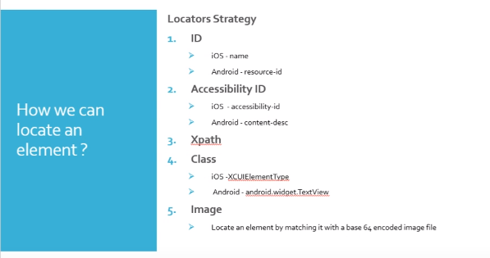

To start the Appium
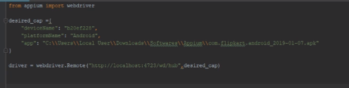
It will install the app and invoke the driver
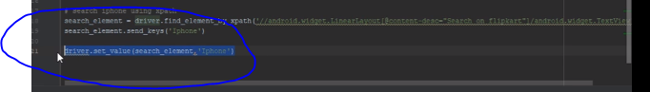
2 ways of sending keys

KeyEvent - https://developer.android.com/reference/android/view/KeyEvent

 to press the search button

Like JavaScript
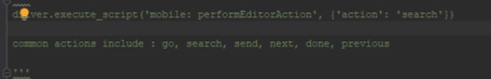
Set Value can be used to click on button/pop-ups

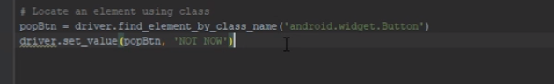

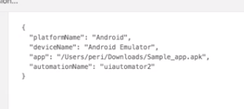
Sufficient to invoke any devices
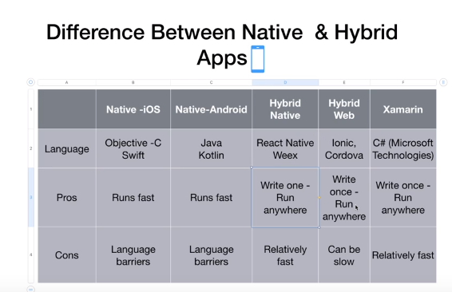
.
To scroll 5 times
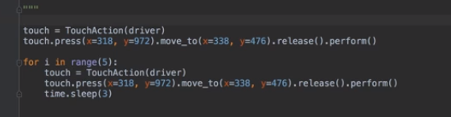
Video recording
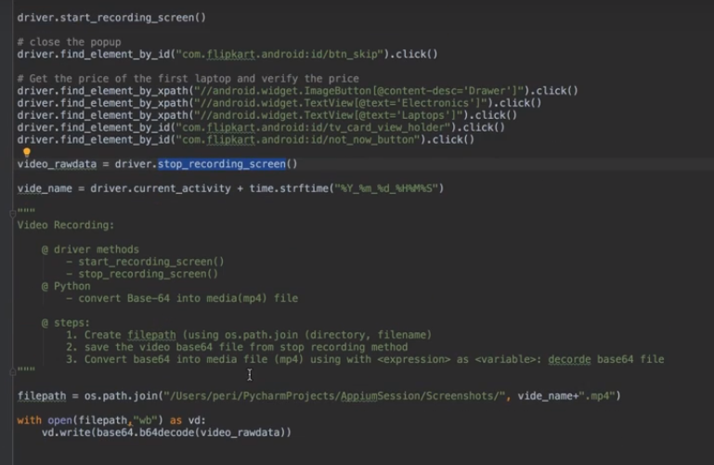
Take screenshot
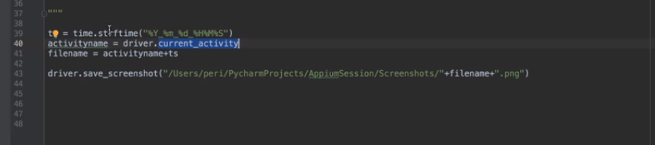
Gestures
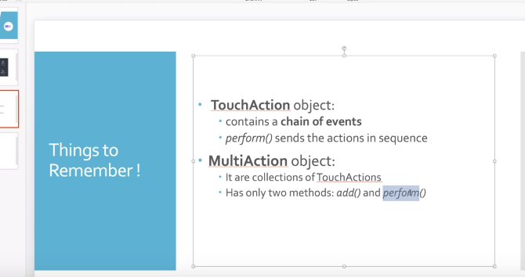

Keep session on
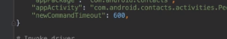
2 frameworks from 2 different vendors formed Appium
