**Further requirements in Mentis for the correct Invoice Processing:**

**Contractor Rates screen changes:**

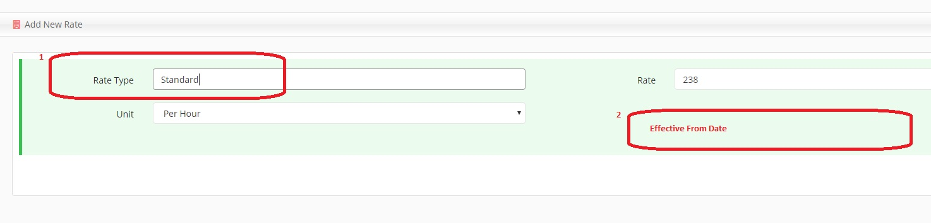

1. Rate Type – Currently this is a input text field and we need to change this as a select box which can have the following values.

*‘Standard’*, ‘*Overtime’* and ‘*Shift Allowance’*

These are the main type of rates and if this field is a input box, then there is chances to have multiple rate types for the same one due to typing mistake.

1. Effective From date : It is a new date field to understand on what date this rate is effective from.

Sometimes there will be two or more standard rates so we can identify this with effective from date.

**Contractor Rates Summary screen:**

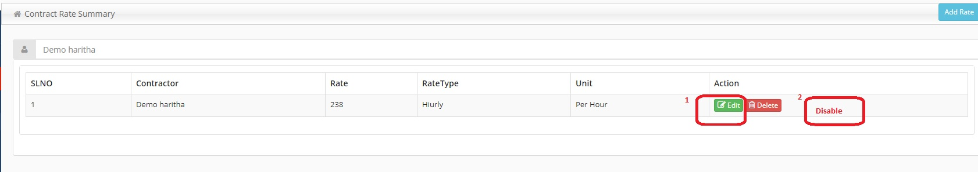

1. Edit button: No need of edit button here as once the rates is created then it won’t be allowed to do the updation as it might be used in any of the invoice creation. We can create a new rate if any updation is needed.
2. Disable button: Need a new button ‘Disable’ for disabling a rate. So in the Invoice Add screen only the enabled rates will be popped up.

**Add Invoice screen:**

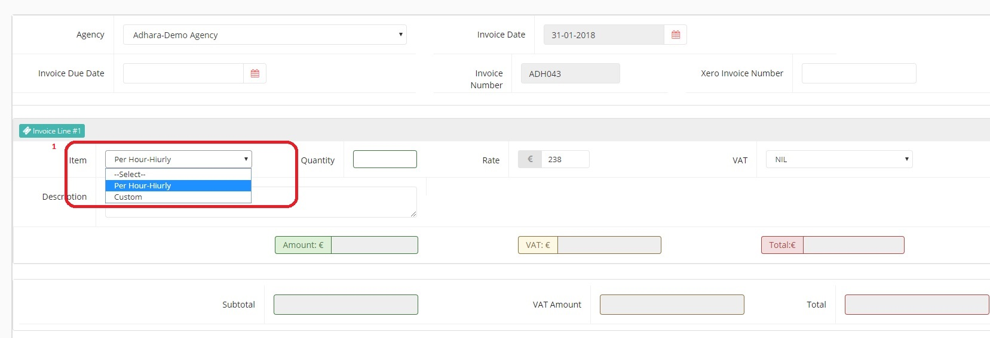

1. **Rate Type** select box, only the enabled rates from the contractor rates screen will be populated here. And this should include the ‘effective from date’ also in its option along with its rate type description.

That is ‘Standard Rate (01-01-2018)’ , Standard Rate (15-01-2018)’ etc.

If no date is set up in contractor rates, then only the description would be appeared. This will help to select correct rate if there is more rates with same description.

1. Also we need a Invoice Currency select box in Invoice Add screen to pick the currency. And this currency should appear in the Invoice Pdf

**Invoice VAT:**

Currently we have the task to auto populate the invoice VAT based on the agency country. That is if the agency country is in Ireland then the VAT should be 23% and if else it should be 0%

We also need some changes related to this in Invoice Pdf. That is if the agency is based in one of the EU countries, then we need to show the VAT registration number and also a note like ‘Inter Community reverse charge vat rules apply’ in the Invoice Pdf.

The VAT number should be placed in ‘Invoice To’ section and the above note should be placed in very bottom line of description box. (Please see the below pic)

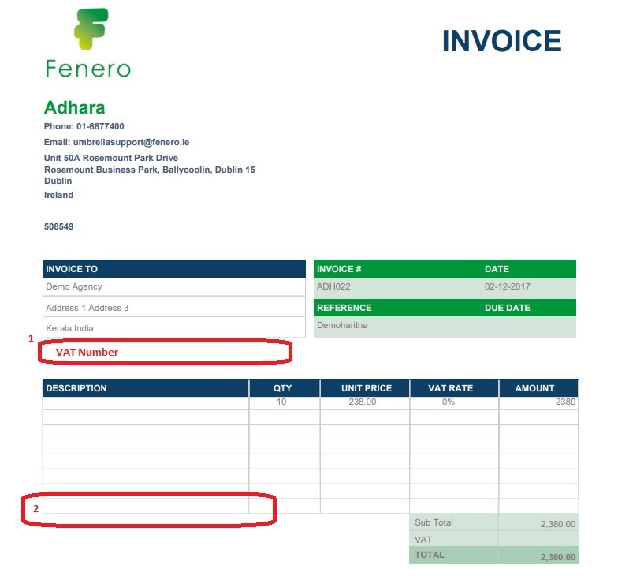

**Agency screen:**

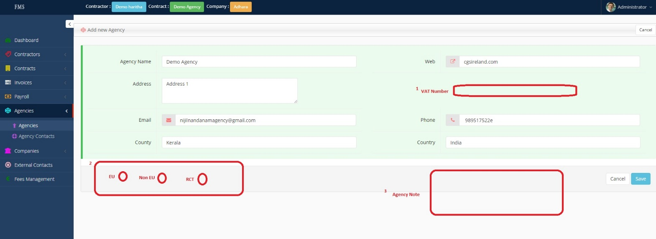

1. Currently the mentis is not holding the agency VAT number, so we need a new field for that in Agency screen. And this will be fetched to Invoice Pdf in case of EU agencies.
2. Also we need three radio button named as ‘EU’, ‘Non EU’ and ‘RCT’ so that we can select any of this while set up an agency. Based on this we can determine whether an agency is EU or Non EU
3. And also a text area for entering the Agency Note. And this note should also be displayed in Invoice Add screen. So this will help to understand the some agency specific things for invoice processing

**Agency Contacts Screen:**

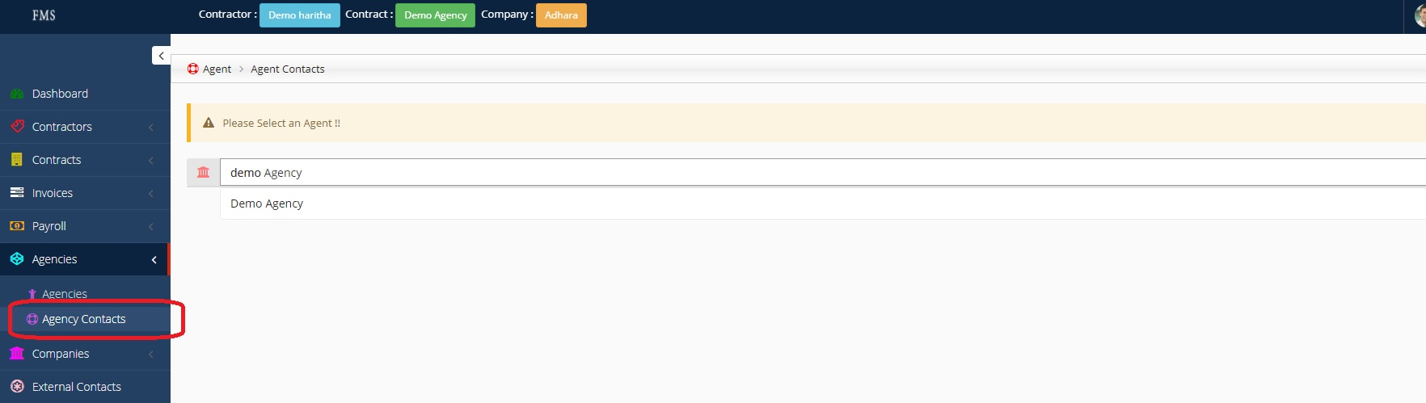

Currently in Agent Contact screen, we have to select an agency each time from the search box and then only it populates its agent contacts. I think we can change this as if the contract has already been selected, then the agent contact screen it should populate its agent contacts. If there is no agency selected then we can keep the screen as it is.

**Agency Contact add screen:**

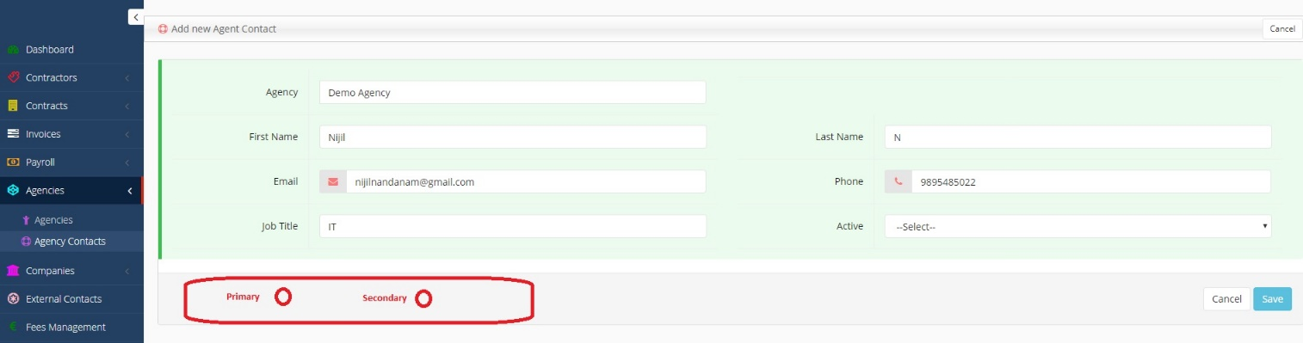

In this screen we need two radio checkboxes to pick whether the agent contact is a primary contact or secondary contact. It could have more primary contacts for an agencies. In such cases all the primary addresses should be populated in ‘To’ address field of Invoice Email pop up. It could be separated by comma. (Please see below)

**Invoice Email Window:**

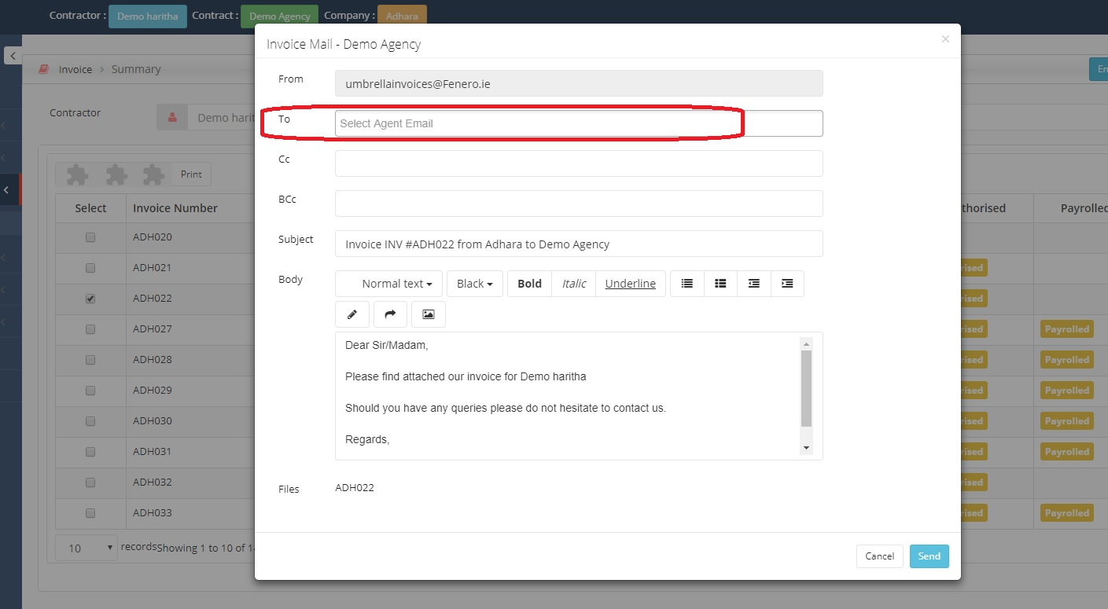

‘To’ email address field should automatically be populated with all the primary agent contacts (Separated by comma). And in the background code a Cc email should send to the contractor as well as to ‘umbrellainvoices@fenero.ie’