# Internship Progress Report

**Project Title: Wood Based Industries Licensing System**

**Intern Name: KIREEDULA NARESH**

**Company: C-DAC, GOVT OF INDIA**

**Internship Duration: JAN - JULY**

**Review Date: 07th of Apr, 2025**

## Introduction

The Wood Based Industries Licensing System is designed to digitalize and streamline the process of issuing and managing licenses for wood-based industries. The system ensures secure authentication, role-based access, and regulatory compliance while improving overall efficiency.

## System Analysis & Design

### Requirement Analysis

This system is designed based on the following requirements:  
- Secure user authentication and access control.  
- Integration with an existing MSSQL database.  
- Management of user roles and permissions.  
- Implementation of CAPTCHA for additional security.

### System Architecture

The application follows a structured architecture:  
- **Frontend**: Developed using React.js to provide a dynamic user experience.  
- **Backend**: Built with Node.js and Express.js to handle authentication and data processing.  
- **Database**: Uses MSSQL to store user details, roles, and licensing information.  
- **Security Measures**: JWT is used for authentication, and bcrypt is applied for password hashing.

### Database Design

The system utilizes the following key tables:  
- **Users Table**: Stores user information and credentials.  
**- Roles Table** Defines various user roles and permissions.  
- **User Roles Table**: Manages the relationship between users and their assigned roles.

-**Remaining Tables**: Existing tables are used for payments, storing license details etc.

## Work Completed

During the internship, the following tasks have been completed:  
- Implemented user authentication using JWT and bcrypt.  
- Integrated role-based access control to restrict functionalities based on user roles.  
- Developed API routes for secure data transmission between frontend and backend.  
- Designed an SVG-based CAPTCHA for enhanced login security.  
- Ensured compatibility with the existing MSSQL database.

-Designed and Developed Homepage, Login Page, Registration page, Contact us, About Us page, User dashboard for Application form, Dashboards for different roles

-Used inbuilt react library for showing stunning dashboard for admin panel for implementing Data Visualization

- Finished Developing the admin dashboard for seamless license tracking and approval and data visualization

# Components worked on (Feb 28 – April 07, 2025)

## Admin DASHBOARD:

Created dashboard for Admin role with tailored features like license approval and status tracking.

* Worked on 6 Data Visualization Components for Admin, they are
  + - Total Units by District Bar Graph
    - Unit Categories Distribution Pie Chart
    - Active vs Expired Licenses Pie Chart
    - Applications Type Comparison per month (Line Chart)
    - District Wise Approved and Pending Applications (Bar Graph)
    - Ownership Changes per Year by Category Wise (Line Graph)

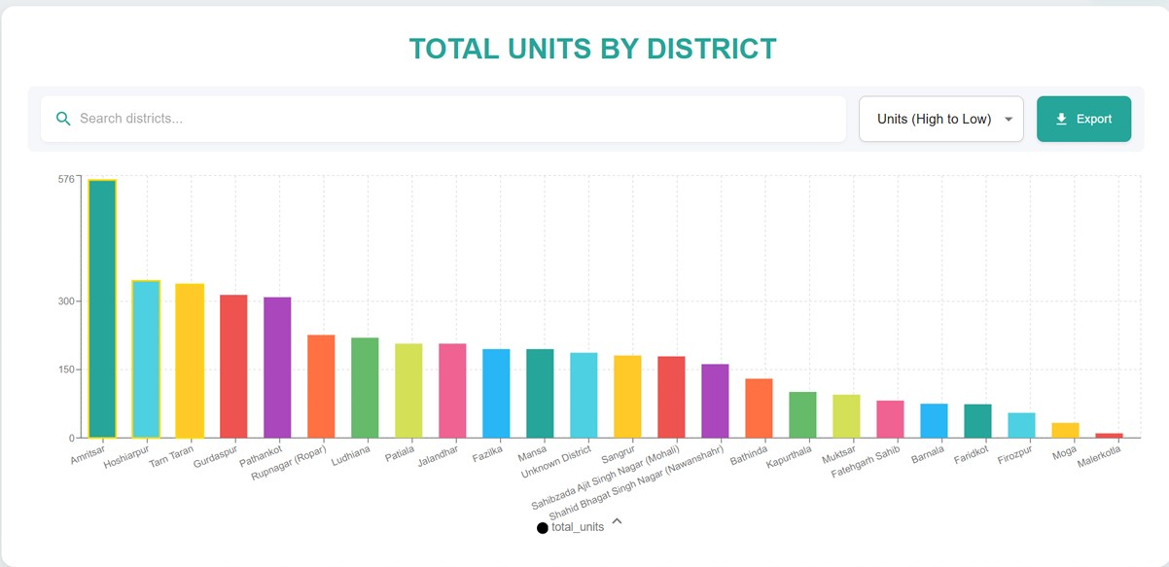

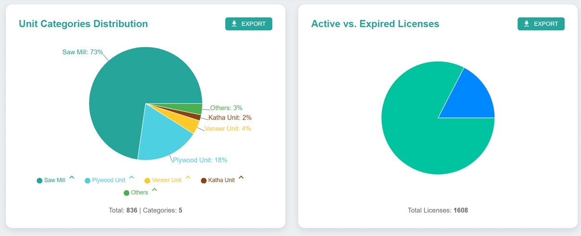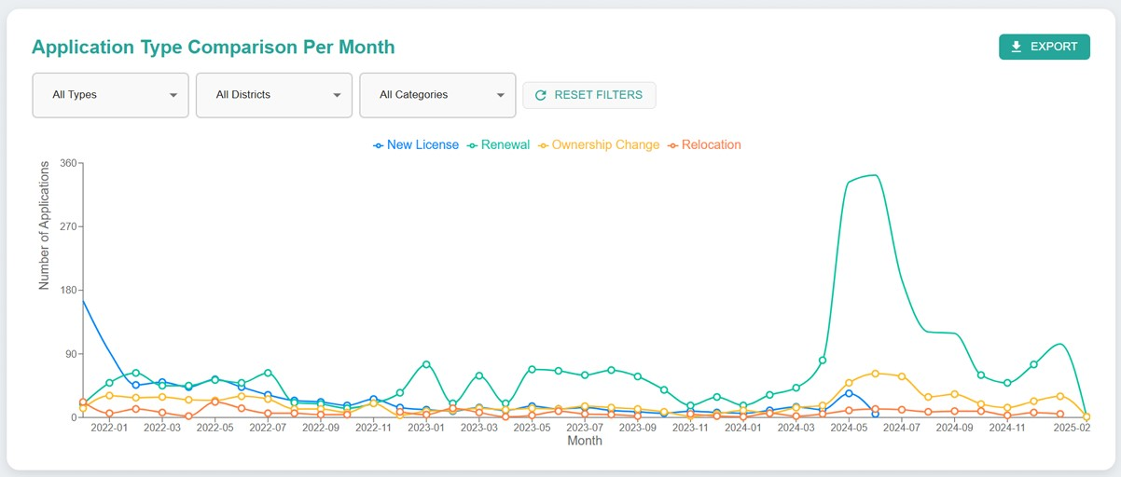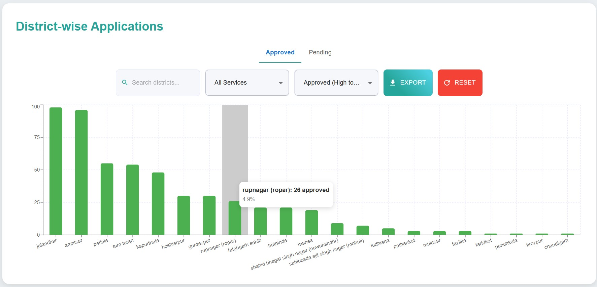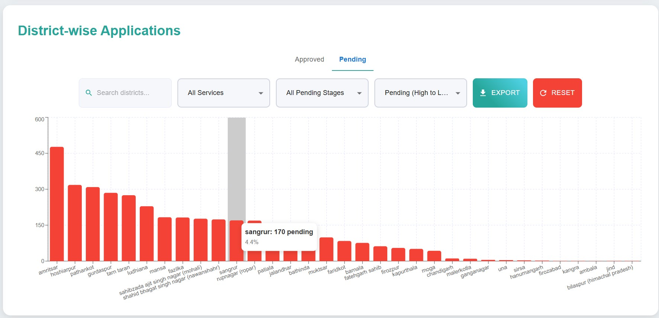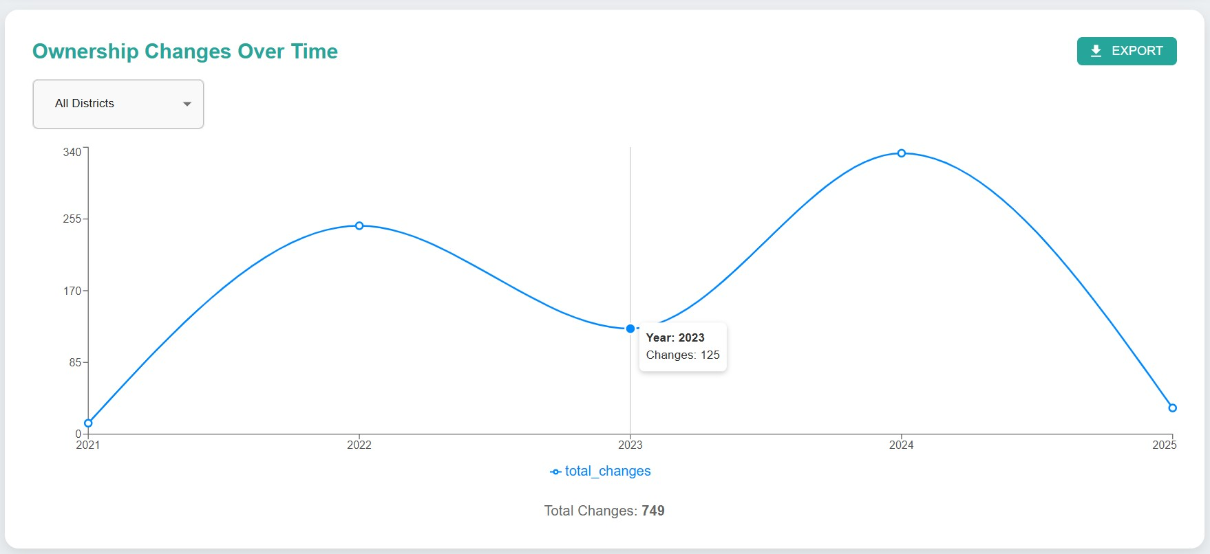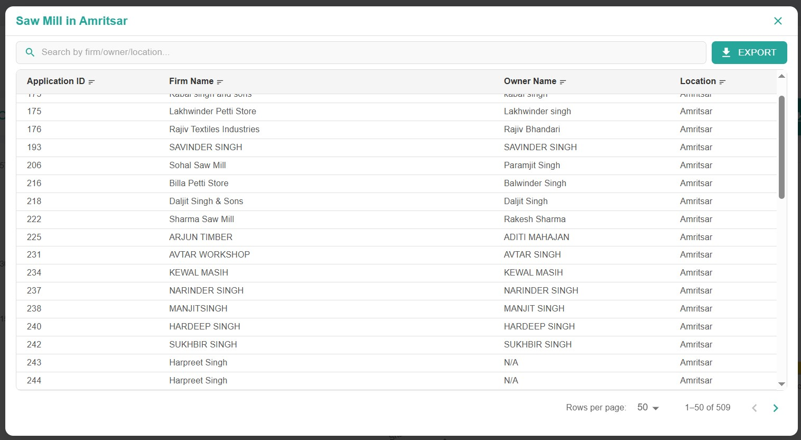

## Challenges Faced

While working on the project, the following challenges were encountered:  
- Converting ASP.NET Identity password hash to work with Node.js authentication.  
- Implementing efficient role-based access control while maintaining security.  
- Managing session expiration using JWT tokens.  
- Designing and integrating a custom CAPTCHA system for login security.

-Cracking the algorithm used for password hash used for existing users

-Finding the same framework like ASP .Net Identity Framework in Node, Express.js

-Implementing the existing database Structure with new tech stack

## Pending Tasks

- Designing and Developing Admin Dashboard and Dashboards for different Officers like District Forest Officer (DFO), Operator etc.  
- Improving UI/UX for better usability.  
-Connecting Existing databases of payments, licenses with the new website.  
- Design and developing the new Application form from user.

-Online File Movement from one role to another role (Officer to Officer)

## Conclusion

Significant progress has been made in developing the Wood Based Industries Licensing System. With authentication, role management, and security measures in place, the system is well on its way to being fully operational. The final steps involve refining the interface, testing the system thoroughly, and deploying it for production use.

Submitted By: **KIREEDULA NARESH**

Date: **07th of April, 2025.**