# EE450

Routing Protocols; RIP & OSPF Simulation using Riverbed Modeller

# NAME: AKSHAY DEEPAK HEGDE

# SESSION 3

Introduction:

RIP is a distance vector routing protocol that uses only the hop count as its metric to determine the best path from source to destination.

In RIP protocol routers learn about the destination networks from neighboring routers through the sharing process. Routers running RIP protocol periodically broadcast the configured networks from all ports. Listing routers will update their routing table based on this information.

* RIP routing protocol uses local broadcast to share routing information.
* RIP broadcasts routing updates in every 30 seconds, regardless something in network has changed or not. Once 30 seconds expires, routers running RIP protocol will broadcast their routing information to any devices connected to their interfaces.
* Before sending routing updates router add a initiating metric to every routes which it has and increments the metric of incoming routes in advertisements so the listing router can learn how far destination network is.
* While sending broadcasts RIP does not care about who listens these broadcast updates or not.
* After sending broadcast RIP does not care whether neighbors received these broadcast updates or not.
* When router receives routing updates, it compares them with the routes which it already has in its routing table.
* If update has information about a route which is not available in its routing table, router will consider that route as a new route.
* Router will add all new routes in routing table before updating existing one.
* If update has better information for any existing route, router will replace old entry with new route.
* If update has worse information for any existing route, router will ignore it.
* If update has exactly same information about any existing route, router will reset the timer for that entry in routing table.

RIP Protocol Simulation:

In the current lab, we are supposed to set up a network that utilizes RIP as its routing protocol and to analyze the routing tables generated in the routers, and observe how RIP is affected by link failures.

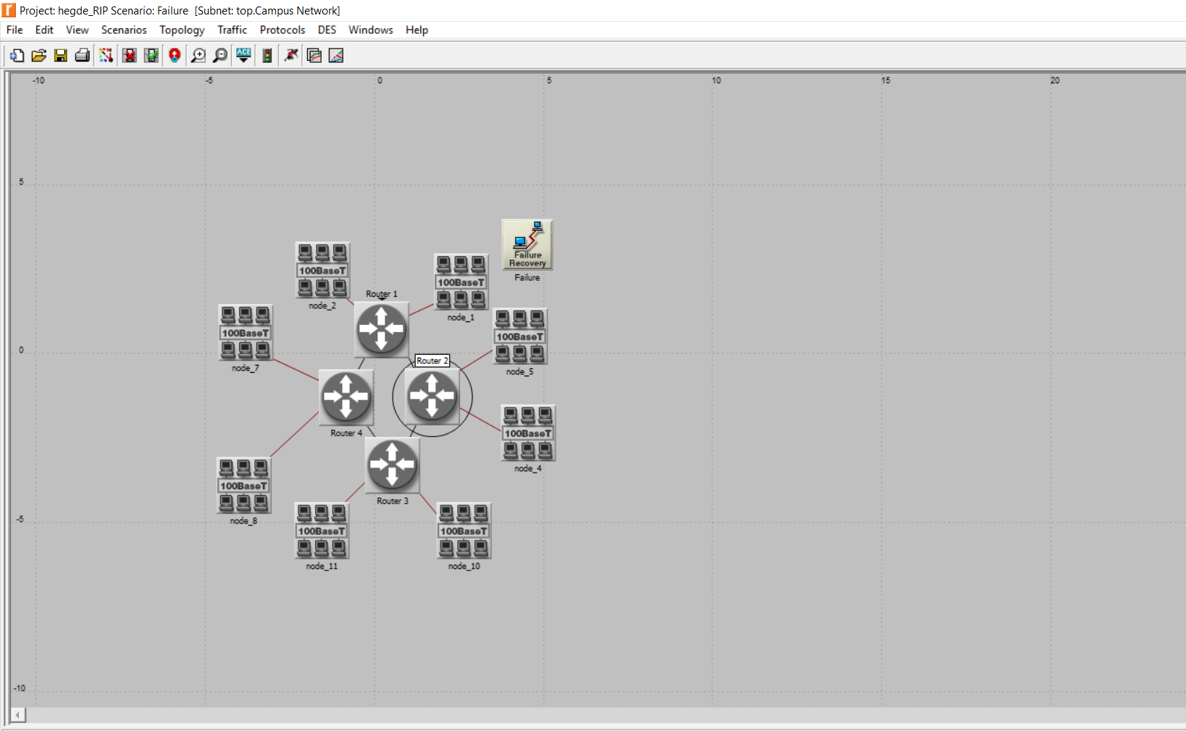

Figure. 1. IP assignment of Routers and Nodes during the simulation

1. Firstly, R1 shares its reachability information to its neighbors R2, R3 and R4 routers. So, the three bar graphs in the first few seconds.

Also, we observe that every 30secs, R1 provides its reachability information to its neighboring routers (R2 and R3). Hence we see two Histogram bar graphs periodically.

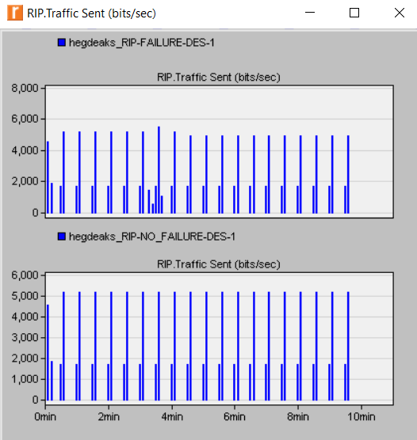

Figure.2. Traffic sent (bits/sec) for No_Failure and Failure scenarios

1. R1 initially uses R2 information to know the distance between R1 and R2. But based on the figures below, the routing table indicates that R1 reaches to R3 via R4 and not via R2. In case of no failure, everything is smooth.

But upon link failure, R1 must have lost the link providing the reachability of Net20 and Net21. Now, R1 takes help of R2 and R3 to reach R4. S0, after failure at 200s, new path from R1 to Net20 and Net21 is R1->R4->R3->R2.

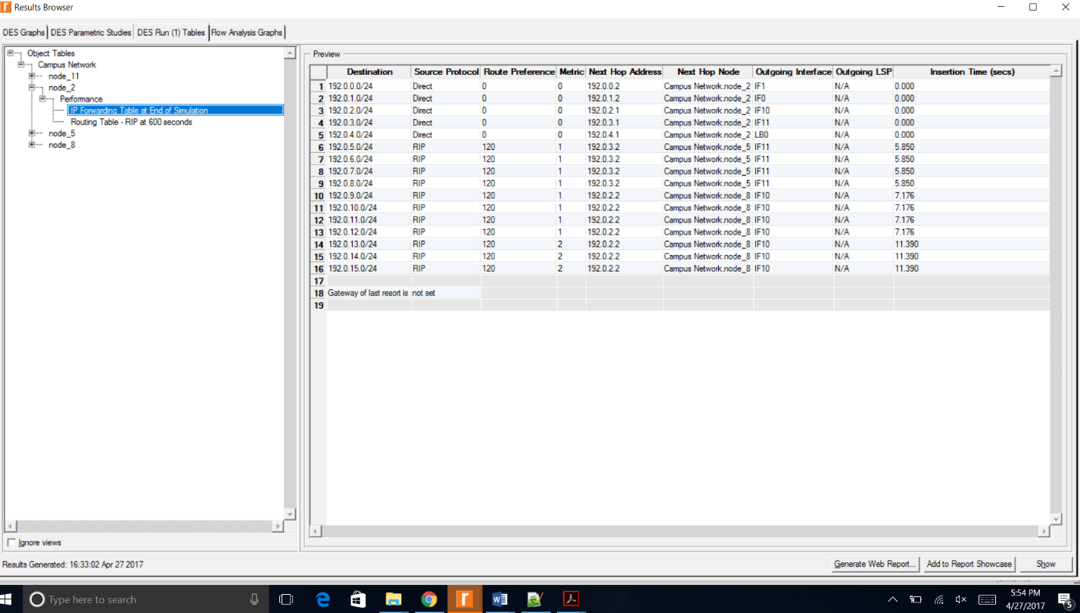

Figure.3. IP Forwarding table at the end of simulation for NO_Failure

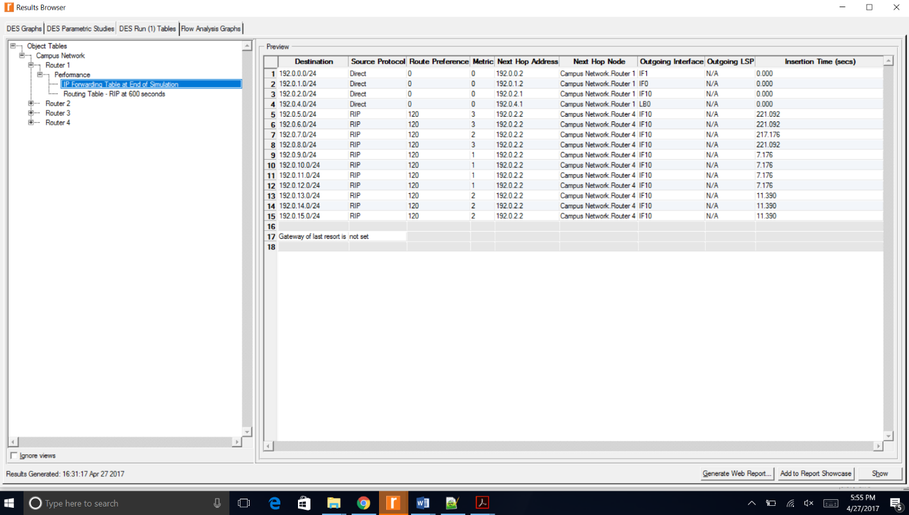

Figure.4. IP Forwarding table at the end of simulation for Failure (200 secs)

1. After the failure of link between R1 and R2 at 200s, the link comes up again at 400s. This implies that the routing information after 400s should be same as initial. So, when the failure of link occurred, R1 reaches Net20 and Net21 via R1->R4->R3->R1. But, after recovery phase, path to Net20 and Net21 nodes is via R2. Hence, it is evident that RIP is impacted upon a link failure and upon restoration.

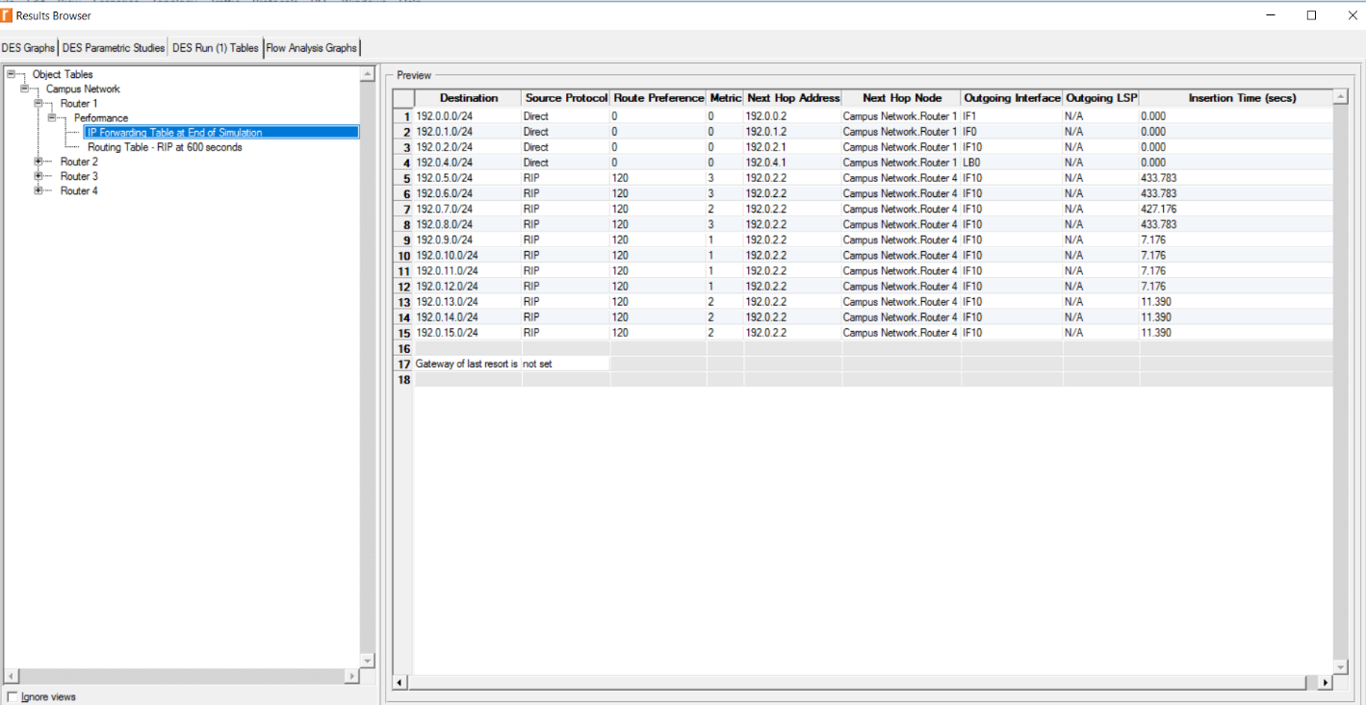

**F**igure.5. IP Forwarding table at the end of simulation for Q3_Recover

OSPF Routing Protocol:

OSPF stands for Open Shortest Path First. OSPF is a link state open standard based routing protocol.

When configured, OSPF will listen to neighbors and gather all link state data available to build a topology map of all available paths in its network and then save the information in its topology database, also known as its **Link-State Database (LSDB).** Using the information from its topology database. From the information gathered, it will calculate the best shortest path to each reachable subnet/network using an algorithm called **Shortest Path First (SFP).** OSPF will then construct **three tables** to store the following information:

* Neighbor Table: Contains all discovered OSPF neighbors with whom routing information will be interchanged
* Topology Table: Contains the entire road map of the network with all available OSPF routers and calculated best and alternative paths.
* Routing Table: Contain the current working best paths that will be used to forward data traffic between neighbors

1.

In case of NO_Areas scenario,

The cost of the path from R-A to R-C is least from R-D and R-E, which is 15.

The cost of the path from R-B to R-H is least from Router A-D-F **or** Router C-E-G, which is 40

In case of Areas scenario,

The cost of the path fromR-A to R-C is direct which is 20.

The cost of the path from R-B to R-H is least from Router A-D-F **or** Router C-E-G, which is 40.

In case of Balanced scenario,

The cost of the path fromR-A to R-C is via R-D and R-E, which is 15.

The cost of the path from R-B to R-H is least from Router A-D-F and Router C-E-G which is 40 where the load of traffic is balanced between both the routes.

Configuration generated in Riverbed to fetch all IP address of all Nodes and interfaces,

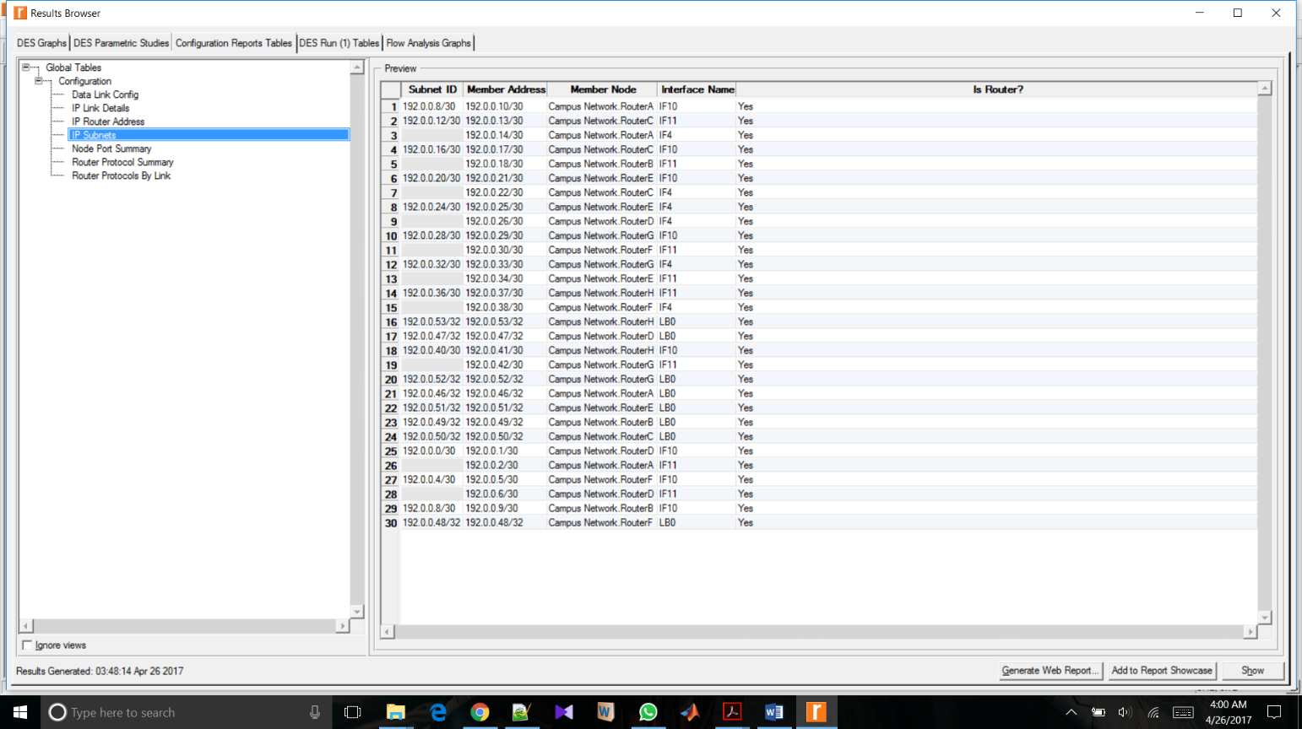

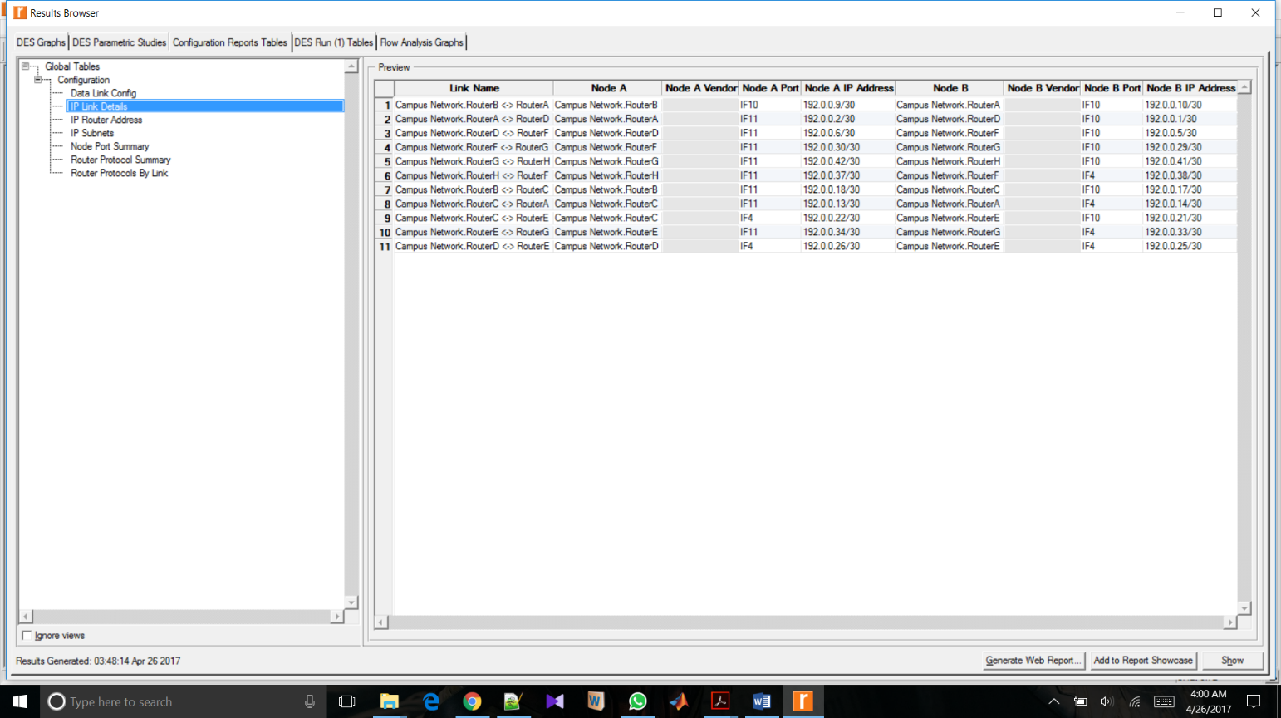

The IP table for all the interfaces and nodes have been generated to examine the generic data file of the generated routing table.

2.

Part-a) No_Areas_Scenario:

Ex: Let us take the first OSPF1 entry from figure-6(marked in blue/black) where the destination is 192.0.0.4/30.

* This belongs to Router F on the interface of side D. Also, the IP 192.0.0.0 belongs to router A. So, if Router A is to send an information/packet to RouterF, it must go via the D.
* The next Hop address is 192.0.0.1 which belongs to the RouterD. This means that the first entry tells us that, “for Router-A to reach RouterF, it has to take the path via RouterD and the metric/cost between them is 5+5 = 10”

Similarly, metric values for all the entries in the routing tables for Router A and other routers are calculated.

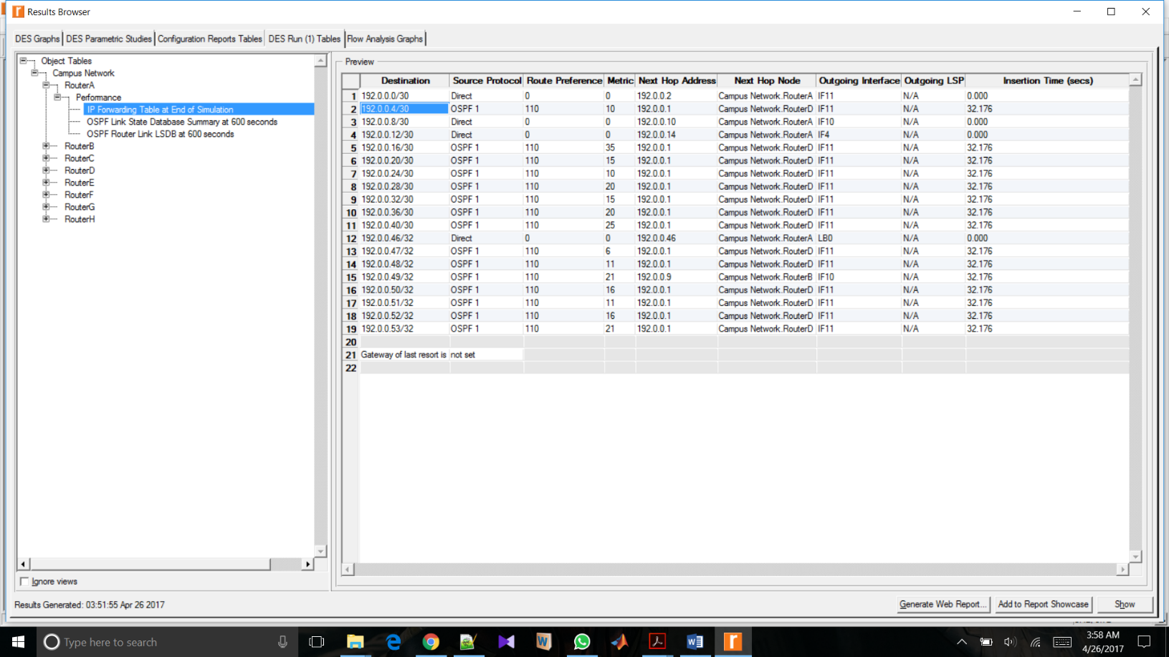

Figure.6. IP Forwarding table at the end of simulation for No_Areas Scenario

Part-b) Areas_Scenario:

Ex: Let us take the entry-5 from figure-7(marked in blue/black) where the destination is 192.0.0.16/30.

* This belongs to Router C on the interface of side B. Also, the IP 192.0.0.0 belongs to router A. The next Hop address is 192.0.0.9 which belongs to the RouterB.
* So, if Router A is to send an information/packet to RouterC and since here the priority of destination is given to routers within same Area, and the fact that the next Hop is RouterB “for Router-A to reach RouterC, it takes the path via RouterB and the metric/cost between them is 20+20 = 40”

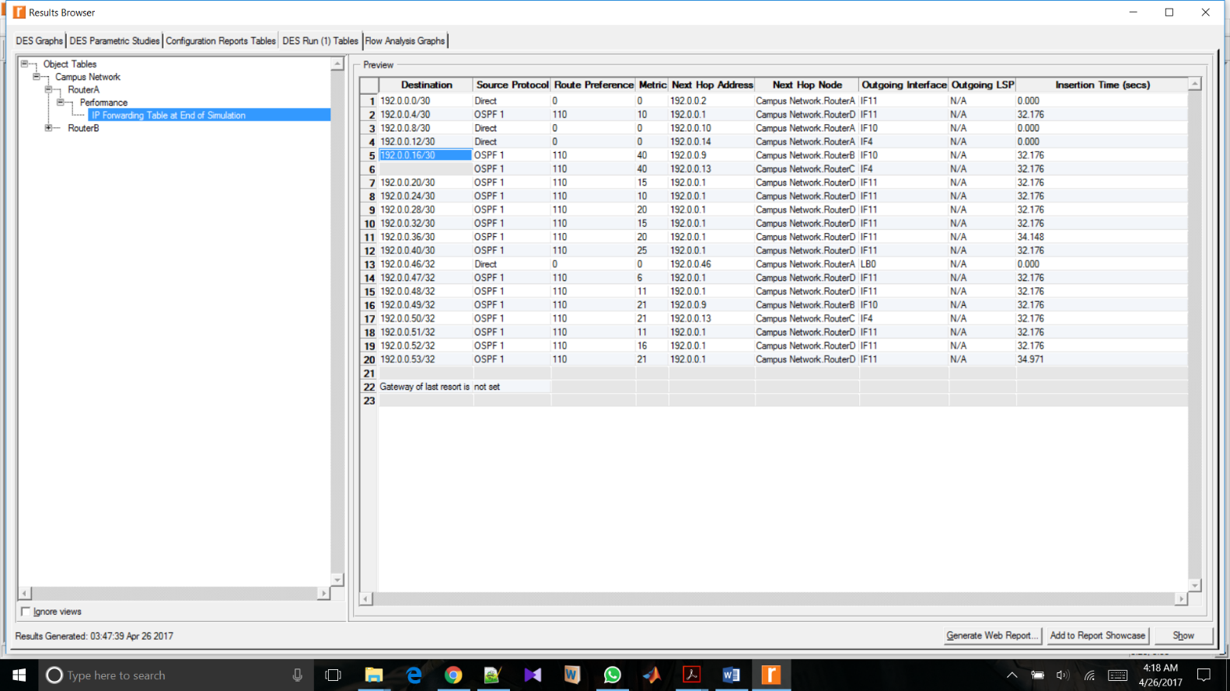

Fig.7. IP Forwarding table at the end of simulation for Areas Scenario

Part-c) Balanced_Scenario:

Ex:Let us take the first OSPF1 entry from figure-6(marked in blue/black) where the destination is 192.0.0.4/30.

* This belongs to Router F on the interface of side D. Also, the IP 192.0.0.0 belongs to router A. So, if Router A is to send an information/packet to RouterF, it must go via the D.
* The next Hop address is 192.0.0.1 which belongs to the RouterD. This means that the first entry tells us that, “for Router-A to reach RouterF, it has to take the path via RouterD and the metric/cost between them is 5+5 = 10”

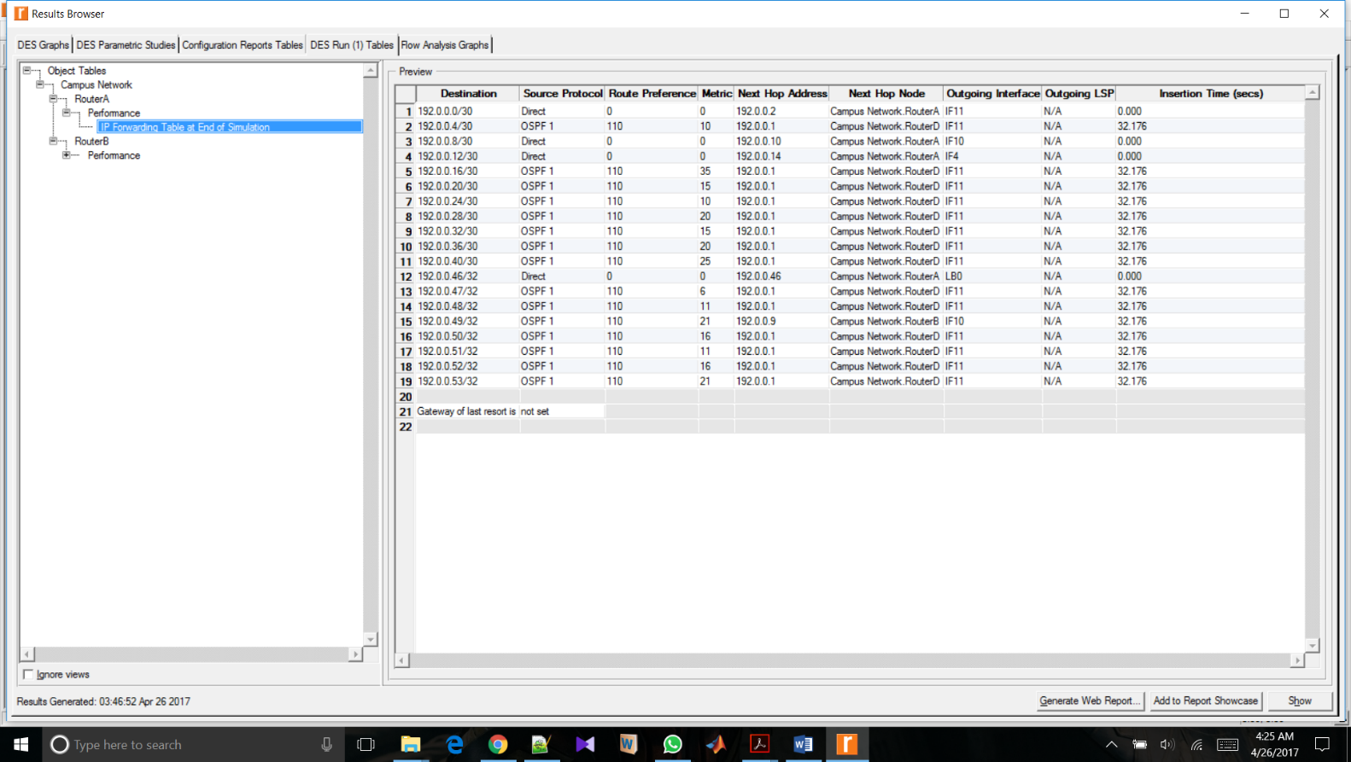

Figure.8. IP Forwarding table at the end of simulation for Balanced Scenario

Conclusion:

Simulation of the the Routing protocols such as RIP and OSPF in this lab helped me understand the concepts and theories behind the protocols. Using the Riverbed Modeller simulation, I could clearly get the picture of the implementation of the above protocols. Particularly, how the link failure make an impact on the protocols.