# EE450

# Wireshark Analysis and Riverbed Modeling of WLANs

# NAME: SHASHIKIRAN GANAPATI HEGDE

# SESSION 1

**WIRESHARK ANALYSIS**

1.

The two access points that are issuing most of the beacon frames have an SSID of “30 Munroe St” and “linksys12”

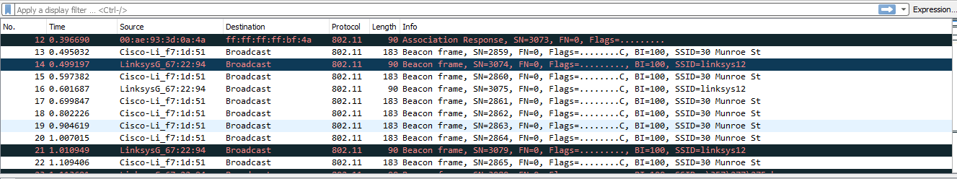

2.

The beacon interval for both access points in reported in the Beacon Interval of the 802.11 wireless LAN Management frame which is equal to .1024 seconds

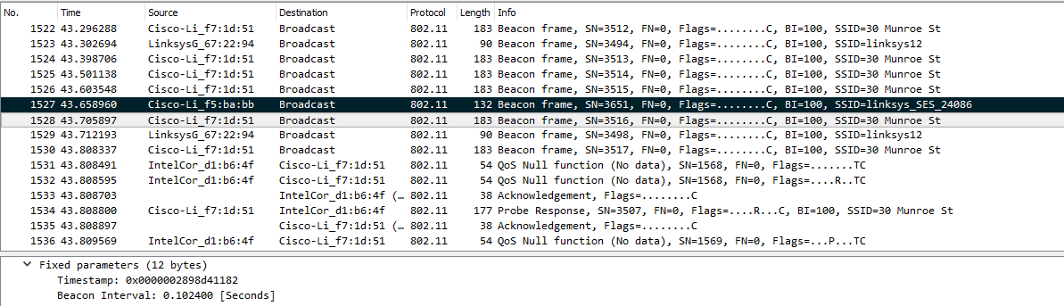

3.

The source MAC address on the 30 Munroe St, beacon frame is 00:16:b6:f7:1d:51

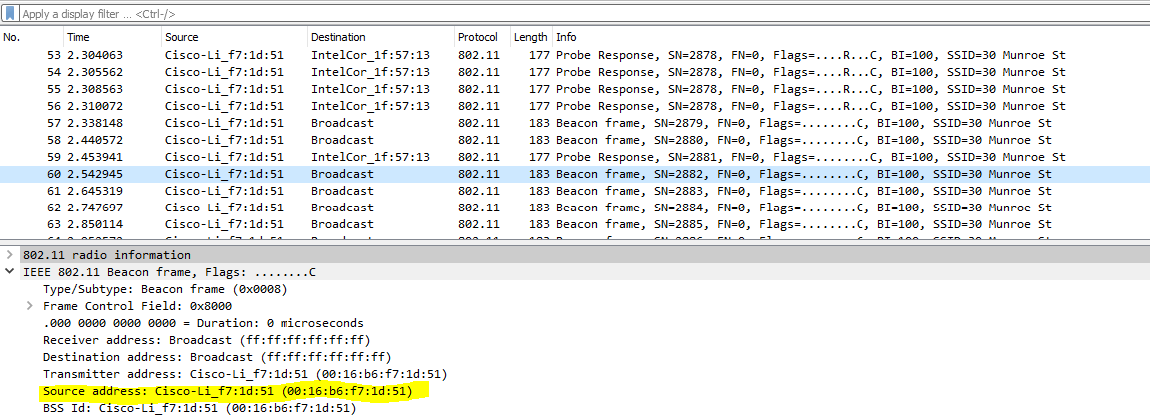

4.

The destination MAC address on the 30 Munroe St beacon frame is ff:ff:ff:ff:ff:ff, i.e., the Ethernet broadcast address as highlighted in yellow.

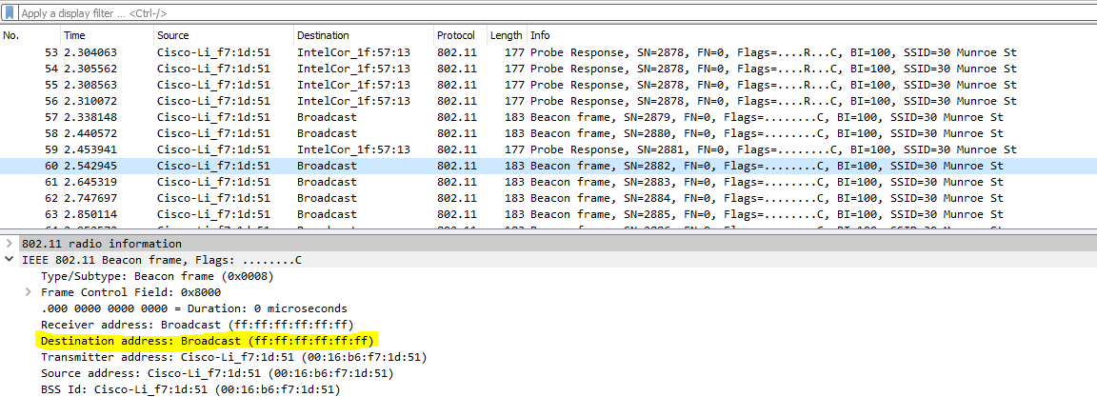

5.

The MAC BSS ID address on the 30 Munroe St, beacon frame is 00:16:b6:f7:1d:51.

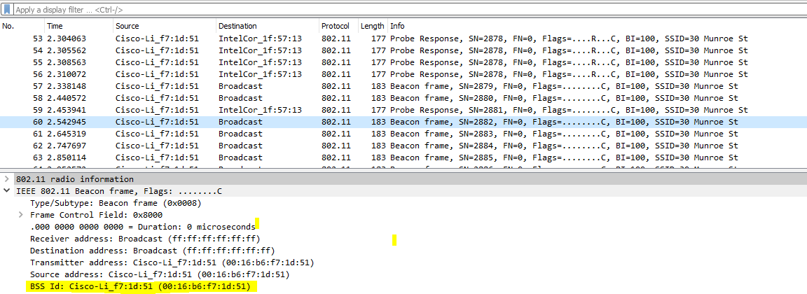

6.

The support rates are 1.0, 2.0, 5.5, 11.0 Mbps. The extended rates are 6.0, 9.0, 12.0, 18.0, 24.0, 36.0, 48.0 and 54.0 Mbps.

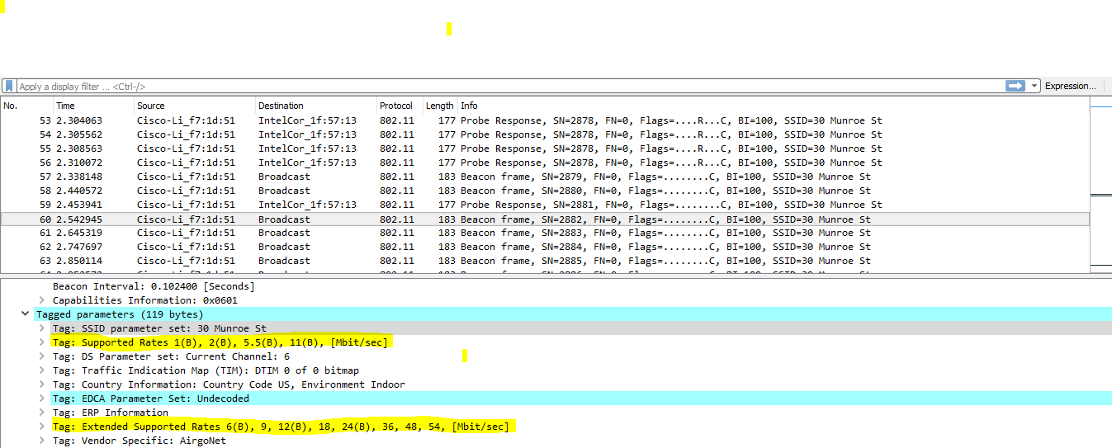

7.

The TCP SYN is sent at t = 24.811093 seconds into the trace. The MAC address for the host sending the TCP SYN is 00:13:02:d1:b6:4f. The MAC address for the destination, which is the first hop router to which the host is connected, is 00:16:b6:f4:eb:a8. The MAC address for the BSS is 00:16:b6:f7:1d:51. The IP address of the host sending the TCP SYN is 192.168.1.109.The destination address is 128.199.245.12. This corresponds to the server gaia.cs.umass.edu.

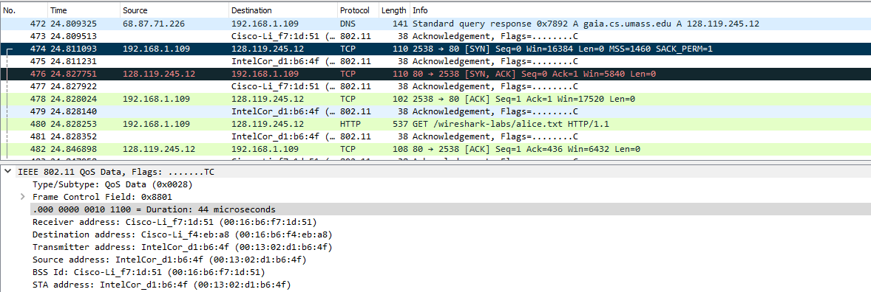

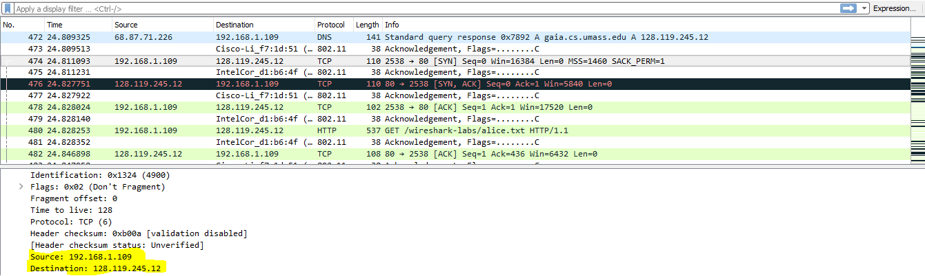

8.

The TCP SYNACK is received at t = 24.827751 seconds into the trace. The MAC address for the sender of the 802.11 frame containing the TCP SYNACK segment is 00:16:b6:f4:eb:a8, which is the 1st hop router to which the host is attached . The MAC address for the destination, which the host itself, is 91:2a:b0:49:b6:4f. The MAC address for the BSS is 00:16:b6:f7:1d:51. The IP address of the server sending the TCP SYNACK is 128.199.245.12 (gaia.cs.umass.edu) .The destination address is 192.168.1.109 .

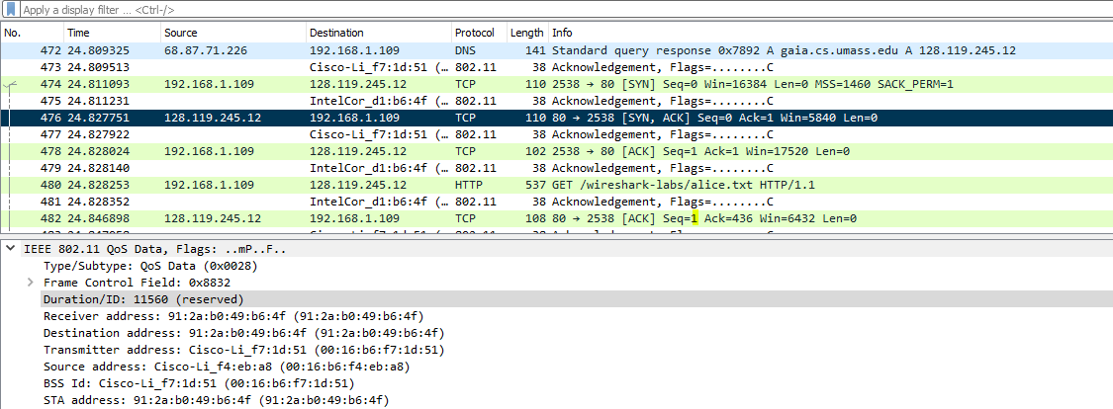

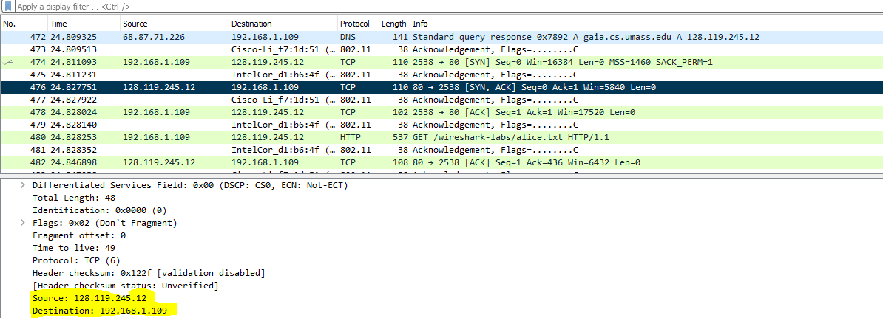

9.

At t = 49.583615 a DHCP release is sent by the host to the DHCP server (whose IP address is 192.168.1.1) in the network that the host is leaving. At t = 49.609617, the host sends a DEAUTHENTICATION frame (Frametype = 00 [Management], subframe type =12[Deauthentication]). I expected to see a DISASSOCIATION request to have been sent.

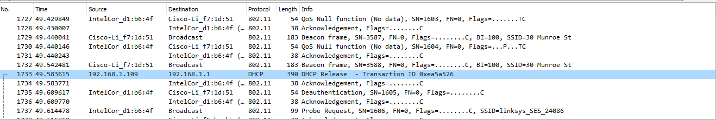

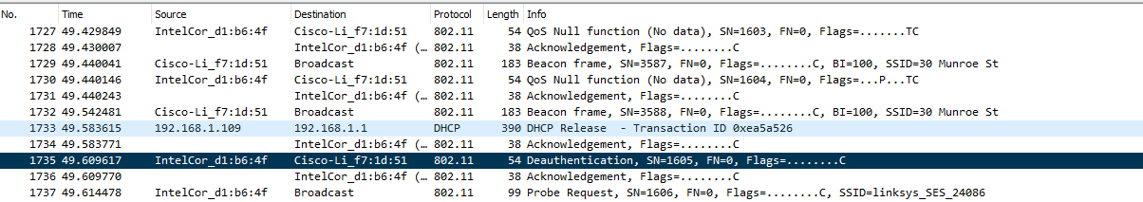

10.

The first AUTHENTICATION from the host to the AP is at t = 49.638857. I could see a total of 5 AUTHENTICATION frames around t=49 s.

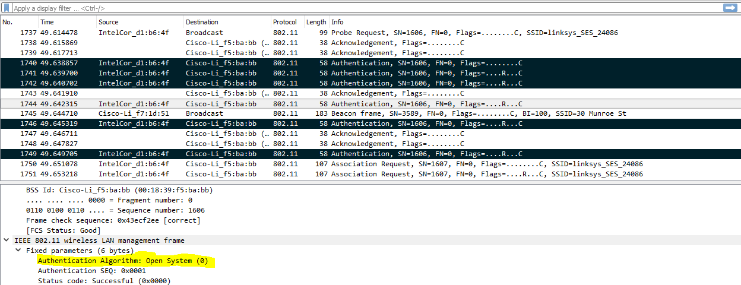

11.

The host is requesting that the association be open by specifying Authentication Algorithm: Open System. It is highlighted in yellow in the previous screenshot.

12.

I can’t find any reply from the AP. This is probably because the AP is configured to require a key when associating with that AP, so the AP is likely ignoring (i.e., not responding to) requests for open access.

13.

At t =63.168087 there is a AUTHENTICATION frame sent from 00:13:02:d1:b6:4f (the wireless host) to 00:16:b7:f7:1d:51 (the BSS). At t = 63.169071 there is an AUTHENTICATION from sent in the reverse direction from the BSS to the wireless host.

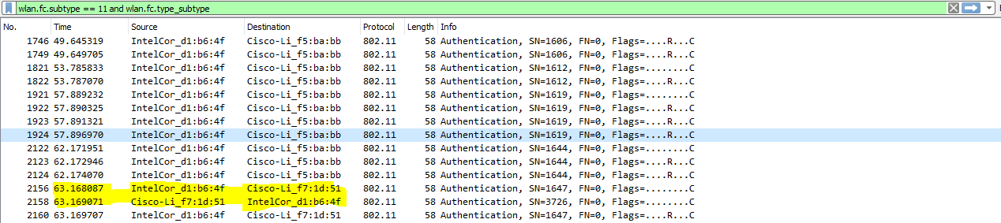

14.

At t = 63.169910 there is an ASSOCIATE REQUEST frame sent from 00:13:02:d1:b6:4f (the wireless host) to 00:16:b7:f7:1d:51 (the BSS). At t = 63.192101 there is an ASSOCIATE RESPONSE from sent in the reverse direction from the BSS to the wireless host. The frames are highlighted in blue in the below screenshot

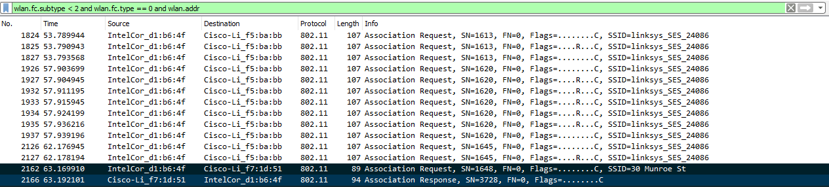

15.

In the ASSOCIATION REQUEST frame the supported rates are advertised as 1, 2, 5.5, 11, 6, 9, 12, 18, 24, 32, 48, and 54 Mbps. The same rates are advertised in the ASSOCIATION RESPONSE. The first screenshot is for ASSOCIATION REQUEST and the second is for ASSOCIATION RESPONSE.

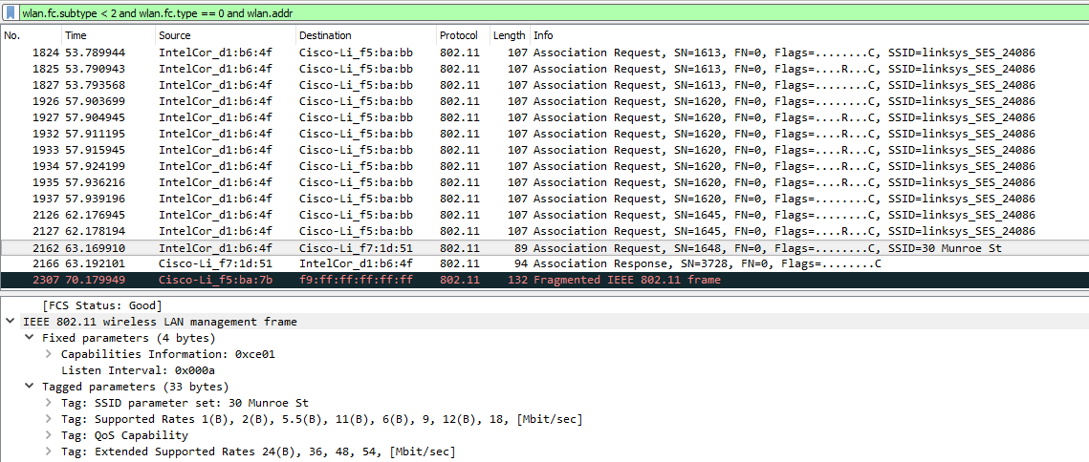

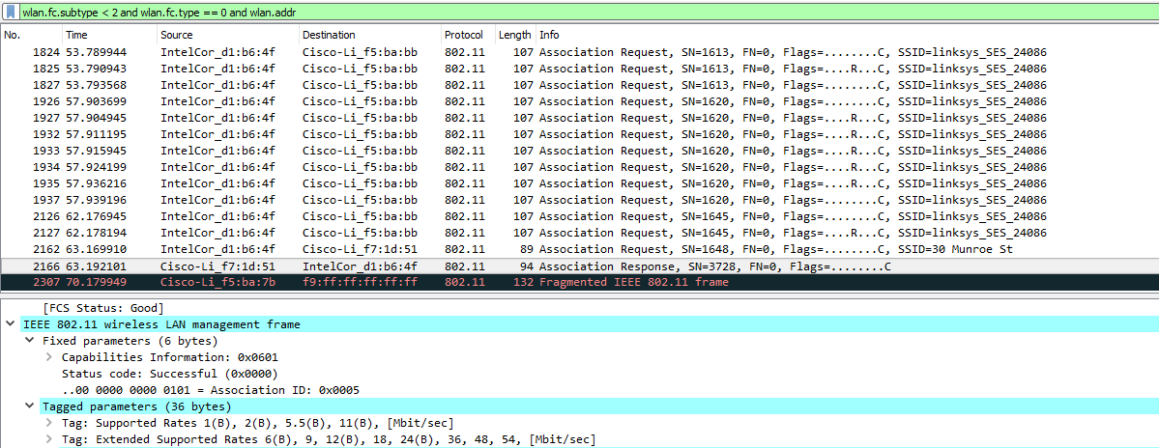

16.

At t = 2.297613 there is a PROBE REQUEST sent with source 00:12:f0:1f:57:13, destination ff:ff:ff:ff:ff:ff, and a BSSID of ff:ff:ff:ff:ff:ff. At t = 2.300697 there is a PROBE RESPONSE sent with source: 00:16:b6:f7:1d:51, destination and a BSSID of 00:16:b6:f7:1d:51. A PROBE REQUEST is used by a host in active scanning to find an Access Point. A PROBE RESPONSE is sent by the access point to the host sending the request.

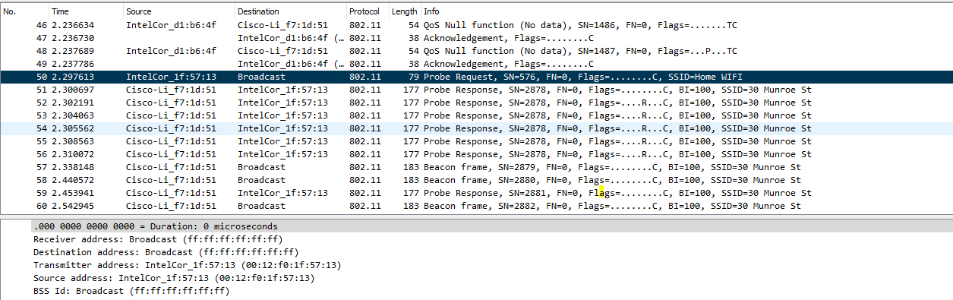

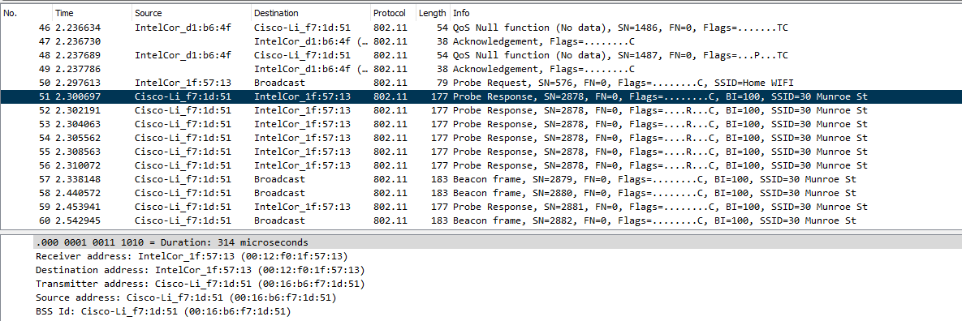

**CONCLUSION**

* The support rates are 1.0, 2.0, 5.5, 11.0 Mbps. The extended rates are 6.0, 9.0, 12.0, 18.0, 24.0, 36.0, 48.0 and 54.0 Mbps for the 30 Munroe street AP
* AUTHENTICATION request is sent from the wireless host to the BSS(Basic service set).
* ASSOCIATION request is sent from the wireless host to the BSS whereas the ASSOCIATION response is sent from the BSS to the wireless host.

**RIVERBED ANALYSIS**

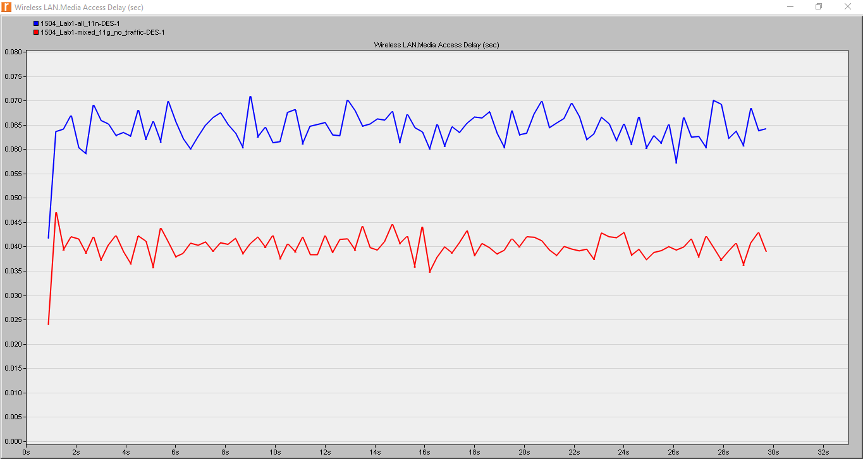

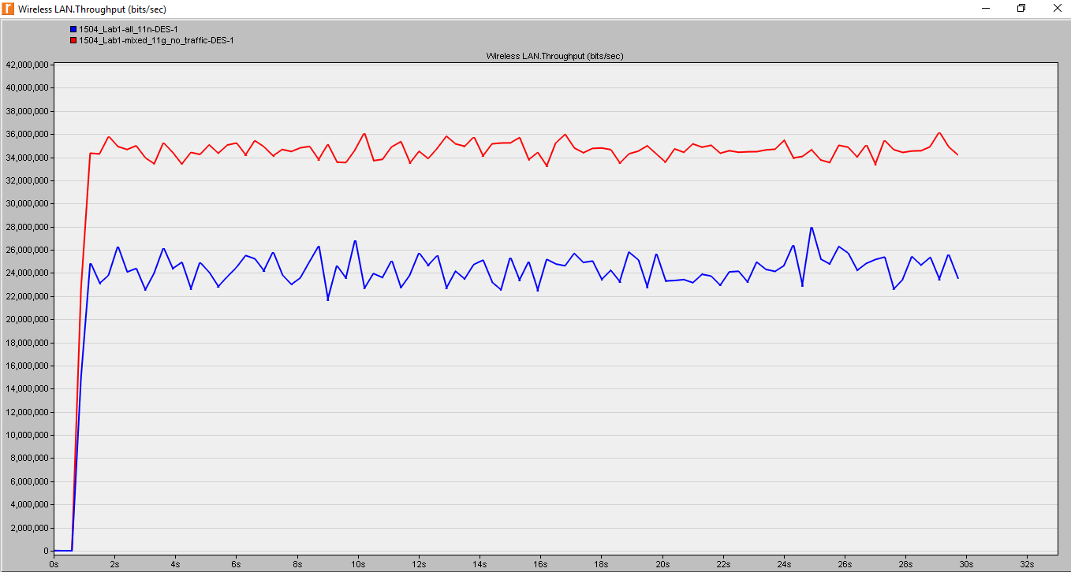

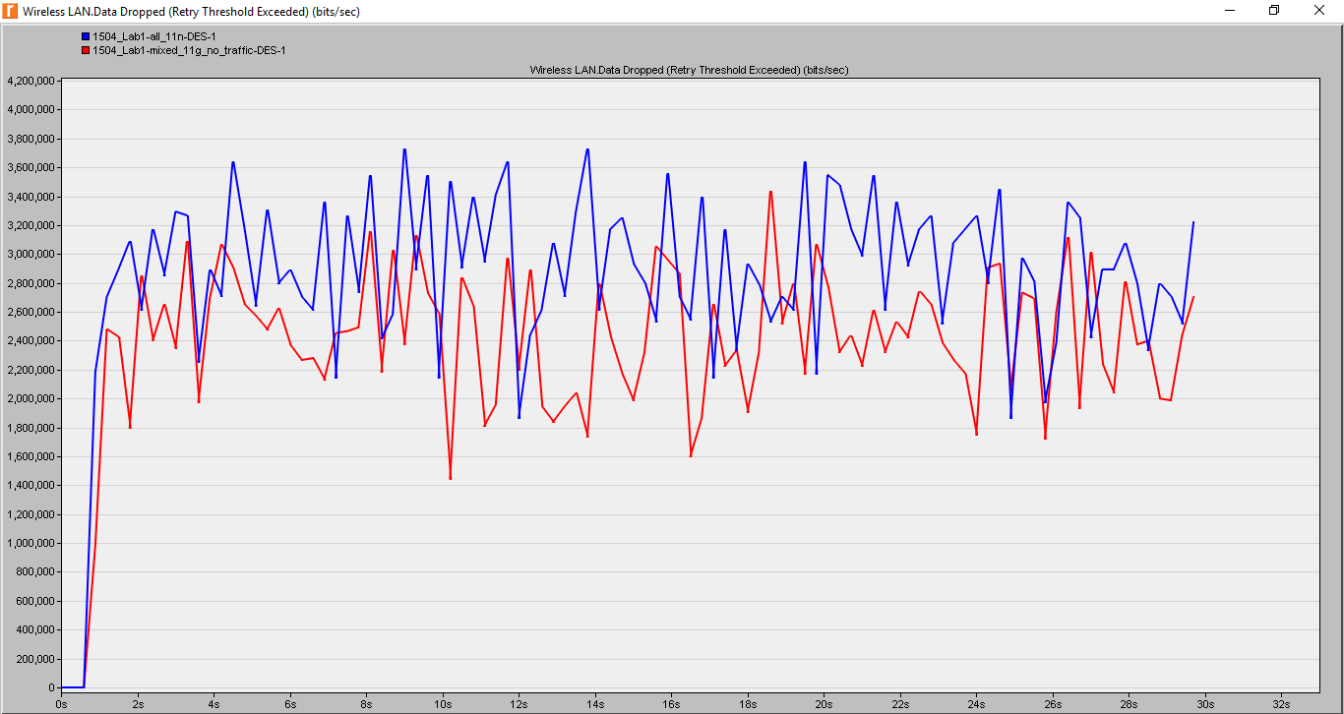

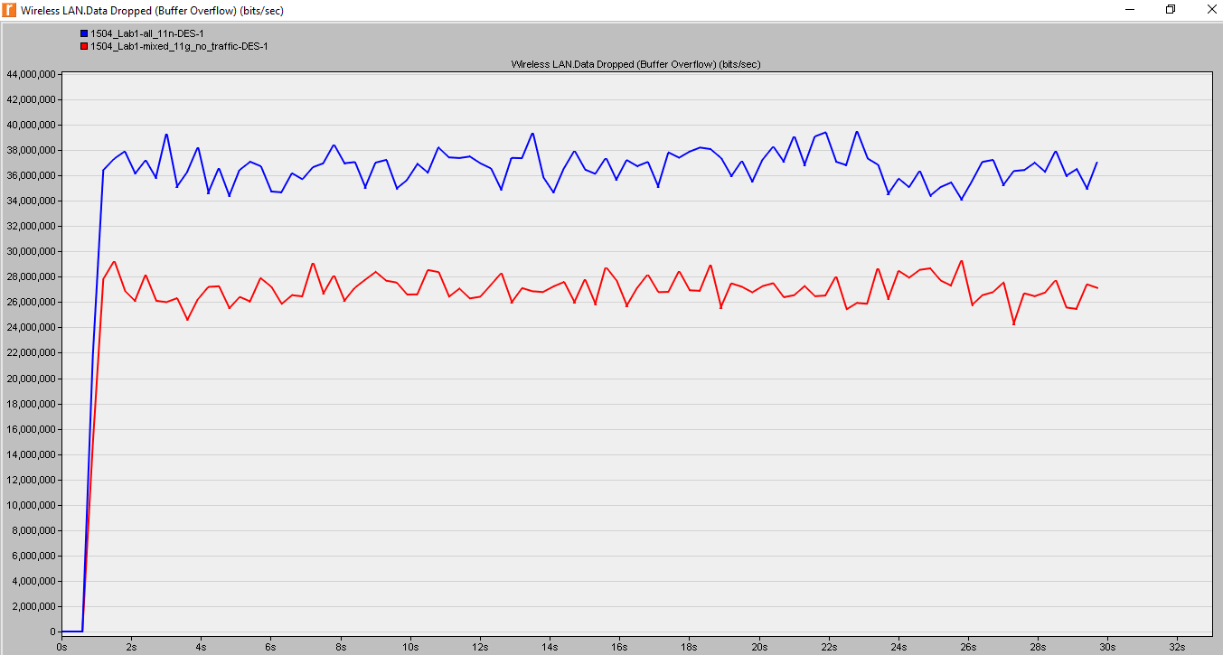

**LAB 2**

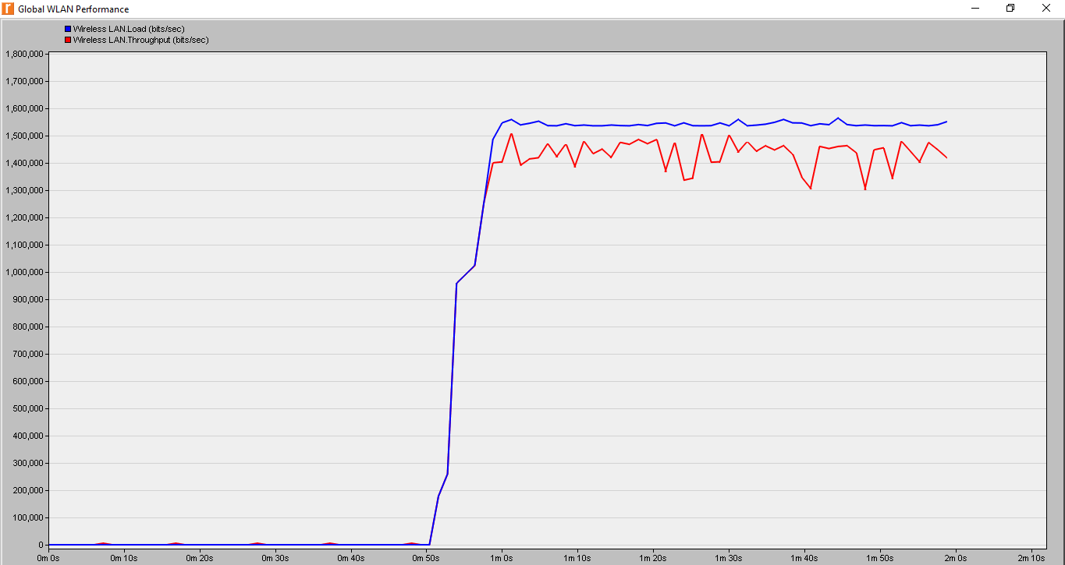

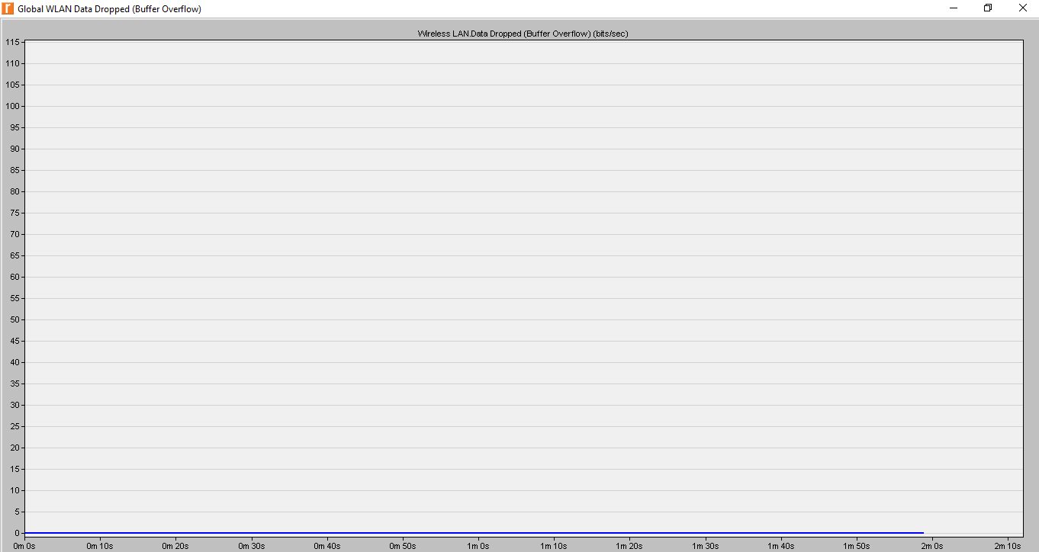

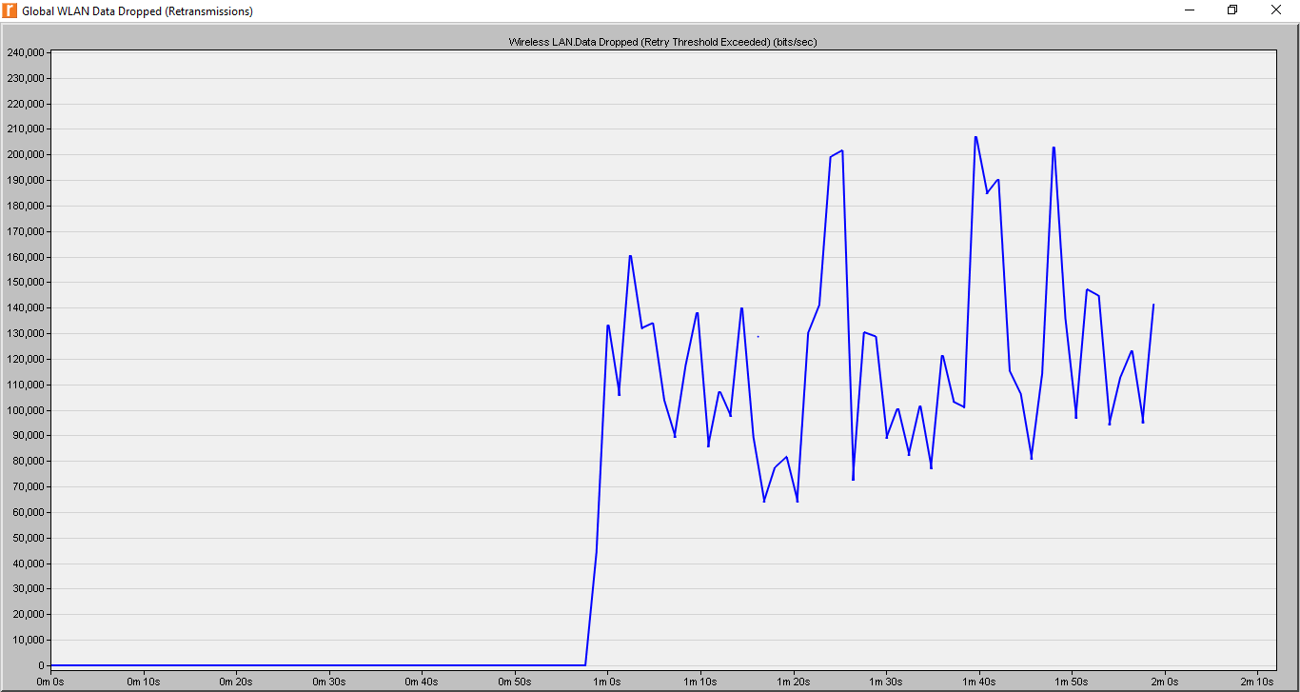

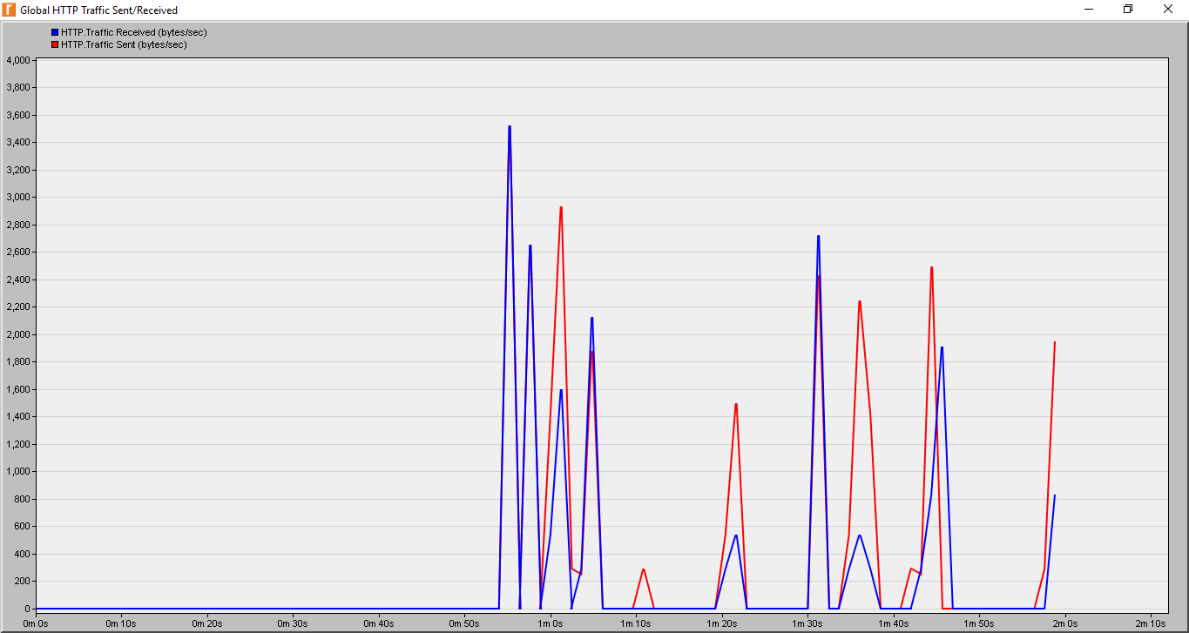

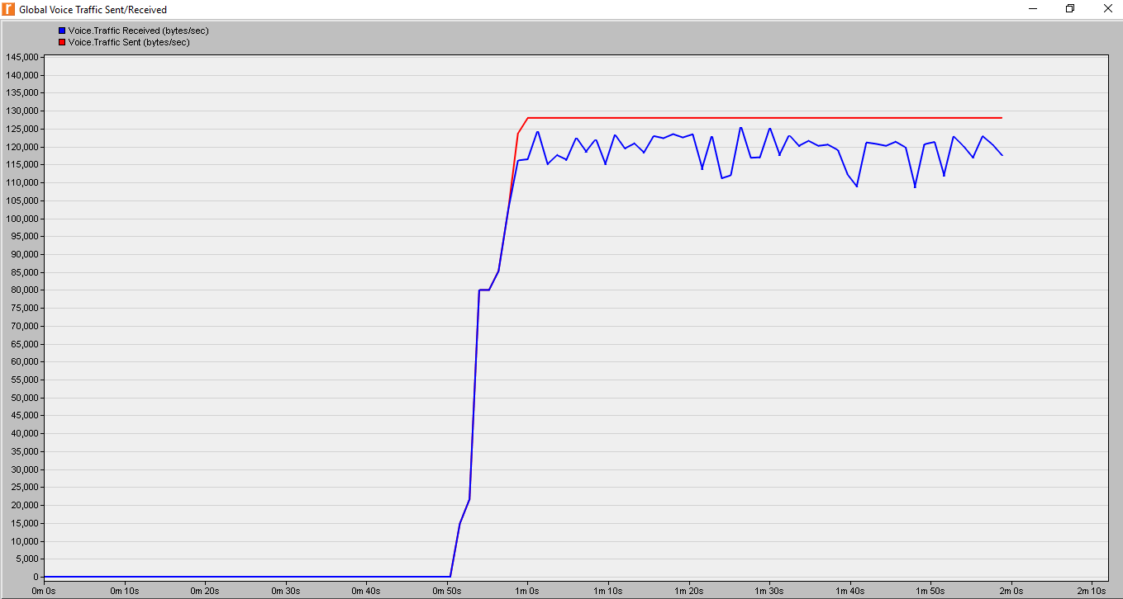

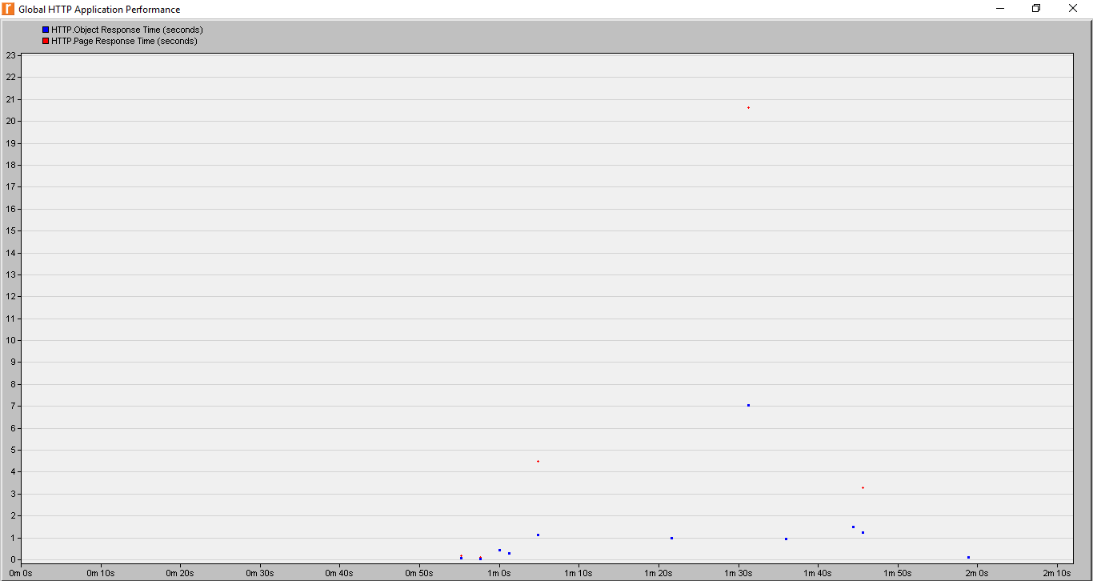

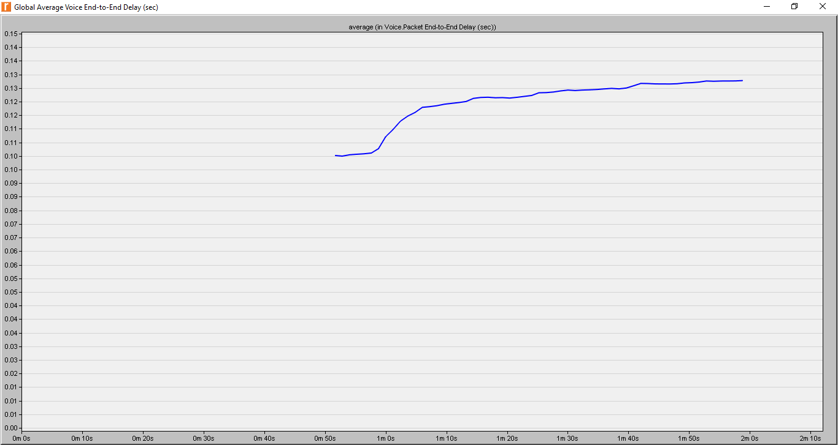

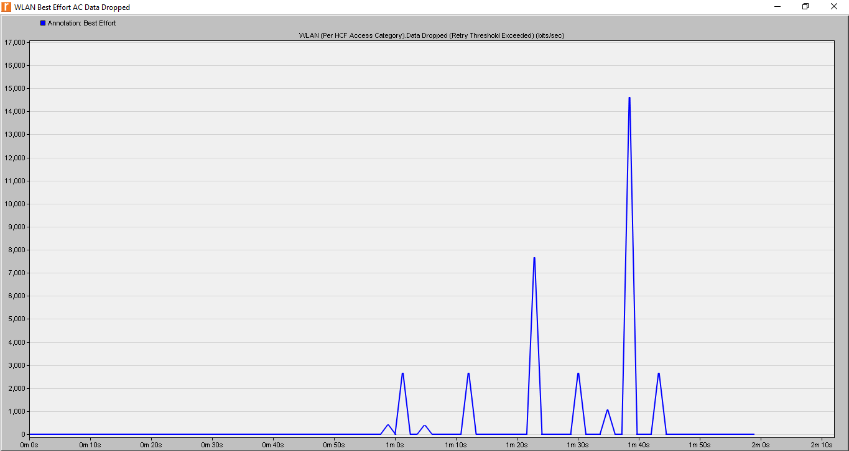

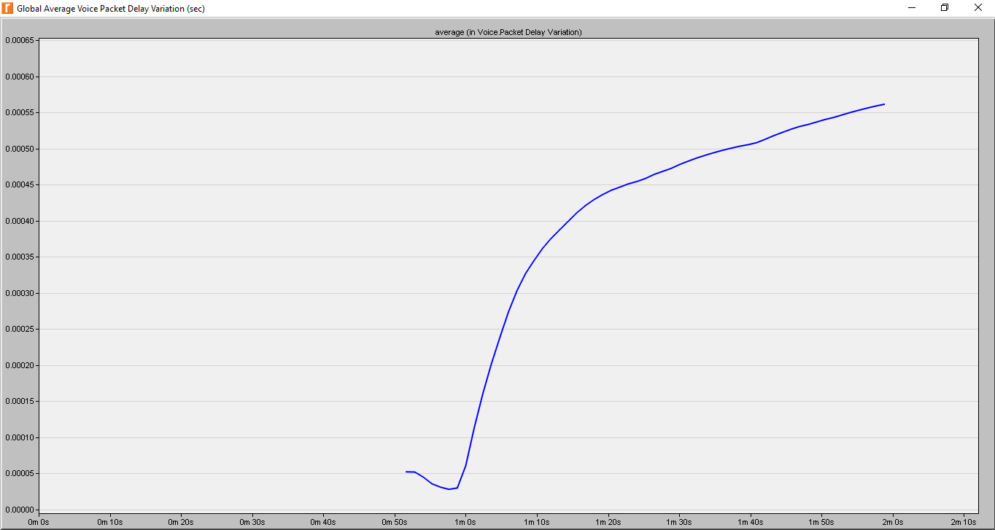

Performance tuning for 11e networks

