University of Southern California
EE511

Simulation Methods for Stochastic Systems

Project #7
Expectation Maximization

BY
Gowrishankar Kollangi Basavarajappa
USC ID: 9836169302
kollangi@usc.edu

Question 1:
Description:
In probability theory and statistics, the multivariate normal distribution or multivariate Gaussian distribution, is a generalization of the one-dimensional (univariate) normal distribution to higher dimensions. One possible definition is that a random vector is said to be k-variate normally distributed if every linear combination of its k components has a univariate normal distribution. Its importance derives mainly from the multivariate central limit theorem. The multivariate normal distribution is often used to describe, at least approximately, any set of (possibly) correlated real-valued random variables each of which clusters around a mean value.
A random vector x = (X1, …, Xk)' is said to have the multivariate normal distribution if it satisfies the following equivalent conditions.
Every linear combination of its components Y = a1X1 + … + akXk is normally distributed. That is, for any constant vector a ∈ Rk, the random variable Y = aTx has a univariate normal distribution, where a univariate normal distribution with zero variance is a point mass on its mean.
The covariance matrix is allowed to be singular (in which case the corresponding distribution has no density). This case arises frequently in statistics; for example, in the distribution of the vector of residuals in the ordinary least squares regression. Note also that the Xi are in general not independent; they can be seen as the result of applying the matrix A to a collection of independent Gaussian variables z.
Methodology:
I have inherited a function RandNumber(N) for N samples. I have initialized an array of consisting of N elements and taken the given sigma and mean values. I have generated N samples of ‘X’ and calculated the sample mean and covariance. Hence, I generated a row vector Z of length # and initialize it with standard normal random variables using normrnd. I generated the lower triangular square matrix ‘A’ by using the chol() function provided in MATLAB, and hence obtained the column vector ‘X’ of length 3.
Code:
function RandNumber(N)
Count = zeros(3,N);
for i = 1:N
mu = [1 2 3];
sigma = [ 3 -1 1;
-1 5 3;
1 3 4 ];
A = chol(sigma,'lower');
Z = normrnd(0,1,1,3);
X = A*Z.' + mu.';
X = transpose(X);
for k = 1:3
Count(k,i) = X(k);
end
end
Count1 = zeros(1,N);
Count2 = zeros(1,N);
Count3 = zeros(1,N);
for i = 1:N
Count1(1,i) = mean(Count(1,i));
Count2(1,i) = mean(Count(2,i));
Count3(1,i) = mean(Count(3,i));
end
display(' Mean');
formatSpecMean = 'The mean is %.2f\n';
mean1 = mean(Count1);
mean2 = mean(Count2);
mean3 = mean(Count3);
fprintf(formatSpecMean,mean1);
fprintf(formatSpecMean,mean2);
fprintf(formatSpecMean,mean3);
covariance = cov(Count.');
display(Covariance');
display(covariance);
end
Result:
>> P7Q1
Enter the number of samples1000
The sample mean is:
The mean of the samples is 0.98
The mean of the samples is 2.08
The mean of the samples is 3.07
The covariance of the samples is:

covariance =

3.0541 -0.8026 1.1061
-0.8026 4.9038 3.2111
1.1061 3.2111 4.2688

>>

Enter the number of samples100000
The sample mean is:
The mean of the samples is 1.00
The mean of the samples is 2.01
The mean of the samples is 3.00
The covariance of the samples is:

covariance =

2.9933 -0.9904 1.0108
-0.9904 4.9849 2.9864
1.0108 2.9864 3.9984

>>

Observation:
The mean and the covariance of the samples generated from the output closely matches with the specified mean and covariance. The difference decreases when the number of samples are increased.

Question 2:
Description:
In probability and statistics, a mixture distribution is the probability distribution of a random variable that is derived from a collection of other random variables as follows: first, a random variable is selected by chance from the collection according to given probabilities of selection, and then the value of the selected random variable is realized. The underlying random variables may be random real numbers, or they may be random vectors (each having the same dimension), in which case the mixture distribution is a multivariate distribution.
In cases where each of the underlying random variables is continuous, the outcome variable will also be continuous and its probability density function is sometimes referred to as a mixture density. The cumulative distribution function (and the probability density function if it exists) can be expressed as a convex combination (i.e. a weighted sum, with non-negative weights that sum to 1) of other distribution functions and density functions. The individual distributions that are combined to form the mixture distribution are called the mixture components, and the probabilities (or weights) associated with each component are called the mixture weights. The number of components in mixture distribution is often restricted to being finite, although in some cases the components may be countably infinite. More general cases (i.e. an uncountable set of component distributions), as well as the countable case, are treated under the title of compound distributions.

Methodology:
I have inherited a function MixedDistribution (N) for N samples. I have initialized an array of consisting of N elements and taken the given sigma and mean values. I have generated N samples of ‘X’ and calculated the sample mean and covariance. Hence, I generated a row vector Z of length # and initialize it with standard normal random variables using normrnd.
Code:
function MixedDistribution(N)
X = rand(N,1);
Y = zeros(N,1);
%%Distribution Generation
for i = 1:N
if(X(i) <= 0.4)
Y(i) = normrnd(-1,1);
else
Y(i) = normrnd(1,1);
end
end
grid on;
histogram(Y);
x = -4:4;
hold on
%Histogram and Theoretical PDF
mixpdf = 10000*(0.4*normpdf(x,-1,1)+ 0.6*normpdf(x,1,1));
plot(x,mixpdf,'linewidth',2,'color','black');
title('Histogram of Distribution overlayed with Theoretical PDF of the Distribution');
xlabel('Sample values');
ylabel('Sample Frequency/Probability');
end
Result:
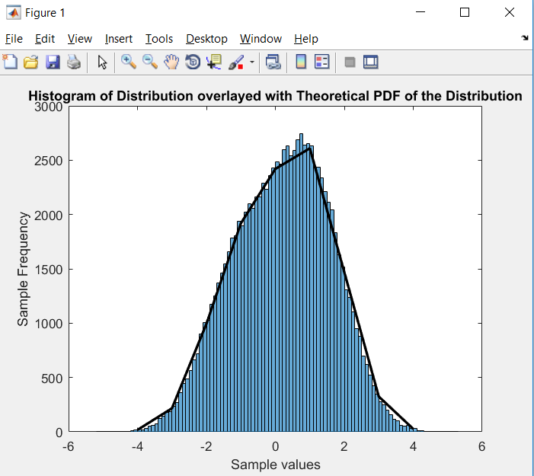
Observation:
The quality of fit increases with increase in number of samples of X. As we can observe in the output that the theoretical and the histogram of X are overlayed perfectly.

Question 3:
Description:
In statistics, a mixture model is a probabilistic model for representing the presence of subpopulations within an overall population, without requiring that an observed data set should identify the sub-population to which an individual observation belongs. Formally a mixture model corresponds to the mixture distribution that represents the probability distribution of observations in the overall population. However, while problems associated with "mixture distributions" relate to deriving the properties of the overall population from those of the sub-populations, "mixture models" are used to make statistical inferences about the properties of the sub-populations given only observations on the pooled population, without sub-population identity information.
Some ways of implementing mixture models involve steps that attribute postulated sub-population-identities to individual observations (or weights towards such sub-populations), in which case these can be regarded as types of unsupervised learning or clustering procedures. However, not all inference procedures involve such steps.
Methodology:
I have created a Gaussian Mixture Distribution object using the gmdistribution () function which creates a distribution with the given specifications. I have used the random() to randomly choose samples from the distribution . I have used the gmdistribution.fit() function which applies the Expectation Maximization algorithm on the Gaussian Mixture Model. I then used the ezcontour() and the ezsurf() to draw the contour and scatter plots

Code:
function EM()
mu = [1 -2;3 4];
sigma = cat(3,[2 0;0 .5],[1 0;0 1]);
a = [0.05,0.95];
%% GMM Algorithm
const = gmdistribution(mu,sigma,a);
samples = random(const,300);
options = statset('Display','final');
ExMax = gmdistribution.fit(samples, 2, 'options',options);
%% 2D projection figure;
ezcontourf(@(x,y) pdf(const,[x y]));
%% view PDF surface figure;
ezsurf(@(x,y)pdf(const,[x y]),[-10 10],[-10 10])
end
Result:
mu = [1 -2;3 4]; and a = [0.05,0.95];
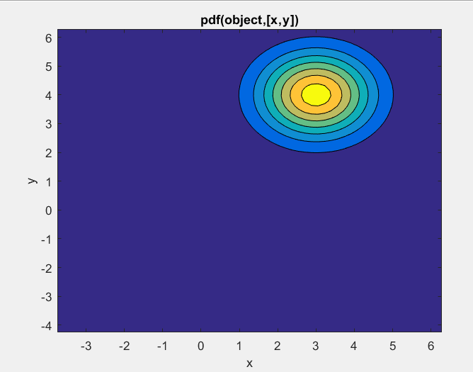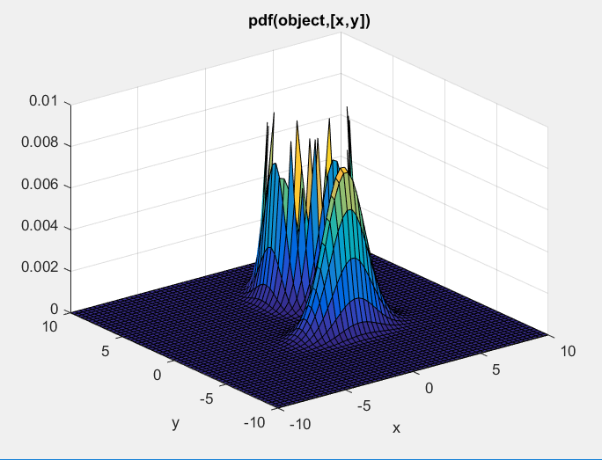

mu = [1 2;-3 -4]; and a= [0.05,0.95];

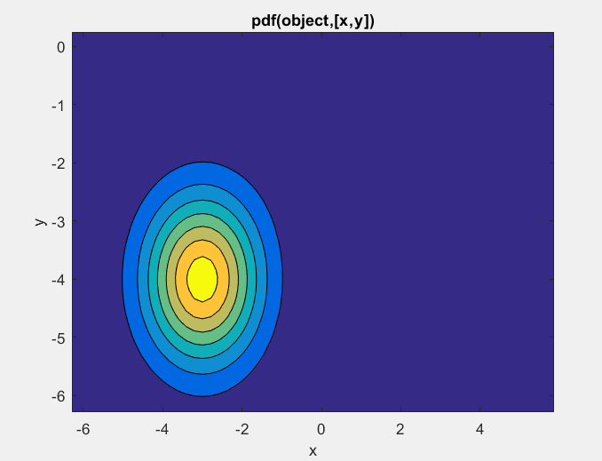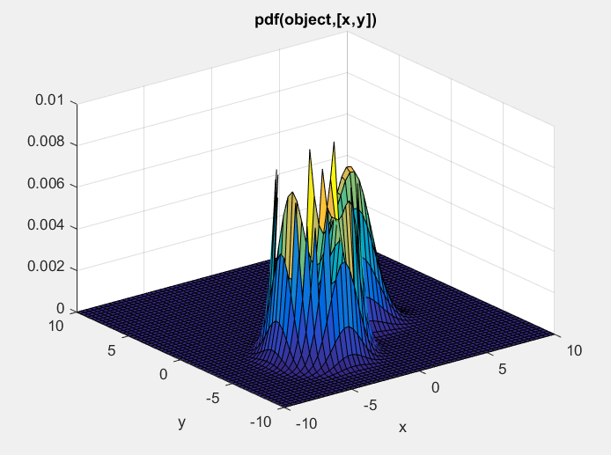

mu = [1 2;-3 -4]; and P = [0.25,0.75];

mu = [1 2;-3 -4]; and P = [0.5,0.5];

mu = [-1 2;-3 -4];

Observation:
As the value of µ changes, the proximity f changes the contour plots of the clusters to each other. As the values of the weights changes, the distribution is effected by each weight. As the values of the ∑ changes, the shapes of the contours also change.

Question 4:

Description:
In statistics, a mixture model is a probabilistic model for representing the presence of subpopulations within an overall population, without requiring that an observed data set should identify the sub-population to which an individual observation belongs. Formally a mixture model corresponds to the mixture distribution that represents the probability distribution of observations in the overall population. However, while problems associated with "mixture distributions" relate to deriving the properties of the overall population from those of the sub-populations, "mixture models" are used to make statistical inferences about the properties of the sub-populations given only observations on the pooled population, without sub-population identity information.
Some ways of implementing mixture models involve steps that attribute postulated sub-population-identities to individual observations (or weights towards such sub-populations), in which case these can be regarded as types of unsupervised learning or clustering procedures. However, not all inference procedures involve such steps.
Methodology:
I used the kmeans() function to generate the clusters and then plot them together by using the hold function after obtaining the data from the datalist. I have used the gmdistribution.fit() function which applies the Expectation Maximization algorithm on the Gaussian Mixture Model. I then used the ezcontour() and the ezsurf() to draw the contour and scatter plots

Code:
Code:

X = [ 3.600 79;
1.800 54;
3.333 74;
2.283 62;
4.533 85;
2.883 55;
4.700 88;
3.600 85;
1.950 51;
4.350 85;
1.833 54;
3.917 84;
4.200 78;
1.750 47;
4.700 83;
2.167 52;
1.750 62;
4.800 84;
1.600 52;
4.250 79;
1.800 51;
1.750 47;
3.450 78;
3.067 69;
4.533 74;
3.600 83;
1.967 55;
4.083 76;
3.850 78;
4.433 79;
4.300 73;
4.467 77;
3.367 66;
4.033 80
3.833 74;
2.017 52;
1.867 48;
4.833 80;
1.833 59;
4.783 90;
4.350 80;
1.883 58;
4.567 84;
1.750 58;
4.533 73;
3.317 83;
3.833 64;
2.100 53;
4.633 82;
2.000 59;
4.800 75;
4.716 90;
1.833 54;
4.833 80;
1.733 54;
4.883 83;
3.717 71;
1.667 64;
4.567 77;
4.317 81;
2.233 59;
4.500 84;
1.750 48;
4.800 82;
1.817 60;
4.400 92;
4.167 78;
4.700 78;
2.067 65;
4.700 73;
4.033 82;
1.967 56;
4.500 79;
4.000 71;
1.983 62;
5.067 76;
2.017 60;
4.567 78;
3.883 76;
3.600 83;
4.133 75;
4.333 82;
4.100 70;
2.633 65;
4.067 73;
4.933 88;
3.950 76;
4.517 80;
2.167 48;
4.000 86;
2.200 60;
4.333 90;
1.867 50;
4.817 78;
1.833 63;
4.300 72;
4.667 84;
3.750 75;
1.867 51;
4.900 82;
2.483 62;
4.367 88;
2.100 49;
4.500 83;
4.050 81;
1.867 47;
4.700 84;
1.783 52;
4.850 86;
3.683 81;
4.733 75;
2.300 59;
4.900 89;
4.417 79;
1.700 59;
4.633 81;
2.317 50;
4.600 85;
1.817 59;
4.417 87;
2.617 53;
4.067 69;
4.250 77;
1.967 56;
4.600 88;
3.767 81;
1.917 45;
4.500 82;
2.267 55;
4.650 90;
1.867 45;
4.167 83;
2.800 56;
4.333 89;
1.833 46;
4.383 82;
1.883 51;
4.933 86;
2.033 53;
3.733 79;
4.233 81;
2.233 60;
4.533 82;
4.817 77;
4.333 76;
1.983 59;
4.633 80;
2.017 49;
5.100 96;
1.800 53;
5.033 77;
4.000 77;
2.400 65;
4.600 81;
3.567 71;
4.000 70;
4.500 81;
4.083 93;
1.800 53;
3.967 89;
2.200 45;
4.150 86;
2.000 58;
3.833 78;
3.500 66;
4.583 76;
2.367 63;
5.000 88;
1.933 52;
4.617 93;
1.917 49;
2.083 57;
4.583 77;
3.333 68;
4.167 81;
4.333 81;
4.500 73;
2.417 50;
4.000 85;
4.167 74;
1.883 55;
4.583 77;
4.250 83;
3.767 83;
2.033 51;
4.433 78;
4.083 84;
1.833 46;
4.417 83;
2.183 55;
4.800 81;
1.833 57;
4.800 76;
4.100 84;
3.966 77;
4.233 81;
3.500 87;
4.366 77;
2.250 51;
4.667 78;
2.100 60;
4.350 82;
4.133 91;
1.867 53;
4.600 78;
1.783 46;
4.367 77;
3.850 84;
1.933 49;
4.500 83;
2.383 71;
4.700 80;
1.867 49;
3.833 75;
3.417 64;
4.233 76;
2.400 53;
4.800 94;
2.000 55;
4.150 76;
1.867 50;
4.267 82;
1.750 54;
4.483 75;
4.000 78;
4.117 79;
4.083 78;
4.267 78;
3.917 70;
4.550 79;
4.083 70;
2.417 54;
4.183 86;
2.217 50;
4.450 90;
1.883 54;
1.850 54;
4.283 77;
3.950 79;
2.333 64;
4.150 75;
2.350 47;
4.933 86;
2.900 63;
4.583 85;
3.833 82;
2.083 57;
4.367 82;
2.133 67;
4.350 74;
2.200 54;
4.450 83;
3.567 73;
4.500 73;
4.150 88;
3.817 80;
3.917 71;
4.450 83;
2.000 56;
4.283 79;
4.767 78;
4.533 84;
1.850 58;
4.250 83;
1.983 43;
2.250 60;
4.750 75;
4.117 81;
2.150 46;
4.417 90;
1.817 46;
4.467 74;];% kmeans and scatter plot

% To find the assignment y and the means C of each cluster
[N,M] = kmeans(X,2);

% Plot results
figure(2)
plot(X(N==1,1),X(N==1,2), 'x');
hold on
plot(X(N==2,1),X(N==2,2), 'o');
plot(M(1,1),M(1,2), 'rx','LineWidth',2);
plot(M(2,1),M(2,2), 'ro','LineWidth',2);

legend('Points of the cluster 1','Points of the cluster 2')
title('Data Points with Labels along with K-means Clustering')
hold off % GMM Distribution
EM = gmdistribution.fit(X,2); % 2D projection
figure;
ezcontourf(@(x,y) pdf(EM,[x y]),[1.5 5.5, 40 100]);

Result:

Observation:
The clusters are well apart and the scatter plots are spherical from the above figures.

