EE511: Simulation Methods for Stochastic Systems
Project 8: Markov Chain Monte Carlo
Professor: Brandon Franzke
Name: Gowrishankar Kollangi Basavarajappa
UID: 9836169302
Mail: Kollangi@usc.edu

Q1)

Description:
Monte Carlo is the art of approximating an expectation by the sample mean of a function of simulated random variables. Monte Carlo is about invoking laws of large numbers to approximate expectations. Importance sampling is choosing a good distribution from which to simulate one’s random variables. It involves multiplying the integrand by 1to yield an expectation of a quantity that varies less than the original integrand over the region of integration. As a final word on importance sampling, the tails of the distributions matter! While h(x) might be roughly the same shape as g(x), serious difficulties arise if h(x) gets small much faster than g(x) out in the tails. In such a case, though it is improbable, if you do, then your Monte Carlo estimator will take a jolt such an g(x)/h(x) that you see.
Methodology:
I have generated the two random numbers using rand() function. The question is asking to conduct the experiment in two parts for the calculation of mean and variance, then calculate the simple monte carlo using stratified sampling and the importance sampling for the series of random numbers.
Code:
clc;
clear all;
disp('1st part');
disp('Sample variance');
% Simple Monte Carlo
p = @(x1,x2)exp(5.*abs(x1-5) + 5.*abs(x2-5));
N = 1000;
u1 = rand(1,N); u2 = rand(1,N);
X = p(u1,u2); disp('simple mc');
disp([mean(X) 2*std(X)/sqrt(N)])

% Stratified sampling
K = 20; Nij = N/K;
%subdivide into k strata
for i = 1:K
for j = 1:K
XS = p((i-1+rand(1,Nij))/K ,(j-1+rand(1,Nij))/K);
XSb(i,j) = mean(XS);
SS(i,j) = var(XS);
end
end
SST = mean(mean(SS/N));
disp('Stratified Estimation');
disp([mean(mean(XSb)) 2*sqrt(SST) ])

% Importance sampling
N = 1000; U1 = rand(1,N); U2 = rand(1,N);
e = exp(1); X1 = log(1+(e-1)*U1); X2 = log(1+(e-1)*U2);
V = (e-1).^2*exp(5.*abs(X1-5)+5.*abs(X2-5)-(X1+X2));
disp('importance sampling');disp( [mean(V) 2*std(V)/sqrt(N)]);

disp('2nd part');
disp('Sample variance');
N=1000;
a=-1; b=1;
X1=rand(1,N); X2=rand(1,N);
V=(b-a)*(b-a)*cos(pi + 5*(a + (b-a)*X1) + 5*(a + (b-a)*X2));
disp('simple mc');
disp([mean(V) 2*std(V)/sqrt(N)])

% Stratified sampling
K = 20; Nij = N/K.*2;
for i = 1:K
for j = 1:K
M1 = (i-1+rand(1,Nij))/K ; M2 = (j-1+rand(1,Nij))/K;
XS = (b-a).*(b-a).*cos(pi + 5*(a + (b-a)*M1) + 5*(a + (b-a)*M2));
XSb(i,j) = mean(XS); SS(i,j) = var(XS);
end
end, SST = mean(mean(SS/N));
disp('Stratified Estimation');
disp([mean(mean(XSb)) 2*sqrt(SST)]);

%Importance sampling
N = 1000;
e = exp(1); U1 = rand(1,N); U2 = rand(1,N)<3/4;
P1 = U2.*U1 + (1-U2).*U1.^(1/3);
P2 = log(1+(e-1)*rand(1,N));
T = 4*(b-a).*(b-a).*cos(pi + 5*(a + (b-a)*P1) + ...
5*(a + (b-a)*P2))./(3*(1+(P1+P2).^2));
disp('Importance sampling');disp( [mean(T) 2*std(T)/sqrt(N)])

Result:
1st part
Sample variance
simple mc
1.0e+20 *

1.8686 0.2624

Stratified Estimation
1.0e+20 *

2.0412 0.0337

importance sampling
1.0e+20 *

1.5358 0.3205

2nd part
Sample variance
simple mc
-0.1913 0.1789

Stratified Estimation
-0.1395 0.0362

Importance sampling
-0.1682 0.1200

>>
Observation:
Q2)
Description:
In statistics, Gibbs sampling or a Gibbs sampler is a Markov chain Monte Carlo(MCMC) algorithm for obtaining a sequence of observations which are approximated from a specified multivariate probability distribution, when direct sampling is difficult. This sequence can be used to approximate the joint distribution (e.g., to generate a histogram of the distribution); to approximate the marginal distribution of one of the variables, or some subset of the variables (for example, the unknown parameters or latent variables); or to compute an integral (such as the expected value of one of the variables). Typically, some of the variables correspond to observations whose values are known, and hence do not need to be sampled. Gibbs sampling is commonly used as a means of statistical inference, especially Bayesian inference. It is a randomized algorithm (i.e. an algorithm that makes use of random numbers), and is an alternative to deterministic algorithms for statistical inference such as the expectation-maximization algorithm (EM). As with other MCMC algorithms, Gibbs sampling generates a Markov chain of samples, each of which is correlated with nearby samples. As a result, care must be taken if independent samples are desired (typically by thinning the resulting chain of samples by only taking every nth value, e.g. every 100th value). In addition, samples from the beginning of the chain (the burn-in period) may not accurately represent the desired distribution.

Methodology:
I have rounded each element to the nearest integer greater than or equal to that element the two random numbers using ceil function. The question is asking to conduct the experiment in two parts for the calculation of mean.
Code:
clc;
clear all;
disp('1st part');
n = 3;
N = 1000;
X = 2*ones(1,n);
for k = 1:N
i = ceil(n*rand);
S = sum(X) - i*X(i);
X(i) = max(15 - S, 0) - log(rand)/1;
H(k) = S + X(i);
end
disp([mean(H) 2*std(H)/sqrt(N)]);

disp('2nd part');
X = 2*ones(1,n);
for k = 1:N
i = ceil(n*rand);
S = sum(X) - i*X(i);
X(i) = log(rand)/1 - max(1 - S, 0);
H(k) = S + X(i);
end
disp([mean(H) 2*std(H)/sqrt(N)]);

Result:
1st part
1.0e+03 *

1.4572 0.0997

2nd part
1.0e+08 *

-1.3830 0.5109

>>
Observation:

Q3)

Description:

Schwefel's function is deceptive in that the global minimum is geometrically distant, over the parameter space, from the next best local minima. Therefore, the search algorithms are potentially prone to convergence in the wrong direction.

function definition
f7(x)=sum(-x(i)·sin(sqrt(abs(x(i))))), i=1:n;
-500<=x(i)<=500.

global minimum
f(x)=-n·418.9829; x(i)=420.9687, i=1:n.

Methodology:

I have generated two 100 linearly equally spaced points between -512 and 512. Then created the 100x100 pairs of points in matrix form from the vectors x and y. Plotted the generated values from the obtained values.

Code:
x1 = linspace(-500,500); % 100 linearly equally spaced points between -512 and 512
x2 = linspace(-500,500); % 100 linearly equally spaced points between -512 and 512
[x1,x2] = meshgrid(x1,x2); % 100x100 pairs of points in matrix form
Y = 418.9829*2 - x1.*sin(sqrt(abs(x1))) - x2.*sin(sqrt(abs(x2)));
figure(1)
contour(x1,x2,Y); % Plot
colorbar;

figure(2)
mesh(x1,x2,Y); % Plot
colorbar;
xlim([-500 500]);
ylim([-500 500]);

x=zeros(n);
y=zeros(n);
T=zeros(n);
x_star=zeros(n);
y_star=zeros(n);
t=1;

T = 100;
for t = 1 :n

x_star(t+1) = x(t) +normrnd(0,10);
y_star(t+1) =y(t) + normrnd(0,10);

val1 = 418.9829*2 - x(t)*sin(sqrt(abs(x(t)))) - y(t)*sin(sqrt(abs(y(t))));
val2 = 418.9829*2 - x_star(t+1)*sin(sqrt(abs(x_star(t+1)))) - y_star(t+1)*sin(sqrt(abs(y_star(t+1))));
alpha = exp(val1 -val2)/ T(t);

if ((val2 <= val1) || (rand(1)<alpha))
x(t+1) = x_star(t+1);
y(t+1) = y_star(t+1);

else
x(t+1)=x(t);
y(t+1) = y(t);

end

T(t+1) = 100/log(t+1);
end

x_star(n)
y_star(n)

Result:
Observation:

Q4)

Description:

Simulated annealing (SA) is a probabilistic technique for approximating the global optimum of a given function. Specifically, it is a metaheuristic to approximate global optimization in a large search space. It is often used when the search space is discrete (e.g., all tours that visit a given set of cities). For problems where finding an approximate global optimum is more important than finding a precise local optimum in a fixed amount of time, simulated annealing may be preferable to alternatives such as gradient descent. The notion of slow cooling implemented in the Simulated Annealing algorithm is interpreted as a slow decrease in the probability of accepting worse solutions as the solution space is explored.

Methodology:
Generated location of cities. rng() function for reproducibility
Then implemented the annealing algorithm.
Then opened the given files and simulated the annealing algorithm for the data set.
Plotted the obtained the values in the graph which are attached below.
Code:
clear all;
%% Generate location of cities
rng(5) % For reproducibility
x = 1:4;
y = 2:5;
[X, Y] = meshgrid(x,y);
n = 7; % number of cities
sample_index = randsample(16,n);
[x_index, y_index] = ind2sub([4,4],sample_index);
city = zeros(7,2);
for a1 = 1:n
city(a1,:) = [X(x_index(a1),y_index(a1)) Y(x_index(a1),y_index(a1))];
end
%% Simulated annealing algorithm
distance = pdist2(city, city);
% Parameters
num_iter = 100; % number of iterations
c = 1;
% Initial path p
p = 1:n;
% Initial length of p
len = 0;
for a1 = 1:n-1
len = len + distance(p(a1),p(a1+1));
end
len = len + distance(p(n),p(1));

% Save the paths and lengths
pathHistory = zeros(num_iter,n);
lenHistory = zeros(1,n);

% Plotting intial path
figure(1)
plot(city(:,1), city(:,2), 'ro');
xlim([0 5]);
ylim([1 6]);
hold on
line(city([p(:); p(1)],1), city([p(:); p(1)],2));
title('Initial path');
hold off

count = 0;

while(count<num_iter)
count = count + 1;
% Create path 2 by randomly swapping two cities
swap_index = randsample(n,2);
p2 = p;
temp = p2(swap_index(1));
p2(swap_index(1)) = p2(swap_index(2));
p2(swap_index(2)) = temp;
% Cost of p2
len2 = 0;
for a1 = 1:n-1
len2 = len2 + distance(p2(a1),p2(a1+1));
end
len2 = len2 + distance(p2(n),p2(1));

q = (1+count)^((len - len2)/c);

if len2 - len <= 0
p = p2;
len = len2;
else
if rand <= q
p = p2;
len = len2;
end
end
pathHistory(count,:) = p;
lenHistory(count) = len;
end

figure(2)
plot(1:num_iter, lenHistory, 'linewidth',2);
title('Length of path in each iteration')

figure(3)
plot(city(:,1), city(:,2), 'ro');
xlim([0 5]);
ylim([1 6]);
hold on
line(city([p(:); p(1)],1), city([p(:); p(1)],2));
title('Final path of TSP using simulated annealing');
hold off

Result: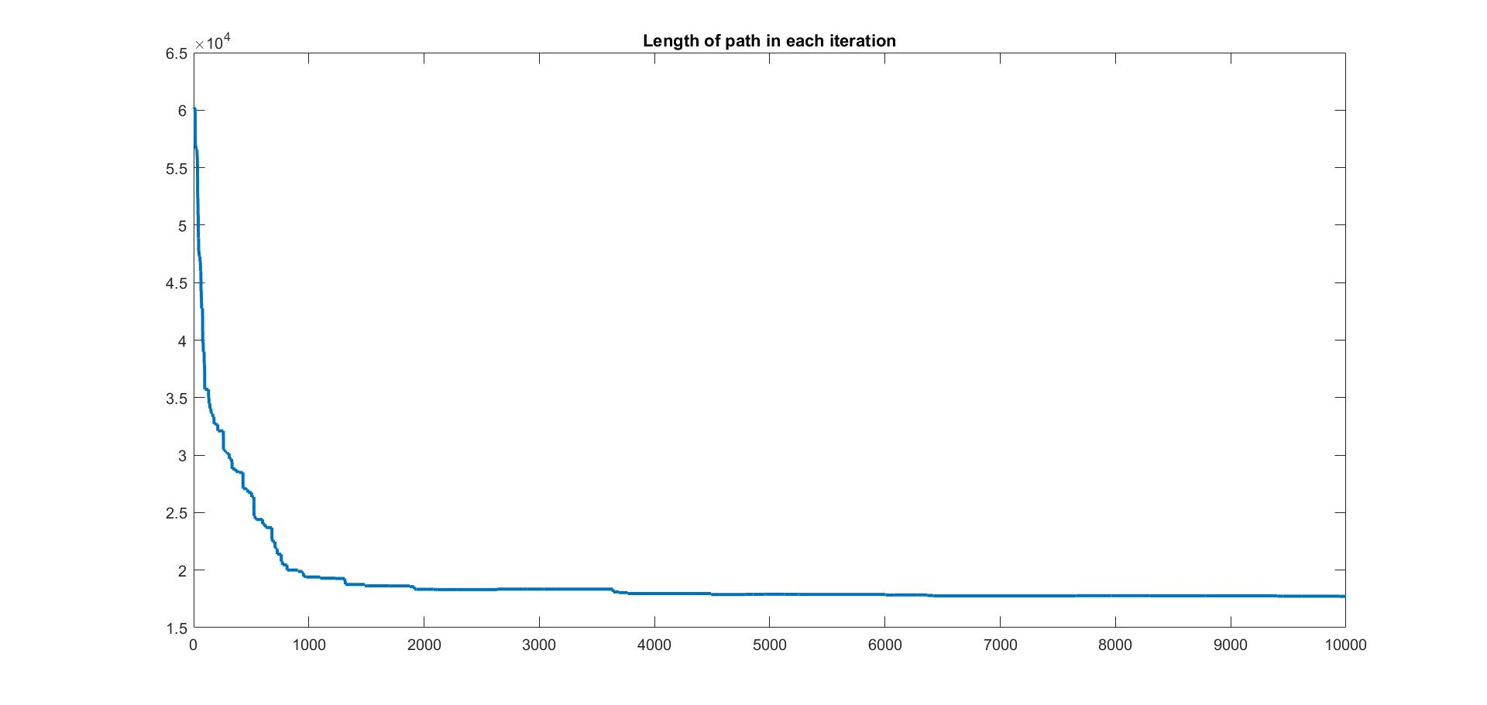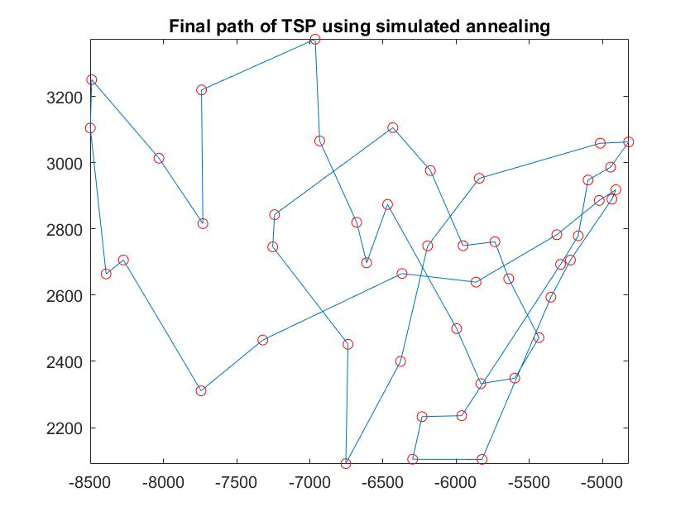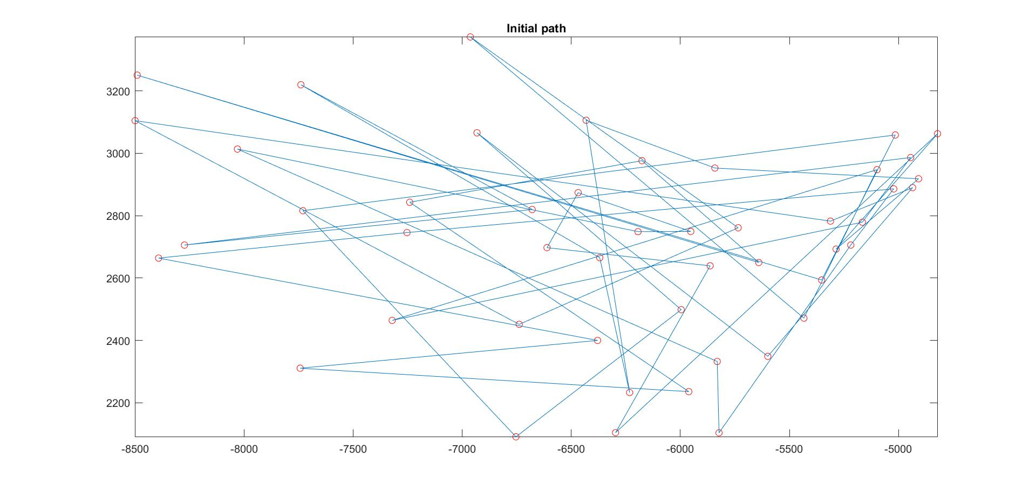
Observation:

