University of Southern California

EE511

Simulation Methods for Stochastic Systems

Project #3

Samples and statistics

BY

Akshay Deepak Hegde

USC ID: 8099460970

[hegdeaks@usc.edu](mailto:hegdeaks@usc.edu)

Question 1. A components manufacturer delivers a batch of 125 microchips to a parts distributor.  The distributor checks for lot conformance by counting the number of defective chips in a random sampling (without replacement) of the lot.  If the distributor finds any defective chips in the sample it rejects the entire lot.  Suppose that there are six defective units in the lot of 125 microchips.  Simulate the lot sampling to estimate the probability that the distributor will reject the lot if it tests five microchips.  What is the fewest number of microchips that the distributor should test to reject this lot 95% of the time?

Question 2.

Description:

Problem demands the simulation of number of arrivals of car per hour using Poisson counting,

1. Bernoulli Trial Method
2. Inverse Transform Method

For (a), average arrival rate, lambda is given as 120. I am dividing the hour into 10000 sub intervals(N) and success probability for Bernoulli trial in each subinterval is calculated by dividing lambda by total number of subintervals. Loop is run for n (number of simulations) times. In each run, a random number is generated using rand() function bernoulli trial is performed. We get either a success or a failure by comparing success probability with the random number generated. Summing up the successes of all Bernoulli trials will give me the desired output.

For (b), we know the average arrival rate, lambda as 120. A loop is run for each N. Random number is generated and required initializations are done (i=0, p= negative exponential of lambda and F=p). If random number generated is less than F, result is stored and I break the loop for next run. Else, F is incremented by p and I by 1, and p is updated.

Histograms for each method are generated using histogram() function.

Code:

% Akshay Deepak Hegde USC ID: 8099460970 %

% -------------------------------------------------------------- %

% Project #3-Samples and statistics , EE511: Spring 2017, Due: 7th Feb

% -------------------------------------------------------------- %

% To simulate one hour of arrivals to the freeway ramp

% (a) sybdividing hour into small time intervals and

% performing Bernoulli trial within each interval.

% (b) Poisson distribution using inverse transform method

% To generate histograms and overlay theoritical pmfs.

% -------------------------------------------------------------- %

clc;

clear;

close all;

% -------------------------------------------------------------- %

n=1000;%number of simulations

lambda = 120;%120 cars per hour on average

N = 10000;%one hour into 10000 subintervals

p = lambda/N;%Success probability in each Bernoulli random variable

Result1 = zeros(1,[]);

% -------------------------------------------------------------- %

% subdividing and performing Bernoulli trials

for i = 1:n

U = rand(N,1);%random number generation

bernoulliTrials = U<p;%perform Bernoulli trial

x = sum(bernoulliTrials);%summing up successes

Result1 = [Result1,x];%store result

end

% -------------------------------------------------------------- %

% Poisson distribution using inverse transform method

lambda = 120;%avearge arrival rate

Result2 = zeros(1,N);%initializing N coulums with 0

% Recursion Method

for k = 1:N

U = rand();

i = 0;

p = exp(-lambda);

F = p;

while(true)

%rand<F, put value and stop, else continue

if (U < F)

Result2(1,k) = i;

break;

else

p = (lambda\*p)/(i+1);

F = F + p;

i = i + 1;

end

end

end

% ------------------------------------------------------------ %

% Display outputs.

u=rand(N,1);

z=poissinv(u,lambda);

figure;

histogram(Result1);

title('Histogram using the Bernoulli Trials Method')

ylabel('count of average number of arrivals per hour');

xlabel('Average number of arrivals per hour');

hold on

histogram(z)

figure;

histogram(Result2);

title('Histogram using the Inverse Transform Method')

ylabel('Count of average number of arrivals per hour');

xlabel('Average number of arrivals per hour');

hold on

histogram(z)

Output:

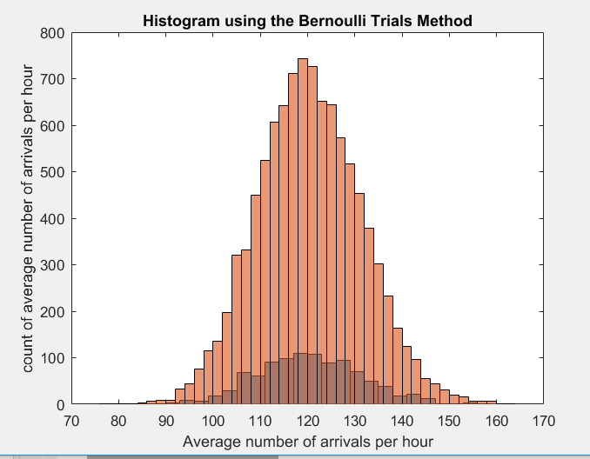

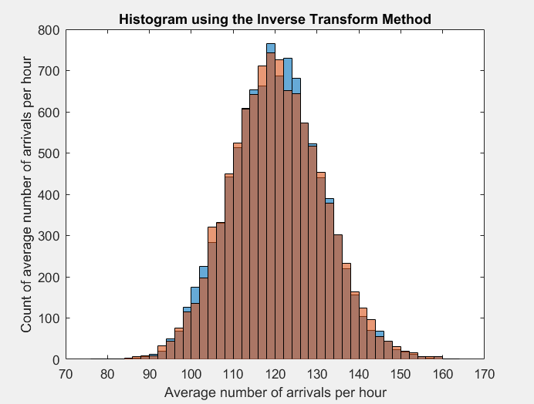

Discussion and Analysis:

Theoretical values are overlayed with the histograms we got. We can see that, theoretical values are in correspondence with the practical ones.

For Poisson counting using Bernoulli trial method, he approximation is finer when I increase the number of sub intervals from 10000 to100000. Hence, as we make the subinterval smaller and smaller, the approximation gets better and better. From the histogram, X-axis represents the average number of cars arriving per hour and Y-axis represents the count. The inverse transform method can be used in practice as long as we are able to get an explicit formula for F inverse of (y) in closed form. Also, as the number of simulations increases, the distribution tend to perfection(more values for corresponding to 120.)

Poisson model is best suited for sampling the data which is observed its event pattern in time. If events occur randomly and independently, *at a constant rate*(in time), then the *count* of these events per unit time will conform to a Poisson distribution.

From the histograms, it is clear that average number of arrivals of car per hour is distributed around 120 but not too far from 120. Also, there are no bars corresponding to the values below 90 and above 150.This indicates that our values are aligned with respect to the theoretical number of arrivals of cars per hour.

Question 3.

Description:

The loop is run for n (number of samples) times. Sum and count are initialized to 0 in each run of the loop. While loop is run until the collective sum of random numbers generated is 4. The counts are being stored in a result array. Histogram of the result is obtained using histogram() command and mean is calculated using mean() function.

CODE:

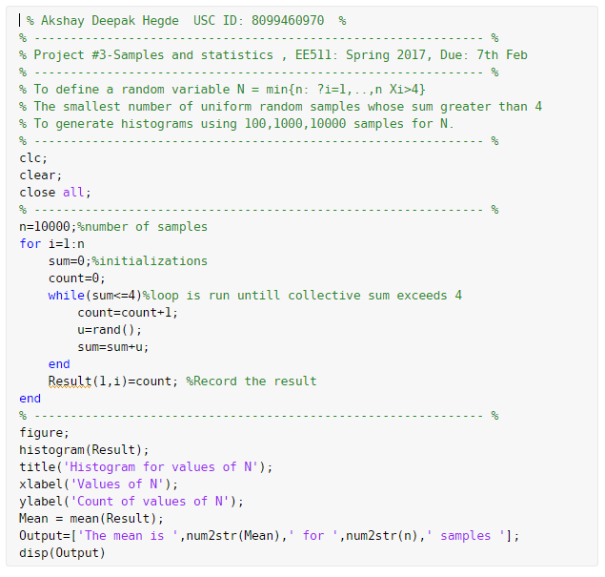

Output:

The mean is 8.79 for 100 samples

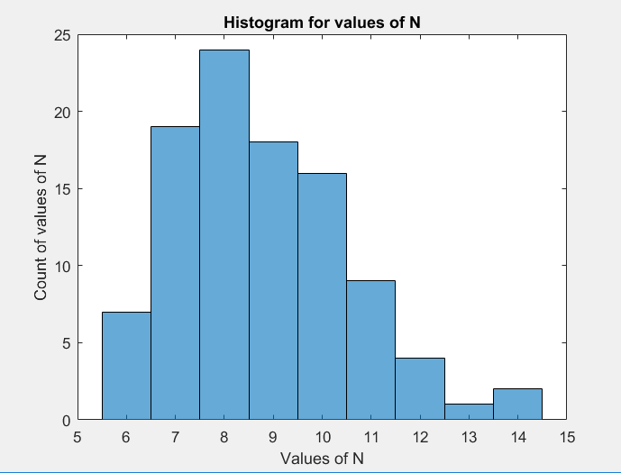

The mean is 8.677 for 1000 samples

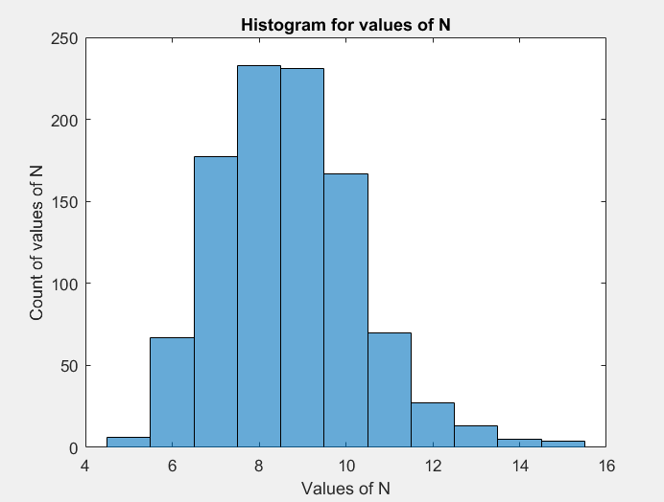

The mean is 8.6902 for 10000 samples

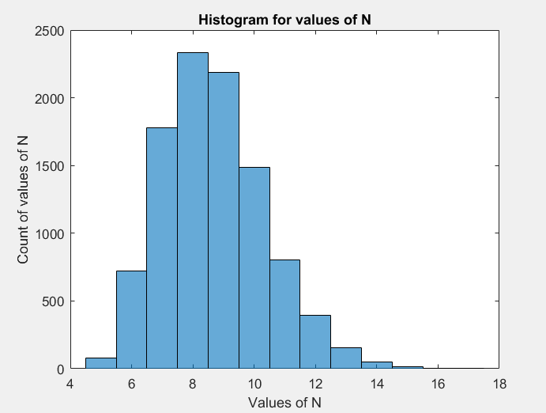

Analysis and Discussion:

E[X] can be calculated using the equation 1/p. Since it assumes the same range irrespective of number of samples, we can say that mean is independent of number of trials.

The above problem is an example of Geometric random variable.

The geometric Random variable involves independent Bernoulli trials with a success probability (say ‘p’) and if ‘X’ is the number of trials until the first success,

then: P[X = n] = p(1 – p)n-1 for all n=>1

Question 5.

Accept-Reject method is used for the particular problem.

Sequence P is given for 10 values and 0’s are appended for next 10 values. Sequence Q is also given.

The value of constant, c is calculated as max(p/q) = 0.15/0.05 = 3

So, the theoretical efficiency of the system = 1/c = 33%

The approach here is to generate random variables (U) and compare them to a ‘P’ of randomly generated index (j) i.e. 3\*U<=P(j)/0.05.

c\*qj forms an envelope over the plot of p(j) and we check if the random variable c\*q(j) falls under the distribution of p(j). If it does, we accept the variable and remove the variables that don’t satisfy the comparison. This way we can generate the probability mass function for p(j).

Code:

Output:

Experimental mean is 6.5195

Experimental variance is 7.0327

Mean of count array is 2.9996

Experimental effeciency is 0.33338

Theorectical Efficiency (1/c): 0.33333

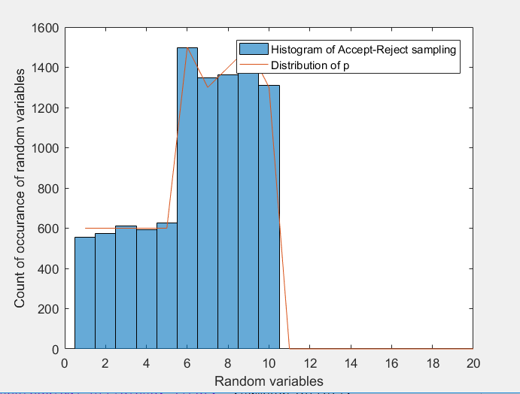

Analysis and Discussion:

From the figure, it is evident that histogram and plot are close.