University of Southern California

EE511

Simulation Methods for Stochastic Systems

Project #4

Integrals and Intervals

BY

Akshay Deepak Hegde

USC ID: 8099460970

[hegdeaks@usc.edu](mailto:hegdeaks@usc.edu)

Question 1:

Approximate the following integrals using a Monte Carlo simulation.  Compare your  estimates with the exact values (if known):

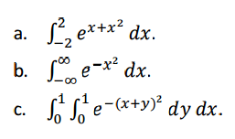

Description:

Monte Carlo simulations are used to model the probability of different outcomes in a process that cannot easily be predicted due to the intervention of random variables. Monte Carlo methods are mainly used in three distinct problem classes: [Optimization](https://en.wikipedia.org/wiki/Optimization), [Numerical integration](https://en.wikipedia.org/wiki/Numerical_integration), and generating draws from a [probability distribution](https://en.wikipedia.org/wiki/Probability_distribution).

Steps followed:

1. Generate a set of random random numbers u(i) uniformly distributed between 0 and 1.
2. Evaluate the function f(x) at each of these randomly evaluated numbers.
3. The function average is then Monte-Carlo estimate of integration and is given by

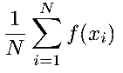

where N is the number of samples

Random number between 0 and 1 for N samples are generated using rand() function. Then using the substitution method, integrals have been solved such that the limits lie in the range 0 to 1. We can then substitute the value of the obtained random number in this function and the resulting value is stored in ‘Result’ vector. Now, we take the sum of all the values of Result and divide it by the number of samples. This gives us the Monte Carlo simulation. Also, the theoretical value can be calculated using the inbuilt syms() and int() functions. But this gives us an expression in terms of the exponential. So, we can use double precision to get the numerical value.

CODE:

a)

% Akshay Deepak Hegde USC ID: 8099460970 %

% -------------------------------------------------------------- %

% Project #4-Integrals and intervals, EE511: Spring 2017

% -------------------------------------------------------------- %

% To approximate integrals using Monte Carlo simulation.

% To compare the estimates with exact values.

% -------------------------------------------------------------- %

clc;

clear;

close all;

% -------------------------------------------------------------- %

n=1000;%Number of samples

for i=1:n

u(i)=rand();% To generate random numbers

end

for i=1:n %To calculate function inside integral

Result(i)=4*exp(2-12*u(i)+16*(u(i))^2);

end

E=sum(Result);%To get the sum

monte=E/n;%The Monte Carlo estimation

disp('The Monte Carlo estimate is :')

disp(monte)

%Calculating Theoretically using syms() and int() functions

syms x;

f=exp(x+x^2);

doubleN=double(int(f,x,-2,2));

disp('The theoretical value of the integral is: ')

disp(doubleN)

**Output**

**N=100**

>> ee511_p4q1a

The Monte Carlo estimate is :

94.8157

The theoretical value of the integral is:

93.1628

**N=1000**

>> ee511_p4q1a

The Monte Carlo estimate is :

94.2471

The theoretical value of the integral is:

93.1628

**N=10000**

>> ee511_p4q1a

The Monte Carlo estimate is :

93.5964

The theoretical value of the integral is:

93.1628

b)

n=10000;%Number of samples

for i=1:n

u(i)=rand();%To generate random numbers

end

for i=1:n %To calculate function inside integral

Result(i)=(2*exp(-1-1/(u(i))^2+2/u(i)))/(u(i))^2;

end

E=sum(Result);%Sum of the Result

monte=E/n;%The Monte Carlo estimation

disp('The Monte Carlo estimate is :');

disp(monte);

%Calculating Theoretically using syms() and int() functions

syms x;

f=(2*exp(-((1/x)-1)^2))/x^2;

doubleN=double(int(f,x,0,1));

disp('The theoretical value of the integral is: ')

disp(doubleN)

**Output**

**N=100**

>> ee511_p4q1b

The Monte Carlo estimate is :

1.9549

The theoretical value of the integral is:

1.7725

**N=1000**

>> ee511_p4q1b

The Monte Carlo estimate is :

1.7562

The theoretical value of the integral is:

1.7725

**N=10000**

>> ee511_p4q1b

The Monte Carlo estimate is :

1.7713

The theoretical value of the integral is:

1.7725

c)

n=100;%Number of samples

for i=1:n

u(i)=rand();%To generate random numbers

end

for j=1:n %To calculate function inside integral

I(j)=exp(-4*(u(j))^2);

end

E=sum(Result);%Sum of the Result

monte=E/n;%The Monte Carlo estimation

disp('The Monte Carlo estimate is :');

disp(monte);

%Calculating Theoretically using syms() and int() functions

syms x y;

f=exp(-(x+y)^2);

doubleN=double(int(int(f,x,0,1),y,0,1));

disp('The theoretical value of the integral is: ')

disp(doubleN);

**Output**

**N=100**

>> ee511_p3q1c

The Monte Carlo estimate is :

0.4217

The theoretical value of the integral is:

0.4118

**N=1000**

>> ee511_p3q1c

The Monte Carlo estimate is :

0.4147

The theoretical value of the integral is:

0.4118

**N=10000**

>> ee511_p3q1c

The Monte Carlo estimate is :

0.4112

The theoretical value of the integral is:

0.4118

Analysis:

It is evident from the above outputs, theoretical values and the Monte Carlo estimates are nearly the same. The theoretical values are calculated by evaluating the integrals. The Monte Carlo estimates are done by averaging over a large number of samples like 100, 1000 and 10000 as shown above. Hence, we can say that Monte Carlo simulation gives us a satisfactory value estimation of the integrals when compared with the theoretical value of the same.

Question 2:

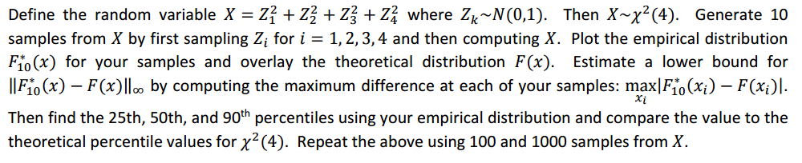

Description:

The empirical distribution function Fn*(x) converges to the cumulative distribution function (cdf) F(x) with probability one(According to Glivenko-Cantelli theorem). That is, the estimation gets better and better as we increase the number of samples n. We can generate empirical distribution function which is simply a step function that jumps up by 1/n at each of the n samples.

Chi-Squared random Varaible Distributions have been generated with degree of freedom = 4.

Using the cdfplot() and the chi2cdf() functions, the empirical and the theoretical distributions of the chi Square Distributions are overlayed. Initially, 100 elements are taken and it is increased to 1000. For calculating the lower bound of the distribution, I used the ecdf() function, which returns the empirical cumulative distribution function evaluated at the points in given distribution.

The maximum of the difference in the two values of the empirical cumulative distribution function and the theoretical distribution, gives us the lower bound. Prctile() function is used to calculate the percentiles. We then calculate the 25th, 50th and 90th percentile and compare them with the theoretical values.

CODE:

N = 100;%Number of samples

X = zeros(N,1);%Initializing with zeros

lower = 1:N;

Z = 1:4;

for j = 1:N %Using for loop to generate N samples of X

for i = 1:4

Z(i) = randn();%Generating a normal distribution R.V

X(j) = X(j) + power(Z(i),2);%calculating X

end

end

cdfplot(X);% Plotting empirical distribution function

hold on % To plot with an overlay

grid on

X = sort (X);%Sort X

theoritical = chi2cdf(X,4);%To calculate the theoretical CDF

plot(X,theoritical);

hold off

f10 = ecdf(X);%Gives a vector of values of the empirical cdf evaluated at X.

legend('Empirical cdf','Theoretical cdf');

ylim([0 1.1]);

title('Empirical Distribution');

xlabel('x');

ylabel('f(x)');

for k = 1:N

lower(k) = abs(f10(k)-theo(k)); %To calculate the lower bound

end

lowerbound = max(lower);

disp('The lower bound is: ')

disp(lowerbound)

%To display output and compare

disp('The 25th percentile');

disp('Empirical Distribution');

disp(prctile(f10,25));

disp('Theoretical Value');

disp(prctile(theoritical,25));

disp('The 50th percentile');

disp('Empirical Distribution');

disp(prctile(f10,50));

disp('Theoretical Value');

disp(prctile(theoritical,50));

disp('The 90th percentile');

disp('Empirical Distribution');

disp(prctile(f10,90));

disp('Theoretical Value');

disp(prctile(theoritical,90));

**Output**

**For N=100**

>> ee511_p4q2

The lower bound is:

0.0566

The 25th percentile

Empirical Distribution

0.2475

Theoretical Value

0.2207

The 50th percentile

Empirical Distribution

0.5000

Theoretical Value

0.4962

The 90th percentile

Empirical Distribution

0.9040

Theoretical Value

0.8598

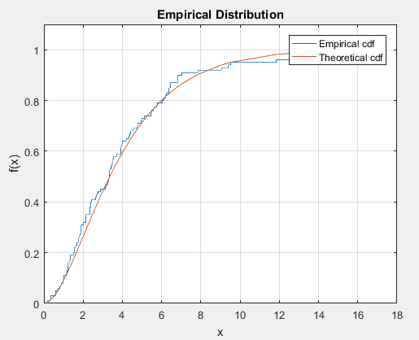

**For N=1000**

>> ee511_p4q2

The lower bound is:

0.0190

The 25th percentile

Empirical Distribution

0.2498

Theoretical Value

0.2544

The 50th percentile

Empirical Distribution

0.5000

Theoretical Value

0.4969

The 90th percentile

Empirical Distribution

0.9004

Theoretical Value

0.8935

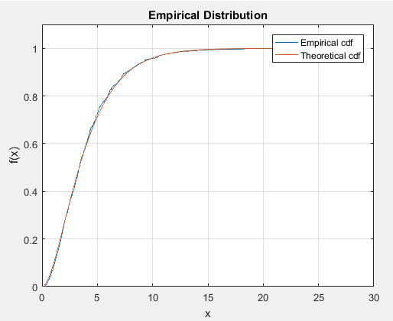

Analysis:

It is evident from the plots that, the difference between the empirical distribution and the theoretical distribution diminishes considerably when the number of samples is increased.  
This verifies the Glivenko-Cantelli theorem, according to which the Empirical Distribution Function given by:

$$F_{n}\left(x\right)=\frac{1}{n}\sum_{i=1}^{n}{I_{\left(-∞,x\right]}(X_{i})}$$

converges to a pointwise convergence (F(x)) when $n→∞$  
So, the Empirical Distribution Function $F_{n}\left(x\right)$ converges to the Cumulative Distribution Function (F(x)), as and when N increases.

Question 3:

A geyser is a hot spring characterized by an intermittent discharge of water and steam.  Old Faithful is a famous  cone geyser in Yellowstone National Park, Wyoming.  It has a predictable geothermal discharge and since 2000  it has erupted every 44 to 125 minutes.  Refer to the addendum data file that contains waiting times and the  durations for 272 eruptions.  Compute a 95% statistical confidence interval for the waiting time using data  from only the first 15 eruptions.  Compare this to a 95% bootstrap confidence interval using the same 15 data  samples.    Repeat  these  calculation  using  all  the  data  samples. Comment on the  relative  width  of  the  confidence intervals when using only 15 samples vs using all sample

Description:

A data file is given with 3 columns stating numbers, waiting times and durations of 272 eruptions respectively. The file is read using fileread() function and the values are scanned to “data” variable. Three column values are taken into x, y, and z respectively. Using std() and sqrt(), standard error is calculated and T-score value is calculated using tinv() function. Hence, 95% statistical confidence interval is found out. To calculate the bootstrap confidence interval, bootstrp() function is used. The upper and the lower bounds are found out using prctile() function.

Code:

% Akshay Deepak Hegde USC ID: 8099460970 %

% -------------------------------------------------------------- %

% Project #4-Integrals and intervals, EE511: Spring 2017

% -------------------------------------------------------------- %

% data file with waiting times and durations are given for 272 eruptions

% To compute 95% statistical confidence interval for first 15 values

% To compute 95% bootstrap confidence interval for first 15 values

% To calculate the same with all data and to compare.

% -------------------------------------------------------------- %

clc;

clear;

close all;

% -------------------------------------------------------------- %

content = fileread( 'faithful.dat.txt' ) ;  % read the data file

data = textscan( content, '%f %f %f%*[^\n]', ...

                        'HeaderLines', 3) ;  % Scan for 3 columns

x = data{1};  % 1st column

y = data{2};  % 2nd column

z = data{3}; % 3rd column

f = (z(1:15)); % First 15 values

  % Statistical confidence interval for 15 values

SError = std(z)/sqrt(length(z));               % To calculate standard error

tscore = tinv([0.025  0.975],length(z)-1);      % To calculate T-score

ConfInt = mean(z) + tscore*SError; % Confidence Interval

disp('Statistical confidence interval for 15 values');

disp(ConfInt);

% Statistical confidence interval for all 272 values

SError = std(f)/sqrt(length(f));               % To calculate standard error

tscore = tinv([0.025  0.975],length(f)-1);      % To calculate T-score

ConfInt = mean(f) + tscore*SError; % Confidence Interval

disp('Statistical confidence interval for all 272 values');

disp(ConfInt);

% Bootstrap confidence interval

y = bootstrp(15, @mean, z)  % Bootstrap interval for 15 values

Sort = sort(y)

disp('Bootstrap confidence interval for 15 values');

CIlow=prctile(Sort,2.5)  % Lower bound

CIhigh=prctile(Sort,97.5) % Upper bound

y = bootstrp(272, @std, f) % Bootstrap interval for all 272 values

Sort = sort(y)

disp('Bootstrap confidence interval for all 272 values');

CIlow=prctile(Sort,2.5) % Lower bound

CIhigh=prctile(Sort,97.5) % Upper bound

Result:

Statistical confidence interval for 15 values

   62.5571   79.3096

Statistical confidence interval for all 272 values

   69.2742   72.5199

Bootstrap confidence interval for 15 values

CIlow =

   62.5333

CIhigh =

   79.4667

Bootstrap confidence interval for all 272 values

CIlow =

   69.1386

CIhigh =

   72.4463

Analysis and Discussion:

It is evident from the output that, as the number of samples increases the confidence interval is reduces. When we take 15 samples and compute the statistical and bootstrap confidence intervals, we can

see that the relative width is higher. When we take all samples the relative widths of statistical and bootstrap confidence intervals are almost the same.