University of Southern California

EE511

Simulation Methods for Stochastic Systems

Project #5

Markov Chains and Discrete Events

BY

Akshay Deepak Hegde

USC ID: 8099460970

[hegdeaks@usc.edu](mailto:hegdeaks@usc.edu)

**1.**

**THEORY:**

A Poisson process is the distribution where average rate of arrivals is not allowed to vary with time. A non-homogeneous Poisson process is similar to an ordinary Poisson process, except that the average rate of arrivals is allowed to vary with time. Many applications that generate random points in time can be modelled using non-homogeneous processes. In our case, we have a Single Server Queuing system, where customers arrive according to a non-homogeneous Poisson process with intensity function lambda(t), t>=0. A customer is handled if server is free or else queued. When server completes serving a customer, it begins handling longest waiting customer( First come first served) or remains free if queue is empty. The amount of time to service a customer follows a probability distribution. Fixed time T after which no new arrivals occur. But server continues to handle all customers in queue. The values of interest to us here are the average time customer spends in queue and the average time past T that last customer departs.

**DESCRIPTION:**

The non-homogeneous algorithm is as below,

Suppose that λ(t) is the bounded intensity function (arrival function) for a non-homogenous Poisson process. To generate a sample Ts that is the time of the first arrival after time s:

Algorithm:

Choose λ so that λ(t)<λ for all t.

Given λ(t), t>0, and λ:

Let t=s.

Generate U1∼U[0,1].

Let t=t−1/λ⋅logU1.

Generate U2∼U[0,1].

If U2≤(λ(t)/λ) set Ts=t and stop.

Goto step 2.

For the calculation of lambda t there are 2 cases. In the first case it linearly increases from 4 to 19 hours for the first 5 hours, which is given by the expression 3*t+4. In the second case it linearly decreases from 19 hours to 4 hours in the next 5 hours which is given by the expression -3*t-4.

The service‐time distribution is exponential with rate 25 jobs per hour. An array of random numbers chosen from the exponential distribution with mean parameter MU is obtained using exprnd() function. Here MU=25. The waiting time is uniformly distributed on (0,0.3). The variable ‘idle’ in the program represents this. So, for 100 hours we increment the break time if there are no jobs waiting in the queue. We get the answer to be 11.055 which means the server is idle for that many hours in 100 hours.

**Code:**

N=100; % Number of hours

x=0;

j=1;

lambda=20;

breaktime=0;

%Non-homogeneous Poisson process Algorithm

while x<100

U=rand();

x=x-(log(U)/lambda);

if(mod(x,10) < 5)

lambda_t=3*x+4; % For the first 5 hours the arrival rate linearly increases

ratio=lambda_t/lambda;

elseif(mod(x,10)>5)

lambda_t=-3*x-4; % For the next 5 hours the arrival rate linearly decreases

ratio=lambda_t/lambda;

end

V=rand();

if(V<=ratio)

Ts(j)=x; % First arrival after some time

j=j+1;

end

end

%Break time calculation

for i=1:length(Ts)-1

s=exprnd(25); % Service time distribution with a rate of 25 jobs per hour

while((s + Ts(i)) < Ts(i+1)) % If at all there are no jobs waiting

idle=0.3*rand();

breaktime=breaktime+idle; % Total break time for 100 hours

s=s+idle;

end

end

% Display the result

output1=['The break time is about', num2str(breaktime)];

disp(output1)

**Output:**

The break time is about 11.055 hours.

**Discussion and Analysis:**

The given problem can be modelled as non-homogeneous Poisson process.

2.

Description:

Two probabilities have been assigned to packet reaching port1 and port2(0.7) in our case. A random number is generated and checked if the value of that is less than 0.7. If it is less, then the packet has arrived at that port. ‘p_switch’ is a variable where if the variable is less than 0.5 in the first case, it won’t be switched. In the asymmetric case if the variable is less than 0.75 at port1 and 0.25 at port2 it won’t be switched.

The four possible states are (00),(01),(10),(11). For the states 11 and 00, contention occurs, only one packet can be sent. If a packet has arrived at the other port it must be buffered. The buffered packet will be sent in the next time slot. For states 01 and 10, packets at both ports can be sent. For the contention case, we are holding 2 flag variables. If flag1=1, then we change the state of port2 to the previous state since packet was in buffer. We reset the buffer and flag for port2. If flag2=1 then we change the state of port1 to the previous state since packet was in buffer. We reset the buffer and flag for port1. We calculate the efficiency of the switch by the total number of packets sent by the total number of packets received in each timeslot. 95% confidence interval is calculated using bootci command.

Code:

N = 1000;

p1 = 0.7; %Probability of packet arriving at port 1

p2 = 0.7; %Probability of packet arriving at port 2

flag1 = 0;

flag2 = 0;

packetnum_1 = 0;

packetnum_2 = 0;

buff_1 = 0;

buff_2 = 0;

P1 = zeros(1,N);

P2 = zeros(1,N);

p_switch1 = zeros(1,N);

p_switch2 = zeros(1,N);

Num_packets = zeros(1,N);

Buff1 = zeros(1,N);

Buff2 = zeros(1,N);

p1_no = 0; p2_no = 0; k = 1;

for i = 1:N

packet_switched = 0; X = 1; Y = 1; nopacket_flag = 0;

P1(i) = rand();

P2(i) = rand();

if (P1(i) < p1) % Packet arrives at line 1

packetnum_1 = packetnum_1 + 1;

p_switch1(i) = rand();

else

nopacket_flag = 1;

end

if (P2(i) < p2) % Packet arrives at line 2

packetnum_2 = packetnum_2 + 1;

p_switch2(i) = rand();

else

nopacket_flag = 1;

end

if (p_switch1(i) < 0.75)

p_switch1(i) = 0;

else

p_switch1(i) = 1;

end

if (p_switch2(i) < 0.25)

p_switch2(i) = 0;

else

p_switch2(i) = 1;

end

if(i>1)

if(flag1 == 1) % If collision

p_switch2(i)=p_switch2(i-1);

if ( buff_2 == 0 ), flag1 = 0; end

end

if(flag2 == 1)

p_switch1(i)=p_switch1(i-1);

if ( buff_1 == 0 ), flag2 = 0; end

end

end

if ((p_switch1(i) == 1 && p_switch2(i) == 0) || (p_switch1(i) == 0 && ...

p_switch2(i) == 1) || nopacket_flag)%for states 01 and 10

packet_switched = packet_switched + ...

packetnum_1 + packetnum_2; X = 0; Y = 0;

else %for states 00 and 11

contention = rand(1);

if(contention < 0.5)

buff_2 = buff_2 + 1;

packet_switched = packet_switched + 1;

if (buff_1 > 0), buff_1 = buff_1 - 1; end

flag1 = 1; X = 0;

else

buff_1 = buff_1 + 1;

packet_switched = packet_switched + 1;

if (buff_2 > 0), buff_2 = buff_2 - 1; end

flag2 = 1; Y = 0;

end

end

Num_packets(i) = packet_switched;

if(packetnum_1*packetnum_2 == 1)

Eff_switch(k) = Num_packets(i)/(packetnum_1 + ...

packetnum_2);

k = k + 1;

end

Buff1(i) = buff_1; Buff2(i) = buff_2;

p1_no = p1_no + packetnum_1 - X;%packets at output 1

packetnum_1 = 0;

p2_no = p2_no + packetnum_2 - Y;%packets at output 2

packetnum_2 = 0;

end

b = bootci(1000, @mean, Eff_switch);

disp('Confidence interval for overall efficiency');

disp(b);

M_switched = mean(Num_packets);

M_B1 = mean(Buff1); M_B2 = mean(Buff2);

Total_packets_switched = p1_no + p2_no;

figure(1);

histogram(Buff1);

disp(M_B1);

title('Distribution of number of packets in buffer at input line 1');

xlabel('Num of packets');

ylabel('Frequency');

figure(2);

histogram(Buff2);

disp(M_B2);

title('Distribution of number of packets in buffer at input line 2');

xlabel('Num of packets');

ylabel('Frequency');

figure(3);

histogram(Num_packets);

disp(M_switched);

title('Distribution of number of packets switched in 1 timeslot');

xlabel('Number of packets');

ylabel('Frequency');

Output:

For the first case r=0.5

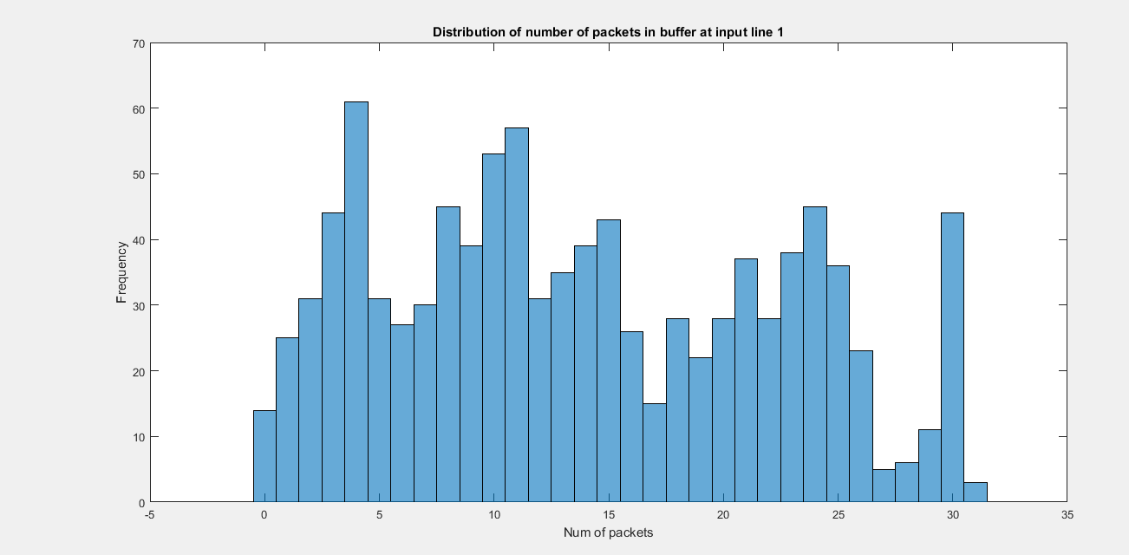

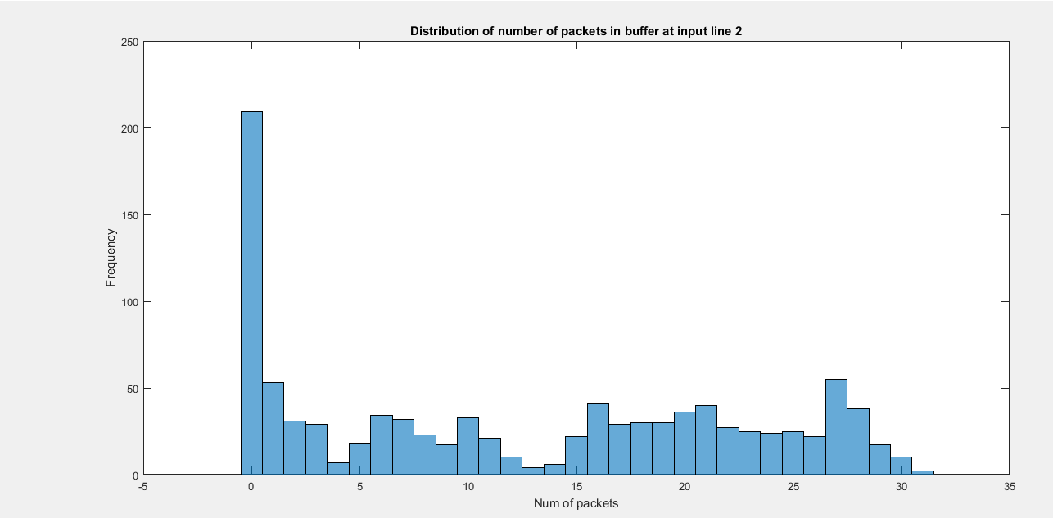

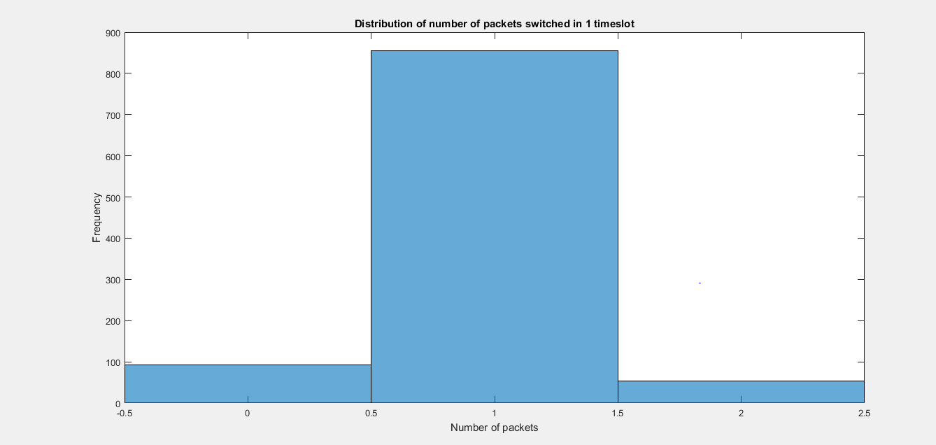

Confidence interval for overall efficiency

0.6700

0.7170

Mean number of packets at port 1= 13.7170

Mean number of packets at port 2= 12.4912

Mean number of packets switched in 1 timeslot= 0.9201

For the second case where r1=0.75 and r2=0.25

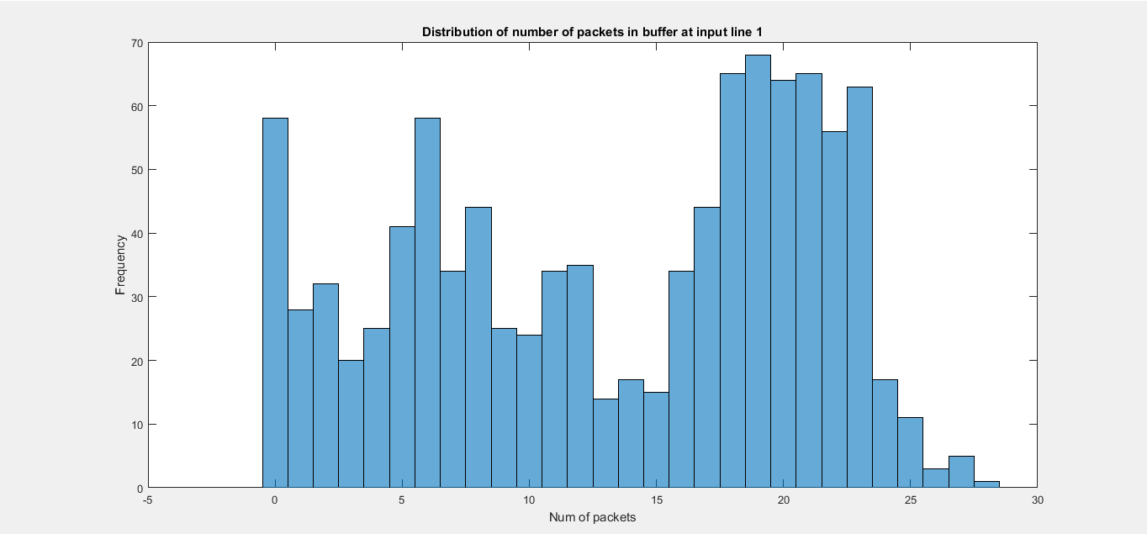

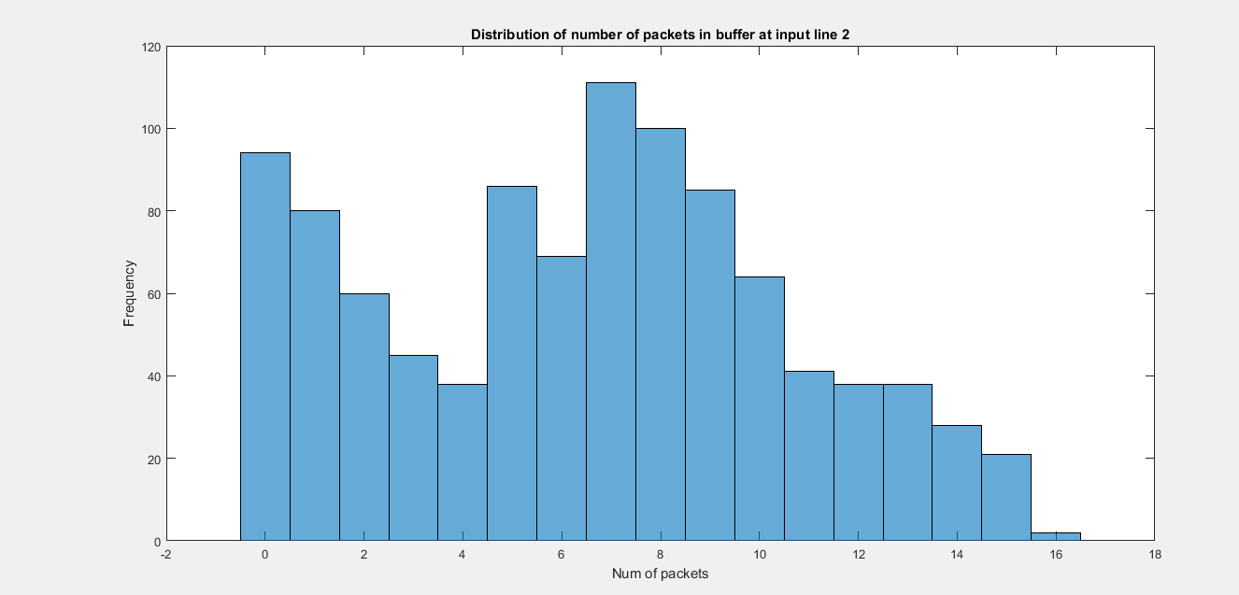

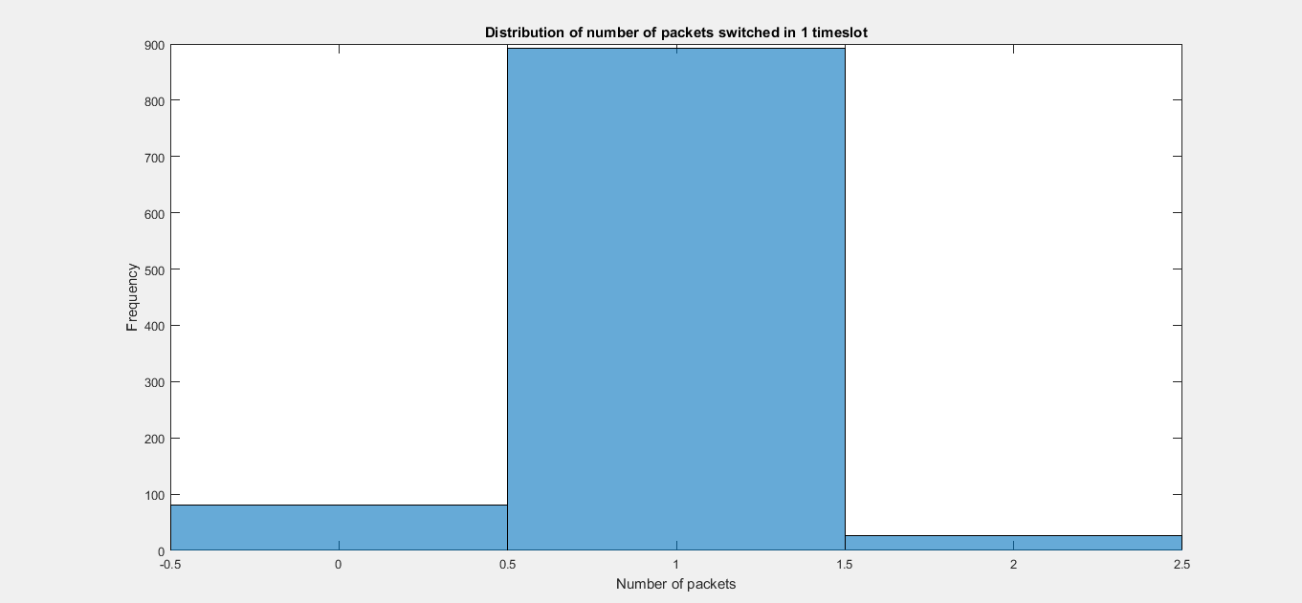

Confidence interval for overall efficiency

0.5082

0.5472

Mean number of packets at port 1= 13.2790

Mean number of packets at port 2= 6.5344

Mean number of packets switched in 1 timeslot= 0.9352

Results and analysis:

The confidence interval in the symmetric case is more than that in the asymmetric case. Also, even the efficiency is more in case of symmetric case.

Head-of-line blocking occurs whenever traffic waiting to be transmitted prevents or blocks traffic destined elsewhere from being transmitted. Head-of-line blocking occurs most often when multiple high-speed data sources are sending to the same destination.

3.

Description:

The problem is about the Wright Fisher model and the model is explained as follows. Assume a simple haploid model; it consists of a population of 2N genes (or alternatively – N diploid organisms) of random reproduction, with each haploid possessing either allele A1 or allele A2. Initially, we may disregard mutation as well as selective forces. At each time-step, a gene (allele) reproduces some number of offspring (which are the exact copies of itself) and dies immediately after that; having a life-span of only one generation. The process, modeled thus, describes how the genes get transmitted from one generation to the next.

The only observable is the frequency of alleles changing from generation to generation since the process of birth and death in the population remains hidden. The allele frequency of the next generation is governed only by a genetic drift. The Genetic drift is defined as a force that reduces heterozygosity by the random loss of alleles. We should just focus on the frequency of allele A1 in the population of 2N haploids. Think of this process as changing from one generation to the next in terms of a Markov Chain, where the state X of the chain corresponds to the number of haploids (genes) of type A1.

In any generation X takes one of the values 0, 1, . . . , 2N, which constitutes a state space. Denote the value taken by X in generation t as Xt . The model assumes that genes for the generation t + 1 are derived by sampling with replacement from the genes of generation t. Thus, the make-up of the next generation is determined by 2N independent Bernoulli trials so that Xt is a binomial random variable.

Let the initial generation consist of i genes of type A1 and 2N − i genes of type A2. Then we define a probability of success (resulting in allele A1) pi and a probability of failure qi (resulting in allele A2) for each Bernoulli trial as pi = i/2N, qi = 1 – i/2N. The process generates a Markov Chain {Xn}, where Xn is the number of A1 genes in the nth generation, among a constant population size of 2N individuals. Basically, Xt+1 is a binomial random variable with index 2N and parameter (probability of success) Xt/2N.

Code:

clc;

clear all;

close all;

In=input('Enter the location of A1 allele');% User input

input=zeros(1,201); % Initial distribution

input(In)=1;

N = 100; % Number of individuals

% transition matrix

Mat=zeros(2*N+1,2*N+1);

for i = 1:2*N+1

for j = 1:2*N+1

Mat(i,j) = nchoosek(2*N,j-1)*((i-1)/(2*N))^(j-1)*(1-(i-1)/(2*N))^(2*N-j+1);

end

end

n=1000; % Number of time steps to take

output=zeros(n+1,2*N+1); % Clear out any old values

t=0:n; % Time indices

output(1,:)=input; % To get first output value

for i=1:n,

output(i+1,:) = output(i,:)*Mat;

LIT =(output(i+1,:)- output(i,:)); % Threshhold calculation

if all(LIT == 1)

break;

end

end

plot(t,output);

xlabel('Time axis');

ylabel('Probability of a particular state')

title('Genetic population composition')

Output:

User input 45

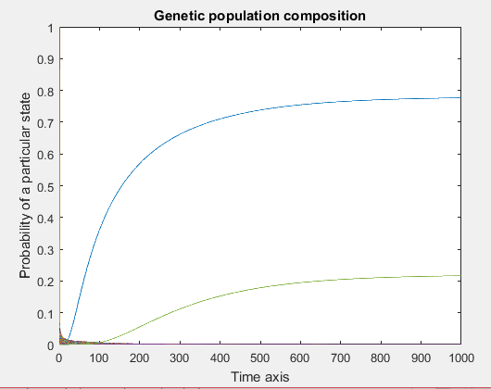

User input 190

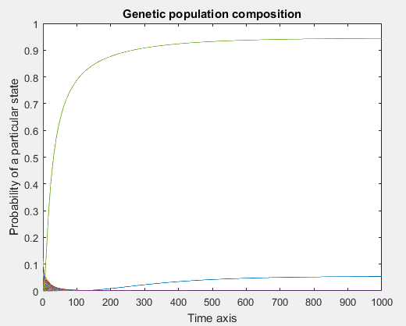

Results and analysis:

As we can observe from the graphs, with different allele initial distribution, the steady state reaches more quickly in the first case when compared to the second graph. Hence, this defies the Perron-Frobenius theorem and the Markov chain ergodic theorem.

The transition probabilities from Xt = i to Xt+1 = j for this Markov Chain can be computed using the binomial distribution as,

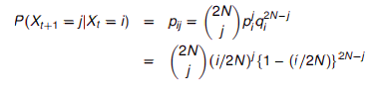

A matrix in which all the column vectors are probability vectors is called a transition matrix or a stochastic matrix.

A Markov chain is a process that consists of a finite number of states and some known probabilities pij, where pij is the probability of moving from state j to state i. We are interested in the probability vector p such that Ap=p, that is, an eigen vector of A associated to the eigenvalue 1. Such vector is called a steady state vector.

The Perron–Frobenius theorem, asserts that a [real square matrix](https://en.wikipedia.org/wiki/Real_square_matrix) with positive entries has a unique largest real [eigen value](https://en.wikipedia.org/wiki/Eigenvalue) and that the corresponding [eigen vector](https://en.wikipedia.org/wiki/Eigenvector) can be chosen to have strictly positive components, and also asserts a similar statement for certain classes of nonnegative matrices. A Markov chain is ergodic if there is a number N such that any state can be reached from any other state in at most N steps (in other words, the number of steps taken are bounded by a finite positive integer N). If all transitions have a non-zero probability, this condition is fulfilled with N=1. A Markov chain with more than one state and just one out-going transition per state is either not irreducible or not aperiodic, hence cannot be ergodic.