EE 511

Simulation Methods of Stochastic Systems

PROJECT #5

Continuous Sampling

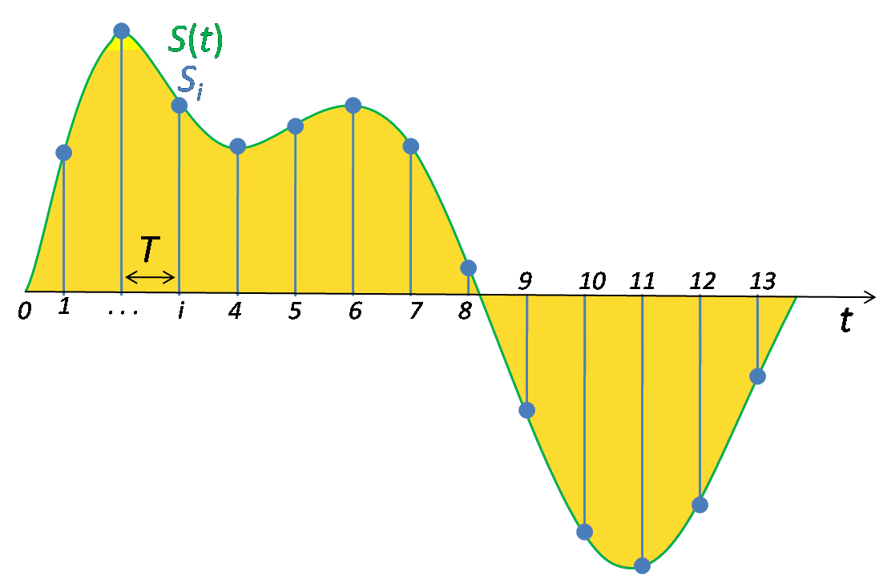

**By**

SHIVA SHANMUGAPPA PATRE

**USC ID: 6129918110**

spatre@usc.edu

**Question 1**

**DESCRIPTION**

The **Box–Muller transform** is a pseudo-random number sampling method for generating pairs of independent, standard, normally distributed (zero expectation, unit variance) random numbers, given a source of uniformly distributed random numbers. It is commonly expressed in two forms. The basic form as given by Box and Muller takes two samples from the uniform distribution on the interval [0, 1] and maps them to two standard, normally distributed samples. The polar form takes two samples from a different interval, [−1, +1], and maps them to two normally distributed samples without the use of sine or cosine functions

Suppose U1 and U2 are independent random variables that are uniformly distributed in the interval (0, 1). Let





Then Z0 and Z1 are independent random variables with a standard normal distribution.

The **Polar Marsaglia** method is a pseudo-random number sampling method for generating a pair of independent standard normal random variables. It is superior to the Box–Muller transform.

The polar method works by choosing random points (x, y) in the square −1 < x < 1, −1 < y < 1 until



and then returning the required pair of normal random variables as.

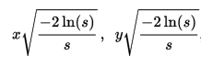

Or equivalently,



where {\displaystyle x/{\sqrt {s}}} represent the cosine and sine of the angle that the vector (x, y) makes with x axis.

The Algorithm followed is as follows:

1: Take u1, u2 from uniform distribution on ( − 1, 1)

2: Accept if s = u1^2 + u2^2 < 1, otherwise get new u1, u2

3: Let X = sqrt( −2 log(s)/s)*u1, Y = sqrt( −2 log(s)/s)*u2

Code Description

We first generate independent random variables using Box-Muller method. BoxMuller_RandomSamples function is used to perform the required operation according to the formulas described above. makedist function is used to make a probability distribution. The covariance is calculated using the ‘cov’ function. The histogram is generated and the theoretical pdf is overlayed on the histogram as can be seen in the graph. We next calculated the computational time taken by Box Muller method for 1 million samples using ‘tic’ and ‘toc’ for stopwatch timers. Similarly we calculate the computational time for Polar Marsaglia method and compare the results. We use PolarMarsaglia_RandomSamples function for the calculation.

Code

clc;

clear all;

close all;

[X,Y,A]=BoxMuller_RandomSamples(1000);%calling BoxMuller function

covariance1=cov(X,Y);

T = -100:100;

mu=3;

sigma=sqrt(13);

pd=makedist('Normal',mu,sigma);%Make probability distribution

P=pdf(pd,T);

%Output

disp('Output for the Box-Muller Method:');

fprintf('\nThe Covariance of X and Y is: \n%f %f\n%f %f\n',covariance1);

yyaxis left

hist(A);

title('Histogram of Random Variable A');

xlabel('Value');

ylabel('Frequency');

yyaxis right

plot(T,P);

ylabel('Probability');

mx=mean(X);

my=mean(Y);

vx=var(X);

vy=var(Y);

fprintf('\nThe Observed mean and variance of X are:\nMean = %f\nVariance = %f\n',mx,vx);

fprintf('\nThe Observed mean and variance of Y are:\nMean = %f\nVariance = %f\n',my,vy);

tic;%start the stopwatch timer

BoxMuller_RandomSamples(1000000);

ET1=toc;%end the stop watch timer and record the value

tic;%start the stopwatch timer

[X1,Y1]=PolarMarsaglia_RandomSamples(1000000);%Calling PolarMarsaglia function

ET2=toc;%end the stop watch timer and record the value

mx1=mean(X1);

my1=mean(Y1);

vx1=var(X1);

vy1=var(Y1);

covariance2=cov(X1,Y1);

disp('Output for Polar Marsaglia method:');

fprintf('\nThe Covariance of X and Y is: \n%f %f\n%f %f\n',covariance2);

fprintf('\nThe Observed mean and variance of X are:\nMean = %f\nVariance = %f\n',mx1,vx1);

fprintf('\nThe Observed mean and variance of Y are:\nMean = %f\nVariance = %f\n',my1,vy1);

disp('The computational time required to generate 1,000,000 pairs of independent samples\n');

fprintf('using the Polar Marsaglia method and the Box Muller method are respectively:\n%f\n%f\n',ET2,ET1);

Functions Used

**1)**

function [X,Y,A] = BoxMuller_RandomSamples(n)

m1=1;%Mean of X

v1=4;%Variance of X

m2=2;%Mean of Y

v2=9;%Variance of Y

for i=1:n

u1=rand(); %Generating uniform random variables

u2=rand();

x(i)=sqrt(-2*log(u1))*cos(2*pi*u2);

y(i)=sqrt(-2*log(u1))*sin(2*pi*u2);

X(i)=sqrt(v1)*x(i)+m1;

Y(i)=sqrt(v2)*y(i)+m2;

A(i)=X(i)+Y(i); %A=X+Y

end

end

**2)**

function[X1,Y1] = PolarMarsaglia_RandomSamples(n)

m3 = 1; % Mean of X

m4 = 2; % Mean of Y

v3 = 4; % Variance of X

v4 = 9; % Variance of Y

i = 0; % the random number generated by the algorithm

% Generate X and Y that are N(0,1) random variables and independent

while(i<=n-1)

u1 = 2*rand()-1;

u2 = 2*rand()-1;

s = u1^2 + u2^2;

if(s < 1)

i = i + 1;

x1(i) = sqrt(-2*log(s)/s)*u1;

y1(i) = sqrt(-2*log(s)/s)*u2;

end

end

% Scaling them to a particular mean and variance

X1 = sqrt(v3)*x1 + m3; % X~ N(m3,v3)

Y1 = sqrt(v4)*y1 + m4; % Y~ N(m4,v4)

end

Output

Output for the Box-Muller Method:

The Covariance of X and Y is:

4.164883 0.391647

0.391647 9.344152

The Observed mean and variance of X are:

Mean = 0.963578

Variance = 4.164883

The Observed mean and variance of Y are:

Mean = 2.189527

Variance = 9.344152

Output for Polar Marsaglia method:

The Covariance of X and Y is:

4.001458 -0.004079

-0.004079 8.974426

The Observed mean and variance of X are:

Mean = 0.996531

Variance = 4.001458

The Observed mean and variance of Y are:

Mean = 1.997356

Variance = 8.974426

**Trial1)**

The computational time required to generate 1,000,000 pairs of independent samples\n

using the Polar Marsaglia method and the Box Muller method are respectively:

**2.083610**

**3.245319**

**Trial2)**

The computational time required to generate 1,000,000 pairs of independent samples\n

using the Polar Marsaglia method and the Box Muller method are respectively:

**1.715589**

**3.124633**

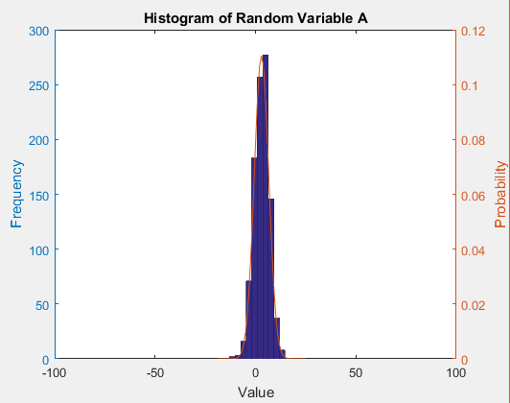

Analysis and Discussion

The outputs are as above. The computational time taken by Polar Marsaglia method is **less** when compared to Box Muller method as can be seen above, from two trials. So we can conclude and say that Polar Marsaglia is a superior method when compared to Box Muller.