**FIGMA DOCUMENTATION: TEAM 1**  
  
**At Data Dialect, our vision is to celebrate and preserve cultural diversity, making it accessible for all. Our mission is to collect, curate, and share regional stories, traditions, and experiences, fostering cross-cultural understanding and appreciation.**

**USER PAGE**

**1. Sign In Page**

**Purpose:**

To enable new users to create an account on the platform.

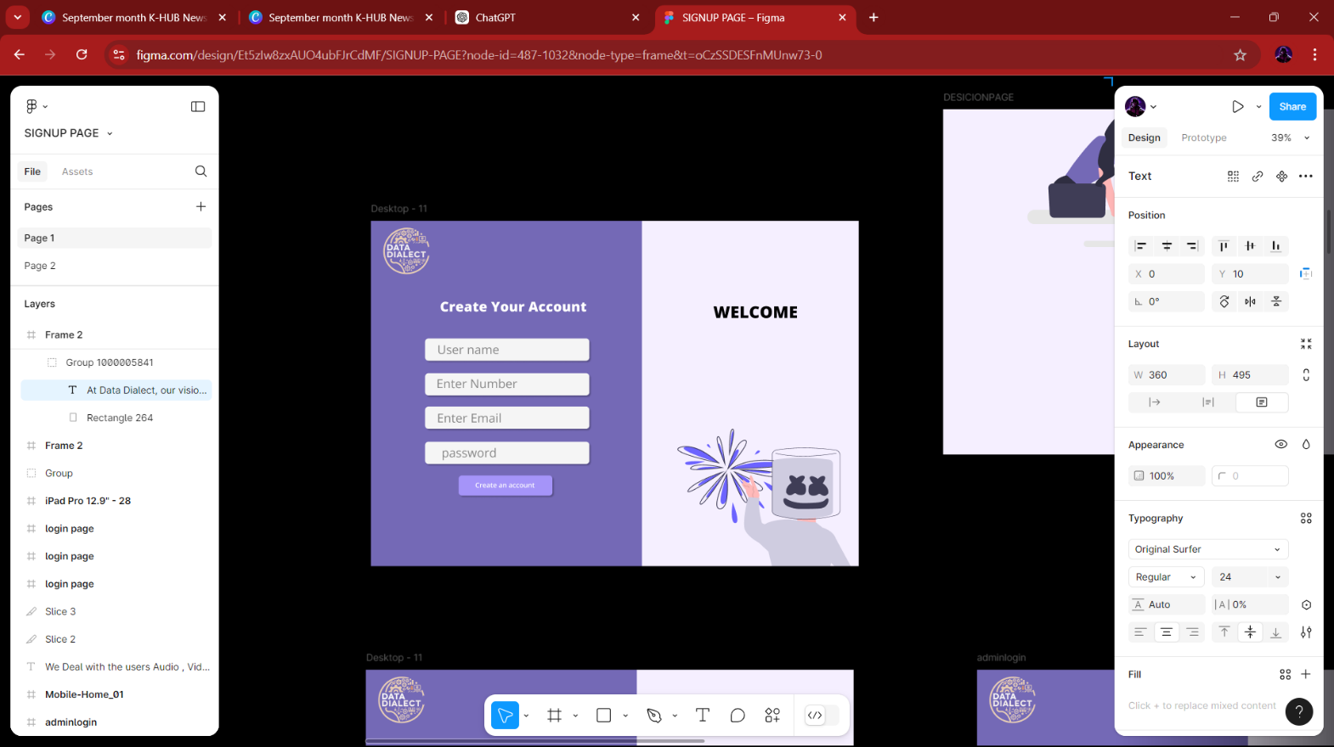**Elements:**

* **Welcome Message:** A friendly greeting to new users.
* **Input Fields:**
  + Username
  + Phone Number
  + Email Address
  + Password
* **Buttons:**
  + Create an Account: Submits the information to create a new user account.

**2. Login Page**

**Purpose:**

To enable returning users to log into their accounts.

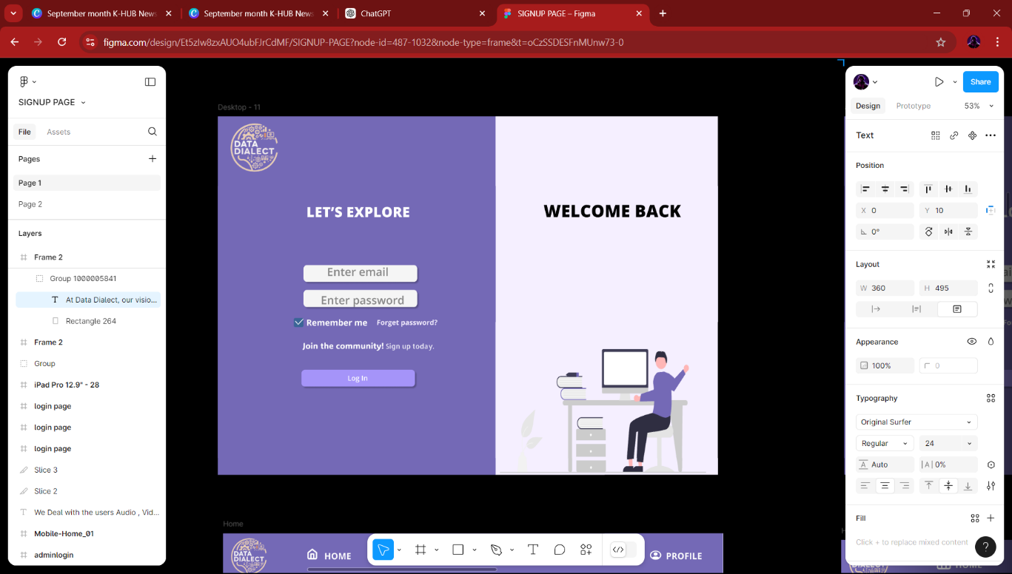**Elements:**

* **Welcome Back Message:** A greeting for returning users.
* **Input Fields:**
  + Email Address
  + Password
* **Checkbox:**

Remember Me: Option to save login details for future sessions.

* **Links:**
  + Forget Password?: Redirects to a password recovery page.
  + Join the Community: Encourages new users to sign up.
* **Button:**
  + Log In: Submits the login credentials.

**3. Home Page**

Main dashboard for users to navigate the platform.

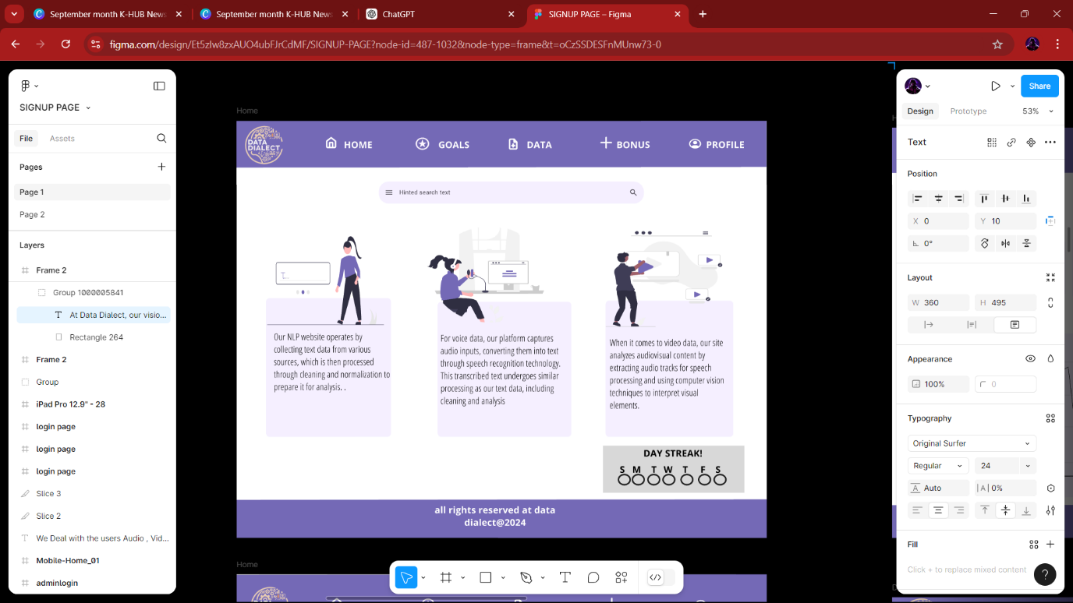**Elements:**

* **Navigation Menu:**
  + Goals
  + Data
  + Bonus
  + Profile
* **Streak Tracker:**
  + Day Streak: Visual representation of the user's learning consistency.
* **Leaderboard Section:**
  + Highest Streak: Displays top users based on their streaks.
  + Rank: Shows the user's rank compared to others.

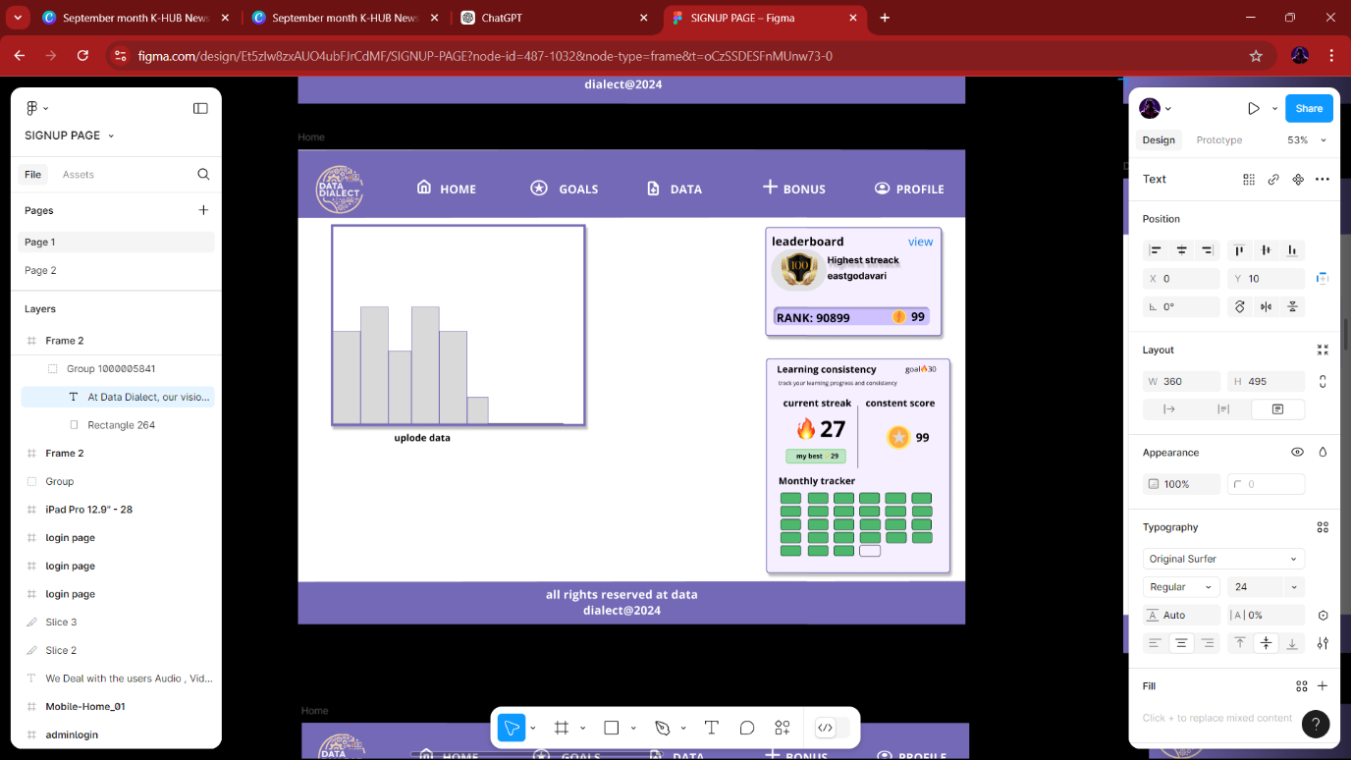**4. Goals Page**

**Purpose:**

To track user learning progress and consistency.

**Elements:**

* **Learning Goals:**
  + Current Goal: Shows the target streak.
  + Current Streak: Displays the ongoing streak.
  + Consistent Score: Indicates the score based on consistency.
* **Upload Data Button:** For users to submit their data for analysis.
* **Monthly Tracker:** A visual representation of progress over the month.

**5. Data Page**

**Purpose:**

To upload and manage different types of data.

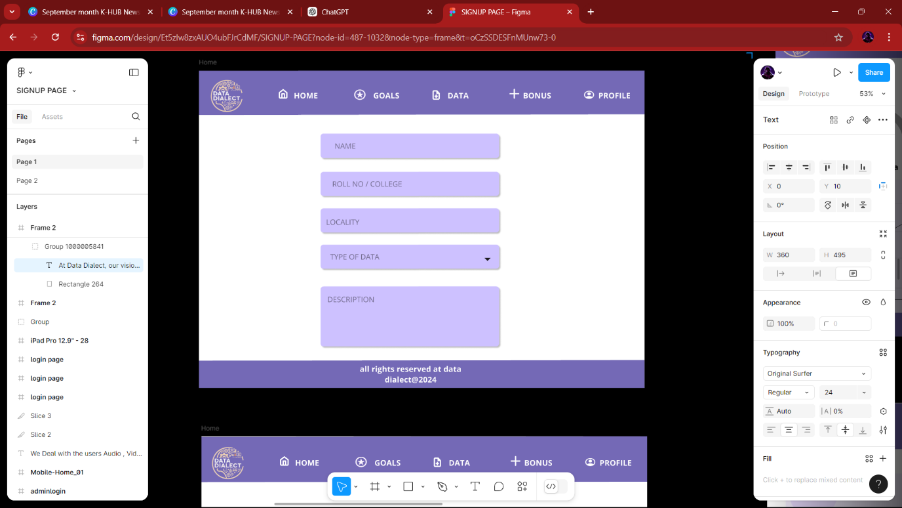**Elements:**

* **Input Fields:**
  + Name
  + Roll No / College
  + Locality
  + Type of Data: Dropdown to select data type.
  + Description: Text area for additional information.
* 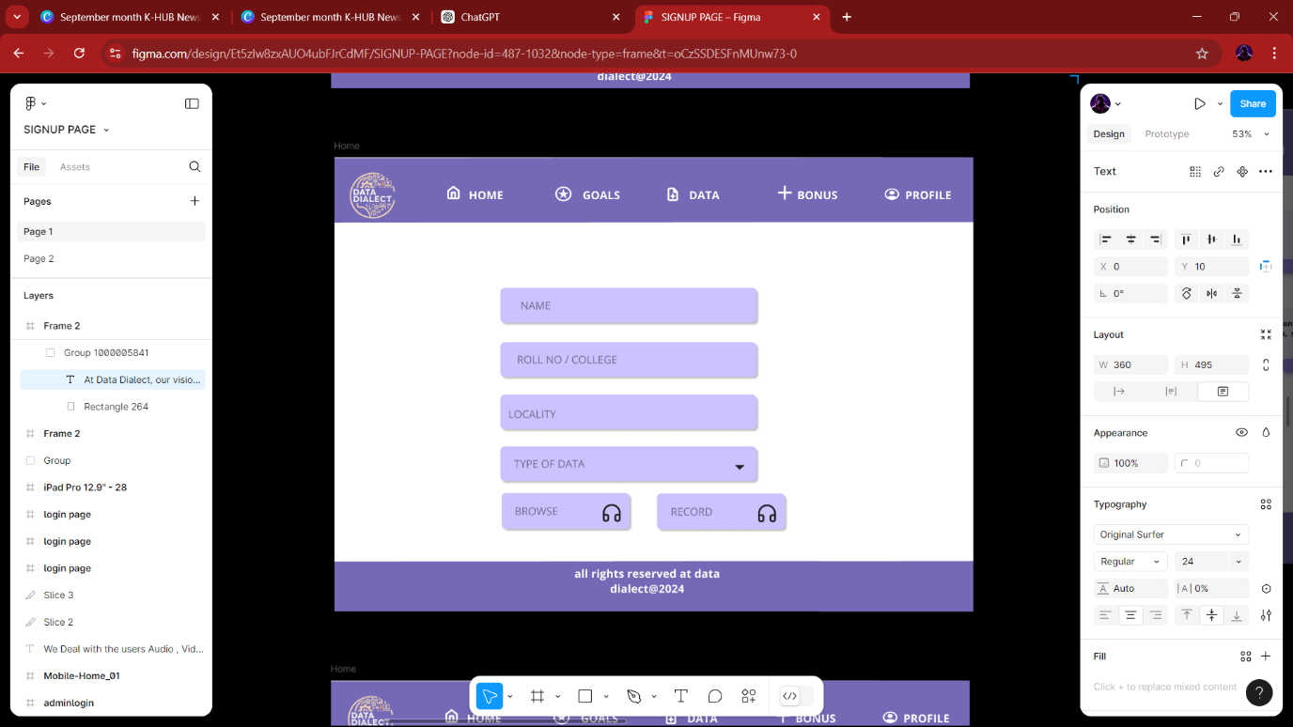**Input Fields:**
  + Name
  + Roll No / College
  + Locality
  + Type of Data: Dropdown to select data type.
  + Audio: Area for addition for audio information.
* **Input Fields:**
  + 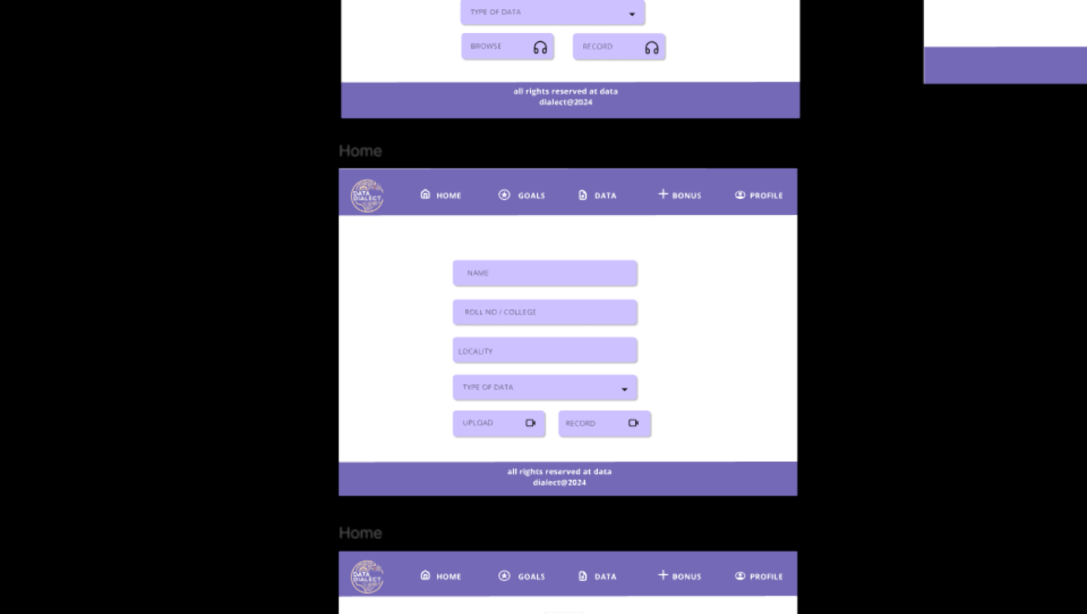Name
  + Roll No / College
  + Locality
  + Type of Data: Dropdown to select data type.
  + Video: Area for addition for video information.
* **Buttons:**
  + Browse: To select files for upload.
  + Record: To start data recording.
  + Upload: To submit the data for processing.

**6. Profile Page**

**Purpose:**

For users to manage their personal information and settings.

**Elements:**

* 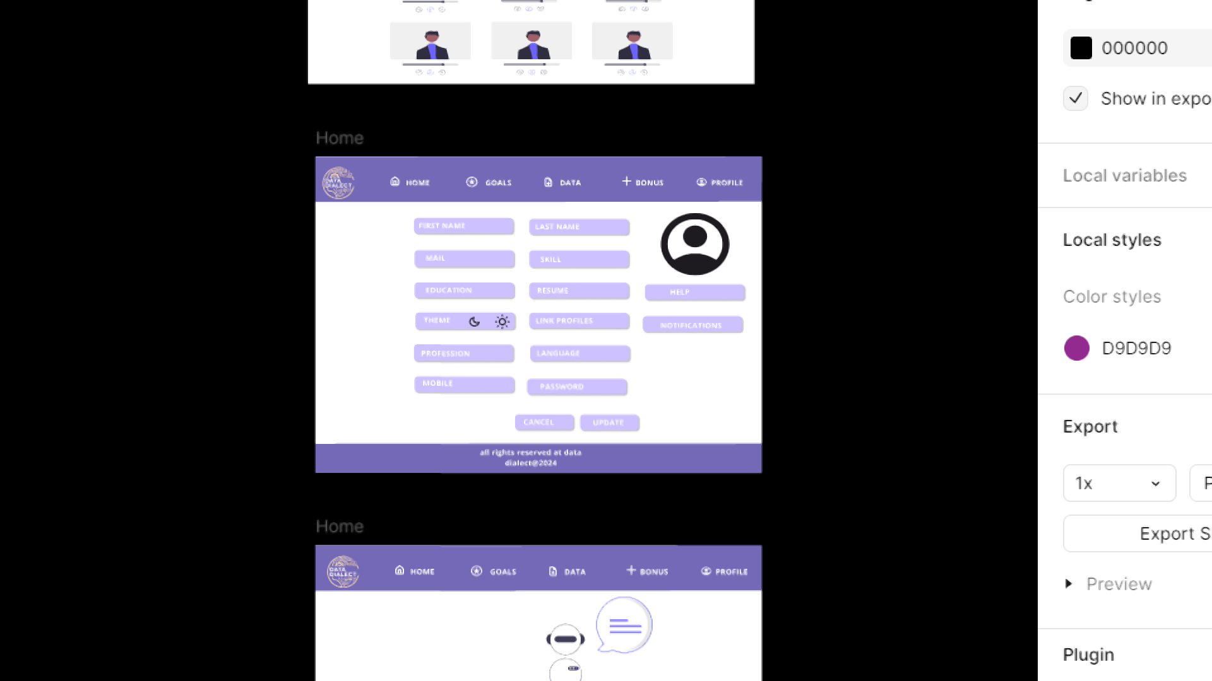**Input Fields:**
  + First Name
  + Last Name
  + Email
  + Skills
  + Education
  + Resume Upload
  + Help Section
  + Theme Preference
  + Linked Profiles
  + Notifications Settings
* **Buttons:**
  + Cancel: To discard changes.
  + Update: To save profile changes.

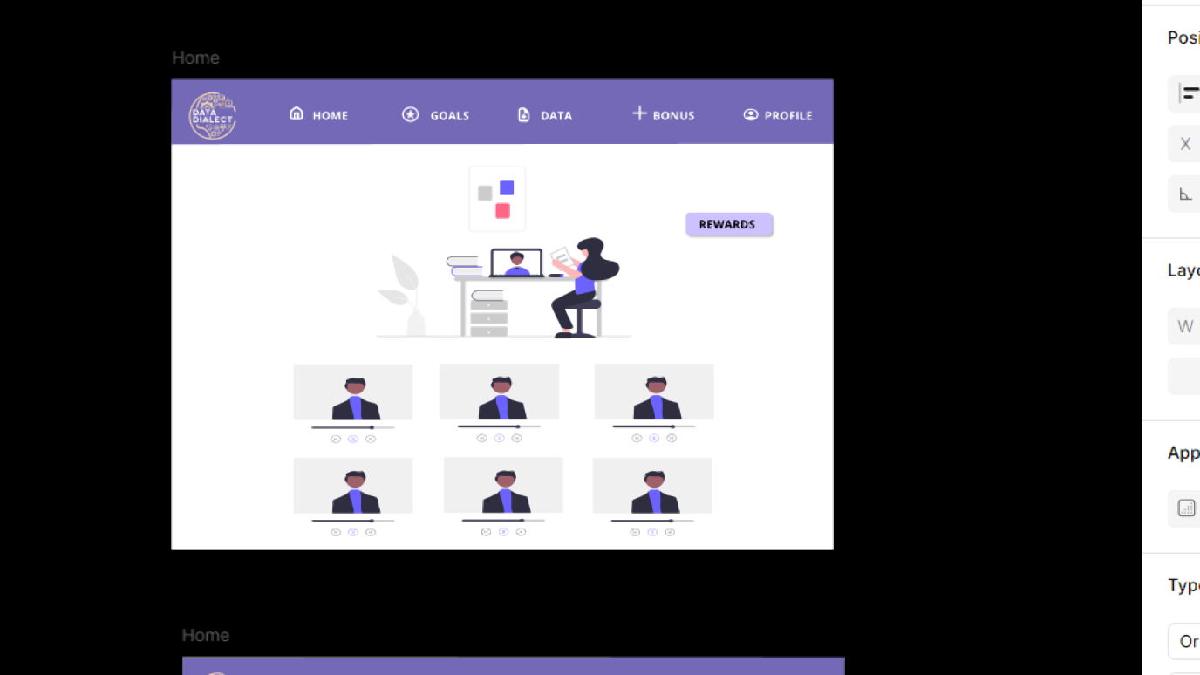

**7. Rewards Page**

**Purpose:**

To display and manage user rewards and bonuses.

**Elements:**

* **Navigation Menu:**
  + Same as the home page for easy access.

**8. Help Section**

**Purpose:**

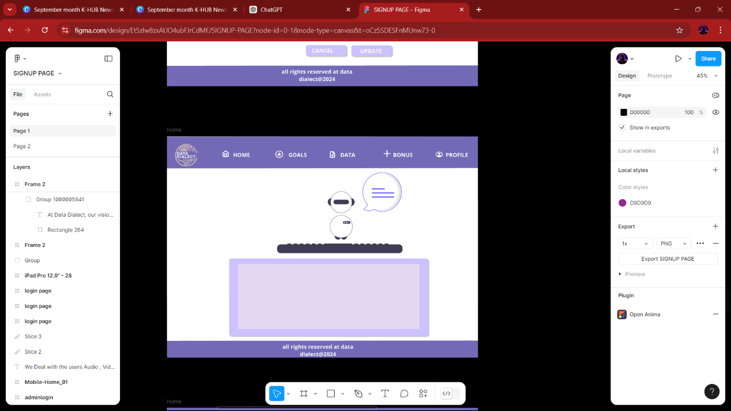To provide users with assistance and support regarding the platform.

**Elements:**

* FAQs: A list of frequently asked questions to help users navigate common issues.
* Contact Support: Information on how to reach support for further assistance.
* Resources: Links to guides and tutorials for using the platform effectively.

**9. Notifications Page**

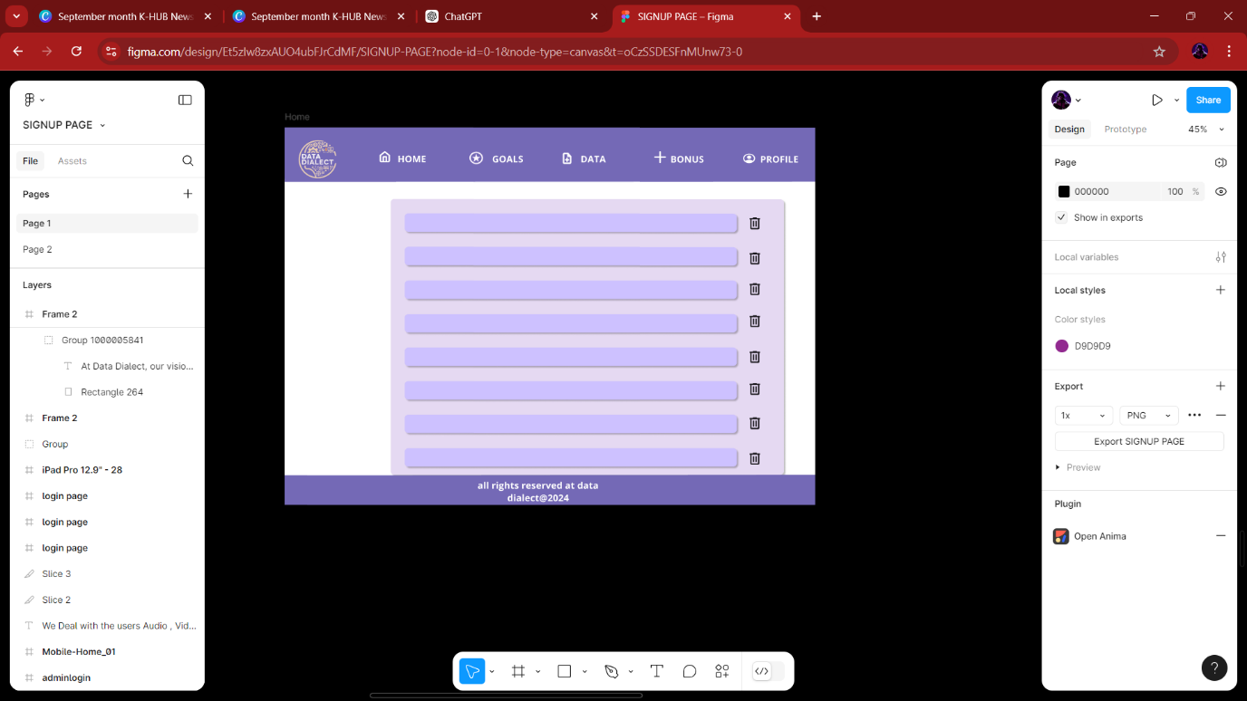**Purpose:**

To keep users informed about important updates and activities on the platform.

**Elements:**

* Notification List: Displays recent notifications, such as messages, updates, and alerts.
* Filter Options: Allows users to sort notifications by date or category.
* Mark as Read: Option to mark notifications as read for better organization.

**10. Footer Section**

**Purpose:**

To provide copyright and other legal information.

**Elements:**

* **Copyright Notice:**
  + “All rights reserved at Data Dialect @2024.

**ADMIN PAGE**

**1. Home Page**

**Purpose:**

The main dashboard for administrators to monitor platform activities and statistics.

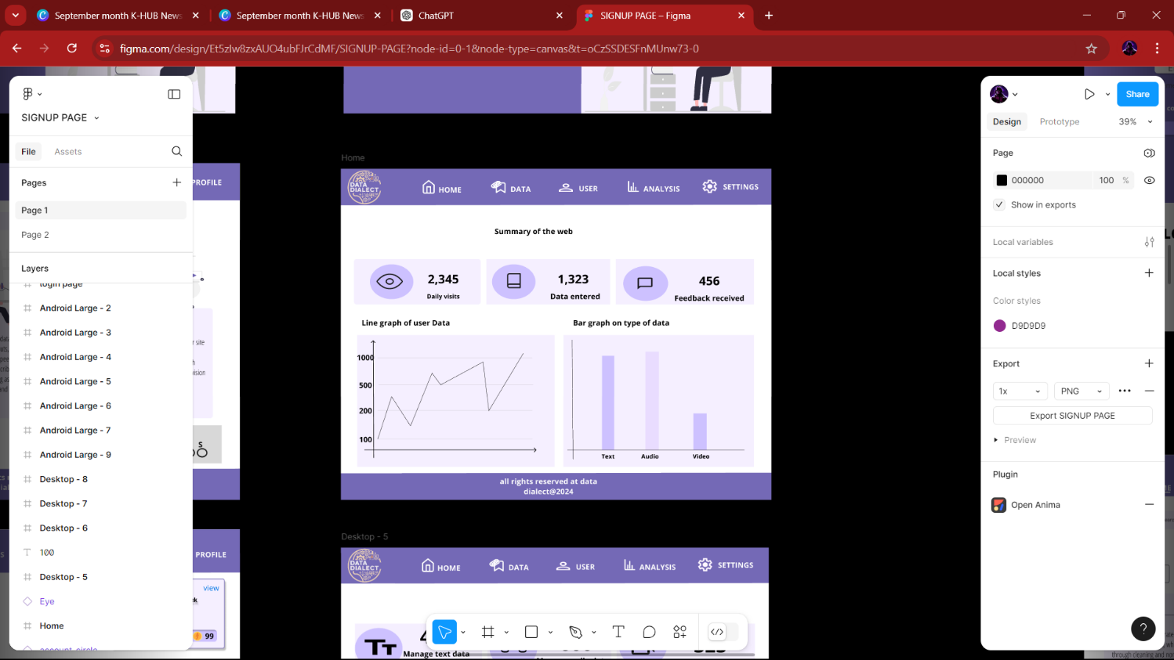**Elements:**

* **Navigation Menu:**
  + Home
  + Data
  + User
  + Analysis
  + Settings
* **Summary of the Web:**
  + Daily Visits: Displays the number of daily visits (e.g., 2,345).
  + Data Entered: Total amount of data submitted by users (e.g., 1,323).
  + Feedback Received: Number of feedback entries (e.g., 456).
* **Graphs:**
  + **Line Graph of User Data:** Visual representation of user activity over time.
  + **Bar Graph on Type of Data:** Breakdown of data types submitted (Text, Audio, Video).

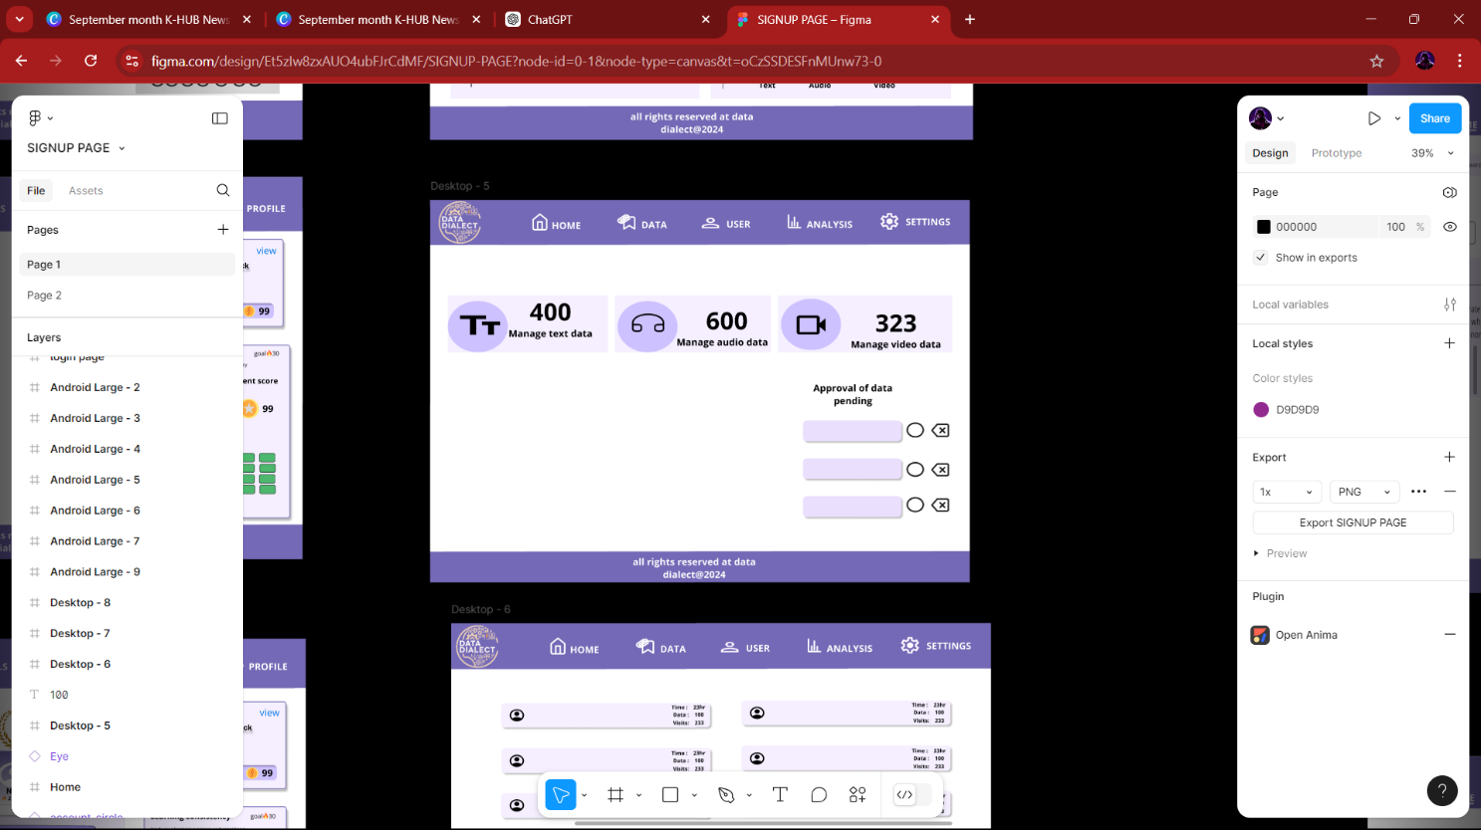**2. Data Management Page**

**Purpose:**

To manage and oversee the data submitted by users.

**Elements:**

* **Manage Data Section:**
  + Manage Text Data: Option to review and manage text data submissions.
  + Manage Audio Data: Option to review and manage audio data submissions.
  + Manage Video Data: Option to review and manage video data submissions.
* **Approval Status:**
  + Approval of Data Pending: Indicator showing the number of submissions awaiting approval.

**3. User Analytics Page**

**Purpose:**

To provide detailed analytics on user activity.

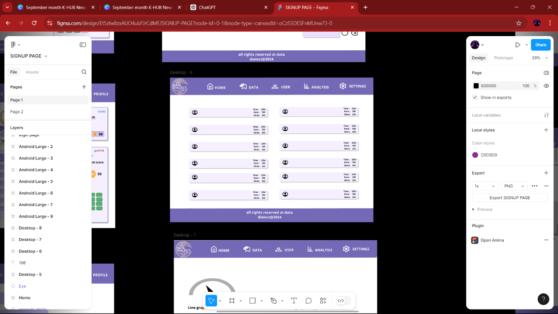**Elements:**

* **User Activity Summary:**
  + Time: Displays time spent by users on the platform (e.g., 23 hr).
  + Data: Amount of data submitted during the session (e.g., 100).
  + Visits: Number of visits logged during the session (e.g., 233).
* **Repetitive Data Summary:**
  + Repeats the above metrics multiple times to display activity trends.

**4. Analysis Page**

**Purpose:**

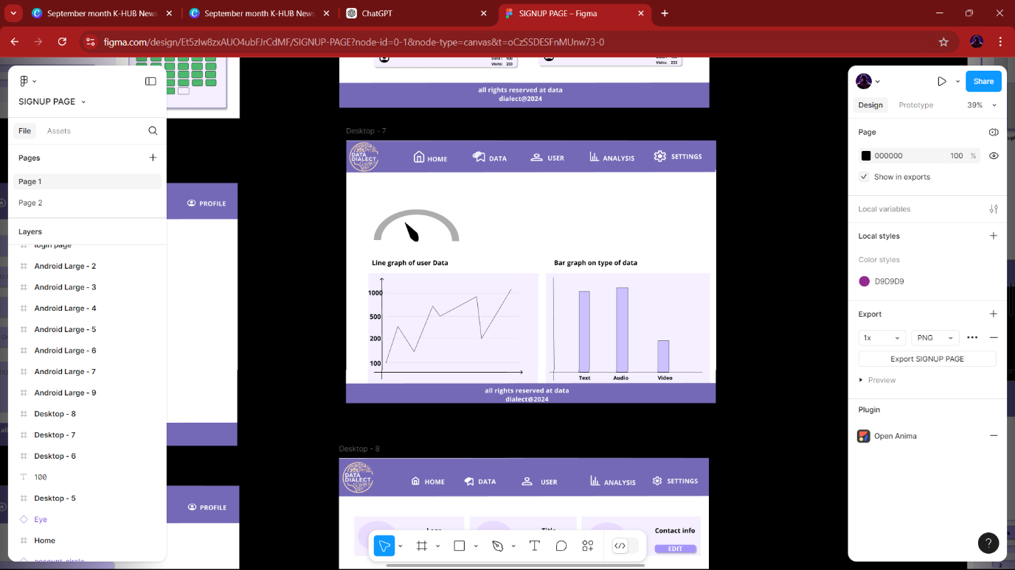To present graphical data on user engagement and submissions.

**Elements:**

* **Graphs:**
  + **Line Graph of User Data:** Shows trends in user activity over time.
  + **Bar Graph on Type of Data:** Displays a comparison of different data types (Text, Audio, Video).

**5. Settings Page**

**Purpose:**

To configure platform settings and manage alerts.

**Elements:**

* 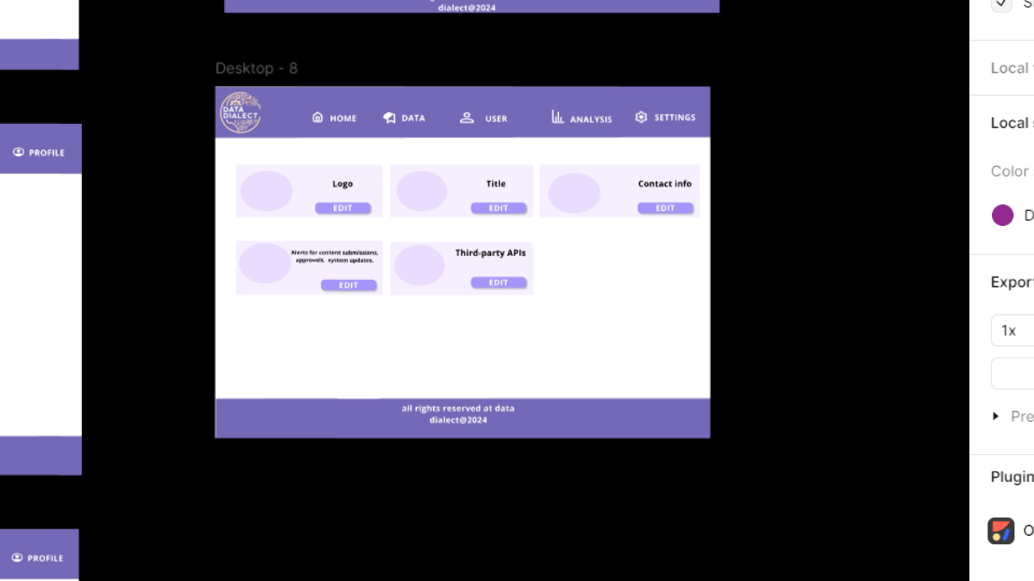**Logo and Title Section:** Displays the platform logo and title.
* **Contact Info:** Contact information for administrative inquiries.
* **Edit Options:**
  + Options to edit various settings, including alerts for:
    - Content submissions
    - Approvals
    - System updates
* **Third-Party APIs:** Section for managing third-party API integrations.
* **Edit Buttons:** Options to modify various settings and configurations.

**6. Responsive Pages**

Responsive pages are designed to adapt seamlessly to different screen sizes, providing an optimal viewing experience on various devices. Specifically, the phone view and tablet view demonstrate how these pages can change in layout and functionality to suit the user's device.

**- Fluid Grids**: Layouts that resize and rearrange based on the screen dimensions, ensuring content remains accessible and visually appealing.

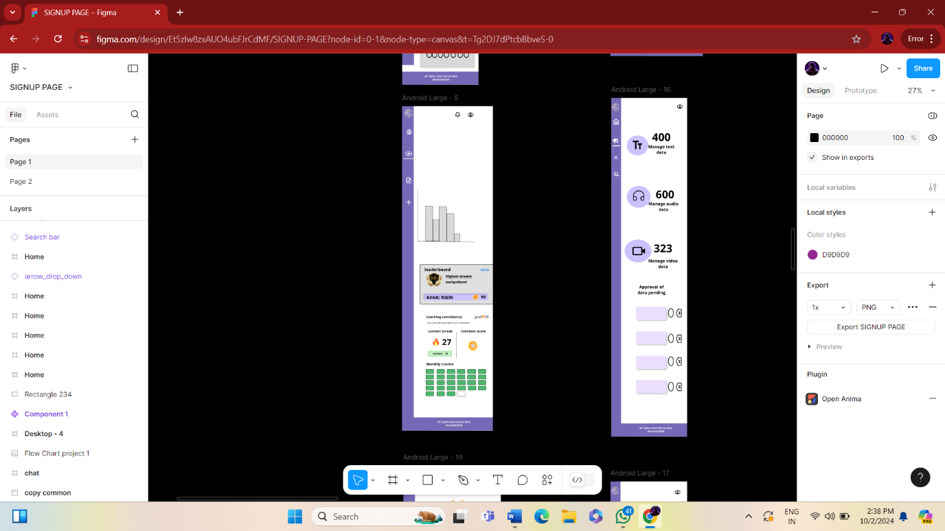**- Flexible Images**: Images that scale within their containing elements to prevent overflow and maintain quality.

**-Media Queries:** CSS techniques that apply different styles based on the device’s characteristics, such as screen size and resolution.

**Phone View**

- Simplified navigation and layout to accommodate smaller screens.

- Touch-friendly buttons and links for easy interaction.

- Content prioritized for quick access to essential information.

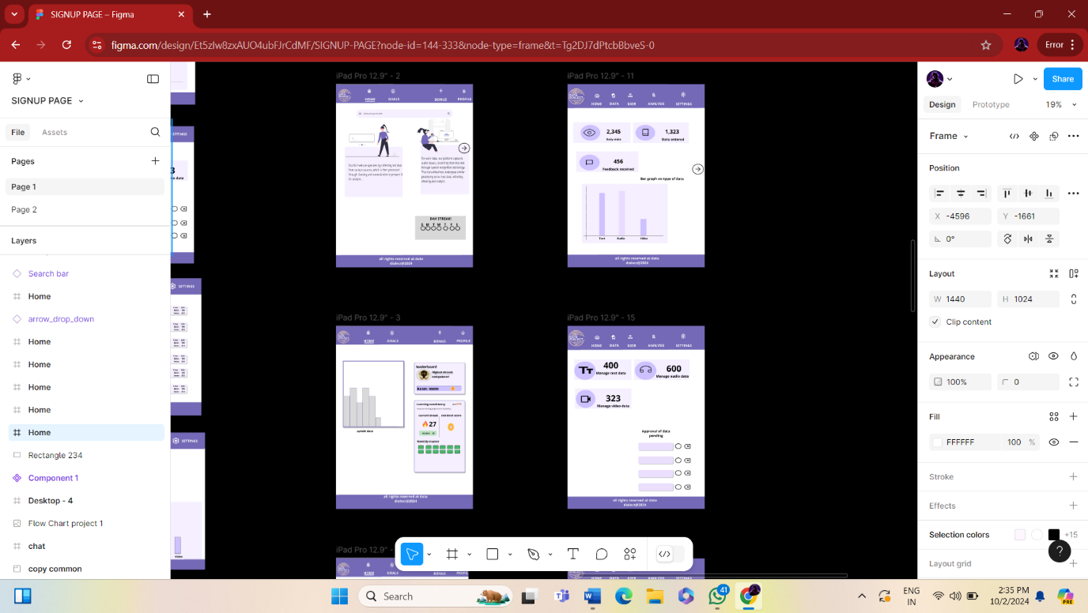**Tablet View:**

- Enhanced layout that utilizes additional screen space while maintaining readability.

- Multi-column designs to display more content without overwhelming the user.

- Improved interaction elements that balance touch and click usability.

# THANK YOU….