Big data and infrastructure

Akshay Deore
Deore-a@ulster.ac.uk

Introduction
While performing a multiple task on a big data in less time Apache spark framework gives a better result. Spark is opensource parallel in memory execution environment for analytics applications. It loads the data in memory and analyze[1] it parallel across the cluster. However, to solve the user queries and bilateral algorithms can be achieved in Apache Spark. Rather than moving the files spark moves the data in memory and that makes it faster than the MapReduce. It has simple programming layer which provides powerful cache and lightning speed approach[2]. Apache sparks works on real time data, so it offers real time computation and low latency because of in memory computation. With help of API’s, code can be written in Python, Scala and java. The data can be stored in HDFS, Local file system and it also supports SQL and NOSQL databases. RDD is backbone of spark and one of the fundamental data structures of spark which supports structure and non-structure data so if we do anything in spark is around RDD, if we reading the data it is read into RDD and if we transform the data then transformation is done on the old RDD and creating a new one[3].
Approach
A. Data Preprocessing:
Data was downloaded from Kaggle website, it was stored in 2 csv files format and uploaded in Google Colab. After installing the spark and creating a spark session anime.csv file was read in the spark session. Using .head() command top 5 entries of the data can be observed and .len() command used for data dimensions.
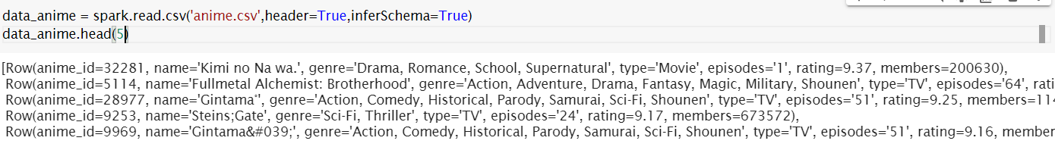
Fig 1 importing csv file.

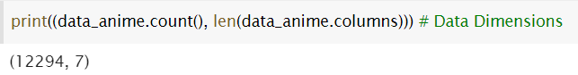
Fig 2 Data Dimensions of anime.csv.
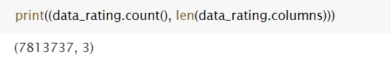
Fig 3 Data dimension for ratings.csv.
In the data preprocessing, below 1 rating which is 0 were removed from the ratings for the further process.

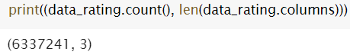
Fig 4 Data dimensions after removing 0 ratings.
After removing all the 0 ratings values, the next step is to print the column names with null values using .isNull command for anime and rating.

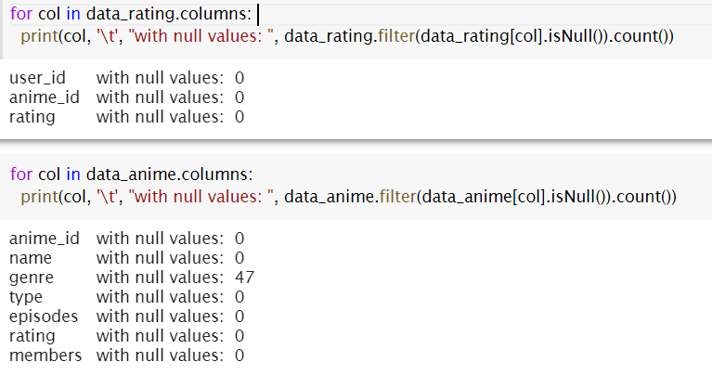
Fig 5 Output of the .isNull().

Fig 6 shows the updated count of the unknown values using count command for each column next to replacing unknown values with 0.
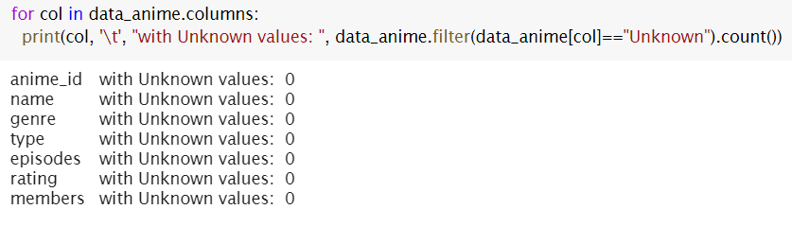
Fig 6 Column names with unknown values count
B. Data Visualization:
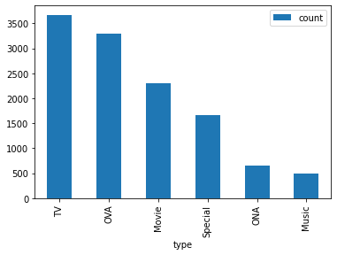
Fig 7 Graphical representation of Type column using groupBy command.

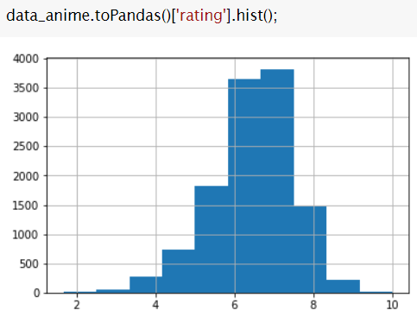

Fig 8 Histogram for the rating column.

Fig 8 illustrates that, most of the ratings are between in 6 to 8 values. And after removing the 0 ratings, graph counts are starts to increase after rating 4.

Algorithm
Aim of the recommendation system to predict the users response after providing the several inputs. It can be categories into 2 types[4]. i.e. Content-based system and Collaborative filtering
1.Content based system do the recommendations by analyzing the item properties.

2. Collaborative Filtering do the operations based on the similar items.

- While designing recommendation system for anime dataset, we need to Normalised the ratings by column and predication is done by adding the average ratings.

- For Collaborative filtering we have to estimate most of the ratings in Utility matrix[4].

Results
1. from the anime dataset, print the highest average rating of anime id with at least 1000 ratings.

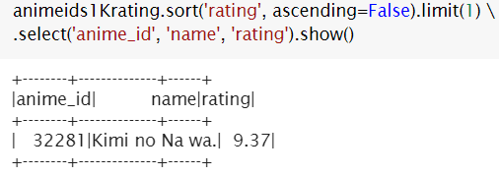
2. Show the anime count with at least 1000 ratings and have a greater than 9 average rating.

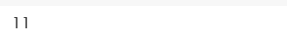
- Count is 11 it s is obtained by using filter command with setting it to (rating > 9).

3. Print the most watched anime

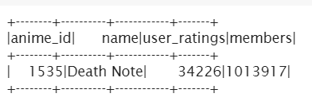
4. Recommendation for user_id 8086

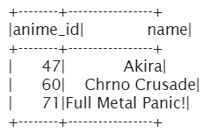

5. Show the top 3 users to recommend anime_id = 4935

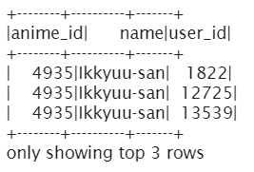
References
[1] R. S. Xin, J. Rosen, M. Zaharia, M. J. Franklin, S. Shenker, and I. Stoica, “Shark: SQL and rich analytics at scale,” in Proceedings of the ACM SIGMOD International Conference on Management of Data, 2013, pp. 13–24, doi: 10.1145/2463676.2465288.
[2] Y. Wang, R. Goldstone, W. Yu, and T. Wang, “Characterization and optimization of memory-resident mapreduce on HPC systems,” in Proceedings of the International Parallel and Distributed Processing Symposium, IPDPS, 2014, pp. 799–808, doi: 10.1109/IPDPS.2014.87.
[3] S. Chintapalli et al., “Benchmarking streaming computation engines: Storm, flink and spark streaming,” in Proceedings - 2016 IEEE 30th International Parallel and Distributed Processing Symposium, IPDPS 2016, Jul. 2016, pp. 1789–1792, doi: 10.1109/IPDPSW.2016.138.
[4] “Content Based Filtering In Recommendation System Using Jupyter Colab Notebook | by Vince Tabora | 0xCODE | Medium.” https://medium.com/0xcode/content-based-filtering-in-recommendation-system-using-jupyter-colab-notebook-9d3e0520af8 (accessed Dec. 09, 2020).

