
ASSIGNMENT 2: USER DEPENDENT AND INDEPENDENT ANALYSIS

CSE 572: DATA MINING

A PROJECT REPORT

Submitted by

AKSHAY DESHNENI (ASU ID: 1218717838)

In partial fulfillment for the completion of the course CSE 572: Data Mining

ARIZONA STATE UNIVERSITY

February 9, 2020


Contents

- Introduction

- Project Phase I

- Project Phase II

- Bibliography


Introduction

In this project, an attempt has been made to develop a computing system that can understand human activities. Data is provided for eating action mixed with other unknown activities. The data consists of 8 EMG sensors for a single user. The aim of the assignment is to identify the eating activities amongst the noise. The assignment is comprised of two phases. In the first phase, we consider the new set of features obtained through PCA in Project 1. For each user, we divide 60% of the data into training set both for eating action and not eating action and the rest 40% of the data as testing set both for eating action and not eating action. Using the training set, we train three types of machines: decision tree, support vector machine and neural network. The models are then validated using the testing set and model evaluation metrics such as accuracy, precision, recall and F1 score are reported. In the second phase, we consider the new set of features obtained through PCA in Project 1. For all users, we divide 60% of the data into training set both for eating action and not eating action and the rest 40% of the data as testing set both for eating action and not eating action. Using the training set, we train three types of machines: decision tree, support vector machine and neural network. All file names mentioned in this project report here onwards are available in the project folder for your reference. The entire project was coded in Python using some of its libraries like numPy, pandas and scikit-Learn.


Project Phase I: User Dependent Analysis

The data provided is collected primarily using two sources:

- Myo Wristband Data: The subject was wearing the wristband and performed eating actions periodically interspersed with non-eating unknown actions. The wristband provides with i) accelerometer, ii) gyroscope, iii) orientation and iv) EMG sensors. But for the scope of this assignment we are going to only consider EMG sensors for all users. The sampling rate of EMG sensors is 100 Hz.

- Ground Truth Data: Video recording of the person performing eating acting actions is used for establishing ground truth data. The ground truth data is provided in the form of frame numbers where an eating action starts and ends. The video data is taken at 30 frames per second.

For each user (30 users), we have applied 6 feature extraction methods like standard deviation, mean, min, max, rms and fast fourier transform (fft). For fft there are 8 features per sample (AMP_FFT1 to AMP_FFT8). But since AMP_FFT2 = AMP_FFT8, AMP_FFT3 = AMP_FFT7 and AMP_FFT4 = AMP_FFT6, we have only considered AMP_FFT1 to AMP_FFT5 in our feature matrix. For each user, we have then divided 60% of the data as training for both eating and not eating actions and the rest 40% of the data as testing for both eating and not eating actions. Now, since the not eating action samples in the case of training and testing are significantly higher than eating action samples, we have selected the same number of eating and not eating action samples in training and testing sets.
In order to reduce the dimensionality of the feature matrix we performed PCA on both the training and testing sets.
PCA for Training Set:
[0.43221332 0.19301987 0.16599063 0.08704134 0.04775326]
92.601841270221
The variance for the first 5 principal components for the training set was found to be ~92%.
PCA for Testing Set:
[0.44761191 0.19376699 0.16523096 0.08019619 0.04561875]
93.24248127868253
The variance for the first 5 principal components for the training set was found to be ~92%.
PCA for Training Set is defined as ‘Phase1_PCA_Training_NewFeatureMatrix.csv’ and the path is:
/Akshay_Deshneni_DataMiningAssignment2
PCA for Testing Set is defined as ‘Phase1_PCA_Testing_NewFeatureMatrix.csv’ and the path is:
/Akshay_Deshneni_DataMiningAssignment2.
Now using the new feature matrices for training and testing sets obtained from PCA we have developed three models: Decision Tree, Neural Network and Support Vector Machine.
Decision Tree:
Using DecisionTreeClassifier method in python’s scikit-Learn the decision tree has been developed.
The parameters used are : class_weight=None, criterion='entropy', max_depth= 2, max_features= 'auto' , max_leaf_nodes=None, min_impurity_decrease=0.0, min_impurity_split=None, min_samples_leaf=1, min_samples_split= 25, min_weight_fraction_leaf=0.0, presort=False, random_state= 15, splitter='best'.
The decision tree is trained using training set and then we fed the testing set for predicting the class label. The predicted output of testing set by the model is then compared to the actual output. Model evaluation metrics such as Accuracy, Precision, Recall and F1 score have been reported below:
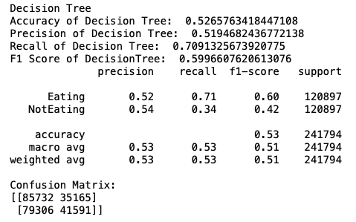
The model gave a good recall of 71% for eating actions, but further tuning of hyper parameters and optimization might be required to make the metrics better.
Neural Network (Multi-Layer Perceptron):
Using MLPClassifier method in python’s scikit-Learn the neural network has been developed.
The parameters used are: activation ='relu', alpha=0.001, batch_size = ‘auto’ , beta_1=0.9, tol = 1e-4, beta_2=0.999, early_stopping=False, epsilon=1e-08, hidden_layer_sizes=(50,) , learning_rate='adaptive', learning_rate_init=0.001, max_iter=200, momentum=0.9, n_iter_no_change=10, nesterovs_momentum=True, power_t=0.5, random_state = None, solver = 'adam'.
The neural network is trained using training set and then we fed the testing set for predicting the class label. The predicted output of testing set by the model is then compared to the actual output. Also, in order to decrease the execution time of the model we have used an ensemble method BaggingClassifier available in scikit-Learn library of python. The Model evaluation metrics such as Accuracy, Precision, Recall and F1 score have been reported below:
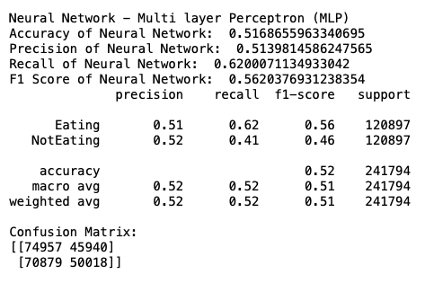
The model gave a recall of 62% for eating actions which is lower than decision tree, but further tuning of hyper parameters and optimization might be required to make the metrics better.
Support Vector Machine:
Using SVC method in python’s scikit-Learn the support vector machine has been developed.
The parameters used are: C=1.0, cache_size=200, class_weight=None, coef0=0.0, decision_function_shape='ovr', degree=3, gamma='auto_deprecated', kernel='rbf', max_iter=-1, probability=False, random_state=None, shrinking=True, tol=0.001, verbose=False.
The support vector machine is trained using training set and then we fed the testing set for predicting the class label. The predicted output of testing set by the model is then compared to the actual output. Also, in order to decrease the execution time of the model we have used an ensemble method BaggingClassifier available in scikit-Learn library of python. The Model evaluation metrics such as Accuracy, Precision, Recall and F1 score have been reported below:
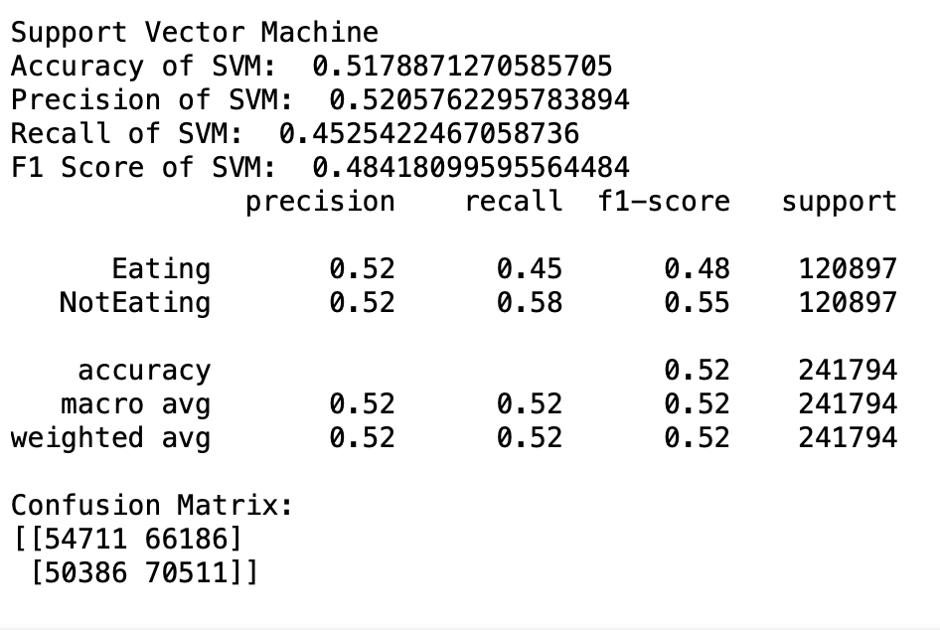
The model gave a recall of 45% for eating actions and 58% for not eating actions. So, for not eating actions it was performing better than both decision tree and neural network, but further tuning of hyper parameters and optimization might be required to make the metrics better.
So, in comparison of all the three models, decision tree has the highest recall for eating actions whereas support vector machine had the highest recall for not eating actions. Neural network gave poor recall for not eating actions and average recall for eating actions. But since the data we are trying to classify is only binary, it might be possible that the neural network (MLP) is not required. This has also been studied by many researchers from both academia and industry where for binary classification problems decision tree or support vector machines gave better results compared to complex neural networks such as a multi layer perceptron.
The entire code for Phase 1 is defined as ‘Phase1.py’ and the path is:
/Akshay_Deshneni_DataMiningAssignment2

Project Phase II: User Independent Analysis

The data provided is collected primarily using two sources:

- Myo Wristband Data: The subject was wearing the wristband and performed eating actions periodically interspersed with non-eating unknown actions. The wristband provides with i) accelerometer, ii) gyroscope, iii) orientation and iv) EMG sensors. But for the scope of this assignment we are going to only consider EMG sensors for all users. The sampling rate of EMG sensors is 100 Hz.

- Ground Truth Data: Video recording of the person performing eating acting actions is used for establishing ground truth data. The ground truth data is provided in the form of frame numbers where an eating action starts and ends. The video data is taken at 30 frames per second.

For each user (30 users), we have applied 6 feature extraction methods like standard deviation, mean, min, max, rms and fast fourier transform (fft). For fft there are 8 features per sample (AMP_FFT1 to AMP_FFT8). But since AMP_FFT2 = AMP_FFT8, AMP_FFT3 = AMP_FFT7 and AMP_FFT4 = AMP_FFT6, we have only considered AMP_FFT1 to AMP_FFT5 in our feature matrix. For all users, we have then divided 60% of the data as training for both eating and not eating actions (18 users) and the rest 40% of the data as testing for both eating and not eating actions (12 users). Now, since the not eating action samples in the case of training and testing are significantly higher than eating action samples, we have selected the same number of eating and not eating action samples in training and testing sets.
In order to reduce the dimensionality of the feature matrix we performed PCA on both the training and testing sets.
PCA for Training Set:
[0.44479209 0.19241699 0.16398943 0.08329796 0.04483856]
92.93350242061456
The variance for the first 5 principal components for the training set was found to be ~92%.
PCA for Testing Set:
[0.43172563 0.1953586 0.1783145 0.08939564 0.04602517]
94.0819524964127
The variance for the first 5 principal components for the training set was found to be ~94%.
PCA for Training Set is defined as ‘Phase2_PCA_Training_NewFeatureMatrix.csv’ and the path is:
/Akshay_Deshneni_DataMiningAssignment2
Now using the new feature matrices for training and testing sets obtained from PCA we have developed three models: Decision Tree, Neural Network and Support Vector Machine.
Decision Tree:
Using DecisionTreeClassifier method in python’s scikit-Learn the decision tree has been developed.
The parameters used are : class_weight=None, criterion='entropy', max_depth= 2, max_features= 'auto' , max_leaf_nodes=None, min_impurity_decrease=0.0, min_impurity_split=None, min_samples_leaf=1, min_samples_split= 25, min_weight_fraction_leaf=0.0, presort=False, random_state= 15, splitter='best'.
The decision tree is trained using training set and then we fed the testing set for predicting the class label. The predicted output of testing set by the model is then compared to the actual output. Model evaluation metrics such as Accuracy, Precision, Recall and F1 score have been reported below:
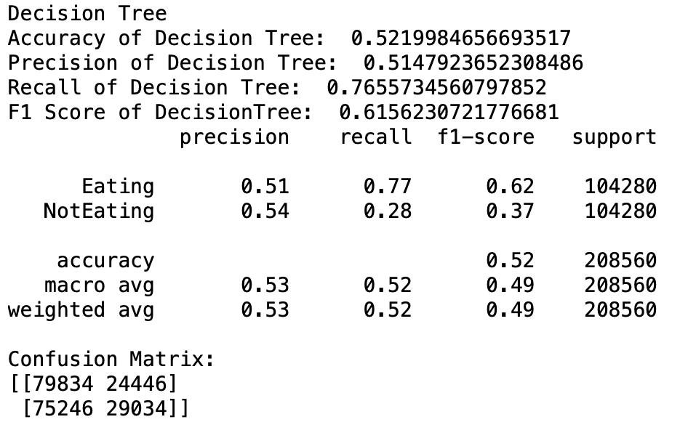
The model gave a good recall of 76% for eating actions. However, it was giving a poor recall of 28% for not eating actions. Further tuning of hyper parameters and optimization might be required to make the metrics better.
Neural Network (Multi-Layer Perceptron):
Using MLPClassifier method in python’s scikit-Learn the neural network has been developed.
The parameters used are: activation ='relu', alpha=0.001, batch_size = ‘auto’ , beta_1=0.9, tol = 1e-4, beta_2=0.999, early_stopping=False, epsilon=1e-08, hidden_layer_sizes=(50,) , learning_rate='adaptive', learning_rate_init=0.001, max_iter=200, momentum=0.9, n_iter_no_change=10, nesterovs_momentum=True, power_t=0.5, random_state = None, solver = 'adam'.
The neural network is trained using training set and then we fed the testing set for predicting the class label. The predicted output of testing set by the model is then compared to the actual output. Also, in order to decrease the execution time of the model we have used an ensemble method BaggingClassifier available in scikit-Learn library of python. The Model evaluation metrics such as Accuracy, Precision, Recall and F1 score have been reported below:
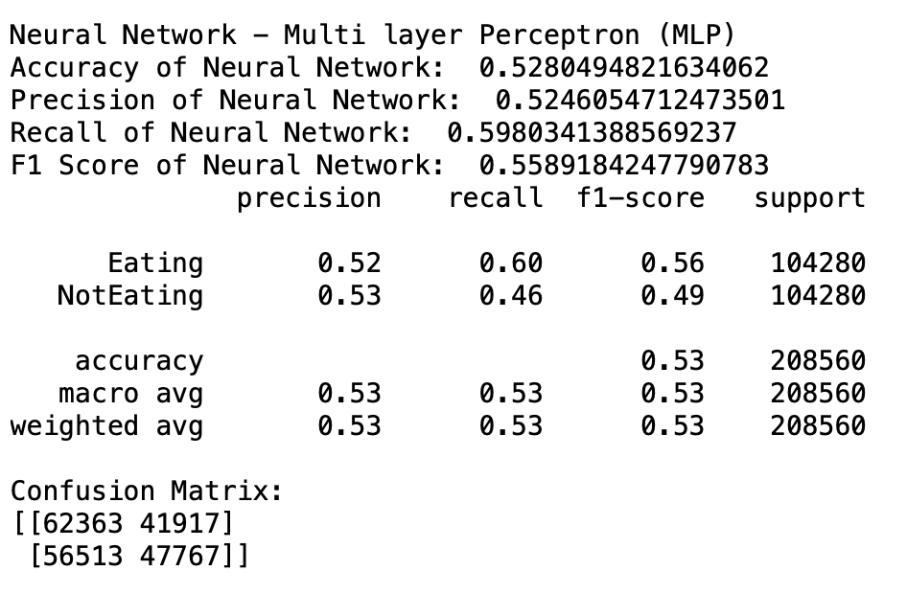
The model gave a recall of 60% for eating actions which is lower than decision tree and recall of 46% for not eating actions. Further tuning of hyper parameters and optimization might be required to make the metrics better.
Support Vector Machine:
Using SVC method in python’s scikit-Learn the support vector machine has been developed.
The parameters used are: C=1.0, cache_size=200, class_weight=None, coef0=0.0, decision_function_shape='ovr', degree=3, gamma='auto_deprecated', kernel='rbf', max_iter=-1, probability=False, random_state=None, shrinking=True, tol=0.001, verbose=False.
The support vector machine is trained using training set and then we fed the testing set for predicting the class label. The predicted output of testing set by the model is then compared to the actual output. Also, in order to decrease the execution time of the model we have used an ensemble method BaggingClassifier available in scikit-Learn library of python. The Model evaluation metrics such as Accuracy, Precision, Recall and F1 score have been reported below:
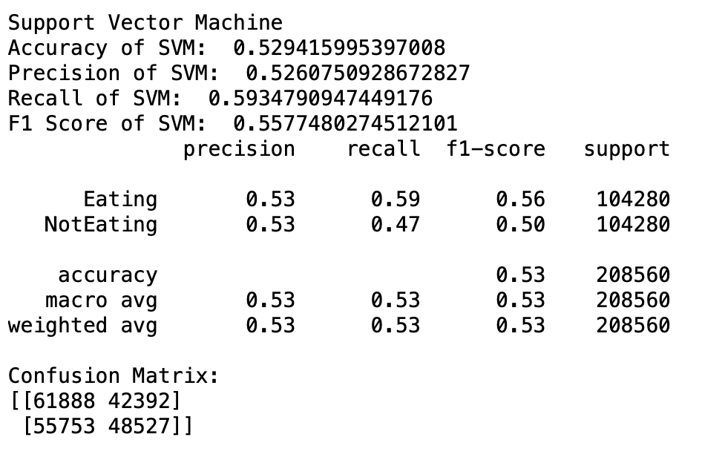
The model gave a recall of 59% for eating actions and 47% for not eating actions. So, for not eating actions it was performing better than both decision tree and neural network, but further tuning of hyper parameters and optimization might be required to make the metrics better.
So, in comparison of all the three models, decision tree has the highest recall for eating actions whereas support vector machine had the highest recall for not eating actions. Neural network gave average recall for not eating actions and average recall for eating actions. So, for user independent analysis using a support vector machine would be a good choice among the three.
The entire code for Phase 2 is defined as ‘Phase2.py’ and the path is:
/Akshay_Deshneni_DataMiningAssignment2

CONCLUSION
In this project an attempt has been made to apply feature extraction techniques to understand the data, performed principal component analysis (PCA) to reduce the dimensionality of the data and three classification models have been developed for predicting the class labels in two scenarios: user dependent analysis and user independent analysis. In comparison of both the approaches, user independent analysis was giving slightly better results than user dependent analysis. Although the scope of this project ends at developing the three models in both approaches, further study can be conducted in tuning the models to find the best possible hyper parameters. Also, since all the three algorithms were not giving very high accuracy, further research can be made to apply ensemble modelling techniques and develop a customized model that can be a combination of a decision tree, support vector machine and multi-layer perceptron.

Bibliography

- ABDELKAREEM BEDRI, RICHARD LI, MALCOLM HAYNES, RAJ PRATEEK KOSARAJU, ISHAAN GROVER, TEMILOLUWA PRIOLEAU, MIN YAN BEH, MAYANK GOEL, THAD STARNER, and GREGORY ABOWD. "EarBit: Using Wearable Sensors to Detect Eating Episodes in Unconstrained Environments." n.d.

- Ben Nicholls, Chee Siang Ang, Kanjo Eiman, Panote Siriaraya, Woon-Hong Yeo. "An EMG-based Eating Behaviour Monitoring System with Haptic Feedback to Promote Mindful Eating." n.d.

- Chee Siang Ang, Eiman Kanjo, Athanasios Tsanas. "An EMG-based Eating Behaviour Monitoring System with Haptic Feedback to Promote Mindful Eating." n.d.

- Jingwei Too, Abdul Rahim Abdullah, Norhashimah Mohd Saad, Weihown Tee. "EMG Feature Selection and Classification Using a Pbest-Guide Binary Particle Swarm Optimization." Computation, 2019.

- Nihal Fatma Guler, Sabri Kocer. "Classification of EMG Signals Using PCA and FFT." Journal of Medical Systems, 2005.

- Alto, Valentino. Towards Data Science. July 13, 2019. https://towardsdatascience.com/pca-eigenvectors-and-eigenvalues-1f968bc6777a.

