# **Insurance Domain User Stories**

**Project Name – GPHI** (Global Principal Heath Insurance)

**End User / Policy holder**

**Insurance companies** – TATA, HDFC, SBI, ICIC, etc

* **How User Stories Looks Like In JIRA :**

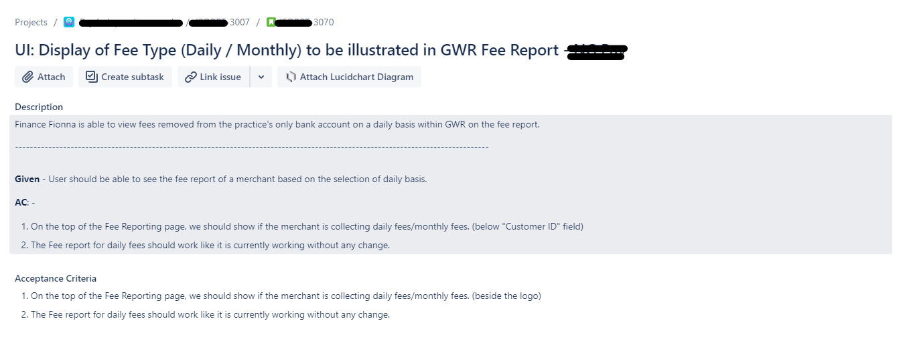

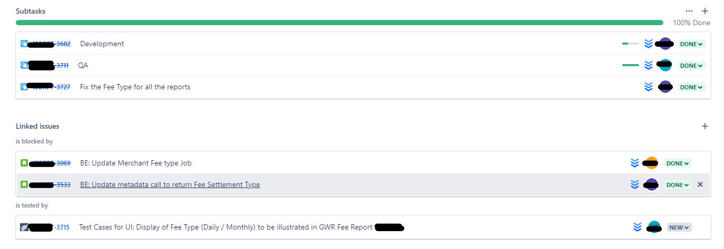

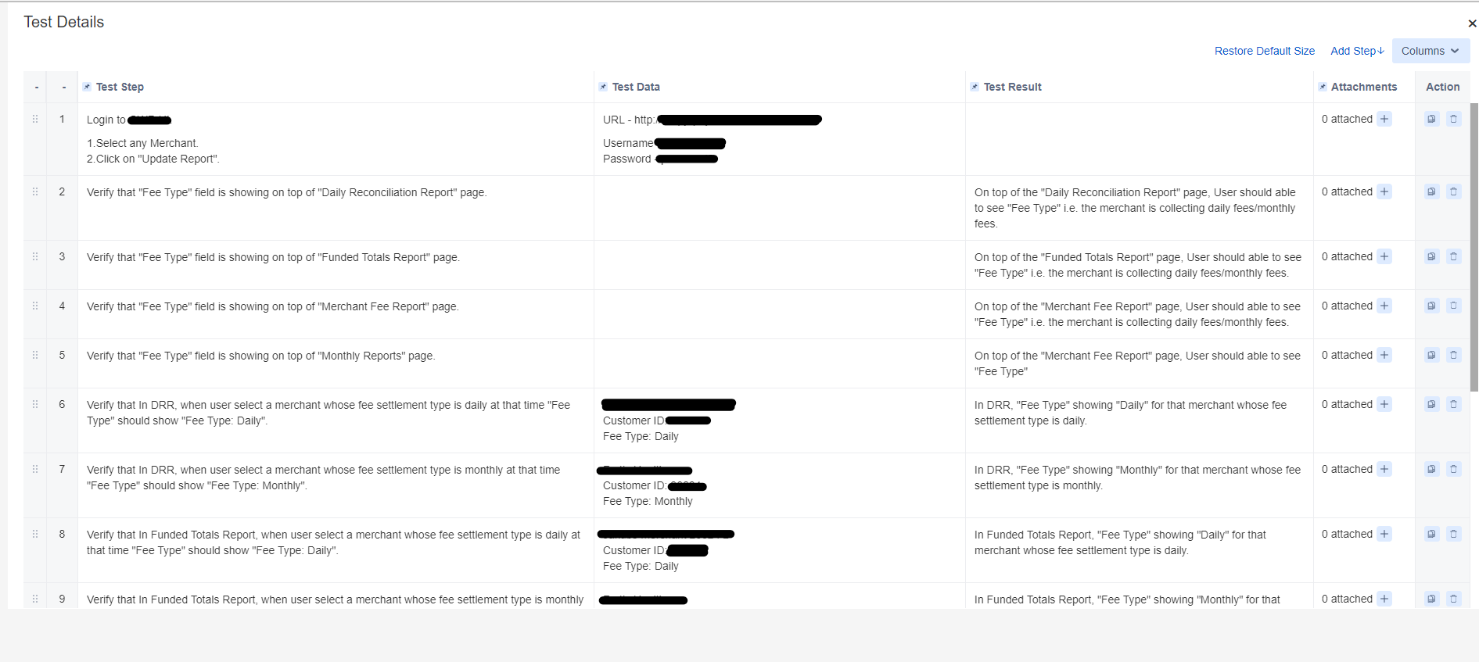

# **Manual Testing:-**

# **IDP 1111 - UI : Life Insurance Module - Different Plans**

**Description** – Health insurance plan offers financial coverage against the fixed amount of premium for a specific term. If the insured person dies during the policy term, a death benefit is paid to the insured person's family. Term plan provides high cover at low premium rates which helps in fulfilling the future requirements of your family in case of your absence.

**Acceptance criteria -**

1. New grid of plane shows all data per screen shows **FRS / SRS.**
2. Grid will show data as per **Insuere (Filter)**, **Life Cover(Drop Down)**, **Cover till age (Drop Down)**, **Claim Settled (Asc & Desc)**, **Pay Monthly/Pay Yearly (Toggle button).**
3. Life cover wedge will open a pop up for values with amount filed text box (drop down / custom values)
4. Amount drop down / custom values pop will shows 20LPA to 20Cr
5. Life cover will open pop will shows “Recommended Life Cover” (as per DB - top 5 or 10)
6. Planes data will comes from main tables - “dim.inc_detail”

**Test Cases -**

* 1. Verify that Insurer Filter is present on that page or not, Spelling is right or wrong.

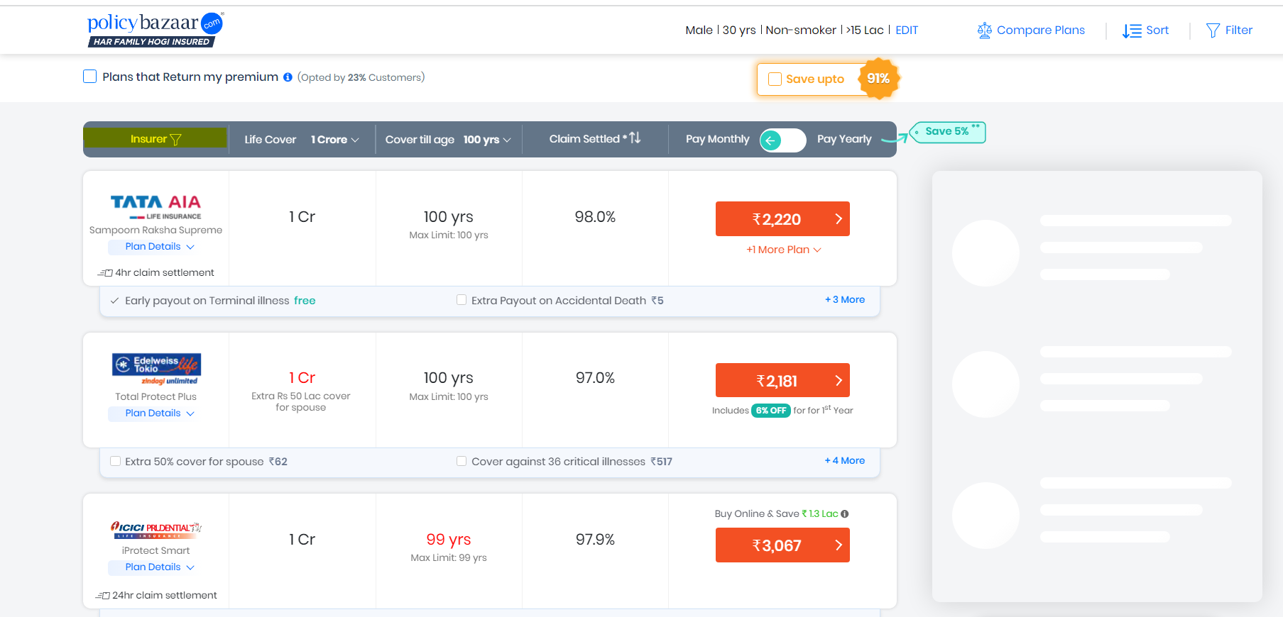

* 1. Verify that Insurer Filter is clickable or not



* 1. Verify that after click on Insurer Filter button the Filer Pop Up window showing or not

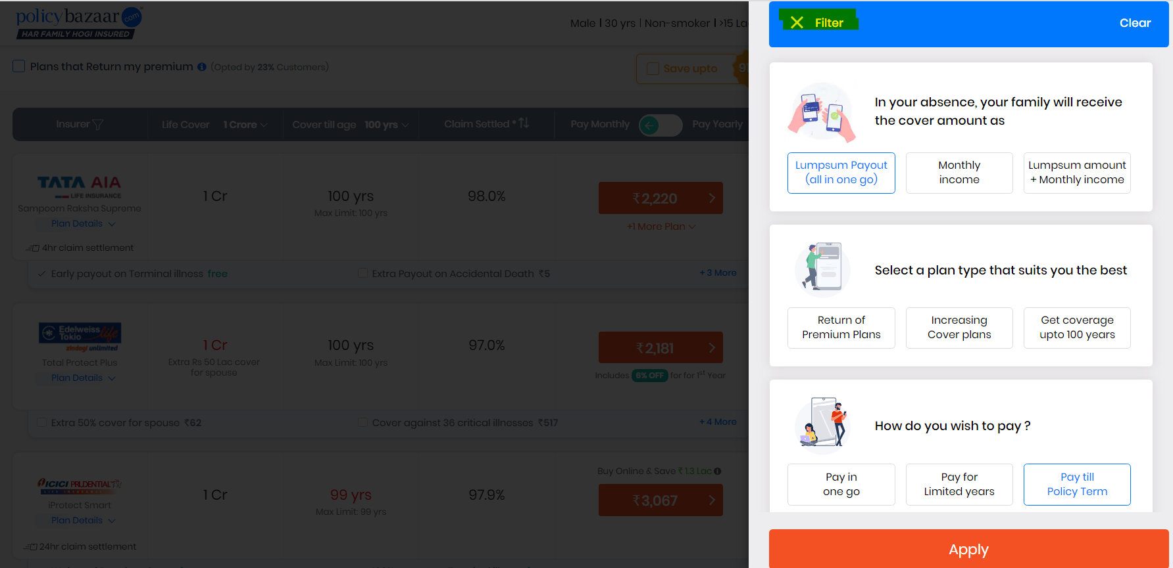

* 1. Verify that Min value for Life Cover is 20 Lakh and Max Value for Life Cover is 20Cr

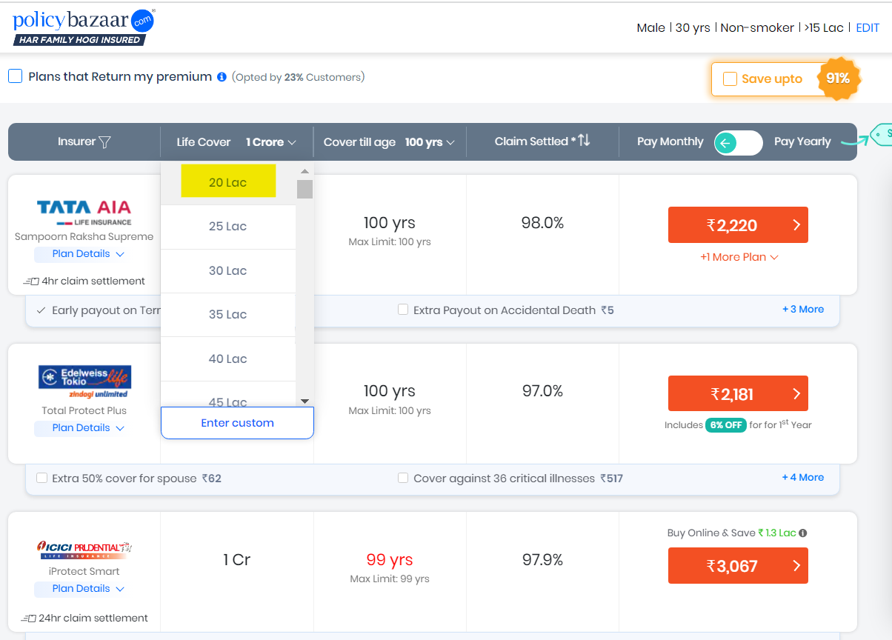

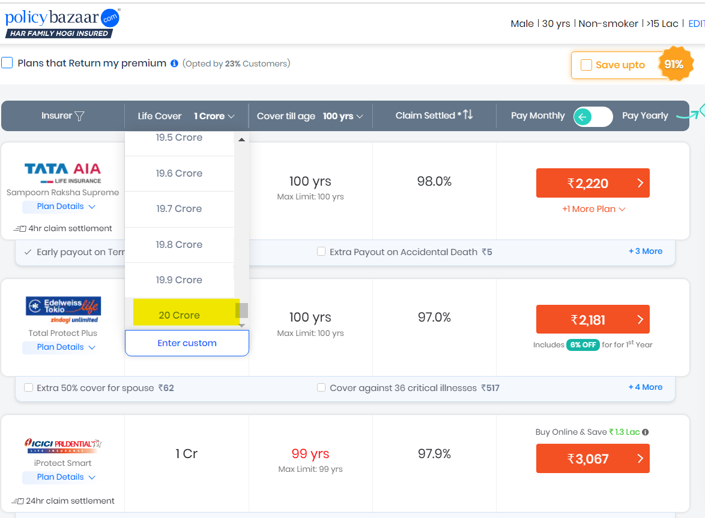

* 1. Verify that End user can add custom values or not.

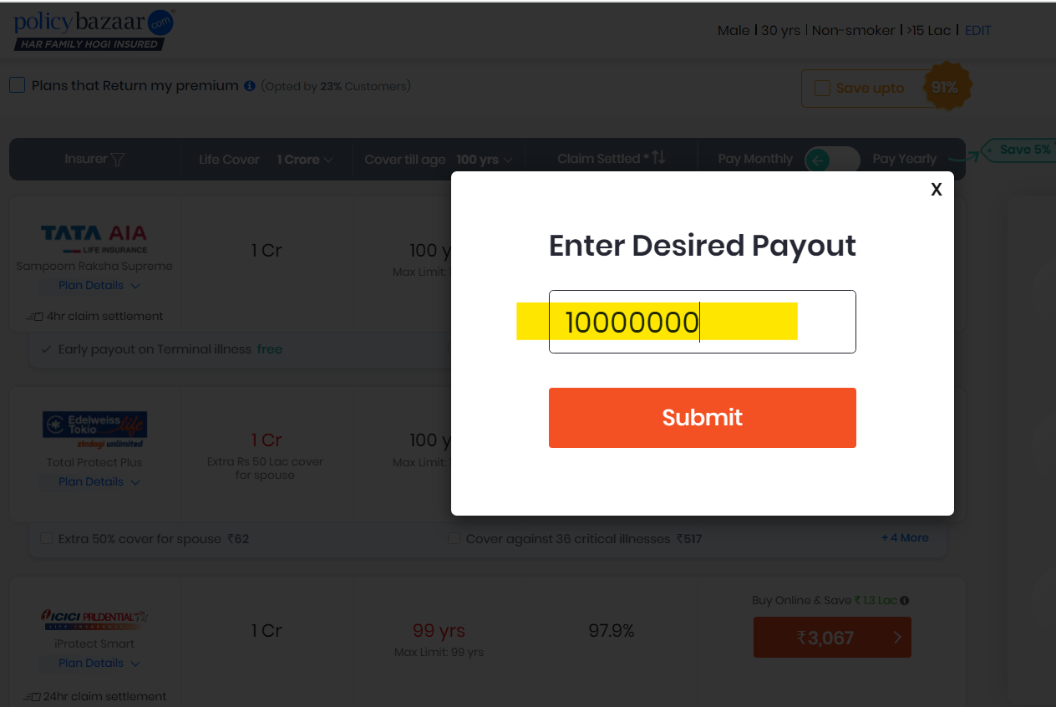

* 1. Verify that When we select a particular amount it shows planes related to that amount

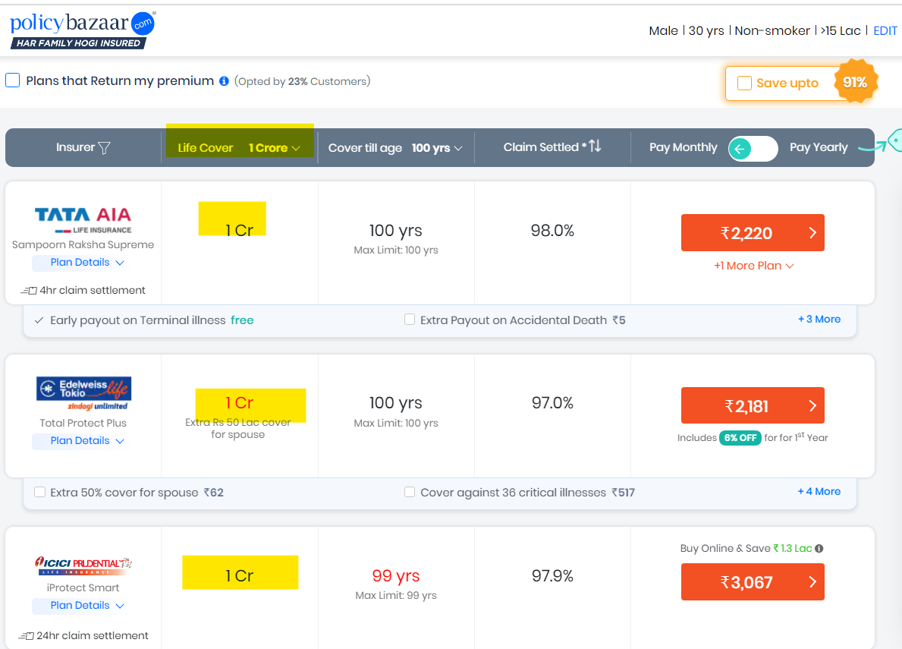

# **IDP 1112 - UI : Life insurance Module - New quotes functionality**

**Description**  – Term insurance also known as a term life insurance plan, offers financial coverage against the fixed amount of premium for a specific term. For more details about end user / policy holder we are providing some details information for providing more details planes. Quotes will provide more details about some question which in the form of drop-down values

**Acceptance criteria-**

1. Quotes will consist of **4 questions only**

A. Do you smoke or chew tobacco?

B. Your annual income

C. Your occupation type

D. Your Educational qualification

2. Question A contains **(Yes/No)**

3. Annual income will be in the form of **drop down of 7 values** (Less than 2 Lac to 15+ Lac)

4. Your occupation type (2 Values - **Salaried & Self-employed**)

5. Educational qualification if **10th 🡪 1 or 2 policies**

6. Educational qualification if **12th 🡪 3 or 4 policy**

7. Educational qualification if **Graduation & above 🡪 Policy as get from different policy provider** (Get from **3rd party policy provider (Tata, ICIC, Max, etc) from IRDAI listed companies**)

8. Plans will show as per quotes data values provided – **For Annual income > 5 Lac shows**

9. Plans data will come from – “**cust.cust_plan_details**”

10. All quotes are mandatory –If not error as “Provide valid data”

**Test Cases -**

1. Verify number of question present in new quotes 🡪EC = New quotes will shows only 4 question=Pass

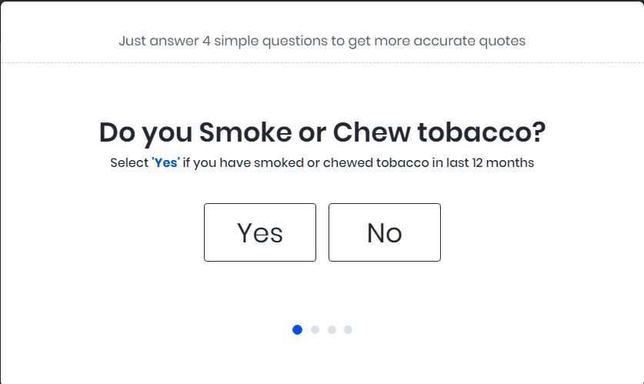

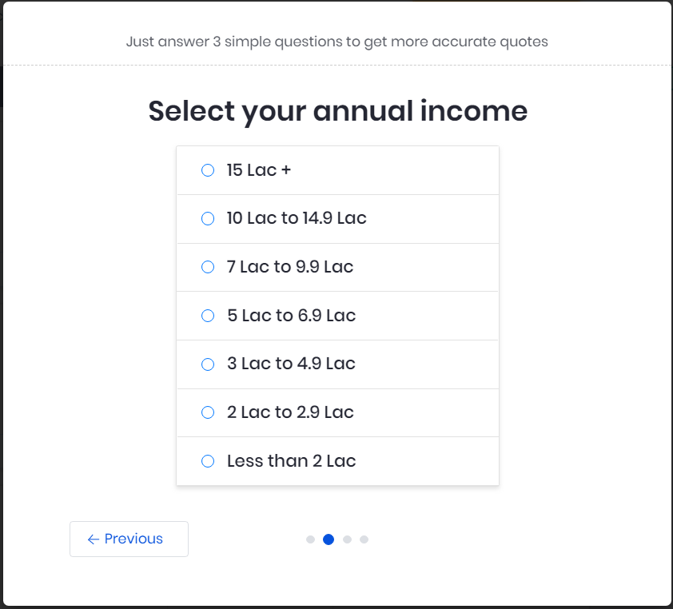

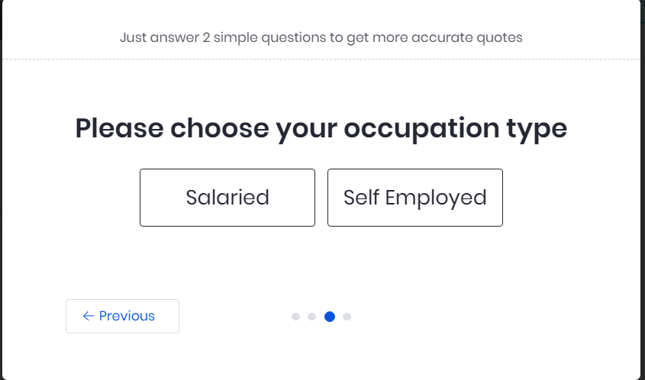

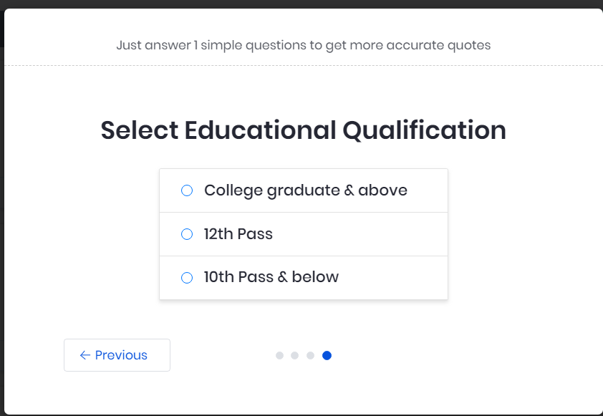

1. Verify text and values present in question number 1 🡪EC = Question no. 1 will shows text as “Do you smoke or chew tobacco?” and values in drop down format are – Yes/ No =Pass



1. Verify text and values present in question number 2 🡪EC = Question no. 2 will shows text as “Your annual income?” and 7 values present in drop down contains=Pass



1. Verify text and values present in question number 3 🡪EC = Question no. 3 will shows text as “Your occupation type?” and 2 values present as “Salaried & Self-employed”=Pass



1. Verify text and values present in question number 4 🡪EC = Question no. 4 will shows text as “Your Educational qualification?” and values present in drop down as “10th, 12th & Graduation & Above”Pass



1. Verify text selected drop down values from the Question no 2(Question= Selected Annual income)🡪EC = If “Selected Annual income” text select then show error message= Pass

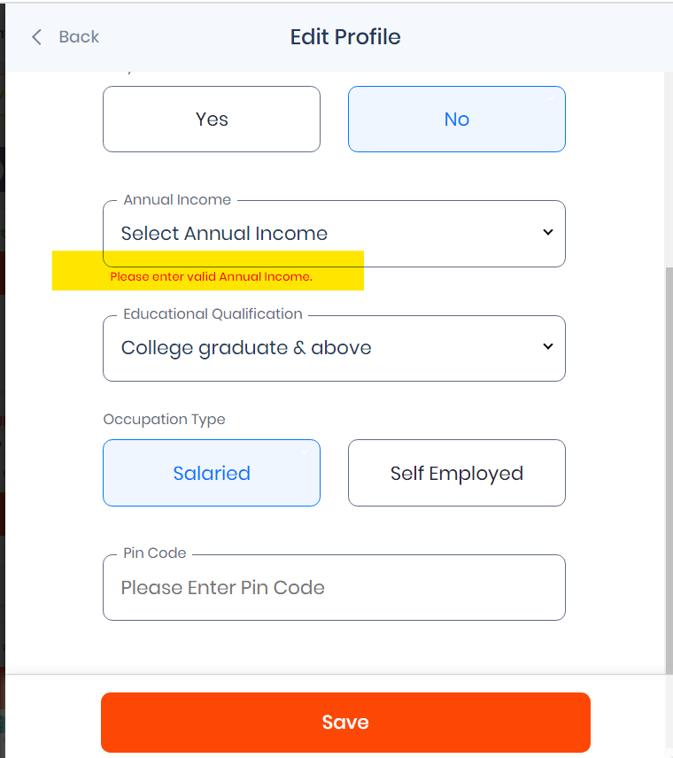

1. Verify text selected drop down values from the Question no 3(Question= Collage Graduation & above)🡪EC = “Select Educational Qualification” text select then show error message= Pass

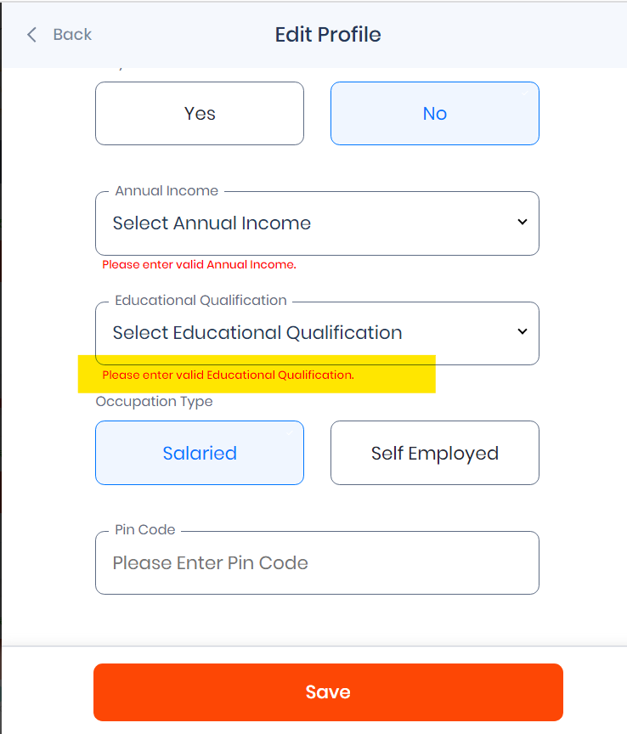

1. Verify plans present for the quotes values (Q1-Yes, Q2-5Lpa, Q3- Salaried, Q4-10th)🡪EC = Two Plan data will shows (Table = cust.cust_plane_details )=Pass

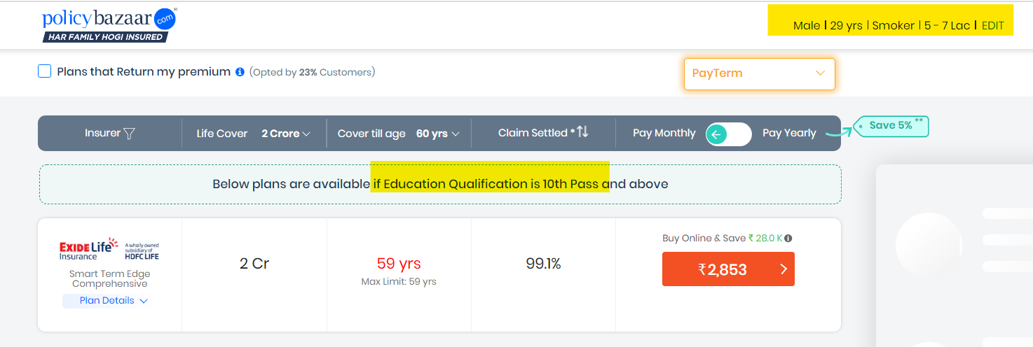

1. Verify plans present for the quotes values (Q1-Yes, Q2-7Lpa, Q3- Salaried, Q4-10th)🡪EC = Two Plan will data will shows (Table = cust.cust_plane_details )
2. Verify plans present for the quotes values (Q1-Yes, Q2-10Lpa, Q3- Self-employed, Q4-10th)🡪EC = Two Plan will data will shows (Table = cust.cust_plane_details )
3. Verify plans present for the quotes values (Q1-No, Q2-10Lpa, Q3- Salaried, Q4- Graduation & Above)🡪EC = Two Plan will data will shows (Table = cust.cust_plane_details)
4. Verify plans present for the quotes values (Q1-No, Q2-15Lpa, Q3- Salaried, Q4-Gradution 🡪EC = Multiple Plan will data will shows (Table = cust.cust_plane_details )=Pass

Table - **cust.cust_plane_details**

**SELECT * FROM cust.cust_plane_details**

**WHERE EDUCATION = ‘GRADATION’**

|  |  |  |  |  |  |  |
| --- | --- | --- | --- | --- | --- | --- |
| Plane_No | Plane_name | Plane_Amount | Plane_Claim | Plane_year | AMC_Id | Education |
| 3910 | Max | 1321 | 90 | 45 | 3001 | 10Th |
| 3942 | Tata | 1131 | 86 | 55 | 3002 | 12th |
| 3947 | HDFC | 1266 | 75 | 34 | 3003 | Gradation |
| 3900 | ICIC | 998 | 82 | 50 | 3004 | Gradation |

1. Verify plans present for the quotes values (Q1-Yes, Q2-2Lpa, Q3- Self-employed, Q4- Graduation & Above)🡪EC = Two Plan will data will shows (Table = cust.cust_plan_details )
2. Verify plans present for the quotes values (Q1-No, Q2-8Lpa, Q3- Self-employed, Q4- 12th)🡪EC = Two Plan will data will shows (Table = cust.cust_plan_details)=PASS

Table - **cust.cust_plane_details**

**SELECT * FROM cust.cust_plane_details**

**WHERE EDUCATION = ‘12TH’**

|  |  |  |  |  |  |  |
| --- | --- | --- | --- | --- | --- | --- |
| Plane_No | Plane_name | Plane_Amount | Plane_Claim | Plane_year | AMC_Id | Education |
| 3910 | Max | 1321 | 90 | 45 | 3001 | 10Th |
| 3942 | Tata | 1131 | 86 | 55 | 3002 | 12th |
| 3947 | HDFC | 1266 | 75 | 34 | 3003 | Gradation |
| 3900 | ICIC | 998 | 82 | 50 | 3004 | Gradation |

1. Verify plans present for the quotes values (Q1-Yes, Q2-13Lpa, Q3- Self-employed, Q4- Graduation & Above)🡪EC = Two Plan will data will shows (Table = cust.cust_plane_details )
2. Verify plans present for the passing quotes values as (Q1-No selected, Q2-13Lpa, Q3- Self-employed, Q4- Graduation & Above)🡪EC = Error message will shows- “Provide valid data”
3. Verify plans present for the passing quotes values as (Q1-Yes, Q2-No selected, Q3- Self-employed, Q4- Graduation & Above)🡪EC = Error message will shows- “Provide valid data”

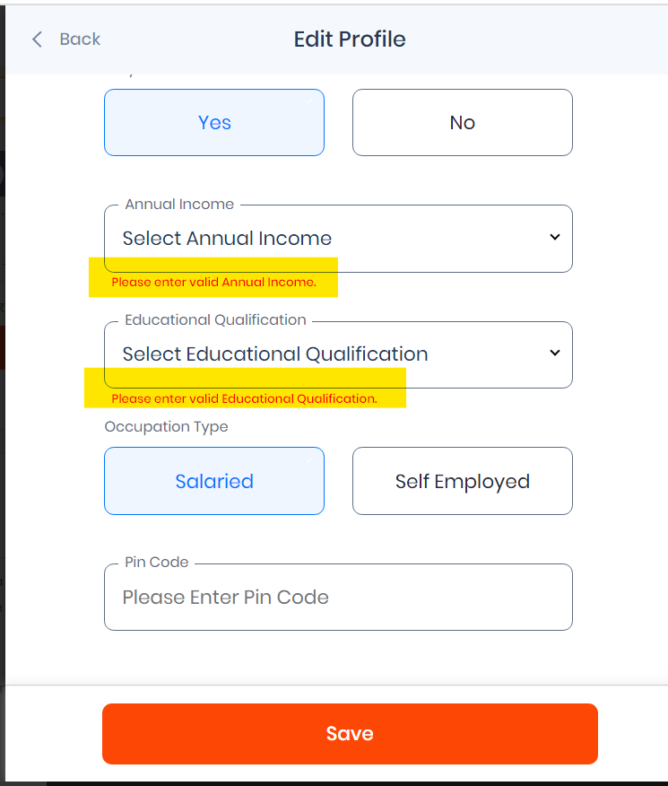

1. Verify plans data for passing quotes values as (Q1-Yes, Q2-10Lpa, Q3- No selected , Q4- Graduation & Above)🡪EC = Error message will shows- “Provide valid data”
2. Verify plans data for passing quotes values as (Q1-Yes, Q2-10Lpa, Q3- Self-employed, Q4- No selected)🡪EC = Error message will shows- “Provide valid data”
3. Verify plans data for passing quotes values as (Q1- No selected, Q2- No selected, Q3- No selected, Q4- No selected)🡪EC = Error message will shows- “Provide valid data”

# **IDP 1113 - UI : Health insurance Module - Proposer Details**

**Acceptance Criteria -**

URL -<https://health.policybazaar.com/prepaymentfirstv2?encenq=S3lubzQ1TEhqY0Z5TENHZVRpelU3SVVOSWx6Zjl4cklNMFpKRlM3MUM0RT0&enquiryid=NDE0MTIzNjA1&iscompareexp=1&new=1&utm_content=home_v12_compareexp>

1. Proposer has to fill all details
2. Proposer has to fill Full Name
3. Proposer has to Select Marital Status
4. Proposer has to Select Gender
5. Proposer has to fill Personal Details (Height, Weight, DOB)
6. Proposer has to fill Contact Details

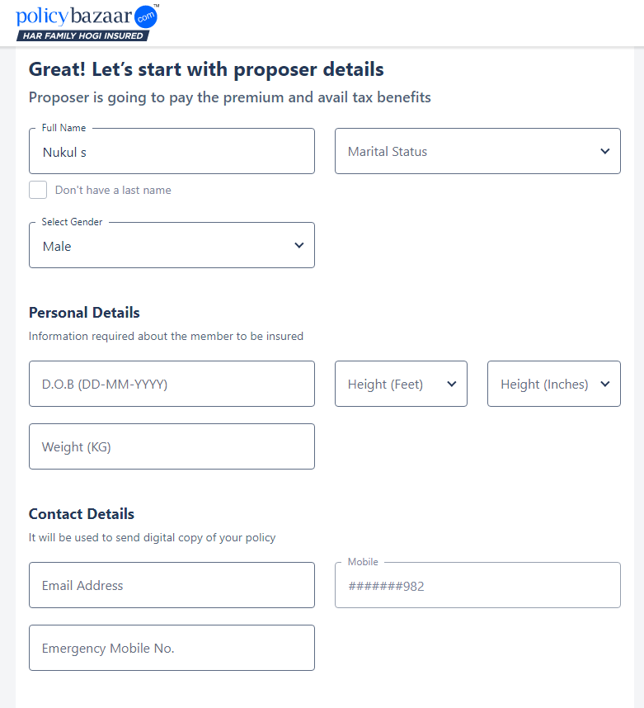

**Test Cases -**

1. Verify Drop-downs by clicking and selecting various values from it.
2. Verify that Pin Code Drop-down contains those pin-codes in which areas that particular policy is applicable.
3. Verify that by clicking “Don't have a last name” checkbox, is it working or not.
4. Verify that Full Name field should accept only alphabet (String).
5. Verify that Emergency mobile number field should accept only 10 digits.
6. Verify that in Mobile number text box it should not accept mobile numbers starts from 0 to 5 (The number starts from 0 to 5 is invalid in India).
7. Verify that in Mobile number text box if we add Mobile number less than 10 digits then it should show us error message as “minimum length should be 10”.
8. Verify that when we add any invalid email id in Email Address text box then it should show us an error message as “Email format is incorrect”.
9. Verify that all information present on UI should be available into DB and vice versa.