# UI Walkthrough:

## Hompage

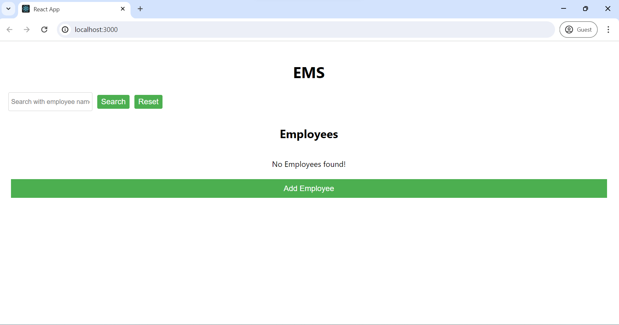

Since we have not added any employees, it says No Employees found!

## Add Employee

When we click on Add Employee button below form opens below to the button

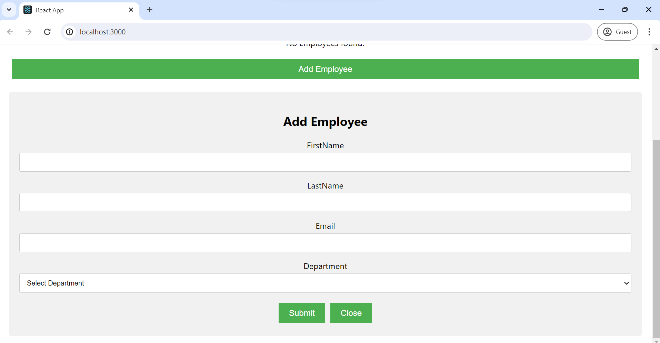

## Validation

### Direct Submit without entering anything

It gives validation errors for all fields not to be blank

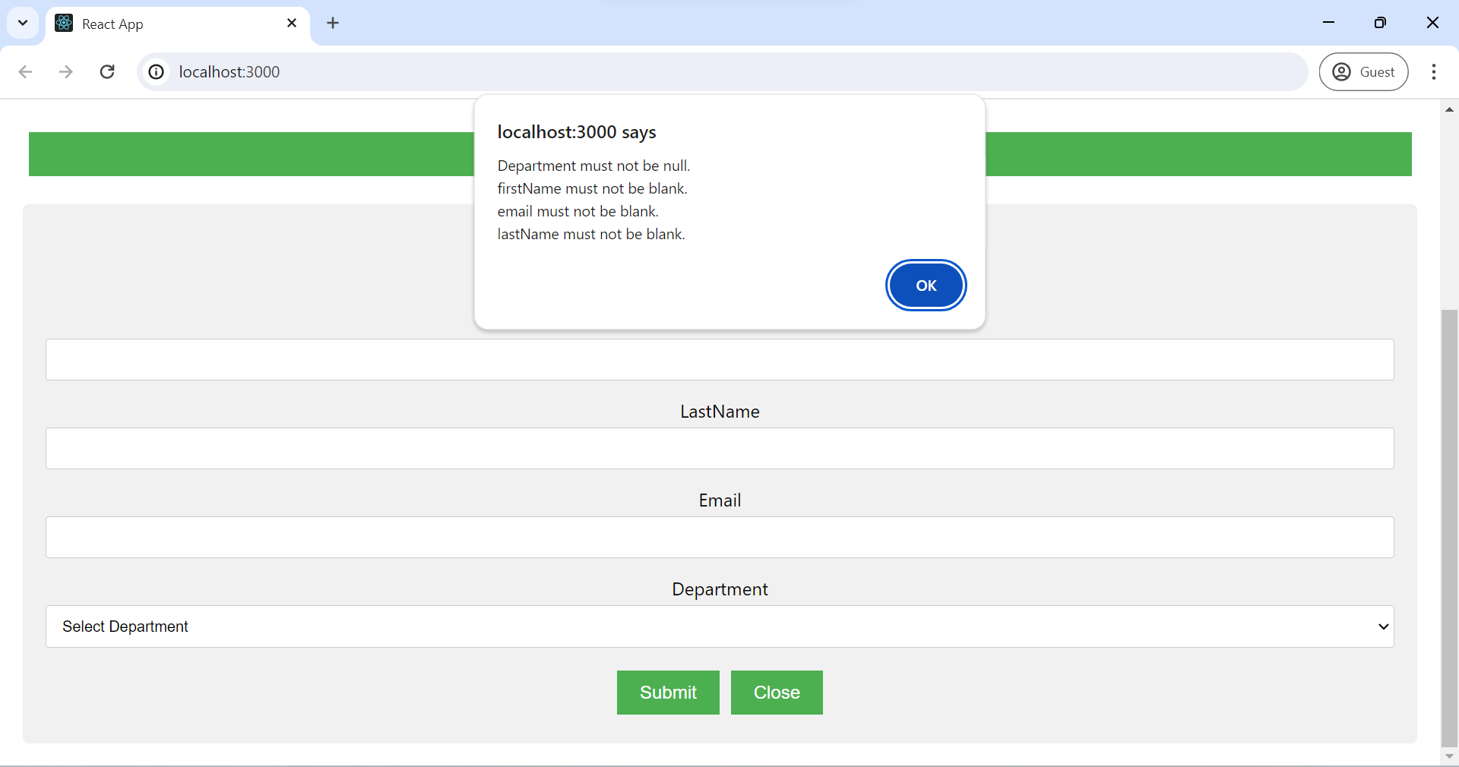

### Adding employee with same employee

It gives error “Duplicate entry. Please check for unique constraints.” and prevents adding the employee

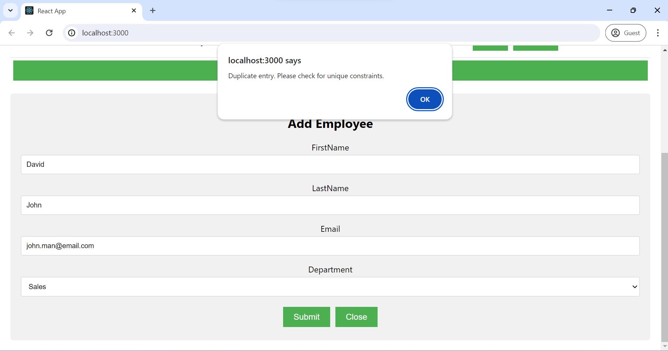

### Enter all fields but with invalid email and submit

It gives “email is not a valid email address” since we entered an invalid email

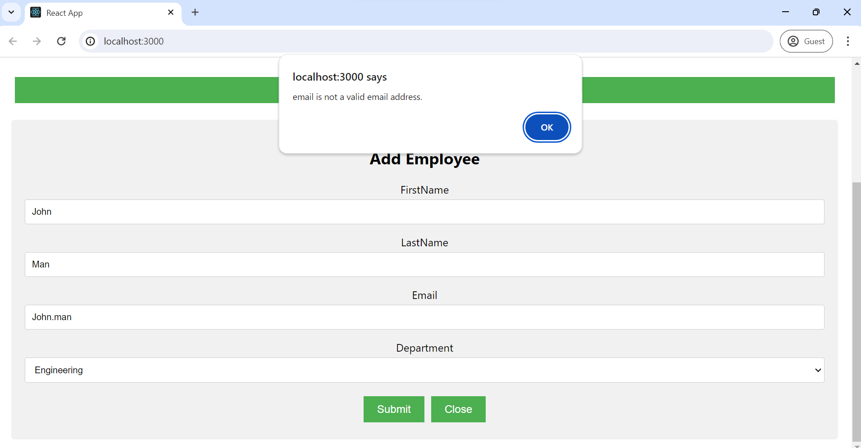

## Submit with valid values

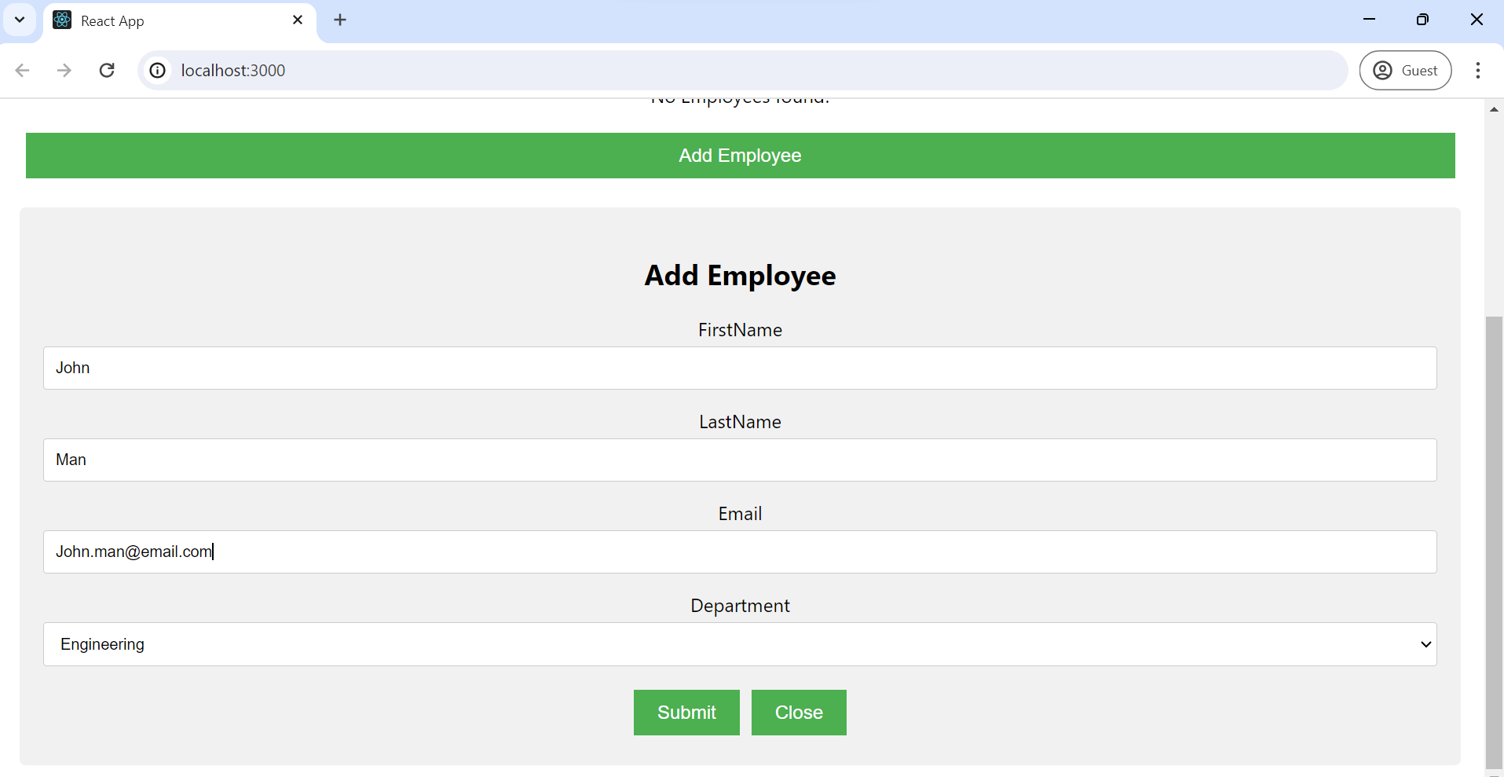It gives an alert saying ”Employee Added”

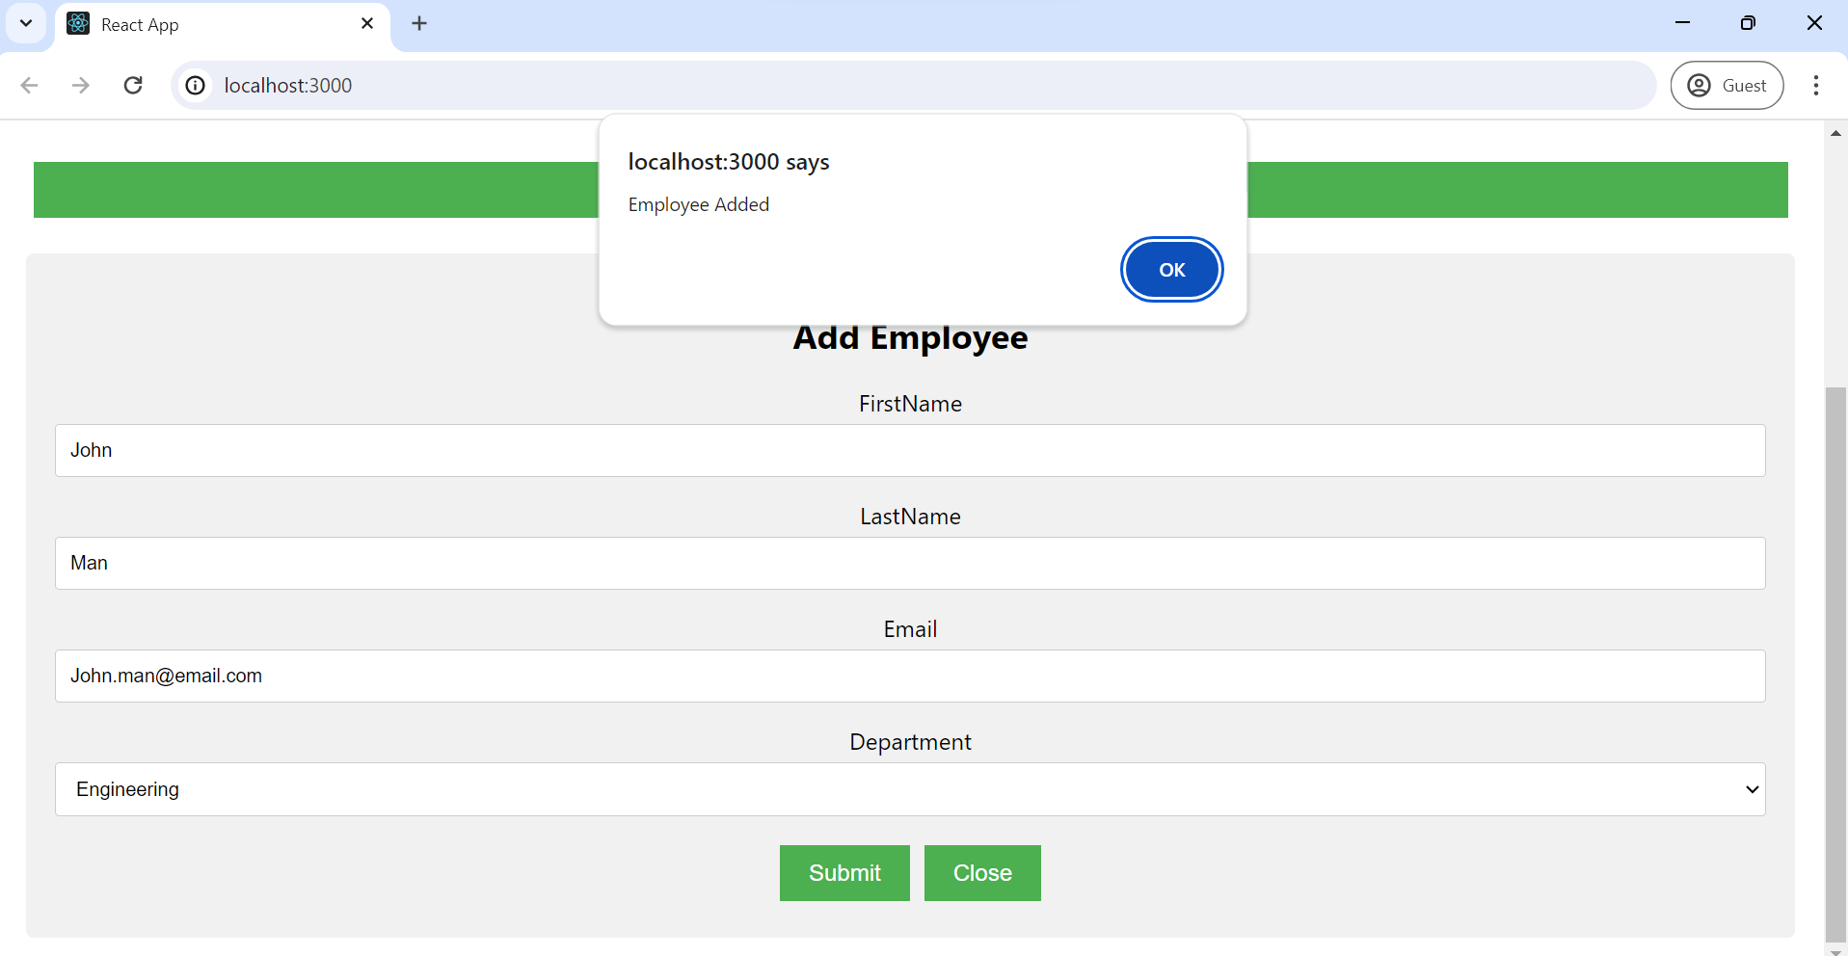When we click ”Ok” the added employee will be displayed in employee table as below

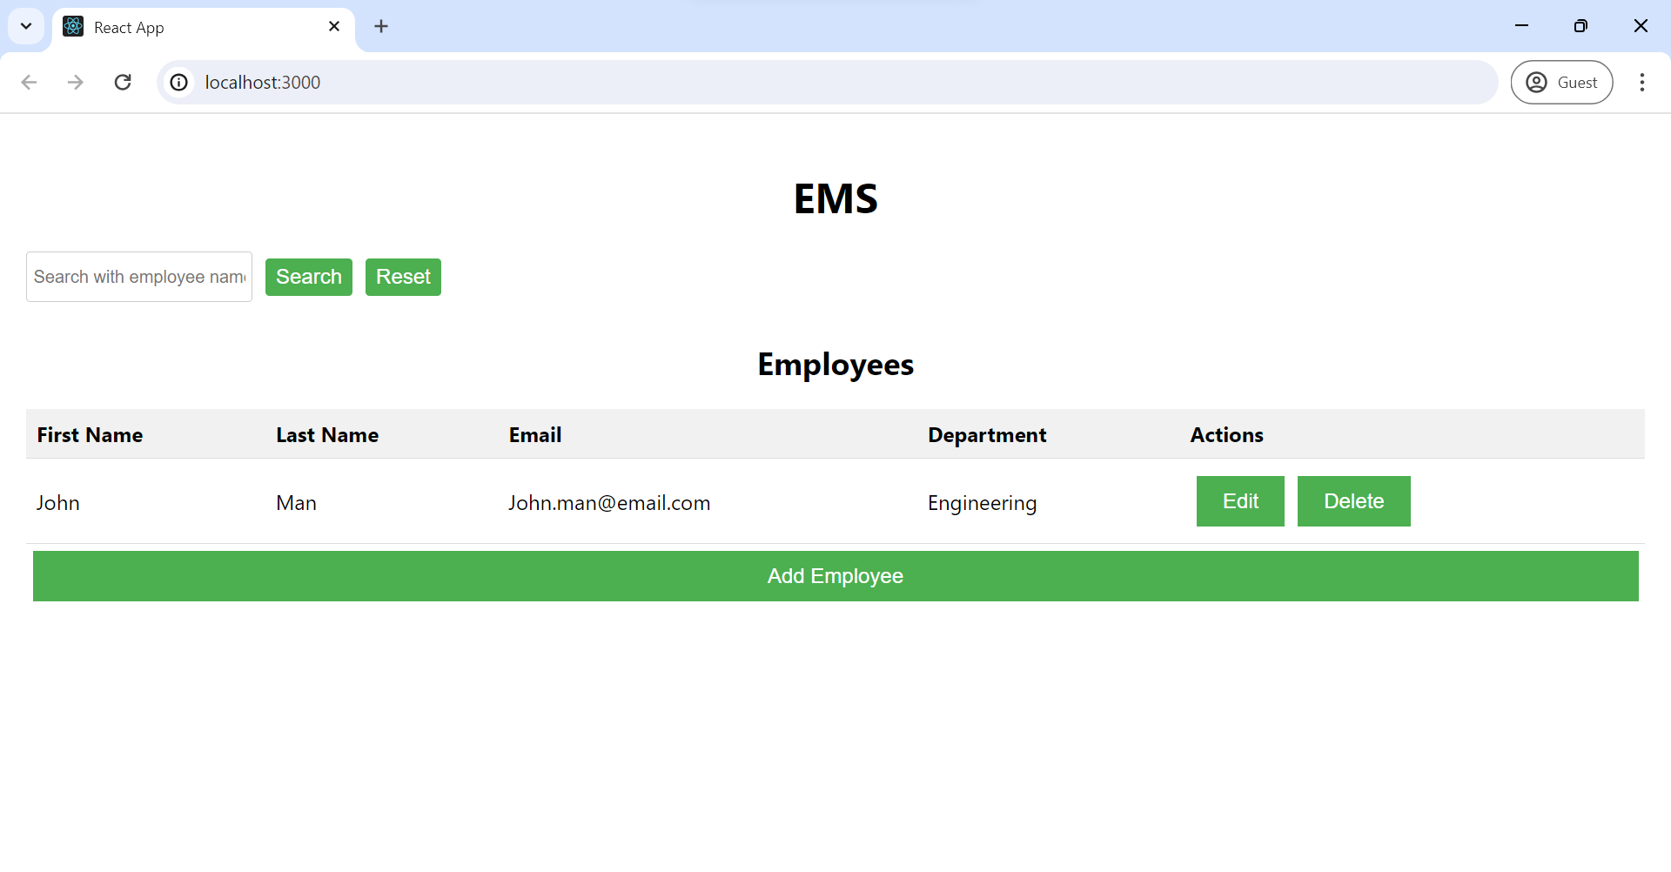

## Employee update

We can update added employee by click on Edit button next to that employee row. It will show Edit Employee form with populated values as below:

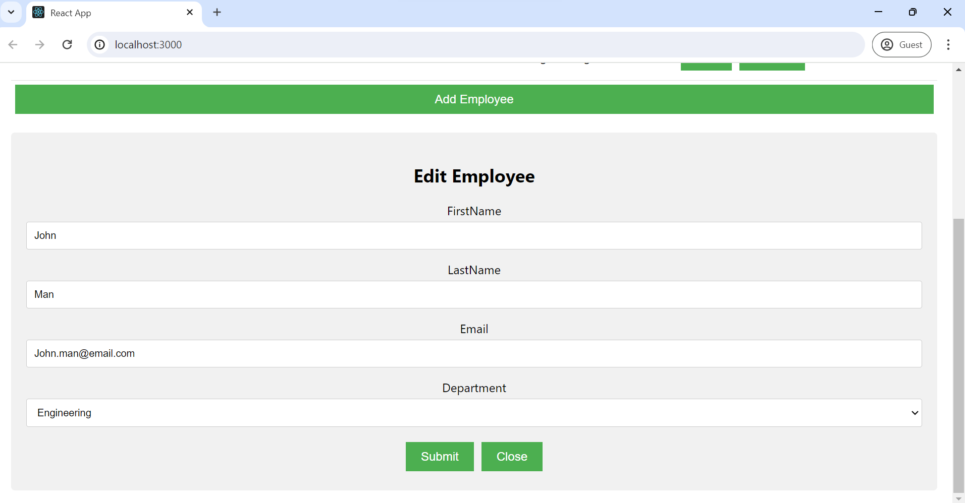After updating the values if we click on Submit button we see alert Employee Updated as below:  
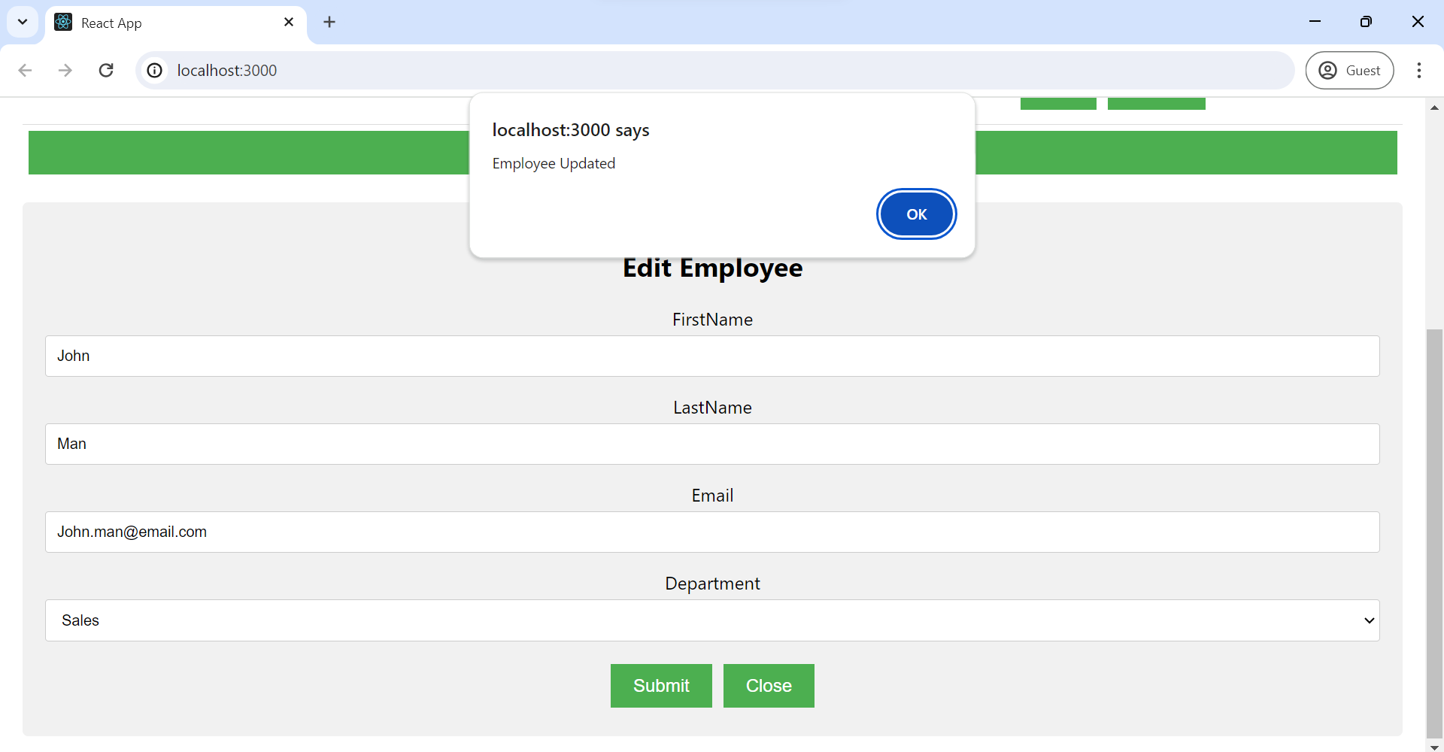click ’Ok’ the employee will be displayed in table with updated values and form will be closed.

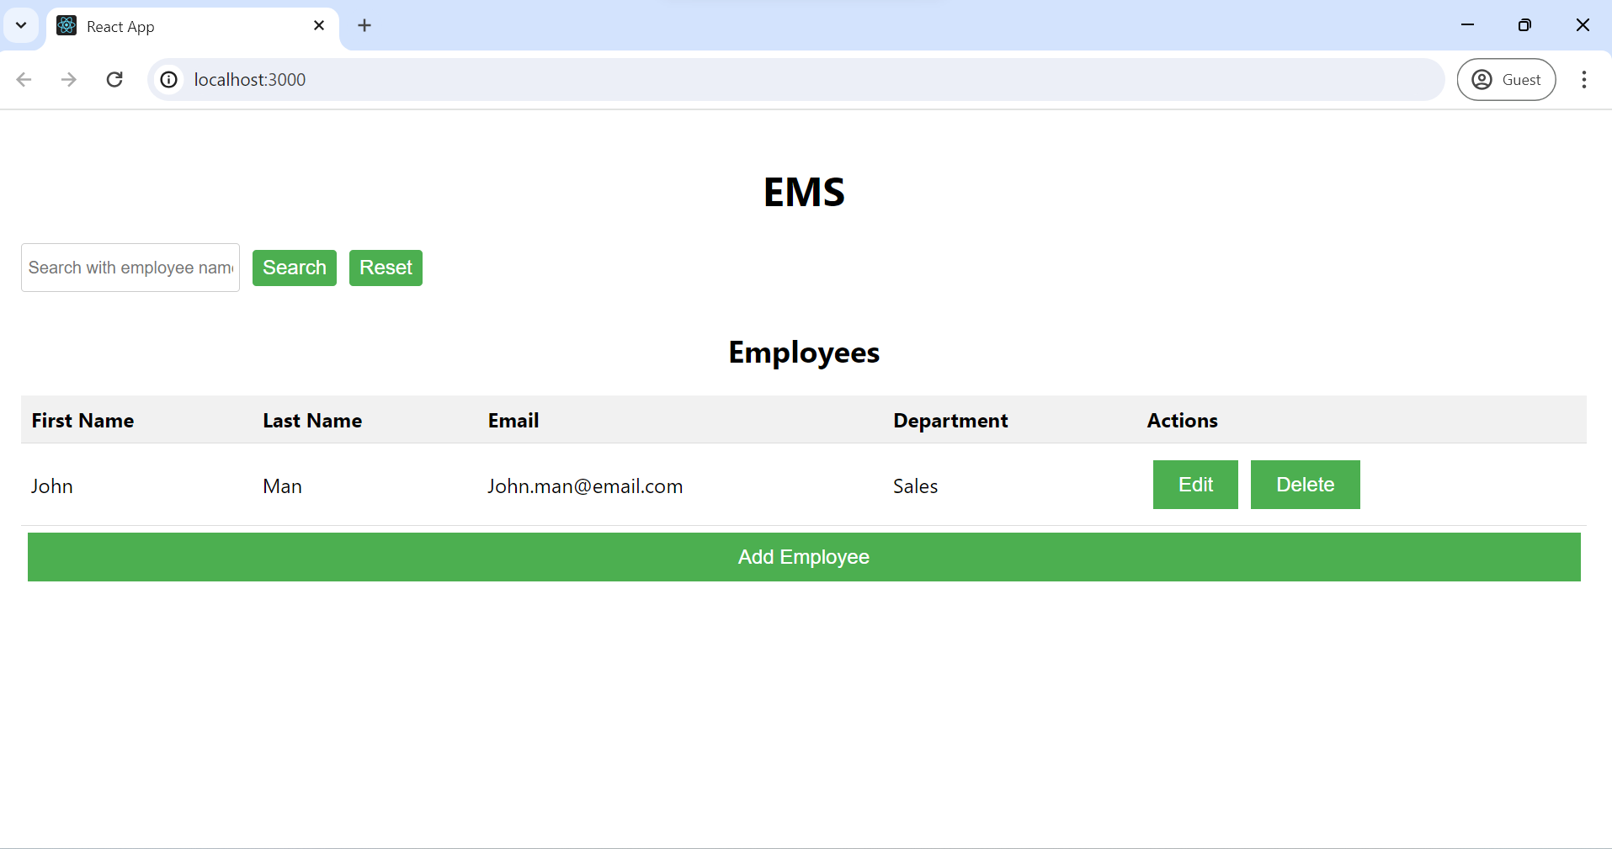

## Delete the employee

Click on delete button next to employee in table, it will display employee deleted

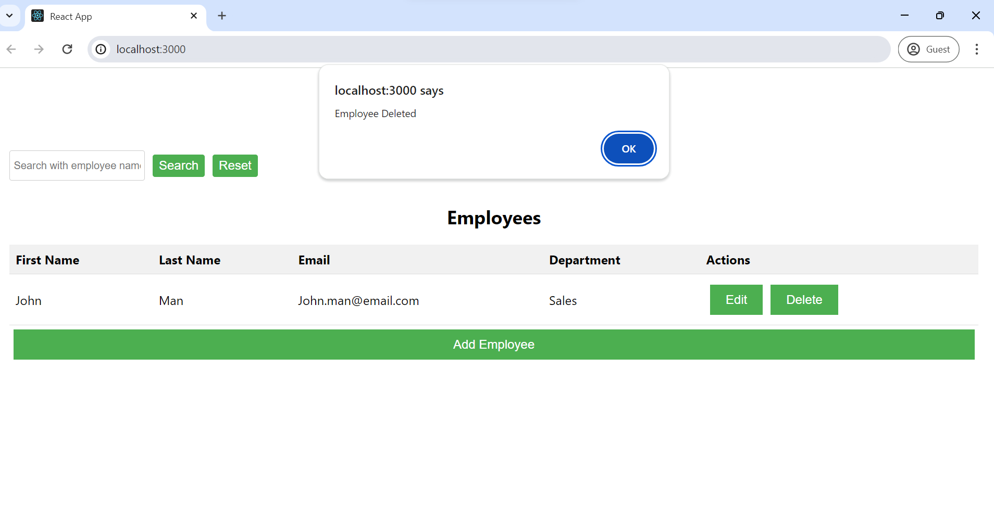

## Searching Employee with partial name

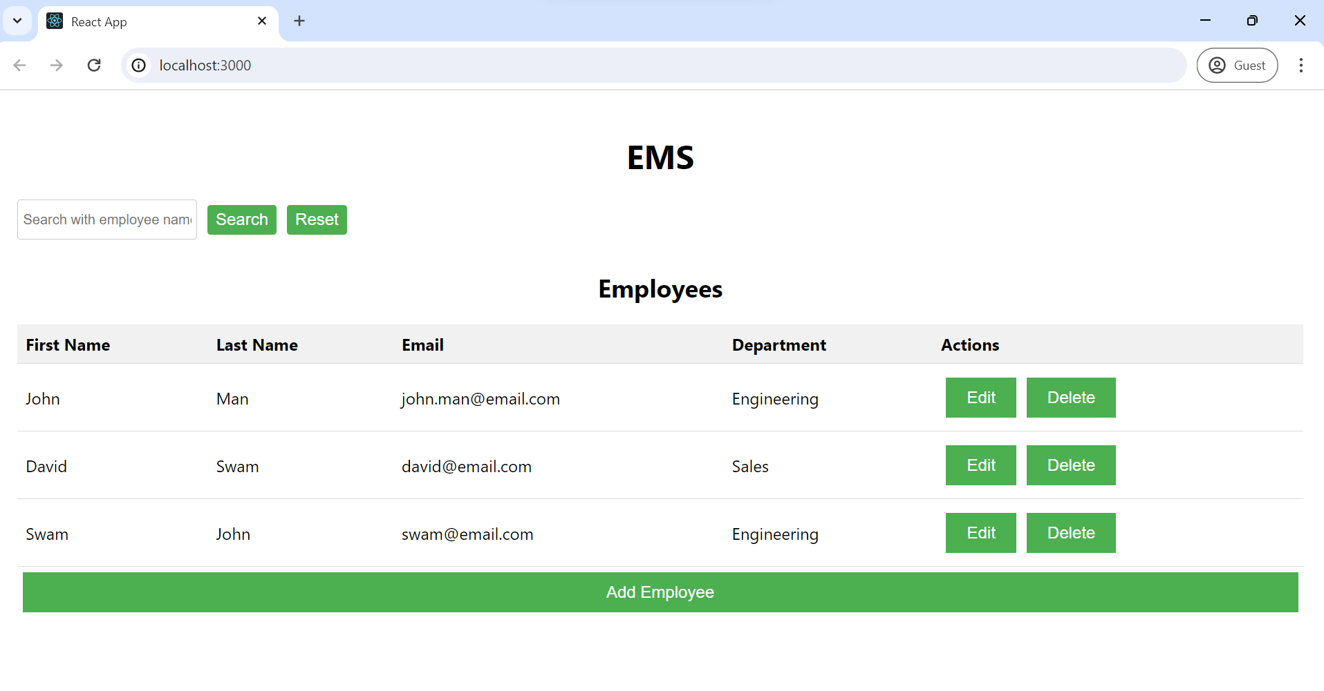

Search with text which is there in either first or last name. Like when I give “John” it gives two employees as they matches search criteria. Also it displays search text next to search/reset button

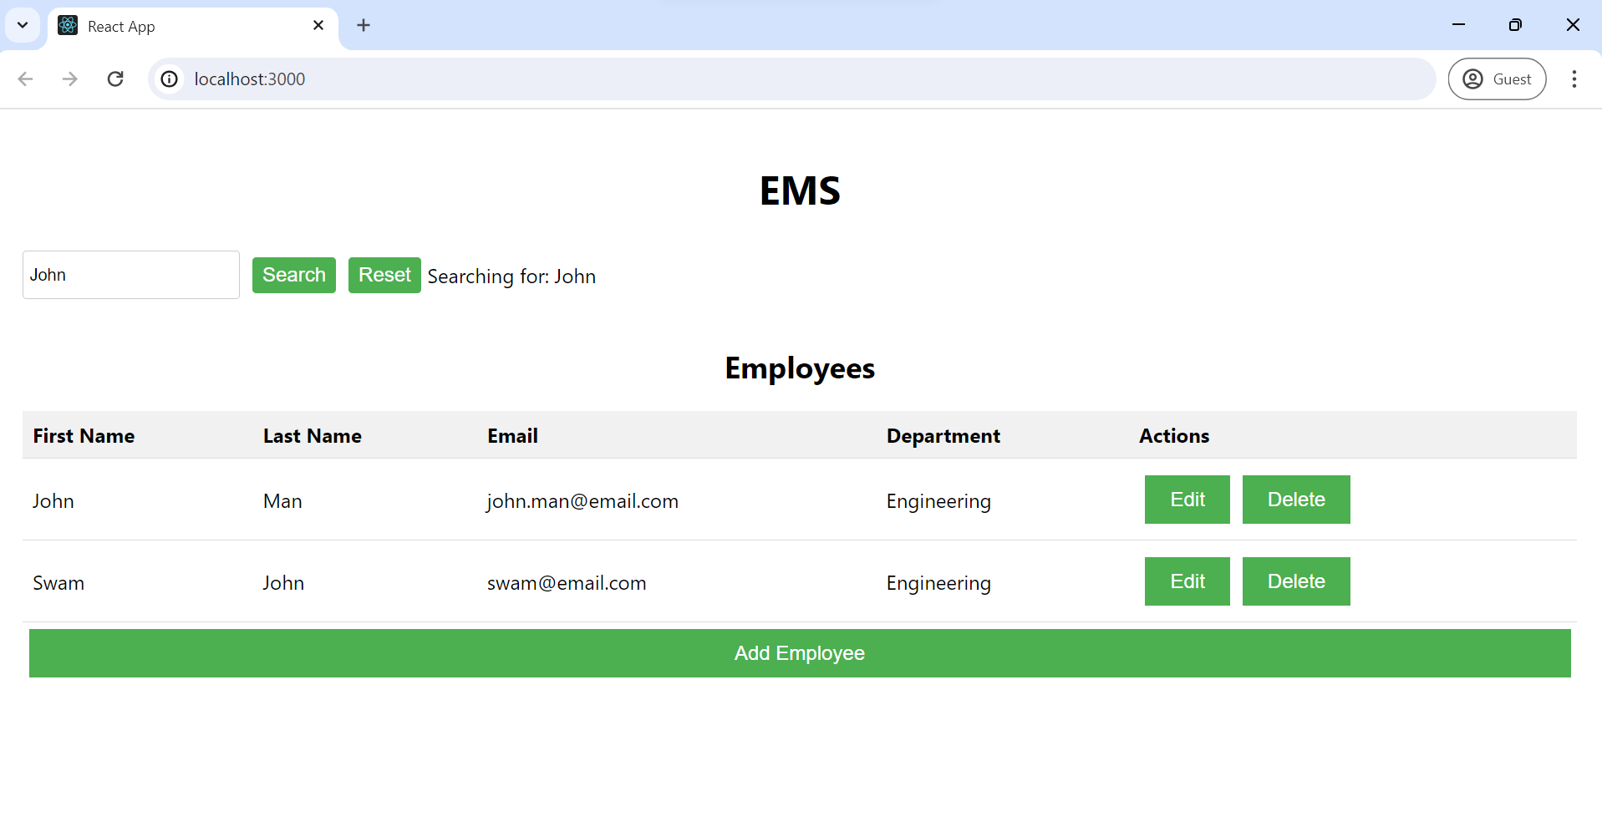

### Reset the search

Resetting the search will give all employees list when we click on reset button

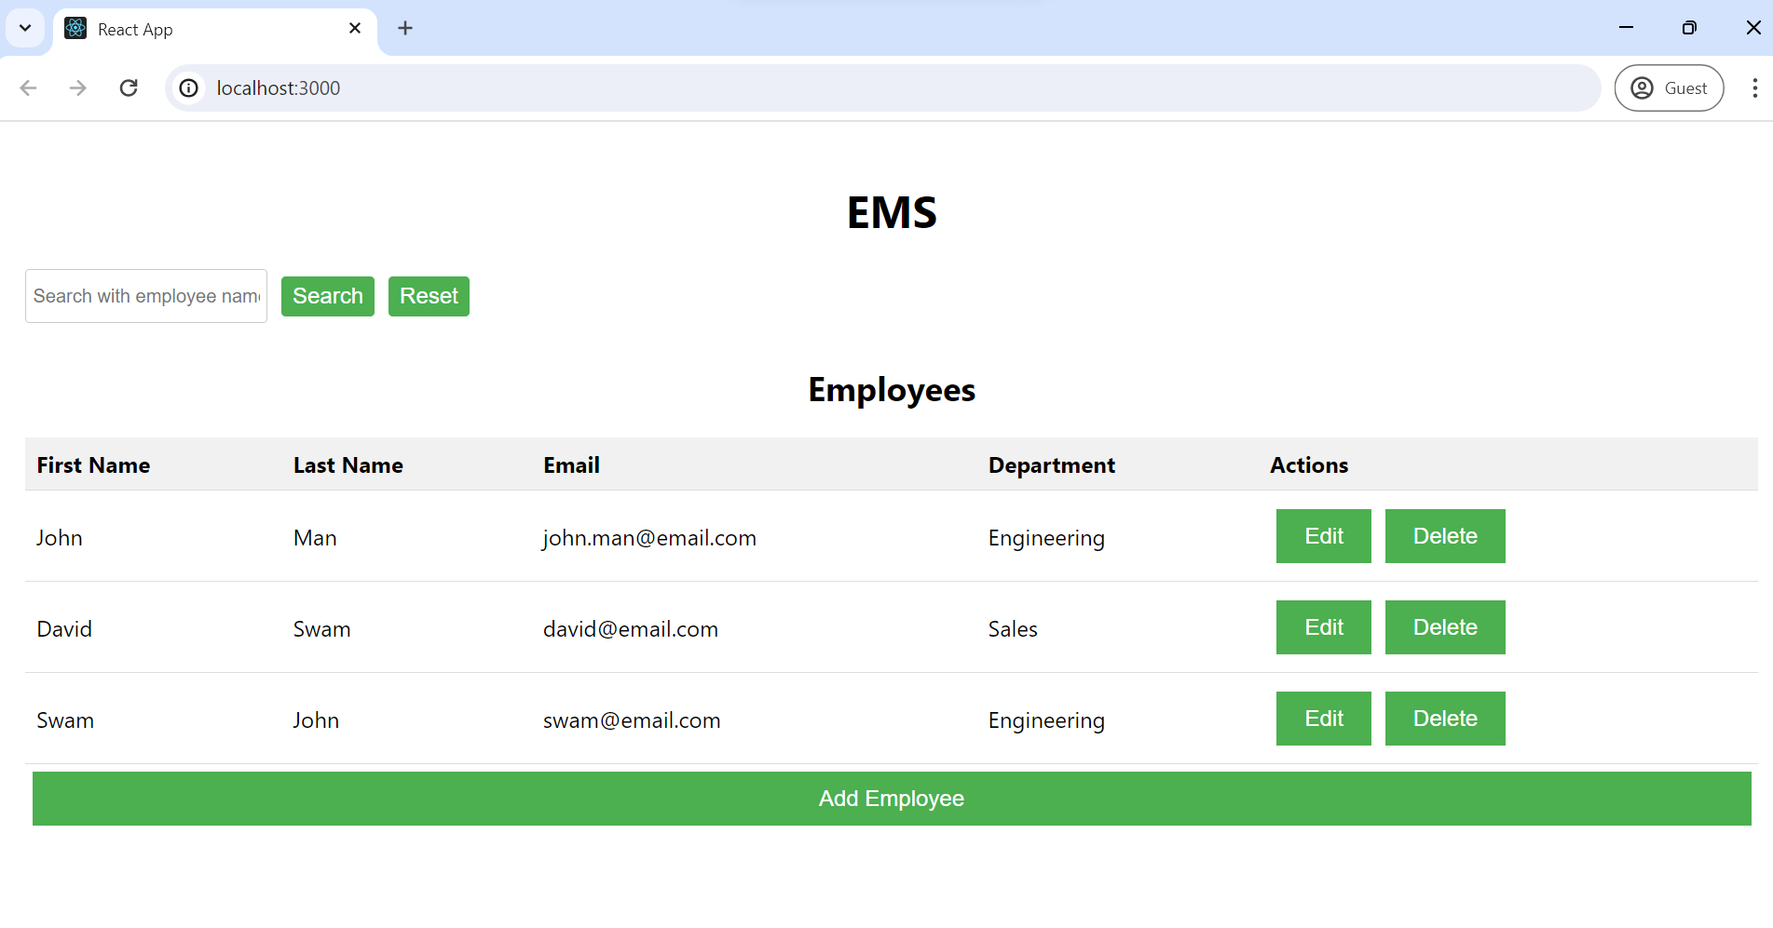

## Responsive UI

All things are responsive and works well in mobile screen

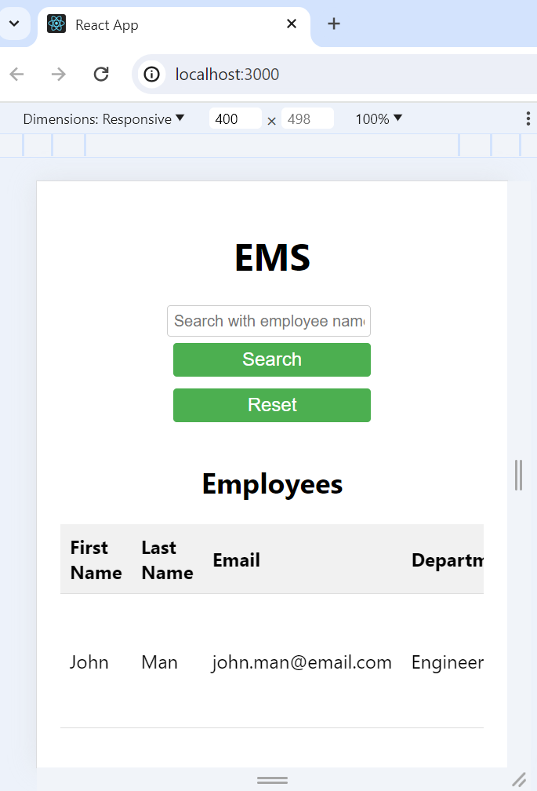

Table with horizontal scroll in mobile screen

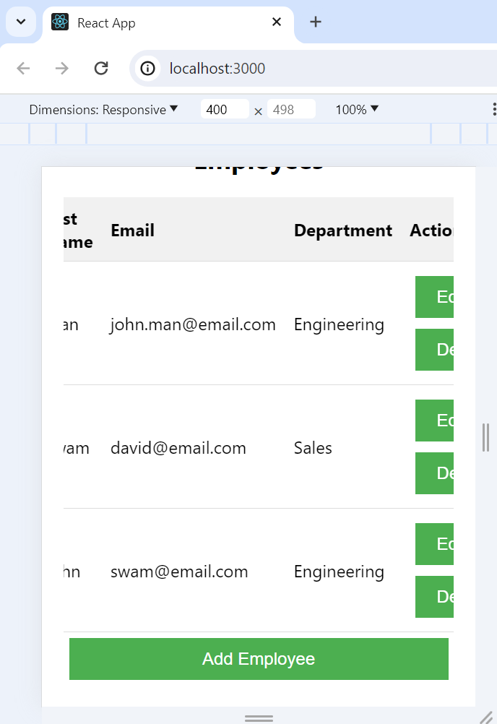

Responsive form

