**HAMY Biologics Pvt. Ltd.**

# Swim Lane Diagram

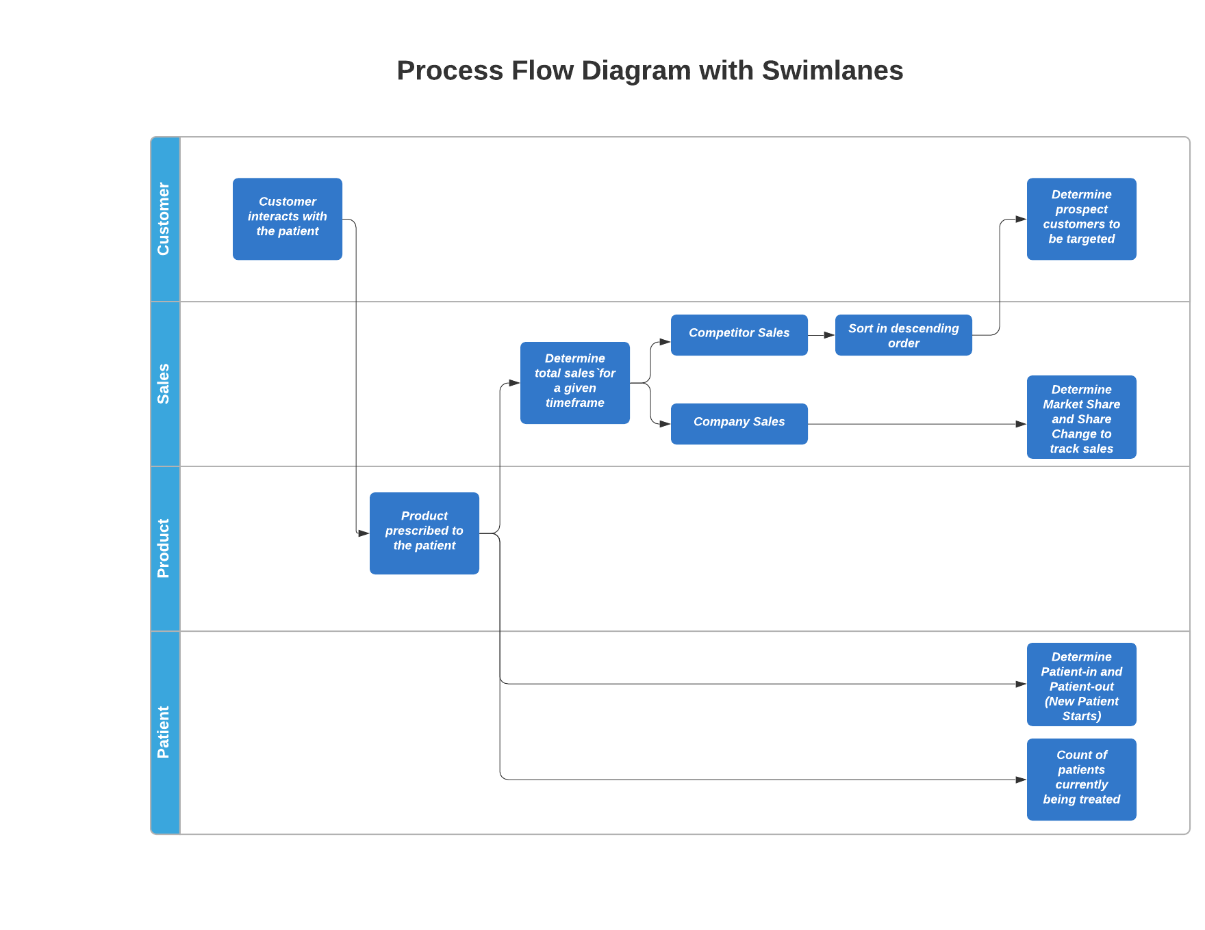

# SQL Code Attachment:

