**URL Response time in Prometheus**

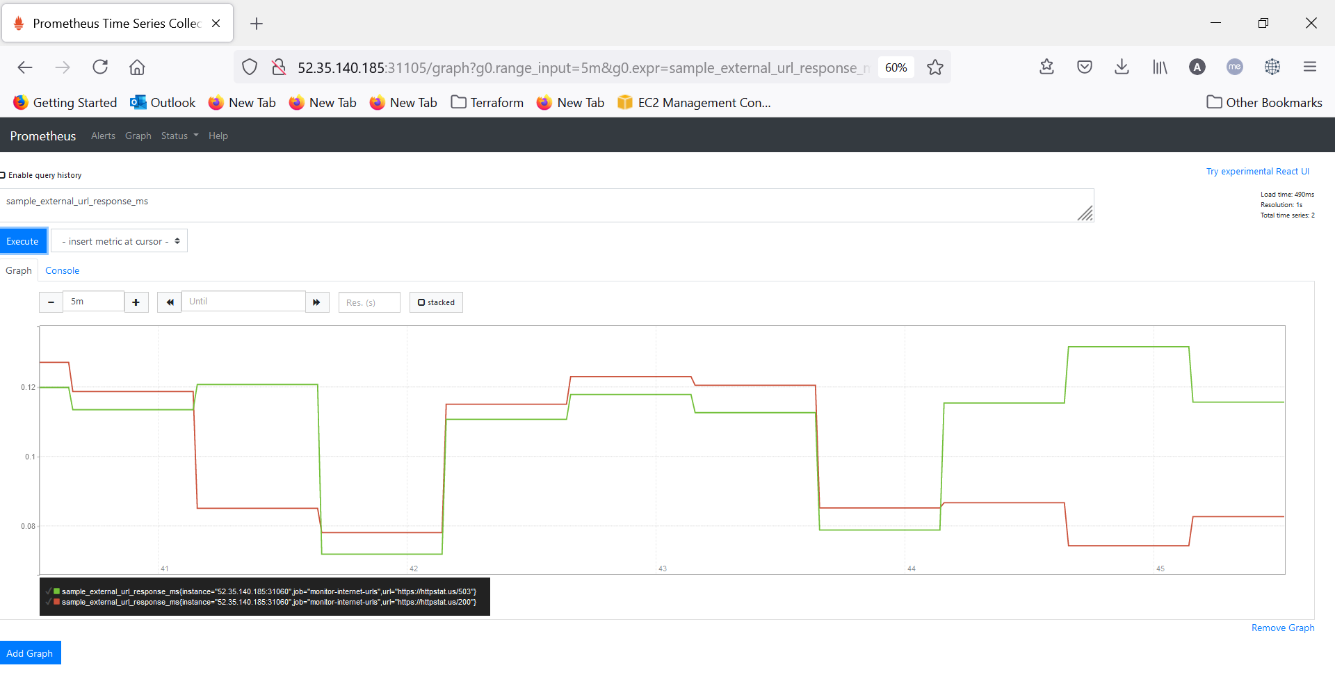

**URL Status in Prometheus**

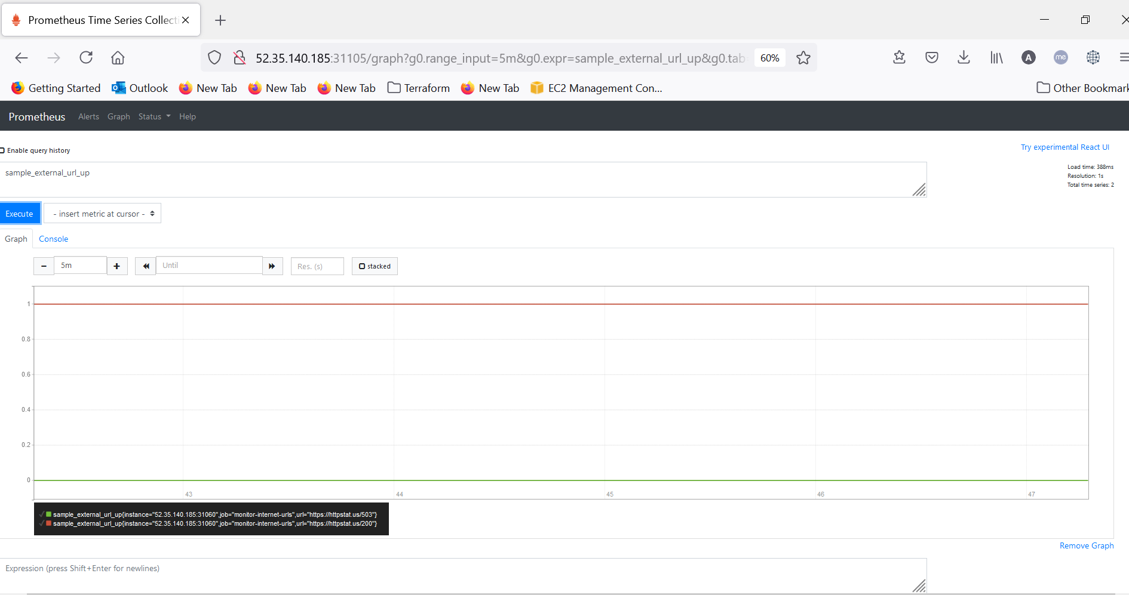

**Dashboard in Grafana**

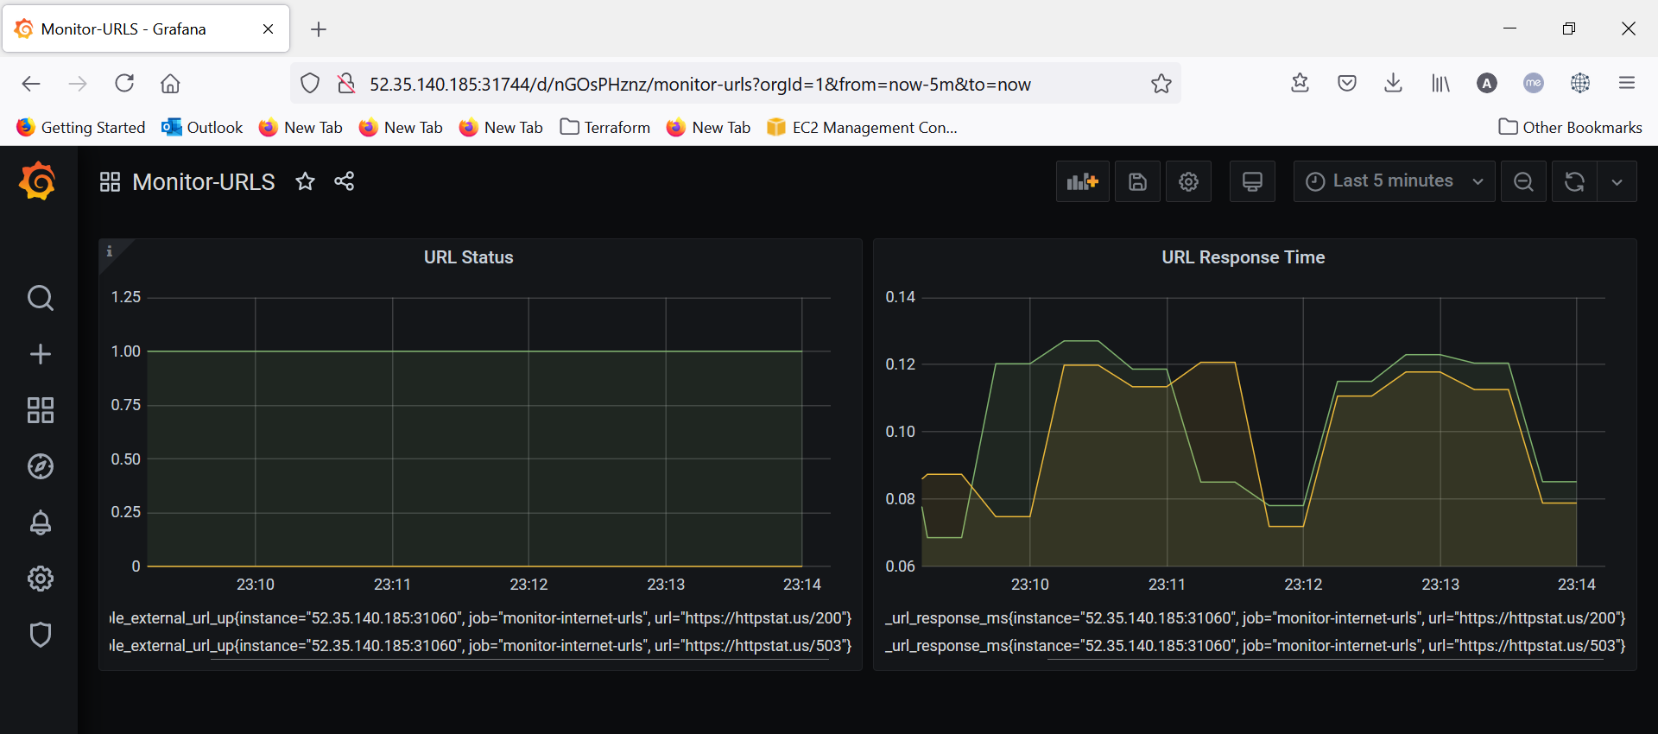

**Prometheus Targets**

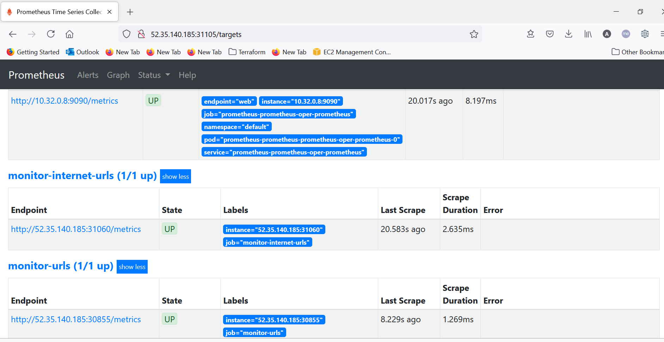

**values.yaml**

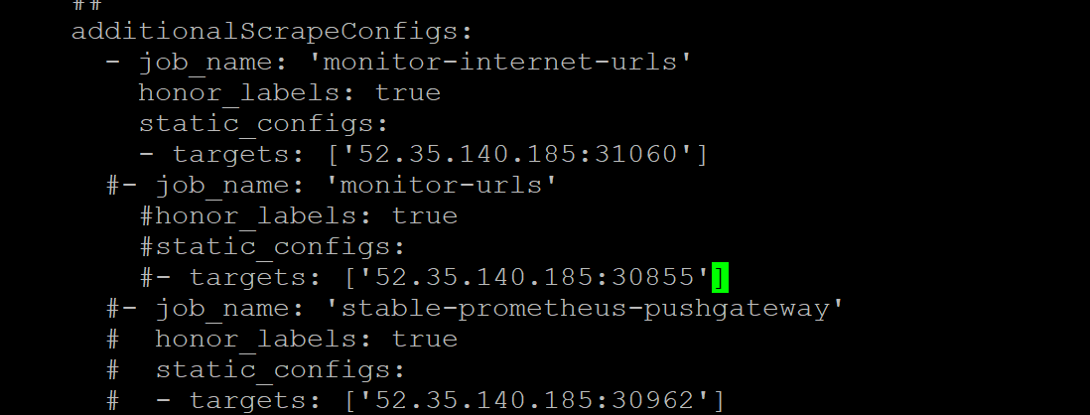

Implemented Solution in 3 ways.

1. **Python** **Web Service**
2. **Go Web Service**
3. **Pushgateway Service**

**Pushgateway Dashboard.**

