**Solution (in python) designed to run on a Kubernetes Cluster to monitor internet urls and provide Prometheus metrics and Grafana.**

<https://github.com/akshaygirpunje/monitor-internet-urls.git>

**URL Response time in Prometheus:**

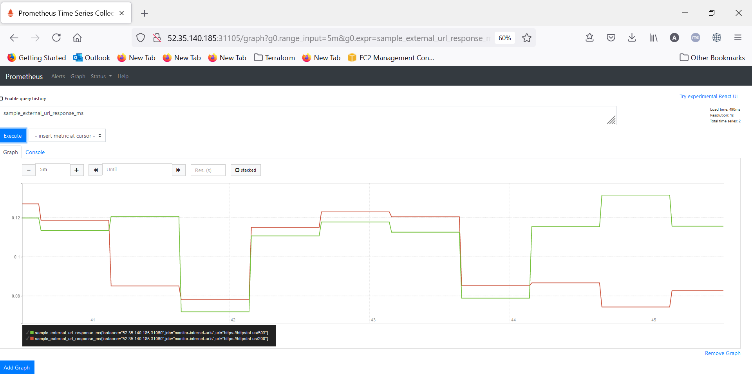

**URL Status code in Prometheus:**

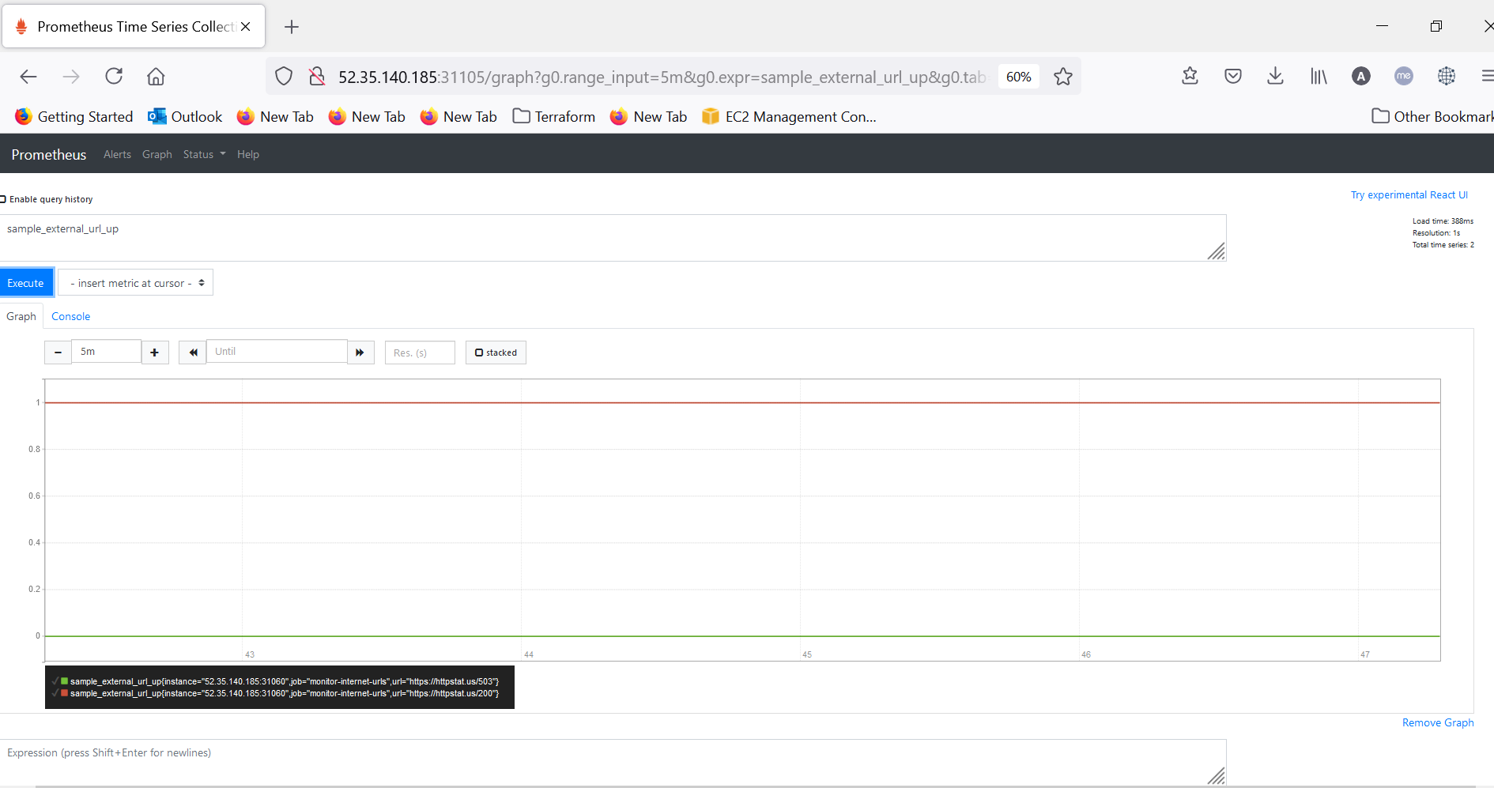

**Prometheus Targets:**

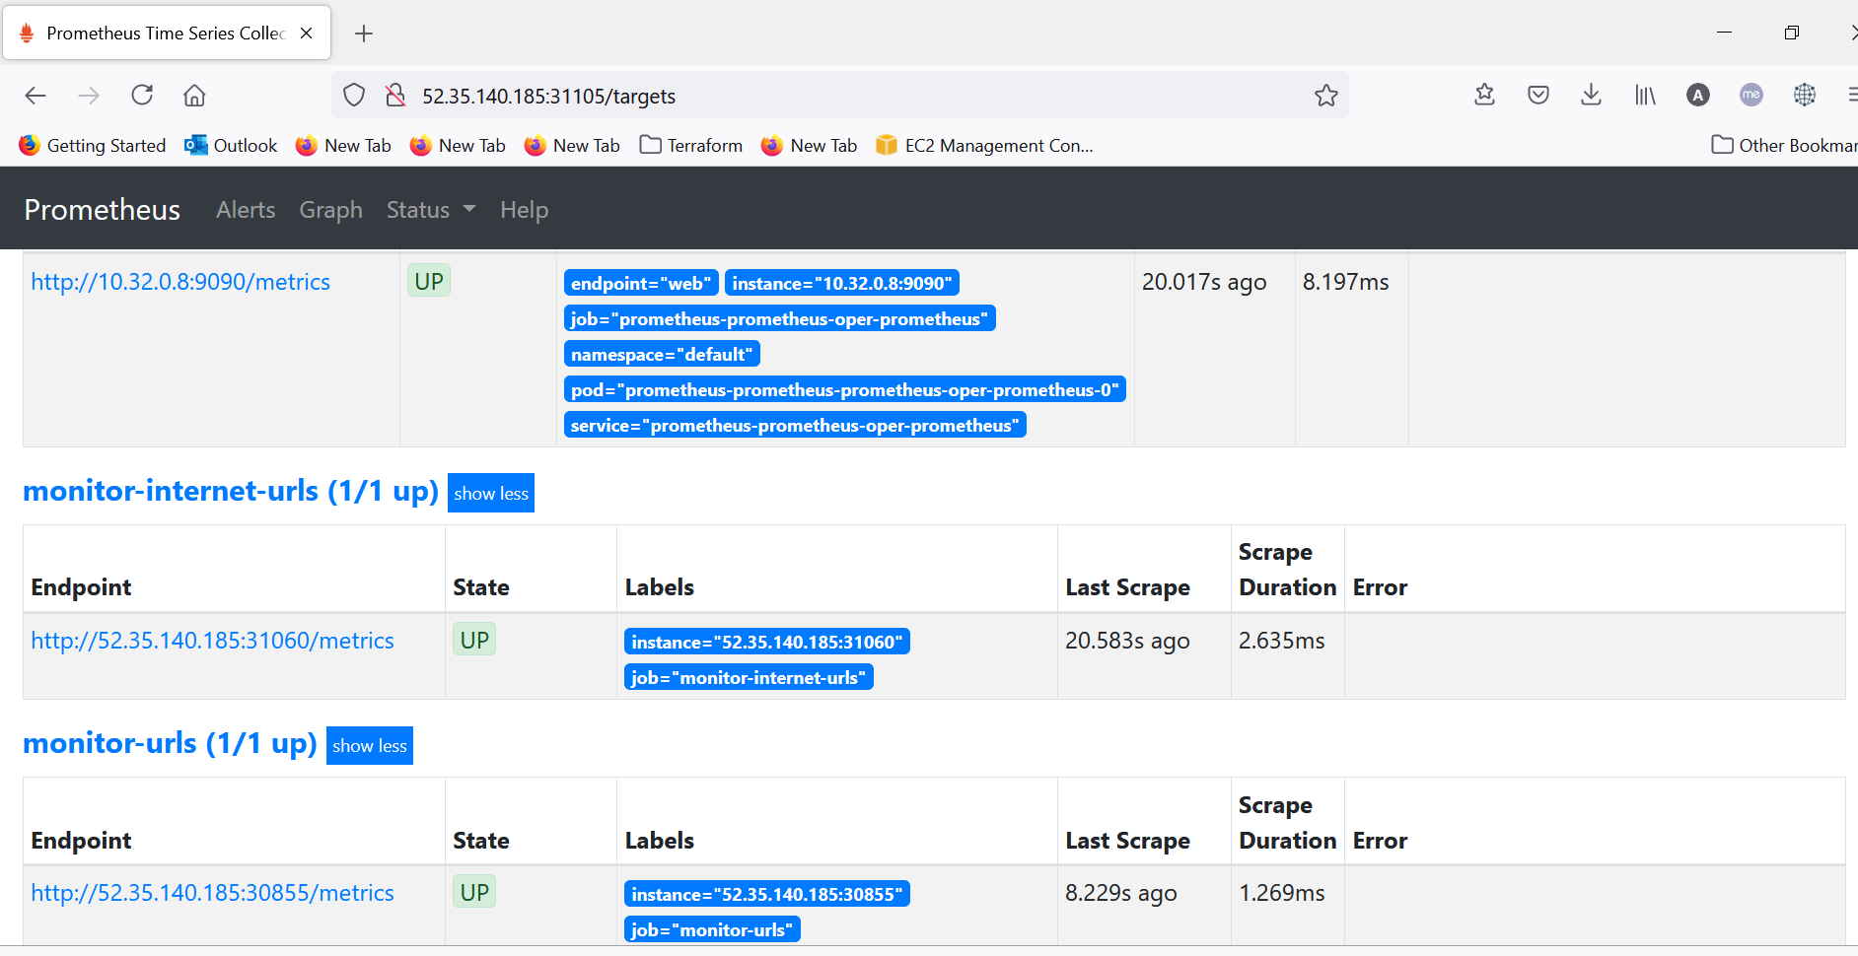

**Dashboard in Grafana:**

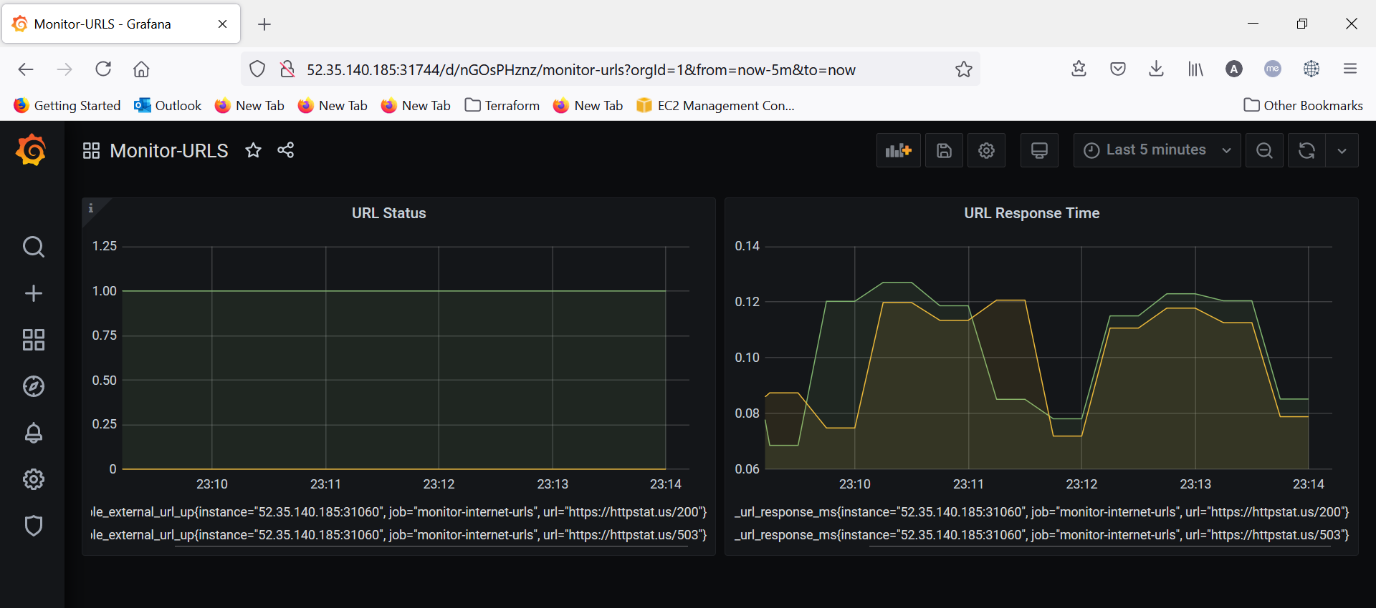

**Python Web Service**

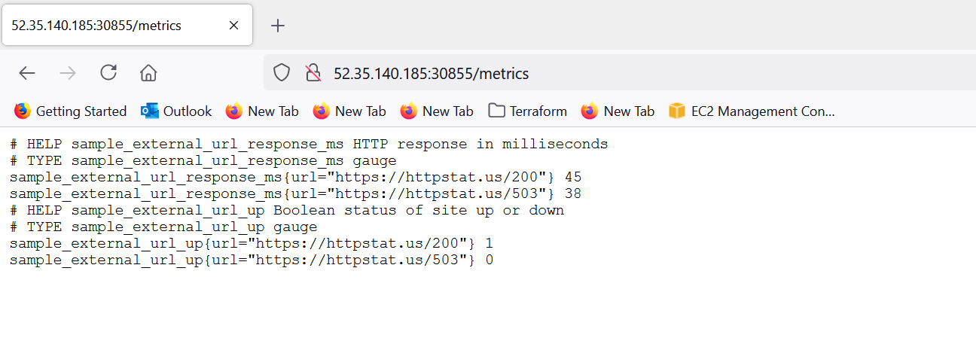

**values.yaml**

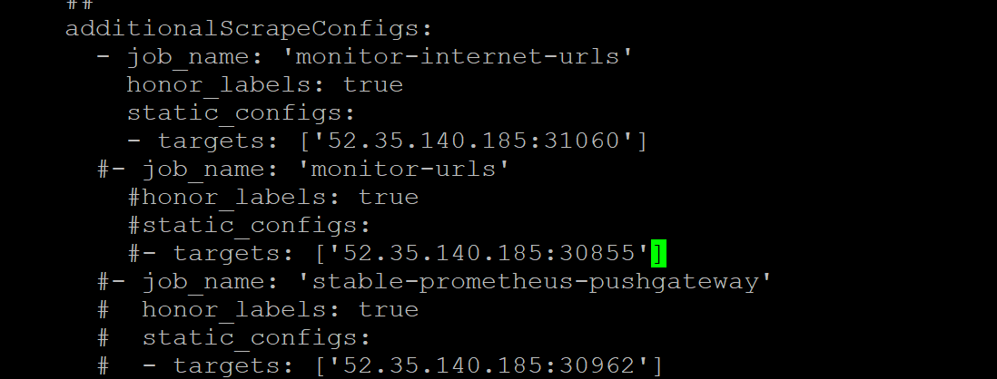

Implemented Solution in 3 ways.

1. **Python** **Web Service**
2. **Go Web Service**
3. **Pushgateway Service**

**Pushgateway Dashboard.**

