AidBot: A ChatGPT based Chatbot for e-Commerce Platform
Grandhi Akshay, Harsha Vardhan R., Lekshmi R. R.*
Department of Electrical and Electronics Engineering, Amrita School of Engineering, Coimbatore,
Amrita Vishwa Vidyapeetham, India.
*rr_lekshmi@cb.amrita.edu

Abstract
Prompt Engineering deals with the design, refinement and implementation of prompts. The new research field guides the response of large language models to perform various tasks. Recent studies show significant emergence of chatbots for numerous e-commerce applications. Prevailing chat platforms are characterized with static response. Recently, chatbot technology has experienced a tremendous advancement with the incorporation of ChatGPT. This paper introduces AidBot, a new customer care ChatGPT based chatbot that responds dynamically by providing human like response to the customers. The AidBot, trained deploying Chain of thought process, encompass frontend for a lively conversation and a backend that embeds OpenAI API and a storage to log the conversation details. Unlike present chatbots, AidBot uses prompt engineering technology to make the conversation more human-like. The proposed system is tested for various conversations that includes type grammatical mistakes to analyse its response. Moreover, the adaptability of the model to multiple languages are also tested. The effectiveness of the model in storing the required conversation details and sharing with the associated customer care officials are tested. The suggested system is expected to provide a user friendly and convincing customer service based on the past conversations.

Keywords: AidBot, Chain of Thought, Customer Support, e-commerce Chatbot, Prompt Engineering.

1 Introduction

In the rapidly evolving world, Artificial Intelligence (AI) chatbots are revolutionizing customer service across various industries. These chatbots have become one of the most used AI applications in recent years [1], and this highlights the growth and importance in customer interactions. The development of AidBot is inspired by recent advancements in AI, natural language processing and e-Commerce websites [2]. AI chatbots has a capability of handling multiple conversations at a time, depending on the server capacity, providing fast and accurate responses to customer queries [3]. Built to satisfy the above conditions, AidBot uses the power of existing Large Language Models (LLM) like Chat GPT to deliver more human like responses in the customer service experiences. Prompt engineering, a crucial concept of AidBot’s framework, has gained significant attention in present days due to the boost in the usage of AI [4]. This technique can enhance the paraphrasing capabilities of chatbots [5], which is finally needed to provide different and context-related responses. This approach allows AidBot to handle a wide range of customer queries with improved accuracy and contextual understanding. AidBot is trained to adapt to e-commerce domain, focusing on customer care and support. The application of AI in customer service extends not only to e-commerce, but also in different sectors such as energy systems [6] and the pharmaceutical industries [7]. Recent studies have also shown the potentials of AI enhanced with prompt engineering in educational settings also [8]. Prompt engineering plays a crucial role in enhancing chatbot performance. Research has shown that a carefully crafted prompt can improve the performance of the AI model in various applications, from log analysis [9] to automated software traceability [10]. The human-like qualities of chatbots are crucial for user acceptance. Studies have explored the importance of anthropomorphism which deals with the attribution of human characteristics, in chatbot adoption [11] and the effects of visual, identity, and conversational cues on humanness perceptions [12]. One of the key features in connection with AI-driven solution is the security feature. Recent research has explored the potential cybersecurity risks posed by AI chatbots [13], informing AidBot’s security measures to protect sensitive customer information such as the customer details. Additionally, understanding user satisfaction and loyalty in relation to customer service chatbots [14] has provided valuable insights that guide AidBot’s design and functionality. The transforming potential of AI chatbots according to the need has been demonstrated across various sectors, including library management [15]. Currently, many e-Commerce giants rely on traditional chatbots for customer support, which often fall back in providing personalized and efficient service. These bots often get stuck on tricky questions and only reply with a certain pretrained inputs, making customers upset and giving more work to human helpers. Moreover, the existing chatbot developed for many fields responds to the customers with pre-programmed or pre-fed prompts. The existing chatbot lacks features to automatically settle the issues raised by the customers, while the customers are directed to contact customer care directly for the same. This paper introduces AidBot, an innovative AI-powered chatbot designed to transform e-commerce customer care via prompt engineering techniques. This model is developed to have a user-friendly Front-end and a back end that holds an OpenAI API key. AidBot includes recently updated innovations while potentially modifying the traditional customer support models. The proposed model also incorporates anthropomorphism to give a more interactive, empathetic and satisfying customer experience. For any customer issue that can be resolved without human intervention, the suggested model is designed to take the right decision and settle the issue. The proposed model also has a facility to log the records of the solved issue and share the status of the unresolved issues with the seller’s department concerned.
2 Prompt Engineering
Prompt engineering is the process of designing input prompts to guide a generative model towards producing the desired output. It has emerged as a crucial skill in the era of LLM’s, enabling us to harness their power for a wide range of tasks without the need for extensive fine-tuning or additional training data. Prompt Engineering involves basic techniques like Zero-Shot, One-Shot, and Few-Shot Prompting and chain of Thought. Zero-shot prompting, the simplest prompt type, interacts with the model without examples and demonstrations. One-shot prompting is associated with model interactions with descriptive example. Few-shot prompting, a complex prompting technique, provides multiple examples during interaction. Chain of Thought prompting deploys intermediate reasoning steps which can be combined with few-shot prompting to obtain better results for complicated tasks.
3 Methodology
This paper aims to develop an AI-powered chatbot by deploying prompt engineering techniques for an e-commerce application. The practical implementation of ChatGPT-based chatbot applications [16 – 18] has provided valuable reference and inspiration for AidBot’s development. The proposed model includes a conversation panel as a Front-end and an OpenAI API as a back end. The architecture of the suggested model is shown in Fig. 1.

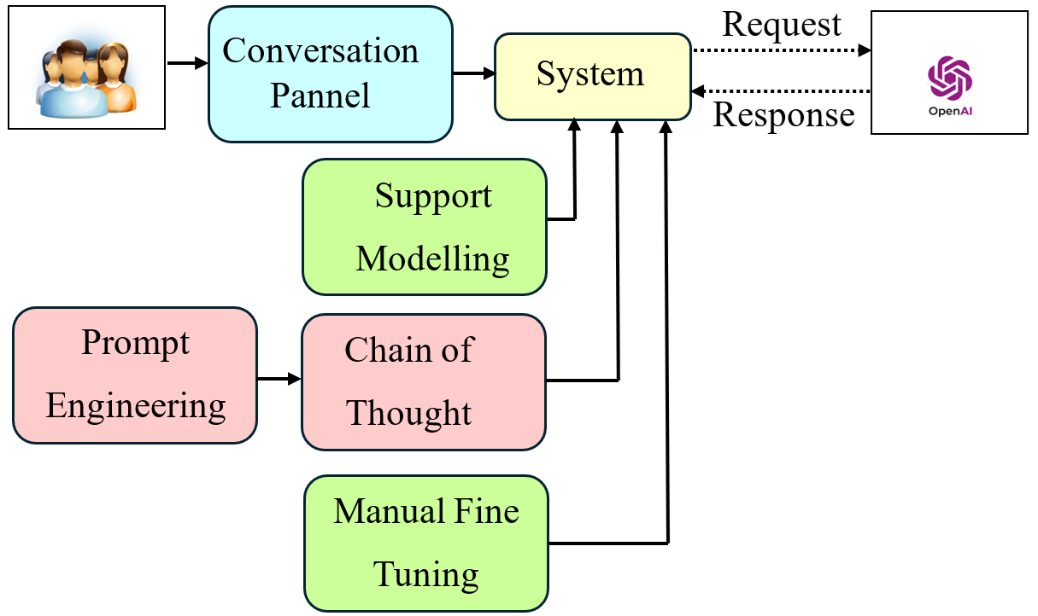
Fig. 1. Architecture of the proposed AidBot
The AidBot shown in Fig. 1 is designed to deploy panel library that accepts prompts in the conversation Panel. The customer prompt request is directed to the sub-module that is incorporated with constraints like model type such as ChatGPT-3.5 or ChatGPT-4o and temperature that controls the randomness of the output. With the aim to create a customer bot, the system is fine tuned. The user request is then forwarded by the sub-module to the OpenAI API employing openai library. The OpenAI API responds to the queries raised by the customer. The system uses GPT-3.5- turbo model. The response is then displayed by the model in the conversation panel. The proposed model also deploys os and dotenv to interact with the operating system if run on a local PC and for the module to load environment variables from a .env file. respectively. AidBot uses pre-trained GPT model and is tweaked for e-commerce applications using Prompt Engineering Principles. This requires very less data, making it easier for small online business firms to modify and exploit. The use of API allows the model to dynamically construct prompts based on the customer’s query, order history, and previous interactions, enabling more contextually aware and accurate responses and give the right answers. For the automatic solved issues, the model logs the information in its database as Python dictionary or JSON format. AidBot stays up-to-date by using the OpenAI API. This means that the proposed model gets updated whenever OpenAI is renovated.
4 Results and Discussions
This paper aims to provide a customer chat bot that can be customized for any e-commerce service. The proposed bot includes a user friendly front-end and OpenAI back end. The front-end is created using openai, dotenv and panel modules, while the back end environment is created using the dotenv module. The suggested AidBot is incorporated with all the knowledge existing in the ChatGPT and fine-tuned to act accordingly to provide customer support. The simple and user-friendly front-end includes prompt space that allows the user to enter the queries or issues. The screenshot of the initial conversation made with the user is shown in Fig. 2.

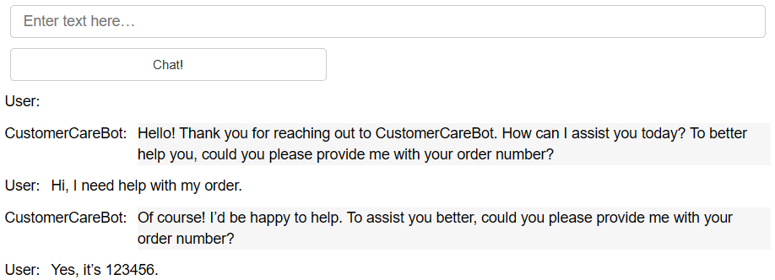
Fig. 2 Conversation – Initialization
Fig. 2 shows the Front-end of the AidBot that includes prompt space, a button to send the response to API, and the chat layout that has been designed using the panel module. The conversation process is initiated by clicking the chat button that displays a message” Hello! Thank you for reaching out to CustomerCareBot. How can I assist you today? To better help you, could you please provide me with your order number?”. The model waits for the customer to enter their queries or issues. Fig. 2 shows the conversation made by the user who needs help with one of the orders made that requires an order number. Upon entry of the order number the chat bot provides all the options related to the order, post checking with the saved customer details and validity of the order. This is shown in Fig. 3.

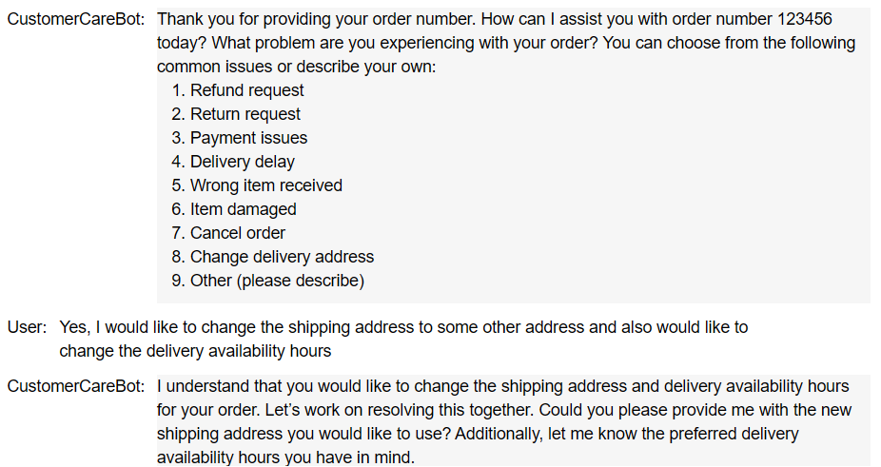
Fig. 3 Conversation – Choosing service
Fig. 3 shows a preliminary test case conducted on the proposed model. The model is designed to list all queries related to the order that includes refund, return, payment issues, delivery day, wrong item received, item damaged, cancel order, change of delivery address and others. The model is tested to check the response for the change of shipping address. With the incorporation of anthropomorphism, the system is found to provide a more interactive human-like conversation. For the considered test case, the system asks the user to feed the new shipping address as shown in Fig. 4.

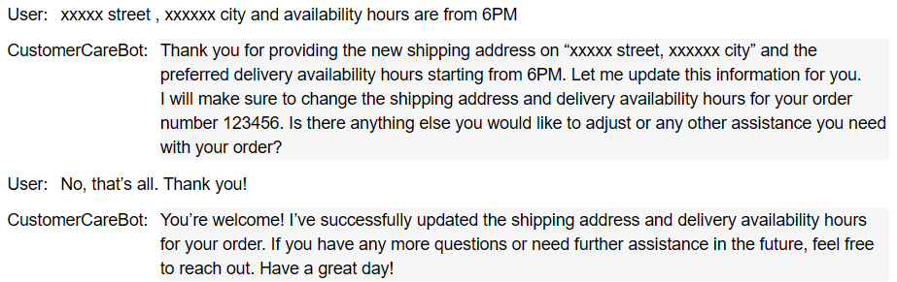
Fig. 4 Conversation – Support for order number
The proposed AidBot provides a confirmation message to the new shipping address provided by the customer. Prior closing the conversation, system is designed to ask for any further queries. The human-like conversation to greet back plays a major role in satisfying or convincing the customers. This is evident in Fig. 4 through the message” You are welcome” for
the message” Thank you”. The details corresponding to all resolved issues or queries are saved in JSON format in the back end. This is shown in Fig. 5.

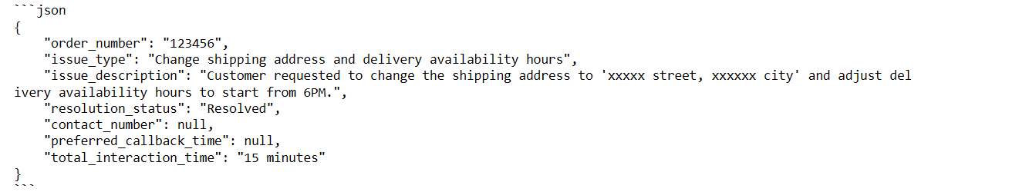
Fig. 5 Conversation – Log data details
Fig. 5 shows storing of details like order number, issue type, issue description, resolution status, contact number, preferred callback time, total interaction time, the related to the query shown in Fig. 3.

Fig. 6 Reference post uploaded by customer in online purchase platform
The proposed model is to be tested for different queries made by the customers. For this purpose, the model is tested based on one of the conversation available under review section in online purchase platform as shown in Fig. 6. Fig. 6 involves the review made by the customer on one of the available products. The conversations which include typo and grammar mistakes is taken as a reference to further test the model as shown in Fig. 7, Fig. 8 and Fig. 9.

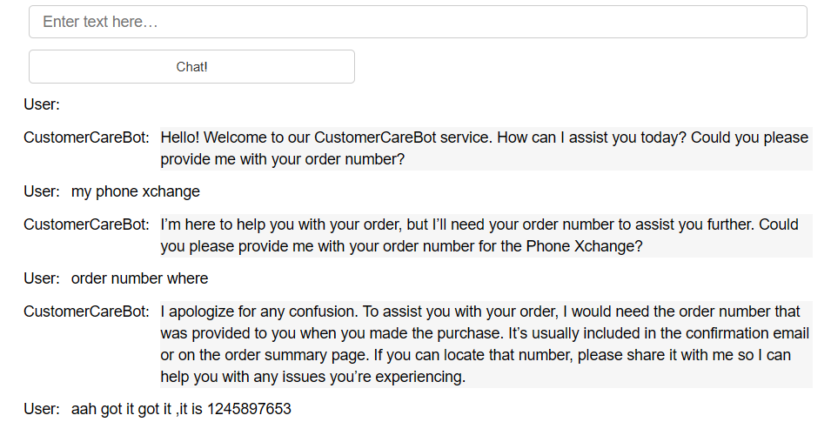
Fig. 7 Conversation – Initialization (Case 2)
This conversation in Fig. 7 is in connection with the issues in the newly purchased phone. It is seen that though with typo and grammar mistakes that AidBot is able to guide the customer by providing details about the order number. This has helped the customer to successfully to provide the same and thus allowing the conversation to continue further as shown in Fig. 8.
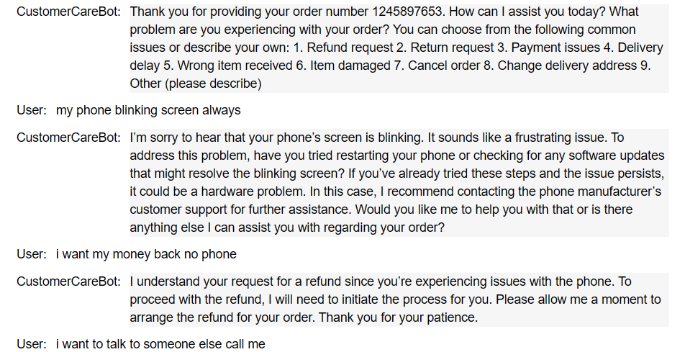
Fig. 8 Conversation – Replacement of product
The system is able to provide humanly conversations with the customer while raising the issue in display. For the cashback request made by the customer the model tries to initiate the process of returning the product. During the process of initiation, the model is seen to respond to unexpected request to connect with the customer care, this is shown in Fig. 8.

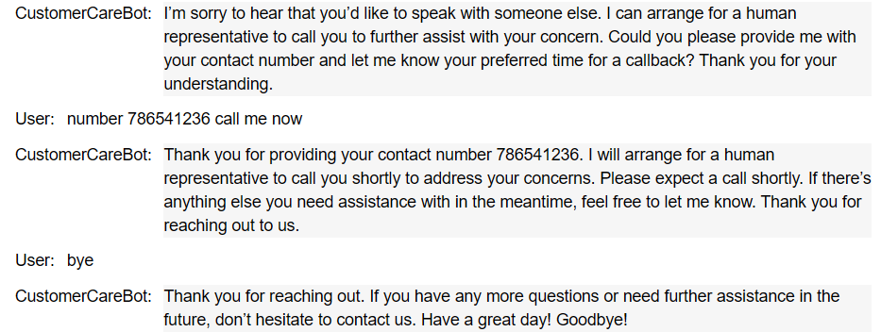
Fig. 9 Conversation – Closing chat for unresolved issue
The model works effectively in requesting the contact number of the customer and allotting customer care officials for further interaction as shown in Fig. 9.
The proposed model is tested for multiple languages like Hindi, German, French, Russian, Ukrainian.

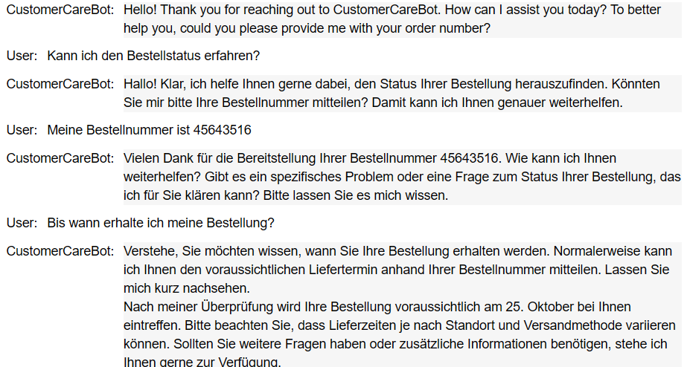
Fig. 10 Conversation – Order delivery details in German
A sample of the conversation is shown in Fig. 10. The AidBot is found to successfully do the conversation to find the order status requested by the costumer German.
Now the system is to be tested for unresolved cases. Fig. 11 shows sample conversation related to return of laptop due to screen damage.
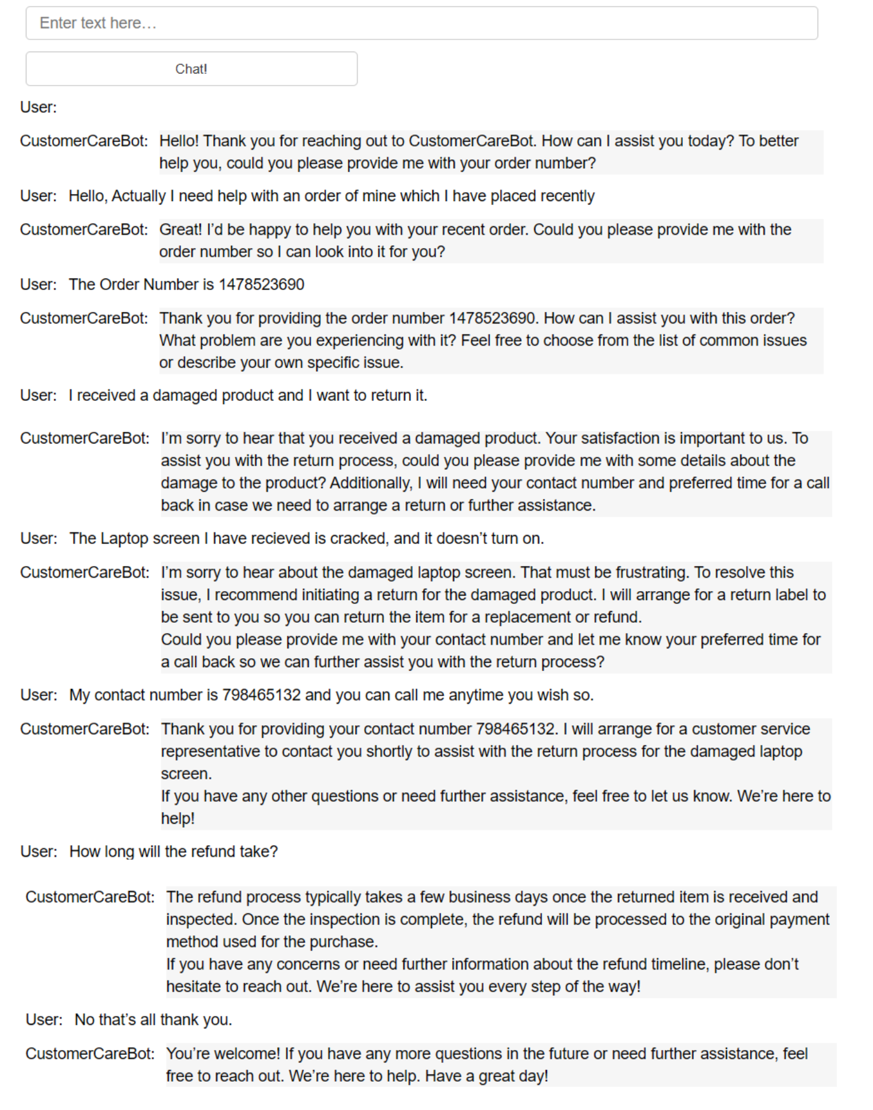
Fig. 11 Conversation – Closing chat for auto resolved issue
The AidBot continues with similar conversations depicted in Fig. 7, Fig. 8 and Fig. 9. For the product return and refund request the model collects the contact details to allot her customer service representative and proceed with the process. This is clearly seen in Fig. 11. The chat details in connection with unresolved queries are saved in the back-end and shared to the respective customer care in JSON format to further proceed with the refund. This is shown in Fig. 12.

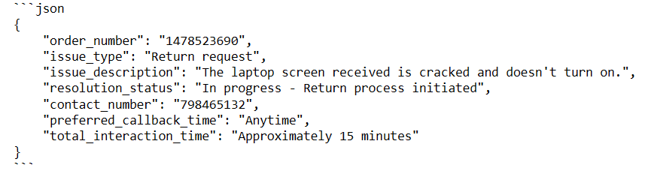
Fig. 12 Conversation – Log data details for auto resolved issue
Fig. 12 involves details like order number, issue type, issue description, resolution status, contact number, preferred callback time, total interaction time.
The conversations highlighted through Fig. 2 to Fig. 12 shows the dynamic response of the model with human type behaviour while interacting with the customers. The proposed model is found to successfully perform conversations in multiple languages, store the data and share to the customer care in JSON format when required.

5 Conclusions
Chatbots are revolutionizing customer service, information access by providing 24/7 instant information without the need of human interaction. This reduces associated costs and officials while handling a greater number of queries with efficient businesses. The chat platforms are widely employed across various sectors including customer service, healthcare, education, e-commerce, banking, and human resources, helping in areas ranging from appointment scheduling to product recommendations. Many existing chatbots are designed with customized prompts. The static behaviour observed in these bots lacks proper understanding of customer requirements which in turn often leads to misinterpretations. Such situations provide the customer with irrelevant and frustrating responses, which can reduce user satisfaction and trust. The paper aims to develop a ChatGPT based chatbot that can be customized for any e-commerce application. The proposed AidBot model includes back end and front-end. The front-end holds a user-friendly interface to accept input and responds. Meanwhile, the back end incorporates OpenAI API and storage to log the chat details in JSON format. The performance of the model is tested for different variations in the conversation. Referring to the customer comments available in an online product purchase platform, similar conversations are provided in multiple languages. The suggested model is observed to provide a human-like guidance even for the vague prompts. The model is found to connect with the customer care representatives associated with the product for further procedures. All the conversation details are successfully stored and sent if required to the customer care in JSON format. The proposed AidBot is seen to work better than the existing chatbots by providing dynamic responses based on the customer queries. Deploying Chat GPT and clever prompt engineering, the suggested AidBot that can be implemented for any company in cheap, provides a promising AI-powered support to e-commerce customer service.
References
- Savanur, Abhishek, M. Niranjanamurthy, M. P. Amulya, and P. Dayananda. “Application of Chatbot for consumer perspective using Artificial Intelligence”, International Conference on Communication and Electronics Systems (ICCES), pp. 1479-1483, IEEE (2021).
- LeelaM, Deepikashini V, Abitha ValliS, S Baghavathi Priya. “AI Based Crop Identification Using Machine Learning and E-Commerce of Crops”, 2nd International conference on Engineering Digital Green Era held at Rajalakshmi Engineering College, (2020).
- Vannala, Rachana, S. B. Swathi, and Yuvaraj Puranam. “AI Chatbot For Answering FAQ’s”, 2nd International Conference on Sustainable Energy and Future Electric Transportation (SeFeT), pp. 1-5. IEEE (2022).
- Manjusha R., “A Comparative Study of Identifying the Most Prompting Nodes in a Network Using Efficiency of Navigating Agents”, International Journal of Mechanical Engineering, Vol.7, No.1, (2022)
- Pehlivanoğlu, Meltem Kurt, Muhammad Abdan Syakura, and Nevcihan Duru. “Enhancing Paraphrasing in Chatbots Through Prompt Engineering: A Comparative Study on ChatGPT, Bing, and Bard”, 8th International Conference on Computer Science and Engineering (UBMK), pp. 432-437, IEEE (2023).
- Gamage, Gihan, Sachin Kahawala, Nishan Mills, Daswin De Silva, Milos Manic, Damminda Alahakoon, and Andrew Jennings. “Augmenting industrial chatbots in energy systems using chatgpt generative AI”, 32nd International Symposium on Industrial Electronics (ISIE), pp. 1-6, IEEE (2023).
- Makharia, Radhika, Youn Chan Kim, Su Bin Jo, Min Ah Kim, Aagam Jain, Piyush Agarwal, Anish Srivastava, Anant Vikram Agarwal, and Pankaj Agarwal. "AI Tutor Enhanced with Prompt Engineering and Deep Knowledge Tracing", International Conference on Interdisciplinary Approaches in Technology and Management for Social Innovation (IATMSI), vol. 2, pp. 1-6, IEEE (2024).
- Bhutada, Sunil, Saran Sri Dath Uppala, SriGeethika Nagavajyula, and Tarun Pottigari. "C 2-PILS: A Chatbot using Chat-GPT for Pharma Industry and Life Sciences", International Conference on Advanced Computing Technologies and Applications (ICACTA), pp. 1-6, IEEE (2023).
- Liu, Yilun, Shimin Tao, Weibin Meng, Feiyu Yao, Xiaofeng Zhao, and Hao Yang. "Logprompt: Prompt engineering towards zero-shot and interpretable log analysis", 46th International Conference on Software Engineering: Companion Proceedings, pp. 364-365, IEEE (2024).
- Rodriguez, Alberto D., Katherine R. Dearstyne, and Jane Cleland-Huang. "Prompts matter: Insights and strategies for prompt engineering in automated software traceability", 31st International Requirements Engineering Conference Workshops (REW), pp. 455-464, IEEE (2023).
- Sheehan, Ben, Hyun Seung Jin, and Udo Gottlieb. "Customer service chatbots: Anthropomorphism and adoption", Journal of Business Research, Vol. 115, pp. 14-24, (2020).
- Go, Eun, and S. Shyam Sundar. "Humanizing chatbots: The effects of visual, identity and conversational cues on humanness perceptions", Computers in human behavior, Volume 97, pp. 304-316, (2019).
- Sebastian, Glorin. "Do ChatGPT and other AI chatbots pose a cybersecurity risk?: An exploratory study", International Journal of Security and Privacy in Pervasive Computing (IJSPPC), Vol. 1, pp. 1-11, (2023).
- Hsu, Chin-Lung, and Judy Chuan-Chuan Lin. "Understanding the user satisfaction and loyalty of customer service chatbots", Journal of Retailing and Consumer Services, Vol. 71, pp. 103211, (2023).
- Verma, Manish. "Novel study on AI-based chatbot (ChatGPT) impacts on the traditional library management", International Journal of Trend in Scientific Research and Development (IJTSRD) 7, Vol. 1, pp. 961-964, (2023).
- Thapa, Astha, and Rajvardhan Patil. "ChatGPT based ChatBot Application", SoutheastCon 2024, pp. 157-164, IEEE (2024).
- Raman, R., Diwakar, S. & Nedungadi, P. "Early research trends on ChatGPT: a review based on Altmetrics and science mapping analysis", International Journal of Emerging Technologies in Learning (IJET), Vol. 18, pp. 13-31, (2023)
- Raghu Raman, Santanu Mandal, Payel Das, Tavleen Kaur, JP Sanjanasri, Prema Nedungadi. “University students as early adopters of ChatGPT: Innovation Diffusion Study”, (2023).

