**6Sense - Bazel Test**

**BUILD file**-

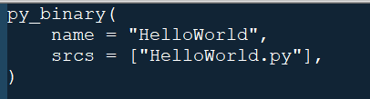

**Python File-**



**Package-**

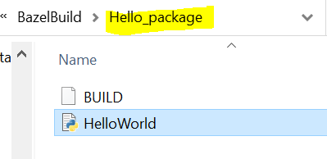

**Build Step**-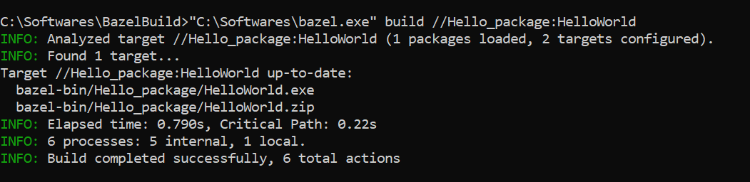

**Output**-

