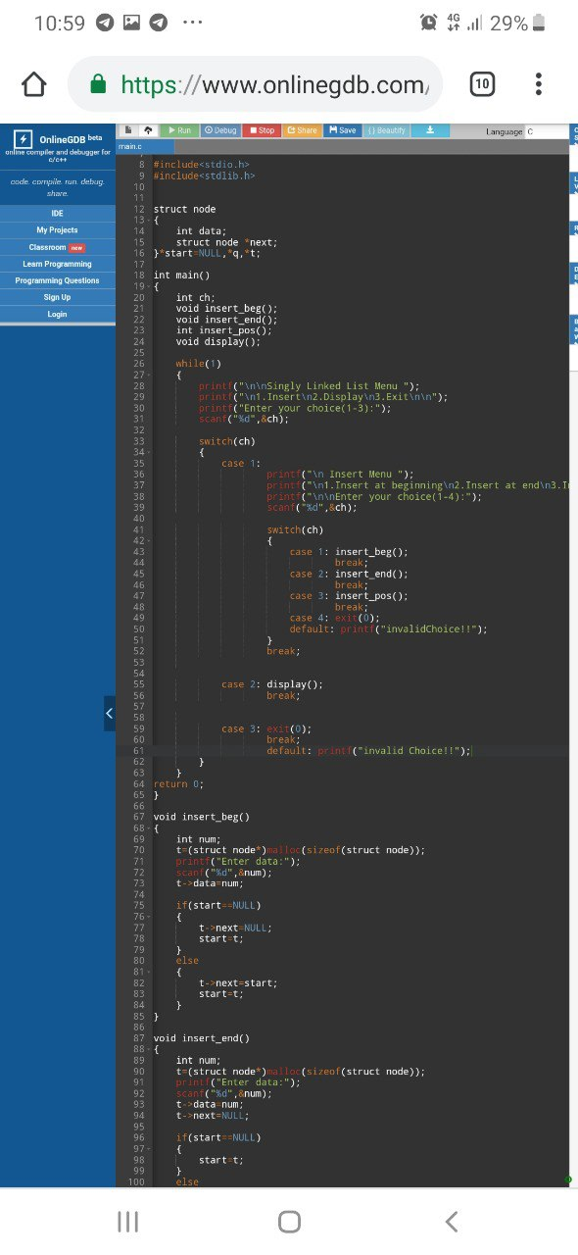

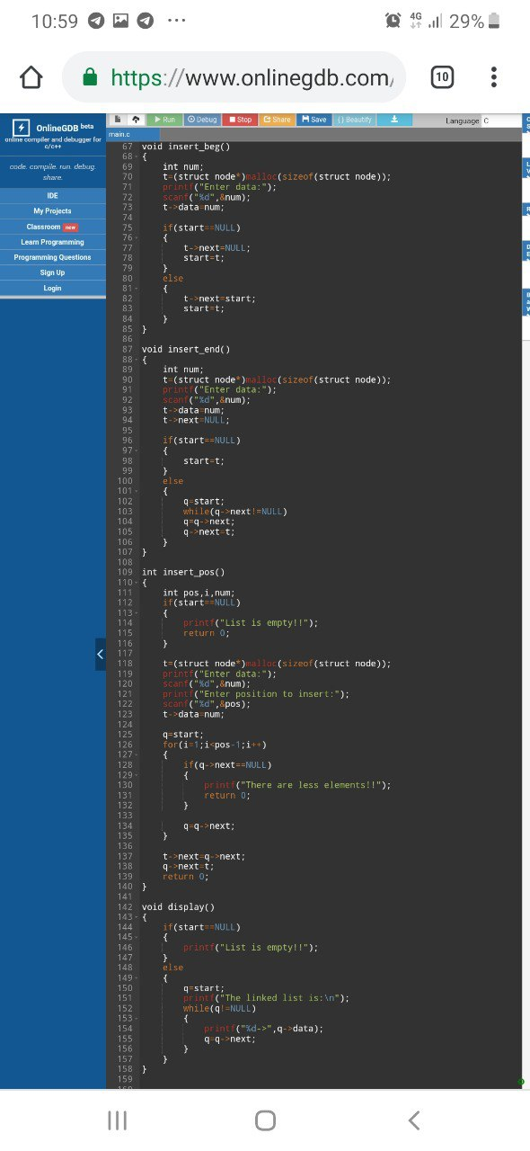

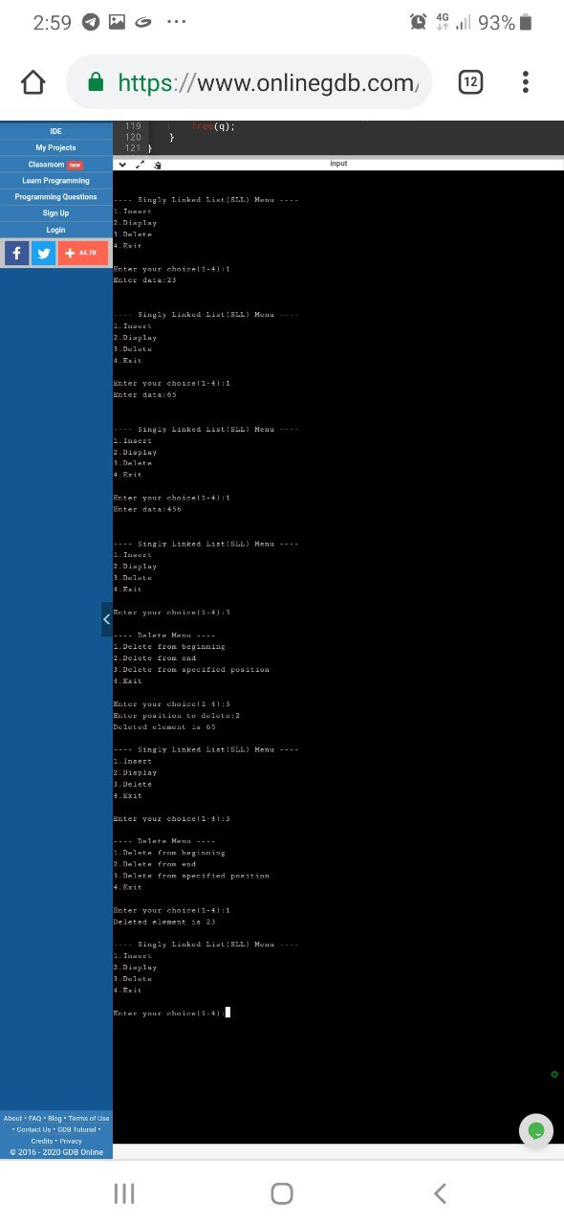

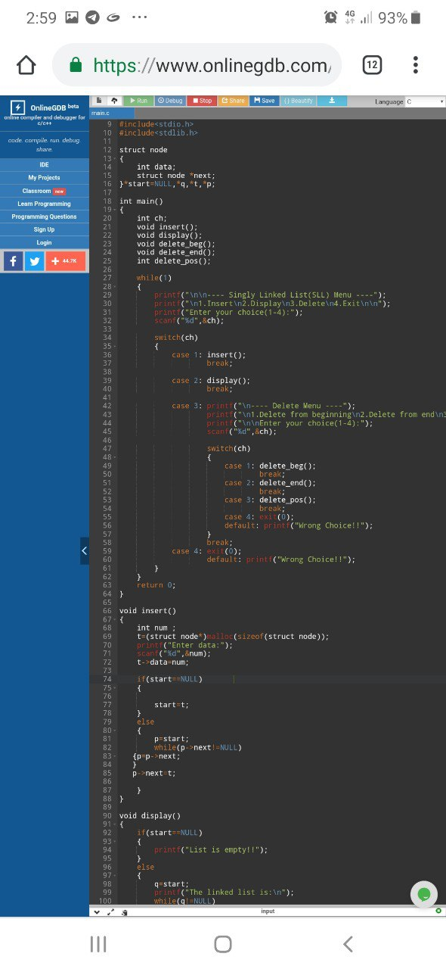

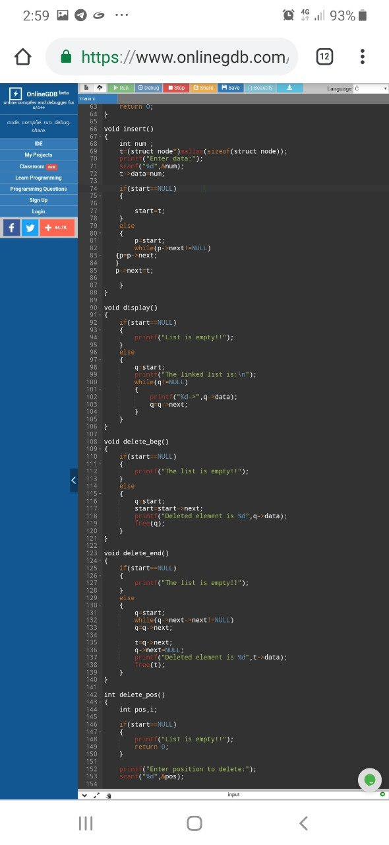

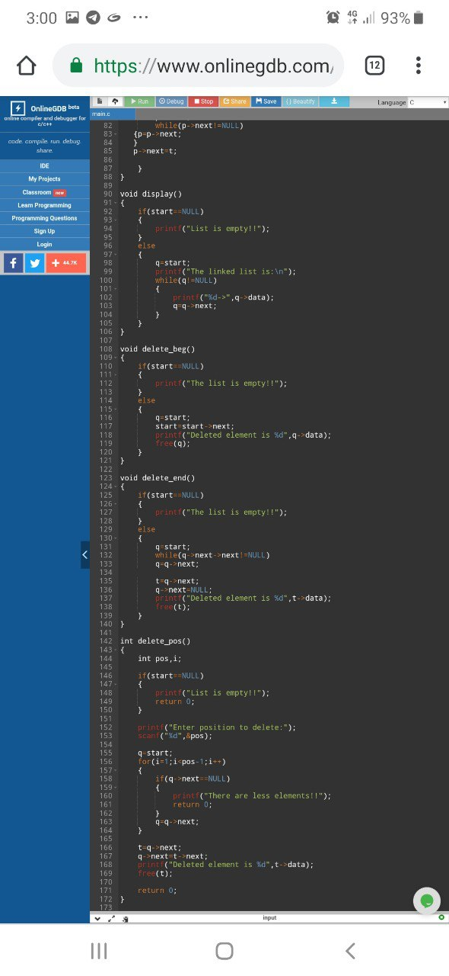

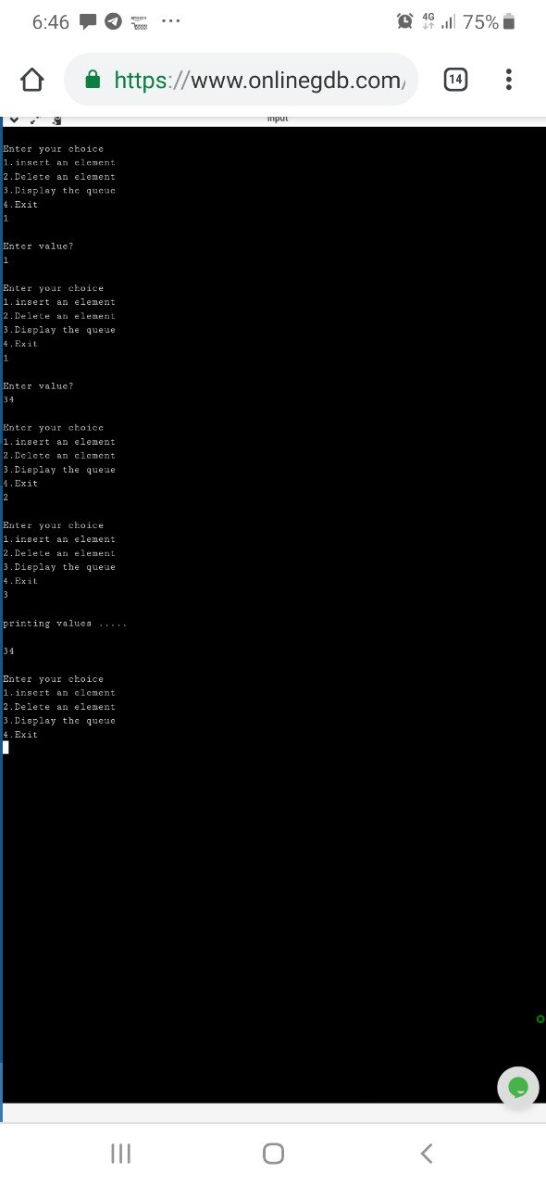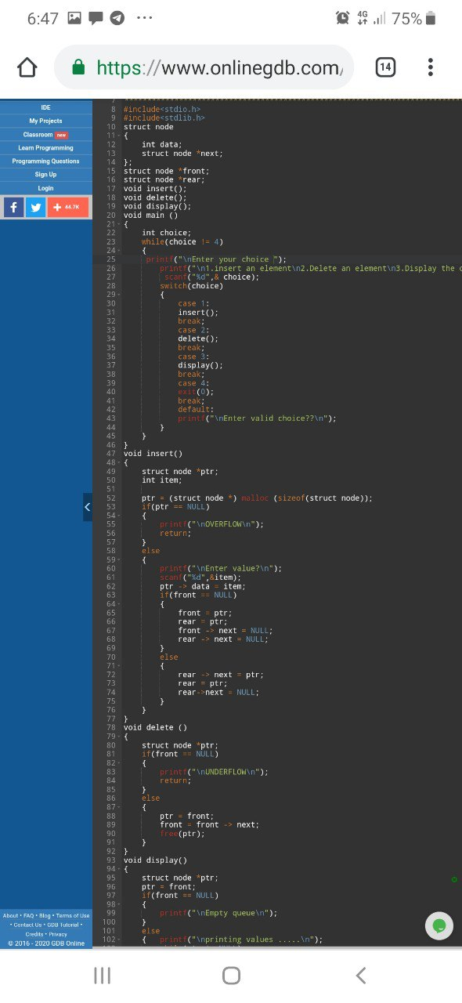

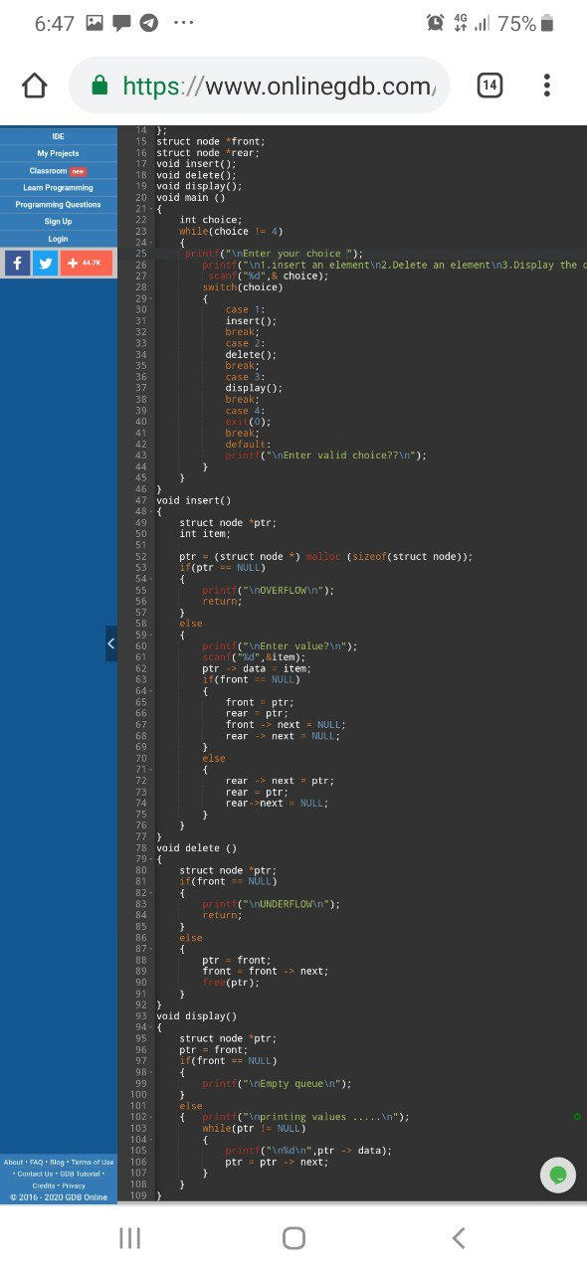

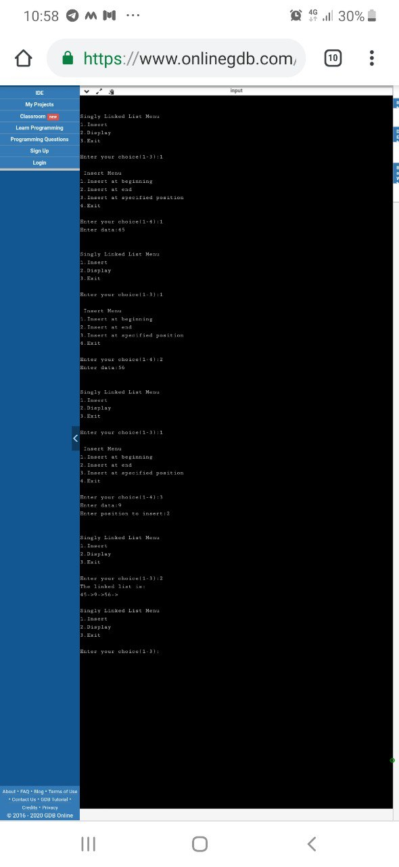

#include<stdio.h>

#include<stdlib.h>

void create();

void display();

struct node

{

int data;

struct node \*link;

};

struct node \*first;

void main()

{

int n,ch;

while(ch!=3)

{

printf("\n1.create\n2.Display\n3.Exit");

printf("\nEnter the choice:");

scanf("%d",&ch);

switch(ch)

{

case 1:{

create();

break;

}

case 2:{

display();

break;

}

case 3:{

printf("\nExit");

break;

}

default:printf("\nExit");

}

};

return;

}

void create(int n)

{

struct node \*temp,\*ptr;

int i;

for(i=0;i<n;i++)

{

temp=(struct node \*)malloc(sizeof(struct node));

if(temp==NULL)

{

printf("list is full\n");

exit(0);

}

printf("Enter the element to insert:");

scanf("%d",&temp->data);

temp->link=NULL;

if(first==NULL)

{

first=temp;

}

else

{

ptr=first;

while(ptr->link!=NULL)

{

ptr=ptr->link;

}

ptr->link=temp;

}

}

}

void display()

{

struct node \*ptr;

if(first==NULL)

{

printf("\nlist is empty");

}

else

{

ptr=first;

while(ptr!=NULL)

{

printf("%d\t",ptr->data );

ptr=ptr->link ;

}

}

}

