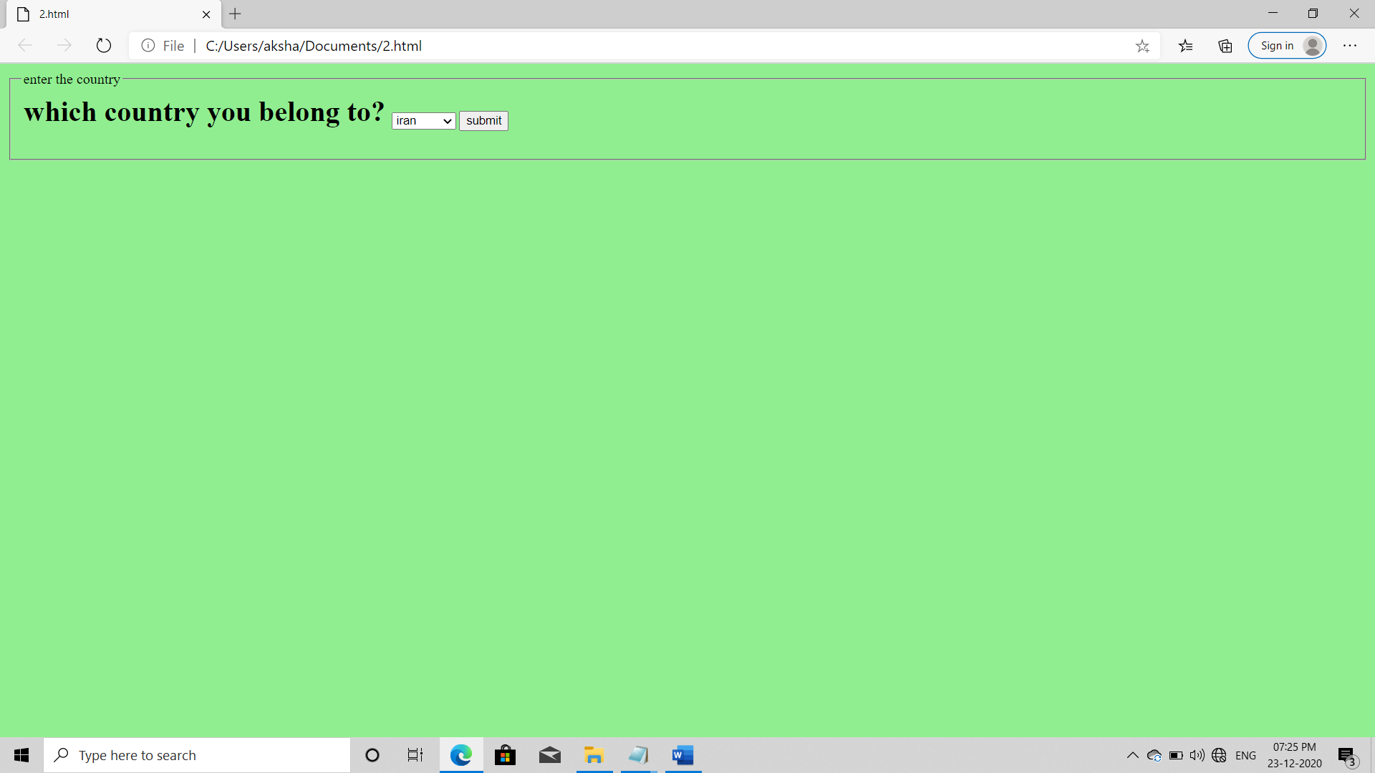

<html>

<body bgcolor="lightgreen">

<form action="" method="post"><fieldset>

<table>

<legend>enter the country</legend>

<td><h1>which country you belong to?</h1><td>

<td><select id="country" name="india">

<option value="iran">iran</option>

<option value="britan">britan</option>

<option value="england">england</option>

<option value="usa">usa</option>

</select></td>

<td><input type="submit" value="submit"></td>

</table>

</fieldset>

</form>

</body>

</html>