**INDIAN INSTITUTE OF INFORMATION TECHNOLOGY, DHARWAD**

**COURSE: DATABASE MANAGEMENT SYSTEM**

Course Code: CS502

**REPORT**

**TOPIC: SQL QUERY OPTIMISATION, IMPORTANCE, TECHNIQUES, TOOLS**

**Prepared By: AKSHAY JAIN Under The Guidance Of:**

**Registration Number: 17BCS002 Dr. UMA Seshadri**

**CONTENTS**

1. INTRODUCTION ……………………………………………………………………………….. 3
2. SCOPE ………………………………………………………………………………………………. 3
3. QUERY OPTIMISER AS A SEARCH PROBLEM ……………………………………… 3
4. IMPORTANCE OF QUERY OPTIMISER ……………………………………………….. 3
5. BASIC TECHNIQUES USED FOR QUERY OPTIMISATION …………………….. 4
6. SOME OF THE AVAILABLE TOOLS ……………………………………………………… 6
7. REFERENCES …………………………………………………………………………………….. 7

**INTRODUCTION**

Query optimization has always been an important badge for application developers and database administrators (DBAs). In order to improve the performance of SQL queries, developers and DBAs need to understand the query optimizer and the techniques it uses to select an access path and prepare a query execution plan. Query improvising involves knowledge of some of Artificial Intelligence - based techniques such as cost-calculation and heuristic-usage optimizers, plus the tools available on SQL platform provides for explaining and executing a query execution plan. The best way to optimise performance is to try to write your queries in a number of different ways and compare their reads and execution plans.

**SCOPE**

This report basically defines the importance of basic SQL Query Optimisation Techniques which can be incorporated in daily query making by the application developer and data administrator. These techniques do not require any use of algorithms or models. It is independent and moreover focuses on query writing guidelines for optimization.

**QUERY OPTIMISER AS A SEARCH PROBLEM**

Query optimization can be regarded as a difficult search problem like in Artificial Intelligence domain. In order to resolve this issue, we need to formulate:

* A space of plans (search space).
* A cost estimation technique so that a cost or path may be designated to each plan in the search space. Intuitively, this is a prediction of the resources usage for the execution of the plan.
* An enumeration algorithm is required that can perform the searching through the execution space.

**IMPORTANCE OF QUERY OPTIMISER**

The task to be accomplished by a query optimization is to reduce the system resources i.e. enhance the usage of CPU and I/O resources, required to fulfil a query, and ultimately provide the end-user with the correct result or view set faster.

* Firstly, it provides the user with quicker results, which makes the application seem quicker to the end-user.
* Secondly, it grants the system to service more queries in the same duration of time, because each optimised request takes less time than unoptimized queries.
* Thirdly, query optimization ultimately deducts the amount of wear on the hardware (e.g. disk drives), and allows the server or the storage space to run more efficiently (e.g. lower power consumption, less memory usage).

**BASIC TECHNIQUES USED FOR QUERY OPTIMISATION**

Each technique was tested by executing by both the unoptimised query and optimised query while retrieving information from the sample database especially on Sales Schema represented as below:

* **sales** {prod_id, cust_id, quantity_sold, time_id}
* **customers** {cust_id, cust_marital_status, country_id}
* **products** {prod_id, prod_min_price, prod_list_price}
* **countries** {country_id, country_name}
* **costs** {prod_id, unit_price}

**Following are the ten techniques:**

1. Use Column Names Instead of * in a SELECT statement

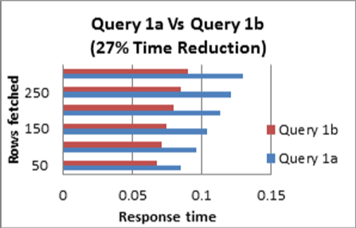 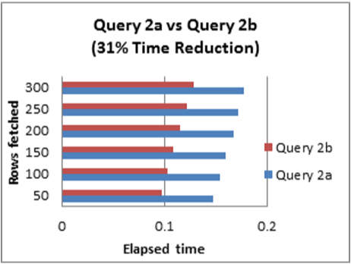

1. Avoid including a HAVING clause in SELECT statements
2. Eliminate unnecessary DISTINCT conditions

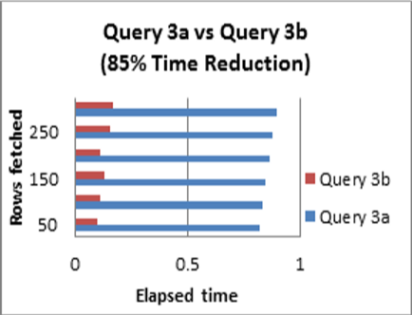 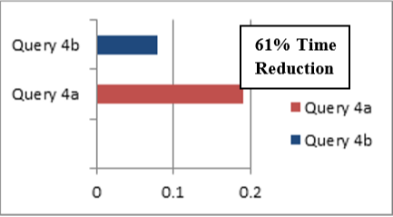

1. Un-nest sub queries
2. Consider using an IN predicate when querying an indexed column

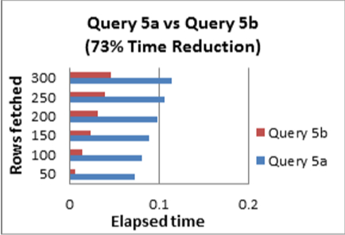 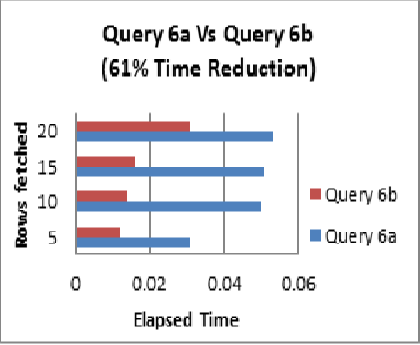

1. Use EXISTS instead of DISTINCT when using table joins that involves tables having one-to-many relationships
2. Try to use UNION ALL in place of UNION

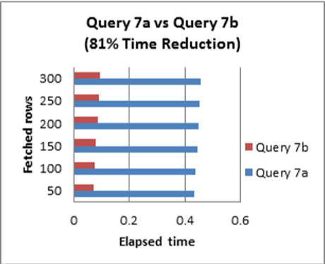 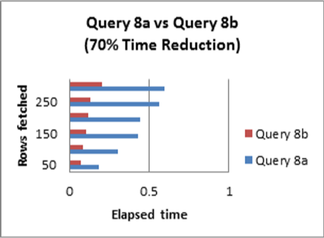

1. Avoid using OR in join conditions
2. Avoid functions on the right hand side of the operator

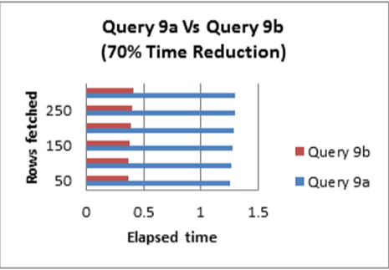 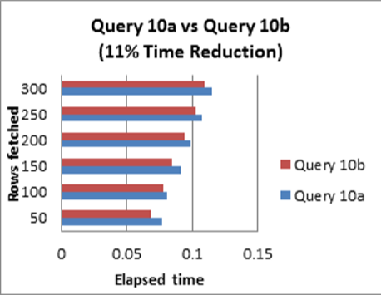

1. Remove any redundant mathematics

**SOME OF THE AVAILABLE TOOLS**

* SolarWinds Database Performance Analyser
* SQL Server Management Studio(Microsoft SQL Sever)
* EverSQL (online tool)

**REFERENCES**

* An overview of Query optimization in Relational Systems (Research Paper by Surajit Chaudhuri)
* Query optimization techniques – Tips for writing efficient and faster SQL Queries (Research Paper by Jean HABIMANA)
* Query Optimization (Research Paper by Yannis E. Ionnidis)
* geeksforgeeks.com/dbms/queryoptimiser
* adictivetips.com/net-admin/sql-query-tools