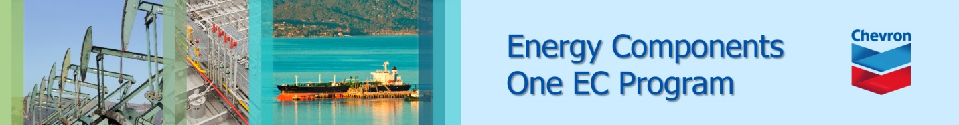

EC Upgrade BKK Use Case

Project Name
BKK Project Energy Components

Use-Case Name
EC_11_2_BKK_UC01_Production Well Status
Origination Date
7-Oct-2017

Revision History

Revision | Date | Description | Prepared  by | Checked  by | Approved by
1.0 | 7-Oct-2017 | Draft of Use Case “Production Well Status” | Wirask C.
1.1 | 9-Nov-2017 | Review and provide feedback | Jennifer Lopez
1.2 | 26-Nov-2017 | Revised this Use Case from ITC comments | Wirasak C.
1.3 | 27-Mar-2018 | Upgraded as per EC11.2 | Tieto
2 | 2nd-July-2020 | Update for Thailand ECaaS Project, added Future Utility? | Wirasak C.

Table of Contents

1. Use Case Information 3
2. Primary Flow: EC_11_2_BKK_UC01_Production Well Status 3
3. Alternatives 6
3.1 Alternate Flow A1: Modify well status data 6
3.2 Alternate Flow A2: Delete well status data 8
4. Exceptions 10
4.1 List of Common Issues/Errors 10

Use Case Information

Use Case Number and Name | EC_11_2_BKK_UC01_Production Well Status
Brief Description | This BF is used to register well status data for wells of class P (Producer), PI (Producer and Injector) or O (Other).
Related Use Cases | - Production Well Daily Data 1  - Maintain Well  - EC Codes
EC Business Functions | - BF – MAINTAIN PRODUCTION WELL STATUS (WR.0004)
EC Roles  (list of EC Roles that should be able to execute Use Case) | - Roles can be able to execute this use case are as follows:  - Erawan Administrator, Erawan Prod.Operator
Prerequisites | - Well is created  - EC Codes is set
Approver

Note: The toolbar on EC11.2 has changed. Refer to the image below for different buttons

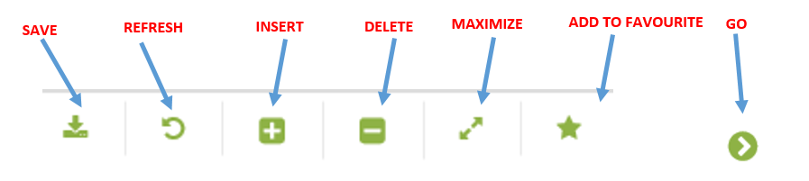

Primary Flow: EC_11_2_BKK_UC01_Production Well Status
Trigger: User insert a new well status data
Step | Actor Action | System Response | Notes
 | Open up Production Well Status screen  EC Production Well Data Production Well Status | The following fields are automatically populated:  - Date is yesterday’s date  - Production Unit  - Production Sub Unit  - Area | Note: Fields are populated according to the navigation role defined for each user
 | Click on the calendar icon in date navigator section and change the date | Date is changed
 | Navigate to the Production Well Status screen using the drop down menus and click Go…  Operation Hierarchy  - Production Unit  - Production Sub Unit  - Area  - Sub Area  - Facility Class 2  - Facility Class 1  - Well (optional) | If there are any records for the well for that date, they will be listed in the Data Window and the section “Last Registered Status” will show the last status of that well  If there were no records for that date, there will be a message “no records found…” and the section “Last Registered Status” will show the last status of that well | Note: The hierarchy information may be pre-populated and user just needs to hit Go…
 | Mouse over to Insert icon in the Tool Bar and click on Well Status | A new data entry form is created in the Data Window. | If a well was not selected in the drop down menu, the user must select a well from the Well Name dropdown before proceeding.
 | Enter data in the empty data fields  - What are the data fields?  - Which are mandatory or optional?  See in your sample data in  Operation Hierarchy  - Production Unit  - Production Sub Unit  - Area  - Sub Area  - Facility Class 2  - Facility Class 1  - Well(optional)  Enter any well of your assets that you want to test.  Well Name, Well Status are mandatory fields.  Comments field is an optional field.  Future Utility? When status is Shut-in, then the dropdown list will populate {Future Utility, No Future Utility, *TBD-Future Utility}  Click the Save icon  Verify that data is saved and displayed correctly | Data was saved and displayed as expected  Active Well Status will change to:  - Active – Open  - Shut-in – Closed  - Drilling – Closed LT | Well Name, Well Status are mandatory fields  Comments field is an optional field  00:00 is time standard.  Status available for the users:  - Drilling  - Active  - Shut-in  In Last Registered Status  Active well status :  - Closed LT  - Open  Closed  * Please note that the modue that linked with “Future Utility” should work the same.
 | END OF USE CASE

Alternatives

Alternate Flow A1: Modify well status data
Details: Once setting a well status data, it may be necessary to update existing records if the record was entered incorrectly.

Step | Actor Action | System Response | Notes
 | Open up Production Well Status screen  EC Production Well Data Production Well Status | The following fields are automatically populated:  - Date is yesterday’s date  - Production Unit  - Production Sub Unit  - Area | Note: Fields are populated according to the navigation role defined for each user
 | Navigate to the Production Well Status screen using the drop down menus and click Go…  - Production Unit  - Production Sub Unit  - Area  - Sub Area  - Facility Class 2  - Facility Class1  - Well (optional) | If there are any records for the well for that date, they will be listed in the Data Window and the section “Last Registered Status” will show the last status of that well  If there were no records for that date, there will be a message “no records found…” and the section “Last Registered Status” will show the last status of that well | Note: The hierarchy information may be pre-populated and user just needs to hit Go…  If a well was not selected in the hierarchy, user must select a well from the Well Name dropdown before proceeding.
 | Change the Date in the Navigator Pane to include the date that the well was created in EC (or date of the well status change) | Date and time is populated | If a well was not selected in the hierarchy, user must select a well from the Well Name dropdown before proceeding.
 | Select the record that needs to be updated | Row is highlighted light blue
 | Edit and modify the data and click the Save icon  Verify that data is saved and displayed correctly  Well Name, Well Status are mandatory fields  Comments field is an optional field  00:00 is time standard. | Data was saved and displayed as expected.  Status available for the users:  - Drilling  - Active  - Shut-in  In Last Registered Status  Active well status :  - Closed LT  - Open  - Closed
 | END OF USE CASE

Alternate Flow A2: Delete well status data
Details: If a Well Status is entered for the wrong well or the wrong date, the user can delete the record

Step | Actor Action | System Response | Notes
 | Open up Production Well Status screen  EC Production Well Data Production Well Status | The following fields are automatically populated:  - Date is yesterday’s date  - Production Unit  - Production Sub Unit  - Area | Note: Fields are populated according to the navigation role defined for each user
 | Navigate to the Production Well Status screen using the drop down menus and click Go…  - Production Unit  - Production Sub Unit  - Area  - Sub Area  - Facility Class 2  - Facility Class 1  - Well (optional) | If there are any records for the well for that date, they will be listed in the Data Window and the section “Last Registered Status” will show the last status of that well  If there were no records for that date, there will be a message “no records found…” and the section “Last Registered Status” will show the last status of that well | Note: The hierarchy information may be pre-populated and user just needs to hit Go…  If a well was not selected in the hierarchy, user must select a well from the Well Name dropdown before proceeding.
 | Change the Date in the Navigator Pane to include the date that the well was created in EC (or date of the well status change)  Well Name, Well Status are mandatory fields  Comments field is an optional field  00:00 is time standard. | Date and time is populated.  Status available for the users:  - Drilling  - Active  - Shut-in  In Last Registered Status  Active well status :  - Closed LT  - Open  Closed
 | Select the record that needs to be updated | Row is highlighted light blue
 | Click the Delete icon in the Tool Bar and click the Save icon | Record was deleted

Exceptions

List of Common Issues/Errors

 | Error | Error Message

Additional Clarifying Information

Additional Variations

Business Rules:
Business Rule | Data Elements | Description
BR.1 | NA | User should only be able to see Hierarchy information for his/her own area.
BR.2 | Daytime | The start date cannot be greater than the current calendar date.  Date format is yyyy-mm-dd hh:mm
BR.3 | Daytime [hh:mm] | Time : 00:00

Data Impacts

Business Entry Screen | Description | Valid Values
Production Well Status - History
Daytime | Mandatory | yyyy-mm-dd hh:mm
Well Name | Mandatory | Drop-down
Well Status | Mandatory | Drop-down

