

EC Upgrade BKK Use Case

Project Name
BKK 11.2 Project Energy Components

Use-Case Name
BKK_UC11.2 – Enter Daily Water Stream Data
Origination Date
28-Nov-2017

Revision History

Revision | Date | Description | Prepared  by | Checked  by | Approved by
0.1 | 28-Nov-2017 | Draft | Wirasak C.
1.0 | 27-Mar-2018 | Updated as per EC 11.0 | Tieto
2 | 2-july-2020 | Thailand ECsasS | Wirasak C.

Table of Contents

1. Use Case Information 3
2. Primary Flow: BKK_UC11.2 – Enter Daily Water Stream Data 3
3. Alternatives 6
3.1 Alternate Flow A1: To correct or update the attributes of an existing Entry 6

4. Exceptions 7
4.1 List of Common Issues/Errors 7

Use Case Information

Use Case Number and Name | BKK_UC11 – Enter Daily Water Stream Data
Brief Description | This BF is used when daily water stream data is available. Data can be entered manually or loaded automatically. The BF requires one entry per stream per day, and Energy Components automatically creates new records for a new production day for all water streams that are part of a stream set for this screen..
Related Use Cases | None
EC Business Functions | - PO.0003-Water Stream Daily Status
EC Roles  (list EC Roles that should be able to execute Use Case) | - Roles can be able to execute this use case are as follows:  - Erawan Administrator, Erawan Prod.Operator
Prerequisites | Water Stream data has been instantiated
Approver

Note: The toolbar on EC11.2 has changed. Refer to the image below for different buttons

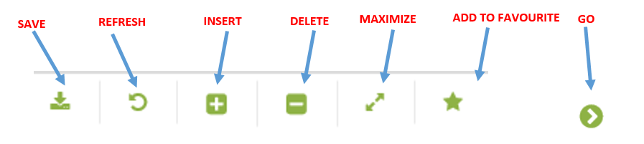

Primary Flow: BKK_UC11.2 – Enter Daily Water Stream Data
Trigger: End of Day Gas stream volumes available from metering system
Step | Actor Action | System Response | Notes
 | Open up Water Stream Daily Data Screen  EC Production Production Operations Data Water Stream Daily Data | The following fields are automatically populated:  Date is yesterday’s date  - Note: The hierarchy fields may be pre-populated for the user
 | - In the Navigator, set the Date | Date is populated
 | Navigate to the Facility for which gas stream daily data is to be recorded using the drop down menus and click Go…  Operation Hierarchy  • Production Unit  • Production Sub Unit  • Area  • Sub Area  • Facility Class 2 | Any existing instantiated measured gas streams will be displayed in the ‘Measured Figures’ data window.  Columns shown as follows:  •Stream Name  • Grs Vol[bbl]  Grs Mass[lb]  • TPH Morning[ppm]  Suspended Solids[PPM]  • Evening[ppm]  • Hg[ppb]  • As[ppb]  • Comments  Any derived gas streams will be displayed in the ‘Derived and Calculated Figures’ data window.  If no streams found that meet the chosen criteria, the following message is displayed in both the data sections: “no records found…”  Columns shown as follows:  • Stream Name  • Grs Vol[bbl]  • Allocated Vol[bbl]  Factor | Strm Category is auto-populated for the streams in ‘Measured Figures’ data window
 | Select the record for which data has to be modified | Record is highlighted | Note: Insert icon is disabled. Records are auto generated using instantiation process
 | Enter Standard volume in Grs Vol [bbl] field for each stream | Grs volume is displayed | Depending on the configuration, the data for all these attributes can be populated using ECIS.
 | Click the Save icon | Entry is saved  The following fields are automatically populated:  - Grs Vol [bbl], | Repeat steps 4-6 for other streams in ‘Measured Figures’ data window.  Once the data is entered for all the measured streams, the data for derived streams, if any, may be auto-populated at this stage.
 | End of Use case

Alternatives

Alternate Flow A1: To correct or update the attributes of an existing Entry

Updates required for stream values due to poor data transfer from source system or mismeasurement
Step | Actor Action | System Response | Ref
 | Open up Water Stream Daily Data Screen  EC Production Production Operations Data Water Stream Daily Data | The following fields are automatically populated:  Date is yesterday’s date  Note: The hierarchy fields may be pre-populated for the user
 | In the Navigator, set the Date | Date is populated
 | Navigate to the Facility for which gas stream daily data is to be recorded using the drop down menus and click Go… | Any existing instantiated measured gas streams will be displayed in the ‘Measured Figures’ data window.  Columns shown as follows:  •Stream Name  • Grs Vol[bbl]  Grs Mass[lb]  • TPH Morning[ppm]  Suspended Solids[PPM]  • Evening[ppm]  • Hg[ppb]  • As[ppb]  • Comments  Any derived gas streams will be displayed in the ‘Derived and Calculated Figures’ data window.  If no streams found that meet the chosen criteria, the following message is displayed in both the data sections: “no records found…”  Columns shown as follows:  • Stream Name  • Grs Vol[bbl]  • Allocated Vol[bbl]  Factor | Strm Category is auto-populated for the streams in ‘Measured Figures’ data window
 | Select the record for which data has to be modified | Record is highlighted | Note: Insert icon is disabled. Records are auto generated using instantiation process
 | Update Standard volume in Grs Vol [bbl] field for each stream | Grs volume is displayed | Depending on the configuration, the data for all these attributes can be populated using ECIS.
 | Click the Save icon | Entry is saved  The following fields are automatically populated:  Grs Vol [bbl] | Repeat steps 4-6 for other streams in ‘Measured Figures’ data window.  Once the data is entered for all the measured streams, the data for derived streams, if any, may be auto-populated at this stage.
 | END OF USE CASE

Exceptions

List of Common Issues/Errors
Not aware of any
 | Error | Error Message

