

EC Upgrade BKK Use Case

Project Name
BKK 11.2 Project Energy Components

Use-Case Name
BKK_UC13 – Enter Operational Comments
Origination Date
28-Nov-2017

Revision History

Revision | Date | Description | Prepared  by | Checked  by | Approved by
0.1 | 28-Nov-2017 | Draft | Wirasak C.
1.0 | 27-Mar-2018 | Updated as per EC 11.2 | Tieto
2 | 2-july-2020 | Thailand ECsasS | Wirasak C.

Table of Contents

1. Use Case Information 3
2. Primary Flow: BKK_UC13 – Enter Operational Comments 3
3. Alternatives 6
3.1 Alternate Flow A1: Alternate Flow A1: Operational Comments – Validate Copy Forward Function 6
4. Exceptions 7
4.1 List of Common Issues/Errors 7

Use Case Information

Use Case Number and Name | BKK_UC13 – Enter Operational Comments
Brief Description | Manual entry of Asset operational comments.
Related Use Cases
EC Business Functions | - Operational comments
EC Roles  (list EC Roles that should be able to execute Use Case) | - Roles can be able to execute this use case are as follows:  - Erawan Administrator, Erawan Prod.Operator
Prerequisites
Approver

Note: The toolbar on EC11.2 has changed. Refer to the image below for different buttons

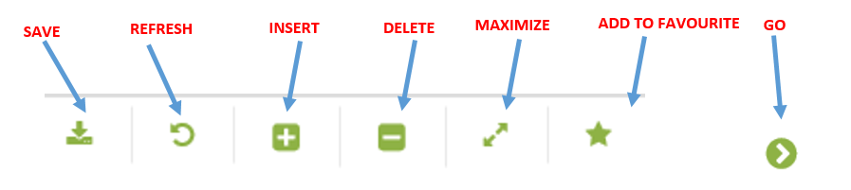

Primary Flow: BKK_UC13 – Enter Operational Comments
Trigger: ECIS has pre-populated the data and user has to check if the data is correct.

Step | Actor Action | System Response | Notes
 | Open up Operational Comments Screen  EC Production Production Operations Data Operational Comments | The following fields are automatically populated:  - Date is default populated to yesterday
 | Change Date to the date of the comments being entered | Date is displayed in entry field
 | Navigate to where the comments should be assigned using the drop down menus and click Go:  Production Unit  Production Sub Unit  Area  Sub Area  Facility Class 2  Facility Class 1(Optional)  Comment Type (Optional) | Previous comments for the date chosen will be shown in the Navigator in the Data Window (if applicable). Comment type normally set to “General”.  Columns shown as follows:  • Time [hh:mm]  • Sub CPP (Dropdown List)  • Comment Type (Dropdown list)  • Copy Forward  • Comments (Text Box-Dropdown)  • Comments 2(Text Box-Dropdown) | Note: Use the Comment Type in the hierarchy if the user would like to filter by “Daily Production Report”, “Daily Mail”or “Weekly Production Report”
 | Click the Insert icon in the Tool Bar | New record entry fields are displayed on screen. Time is defaulted to 00:00  Displays fields:  • Time [hh:mm]  • Sub CPP (Dropdown List)  • Comment Type (Dropdown list)  Type  Name  • Copy Forward  • Comments (Text Box-Dropdown)  • Comments 2(Text Box-Dropdown)  EC populates the Sub CPP dropdown list of each hierarchy automatically by SUB_CPP EC codes
 | Change Time if necessary | Time is displayed in entry field (hh:mm)
 | Select Sub Cpp “ERCPP” | Sub CPP dropdown options include:  • ERLQ1  • ERLQ2  • ERCPP  • ERCP  • ERMRP
 | Select Comment Type “General” (Mandatory) | EC populates the Comment Type dropdown list automatically by COMMENT_TYPE EC codes.  Comment type is displayed in entry field.  Dropdown options include:  Unassigned Deferment  General  BC  WUU  MPP  Gas Lift Platform
 |  |  | Report box is not found on screen.
 | If you want to Copy Forward comment, click to check box | Copy forward box is checked
 | Enter Comments, use drop-down to display a larger area to write notes in, then click Ok | Comments are displayed in entry field
 | Click the Save icon | Entry is saved | Ensure that once comments are saved they can be modified after the fact
 | END OF USE CASE

Alternatives

Alternate Flow A1: Alternate Flow A1: Operational Comments – Validate Copy Forward Function
Details: Previous case must be run with the copy forward check box checked the day before you run this test (This test relies in instantiation of the record that was flagged to Copy Forward and this runs overnight. )

Step | Actor Action | System Response | Ref
 | Open up Operational Comments Screen  EC Production Production Operations Data Operational Comments | The following fields are automatically populated:  Date is default populated to yesterday
 | Date: Search Production Date One day greater than the Original Record date that had the copy forward checked | Date is changed successfully. | Note: The hierarchy information may be pre-populated and user just needs to hit Go…
 | - Navigate to where the comments should be assigned using the drop down menus and Click Go:  Operation Hierarchy  • Production Unit  • Production Sub Unit  • Area  • Sub Area  • Facility Class 2  • Comment Type (Optional) | Previous comments for the date chosen will be shown in the Navigator in the Data Window (if applicable).
 | Verify that the copy forward process worked | Comment should exist for one day greater than primary use case above. Copy forward comments are displayed.
 | Go back to original record date to validate copy forward checkbox is unchecked. |  | instantiation process automatically unchecks this
 | END OF USE CASE

Exceptions

List of Common Issues/Errors
Not aware of any
 | Error | Error Message

