

EC Upgrade BKK Use Case

Project Name
BKK 11.2 Project Energy Components

Use-Case Name
BKK_UC17 – Run Daily Allocation
Origination Date
28-Nov-2017

Revision History

Revision | Date | Description | Prepared  by | Checked  by | Approved by
0.1 | 28-Nov-2017 | Draft | Wirasak C.
1.0 | 27-Mar-2018 | Updated as per EC 11.2 | Tieto
2 | 2-july-2020 | Thailand ECsasS | Wirasak C.

Table of Contents

1. Use Case Information 3
2. Primary Flow: BKK_UC17 – Run Daily Allocation 3
2.1 Trigger: Run Daily allocation process 3
3. Alternatives 5
3.1 Alternate Flow A1: None 5
4. Exceptions 5
4.1 List of Common Issues/Errors 5

Use Case Information

Use Case Number and Name | BKK_UC17 – Run Daily Allocation
Brief Description | This screen is used to run status process for data records in EC.
Related Use Cases | - N/A
EC Business Functions | HA.0001 – Daily Allocation
EC Roles  (list EC Roles that should be able to execute Use Case) | - Roles can be able to execute this use case are as follows:  - Erawan Administrator, Erawan Prod.Operator
Prerequisites
Approver

Note: the toolbar on EC11.2 has changed. Refer to the image below for different buttons

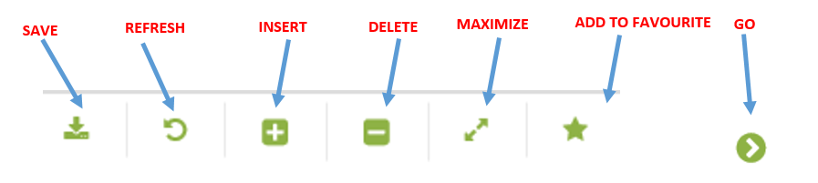

Primary Flow: BKK_UC17 – Run Daily Allocation

Trigger: Run Daily allocation process
.

Step | Actor Action | System Response | Notes
 | Open up Daily Allocation screen  EC Production Allocation Daily Allocation | The following fields are automatically populated:  - To Date is Yesterday’s date  - The hierarchy fields may be pre-populated for the user
 | Select From Date (if required) to run the allocation | From date is displayed in entry field
 | Select To Date to include the end date of the allocation event | To date is displayed in entry field
 | Navigate to the network using the drop down menus and click Go…  - Allocation Network  - Calculation Job | If the allocation process hasn’t been run for selected dates the following message is displayed: “no records found…”
 | Click Run calculation | The following data are displayed:  - Run Date  - Run By  - Allocation Date  - Duration  - Calculation job  - Log level  - Exit Status  - Comment  - Approval Status | To get result of the calculation the user needs to hit Go…
 | Confirm the job status is Success
 | Enter any notes about the job in Comments | Notes are displayed | Enter any notes about the event in Comments
 | Click the Save icon in the Tool Bar | The record is saved. | Click the Save icon in the Tool Bar
 | END OF USE CASE

Alternatives

Alternate Flow A1: None
Details:
Step | Actor Action | System Response | Ref
 | END OF USE CASE

Exceptions

List of Common Issues/Errors
Not aware of any
 | Error | Error Message

