

EC Upgrade BKK Use Case

Project Name
BKK 11.2 Project Energy Components

Use-Case Name
BKK_UC17 – Run Verify Data
Origination Date
28-Nov-2017

Revision History

Revision | Date | Description | Prepared  by | Checked  by | Approved by
0.1 | 28-Nov-2017 | Draft | Wirasak C.
1.0 | 27-Mar-2018 | Updated as per EC 11.2 | Tieto
2 | 2-July-2020 | Thailand ECsasS | Wirasak C.

Table of Contents

1. Use Case Information 3
2.1 Trigger: Well Downtime Event 3

3. Alternatives 5
3.1 Alternate Flow A1: None 5
4. Exceptions 5
4.1 List of Common Issues/Errors 5

Use Case Information

Use Case Number and Name | BKK_UC17 – Run Verify Data
Brief Description | This screen is used to run status process for data records in EC.
Related Use Cases
EC Business Functions | - HA.0001 – Daily Verify Data
EC Roles  (list EC Roles that should be able to execute Use Case) | - Roles can be able to execute this use case are as follows:  - Erawan Administrator, Erawan Prod.Operator
Prerequisites
Approver

Note: the toolbar on EC11.2 has changed. Refer to the image below for different buttons

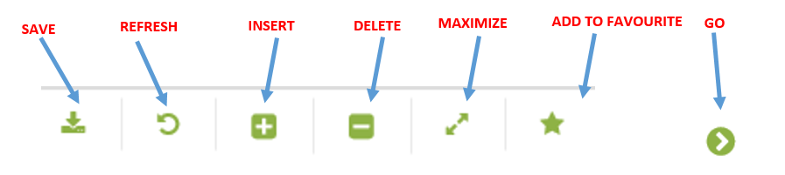

- Primary Flow: BKK_UC17 – Run Verify Data

Trigger: Run Daily allocation process
.

Step | Actor Action | System Response | Notes
 | Open up Daily Verify Data screen  EC Production Allocation Daily Verify Data | The following fields are automatically populated:  - From Date is Yesterday’s date  - To Date is Yesterday’s date  - The hierarchy fields may be pre-populated for the user
 | Select From Date (if required) to run the allocation | From date is displayed in entry field
 | Select To Date to include the end date of the allocation event | To date is displayed in entry field
 | Navigate to the network using the Process drop down menus and click Go… | If the status process hasn’t been run for selected dates the following message is displayed: “no records found…” | Process dropdown options are:  - Verify Platong Data  - Verify Satun Data  - Verify Benchamas Data  - Approve Benchamas Data
 | Click Run Process | The following data are displayed:  - Run Date  - Run By  - Process From Date  - Process To Date  - Process Name  - New Status  - # Rows Updated | To get result of the status process, the user needs to hit Go…
 | Confirm the job status is Success |  | # Rows updated should show the number of records where the new status was set. If it shows 0, then that means there was no record that needed to be updated with the new record status.
 | END OF USE CASE

Alternatives

Alternate Flow A1: None
Details:
Step | Actor Action | System Response | Ref
 | END OF USE CASE

Exceptions

List of Common Issues/Errors
Not aware of any
 | Error | Error Message

