

EC Upgrade BKK Use Case

Project Name
BKK 11.2 Project Energy Components

Use-Case Name
BKK_UC20 – Monthly Data Locking
Origination Date
28-Nov-2017

Revision History

Revision | Date | Description | Prepared  by | Checked  by | Approved by
0.1 | 28-Nov-2017 | Draft | Wirasak C.
1.0 | 27-Mar-2018 | Updated as per EC 11.2 | Tieto
2 | 2-July-2020 | Thailand ECsasS | Wirasak C.

Table of Contents

1. Use Case Information 3
2. Primary Flow: BKK_UC20 – Monthly Data Locking 3
2.1 Trigger: Monthly Data locking 3
3. Alternatives 5
3.1 Alternate Flow A1: Monthly data unlocking 5
4. Exceptions 5
4.1 List of Common Issues/Errors 5

Use Case Information

Use Case Number and Name | BKK_UC20 – Monthly Data Locking
Brief Description | This screen is used to run status process for data records in EC.
Related Use Cases | - BKK_UC19 – Run Verify Data
EC Business Functions | - Monthly Data Locking
EC Roles  (list EC roles that may execute Use Case) | - Roles can be able to execute this use case is Thailand EC Admin
Prerequisites
Approver

Note: the toolbar on EC11.2 has changed. Refer to the image below for different buttons

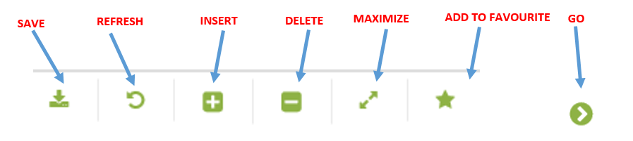

Primary Flow: BKK_UC20 – Monthly Data Locking

Trigger: Monthly Data locking
.Details: Following Regulatory reporting issued to respective government agencies EC data is locked to prevent adjustment. It will be performed after M&M confirmation to lock data.

Step | Actor Action | System Response | Notes
 | Open up Monthly Data Locking screen  EC Production Allocation Monthly Data Locking | The following fields are automatically populated:  - From Month is first Month of the year (mandatory)  - To Month is today’s Month(mandatory)
 | Select From Month to run the lock the data | From month is displayed in entry field
 | Select To Month to include the end date of the allocation event | To month is displayed in entry field
 | Click Go… | The months and Lock status of each month in the period is displayed, columns displayed on the following:  - Month(YYY-MM)  - Lock (Checked Box)  - Comments
 | Check each month Lock checkbox to be locked and click save | - Each month is locked and cannot be edited or re-run allocation in every business function included in locked month.
 | END OF USE CASE

Alternatives

Alternate Flow A1: Monthly data unlocking
Details: Unlocking may be required in order to rerun allocation
Step | Actor Action | System Response | Ref
 | Open up Monthly Data Locking screen  EC Production Allocation Monthly Data Locking | The following fields are automatically populated:  - From Month is first month of the year  - To Month is today’s Month
 | Select From Month to run the unlock data | From month is displayed in entry field
 | Select To Month to include the end date or the latest locking month. | To month is displayed in entry field
 | Click Go… | The months and Lock status of each month in the period is displayed.
 | Uncheck each month Lock checkbox to be unlocked and click save | - Each month unchecked is unlocked: Allocation can be rerun, data can be edited
 | END OF USE CASE

Exceptions

List of Common Issues/Errors
Not aware of any
 | Error | Error Message

