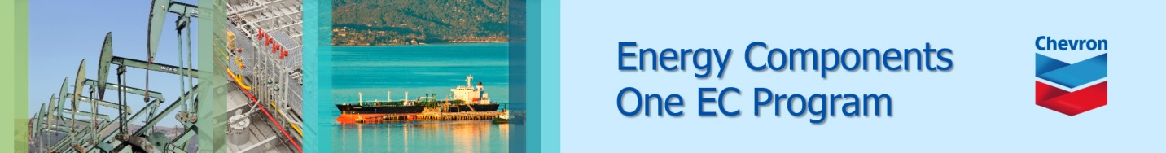

EC Upgrade BKK Use Case

Project Name
BKK 11.2 Project Energy Components

Use-Case Name
BKK_UC37 – MaintainWell
Origination Date
28-Dec-2017

Revision History

Revision | Date | Description | Prepared  by | Checked  by | Approved by
1.0 | 28-Dec-2017 | Draft of Use Case “Maintain Well” | Wirasak C.
1.1 | 27-Mar-2018 | Updated as per EC 11.2 | Tieto
2 | 2-July-2020 | Thailand ECsasS | Wirasak C.

Table of Contents

1. Use Case Information 4
2. Primary Flow: BKK_UC37 Maintain well 4
3. Alternatives 6
3.1 Alternate Flow A1: Modify en existing well 6
4. Exceptions 8
4.1 List of Common Issues/Errors 8

Use Case Information

Use Case Number and Name | BKK_UC37 Maintain Well
Brief Description | This BF is used to Maintain wells
Related Use Cases | - Enter Production Well Status  - Enter Production Well Daily Data 1  - Enter Well Test Result  - Enter Injection Well Status  - Enter Water Injection Well Daily Data  - Maintain Well Bore
EC Business Functions | - BF – WELL (CO.0049)
EC Roles | - B8/32 Administrator  - Baanpot Administrator  - Thailand ECIS Admin  - Erawan Administrator  - Funan Administrator  - M and M Admin COTL  - M and M Admin CTEP  - Pailin Administrator  - Platong Administrator  - Satun Administrator  - Satun Funan Administrator
Prerequisites
Approver

Note: the toolbar on EC11.2 has changed. Refer to the image below for different buttons

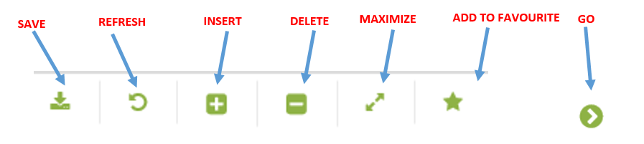

Primary Flow: BKK_UC37 Maintain well

Trigger: User needs to maintain a well

Step | Actor Action | System Response | Notes
1. | Open up Maintain Well screen  Administration Assets Well and Reservoir Objects Maintain Well | The following fields are automatically populated:  - Date is yesterday’s date  - Production Unit  - Production Sub Unit  - Area | Note: Fields are populated according to the navigation role defined for each user
2. | Change the Date to include the date of data being entered | Dates are displayed
3 | Navigate to the tank stream that you need to enter data on using the drop down menus and click Go…  - Production Unit  - Production Sub Unit  - Area  - Sub Area  - Facility Class 2  - Facility Class 1 | If there are any records, they will be listed in the Data Window.  If there were no records for that date, there will be a message “no records found…” | Note: The hierarchy information may be pre-populated and user just needs to hit Go…
4. | Mouse over to the Insert icon on the toolbar | If there are current wells listed in the Data Window, two options are displayed:  • New Version  • New Object  A new data entry form is created in the Data Window.
5. | If prompted, click “New Object” | A data entry screen is displayed in the Data Window:  Mandatory fields are Well Code, Well Name, Start Date, , Well Type, Theoretical Calc Method, ,  All Attributes include:  - Well Code  - Well Name  - Description  - Start Date  - End Date  - Well UID  - Top Depth  - Well Type  - Production Method  - Pump Type  - Meter Frequency  - Well Test Equipment Method  - Daily Methods  - Gas Lift Method  - Theoretical Calc Method  - Calculate Mass Method  - Theoretical Inj Calc Method  - Theoretical Water Inj Calc Method  - Potential Method  - Potential Mass Method  - Potential Gas Inj Method  - Potential Water Inj Method  - On Stream Method  - BS&W Volume Method  - Other Config Options  - Well Test Shrinkage Method  - Calculation Rule  - Override Well Calculation Rule  - Alloc By Fixed GOR  - Alloc By Fixed WC  - Include in allocat - Choke UOM  - Oil Density On Well  - Gas Density On Well  - Water Density On Well  - Active Production Day Definition  - Well Reference Object  - Zone  - Report Well Category  - Choke  - Gas Lift Choke  - Deferment Calculation Rule  - Well Hole  - Commercial Entity  - Process Train  - Test Device  - Op Production Unit  - Op Sub Production Unit  - Op Area  - Op Sub Area  - Op Facility Class 2  - Op Facility Class 1  - Geo Field  - Geo Country  - Geo Region  - Geo License | New object is selected because the user is creating a new well.
7. | Click the Save icon  Verify that data is saved and displayed correctly | The well is saved and available for data entry.
 | END OF USE CASE

Alternatives

Alternate Flow A1: Modify an existing well
Details: Once daily information are entered, it may be necessary to update existing records if the record was entered incorrectly.
Step | Actor Action | System Response | Ref
 | Open up Maintain Well screen  Administration Assets Well and Reservoir Objects Maintain Well | The following fields are automatically populated:  - Date is yesterday’s date  - Production Unit  - Production Sub Unit  - Area | Note: Fields are populated according to the navigation role defined for each user
 | Change the Date to include the date of data being entered | Dates are displayed
 | Navigate to the tank stream that you need to enter data on using the drop down menus and click Go…  - Production Unit  - Production Sub Unit  - Area  - Sub Area  - Facility Class 2  - Facility Class 1 | If there are any records, they will be listed in the Data Window.  If there were no records for that date, there will be a message “no records found…” | Note: The hierarchy information may be pre-populated and user just needs to hit Go…
 | Mouse over to the Insert icon on the toolbar | If there are current wells listed in the Data Window, two options are displayed:  • New Version  • New Object  A new data entry form is created in the Data Window.
 | If prompted, click “New Version” and select the date of the version for this well | A data entry screen is displayed in the Data Window  Select Daytime of the version of this well
 | Click the Save icon  Verify that data is saved and displayed correctly | New version was saved and displayed as expected
 | Select the field that needs to be updated | Row is highlighted
 | Modify the data in the input fields that need to be updated | Updated data appears in entry field
 | Click the Save icon  Verify that data is saved and displayed correctly | Data was saved and displayed as expected
 | END OF USE CASE

Exceptions

List of Common Issues/Errors

 | Error | Error Message

