

EC Upgrade BKK Use Case

Project Name
BKK 11.2 Project Energy Components

Use-Case Name
BKK_UC39 – Maintain Well Bore
Origination Date
28-Dec-2017

Revision History

Revision | Date | Description | Prepared  by | Checked  by | Approved by
1.0 | 28-Dec-2017 | Draft of Use Case “Maintain Well Bore” | Wirasak C.
1.1 | 27-Mar-2018 | Updated as per EC 11.2 | Tieto
2 | 2-July-2020 | Thailand ECsasS | Wirasak C.

Table of Contents

1. Use Case Information 4
2. Primary Flow: BKK_UC39 Enter a new Well Bore 4
3. Alternatives 6
3.1 Alternate Flow A1: Modify en existing Well Hole 6
4. Exceptions 8
4.1 List of Common Issues/Errors 8

Use Case Information

Use Case Number and Name | BKK_UC39 Maintain Well Bore
Brief Description | This BF is used to Maintain a well bore
Related Use Cases | - Maintain Well  - Maintain Well bore Split
EC Business Functions | - MAINTAIN WELL BORE (CO.0054)
EC Roles | - B8/32 Administrator  - Baanpot Administrator  - Thailand ECIS Admin  - Erawan Administrator  - Funan Administrator  - M and M Admin COTL  - M and M Admin CTEP  - Pailin Administrator  - Platong Administrator  - Satun Administrator  - Satun Funan Administrator
Prerequisites | Well created
Approver

Note: the toolbar on EC11.2 has changed. Refer to the image below for different buttons

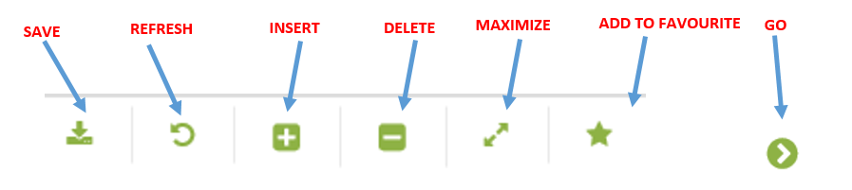

Primary Flow: BKK_UC39 Enter a new Well Bore

Trigger: User needs to Maintain a well bore

Step | Actor Action | System Response | Notes
1. | Open up Well Bore screen  Administration Assets Well and Reservoir Objects Well Bore | The following fields are automatically populated:  - Date is yesterday’s date  - Production Unit  - Production Sub Unit  - Area | Note: Fields are populated according to the navigation role defined for each user
2. | In well dropdown list navigator , Change the Date to include the date of data being entered | Dates are displayed
3 | Navigate to facility class 1 you need to create a well bore on using the drop down menus and click Go…  - Production Unit  - Production Sub Unit  - Area  - Sub Area  - Facility Class 2  - Facility Class 1  - Well (Mandatory) | If there are any records, they will be listed in the Data Window.  If there were no records for that date, there will be a message “no records found…” | Note: The hierarchy information may be pre-populated and user just needs to hit Go…
5. | Then select a well,  Fill-in data on the following:  - Well Bore Code  - Well Bore Name  - Start Date  - Well Bore UID  - X Bottom Hole  - Y Bottom Hole  - Bottom Depth | A data entry screen is displayed in the Data Window | New object is selected because the user is creating a new well.  Mandatory fields are Well Hole Code, Well Hole Name, Start Date
7. | Click the Save icon  Verify that data is saved and displayed correctly | The well is saved and available for data entry.
 | END OF USE CASE

Alternatives

Alternate Flow A1: Modify an existing Well Hole
Details: Once daily information are entered, it may be necessary to update existing records if the record was entered incorrectly.
Step | Actor Action | System Response | Ref
 | Open up Well Bore screen  Administration Assets Well and Reservoir Objects Well Bore | The following fields are automatically populated:  - Date is yesterday’s date  - Production Unit  - Production Sub Unit  - Area | Note: Fields are populated according to the navigation role defined for each user
 | Change the Date to include the date of data being entered | Dates are displayed
 | Navigate to the tank stream that you need to enter data on using the drop down menus and click Go…  - Production Unit  - Production Sub Unit  - Area  - Sub Area  - Facility Class 2  - Facility Class 1  - Well (Mandatory) | If there are any records, they will be listed in the Data Window.  If there were no records for that date, there will be a message “no records found…” | Note: The hierarchy information may be pre-populated and user just needs to hit Go…
 | Mouse over to the Insert icon on the toolbar | If there are current wells listed in the Data Window, two options are displayed:  • New Version  • New Object  A new data entry form is created in the Data Window.
 | If prompted, click “New Version” and select the date of the version for this well | A data entry screen is displayed in the Data Window  Daytime is the mandatory field | If a records already exist, End Date field has to be set to last record.
 | Click the Save icon  Verify that data is saved and displayed correctly | New version was saved and displayed as expected
 | Select the field that needs to be updated | Row is highlighted
 | Modify the data in the input fields that need to be updated | Updated data appears in entry field
 | Click the Save icon  Verify that data is saved and displayed correctly | Data was saved and displayed as expected
 | END OF USE CASE

Exceptions

List of Common Issues/Errors

 | Error | Error Message

