

EC Upgrade BKK Use Case

Project Name
BKK 11.2 Project Energy Components

Use-Case Name
BKK_UC40 – Maintain Well Bore Split
Origination Date
28-Dec-2017

Revision History

Revision | Date | Description | Prepared  by | Checked  by | Approved by
1.0 | 28-Dec-2017 | Draft of Use Case “Maintain Well Bore Split” | Wirasak C.
1.1 | 27-Mar-2018 | Updated as per EC 11.2 | Tieto
2 | 2-July-2020 | Thailand ECsasS | Wirasak C.

Table of Contents

1. Use Case Information 4
2. Primary Flow: BKK_UC40 Maintain Well Bore Split 4
3. Alternatives 5
3.1 Alternate Flow A1: N/A 5
4. Exceptions 5
4.1 List of Common Issues/Errors 5

Use Case Information

Use Case Number and Name | BKK_UC40 Maintain Well Bore Split
Brief Description | This BF is used to Maintain a well bore split
Related Use Cases | - Maintain Well  - Maintain Well Bore
EC Business Functions | - MAINTAIN WELL BORE (CO.0054)
EC Roles | - B8/32 Administrator  - Baanpot Administrator  - Thailand ECIS Admin  - Erawan Administrator  - Funan Administrator  - M and M Admin COTL  - M and M Admin CTEP  - Pailin Administrator  - Platong Administrator  - Satun Administrator  - Satun Funan Administrator
Prerequisites | - Well Bore configured
Approver

Note: the toolbar on EC11.2 has changed. Refer to the image below for different buttons

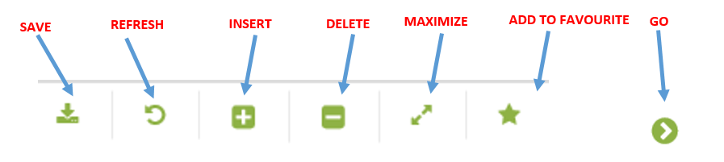

Primary Flow: BKK_UC40 Maintain Well Bore Split

Trigger: User needs to maintain a well bore split

Step | Actor Action | System Response | Notes
1. | Open up Well Bore Split screen  Administration Assets Well and Reservoir Objects Well Bore Split | The following fields are automatically populated:  - Date is yesterday’s date  - Production Unit  - Production Sub Unit  - Area | Note: Fields are populated according to the navigation role defined for each user
2. | Change the Date to include the date of data being entered | Dates are displayed
3 | Navigate to the facility class 1 that you need to enter data on using the drop down menus and click Go…  - Production Unit  - Production Sub Unit  - Area  - Sub Area  - Facility Class 2  - Facility Class 1  - Well (Mandatory) | If there are any records, they will be listed in the Data Window.  If there were no records for that date, there will be a message “no records found…” | Note: The hierarchy information may be pre-populated and user just needs to hit Go…
4. | Mouse over to the Insert icon on the toolbar and click on New Version/New Object | A data entry screen is displayed in the Data Window | Mandatory fields is Well Bore
5. | Click the Save icon  Verify that data is saved and displayed correctly | The well bore split is saved and available for data entry.
 | END OF USE CASE

Alternatives

Alternate Flow A1: N/A

Exceptions

List of Common Issues/Errors

 | Error | Error Message

