

EC Upgrade BKK Use Case

Project Name
BKK 11.2 Project Energy Components

Use-Case Name
BKK_UC45 – Maintain Well Reference Values

Origination Date
28-Dec-2017

Revision History

Revision | Date | Description | Prepared  by | Checked  by | Approved by
1.0 | 28-Dec-2017 | Draft of Use Case “Maintain Perforation Interval Split” | Wirasak C.
1.1 | 27-Mar-2018 | Updated as per EC 11.2 | Tieto
2 | 2-July-2020 | Thailand ECsasS | Wirasak C.

Table of Contents

1. Use Case Information 4
2. Primary Flow: BKK_UC45 Maintain Well Reference Value 4
3. Alternatives 5
3.1 Alternate Flow A1: N/A 5
4. Exceptions 5
4.1 List of Common Issues/Errors 5

Use Case Information

Use Case Number and Name | BKK_UC45 Maintain Well Reference Values
Brief Description | If the well has any fixed attributes, these can be set in the Maintain Well Reference Value screen and will be included in calculations in other EC screens.
Related Use Cases | - MaintainWell  - MaintainWell Bore  - MaintainWell Bore Interval
EC Business Functions | - BF – Maintain Well Reference Value (CO.0156)
EC RoelsRoles | - B8/32 Administrator  - Baanpot Administrator  - Thailand ECIS Admin  - Erawan Administrator  - Funan Administrator  - M and M Admin COTL  - M and M Admin CTEP  - Pailin Administrator  - Platong Administrator  - Satun Administrator  - Satun Funan Administrator
Prerequisites | - Production Well Daily Data
Approver

Note: The toolbar on EC11.2 has changed. Refer to the image below for different buttons

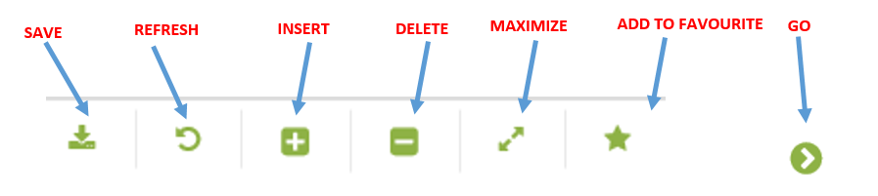

Primary Flow: BKK_UC45 Maintain Well Reference Value

Trigger : an user has received a request from PE to set-up the well, with Field has included some specific constant values that apply to the well. These constant values will be applied to various calculations and used for reporting. Use this process to enter reference values for a new well or to enter a new version of reference values for a well that should be applied after a specific date.

Step | Actor Action | System Response | Notes
1. | EC Support opens up the Well Reference Value Screen  Administration Assets Well and Reservoir Objects Well Reference Value | The following fields are automatically populated:  - Date is yesterday’s date
2. | Change the From Date to the well’s start date and To Date to today’s date | The dates are populated | Date format is yyyy-mm-dd  Must
3 | EC Support navigates to the Well they want to enter reference values for using the drop down menu and click Go…  Operation Hierarchy  - Production Unit  - Production Sub Unit  - Area  - Sub Area  - Facility Class 2  - Facility Class 1  - Well (Mandatory) | If there are no current reference value records created within date range, the Data Window will be blank, “no records found”.  If there are reference value records created within the Date Range, they will be displayed in the Data Window. | Note: The hierarchy information may be pre-populated and user just needs to hit Go
4. | Mouse over to the Insert icon on the toolbar | New Daytime field will show up for entry
5. | Enter the date that the reference values should be applied to the well in Daytime.  (For new wells, enter the Effective Date from the WIN form.) | Date is displayed | Date format is yyyy-mm-dd
6. | Click the Save icon in the Tool Bar | Additional entry fields are displayed for entry.  If there was a previous Well Reference Value record, any attributes previously set will be pre-populated.
 | END OF USE CASE

Alternatives

Alternate Flow A1: N/A

Exceptions

List of Common Issues/Errors

 | Error | Error Message

