

EC Upgrade BKK Use Case

Project Name
BKK 11.2 Project Energy Components

Use-Case Name
BKK_UC50- Initiate Day
Origination Date
29-Dec-2017

Revision History

Revision | Date | Description | Prepared  by | Checked  by | Approved by
1.0 | 29-Dec-2017 | Draft of Use Case “Initiate Day” | Wirasak C.
1.1 | 27-Dec-2018 | Updated as per EC 11.2 | Tieto

Table of Contents

1. Use Case Information 4
2. Primary Flow: BKK_UC50 Create Facility Class 1 4
3. Alternatives 4
3.1 Alternate Flow A1: Add New Version to a Facility Class 1 4
4. Exceptions 5
4.1 List of Common Issues/Errors 5

Use Case Information

Use Case Number and Name | BKK_UC50- Initiate Day
Brief Description | When new wells or streams are created, they sometimes have to be initiated back to the first of the month allocation and stream mapping purposes. This use case includes detailed information to execute the initiate day job.
Related Use Cases
EC Business Functions | - BF – INTIATE DAY (CO.0077)
Prerequisites | - User is logged In  - User has permission to execute Initiate Day
Approver

Note: the toolbar on EC11.2 has changed. Refer to the image below for different buttons

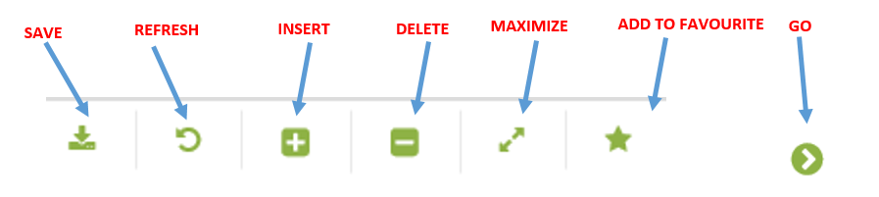

Primary Flow: BKK_UC50 Create Facility Class 1

Trigger: Created a new well or stream in EC that needs instantiation records, EC Support will run the process as needed.
Step | Actor Action | System Response | Notes
1. | EC Support opens up the Allocation Network List screen.  Administration System Initiate Day | From Date and To date should be displayed as yesterday’s date
2. | Enter Start Date manually or by using the calendar icon. | Date is displayed | Date format is yyyy-mm-dd
3 | Enter To Date manually or by using the calendar icon and click Go… | Date is displayed | Date format is yyyy-mm-dd
4. | click Initiate Day | Start Time and Status are displayed | Run time can be several minutes based on the number of days being instantiated
 | END OF USE CASE

Alternatives
none

Exceptions

List of Common Issues/Errors

 | Error | Error Message
 | User does not enter an EC required field | Error: “Please enter” + required field not entered.

