

EC Upgrade BKK Use Case

Project Name
BKK 11.2 Project Energy Components

Use-Case Name
BKK_UC51 - SetUp Allocation Network List
Origination Date
29-Dec-2017

Revision History

Revision | Date | Description | Prepared  by | Checked  by | Approved by
1.0 | 29-Dec-2017 | Draft of Use Case “SetUp Allocation Network List” | Wirasak C.
1.1 | 27-Mar-2018 | Updated as per EC 11.2 | Tieto

Table of Contents

1. Use Case Information 4
2. Primary Flow: BKK_UC51 Add Facility Class 1 to Allocation Network List 4
3. Alternatives 5
3.1 Alternate Condition A1: End Date a Facility Class 1 in the Allocation Network List 5
4. Exceptions 5
4.1 List of Common Issues/Errors 5

Use Case Information

Use Case Number and Name | BKK_UC51- SetUp Allocation Network List
Brief Description | In order to allocate production, several EC screens must be set up for the allocation network. These screens will allow the wells and stream to be linked to allow production allocation. The Allocation Network List is the list of Facility Class 1’s that are in that network
Related Use Cases
EC Business Functions | - BF – ALLOCATION NETWORK LIST (CO.0085)
EC Roles | - EC Thailand Admin
Prerequisites | - User is logged In  - User has permission to add/modify allocation networks list.
Approver

Note: The toolbar on EC11.2 has changed. Refer to the image below for different buttons

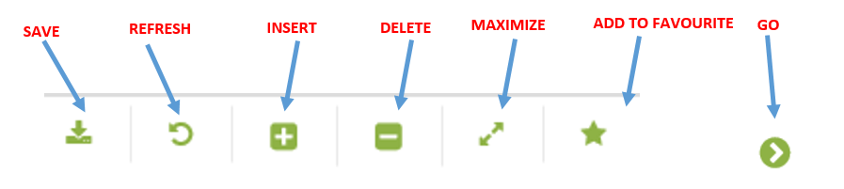

Primary Flow: BKK_UC51 Add Facility Class 1 to Allocation Network List
Trigger: Receive notification for a new allocation network design, The field has developed a new product flow that requires an allocation network set up. This is the creation of the allocation network list of facility class 1’s.
Step | Actor Action | System Response | Notes
1. | EC Support opens up the Allocation Network List screen.  Administration Assets Calculation Objects Allocation Network List | Allocation Network List screen should displayed with Calculation Group dropdown.
2. | Select Calculation Group using the drop-down menu and click Go… | List of existing Delivery Networks are displayed
3 | Mouse over to the Insert icon on the toolbar and click on Calc Group List | A blank entry form for the allocation network list will appear in the Data Window.
4. | Enter in Start Date the effective date of the facility Class 1 connection | Start date is displayed | Date format is yyyy-mm-dd
5. | Select Node Name using the drop-down menu | Entry is displayed | Node name list is all nodes that are available for allocation
6. | Click the Save icon | The allocation network list is saved and available for use in other EC screens.
 | END OF USE CASE

Alternatives

Alternate Condition A1: End Date a Facility Class 1 in the Allocation Network List
Details: The steps below are relevant when an allocation network list requires an end date due to a facility class 1 be taken out of service
Step | Actor Action | System Response | Notes
1. | EC Support opens up the Allocation Network List screen.  Administration Assets Calculation Objects Allocation Network List | Allocation Network List screen should displayed with Calculation Group dropdown.
2. | Select Calculation Group using the drop-down menu and click Go… | List of existing Delivery Networks are displayed
3 | Add End Date as the effective date that the facility class 1 was removed | The Date is displayed | Date format is yyyy-mm-dd
4. | Click the Save icon | Updates to the allocation network list are saved.
 | END OF USE CASE

Exceptions

List of Common Issues/Errors

 | Error | Error Message
 | User does not enter an EC required field | Error: “Please enter” + required field not entered.

