

EC Upgrade BKK Use Case

Project Name
BKK 11.2 Project Energy Components

Use-Case Name
BKK_UC52-Setup Allocation Network
Origination Date
29-Dec-2017

Revision History

Revision | Date | Description | Prepared  by | Checked  by | Approved by
1.0 | 29-Dec-2017 | Draft of Use Case “Setup Allocation Network” | Wirasak C.
1.1 | 27-Mar-2018 | Updated as per EC 11.2 | Tieto

Table of Contents

1. Use Case Information 4
2. Primary Flow: BKK_UC52 Add Allocation Network 4
3. Alternatives 5
3.1 Alternate Condition A2: Update Allocation Network details as a new version 5
4. Exceptions 6
4.1 List of Common Issues/Errors 6

Use Case Information

Use Case Number and Name | BKK_UC52- Setup Allocation Network
Brief Description | In order to allocate production, several EC screens must be set up for the allocation network. These screens will allow the wells and stream to be linked to allow production allocation.  This use case includes detailed information to setup an allocation network.
Related Use Cases
EC Business Functions | - BF – ALLOCATION NETWORK (CO.0084)
EC Roles | - EC Thailand Admin
Prerequisites | - User is logged In  - User has permission to add/modify allocation networks.
Approver

Note: The toolbar on EC11.2 has changed. Refer to the image below for different buttons

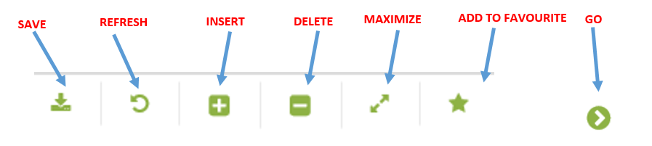

Primary Flow: BKK_UC52 Add Allocation Network

Trigger: Receive notification for a new allocation network design. The asset has developed a new product flow that requires an allocation network set up.

Step | Actor Action | System Response | Notes
1. | EC Support opens up the Allocation Network screen.  Administration Assets Calculation Objects Allocation Network | A list of the allocation networks that are currently setup in EC appear in the Data Window.
2. | Mouse over to the Insert icon on the toolbar | Two menu options appear:  - New Version  - New Object
3. | Click New Object | A blank entry form for the allocation network will appear in the Data Window.
4. | Enter the Allocation Network Code  (ALL CAPS) | Entry is displayed | Mandatory field;
5. | Enter Allocation Network Name  (ALL CAPS) | Entry is displayed | Mandatory field
6. | Enter Start Date manually or by using the calendar icon | Date is displayed | Date format is yyyy-mm-dd
7. | Select Period using the drop-down menu | Selection is displayed | Options for Period are:  - - Daily  - - Monthly  - - Yearly  - - Daily and monthly  - - Daily, monthly and yearly  - - Monthly and yearly  - - Sub-daily  - - Sub-daily and daily  - - Sub-daily, daily and monthly  - - Not included
9. | Click the Save icon | The allocation network is saved and available for use in other EC screens.
 | END OF USE CASE

Alternatives

Alternate Condition A2: Update Allocation Network details as a new version
Details: The steps below are relevant when an allocation network requires an update to any attributes and the needs to be saved as a new version. History of the allocation network will be saved.
Step | Actor Action | System Response | Ref
A2.1 | EC Support opens up the Allocation Network screen.  Administration Assets Calculation Objects Allocation Network | A list of the allocation networks that are currently setup in EC appear in the Data Window.
A2.2 | Click the Allocation Network in the Data Window that requires an update | Row will be highlighted  .
A2.3 | Mouse over to the Insert icon on the toolbar | Two menu options are displayed:  - New version  - New object
A2.4 | Click New Version | New form is displayed in the bottom half of the Data Window:  - Start Date is populated with the original start date of the allocation network in EC  - End Date is blank  - Daytime entry is open for entry
A2.5 | Manually enter the correct date for the update or use the calendar icon | Date is displayed.
A2.6 | Click the Save icon | Changes to Allocation Network are saved; Allocation Network form is displayed with current data displayed.
A2.7 | Update necessary attributes for the new version of the allocation network | Updates are displayed.
A2.8 | Click the Save icon | New version with updates to attributes is saved.
 | END OF USE CASE

Exceptions

List of Common Issues/Errors

 | Error | Error Message
 | User does not enter an EC required field | Error: “Please enter” + required field not entered.

