

EC Upgrade BKK Use Case

Project Name
BKK 11.2 Project Energy Components

Use-Case Name
BKK_UC53- Setup Node
Origination Date
29-Dec-2017

Revision History

Revision | Date | Description | Prepared  by | Checked  by | Approved by
1.0 | 29-Dec-2017 | Draft of Use Case “Setup Node” | Wirasak C.
1.1 | 27-Mar-2018 | Updated as per EC 11.2 | Tieto

Table of Contents

1. Use Case Information 4
2. Primary Flow: BKK_UC53 Receive notification for a new allocation network design. 4
3. Alternatives 5
3.1 Alternate Condition A1: Update the Node due to error 5
3.2 Alternate Condition A2: Update Node details as a new version 6
4. Exceptions 7
4.1 List of Common Issues/Errors 7

Use Case Information

Use Case Number and Name | BKK_UC53- Setup Node
Brief Description | In order to allocate production, several EC screens must be set up for the allocation network. These screens will allow the wells and stream to be linked to allow production allocation. In some instances a Node needs to be set up when multiple Facility Class 1’s need to be linked. This use case includes detailed information to setup a Node.
Related Use Cases
EC Business Functions | - BF – NODE (CO.0025)
EC Roles | - EC Thailand Admin
Prerequisites | - User is logged In  - User has permission to add/modify Nodes.
Approver

Note: The toolbar on EC11.2 has changed. Refer to the image below for different buttons

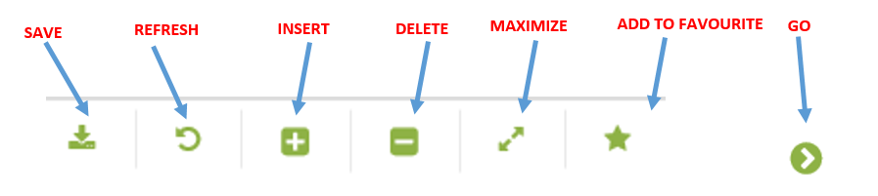

Primary Flow: BKK_UC53 Receive notification for a new allocation network design. Trigger: The field has developed a new product flow that requires a Node set up.
Step | Actor Action | System Response | Notes
1. | EC Support opens up the Node screen.  Administration Assets Calculation Objects Node | A list of Nodes that are currently setup in EC appear in the Data Window.
2. | Mouse over to the Insert icon on the toolbar | Two menu options appear:  - New Version  - New Object
3. | Click New Object | A blank entry form for the allocation network will appear in the Data Window.
4. | Enter the Node Code | Entry is displayed | Mandatory field;
5. | Enter Node Name | Entry is displayed | Mandatory field
6. | Enter Start Date manually or by using the calendar icon | Date is displayed | Date format is yyyy-mm-dd
7. | Enter the Calculation Sequence Number | Calculation Sequence Number is displayed | This affects order of allocation
8. | Click in the box in Include in Allocation | Check mark is displayed
9. | Other input boxes are left blank
10. | Click the Save icon | The allocation network is saved and available for use in other EC screens.
 | END OF USE CASE

Alternatives

Alternate Condition A1: Update the Node due to error
Details: The steps below are relevant when a Node requires an update to any attributes due to error.
Step | Actor Action | System Response | Ref
A1.1 | EC Support opens up the Node screen.  Administration Assets Calculation Objects Node | A list of Nodes that are currently setup in EC appear in the Data Window.
A1.2 | Click the Node Code in the Data Window that requires an update | Row will be highlighted
A1.3 | Update necessary attributes in the Data Window | Updates are displayed
A1.4 | Click the Save icon | Updates to the chemical product are saved.
 | END OF ALTERNATE USE CASE

Alternate Condition A2: Update Node details as a new version
Details: The steps below are relevant when a Node requires an update to any attributes and the needs to be saved as a new version. History of the Node will be saved.
Step | Actor Action | System Response | Ref
A2.1 | EC Support opens up the Node screen.  Administration Assets Calculation Objects Node | A list of Nodes that are currently setup in EC appear in the Data Window.
A2.2 | Click the Node Code in the Data Window that requires an update | Row will be highlighted
A2.3 | Mouse over to the Insert icon on the toolbar | Two menu options are displayed:  - New version  - New object
A2.4 | Click New Version | New form is displayed in the bottom half of the Data Window:  - Start Date is populated with the original start date of the allocation network in EC  - End Date is blank  - Daytime entry is open for entry
A2.5 | Manually enter the correct date for the update or use the calendar icon | Date is displayed.
A2.6 | Click the Save icon | Changes to node are saved; Node form is displayed with current data displayed.
A2.7 | Update necessary attributes for the new version of the allocation network | Updates are displayed.
A2.8 | Click the Save icon | New version with updates to attributes is saved.
 | END OF USE CASE

Exceptions

List of Common Issues/Errors

 | Error | Error Message
 | User does not enter an EC required field | Error: “Please enter” + required field not entered.

