

EC Upgrade BKK Use Case

Project Name
BKK 11.2 Project Energy Components

Use-Case Name
BKK_UC54-Stream Node Diagram
Origination Date
29-Dec-2017

Revision History

Revision | Date | Description | Prepared  by | Checked  by | Approved by
1.0 | 29-Dec-2017 | Draft of Use Case “Stream Node Diagram” | Wirasak C.
1.1 | 27-Mar-2018 | Updated as per EC 11.2 | Tieto

Table of Contents

1. Use Case Information 4
2. Primary Flow: BKK_UC54 Receive notification for a new allocation network design 4
3. Alternatives 4
4. Exceptions 4
4.1 List of Common Issues/Errors 4

Use Case Information

Use Case Number and Name | BKK_UC54-Stream Node Diagram
Brief Description | After all of the screens and links are complete for a delivery network, the completed flow diagram can be displayed and reviewed through the stream node diagram screen. This allows review for structure errors.  This use case includes detailed information to execute the stream node diagram screen.
Related Use Cases
EC Business Functions | - BF – Stream Node Diagram (CO.0094)
EC Roles | - EC Thailand Admin
Prerequisites | - User is logged In  - User has permission to add/modify Stream Node Diagram.
Approver

Note: The toolbar on EC11.2 has changed. Refer to the image below for different buttons

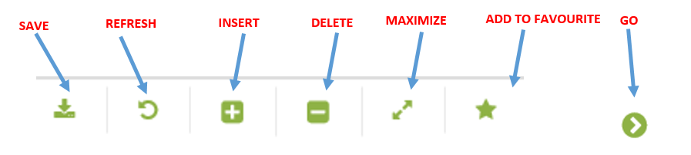

Primary Flow: BKK_UC54 Receive notification for a new allocation network design
4.1 Trigger: Receive notification for a new allocation network design.

Step | Actor Action | System Response | Notes
1. | EC Support opens up the Stream Node Diagram screen.  Administration Assets Calculation Objects Stream Node Diagram | Stream Node Diagram screens should open with option to select Allocation network from dropdown  Date displayed is yesterday’s date.
2. | Change Date to the date that the diagram should be in effect, the “Effective Date” | Date is updated
3 | Click the Network drop down and select Allocation Network Name and click Go… | Stream Node Diagram for the particular network is populated | The list is all available delivery networks
4. | Right Click the diagram, Mouse over to Network and click on Auto layout | Stream Node Diagram is displayed.
 | Network diagram is displayed and can be reviewed for accuracy.
 | END OF USE CASE

Alternatives
none

Exceptions

List of Common Issues/Errors

 | Error | Error Message
 | User does not enter an EC required field | Error: “Please enter” + required field not entered.

