

EC Upgrade BKK Use Case

Project Name
BKK Project Energy Components

Use-Case Name
EC_12_22_BKK_UC04_ Well Test – Single
Origination Date
14-Oct-2017

Revision History

Revision | Date | Description | Prepared  by | Checked  by | Approved by
1.0 | 12-Apr-2017 | Draft of Use Case “Well Test – Single” | Wirasak C.
1.1 | 9-Nov-2017 | Review and feedback | Jennifer Lopez
1.2 | 27-Mar-2018 | Updated as per EC 11.2 | Tieto
2 | 2nd-July-2020 | Update for Thailand ECaaS Project | Wirasak C.
2 | 20-June_2021 | Updated as per Ec12.2 | Tieto

Table of Contents

1. Use Case Information 3
2. Primary Flow: CSJ_UC04 Enter Well Test Result 3
3. Alternatives 7
3.1 Alternate Flow A1: Modify a Well Test Result 7
4. Exceptions 9
4.1 List of Common Issues/Errors 9

Use Case Information

Use Case Number and Name | EC _12_2BKK_UC04_ Well Test – Single
Brief Description | This BF describes the entry of a well test after well test data readings have been captured by field personnel.
Related Use Cases | - Production Well Daily Data 1  - Maintain Well
EC Business Functions | - PRODUCTION TEST RESULT (PT.0010)
EC Roles
(list of EC Roles that may execute Use Case)
Prerequisites | - Well Active Status should be OPEN
Approver

Note: The toolbar on EC11.2 has changed. Refer to the image below for different buttons

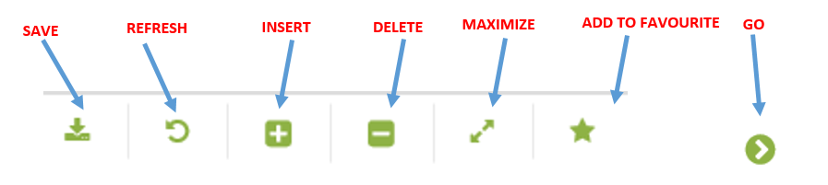

Actors

Primary Actor

Production Operator, Production Lead Operator

Secondary Actors

Asset Technologist

Pre-Conditions

Well test data of conventional platform or allocation well test type have been captured manually by Production Operator or Lead Operator

Production lead operator is responsible for daily well test data QA/QC and accept/reject well test and include well test in allocation, Asset Technologist also responsible for monthly or weekly well test QA/AC and revise well test and accept/reject well test according to PE’s platform (facility class 1) review.

ECIS must automatically transfer data to EC for only ECIS tag mapping available

The proper access level granted to the user to enter well test data on a well

Logged into EC

Navigate to the proper well

Primary Flow: Well Test – Single
Trigger: User enter a well test result
Step | Actor Action | System Response | Notes
 | Open up Well Test - Single screen  EC Production à Production Testing à Well Test – Single | The following fields are automatically populated:  - From Date is yesterday’s date  - To Date is Yesterday’s date  - Production Unit  - Production Sub Unit  - Area | Note: Fields are populated according to the navigation role defined for each user
 | Select a From Date and To Date in the navigation menu that will include the date of the test being entered. | Date is populated.
 | Navigate to the Well Test - Single screen using the drop down menus and click Go…  - Production Unit  - Production Sub Unit  - Area  - Sub Area  - Facility Class 2  - Facility Class 1  - Well (Optional)  - Status (Optional) | If there are any records for that date, they will be listed in the Data Window.  If there were no records for that date, there will be a message “no records found…”  Oil Rate Column will be non-editable for GP well type, and Condyu Rate Column will be non-editable for OP well. | Note: The hierarchy information may be pre-populated and user just needs to hit Go…  For assets have ECIS well test tag mapping, the well test result is automatically loaded by ECIS.  For assets don’t have ECIS well test tag mapping or need to add any well test e.g. conventional platform or allocation well test type, the well test result is manually entered.  If a well have not been selected you can choose it when the well was inserted
 | Mouse over to Insert Icon in the Tool Bar and click on Well Test Single | A blank well test record is created in the Well Test Result area below the Navigation area of the screen.  If a list of tests exists in the Well Test Result area, the blank well test record will be placed at the bottom of the list.  The following attributes are populated by default:  • Daytime :  Daytime must be default equal to To Date in navigator with default time is 00:00 | Availability to enter refer to table 1.1
 | (for Pailin Asset Only)  Click the Insert Icon in the Tool Bar and select Test Device. See Figure 1.  A blank Test Device Result record is created.  Navigate to the drop down menu and click on the Test Device…  Click the Save icon | Data was saved and displayed as expected. | When update Test Device Result :  - Raw Condy Rate,  - Pressure,  - Temperature  And click Save icon,  Adjust Condensate will be updated by Raw Condy Rate * Ron May Factor.  cv_bkk_utilities.GET_ron_may_factor(n_TDEV_TEMP,n_TDEV_PRESS)*n_NET_COND_RATE_FLC
 | Click on the Well tab | If there were no records for that date, there will be a message “no records found…”
 | Mouse over to Insert Icon in the Tool Bar and Click on the Well Test Result | A blank Wells Result record is created. | Well Name is mandatory  Available to enter:  - Well Name  (Dropdown List)  - Daytime  (Dropdown List)  - Test Duration  - Valid From Daytime  - Result Type  - Oil rate  - Gas rate  - Condy rate  - Motor Frequency  - Separator Press, Temp  - Choke  - Casing Press  - Orifice Plate Dia  - Oil Gravity  - Shrinkage Factor  - BS&W  - Test reason  - Test device
 | Navigate to the drop down menu and click on the well…  Click the Save icon | Data was saved and displayed as expected  Primary and Flowing check box is marked  The status of the well test result is New
 | Click the Accept, use alloc button to accept and use the well test result in the allocation  Click the Accept, no alloc button to accept but not use in the allocation  Click the Reject button to reject the well test result | Status is Accepted and check box “Use in Alloc” is marked  Status is Accepted and check box “Use in Alloc” is not marked  Status is Rejected and check box “Use in Alloc” is not marked | For rejecting a well test result, an input in the Reason field is required
 | END OF USE CASE

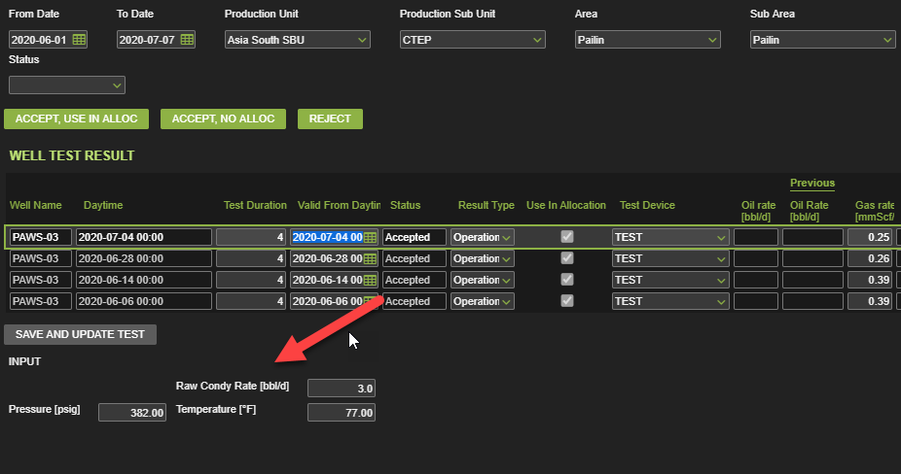
Figure 1. Test Device for Area Pailin that will automatically update data to Well Test Result when save or update the value.

Alternatives

Alternate Flow A1: Modify a Well Test Result
Details: Once daily a well test result is entered, it may be necessary to update existing records if the record was entered incorrectly.

Step | Actor Action | System Response | Notes
 | Open up Well Test - Single screen  EC Production à Production Testing à Well Test – Single | The following fields are automatically populated:  - From Date is yesterday’s date  - To Date is Yesterday’s date  - Production Unit  - Production Sub Unit  - Area | Note: Fields are populated according to the navigation role defined for each user
 | Select a From Date and To Date in the navigation menu that will include the date of the test being entered. | Date is populated.
 | Navigate to the Well Test - Result screen using the drop down menus and click Go…  - Production Unit  - Production Sub Unit  - Area  - Sub Area  - Facility Class 2  - Facility Class 1  - Well (optional)  - Status (optional) | If there are any records for that date, they will be listed in the Data Window.  If there were no records for that date, there will be a message “no records found…”
 | Select the record that needs to be updated | Row is highlighted
 | Edit and modify the data and click the Save icon  Verify that data is saved and displayed correctly | Data was saved and displayed as expected | Available Fields for updating  - Test Duration  - Valid From Daytime  - Result Type  - Oil rate  - Gas rate  - Condy rate  - Motor Frequency  - Separator Press, Temp  - Choke  - Casing Press  - Orifice Plate Dia  - Oil Gravity  - Shrinkage Factor  - BS&W  (Only Pailin Asset)  When update Test Device Result :  - Raw Condy Rate,  - Pressure,  - Temperature  And click Save icon,  Adjust Condensate will be updated by Raw Condy Rate * Ron May Factor.  cv_bkk_utilities.GET_ron_may_factor(n_TDEV_TEMP,n_TDEV_PRESS)*n_NET_COND_RATE_FLC
 | END OF USE CASE

Exceptions

List of Common Issues/Errors

 | Error | Error Message

